Data Analysis and Visualization (DAV)
Final Architecture and FinOps Report
Phase 3: Gold layer, Power BI dashboard, query-plan analysis and cost evaluation
Project: GitHub Open-Source Project Health Analytics
Platform: Databricks (Free Edition, serverless) with Delta Lake and Unity Catalog; Power BI Desktop
Team: Hamza Sheikh (24L-2500) and Sadeem Arshad (24L-2502)
Institution: FAST-NUCES, Lahore
Date: 24 October 2026
Repository: github.com/Sadeem-Arshad/dav-project

Contents
1. Overview and results
2. Architecture
3. Gold data model
4. Pipeline integration and logging
5. Decision log
6. Query plan and DAG analysis
7. Power BI semantic model and dashboard
8. Cost and FinOps evaluation
9. Limitations and checks

1. Overview and results
The project answers one business question: which open-source Python projects are healthy and active, who contributes to them, and how fast are issues and pull requests handled? Data comes from the GitHub REST API for eight repositories (pandas, numpy, scikit-learn, matplotlib, scipy, fastapi, flask, pytest). A Medallion pipeline on Databricks turns the raw API responses into a Gold star schema, and a Power BI dashboard reads Gold directly from a Databricks SQL warehouse.
Phases 1 and 2 built the extraction and the Bronze and Silver layers. This report covers Phase 3: the Gold layer, the automatic refresh, the dashboard, and the engineering and cost decisions behind them.

What was loaded (12-month history load, 13 windows of 30 days)
Layer | Table | Rows | How it was measured
Bronze | bronze_commits | 13,780 inserted, 60 updated | Sum of the 13 window logs
Bronze | bronze_issues (includes pull requests) | 26,449 inserted | Sum of the 13 window logs
Bronze | bronze_pulls | 17,774 inserted | Sum of the 13 window logs
Silver | silver_commit | 13,840 (1 quarantined) | 02 log: 13,800 inserted + 43 updated
Silver | silver_issue | 8,835 | Real issues only; pull requests are removed
Silver | silver_pull_request | 18,156 | 02 log
Gold | dim_repo / dim_date / dim_contributor | 8 / 8,401 / 8,125 | 04 row-count check
Gold | fact_commit / fact_issue / fact_pull_request | 13,840 / 8,835 / 18,156 | 04 row-count check
Gold | fact_repo_daily_activity | 8,597 | 04 row-count check

Every foreign key in Gold resolves to a dimension row: the seven link checks (commit to repo, author and date; issue to repo and author; pull request to repo and author) all returned 0 broken rows.

Phase 3 deliverables and where to find them
Rubric item | Where it is covered
Dimensional model (star schema) and data dictionary | Section 3; notebook 04_silver_to_gold
Liquid Clustering / OPTIMIZE | Sections 3 and 5; notebook 04
Gold refreshes automatically after Silver; Silver-to-Gold logging | Section 4; notebooks 05 and 04
Power BI connected to Databricks; relationships; at least 3 visuals; audit visuals | Section 7; .pbix file
Architecture diagram, decision log, query plan analysis | Sections 2, 5 and 6
Cost and FinOps | Section 8

2. Architecture
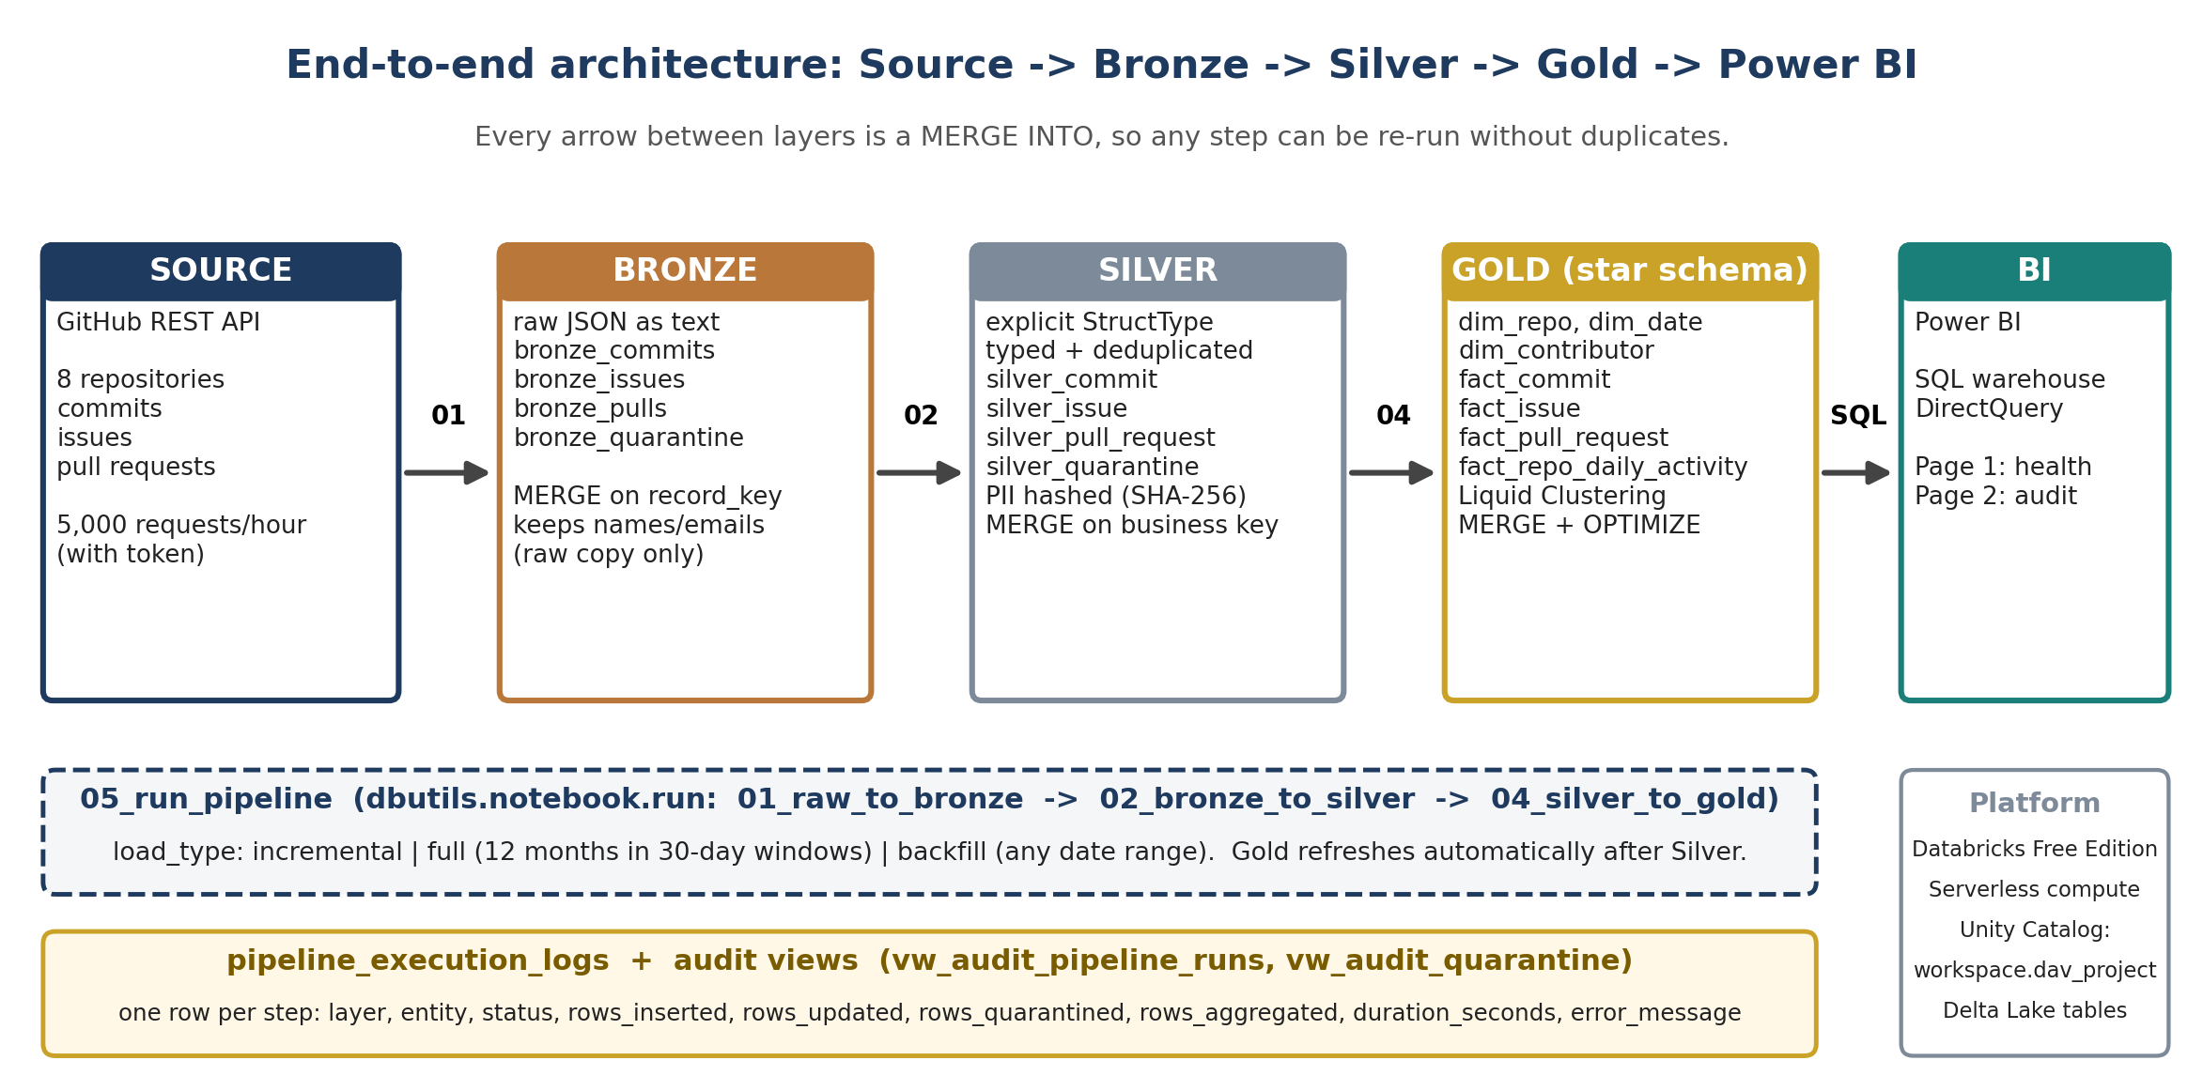
Figure 1. Source to Bronze to Silver to Gold to Power BI, with the orchestration and logging layers.
Layer | Notebook | What it does
Source | 01_raw_to_bronze | Calls the GitHub REST API page by page. Retries temporary errors (500, 502, 503, 504, timeouts) with growing waits. A repository that cannot be fetched marks the step FAILED instead of silently losing data.
Bronze | 01_raw_to_bronze | Stores each record unchanged as JSON text with its repo, batch and load time. MERGE on record_key. Records with no usable key go to bronze_quarantine.
Silver | 02_bronze_to_silver | Parses with explicit StructType schemas, fixes types, removes duplicates, splits pull requests out of the issues feed, replaces names and emails with a salted SHA-256 key. MERGE on the business key. Bad records go to silver_quarantine.
Gold | 04_silver_to_gold | Builds three dimensions, three fact tables and one daily aggregate. MERGE for every table. Writes primary and foreign key constraints, runs OPTIMIZE, creates two audit views.
Orchestrator | 05_run_pipeline | Runs 01, 02 and 04 in order with dbutils.notebook.run. Supports incremental, full (12 months cut into windows) and backfill loads.
BI | Power BI Desktop | Connects to the Databricks SQL warehouse (server hostname, HTTP path, access token) in DirectQuery mode.

3. Gold data model
Gold is a star schema: small dimension tables describe things (repository, day, person) and fact tables hold the events (commits, issues, pull requests). Each fact row points to its dimensions by key, so a dashboard can slice any fact by repo, date or contributor without joining facts to each other.
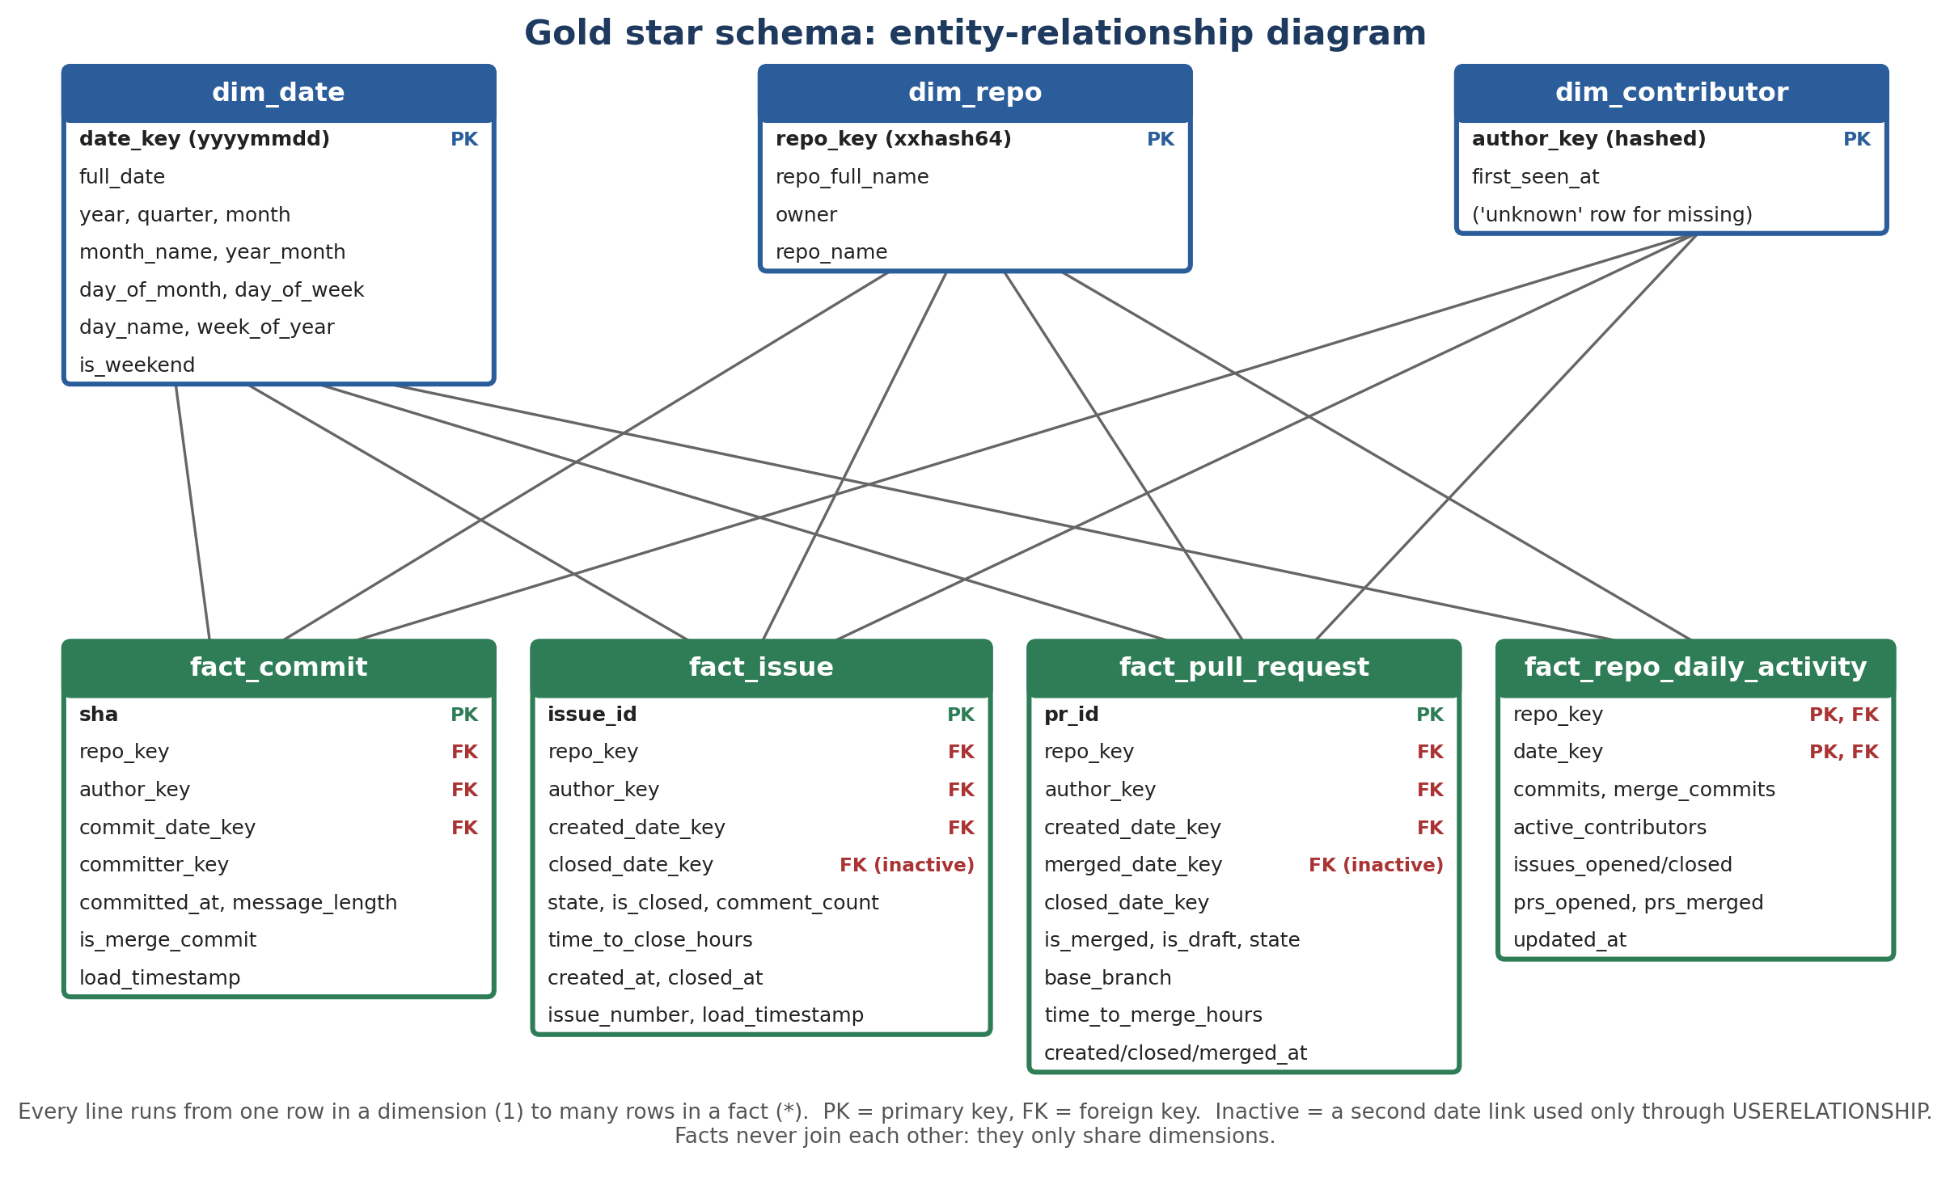
Figure 2. Entity-relationship diagram of the Gold layer.

Audit views for the dashboard
View | Columns | Purpose
vw_audit_pipeline_runs | run_id, layer, entity, status, rows_inserted, rows_updated, rows_quarantined, rows_aggregated, duration_seconds, start_time, end_time, run_date, error_message | Run history for every step of every layer
vw_audit_quarantine | layer, entity_type, repo, reason, load_date, quarantined_rows | Counts of bad records by layer and reason. Raw JSON is left out on purpose, because it can hold names and emails

Data dictionary
PK = primary key. FK = foreign key. Types are the Delta column types. Constraints are written to Unity Catalog as informational constraints (stored and visible, not enforced); uniqueness is actually enforced by the MERGE keys.
Table | Column | Type | Key | Meaning
dim_repo | repo_key | BIGINT | PK | xxhash64 of the repo name
 | repo_full_name, owner, repo_name | STRING |  | e.g. pandas-dev/pandas, pandas-dev, pandas
dim_date | date_key | INT | PK | Day as a number, e.g. 20261024. Covers 2008-01-01 to 2030-12-31 (8,401 days)
 | full_date | DATE |  | Calendar date
 | year, quarter, month, day_of_month, day_of_week, week_of_year | INT |  | Calendar parts
 | month_name, year_month, day_name | STRING |  | Labels; year_month like 2026-10 sorts correctly
 | is_weekend | BOOLEAN |  | Saturday or Sunday
dim_contributor | author_key | STRING | PK | Salted SHA-256 hash of the login or email. One extra member, unknown, covers missing authors
 | first_seen_at | TIMESTAMP |  | Earliest activity seen for this person
fact_commit | sha | STRING | PK | Commit id
 | repo_key, author_key | BIGINT, STRING | FK | To dim_repo and dim_contributor
 | commit_date_key | INT | FK | To dim_date
 | committer_key | STRING |  | Hashed committer
 | committed_at, message_length, is_merge_commit, load_timestamp | mixed |  | Event time, size of the message, true when 2+ parents
fact_issue | issue_id | STRING | PK | GitHub issue id
 | repo_key, author_key, created_date_key | mixed | FK | To dim_repo, dim_contributor, dim_date
 | closed_date_key | INT | FK (inactive) | Second date link; empty while the issue is open
 | issue_number, state, is_closed, comment_count, time_to_close_hours, created_at, closed_at, load_timestamp | mixed |  | Measures and timestamps
fact_pull_request | pr_id | STRING | PK | GitHub pull request id
 | repo_key, author_key, created_date_key | mixed | FK | To dim_repo, dim_contributor, dim_date
 | merged_date_key | INT | FK (inactive) | Second date link; empty when not merged
 | closed_date_key | INT |  | Close day
 | pr_number, state, is_merged, is_draft, base_branch, time_to_merge_hours, created_at, closed_at, merged_at, load_timestamp | mixed |  | Measures and timestamps
fact_repo_daily_activity | repo_key + date_key | BIGINT, INT | PK, FK | One row per repository per day; links to dim_repo and dim_date
 | commits, merge_commits, active_contributors, issues_opened, issues_closed, prs_opened, prs_merged | BIGINT |  | Daily counts rebuilt from the three fact tables
 | updated_at | TIMESTAMP |  | When the aggregate row was last computed

4. Pipeline integration and logging
Gold is refreshed automatically at the end of the pipeline. Notebook 05_run_pipeline runs 01 (Bronze), then 02 (Silver), then 04 (Gold) with dbutils.notebook.run. Gold only starts when Silver finished. Gold facts read only the Silver rows loaded since the pipeline started (the silver_since filter), so a daily run does not redo old work.

How each Gold table is written
- MERGE INTO for every table, so a re-run never creates duplicates. Dimensions use insert-only or a guarded update; facts update matched rows and insert new ones.
- fact_repo_daily_activity is recomputed from the three Gold fact tables each run. A matched row is updated only when one of its counts changed.
- Dimensions first, then facts, because facts point to dimensions.
- If one table fails, it is logged as FAILED, the next table still runs, and the notebook reports the failure to the orchestrator.

Silver-to-Gold logging
Every Gold table writes one row to pipeline_execution_logs with layer = Silver-to-Gold, rows_aggregated (the rows the MERGE read, from Delta's numSourceRows) and duration_seconds. Real values from the first full Gold build:
Entity | Status | Rows inserted | Rows updated | Rows aggregated | Seconds
dim_repo | SUCCESS | 9 | 0 | 9 | 4.29
dim_date | SUCCESS | 8,401 | 0 | 8,401 | 4.81
dim_contributor | SUCCESS | 8,087 | 0 | 8,087 | 5.09
fact_commit | SUCCESS | 43 | 0 | 43 | 5.11
fact_issue | SUCCESS | 8,835 | 0 | 8,835 | 4.55
fact_pull_request | SUCCESS | 18,156 | 0 | 18,156 | 4.48
fact_repo_daily_activity | SUCCESS | 8,570 | 0 | 8,570 | 8.11

This first build ran while silver_commit still held only 43 rows (a Silver bug, explained in section 5). After the fix the build was run again. The second run shows that MERGE is idempotent: the dimension tables inserted 0 and updated 0 rows for rows that already existed.
Entity | Status | Rows inserted | Rows updated | Rows aggregated | Seconds
dim_repo | SUCCESS | 0 | 0 | 8 | 3.71
dim_date | SUCCESS | 0 | 0 | 8,401 | 4.01
dim_contributor | SUCCESS | 38 | 112 | 8,124 | 6.18
fact_commit | SUCCESS | 13,800 | 40 | 13,840 | 4.20
fact_issue | SUCCESS | 0 | 8,835 | 8,835 | 4.74
fact_pull_request | SUCCESS | 0 | 18,156 | 18,156 | 4.72
fact_repo_daily_activity | SUCCESS | 28 | 2,166 | 8,597 | 7.37

The fact tables report every matched row as updated because their load_timestamp is refreshed on each Silver run. The four OPTIMIZE steps took 4.1, 4.3, 4.0 and 4.1 seconds. The whole Gold notebook runs in about 70 seconds on serverless compute.

Backfill and history load
The 12-month history was loaded as 13 windows of 30 days, each window run through notebook 01 on its own, then Silver once and Gold once. A single window takes about 8 to 9 minutes (observed 9 min 8 s and 8 min 20 s for the first two). Most of that time is spent waiting for the GitHub API: its issues and pulls endpoints have no end-date filter, so the notebook pages newest-first and discards what is newer than the window. Splitting into windows also keeps each load small enough for the driver's memory and the API rate limit.

5. Decision log
Each entry gives the decision, the reason, and the alternative that was rejected.

5.1 Partitioning and clustering
Decision | Reason | Rejected alternative
No partitioning on any table | The biggest table has 18,156 rows. Partitioning small tables creates many tiny files and slows every query. Databricks guidance is to avoid partitioning tables below roughly 1 TB. | PARTITIONED BY date or repo
Liquid Clustering on the facts: CLUSTER BY (repo_key, commit_date_key) / (repo_key, created_date_key) / (repo_key, date_key) | The dashboard filters on one repository and a date range. Clustering keeps those rows close together so file skipping works. The clustering columns can be changed later without rewriting the table. | Z-ORDER (fixed at write time) or no layout
OPTIMIZE at the end of 04 | On a clustered table, OPTIMIZE both merges small files and sorts rows by the clustering keys. Run once per load, not per query. | Running it before every query
Bronze and Silver left unclustered | They are read by MERGE on a unique key and scanned in full by Silver and Gold loads. Clustering would not help those reads. | Clustering every layer

5.2 Schema drift
Situation | How the pipeline handles it
Source adds a new field | Silver parses with an explicit StructType and from_json. Unknown fields are ignored; nothing breaks. Bronze keeps the full raw JSON, so the field can be added to Silver later.
A field arrives in the wrong shape | from_json returns null for that one field. The row still loads.
A whole record is broken or has no key | The record goes to bronze_quarantine or silver_quarantine with a reason, and the run continues. Counts show up in the audit view.
We add a column on purpose | MERGE WITH SCHEMA EVOLUTION INTO adds the column without rebuilding the table (demonstrated in notebook 03). Serverless blocks the global autoMerge setting, so the per-statement form is used.
Lesson from Phase 3: a Silver table has more columns than the incoming batch | Our commit MERGE used UPDATE SET *. After the schema-drift demo added has_extra_stats, the MERGE failed with DELTA_MERGE_UNRESOLVED_EXPRESSION. Issues and pull requests loaded, but Silver stayed at 43 commits. The failure was logged, but nothing downstream noticed. Fix: the MERGE now lists its eight columns by name, so extra columns in the target are left alone. Silver now also reports failed steps to the orchestrator, which stops Gold from running on partial data.

5.3 Personal data (PII)
Decision | Reason
Names and emails exist only inside Bronze raw_json | Bronze must be a faithful raw copy. Access to it should be restricted in a real deployment.
Silver replaces login and email with a salted SHA-256 author_key | The same person always hashes to the same key, so counts of contributors and joins still work, but nobody can be read off the table.
Gold, the audit views and Power BI contain no names or emails | Only hashed keys travel downstream. vw_audit_quarantine omits raw_json for this reason.
Salt is a fixed string in the code | Needed so a person keeps the same key on every run. Because the repository is public, the salt is not a secret. In production it would live in a Databricks secret scope. A known weakness of this project.

5.4 Other decisions
- Explicit schemas everywhere (no inferSchema): predictable types and no surprise null columns.
- Stable surrogate keys: repo_key = xxhash64(repo), date_key = yyyymmdd as INT. Both can be rebuilt from the data, so no key table has to be kept in sync.

6. Query plan and DAG analysis
Most complex transformation: the build of fact_repo_daily_activity (notebook 04). It reads the three Gold fact tables, runs five grouped aggregations, builds a union of every (repo, day) pair, joins the five results back with five LEFT JOINs, and merges the result into the target table.
Free Edition note. The classic Spark UI is not available on serverless compute. The equivalent evidence is the Query Profile (Query History, open the MERGE statement) and the EXPLAIN FORMATTED output printed by notebook 04. The plan below is read from the SQL; the screenshot frame is for the Query Profile of the same statement.

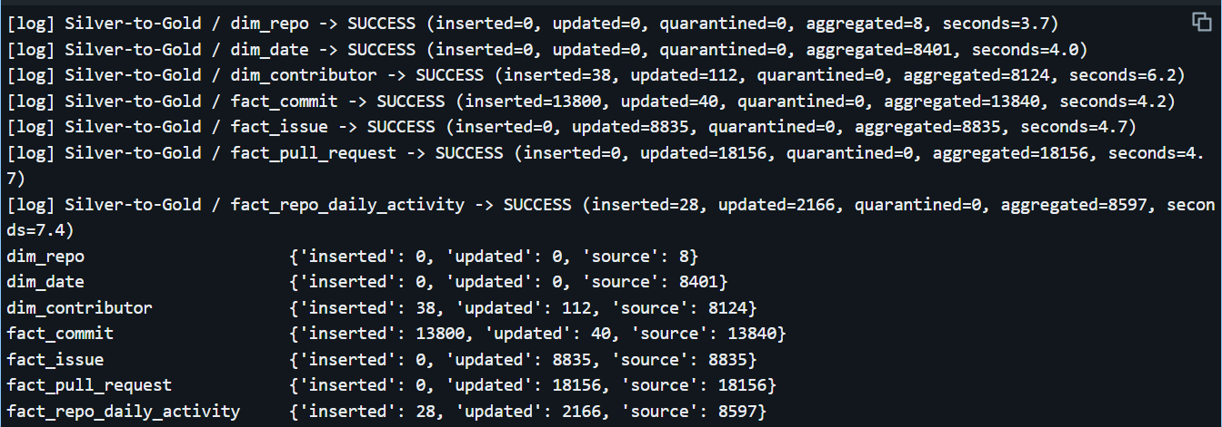

Figure 3. Query Profile of the heaviest statement.

What the plan contains
Plan feature | Where it appears | Why it matters
Shuffle (Exchange hashpartitioning) | Each of the five GROUP BY (repo_key, date_key) steps: partial aggregate, then an exchange that sends rows with the same key to the same worker, then the final aggregate. COUNT(DISTINCT author_key) adds a further exchange. The UNION of key pairs removes duplicates, which is another exchange. The MERGE itself joins source to target on (repo_key, date_key). | Shuffles move data across the network and are the most expensive operator in the plan. This query has several, so it is the best candidate for tuning.
Broadcast join | The five aggregated sides are small (a few thousand rows each), so the optimizer can copy them to every worker instead of shuffling both sides. | A broadcast join avoids a shuffle on the large side. Verify in the profile that the joins say BroadcastHashJoin rather than SortMergeJoin.
Predicate pushdown | Filters such as commit_date_key IS NOT NULL, closed_date_key IS NOT NULL and the incremental filter load_timestamp >= '...' are applied inside the Delta scan (PushedFilters / DataFilters). | Rows and whole files that cannot match are skipped using file statistics, so less data is read from storage.
Column pruning | Each scan reads only the columns it needs (repo_key, the date key, author_key, is_merge_commit), not all 9 to 16 columns of the fact table. | Delta stores data by column, so unused columns cost nothing.
File skipping on the MERGE target | Liquid Clustering on (repo_key, date_key) keeps matching rows in few files, so the MERGE rewrites few files. | Fewer files rewritten means less write cost per run.

Observed cost
The MERGE into fact_repo_daily_activity took 7.4 to 8.1 seconds, the slowest of the seven Gold tables, and it aggregated 8,570 to 8,597 source rows. The other six tables took 3.7 to 6.2 seconds each. At this data size the time is mostly fixed overhead (planning, the join to the target, transaction commit), not data volume.

Possible improvements if the data grew
- Update only the days touched by new Silver rows instead of rebuilding every day (an incremental aggregate), or compute the five measures in one scan with conditional aggregation. Either removes most of the scans and shuffles.

7. Power BI semantic model and dashboard
Power BI Desktop connects to the Databricks SQL warehouse (Serverless Starter Warehouse, 2X-Small) with the server hostname, HTTP path and a personal access token, in DirectQuery mode, so the dashboard always shows what is in Gold. Nine objects are loaded: three dimensions, four fact tables, and two audit views.

Semantic model
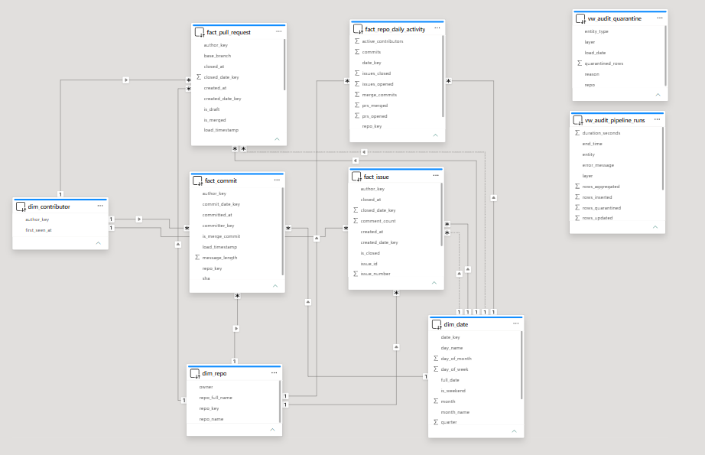
Figure 4. Power BI Model view. Solid lines are active relationships, dotted lines are inactive.
From (many side) | To (one side) | Active | Used for
fact_commit, fact_issue, fact_pull_request, fact_repo_daily_activity : repo_key | dim_repo : repo_key | Yes | Slice any fact by repository
fact_commit : commit_date_key | dim_date : date_key | Yes | Commits by day, month, year
fact_issue : created_date_key | dim_date : date_key | Yes | Issues opened over time
fact_issue : closed_date_key | dim_date : date_key | No | Issues closed over time (USERELATIONSHIP)
fact_pull_request : created_date_key | dim_date : date_key | Yes | Pull requests opened over time
fact_pull_request : merged_date_key | dim_date : date_key | No | Pull requests merged over time
fact_repo_daily_activity : date_key | dim_date : date_key | Yes | Daily activity
fact_commit, fact_issue, fact_pull_request : author_key | dim_contributor : author_key | Yes | Contributors

All relationships are one-to-many with a single filter direction, from a dimension to a fact. No fact table is related to another fact table. The two audit views are standalone.

DAX measures
Total Commits = COUNTROWS(fact_commit)
Issues Opened = COUNTROWS(fact_issue)
Issues Closed = CALCULATE(COUNTROWS(fact_issue), USERELATIONSHIP(fact_issue[closed_date_key], dim_date[date_key]))
Open Issues = CALCULATE(COUNTROWS(fact_issue), fact_issue[is_closed] = FALSE())
Avg Days To Close Issue = DIVIDE(AVERAGE(fact_issue[time_to_close_hours]), 24)
PRs Opened = COUNTROWS(fact_pull_request)
PRs Merged = CALCULATE(COUNTROWS(fact_pull_request), fact_pull_request[is_merged] = TRUE())
PR Merge Rate = DIVIDE([PRs Merged], [PRs Opened])
Avg Hours To Merge PR = AVERAGE(fact_pull_request[time_to_merge_hours])
Active Contributors = DISTINCTCOUNT(fact_commit[author_key])
Failed Runs = CALCULATE(COUNTROWS(vw_audit_pipeline_runs), vw_audit_pipeline_runs[status] = "FAILED")

Dashboard page 1: Project health
Answers the Phase 1 question: which projects are active, who contributes, and how fast issues and pull requests are handled. Visuals: four KPI cards, a line chart of commits per month by repository, bar charts of average days to close an issue and average hours to merge a pull request, a column chart of issues opened against closed, and slicers for repository and year.
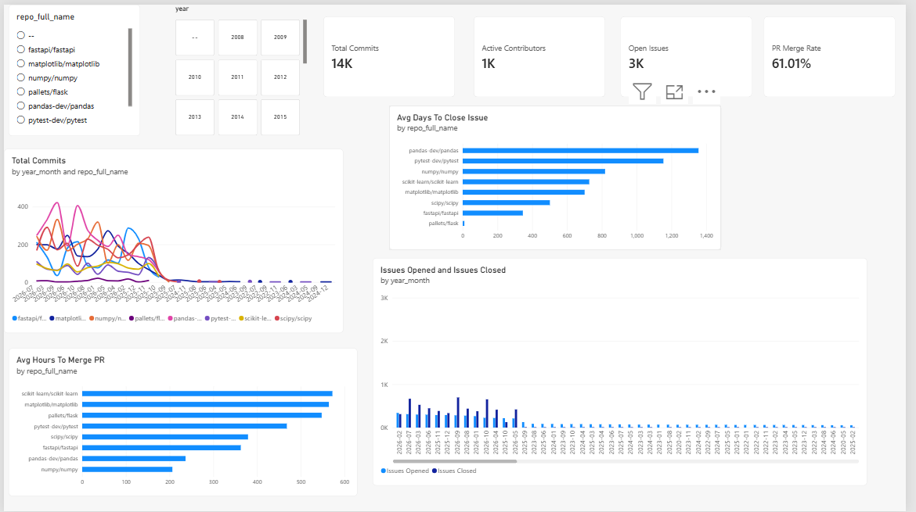

Figure 5. Dashboard page 1.

Dashboard page 2: Pipeline audit
Reads the audit views: the number of failed runs, a table of every pipeline step with rows and seconds, run time per entity and layer, and quarantined records by reason.
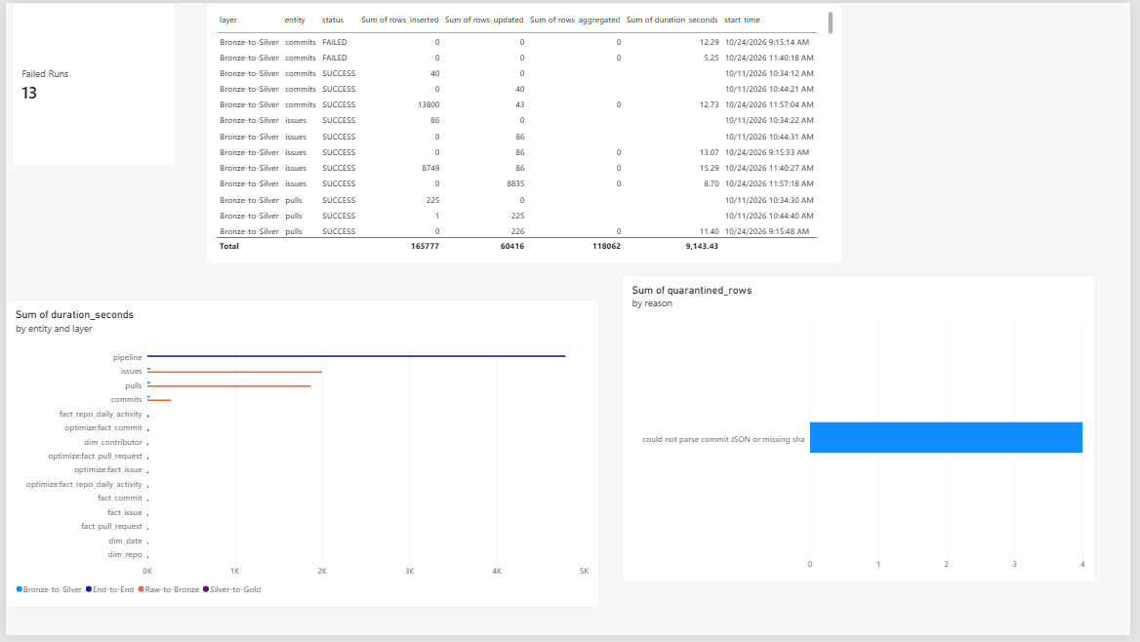

Figure 6. Dashboard page 2.

8. Cost and FinOps evaluation
Read this first. The project ran on Databricks Free Edition, so the real bill is $0. The numbers below estimate what the same pipeline would cost on a paid workspace. Figures marked ASSUMED are our estimates, not measurements, and prices should be checked on the Databricks pricing page before they are used. The inputs are listed in the table so any one of them can be changed and the totals recomputed.

Inputs
Input | Value | Source
Jobs Compute (classic, AWS Premium) | $0.15 per DBU | DoiT pricing guide, March 2026
Classic job cluster size | 3 small nodes, about 2.25 DBU/h plus about $0.58/h of VMs | ASSUMED
Serverless jobs compute | 3.0 DBU/h at $0.35 per DBU (VM cost included) | ASSUMED, not found in the guide used
Serverless SQL warehouse (2X-Small) | 4 DBU/h at $0.75 per DBU = $3.00/h | DoiT pricing guide, March 2026
One daily incremental run, wall clock | 10 minutes (Bronze about 7, Silver about 1.5, Gold about 1.2) | ASSUMED; Gold and Silver are measured, Bronze is dominated by GitHub API waiting
One hourly incremental run | 6 minutes | ASSUMED
Dashboard use | Warehouse awake 2 hours/day | ASSUMED
Storage | Under 1 GB of Delta files; object storage about $0.023 per GB-month, under $0.03 per month | Estimate from table sizes

Typical daily incremental run
Cost of one run = hours of compute x cost per hour. With a 3-node job cluster at about $0.92/hour, or serverless at about $1.05/hour:
Compute option | Cost per hour | One 10-minute run | 30 days | One year (365 runs)
Classic job cluster | $0.92 | $0.15 | $4.59 | $55.81
Serverless job | $1.05 | $0.17 | $5.25 | $63.87

Because most of a daily run is the pipeline waiting on the GitHub API, not computing, the compute cost per day stays small and extra cluster size would not make it faster.

Enterprise estimate: run every hour for a year
There are 8,760 runs in a year. At 6 minutes each, that is 876 hours of compute.
Item | Calculation | Cost per year
Pipeline on a classic job cluster | 876 h x $0.92/h | $804
Pipeline on serverless jobs | 876 h x $1.05/h | $920
Dashboard queries (serverless SQL) | 2 h/day x 365 x $3.00/h | $2,190
Storage | under 1 GB | under $1
Total, pipeline on a classic job cluster plus dashboards |  | $2,994
Total, pipeline on serverless plus dashboards |  | $3,110
Compare: a cluster left running all year | 8,760 h x $0.92/h | $8,037

The warehouse for dashboard users is the largest single line. A job cluster that starts for each run and stops after it costs about 10 times less than keeping the same cluster on all year.

Optimizations applied or recommended
Optimization | Status | Effect
Incremental loads: Gold reads only Silver rows loaded since the run started | Done | A daily run touches one day of data, not 12 months. The 12-month history load took about 2 hours; one day should take a small fraction of that.
MERGE instead of full overwrite at every layer | Done | Writes only changed rows and makes re-runs safe.
No partitioning; Liquid Clustering plus OPTIMIZE after loads | Done | No tiny-file overhead; dashboard filters on repo and date skip files.
Pre-aggregated fact_repo_daily_activity | Done | The dashboard reads about 8,600 rows instead of scanning about 40,000 fact rows for common charts.
Start compute per run and stop it afterwards (job cluster or serverless) | Recommended | Avoids paying for idle time. See the always-on comparison above.
Warehouse auto-stop after a few minutes; Import mode with a scheduled refresh instead of DirectQuery | Recommended | The largest line in the estimate is the warehouse. Import mode only wakes it during the refresh.
Skip Gold when no Silver rows changed; shorten the hourly run | Recommended | At 4 minutes instead of 6 the pipeline line falls to about $536 a year on a classic cluster.
Conditional requests (ETag) to the GitHub API | Recommended | Unchanged data returns 304 and does not use the rate limit, which shortens the waiting that dominates the run time.
Run VACUUM on a schedule | Recommended | Removes old file versions so storage does not grow with every MERGE.

9. Limitations and checks

What was verified
- Row counts after each layer, and seven foreign-key checks on Gold that all returned 0 broken links.
- Re-running Gold does not duplicate rows (dimension tables inserted 0 and updated 0 on the second run).
- Every step of every layer writes a log row; the audit page in Power BI reads them.
- The SELECT statements behind every Gold table were first tested on a local Spark session with hand-made data and hand-computed expected values (counts per repo per day, the earliest-seen time per contributor, the incremental filter, and the plan containing an Exchange).

Known limitations
- Free Edition: serverless only, one small SQL warehouse, a fair-use compute limit, and no classic Spark UI. When the notebook and the warehouse were both active the warehouse failed to start with RESOURCE_EXHAUSTED until the notebook compute was released.
- GitHub API: issues and pulls have no end-date filter, so history windows are slow; unauthenticated calls are limited to 60 an hour. The issues feed contains pull requests, which Silver removes.
- Constraints are informational: Databricks stores primary and foreign keys but does not enforce them. The MERGE keys enforce uniqueness.
- Fixed salt for the PII hash is in the code; a production system would use a secret scope.
- Cost figures are estimates as described in section 8; the Free Edition itself cost nothing.
- Hashed contributors mean the dashboard counts people but cannot name them. This is deliberate.

Reproducing the project
Step | Action
1 | Import the notebooks from the databricks folder of the repository into one Databricks folder.
2 | Run 00_setup_and_logging once.
3 | Run 05_run_pipeline with load_type = full (about 2 hours for 12 months) and a GitHub token pasted in the github_token widget. Clear the widget afterwards.
4 | For daily use run 05_run_pipeline with load_type = incremental. Gold refreshes at the end.
5 | Open the .pbix in Power BI Desktop, point it at the SQL warehouse hostname and HTTP path, and sign in with an access token.

