AI2002 - Artificial Intelligence
Phase 3 Report
Drug Response Prediction Under Unseen Cell-Type Shift Using Single-Cell Gene Expression
Group ID: F26-14 Section: BDS-5A FAST-NUCES Lahore
Members: Sadeem Arshad (24L-2502), Hannan Khan (24L-2550), Saaif Suleman (24L-2606)

1. Problem and Data
In this project we want to know if a model trained on the drug responses of two cell lines (A549 and MCF7) can predict the drug response of a third cell line (K562) that it has never seen. K562 is not used for training or for choosing any setting. We only use it at the end for testing.
The dataset from Phase 2 describes each treatment (cell line, drug, dose and replicate) with 20 numbers. These are the first 20 principal components (PCs) of the change in gene expression caused by the drug. The PCA was fitted on A549 and MCF7 only, and K562 was only projected into it. We have 2,984 training rows (A549 1,493 and MCF7 1,491) and 1,497 test rows (K562), with 188 drugs, 4 doses (10, 100, 1000 and 10000 nM) and 2 replicates. So the task is multi-output regression: the input is drug and dose and the output is 20 numbers. All 751 drug-dose pairs of K562 also exist in the training data.

2. Model Selection and Justification
We used two baselines and four regression models. The only inputs are the drug name and the dose, because this is the only treatment information in our dataset. We did not use any chemical features.
Model | Description | Reason for choosing it
Global Mean | Same average training response for every K562 row | Lowest bar: a useful model must beat it
Source Drug-Dose Mean | Average of A549 and MCF7 for the same drug and dose | Simple transfer idea: K562 behaves like the other two cell lines
Ridge | Linear regression with L2 penalty on one-hot drug and log10(dose) | Simple, few settings, and the penalty helps when test data differs from training data
Drug-Dose Ridge | Ridge with one input for each drug-dose pair | Lets every dose of every drug have its own effect
Random Forest | Ensemble of decision trees | Can learn non-linear drug-dose effects
Extra Trees | Tree ensemble with more randomness | A second non-linear model to compare with Random Forest
We did not try a neural network in this phase. We wanted models that are easy to explain and to compare fairly.

3. Implementation Details
- Language and libraries: Python, NumPy and pandas for the data, scikit-learn for the models (Ridge, RandomForestRegressor, ExtraTreesRegressor), the preprocessing (OneHotEncoder, ColumnTransformer), pipelines and metrics, and matplotlib for the figures. The exact versions are printed in the first cell of the notebook.
- Each model is a scikit-learn Pipeline (one-hot encoding and then the regressor), so the encoding is learned from the training rows only. The tree models use random seed 42.
- Metrics: RMSE, MAE, R² and Pearson correlation, calculated over all 20 outputs together. We calculate them on the K562 rows and also on the replicate-averaged K562 responses (751 conditions).
- Code: F26-14.ipynb runs from top to bottom using the files in data/processed and saves the tables and figures in results/.

4. Code Workflow (data input to model to output)
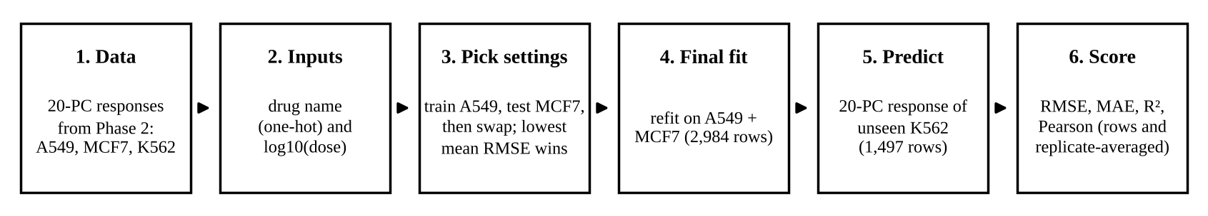
Figure 1. Workflow from the Phase 2 data to the K562 scores.

5. Training Process
- Data split: training uses A549 and MCF7 (2,984 rows) and testing uses K562 (1,497 rows), only once at the end. We did not use a random split because K562 rows would go into training and the cell-type shift would be hidden.
- Choosing settings: we train on A549 and validate on MCF7, then train on MCF7 and validate on A549, and take the average RMSE of the two. The best setting is then trained again on all training rows.
- Other setup: the replicate is not used as an input and the dose is converted with log10. Epochs do not apply here because Ridge is solved directly and the tree models are built in one pass.

Model | Settings tried | Selected | Mean validation RMSE
Ridge | alpha = 0.01, 0.1, 1, 10, 100, 1000 | alpha = 10 | 4.0548
Drug-Dose Ridge | same alpha values | alpha = 1 | 3.9134
Random Forest | (trees, depth) = (200, 10), (200, 20), (300, none) | 200, 20 | 3.9980
Extra Trees | (trees, depth) = (300, 10), (300, 20), (500, none) | 300, 10 | 4.1293

6. Initial Results
The table shows the scores on the unseen K562 cell line. Bold values are the best in each column.
 | K562 rows (n = 1,497) |  |  | Replicate-averaged K562 (n = 751)
Model | RMSE | R² | Pearson | RMSE | R² | Pearson
Global Mean | 2.8069 | -0.0007 | -0.1049 | 2.5049 | -0.0009 | -0.1171
Source Drug-Dose Mean | 3.1843 | -0.2879 | 0.3885 | 2.9350 | -0.3741 | 0.4426
Ridge | 2.6817 | 0.0865 | 0.3463 | 2.3565 | 0.1142 | 0.3935
Random Forest | 2.9132 | -0.0779 | 0.3800 | 2.6333 | -0.1062 | 0.4328
Drug-Dose Ridge | 2.7983 | 0.0054 | 0.4027 | 2.4930 | 0.0086 | 0.4588
Extra Trees | 2.9502 | -0.1055 | 0.3157 | 2.6564 | -0.1256 | 0.3663

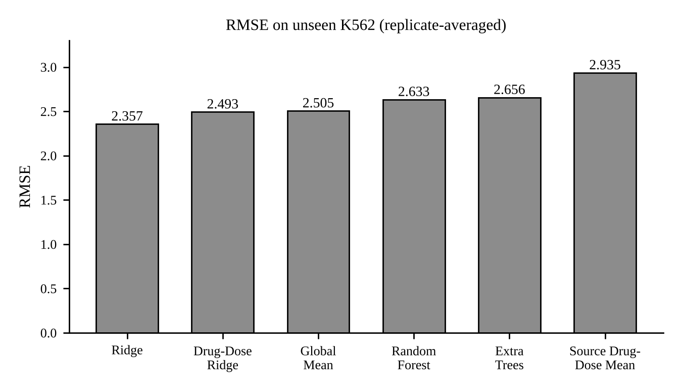  Figure 2. RMSE of each model on K562. | 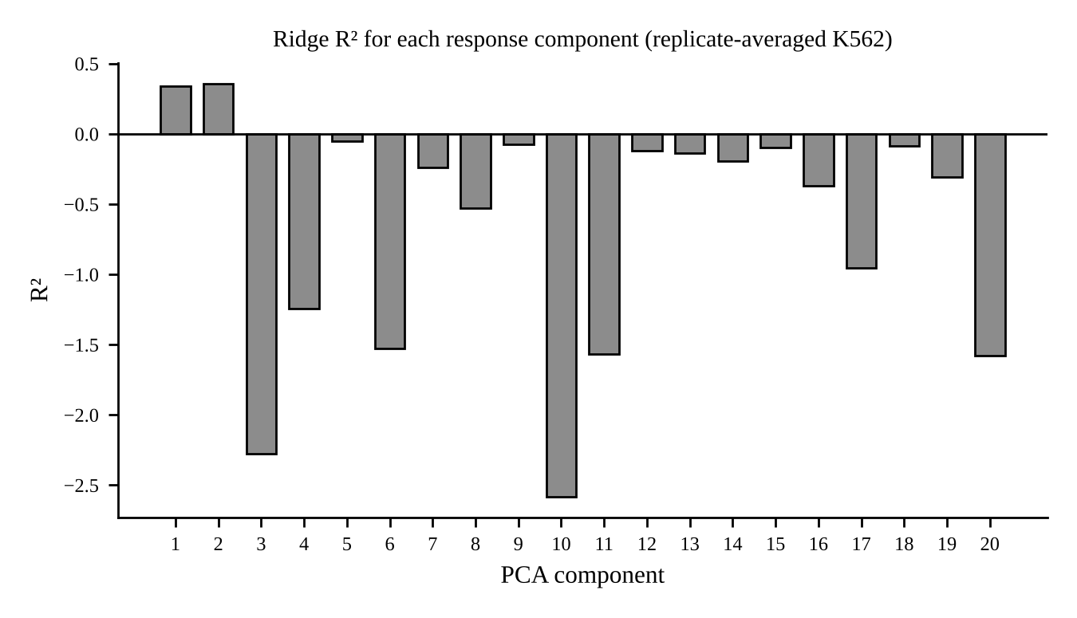  Figure 3. Ridge R² for each PC.

- Ridge gave the lowest error on K562: the replicate-averaged RMSE is 2.3565, compared with 2.5049 for the global mean, and it also has the highest R² (0.1142). Drug-Dose Ridge has the highest Pearson correlation (0.4588). Averaging the two K562 replicates lowered the RMSE of every model (for Ridge from 2.6817 to 2.3565), so a part of the error is only measurement noise. The MAE values are in the notebook.
- Per component: Ridge R² is positive only for PC1 (0.3415) and PC2 (0.3572), as shown in Figure 3. Pearson is 0.28 or more for 7 PCs (PC1, 2, 4, 6, 8, 9 and 11) and below 0.15 for 10 of the 20 PCs. PC1 and PC2 have the largest scale, so they dominate the overall R² and Pearson.
- Per drug: the Ridge RMSE goes from 1.27 (SRT2104) to 5.24 (Flavopiridol HCl). The highest correlations are mostly HDAC inhibitors (Quisinostat 0.90 and Panobinostat 0.90), but their RMSE is still about 2.8 to 3.0. Each drug is scored from only 4 doses and 20 PCs, so these are just examples and not a proof.

7. Discussion
- Only a small part of the response transfers to K562. The best R² is 0.11 and it comes mostly from PC1 and PC2.
- Source-only validation picked Drug-Dose Ridge (3.9134), but Ridge was the best on K562. We report both and we did not tune anything on K562. The differences between the models are small and come from one run on noisy data, so the ranking should not be trusted too much.
- The models do not know the cell type. A K562 prediction is just a smoothed average of what A549 and MCF7 show for that drug and dose. This is probably why Ridge is better than the raw drug-dose average, because it pulls the prediction toward the middle. The tree models did not help.

8. Challenges Faced
- K562 is noisy. The two replicates agree only weakly, which limits every score, and we needed replicate averaging to see the signal.
- There is no cell-type information. Using K562 data to adapt the model would break the unseen cell-type rule, so the models can only copy what A549 and MCF7 show for each treatment.
- The best model on the validation swap (Drug-Dose Ridge) is not the best model on K562 (Ridge). We kept all tuning on A549 and MCF7 and wrote down this difference.
- The overall R² and Pearson hide the weak components, and RMSE and Pearson disagree for some models (Drug-Dose Ridge has the best Pearson but its R² is almost 0). Because of this we added per-component and per-drug results.
- Limits: the PCA from Phase 2 was fitted on both source cell lines, so the validation swap is not perfectly clean. We also tested only one direction (A549 and MCF7 to K562) and used no chemical features.

9. Conclusion
We built and ran the full pipeline: two baselines and four regression models were compared on an unseen cell line, and every setting was chosen using A549 and MCF7 only. Some of the response transfers to K562, mainly in PC1 and PC2, but most of the variation is still unexplained. In future work we can use models with more inputs than drug name and dose, and add error bars over drugs to the model comparison.

