**University of Engineering and Technology**

**New Campus, Lahore.**



**Department of Computer Science**

**Session: 2021**

**OOP PROJECT**

AIRLINE MANAGEMENT SYSTEM

**Submitted To**

NAMRA SHEIKH

**Submitted By**

ALI ARSHAD (2021-CS-643)

SADEEM ASIM (2021-CS-644)

MASOOD ALI (2021-CS-646)

**Purpose of the project**  
  
 Handling of flight’s record to enhance the accuracy, flexibility, reliability and to remove the human’s error.  
• An airline provides air transport services for passengers, generally with a recognized operating  
• To provide accurate information about the addition, deletion and modified flights record.  
• To provide, efficient, accurate, reliable, fast, and robust structure that can handle any number of passenger’s transactions.

**Description**

Airline Reservation System (ARS) provides an interface to schedule flights and reservations for an airline that services. The main objective of this project is to manage the details of the flight, ticket, booking, passenger, and payment. The system is built at the administrative end and user end, where the admin can add or remove the flights while the user can book a ticket, print a ticket, send packages and see all other flight schedules as well.

The project named “Airline Management System” is written in Visual Studio Code, mainly because of it’s suitability for this type of application. It has user friendly nature and in-built documentation, complication, error detection, binding facilities and interaction with other software packages make it most powerful tool for software development. Moreover, Visual Studio code/ Visual Studio of all the technologies that help in creating and running robust, scalable and distributed packages .C++ is a general-purpose object-oriented programming language, and is intended to be an improved C with object capabilities  
Assistance is provided to the user at each and every step so that no problem is faced during using it. Further the details of every process and the user manuals attached in the report make it very easy to understand. Every possible care has been taken to make the software and the report clear, simple and error free which makes it so special and one of its kind.

**Preface**

The functions which are used for this project are   
1- mainMenuAdmin();  
2- mainMenuUser();  
 3-logInAndSignUp();  
  
  
1. MenuAdmin   
  
This will enable the admin to add a flight , to see all the flights and to delete the flights.  
  
2. MenuUser   
  
This will help the user to book tickets and flights along with booking seats, sending Packages, to see all flights schedule and to print his Ticket.  
   
  
3. logInAndSignup   
  
For login, if user already have an account for the airline system then he'll enter his username and password to proceed for next procedure.  
For sign up, if user does not have an account for the airline system then sign up will help the user to create his account to proceed for next procedure.

When The Program Is Started Two Options Are Given To User

1-SignUp

2-LogIn

Signing Up Gets The Details Required For A Proper User. Save It In A File And directly log in.

Logging in Asks The User For Email And Password And Check If the user account data already exists, then check the details and log in.

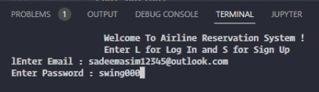

**WORKING OF THE PROJECT**

➢ User can view records about all flights by selecting the respectable option from the main menu.  
➢ User can reserve their seat after viewing the flights schedule.  
➢ User can also cancel their reserved ticket for flight.

**Methodology**

The Program Is Designed In A Way That There Are Two Faces Of This Program . **Admin Panel And User Panel.**

During Sign Up You Can Enter Whether To Be An Admin Or User

If The User Is Admin Then This Is Showed Up.

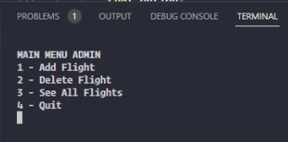

There Are Three Functions The Admin Panel Is Supporting.

**1-Add Flight :**

In This Function All The Flight Details Necessary Is Taken And Simply Saved Where All Flights Are Previously Saved.

**2-Delete Flight :**

In This Function The Program Shows All The Flights And Prompt admin To Enter The Flight To Delete

After Entering The Right Option The Flight Is Then Popped Out From The Array And Previously Saved flight file is deleted. Now In the meantime a new file is been created and all flights except that flight is printed in the file.

**3-See All Flights :**

In This Function All The Flights Are Read From The File And Then Printed In A Nice Tabular Way.

**Main Menu User**

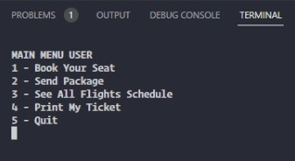

In the Main Menu Of User, There Are Three Functions:

**1-Book Your Seat :**

In This Function Of Booking Of Your Flight Ticket Or Seat. First All The Available Flights Are Showed. Then In The Selected Flight According To The Total Seats Of the Airplane’s Economy, First-Class And Business Class Seats Are Distributed. And Asked Which Seat You want to Choose Because There Are Different Prices Of Tickets for Economy class and First-Class And Business Class. Then The Airplane Seats Are

Printed In A Way That Every Ticket Number Is Shown. If The Ticket Is already Booked Or Reserved Then It is Showed That The Ticket Is already Booked And it can’t be booked again. After Selecting any available Seat The Data Of Booked Tickets Are Saved In The File And Also It Is Saved In The Current User’s Booked Ticket.

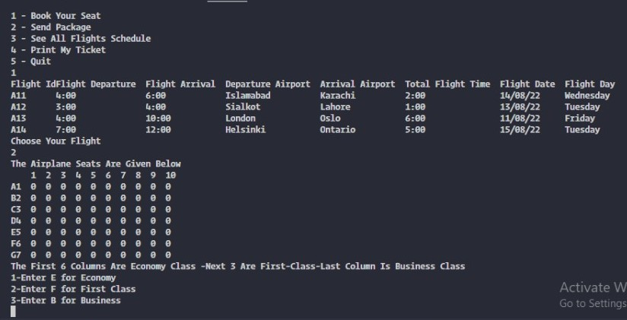

**2 – See All Flights :**

As Previously Defined It Print All The Flights Schedule.

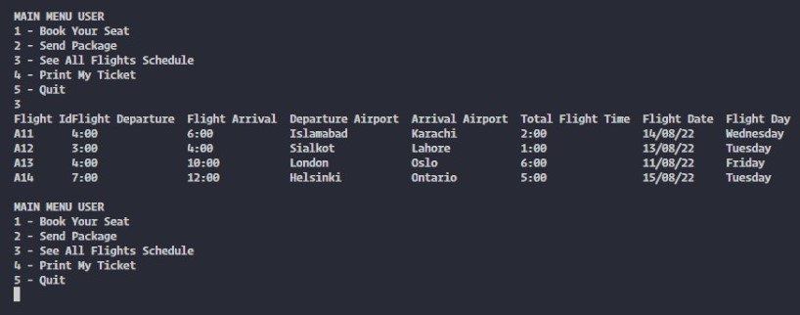

**3-Print My Ticket:**

In This Function, If the user has a booked ticket, then a file is created with all the details and necessary information related to the ticket is printed.

…………………………………………………………………………………………………

