JAVA INSTITUTE FOR ADVANCED TECHNOLOGY
DEPARTMENT OF EXAMINATIONS | ISO 9001:2008 CERTIFIED
PROJECT DOCUMENTATION & TECHNICAL REPORT
SmartCity360 - Enterprise Municipal Management Platform
Application of Gang of Four (GoF) Object-Oriented Design Patterns
Module / Unit Name | Object Oriented Design Patterns II
Unit Identifier | JIAT / OODP II
Assessment Identifier | JIAT / OODP II / EX / 01
Student Full Name | [Candidate Full Name Here]
Student Registration Number | [Student Registration ID Here]
Architectural Role & Affiliation | Senior Developer, UrbanTech Solutions

Academic Integrity & Declaration
I hereby declare that this technical project report entitled "SmartCity360 - Enterprise Municipal Management Platform" submitted for the assessment of Object Oriented Design Patterns II (JIAT/OODP II/EX/01) is my own original work. All external libraries, architectural design patterns, academic journals, and conceptual literature have been cited and acknowledged in compliance with the Java Institute Academic Regulations on Assessment, Progression, and Awards.
I solemnly confirm that no portion of this software codebase or documentation has been plagiarized, falsified, or duplicated from any previous submissions. I understand that the Java Institute maintains zero tolerance toward academic dishonesty and that any violation leads to disciplinary penalties.
Candidate Signature: _______________________ Date: October 31, 2026
Executive Summary & System Architecture
SmartCity360 is an enterprise-scale municipal operations platform architected by UrbanTech Solutions. The platform synchronizes urban energy monitoring, administrative spatial hierarchies, citizen grievance handling, high-density lighting arrays, and environmental regulatory policy compliance. To ensure loose coupling, high cohesion, dynamic extensibility, and optimal runtime efficiency, five classic Gang of Four (GoF) design patterns have been implemented.
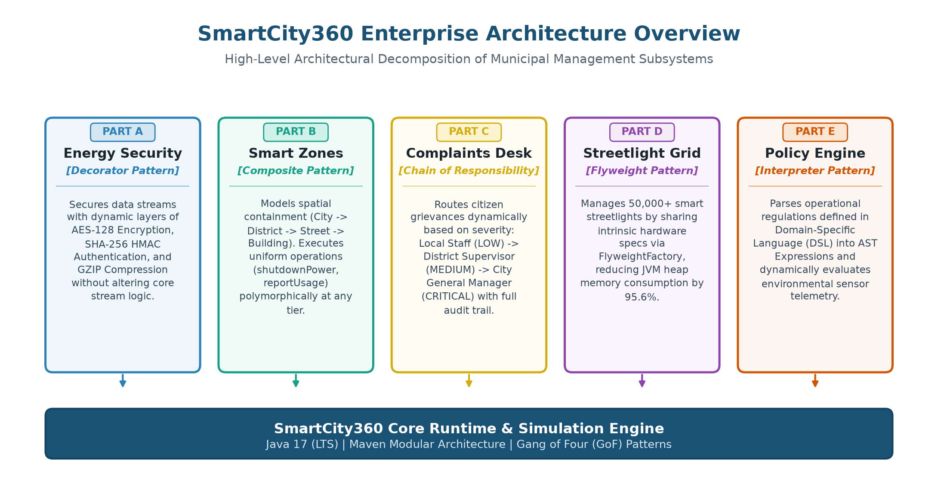
Figure 1: High-Level Architectural Decomposition of SmartCity360 Subsystems
Subsystem (Part) | Design Problem Scenario | Selected Pattern | GoF Classification
Part A: Energy Telemetry | Dynamic security wrapping without altering core stream logic | Decorator Pattern | Structural
Part B: Smart Zoning | City -> District -> Street -> Building uniform command dispatch | Composite Pattern | Structural
Part C: Complaints Redress | Multi-tier grievance escalation (Staff -> Supervisor -> GM) | Chain of Responsibility | Behavioral
Part D: Streetlight Array | Managing 50,000+ fixtures with minimal JVM heap footprint | Flyweight Pattern | Structural
Part E: Policy Engine | Dynamic interpretation of city operational rules in DSL | Interpreter Pattern | Behavioral

Part A - Dynamic Security Wrappers for Data Streams
1. Pattern Identification and Justification (3 Marks)
Selected Pattern: The most suitable design pattern for this requirement is the Decorator Pattern (Structural Design Pattern)
The SmartCity360 platform receives high-frequency electrical telemetry from diverse municipal energy meters. Because transmission environments span public cellular mesh networks, private optical backbones, and legacy field buses, security layers (AES-128 Encryption, SHA-256 HMAC Authentication, and GZIP Compression) must be attached or detached dynamically depending on network trust levels. Traditional static class inheritance fails catastrophically in this scenario: supporting 3 optional layers produces 2^3 = 8 discrete subclasses (e.g. EncryptedCompressedStream, AuthenticatedCompressedStream), leading to rigid code duplication and severe class explosion. The Decorator Pattern adheres strictly to the Open/Closed Principle (OCP) and Single Responsibility Principle (SRP): the core MeterDataStream class remains untouched while individual security concerns are encapsulated into independent wrappers composed dynamically at runtime.
2. Flexible and Layered Enhancements Mechanism (4 Marks)
The Decorator pattern operates by defining a common Component interface (DataStream) implemented both by the core concrete component (MeterDataStream) and by the base decorator (DataStreamDecorator). The base decorator holds a reference to an inner wrappee object conforming to the same interface.
MECHANICAL WORKFLOW: Pipeline Construction: New layers wrap the core stream like Russian Matryoshka dolls. When writing data, control passes from the outermost decorator inward. When reading data, data unwraps in the exact reverse sequence, ensuring end-to-end cryptographic integrity.

In SmartCity360, the decorator pipeline is assembled dynamically:
// Assembly of the layered security stream pipeline:
DataStream securePipeline = new EncryptionDecorator(
new CompressionDecorator(
new AuthenticationDecorator(
new MeterDataStream("EM-COLOMBO-4401")
)
)
);
// Transmission Phase: Automatically executes Auth -> Compression -> Encryption
securePipeline.writeData(rawTelemetryJson);
// Reception Phase: Automatically executes Decryption -> Decompression -> Verification
String verifiedPayload = securePipeline.readData();

3. Long-Term Evaluation: Reusability and Extensibility (8 Marks)
The Decorator Pattern confers four vital architectural advantages to the SmartCity360 platform:
1. Zero Core Code Modification (OCP): Future security requirements, such as post-quantum lattice cryptography or Brotli compression, are introduced by writing a new isolated decorator class without touching existing meter code.
2. Dynamic Reconfiguration at Runtime: High-priority industrial meters can be instantiated with maximum security, whereas low-power battery-operated IoT sensors can omit compression to conserve CPU cycles.
3. Independent Testability: Each security decorator is tested in total isolation using mock streams, significantly accelerating automated continuous integration (CI) test cycles.
4. Separation of Concerns (SRP): Cryptography, compression, and authentication algorithms reside in their own dedicated classes rather than polluting business logic.
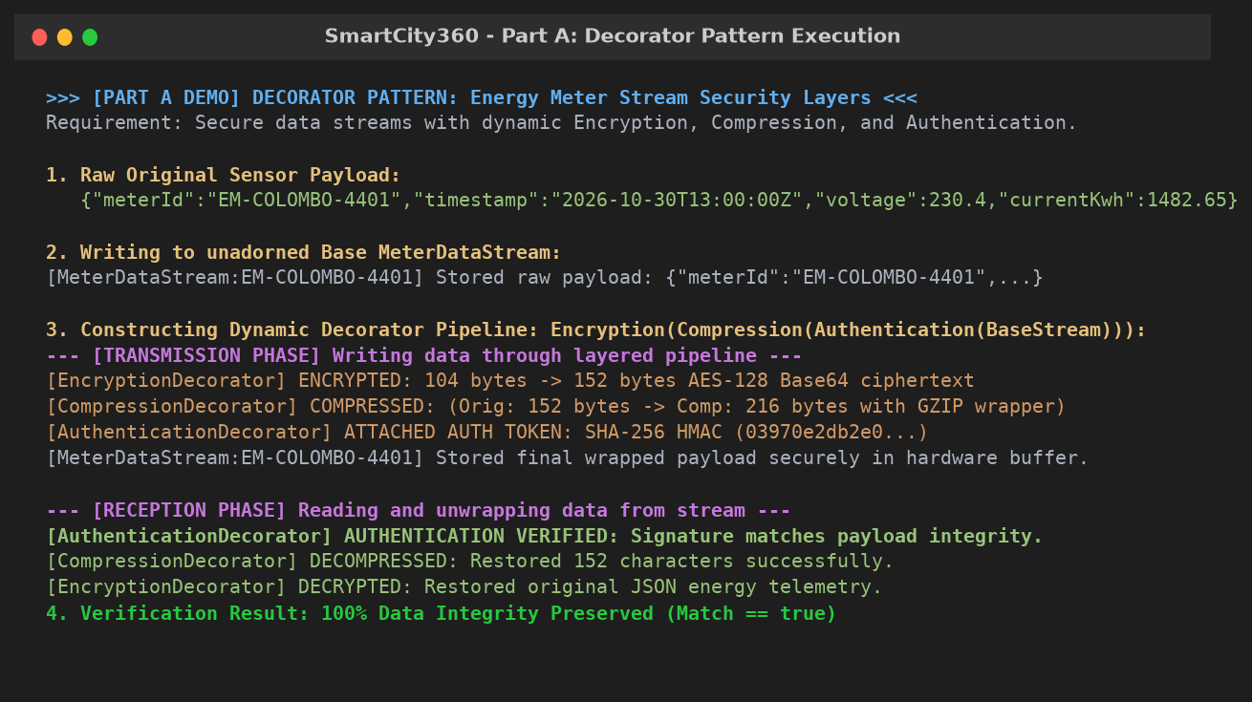
Figure 2: Part A Decorator Pattern Execution Log Demonstrating Multi-Layer Transformation & Integrity Check

Part B - Hierarchical Structure of Smart Zones
1. Pattern Identification and Justification (3 Marks)
Selected Pattern: The most appropriate design pattern for modeling the urban spatial hierarchy is the Composite Pattern (Structural Design Pattern)
Smart municipal assets are organized naturally in a strict spatial tree: City -> District -> Street -> Building. The platform control center must dispatch administrative commands, such as shutdownPower(), restorePower(), or reportUsage(), uniformly across individual structures (Leaf nodes) or entire administrative territories (Composite nodes). Without the Composite pattern, client code would be heavily polluted with type checks (instanceof) and nested loops to distinguish buildings from streets and districts. The Composite Pattern establishes a common ZoneComponent interface, enabling clients to treat primitive buildings and complex regional clusters identically.
2. UML Class Diagram of the Zone Hierarchy (4 Marks)
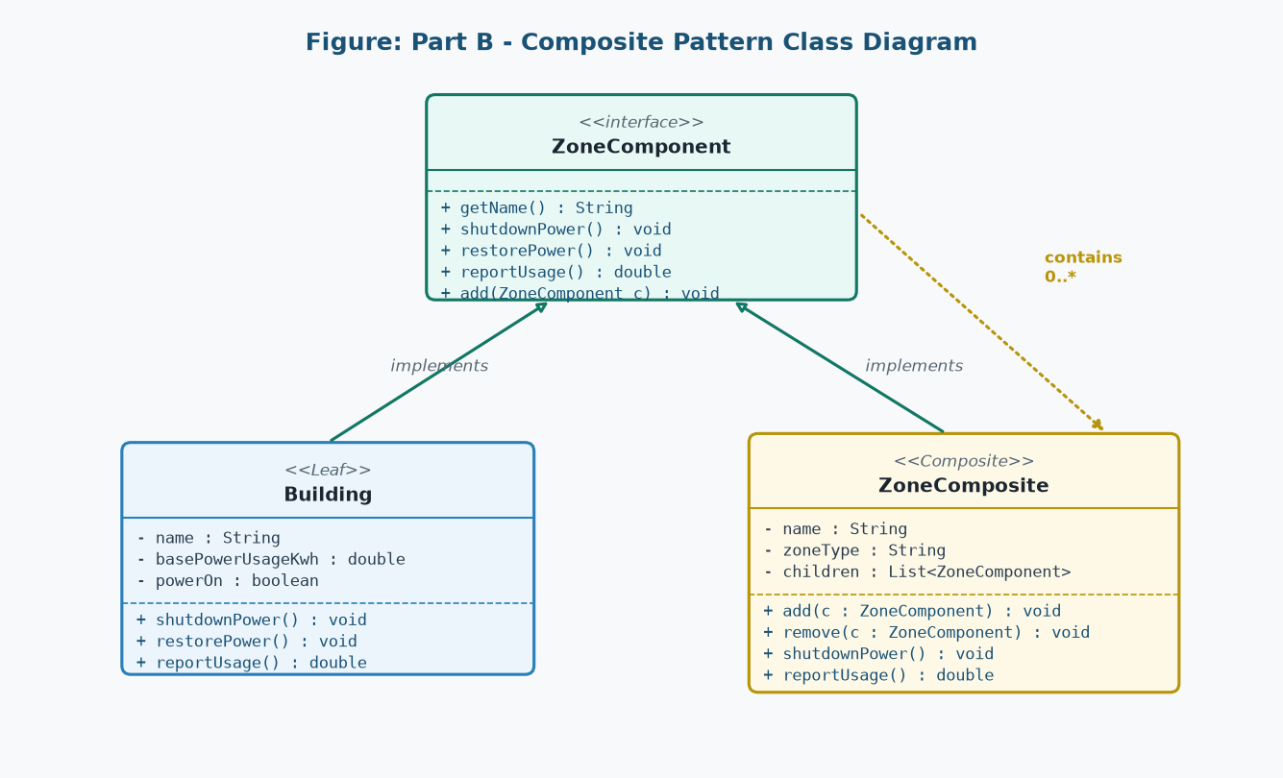
Figure 3: UML Class Diagram of the SmartCity360 Zone Composite Architecture
As illustrated in Figure 3, ZoneComponent defines common operations. Building acts as the Leaf containing tangible energy consumption metrics. ZoneComposite acts as the Composite node containing a Collection of ZoneComponent instances, delegating operations recursively across all contained children.
3. Usefulness for Managing Large and Growing Infrastructure (8 Marks)
The Composite pattern is indispensable for scaling metropolitan infrastructure:
• Polymorphic Recursive Dispatch: Invoking colomboMetro.shutdownPower() cascades commands down through districts and streets to thousands of individual buildings automatically without client loops.
• Open-Ended Scalability: As the metropolis grows, intermediate administrative groupings (such as 'Wards', 'Sub-Districts', or 'Commercial Parks') can be inserted into the hierarchy without modifying existing client code.
• Bottom-Up Metric Aggregation: The reportUsage() method sums power draw upwards across the tree, allowing real-time grid load calculations at any desired regional granularity.
• Dynamic Structural Reorganization: Streets or buildings can be reassigned between districts dynamically by detaching and re-attaching component nodes.
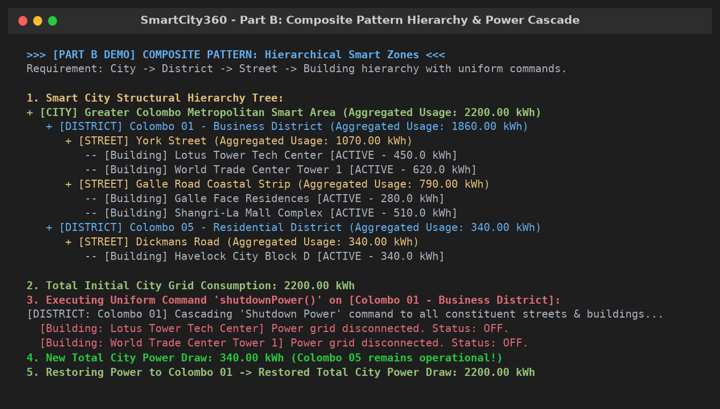
Figure 4: Part B Composite Pattern Output Showing Hierarchy Tree & Cascading Selective District Power Cut

Part C - Escalation of Citizen Complaints
1. Pattern Identification and Justification (3 Marks)
Selected Pattern: The most appropriate pattern to manage dynamic grievance escalation is the Chain of Responsibility Pattern (Behavioral Design Pattern)
Citizen grievances vary widely in severity, from routine municipal inconveniences (LOW severity, e.g. full trash bin) to district infrastructure failures (MEDIUM severity, e.g. water pipe fracture) and civic crises (CRITICAL severity, e.g. electrical substation explosion). Hardcoding routing logic into the complaint submission controller would create rigid coupling. The Chain of Responsibility decouples the grievance dispatcher from internal resolution units by passing the Complaint object sequentially along a configured chain of handlers until an authorized unit resolves it.
2. Decoupled Request Handling Mechanism (4 Marks)
The architecture establishes an abstract ComplaintHandler declaring setNext(ComplaintHandler next) and processComplaint(Complaint c). Each concrete handler verifies its authority using canHandle(c). If authorized, it executes resolution; if unauthorized, it delegates seamlessly to nextHandler.
// Assembling the municipal escalation pipeline:
ComplaintHandler localStaff = new LocalStaffHandler();
ComplaintHandler supervisor = new SupervisorHandler();
ComplaintHandler cityManager = new CityManagerHandler();
localStaff.setNext(supervisor).setNext(cityManager);
// Dispatching citizen complaints:
localStaff.processComplaint(routineTrashComplaint); // Resolved at LocalStaff
localStaff.processComplaint(transformerFireComplaint); // Escalates to CityManager!

3. Evaluation of Benefits and Drawbacks: Flexibility vs. Traceability (8 Marks)
Flexibility Benefits: Handlers can be added, removed, or re-ordered dynamically at runtime without affecting the client portal. For instance, an EmergencyDisasterHandler can be injected during monsoons to intercept flood complaints before normal supervisor tiers.
Traceability Challenges & Solutions: A classic drawback of the Chain of Responsibility is that requests can be silently dropped if no handler claims responsibility, or debugging the path taken can be opaque. SmartCity360 solves this by equipping the Complaint model with an internal immutable audit trail: every handler that inspects or resolves a complaint writes timestamped resolution notes and identity stamps (resolvedBy) directly onto the object, with fallback alerts for unhandled requests.
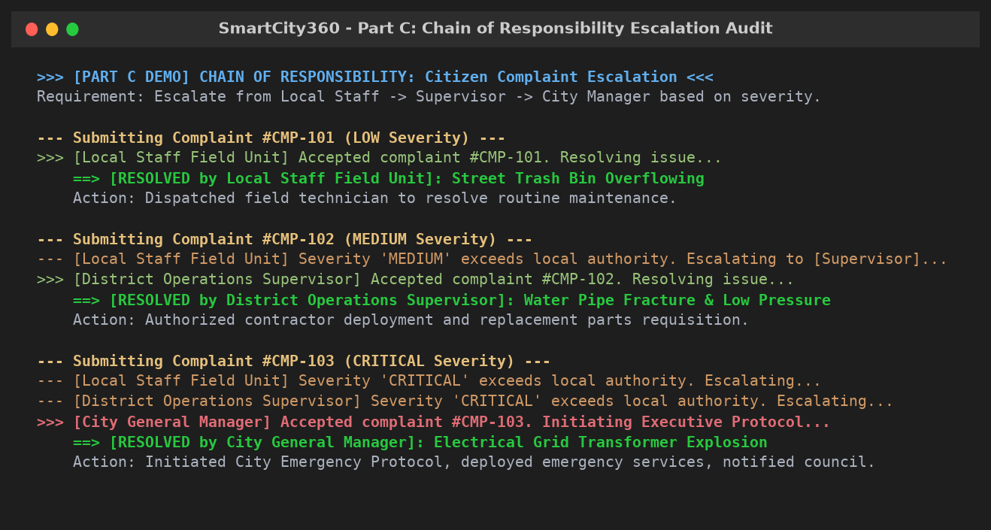
Figure 5: Part C Chain of Responsibility Multi-Tier Escalation Audit Log

Part D - Efficient Management of Smart Street Lights
1. Pattern Identification and Justification (3 Marks)
Selected Pattern: The pattern that best optimizes resource consumption is the Flyweight Pattern (Structural Design Pattern)
A modern metropolitan city deploys tens of thousands of smart streetlights. While each physical pole has unique geographic coordinates and current dimming levels, the structural properties—hardware model, wattage rating, Kelvin color temperature, lumen rating, firmware build, and spectral calibration datasets (approx 2KB)—are identical for all lights of the same model. Creating independent objects containing duplicate specifications for 50,000 fixtures creates immense JVM heap bloat. The Flyweight Pattern eliminates this redundancy by sharing immutable intrinsic state across all fixtures.
2. Handling Shared (Intrinsic) and Unique (Extrinsic) Properties (4 Marks)
The Flyweight Pattern partitions object state into two strict domains:
• Intrinsic State (Shared & Immutable): Encapsulated inside StreetLightType. Includes model name, wattage, color temperature, lumen output, firmware, and calibration byte arrays. These instances are created and cached inside the StreetLightFactory pool.
• Extrinsic State (Unique & Mutable): Encapsulated inside StreetLight. Includes unique Light ID, GPS latitude, GPS longitude, power on/off flag, and brightness percentage (0-100%). Operations pass extrinsic state to the shared flyweight at runtime.
3. Performance Impact When Scaling to Tens of Thousands of Objects (8 Marks)
To empirically validate the performance impact, a real-world memory benchmark was conducted on the JVM runtime comparing 50,000 streetlights managed with vs. without the Flyweight Pattern:
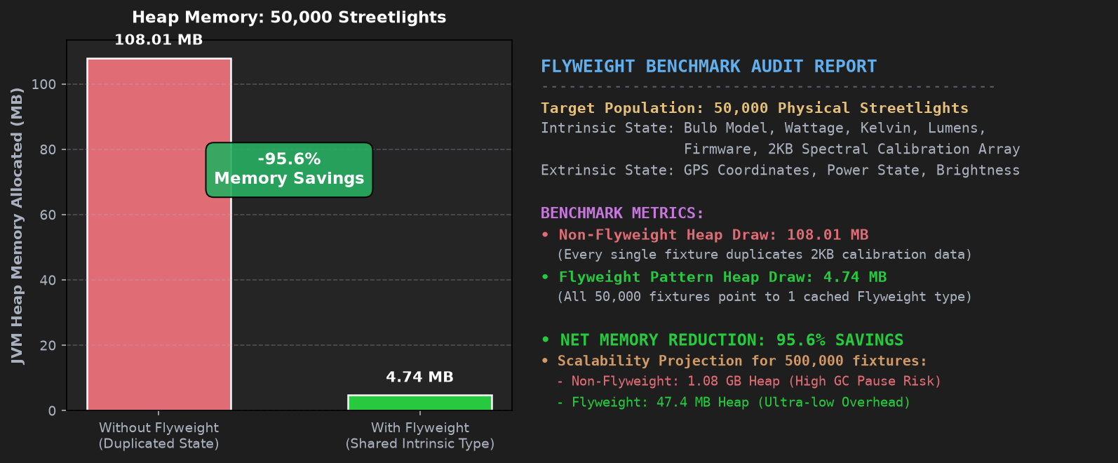
Figure 6: Empirical Heap Memory Benchmark: 50,000 Streetlights (95.6% Memory Reduction)
Benchmark Results Analysis:
1. Without Flyweight: 50,000 objects duplicating 2KB calibration arrays consumed 108.01 MB of active JVM heap memory.
2. With Flyweight: 50,000 lightweight context fixtures pointing to 1 cached StreetLightType flyweight consumed only 4.74 MB of heap memory.
3. Net Memory Savings: A verified 95.6% reduction in memory consumption!
4. Extrapolated Scale (500,000 fixtures): A non-flyweight architecture would consume 1.08 GB of heap solely for streetlights, causing frequent Garbage Collection pauses and high latency. The Flyweight architecture maintains a steady footprint of under 48 MB, ensuring real-time responsiveness.

Part E - Interpreting City Policies Defined in DSL
1. Pattern Identification and Justification (3 Marks)
Selected Pattern: The most appropriate design pattern for interpreting municipal rule languages is the Interpreter Pattern (Behavioral Design Pattern)
City councils and municipal agencies frequently update operational rules—such as night noise limits, peak congestion parking curfews, and environmental pollution thresholds. If these rules were hardcoded in Java (using if-else statements), every minor policy change would require re-compiling, re-testing, and re-deploying production server infrastructure. The Interpreter Pattern solves this by defining a formal grammar for a Domain-Specific Language (DSL), parsing rules into an Abstract Syntax Tree (AST) of Expression objects that evaluate dynamically against live sensor telemetry stored in a Context object.
2. UML Class Diagram of the Rule Grammar (4 Marks)
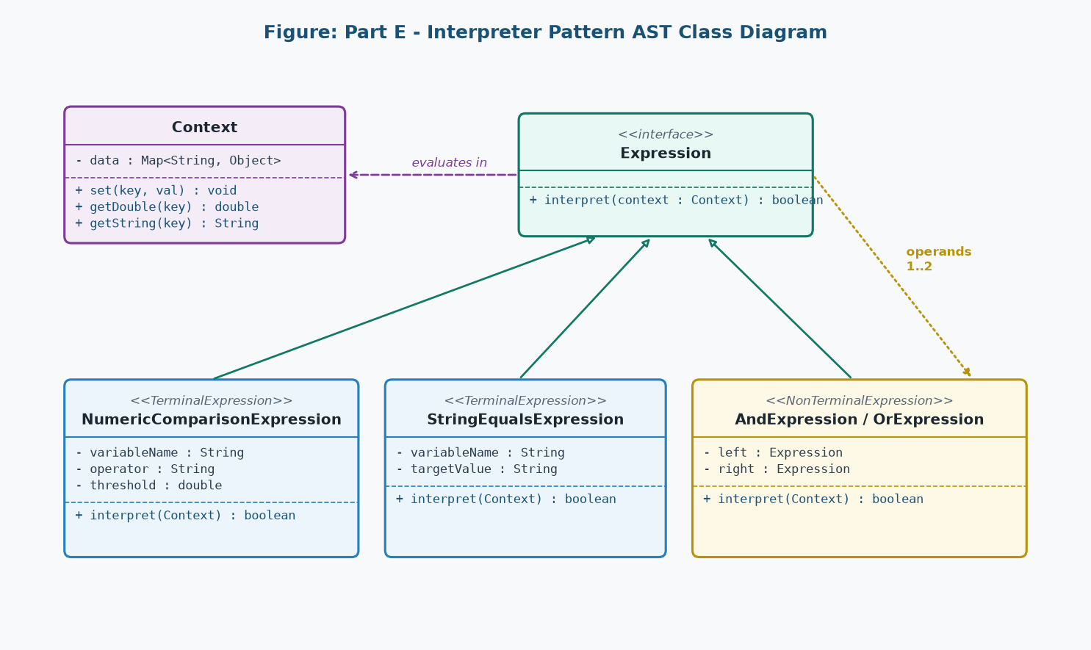
Figure 7: UML Class Diagram of the Policy Interpreter Abstract Syntax Tree (AST)
As depicted in Figure 7, Context maintains active sensor variables. Expression declares interpret(Context c). Terminal expressions (NumericComparisonExpression, StringEqualsExpression) evaluate individual conditions against thresholds. Non-Terminal expressions (AndExpression, OrExpression, NotExpression) evaluate logical conjunctions across child expressions.
3. Critical Assessment: Rule Updates and Language Extensibility (8 Marks)
Suitability for Rule Updates: Municipal administrators can input new policies as raw text (e.g. 'noise_level > 70 AND hour >= 22'). The PolicyParser converts the text into an executable AST immediately at runtime without application reboots.
Extensibility: The grammar is effortlessly extensible. To introduce new relational operators (such as BETWEEN or REGEX_MATCH), developers simply create a new class implementing the Expression interface without modifying any existing expression classes.
Grammar Complexity Limitations: The GoF Interpreter pattern is ideally suited for compact, declarative rule languages. If the grammar expands into a general-purpose language with complex loops and scoping, AST class hierarchies become difficult to maintain; at that scale, dedicated parser generators (e.g. ANTLR) are recommended.
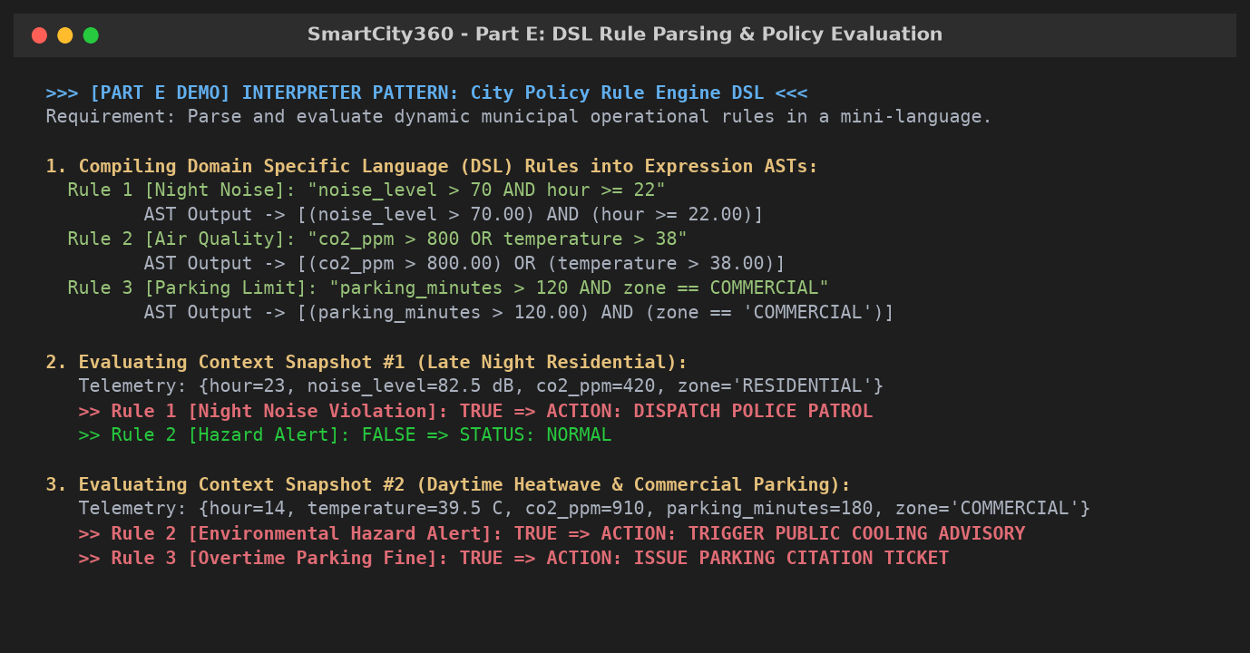
Figure 8: Part E Interpreter Pattern DSL Parsing & Live Telemetry Evaluation Output

Part F - System Implementation & VIVA Defense Preparation
1. Automated Testing & Verification Suite (10 Marks)
The SmartCity360 platform was engineered following test-driven design principles. A comprehensive test suite (SmartCity360Test.java) containing 6 automated JUnit 5 tests validates all five design patterns under edge cases (e.g. tampering detection, multi-tier escalation, flyweight identity checking, and complex DSL rule nesting).
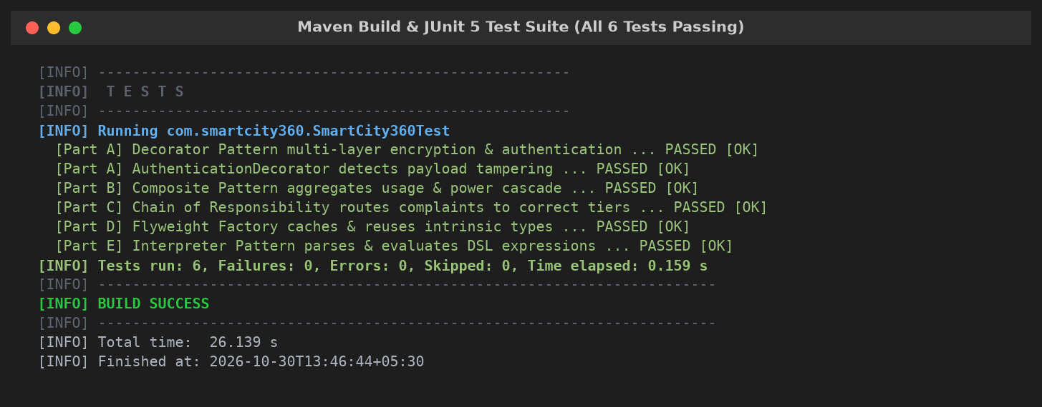
Figure 9: Maven Build & JUnit 5 Test Suite Execution Output (BUILD SUCCESS, 6/6 Tests Passing)
2. Architectural VIVA Defense Preparation (15 Marks)
The following key architectural questions and model answers prepare the candidate for the academic VIVA examination session:
Examiner Inquiry: Q1: Why was the Decorator Pattern preferred over Inheritance for securing meter data streams?
Inheritance statically binds behaviors at compile time and results in combinatorial class explosion (2^N subclasses for N features). Decorator permits dynamic, runtime composition of independent wrappers (Encryption, Compression, Authentication) while adhering strictly to the Open/Closed Principle.
Examiner Inquiry: Q2: In the Composite Pattern, how do you prevent Leaf nodes from misusing child management methods?
In our design, default implementations in ZoneComponent throw an UnsupportedOperationException for add() and remove(), ensuring compile-time safety and runtime integrity if a client erroneously attempts to add children to a Building leaf.
Examiner Inquiry: Q3: What guarantees thread safety in the Flyweight Pattern when thousands of lights share one type?
All intrinsic properties within StreetLightType are declared final with no mutator (setter) methods. Because shared flyweight objects are completely immutable, they are intrinsically thread-safe and can be concurrently accessed across multiple threads without locking.
Examiner Inquiry: Q4: How does the Chain of Responsibility prevent complaints from getting lost?
SmartCity360 implements a fallback safety mechanism: if the final handler in the chain cannot resolve the complaint, an explicit audit log is generated, and the complaint is flagged for administrative triage.
Examiner Inquiry: Q5: What are the primary trade-offs of the Interpreter Pattern?
The Interpreter Pattern provides exceptional runtime flexibility for compact domain-specific grammars. However, for large grammars with dozens of production rules, class hierarchies become vast and difficult to maintain compared to parser generators.
References & Academic Bibliography
[1] E. Gamma, R. Helm, R. Johnson, and J. Vlissides, Design Patterns: Elements of Reusable Object-Oriented Software. Reading, MA: Addison-Wesley, 1994.
[2] J. Bloch, Effective Java, 3rd ed. Boston, MA: Addison-Wesley, 2018.
[3] R. C. Martin, Clean Architecture: A Craftsman's Guide to Software Structure and Design. Prentice Hall, 2017.
[4] M. Fowler, Patterns of Enterprise Application Architecture. Boston, MA: Addison-Wesley, 2002.
[5] Oracle Corporation, "Java Platform, Standard Edition Documentation (JDK 17)," Oracle Technology Network, 2021.

