Sri Lanka Institute of Information Technology



IT3101 – Data Warehousing and Business Intelligence
Year 3, Semester 1- 2026
Group Assignment
WE.DS.01.02
2026-DS-57

Registration no | Name
IT24102178 | Peiris W.U.M
IT24101780 | Wanigasekara Y.A.
IT24102310 | Jayawardena H.S.P.P
IT24101808 | Jayawardane K.V.G.P.C.A.

Table Content
1. Introduction 5
Tools Utilized 5
2. Task 1: Dataset Selection and Business Scenario Identification 6
2.1 Dataset Overview 6
Business Domain 6
Purpose of the System 6
Business Problem Addressed 6
Dataset Source 7
Dataset Formats 7
Record Counts 7
Attribute Descriptions 8
2.2 Dataset Suitability 8
3. Task 2: Data Source Identification and Preparation 10
3.1 Data Sources 10
3.2 Relationships Between Sources 10
Source Relationship Diagram 11
3.3 Data Preparation and Integration Strategy 11
Staging Load Sequence 12
Staging Validation 13
4. Task 3: Data Warehouse Architecture Design 14
4.1 Architecture Diagram 14
4.2 Architectural Components 15
Data Source Layer 15
Data Integration Layer 15
Storage Layer 15
Presentation Layer 15
4.3 Rationale for Layered Separation 15
5. Task 4: Dimensional Data Warehouse Design and Implementation 16
5.1 Business Processes and Grain 16
Website Session Analysis 16
Sales and Product Analysis 16
5.2 Schema Diagram 17
5.3 Dimension Tables 18
5.4 Fact Tables 18
5.5 Hierarchies and Relationships 18
5.6 Design Assumptions 18
6. Task 5: ETL Process Development 20
6.1 Extraction 20
CSV Extraction 20
JSON Extraction 20
6.2 Transformation 20
Missing Value Handling 20
Data Cleansing and Standardisation 20
Data Type Conversion 20
Calendar Generation 20
Aggregation 21
Derived Attributes 21
6.3 Loading Sequence 21
6.4 ETL Workflow Diagram 22
6.5 ETL Validation 22
7. Task 6: Data Mart Development 24
7.1 Marketing Performance Data Mart 24
7.2 Purpose 24
7.3 Target Users 24
7.4 Grain 25
7.5 Data Mart Measures 25
7.6 Analytical Benefits 25
7.7 Data Mart Validation 26
8. Task 7: OLAP Analysis and Business Intelligence Dashboard Development 28
8.1 Power BI Dashboard Development 28
8.2 Power BI Data Model 28
8.3 Report Page 1: Executive Summary 29
8.4 Report Page 2: Trend Analysis 31
8.5 Report Page 3: Interactive Analysis 32
8.6 OLAP and Interactive Analysis Capabilities 33
8.7 Dashboard Measures 34
8.8 Dashboard Contribution to Business Intelligence 34
9. Task 8: Business Insights and Recommendations 35
9.1 Overview 35
9.2 Insight 1: Google Search Is the Largest Marketing Source 35
Business Meaning 35
Recommendation 35
9.3 Insight 2: Direct Traffic Has a Strong Conversion Rate 36
Business Meaning 36
Recommendation 37
9.4 Insight 3: Socialbook Has the Weakest Marketing Performance 37
Business Meaning 37
Recommendation 37
9.5 Insight 4: The Business Shows Significant Activity Across Multiple Years 38
Business Meaning 38
Recommendation 39
9.6 Insight 5: Refunds Reduce the Revenue Retained by the Business 41
Business Meaning 41
Recommendation 41
9.7 Insight 6: Product Performance Is Not Uniform 42
Business Meaning 42
Recommendation 42
9.8 Insight 7: Website Traffic Alone Does Not Determine Marketing Success 43
Business Meaning 43
Recommendation 43
9.9 Overall Recommendations 44
9.10 Support for Business Decision-Making 45

Design and Implementation of a Data Warehouse and Business Intelligence Solution

1. Introduction
This report presents the design and implementation of an end-to-end Data Warehouse and Business Intelligence solution for an e-commerce toy store. The project covers dataset selection, data source preparation, Data Warehouse architecture, dimensional modelling, ETL implementation, and development of a department-specific Data Mart. Power BI is used as the presentation layer for the BI dashboards.
The selected dataset represents the activities of an online e-commerce business and contains website sessions, pageviews, products, orders, order items, and refunds. The operational data is stored in multiple CSV and JSON files. A staging database and dimensional Data Warehouse were developed using Microsoft SQL Server, while the ETL processes were implemented using T-SQL in SQL Server Management Studio (SSMS).
The overall solution follows the flow:
Operational Data Sources → Staging → ETL → Data Warehouse → Data Mart → Power BI → Business Insights

Tools Utilized
Component | Tool/Technology
Database and Data Warehouse | Microsoft SQL Server
Database Management | SQL Server Management Studio (SSMS)
ETL | T-SQL
CSV Loading | BULK INSERT
JSON Loading | OPENROWSET and OPENJSON
BI and Visualization | Microsoft Power BI
Diagrams | SSMS Database Diagrams / draw.io

2. Task 1: Dataset Selection and Business Scenario Identification

2.1 Dataset Overview

Business Domain
The selected business domain is E-commerce and Online Retail.

Purpose of the System
The operational system records the activities of customers using an online store. It captures website visits, pages viewed by users, customer orders, products purchased, and refunds.
This provides information about the customer journey from website activity through to completed purchases and post-purchase refunds.

Business Problem Addressed
The business generates website, marketing, product, sales, and refund data across multiple operational datasets. Analysing these files separately makes it difficult for management to obtain a unified view of business performance.
The main business problem addressed is:
How can the e-commerce business integrate its website, marketing, sales, product, and refund data into a unified analytical environment to monitor performance and support better business decisions?
The BI solution is designed to investigate questions such as:
- How are revenue, orders, sessions, and conversions changing over time?
- Which marketing sources and campaigns generate the most traffic, orders, and revenue?
- Which marketing channels achieve the highest and lowest conversion rates?
- How does performance differ between desktop and mobile traffic?
- Which products contribute most to revenue?
- How significant are refunds and how do they affect financial performance?
- How effectively are website sessions converted into purchases?
- How much website activity comes from repeat sessions?
These questions will guide the Power BI dashboards and the final business recommendations.

Dataset Source
The project uses the Maven Fuzzy Factory e-commerce dataset from Maven Analytics.

Dataset Formats
Six operational source files were used:
Data Source | Format
products.csv | CSV
orders.csv | CSV
order_items.csv | CSV
order_item_refunds.csv | CSV
website_sessions.json | JSON
website_pageviews.json | JSON

Record Counts
The final source data loaded into staging contained:
Dataset | Records
Products | 4
Website Sessions | 472,871
Website Pageviews | 1,188,124
Orders | 32,313
Order Items | 40,025
Order Item Refunds | 1,731

Attribute Descriptions
Source | Main Attributes
Website Sessions | website_session_id, created_at, user_id, is_repeat_session, utm_source, utm_campaign, utm_content, device_type, http_referer
Website Pageviews | website_pageview_id, created_at, website_session_id, pageview_url
Orders | order_id, created_at, website_session_id, user_id, primary_product_id, items_purchased, price_usd, cogs_usd
Order Items | order_item_id, created_at, order_id, product_id, is_primary_item, price_usd, cogs_usd
Order Item Refunds | order_item_refund_id, created_at, order_item_id, order_id, refund_amount_usd
Products | product_id, created_at, product_name

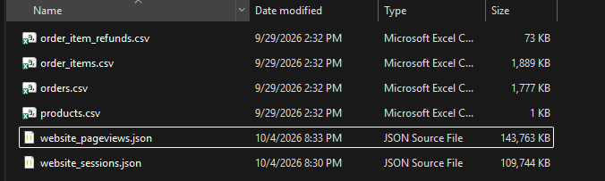

Figure 1: Source folder showing the six source files

2.2 Dataset Suitability
The dataset represents an OLTP-style e-commerce environment because individual operational events such as website sessions, pageviews, orders, order items, and refunds are stored as separate records.
The dataset is suitable for Data Warehousing because it contains:
- sufficient records for analytical processing;
- relationships between sessions, orders, products, order items, and refunds;
- descriptive attributes suitable for dimensions;
- numerical measures such as price, cost, and refund amount;
- date information for time-based analysis;
- marketing attributes for channel analysis;
- product attributes for product analysis.
A limitation of the source is that it does not provide meaningful customer demographic attributes such as age, gender, location, or customer segment. Therefore, a separate Customer/User dimension was not created.
Instead, user_id is retained in the relevant fact tables to support user-level analysis where required

3. Task 2: Data Source Identification and Preparation

3.1 Data Sources
Multiple source formats were used to represent different parts of the operational environment.
Operational Area | Files | Format | Purpose
Product Catalog | products.csv | CSV | Product information
Order Processing | orders.csv | CSV | Completed customer orders
Order Processing | order_items.csv | CSV | Individual purchased products
Refund Processing | order_item_refunds.csv | CSV | Product refund transactions
Web Analytics | website_sessions.json | JSON | Website sessions and marketing information
Web Analytics | website_pageviews.json | JSON | Individual website pageviews

This allows structured CSV data and semi-structured JSON data to be integrated into a common analytical environment.

3.2 Relationships Between Sources
The source datasets are connected using common business identifiers:
Parent Source | Related Source | Relationship Key
Website Sessions | Website Pageviews | website_session_id
Website Sessions | Orders | website_session_id
Orders | Order Items | order_id
Products | Order Items | product_id
Order Items | Order Item Refunds | order_item_id

Source Relationship Diagram
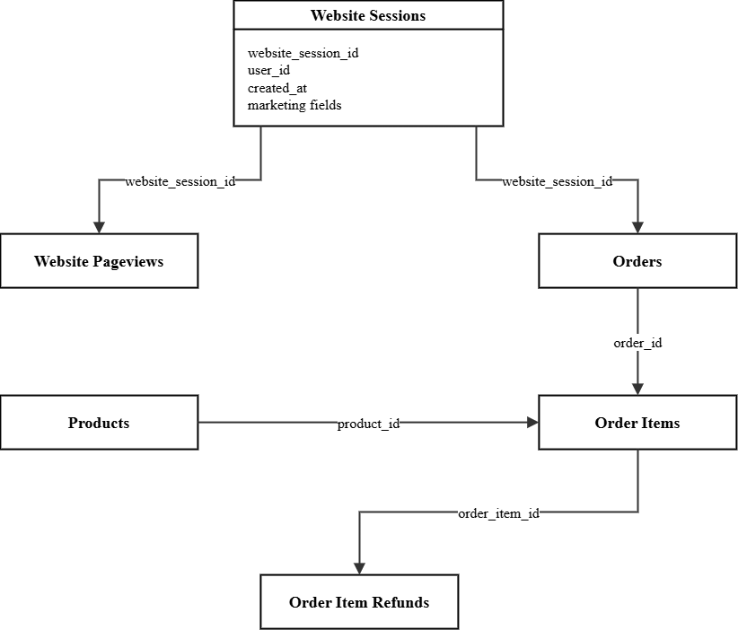
Figure 2: Relationships between operational e-commerce data sources.

3.3 Data Preparation and Integration Strategy
A separate SQL Server database named:
ToyStore_StagingDB
was created as the staging area.
The following staging tables were implemented:
Staging Table | Purpose
stg_products | Product source data
stg_website_sessions | Website session data
stg_website_pageviews | Pageview data
stg_orders | Order data
stg_order_items | Individual order-item data
stg_order_item_refunds | Refund data

The staging area is designed primarily as a landing and preparation layer. Primary identifiers are retained, while unnecessary foreign-key constraints are not enforced between staging tables. This allows source data to be loaded and checked before warehouse relationships are applied.
CSV sources, including products.csv, were loaded using BULK INSERT.
The two JSON sources were loaded using OPENROWSET and parsed using OPENJSON.
During the website session and pageview loads, the source timestamp format was handled using SQL Server datetime conversion with style 120.
CONVERT(DATETIME, pv.created_at, 120)
Style 120 matches timestamps in the form:
YYYY-MM-DD HH:MM:SS
This ensured that the JSON pageview dates were correctly converted into SQL DATETIME values.

Staging Load Sequence
Products
↓
Website Sessions
↓
Website Pageviews
↓
Orders
↓
Order Items
↓
Order Item Refunds

Staging Validation
The completed staging load produced:
Staging Table | Rows
stg_products | 4
stg_website_sessions | 472,871
stg_website_pageviews | 1,188,124
stg_orders | 32,313
stg_order_items | 40,025
stg_order_item_refunds | 1,731

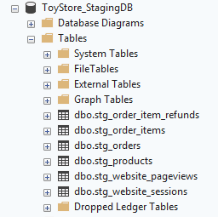

Figure 3: SSMS showing all six staging tables in ToyStore_StagingDB.
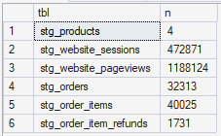

Figure 4: Staging validation results showing row counts

4. Task 3: Data Warehouse Architecture Design

4.1 Architecture Diagram

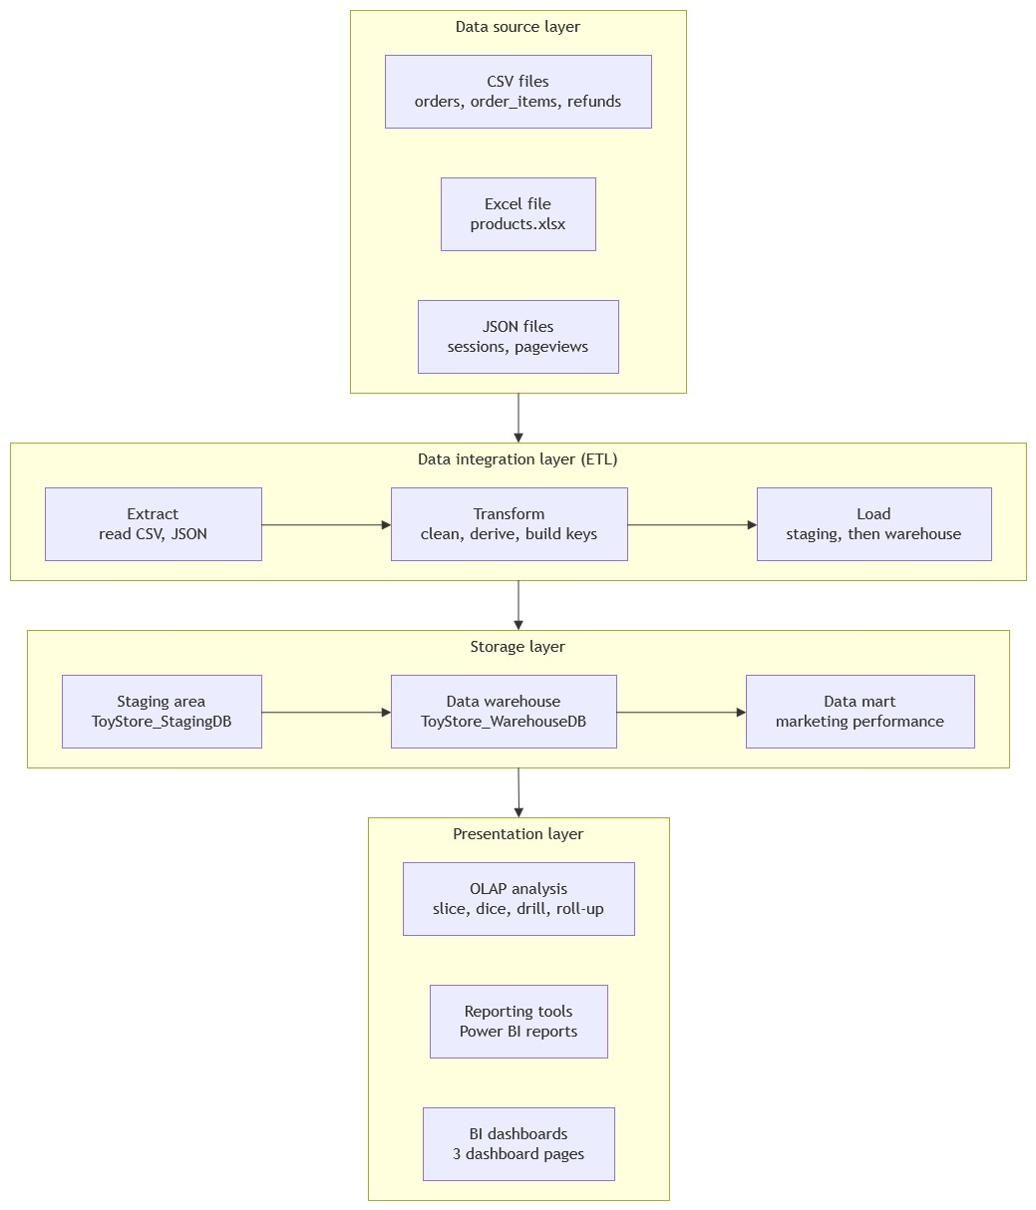

Figure 5: Data Warehouse and Business Intelligence architecture.

4.2 Architectural Components

Data Source Layer
The Data Source Layer contains the original CSV and JSON operational files representing products, website activities, orders, purchased items, and refunds.

Data Integration Layer
The Data Integration Layer is implemented using ToyStore_StagingDB and T-SQL ETL processes. Source data is first loaded into staging and then cleaned, standardized, converted, aggregated, and prepared for dimensional loading.

Storage Layer
The Storage Layer consists of the central ToyStore_WarehouseDB, containing dimension and fact tables, together with the Marketing Performance Data Mart.
The warehouse maintains detailed analytical data, while the Data Mart provides summarized information targeted at marketing analysis.

Presentation Layer
Microsoft Power BI is used as the presentation layer. It will provide KPIs, analytical charts, interactive filters, slicers, and OLAP-style drill-down and roll-up operations.

4.3 Rationale for Layered Separation
Separating source data, staging, warehouse storage, Data Mart, and presentation improves the organization and maintainability of the solution.
The staging layer allows operational data to be loaded and checked independently. The warehouse provides structured dimensional data with enforced analytical relationships. The Data Mart then provides summarized information for a particular business area, while Power BI provides the final interactive analytical interface.

5. Task 4: Dimensional Data Warehouse Design and Implementation

5.1 Business Processes and Grain
The dimensional warehouse supports two main business processes:

Website Session Analysis
Implemented using Fact_Sessions.
Grain: One row represents one website session.
Important measures and indicators include:
- pageview_count
- is_repeat_session
- converted_flag
The table also retains:
- website_session_id
- user_id
This allows session-level and user-level analysis.

Sales and Product Analysis
Implemented using Fact_Order_Items.
Grain: One row represents one purchased order item.
Measures include:
- price_usd
- cogs_usd
- refund_amount_usd
Identifiers retained include:
- order_id
- website_session_id
- user_id
This allows individual purchased items to be analysed while maintaining links to their orders, sessions, and users.

5.2 Schema Diagram
The dimensional model implemented in ToyStore_WarehouseDB consists of three dimension tables and two fact tables.

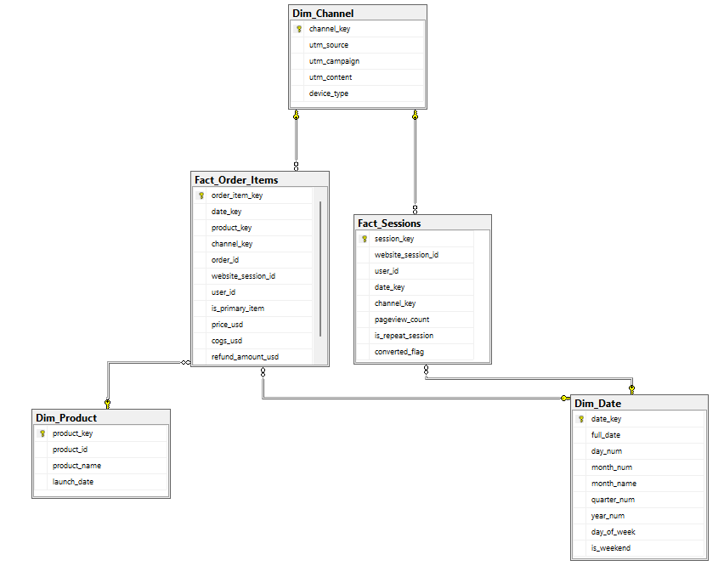
Figure 6: Dimensional model implemented in ToyStore_WarehouseDB

5.3 Dimension Tables
Dimension | Key | Main Attributes | Purpose
Dim_Date | date_key | full_date, day_num, month_num, month_name, quarter_num, year_num, day_of_week, is_weekend | Time-based analysis
Dim_Product | product_key | product_id, product_name, launch_date | Product analysis
Dim_Channel | channel_key | utm_source, utm_campaign, utm_content, device_type | Marketing/channel analysis

5.4 Fact Tables
Fact Table | Grain | Measures | Main Foreign Keys
Fact_Sessions | One website session | pageview_count, is_repeat_session, converted_flag | date_key, channel_key
Fact_Order_Items | One purchased order item | price_usd, cogs_usd, refund_amount_usd | date_key, product_key, channel_key

Both facts also retain user_id for user-level analysis.

5.5 Hierarchies and Relationships
The Date dimension supports the hierarchy:
Year → Quarter → Month → Date
This can later be used in Power BI for drill-down and roll-up analysis.
The Channel dimension contains related marketing attributes:
UTM Source → UTM Campaign → UTM Content
This allows marketing performance to be examined at different levels.

5.6 Design Assumptions
The following design decisions were made:
- A star-schema-based dimensional structure was used for simple and efficient analytical querying.
- Surrogate keys are used for Product and Channel dimensions.
- Dim_Date uses an integer date key in YYYYMMDD format.
- user_id is retained directly in Fact_Sessions and Fact_Order_Items.
- A separate Dim_User was intentionally not created because the source does not contain useful descriptive customer attributes.
- Missing or blank marketing values are standardized to direct.
- Refund amounts are aggregated to their corresponding order items.
- Product launch date is retained as a descriptive Product attribute.
- Referential relationships are enforced in the warehouse even though the staging layer remains less restrictive.

6. Task 5: ETL Process Development

6.1 Extraction
The ETL process extracts data from both CSV and JSON sources.

CSV Extraction
The following files are loaded using SQL Server BULK INSERT:
- products.csv
- orders.csv
- order_items.csv
- order_item_refunds.csv

JSON Extraction
The following are loaded using OPENROWSET and OPENJSON:
- website_sessions.json
- website_pageviews.json
All extracted records are initially loaded into ToyStore_StagingDB.

6.2 Transformation
The main transformations performed during ETL include:

Missing Value Handling
Blank or NULL marketing attributes are standardized to direct so that sessions without explicit campaign information remain available for analysis.

Data Cleansing and Standardisation
Text values used for analytical dimensions are cleaned and standardized before loading.

Data Type Conversion
Source values are converted into the required SQL data types.
For example, website pageview timestamps use:
CONVERT(DATETIME, pv.created_at, 120)
because the source timestamp follows:
YYYY-MM-DD HH:MM:SS

Calendar Generation
Dim_Date is generated for the required analytical date range and contains attributes such as day, month, quarter, year, weekday, and weekend status.

Aggregation
Website pageviews are grouped by session to calculate pageview_count.
Refund transactions are aggregated by order item before being loaded into Fact_Order_Items.

Derived Attributes
Derived analytical fields include:
- Date keys
- Month name
- Quarter
- Year
- Day of week
- Weekend indicator
- Pageview count
- Converted-session flag

6.3 Loading Sequence
The warehouse load follows this sequence:
Staging Data
↓
Clean Session Data
↓
Dim_Date
↓
Dim_Product
↓
Dim_Channel
↓
Fact_Sessions
↓
Fact_Order_Items
↓
Validation

Dimension tables are loaded before fact tables so that their dimension keys are available when fact records are inserted.
The warehouse ETL is also executed within a transaction to reduce the possibility of leaving the warehouse partially loaded if a failure occurs.

6.4 ETL Workflow Diagram
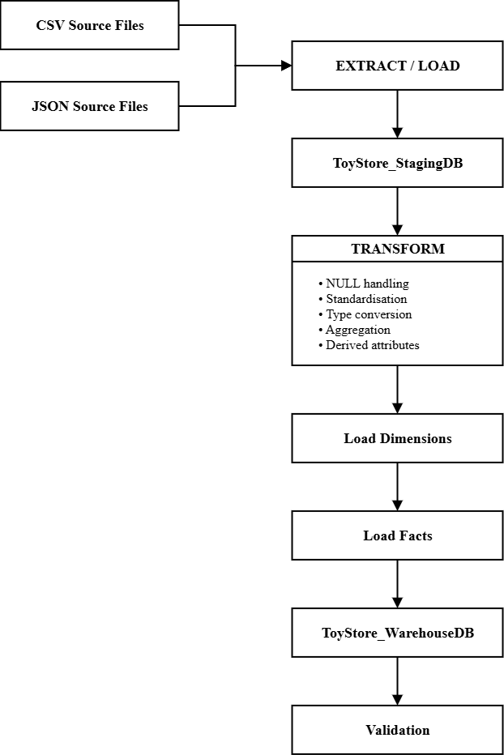
Figure 7: ETL workflow implemented for the e-commerce Data Warehouse.

6.5 ETL Validation
The completed Data Warehouse contains:
Warehouse Table | Records
Dim_Date | 1,096
Dim_Product | 4
Dim_Channel | 13
Fact_Sessions | 472,871
Fact_Order_Items | 40,025

Important business totals were also reconciled against staging:
Measure | Staging | Warehouse | Result
Revenue | $1,938,509.75 | $1,938,509.75 | Matched
Refunds | $85,338.69 | $85,338.69 | Matched
Pageviews | 1,188,124 | 1,188,124 | Matched

The warehouse retained:
- 394,318 unique session users
- 31,696 unique purchasing users
These checks confirm that the ETL pipeline preserved the important source totals while transforming the operational data into the dimensional structure.

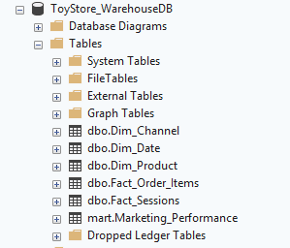

Figure 8: SSMS showing the final warehouse tables: dbo.Dim_Date, dbo.Dim_Product, dbo.Dim_Channel, dbo.Fact_Sessions, and dbo.Fact_Order_Items.

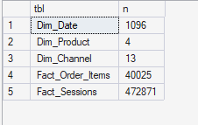

Figure 9: Warehouse row-count validation

Figure 10: Business-total reconciliation between staging and warehouse.

7. Task 6: Data Mart Development

7.1 Marketing Performance Data Mart
A department-specific Marketing Performance Data Mart was created from the central Data Warehouse.
It consists of:
mart.Marketing_Performance
which is the physical summarized Data Mart table, and:
mart.vw_Channel_Performance
which is an analytical SQL view built on the Data Mart.

7.2 Purpose
The purpose of the Marketing Performance Data Mart is to provide marketing and management users with a simplified analytical dataset for monitoring website traffic, conversions, marketing channels, sales, and financial performance.
Instead of repeatedly querying detailed session and order-item records, the Data Mart provides pre-aggregated information suitable for BI dashboards.

7.3 Target Users
The main target users are:
- Marketing Managers
- Sales Managers
- Business Analysts
- Management users

7.4 Grain
The grain of mart.Marketing_Performance is:
One row per date per marketing channel.
The completed Data Mart contains:
10,123 rows

7.5 Data Mart Measures
The physical Data Mart contains measures including:
Area | Measures
Website Activity | Sessions, Repeat Sessions, Converted Sessions, Pageviews
Sales | Orders, Items Sold
Financial | Revenue, COGS, Refund Amount

The analytical view additionally provides calculations such as:
Analytical Measure | Purpose
Net Revenue | Revenue remaining after refunds
Gross Profit | Revenue less COGS
Profit After Refunds | Revenue less COGS and refunds
Conversion Rate | Percentage of sessions converted
Revenue per Session | Revenue generated per website session
Average Order Value | Average revenue per order
Refund Rate | Refund amount relative to revenue
Pages per Session | Average pageviews generated per session

7.6 Analytical Benefits
The Data Mart allows users to:
- compare marketing sources and campaigns;
- identify channels generating high and low conversion;
- compare desktop and mobile performance;
- monitor traffic, sales, and revenue trends;
- analyse refund impact;
- compare revenue generated by different channels;
- quickly provide summarized information to Power BI.

7.7 Data Mart Validation
The completed Data Mart was reconciled against the central Data Warehouse.
Measure | Data Mart | Warehouse | Result
Sessions | 472,871 | 472,871 | Matched
Repeat Sessions | 78,553 | 78,553 | Matched
Converted Sessions | 32,313 | 32,313 | Matched
Pageviews | 1,188,124 | 1,188,124 | Matched
Orders | 32,313 | 32,313 | Matched
Items Sold | 40,025 | 40,025 | Matched
Revenue | $1,938,509.75 | $1,938,509.75 | Matched
COGS | $722,370.25 | $722,370.25 | Matched
Refunds | $85,338.69 | $85,338.69 | Matched

A duplicate-grain validation was also performed to confirm that there is only one Data Mart record for each Date + Marketing Channel combination.
This confirmed that the Data Mart was correctly aggregated without duplicating its intended grain.
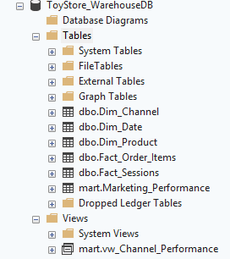

Figure 11: SSMS showing the Data Mart objects mart.Marketing_Performance and mart.vw_Channel_Performance in ToyStore_WarehouseDB

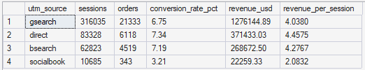

Figure 12: Data Mart channel-performance analytical output showing the following results.
Source | Sessions | Converted Sessions | Orders | Conversion Rate | Revenue
gsearch | 316,035 | 21,333 | 21,333 | 6.75% | $1,276,144.89
direct | 83,328 | 6,118 | 6,118 | 7.34% | $371,433.03
bsearch | 62,823 | 4,519 | 4,519 | 7.19% | $268,672.50
socialbook | 10,685 | 343 | 343 | 3.21% | $22,259.33

This is useful evidence that the Data Mart isn't merely created, as it actually supports meaningful analytical queries.

8. Task 7: OLAP Analysis and Business Intelligence Dashboard Development

8.1 Power BI Dashboard Development
Microsoft Power BI was used as the presentation and visualization layer of the Business Intelligence solution. The dashboards connect the dimensional Data Warehouse and Marketing Performance Data Mart to interactive visualizations that allow management users to analyse business performance.
The Power BI solution was organized into three report pages:
- Executive Summary
- Trend Analysis
- Interactive Analysis
The dashboards use the Date, Channel, Product, Session, Order Item, and Marketing Performance data available in the analytical model. The Date dimension supports the hierarchy Year → Quarter → Month → Date, while the Channel dimension supports analysis using marketing source, campaign, content, and device type. These hierarchies were established as part of the dimensional design.
The final analytical dataset covers the period from 2012 to 2015, allowing both overall performance analysis and comparison of business performance over time.

8.2 Power BI Data Model
The Power BI model uses the warehouse dimension and fact tables together with the Marketing Performance Data Mart.
The principal tables used for dashboard analysis are:
- Dim_Date
- Dim_Channel
- Dim_Product
- Fact_Sessions
- Fact_Order_Items
- mart.Marketing_Performance
The dimensional model separates descriptive dimensions from measurable business events. Fact_Sessions represents website-session activity, while Fact_Order_Items represents individual purchased products.
The Marketing Performance Data Mart provides summarized information at the grain of one row per date per marketing channel, making it suitable for dashboard KPIs, trends, marketing comparisons, and interactive analysis.
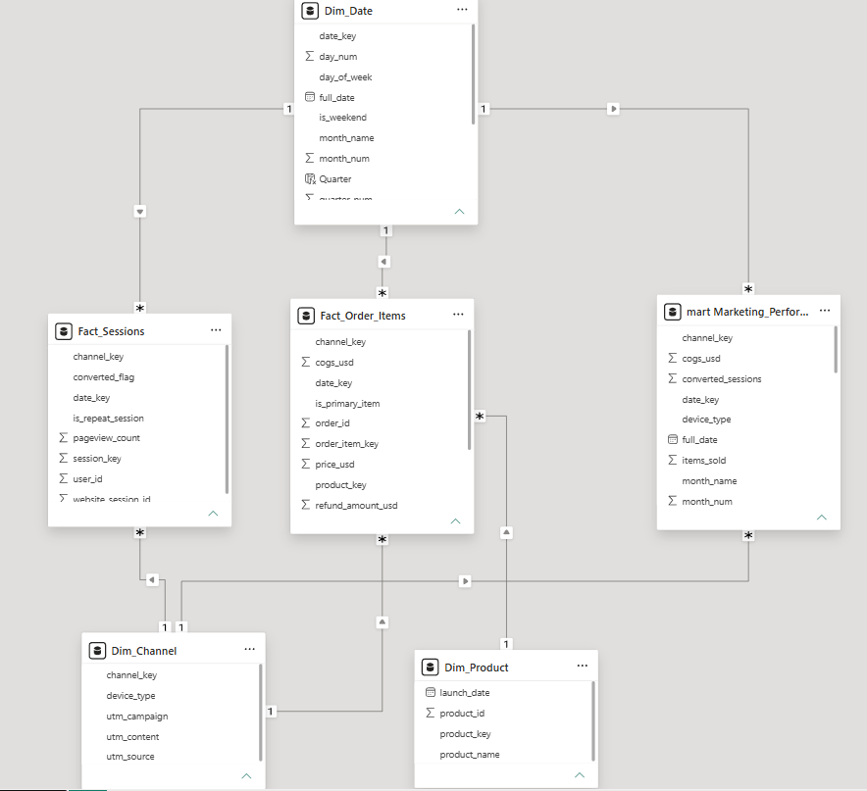

Figure 13: Power BI data model used for Business Intelligence dashboard development.

8.3 Report Page 1: Executive Summary
The Executive Summary dashboard provides management with a high-level view of the overall performance of the e-commerce business.
The page contains KPI cards for:
- Total Revenue
- Total Orders
- Total Sessions
- Conversion Rate
- Profit After Refunds
These KPIs provide an immediate summary of website traffic, sales activity, conversion performance, and financial performance.
The page also contains the following analytical visualizations:
- Revenue by Marketing Source: compares the revenue generated through different marketing sources.
- Revenue Trend: shows how business revenue changes over time.
- Revenue by Device Type: compares the contribution of desktop and mobile traffic to revenue.
- Marketing Channel Performance: provides a detailed comparison of marketing channels using important performance measures.
- Device Type Slicer: allows users to interactively filter the dashboard by device type.
Together, these visuals provide management with a consolidated overview of the business and make it possible to quickly identify important marketing and financial performance patterns.

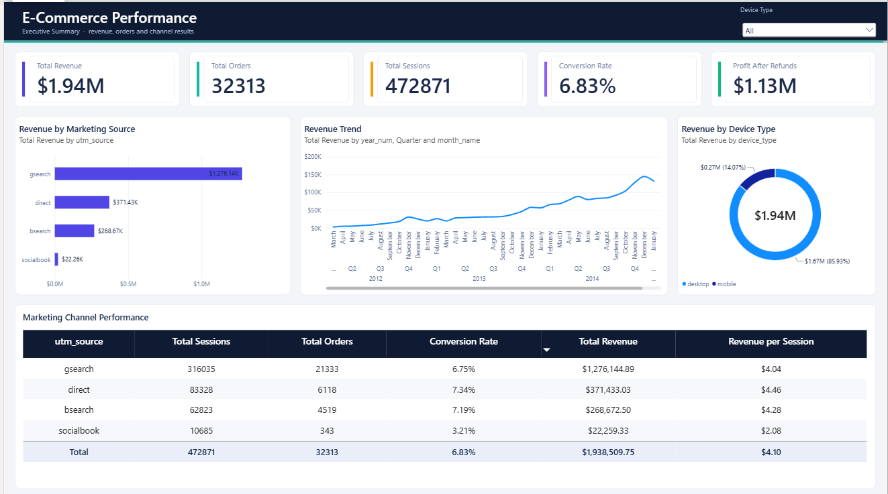

Figure 14: Executive Summary dashboard showing overall business KPIs, revenue trends, marketing-source performance, device performance, and interactive filtering.

8.4 Report Page 2: Trend Analysis
The Trend Analysis page focuses on analysing how business performance changes over time.
The page contains KPI cards for:
- Total Revenue
- Total Orders
- Total Sessions
- Total Refunds
The main time-based visualizations include:
- Monthly Revenue Trend: shows changes in revenue across the available time period.
- Monthly Conversion Rate Trend: shows how effectively website sessions were converted over time.
- Revenue and Refund Comparison: compares revenue with refund amounts over time.
- Monthly Performance Summary: provides summarized monthly performance information for detailed comparison.
A date slicer is included so that users can select a particular period and analyse the corresponding performance.
The Date dimension supports the hierarchy:
Year → Quarter → Month → Date
This enables OLAP-style roll-up and drill-down. For example, users can begin with yearly performance, drill down to quarters or months, and then examine individual dates where more detailed investigation is required. The hierarchy was specifically designed to support this type of time-based analysis.
The Trend Analysis page therefore helps management identify growth, decline, seasonal changes, unusual periods, and changes in conversion or refund behaviour.

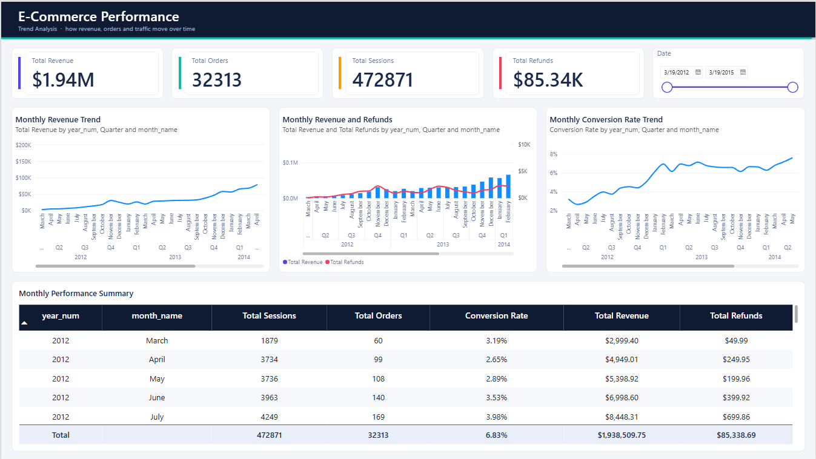

Figure 15: Trend Analysis dashboard showing time-based revenue, orders, sessions, refunds, conversion performance, and monthly comparisons.

8.5 Report Page 3: Interactive Analysis
The Interactive Analysis page provides more detailed exploratory analysis and allows users to interact with the data using multiple filters.
The page includes slicers for:
- Date
- Marketing Source
- Campaign
- Device Type
These slicers allow users to dynamically change the analytical context. For example, a manager can select a particular marketing source and device type to examine only the corresponding business activity.
The main visualizations include:
- Conversion Rate by Marketing Source: compares how effectively different traffic sources generate conversions.
- Revenue by Product: compares the revenue contribution of individual products.
- Items Sold by Product: compares product sales volumes.
- Sessions vs Revenue by Marketing Source: compares website traffic with the revenue generated by different marketing sources.
- Detailed Marketing Performance: provides supporting channel-level information for deeper analysis.
Product analysis is performed using Fact_Order_Items and Dim_Product, because the order-item fact contains the revenue and product relationships required for individual product analysis. The warehouse design defines each Fact_Order_Items record as one purchased order item.
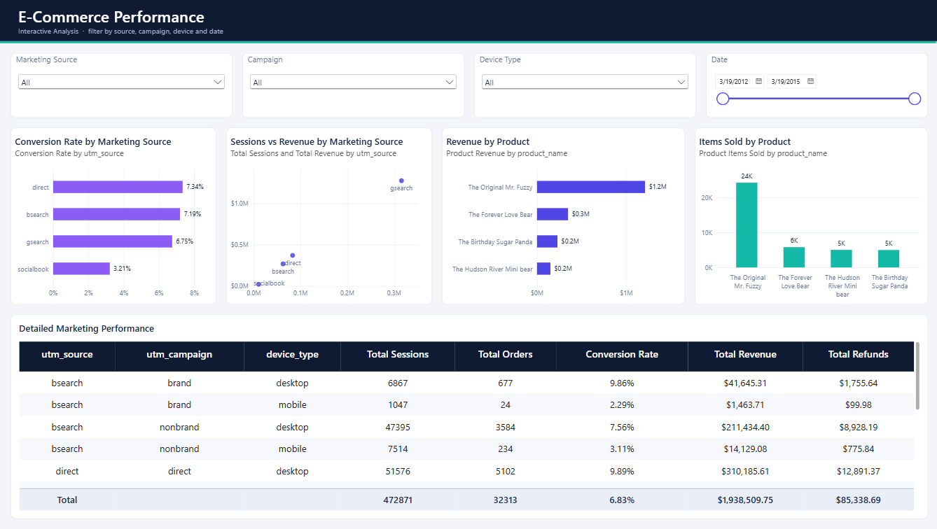
The interactive functionality enables users to move from an overall view to more specific segments without creating separate reports for every business question.

Figure 16: Interactive Analysis dashboard showing marketing-source conversion, product performance, sessions versus revenue, and interactive slicers.

8.6 OLAP and Interactive Analysis Capabilities
The Power BI dashboards provide several OLAP-style analytical capabilities.
Drill-down allows users to move from summarized information to more detailed information. The Date hierarchy can be explored from Year to Quarter, Month, and individual Date.
Roll-up allows users to move in the opposite direction and summarize detailed information at a higher level, such as moving from monthly results to quarterly or yearly results.
Slice operations are supported through slicers such as Date, Marketing Source, Campaign, and Device Type. Selecting one value creates a focused view of that segment.
Dice operations can be performed by combining several filters. For example, a user can analyse a selected marketing source for a specific campaign, device type, and time period.
The dashboards therefore provide both summarized management information and detailed interactive analysis from the same Business Intelligence environment.

8.7 Dashboard Measures
Several business measures were created or used in Power BI to support dashboard analysis.
Measure | Business Purpose
Total Revenue | Measures total sales revenue
Total Orders | Measures the number of customer orders
Total Sessions | Measures website traffic
Conversion Rate | Measures the percentage of sessions resulting in conversion
Total Refunds | Measures refunded sales value
Total COGS | Measures the cost associated with sold products
Gross Profit | Revenue less COGS
Net Revenue | Revenue less refunds
Profit After Refunds | Revenue less COGS and refunds
Average Order Value | Measures average revenue generated per order
Revenue per Session | Measures revenue generated relative to website traffic
Pages per Session | Measures average website pageviews per session
Product Revenue | Measures revenue generated by individual products
Product Items Sold | Measures the number of purchased product items

These measures extend the additive measures stored in the Data Mart into meaningful business indicators. The underlying analytical design already defines Net Revenue, Gross Profit, Profit After Refunds, Conversion Rate, Revenue per Session, Average Order Value, Refund Rate, and Pages per Session.

8.8 Dashboard Contribution to Business Intelligence
The three dashboards address the business questions identified at the beginning of the project.
The Executive Summary provides an overall management view, the Trend Analysis dashboard identifies changes over time, and the Interactive Analysis dashboard enables detailed investigation of marketing, product, campaign, and device performance.
Together, these dashboards transform the integrated warehouse data into information that can support decisions concerning marketing investment, website performance, product performance, sales growth, and refund management.

9. Task 8: Business Insights and Recommendations

9.1 Overview
The completed Business Intelligence solution enables the e-commerce business to move from separate operational datasets to an integrated analytical environment.
Analysis of the dashboard outputs provides several business insights that can support management decision-making.
The insights below are based on the completed warehouse and Data Mart results and should be supported by the corresponding Power BI visuals in the final report.

9.2 Insight 1: Google Search Is the Largest Marketing Source
The marketing analysis shows that gsearch is the dominant marketing source.
Across the complete dataset, gsearch generated approximately:
- 316,035 sessions
- 21,333 converted sessions
- 21,333 orders
- $1,276,144.89 in revenue
- 6.75% conversion rate
This represents the largest contribution to both website traffic and revenue among the available marketing sources.

Business Meaning
The business is highly dependent on Google Search traffic for generating website visits and sales. This makes gsearch an important channel for maintaining overall revenue performance.

Recommendation
Management should continue investing in successful Google Search campaigns while regularly monitoring conversion rate, revenue per session, and campaign-level performance. The business should also avoid becoming excessively dependent on a single acquisition source by continuing to develop other effective channels.

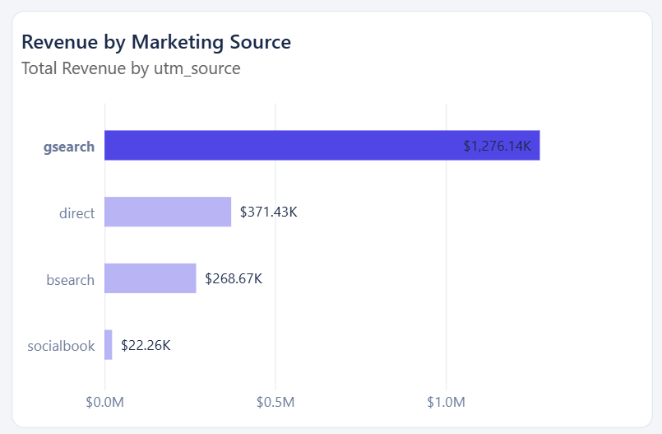 Figure 17: Marketing-source performance highlighting the contribution of gsearch.

9.3 Insight 2: Direct Traffic Has a Strong Conversion Rate
Although direct traffic generates fewer sessions and less total revenue than gsearch, it achieves a 7.34% conversion rate, compared with approximately 6.75% for gsearch.
Direct traffic generated approximately:
- 83,328 sessions
- 6,118 conversions/orders
- $371,433.03 revenue
This suggests that direct visitors have relatively strong purchase intent.

Business Meaning
Visitors arriving directly at the website may already be familiar with the business or may have a stronger intention to purchase than some paid or campaign-generated visitors.

Recommendation
The business should strengthen customer retention and brand awareness activities that can encourage users to return directly to the website. Direct traffic should also be monitored alongside repeat-session behaviour to understand the contribution of returning website activity.

9.4 Insight 3: Socialbook Has the Weakest Marketing Performance
The socialbook source generated approximately:
- 10,685 sessions
- 343 conversions/orders
- $22,259.33 revenue
- 3.21% conversion rate
Its conversion rate is substantially below gsearch, direct, and bsearch.

Business Meaning
Socialbook contributes traffic, but this traffic is less effective at producing purchases than the other major marketing sources.

Recommendation
Management should review Socialbook campaigns before increasing marketing expenditure. Campaign targeting, advertisements, audience selection, and landing experience should be evaluated. Budget can then be redirected toward stronger campaigns if Socialbook performance does not improve.

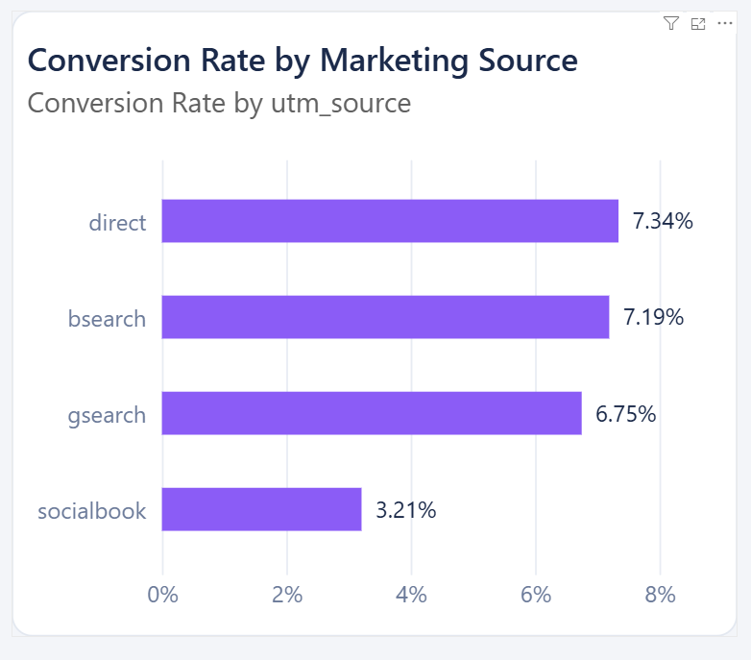 Figure 18: Comparison of conversion rates across marketing sources.

9.5 Insight 4: The Business Shows Significant Activity Across Multiple Years
The corrected analytical dataset covers 2012 to 2015, allowing management to analyse business development across multiple years rather than relying on a single-year view.
The Trend Analysis dashboard makes changes in revenue, sessions, orders, conversion, and refunds visible over time. The monthly analysis also allows periods of stronger and weaker business activity to be identified.

Business Meaning
Multi-year analysis gives management a more reliable understanding of business performance because individual months or years can be interpreted within a longer-term context.

Recommendation
Management should continue monitoring monthly and yearly trends and compare changes in revenue with sessions and conversion performance. Periods showing unusually high or low performance should be investigated at the marketing-source and campaign levels.

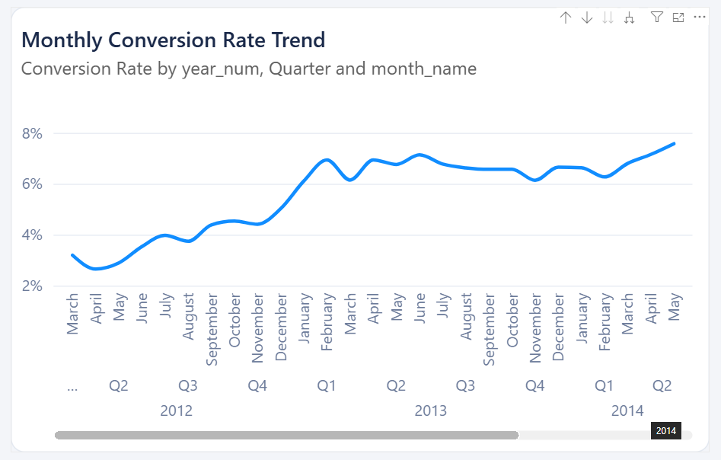

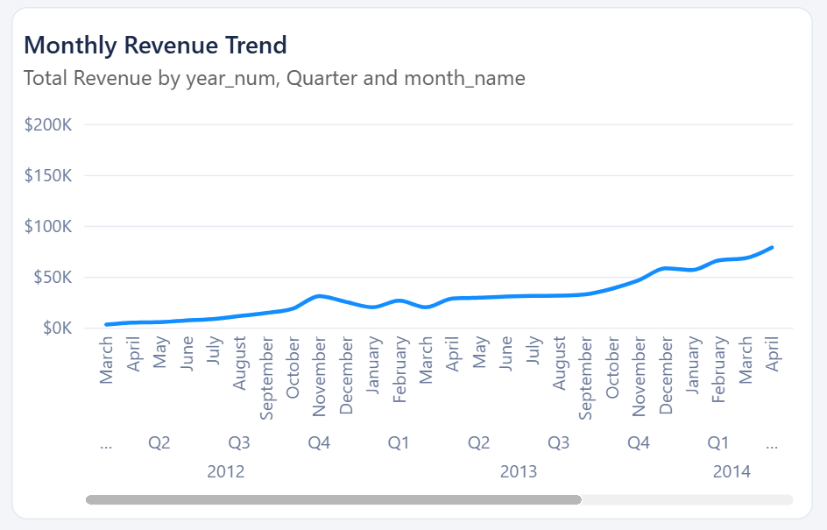

Figure 19: Multi-year trend analysis showing changes in business performance from 2012 to 2015.

9.6 Insight 5: Refunds Reduce the Revenue Retained by the Business
The complete dataset contains:
- Total Revenue: $1,938,509.75
- Total Refunds: $85,338.69
Therefore, although gross sales revenue is substantial, part of that revenue is subsequently lost through customer refunds.
The dashboard's revenue and refund comparison makes it possible to monitor this financial impact over time.

Business Meaning
Revenue alone does not provide a complete picture of financial performance. Refund activity needs to be considered when evaluating the actual value retained from sales.

Recommendation
Management should monitor refund trends together with products, sales periods, and marketing activity. Periods or products associated with unusually high refund activity should be investigated to identify possible product-quality, customer-expectation, or operational issues.

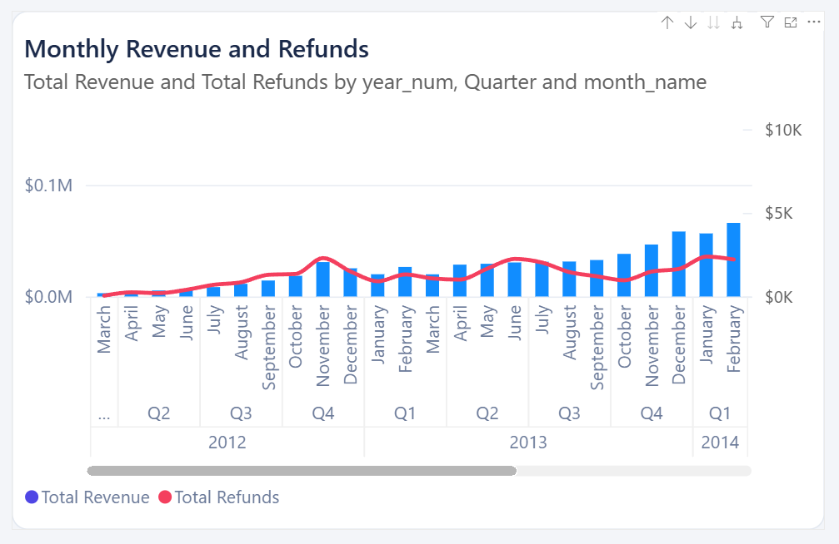

Figure 20: Revenue and refund comparison used to evaluate the financial impact of refunds.

9.7 Insight 6: Product Performance Is Not Uniform
The Interactive Analysis dashboard compares both Revenue by Product and Items Sold by Product.
The visual comparison demonstrates that individual products make different contributions to overall sales revenue and sales volume. This allows management to identify stronger and weaker products rather than treating the entire product catalogue as having equal performance.

Business Meaning
Products generating high revenue or sales volumes are commercially important, while lower-performing products may require further investigation.

Recommendation
Management should use product-level revenue and sales-volume information when making decisions about product promotion, inventory planning, and marketing campaigns. High-performing products can receive stronger promotional support, while weaker products can be reviewed to determine whether pricing, promotion, or product strategy should be changed.

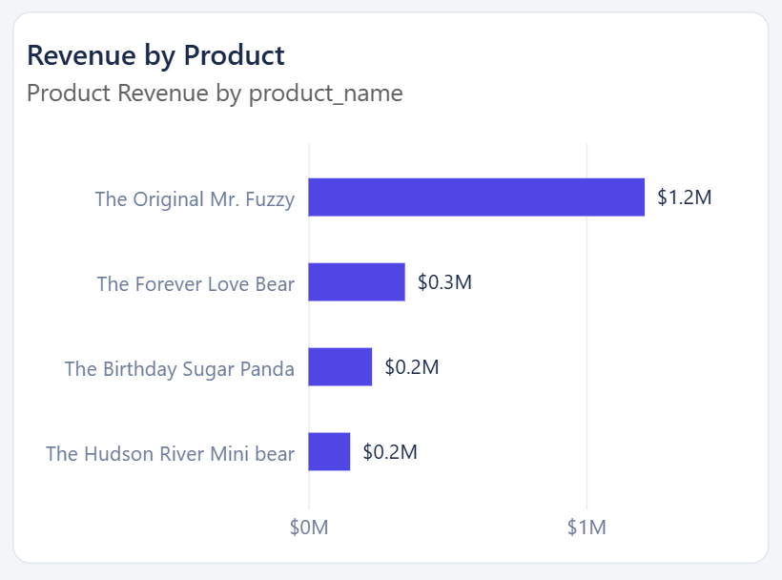

Figure 21: Product-level comparison of revenue and items sold.

9.8 Insight 7: Website Traffic Alone Does Not Determine Marketing Success
The Sessions vs Revenue analysis allows website traffic and generated revenue to be examined together for each marketing source.
For example, search produces both the largest traffic volume and the largest revenue, while other channels differ in their traffic, conversion, and revenue contribution. Conversion-rate analysis also shows that the source with the most traffic does not automatically have the highest conversion rate.

Business Meaning
Marketing channels should not be evaluated only by the number of visitors they generate. A channel can generate substantial traffic but still perform differently in terms of conversion and revenue efficiency.

Recommendation
Marketing decisions should consider several measures together, particularly sessions, conversion rate, revenue, and revenue per session, rather than using traffic volume alone.
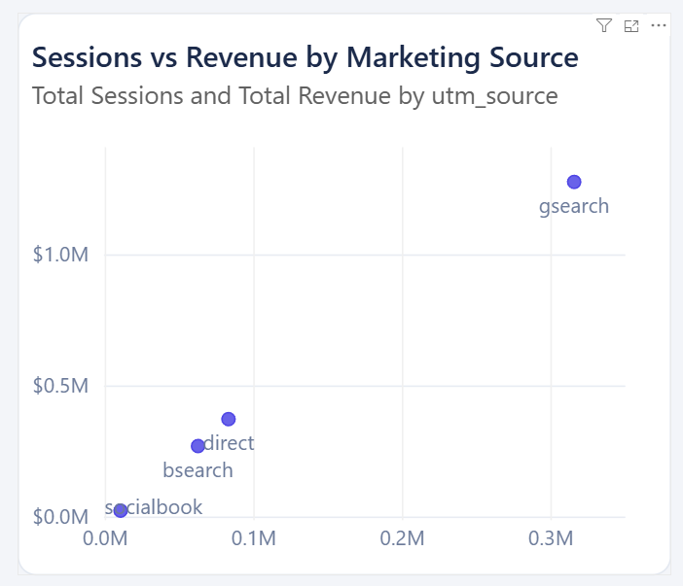
Figure 22: Sessions versus revenue analysis used to compare marketing-source efficiency.

9.9 Overall Recommendations
Based on the dashboard analysis, the business should continue monitoring high-performing search channels while reviewing weaker marketing sources, use conversion and revenue efficiency alongside traffic when allocating marketing budgets, investigate refund patterns to protect retained revenue, use product-level analysis to support promotion and inventory decisions, and continuously monitor multi-year and monthly trends to detect changes in business performance.
The interactive nature of the Power BI solution allows these recommendations to be investigated further by filtering the dashboards according to date, source, campaign, and device type.

9.10 Support for Business Decision-Making
The completed Business Intelligence solution provides management with a unified view of website activity, marketing performance, product sales, revenue, costs, and refunds.
Rather than analysing individual operational files separately, decision-makers can use the dashboards to identify performance trends, compare marketing channels, evaluate product contribution, monitor conversion performance, and investigate financial outcomes.
The Executive Summary supports high-level monitoring, the Trend Analysis page supports time-based decision-making, and the Interactive Analysis page supports detailed investigation. As a result, the Data Warehouse and BI solution converts operational e-commerce data into actionable information that can support more informed business decisions.
10 Acknowledgement of AI Use
AI tools were used in accordance with the assessment guidelines as a supporting tool for learning and development. Assistance was obtained for brainstorming ideas, clarifying Data Warehousing and Business Intelligence concepts, debugging technical issues, improving explanations, and refining the structure and presentation of the report. All AI-assisted suggestions were critically reviewed, verified, and appropriately adapted by the project team. The final implementation, analysis, results, and conclusions reflect the team’s own work and understanding.

