Dear Mr. Tischer,
Thank you for sharing the reader’s comments and for giving us the opportunity to clarify the experimental setup and interpretation of our data in the article: “Modeling based on machine learning to investigate flue gas desulfurization performance by calcium silicate absorbent in a sand bed reactor” (DOI: 10.1038/s41598-024-51586-7).
We believe the core of the reader’s concern arises from a misinterpretation of the plotted variable in Figures 12(c), (e), and (f). We appreciate this opportunity to explain the data in proper context and address each point.
Clarification of output variable:
Throughout our study, the output variable predicted by the machine learning model is the SO₂ concentration (in ppm) at the outlet of the sand bed reactor, as measured continuously by the SO₂ gas analyzer. It is not the adsorption capacity or removal efficiency. The analyzer, installed downstream of the reactor, provides real-time concentration values of SO₂ remaining in the effluent gas.
Therefore, the typical behavior observed and modeled is as follows:
- At the beginning of the process, the fresh absorbent actively removes SO₂, so the analyzer detects a declining SO₂ concentration.
- As time progresses and the absorbent becomes saturated, its removal capacity drops. Consequently, the outlet SO₂ concentration rises, approaching the inlet concentration.
- By approximately 20 min, the absorbent is saturated, and the analyzer detects a plateau, reflecting the baseline concentration of SO₂ without any further removal.

Figure 12(c):
In machine learning, overfitting occurs when a model learns the details and noise in the training data to the extent that it negatively impacts the performance of the model on new, unseen data. The key indicator of overfitting is when the model performs significantly better on the training set compared to the validation or test sets. To ensure a model’s generalization capability, it is essential to examine learning curves and evaluation metrics.
In this study, a Random Forest Regressor model was trained and evaluated on a dataset containing various parameters. The model was assessed for overfitting by analyzing the learning curve, which plots the model’s error (in terms of RMSE) on both the training and validation sets over varying training sizes. The following analysis is based on the evaluation of the learning curve and the associated metrics.
Learning curve analysis
A learning curve provides valuable insight into how the model's performance improves as more training data is introduced. In this case, a Random Forest model was trained using 9 estimators and a maximum depth of 16, with a poisson criterion and other standard hyperparameters. The resulting learning curve, shown in the Fig. 1, compares the training RMSE and validation RMSE for different training set sizes.
- The training RMSE is plotted in blue and represents the error on the training data. This curve shows a steady decrease as more training data is used, with the model’s performance improving as expected.
- The Validation RMSE, represented by the orange line, also shows a decrease over time. The gap between the training and validation RMSE decreases as the training set grows, suggesting that the model is generalizing well to the unseen validation data.
- Most importantly, the validation curve flattens, indicating that after a certain point, increasing the size of the training set no longer significantly improves validation performance. This is typical in models that are not overfitting.
In the absence of overfitting, the training and validation errors should converge as the model receives more training data. The observed trend suggests that the model does not memorize the training data, but rather learns useful patterns that generalize well to unseen examples.
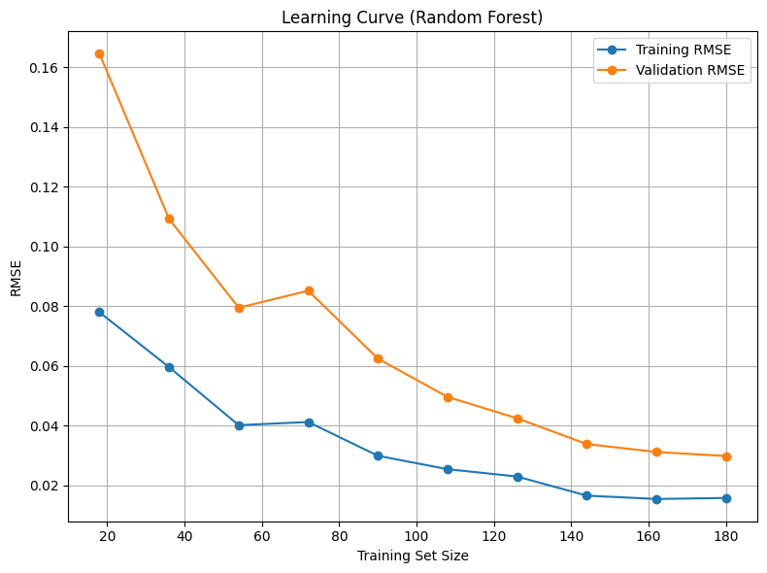
Fig. 1. Learning curves of RF.
Evaluation Metrics
Additional evidence supporting the absence of overfitting can be found in the evaluation metrics obtained from the model’s performance on both the training and validation sets. The following metrics were calculated:
- Training Set:
  - MSE (Mean Squared Error): The training MSE was relatively low, indicating that the model fits the training data well.
  - RMSE (Root Mean Squared Error): The RMSE on the training set was 0.0525, reflecting a good fit.
  - R²: The R² score on the training set was 0.988, suggesting that the model accounts for nearly 99% of the variance in the training data.
  - MAE (Mean Absolute Error): The MAE was 0.0395, indicating a small absolute error between predicted and actual values.
- Validation Set:
  - MSE: The MSE for the validation set was similarly low, suggesting that the model is performing well on unseen data.
  - RMSE: The RMSE on the validation set was 0.085, which is slightly higher than on the training set but still quite reasonable.
  - R²: The R² score for the validation set was 0.967, which remains strong and consistent with the training set.
  - MAE: The MAE was 0.064, indicating a relatively small error between the predicted and actual values on the validation data.
The small difference in RMSE and R² values between the training and validation sets further supports the conclusion that the model is not overfitting. A large discrepancy would typically indicate that the model is memorizing the training data, but this was not the case.
Conclusion
Based on both the learning curve analysis and the evaluation metrics, it is evident that the Random Forest model is not overfitting. The training and validation RMSE values decrease steadily and converge as the model learns from more data, indicating good generalization to the validation set. The evaluation metrics show that the model performs similarly on both training and validation sets, which further suggests that it has not overfit the training data. This conclusion is reinforced by the stable R² scores and small differences in MAE values between the sets.
Thus, the model is considered to have a good balance between bias and variance, making it well-suited for deployment on unseen data. This assessment confirms that the Random Forest model is generalizing well without overfitting.
Regarding negative values observed around a relative humidity of 75%, we agree that negative concentrations of SO₂ have no physical meaning. This issue indicates prediction inaccuracies inherent in data-driven approaches, particularly near data-sparse regions or boundaries of the experimental data domain. Such predictions signal limitations in the ML model when extrapolating beyond or near the edges of the input space. If required, we can supply an amended version of Figure 12 (c).
Figure 12(e):
In this scenario, the model shows a decline in SO₂ concentration followed by a slight increase and then stabilization. Interpreting this correctly:
- This is not a sign of reactivation or renewed adsorption.
- It simply reflects the analyzer’s response as the small amount of absorbent becomes saturated early, and the outlet SO₂ concentration returns to its initial value, exactly as expected from a physical and instrumental standpoint.
The reader's interpretation—that the absorbent regains capacity—is based on the assumption that the figure shows adsorption efficiency, which is not the case.
Figure 12(f):
We acknowledge the reader's concern regarding the significantly negative SO₂ concentrations (~ -1000 ppm) identified between 40-45°C and 5-8 minutes absorption time. These values are non-physical and purely computational artifacts due to sparse training data in that zone. The raw experimental data do not contain any such values. If required, we will submit corrected figures with clearly marked reliable prediction domains.

Clarification based on reference data:
To further clarify, the data used for machine learning training and validation in our study were extracted from published experimental results such as the one shown in the figure below [1]. These data represent the measured outlet concentration of SO₂ over time, not the adsorbed amount or removal percentage. As illustrated, the SO₂ concentration decreases rapidly at the start due to strong initial adsorption by the fresh absorbent, then increases gradually as the absorbent becomes saturated, eventually stabilizing near the inlet concentration. Our ML model was trained to reproduce this measured behavior. Any misinterpretation as adsorption efficiency or material regeneration would therefore be incorrect.

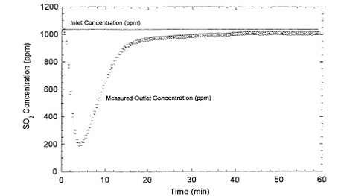
Fig. 2. SO₂ concentration data vs. time data from experiment [1].
We reiterate that our manuscript’s aim was explicitly focused on machine learning-based predictive modeling, relying on previously reported experimental data. Our contribution lies in assessing the effectiveness of various ML approaches (ANN, MLP, RBFNN, RF, ETR, and SVR) for predicting SO₂ concentration based on input parameters. Physical interpretations from these ML predictions should always be cross-verified with experimental validation. We thank the reader for their insightful comments, which have significantly aided in identifying opportunities for further refining the robustness and interpretability of machine learning models applied to environmental and chemical engineering processes.
Raw Data and Code Availability
The full outlet-concentration dataset has been deposited in the Supplementary Information.
The complete Python materials—data-cleaning routine, random-forest training/validation—will be provided in a standalone file together.
These files will allow full transparency and reproducibility. We hope this clarifies the source of confusion and the nature of our modeling approach.
Best regards,
Dr. Ghaemi
Iran university of science and technology
aghaemi@iust.ac.ir

References:
[1] L.F. Arthur, Silicate sorbents for flue gas cleaning, The University of Texas at Austin1998.

