IMPLEMENTATION AND ANALYSIS OF THE
LONGEST JOB FIRST (LJF) SCHEDULING
ALGORITHM USING SEMAPHORES
A Technical Research Report
Operating Systems / Real-Time Systems
Implementation language: C++20
Prepared: October 2026

Abstract
This report studies the implementation of the non-preemptive Longest Job First (LJF) CPU-scheduling policy in a system where process-arrival handlers and a scheduler may access a shared ready queue concurrently. LJF selects, from the processes that have arrived and are ready, the job with the largest CPU-burst estimate; ties are resolved here by first-come, first-served (FCFS). A binary semaphore is used as a mutual-exclusion primitive around shared scheduler state. The report emphasizes that the semaphore does not itself implement LJF: the policy is implemented by the selection rule, while synchronization preserves queue consistency and prevents concurrent updates from racing.
A discrete-event model, pseudocode, a C++20 implementation, three flowcharts, and a worked numerical example are presented. The example contains three processes that all arrive at time zero, with bursts of 3, 7, and 5 time units. Its non-preemptive schedule is P2, P3, P1, with an average waiting time of 6.33 time units and average turnaround time of 11.33 time units. Under the explicitly stated idealized model, CPU utilization is 100% and throughput is 0.2 processes per time unit. These are analytical values derived from the input, not empirical performance measurements. The discussion also covers contention, starvation, deadlock prevention, and the distinction between simulated CPU time and wall-clock execution. Finally, LJF is compared with Earliest Deadline First (EDF) and Rate Monotonic (RM), which target different scheduling objectives and assumptions.
Keywords: Longest Job First; Semaphore; Process Scheduling; Mutual Exclusion; Race Condition; Operating Systems; Real-Time Scheduling.

Contents

Note: In Microsoft Word, update the table of contents field (right-click → Update Field) if page numbers or headings change.

1. Introduction

1.1 CPU scheduling objectives
CPU scheduling decides which ready process receives a processor next. Common objectives include reducing waiting and turnaround times, maintaining responsiveness, increasing throughput, keeping the CPU busy, and meeting deadlines where the workload has timing constraints. These goals can conflict: a policy that optimizes one metric for a particular workload may perform poorly on another. Scheduling-policy behavior must therefore be evaluated against an explicit workload model and objective [1], [2].

1.2 The Longest Job First policy
Longest Job First (LJF) is a non-preemptive policy in the model used here. Whenever the CPU becomes available, the scheduler examines all processes that have arrived and are ready, then selects the one with the largest CPU-burst duration. Once dispatched, the selected process runs to completion. If two or more ready processes have equal burst durations, this report resolves the tie using FCFS, with process identifier as a deterministic final tie-breaker. The name LJF is not a guarantee of optimality: for many conventional workloads, selecting a long job first can increase the waiting time of short jobs.

1.3 Scheduling policy versus synchronization
A scheduling policy specifies the rule for choosing the next job; a synchronization mechanism specifies how concurrent activities safely access shared state. A semaphore does not inherently implement LJF. The LJF comparison and tie-breaking logic implement the policy, while a binary semaphore protects the ready queue and related state against simultaneous conflicting updates. This separation is essential when analyzing correctness.

1.4 Semaphore and concurrency concepts
A semaphore is a synchronization primitive with atomic acquire and release operations. A binary semaphore is used here with an initial count of one to provide mutual exclusion. A counting semaphore can instead represent a count of available instances or events, such as the number of queued work notifications. In C++20, std::binary_semaphore is an alias for std::counting_semaphore<1>; acquire decrements the count or blocks, and release increments it [3].
A critical section is a region that accesses shared state and must not be executed concurrently by conflicting operations. A race condition occurs when the result depends on an uncontrolled interleaving of operations. Deadlock is a permanent wait caused by a cycle or equivalent dependency among activities. Starvation occurs when a process waits indefinitely because other work is continually favored. Priority inversion occurs when a higher-priority activity is delayed by a lower-priority activity holding a needed resource; it is more directly associated with priority-based real-time systems than with the basic LJF example.

1.5 Scope and contribution
This report gives a reproducible analytical example and a reference implementation using C++20 standard synchronization. The code models scheduling decisions and simulated time; it does not claim to reproduce a kernel scheduler, hardware parallelism, context-switch costs, or real-time guarantees. Standard operating-systems references provide the general scheduling and synchronization background [1], [2].

2. System Model and Assumptions
- Each process i is represented by (PID, arrival time Aᵢ, CPU burst Bᵢ), where Aᵢ ≥ 0 and Bᵢ > 0.
- The CPU is a single logical processor and the scheduling policy is non-preemptive.
- At simulated time t, only processes with Aᵢ ≤ t that have not started or completed are eligible.
- The selected process is the eligible process with the largest burst Bᵢ. Ties use earlier arrival time, then lexicographically smaller PID.
- The selected process runs for its full burst. The simulated clock advances by Bᵢ; no context-switch or synchronization overhead is added to simulated time.
- The ready queue and scheduling state are shared resources. A binary semaphore initialized to one guards each critical section that reads or mutates those resources.
- Semaphore acquire/release operations are assumed atomic according to the C++20 semaphore contract. A semaphore is not used as a substitute for a well-defined policy.
When the ready queue is empty but unfinished processes remain, the simulated scheduler advances its clock to the next arrival time; it does not spin or execute an empty job. When several processes arrive at the same time, all are made eligible before the next dispatch decision in the discrete-event model. The example has all three processes arrive at time zero, so no arrival-order ambiguity affects the selected order.

2.1 Scheduling equations
For each process i, completion time Cᵢ is the simulated time at which its burst ends. Turnaround time is TATᵢ = Cᵢ − Aᵢ. Waiting time is Wᵢ = TATᵢ − Bᵢ. Average metrics are arithmetic means across n processes. For a single CPU, utilization is busy time divided by the measurement interval. Throughput is completed processes divided by elapsed simulated time.

2.2 Model boundaries
The deterministic example assumes known CPU bursts and no I/O blocking. Real systems generally estimate bursts, handle interrupts, account for context switches, and interleave CPU and I/O bursts. Those complications are outside the core example and would require an extended model.

3. Semaphore-Based Architecture
The architecture consists of an arrival handler, a shared ready queue, a policy-specific LJF selection routine, a binary semaphore, a dispatcher/CPU simulation, and a statistics module. Arrival handlers publish processes into the queue. The scheduler selects a process only after the event model has made all arrivals up to the current simulated time visible. The semaphore protects the shared queue and any queue-associated state such as membership or sequence numbers.
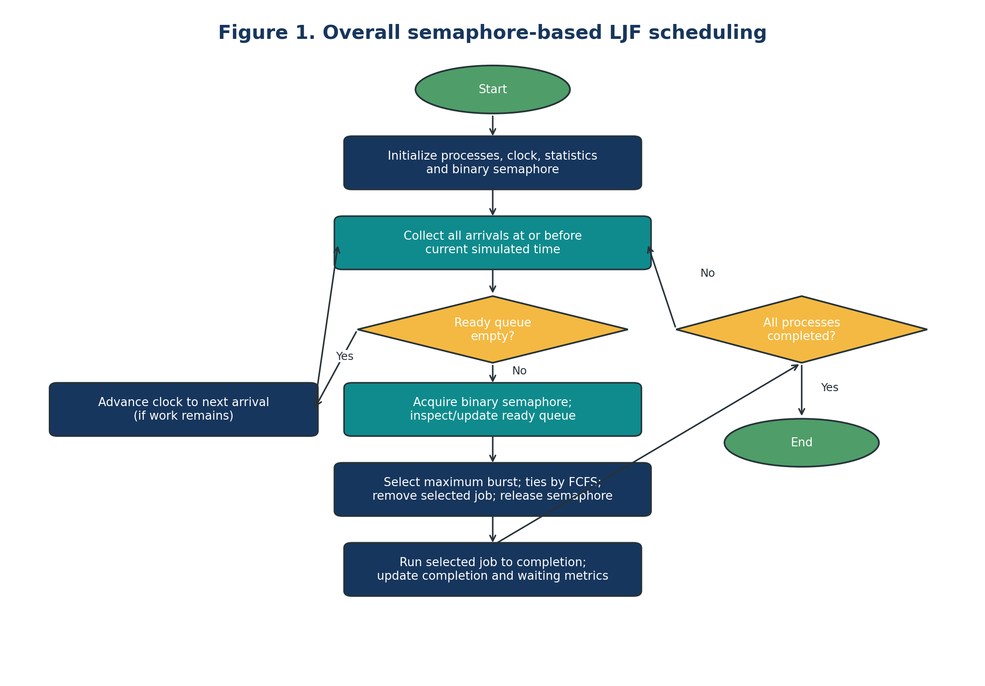
Figure 1. Overall semaphore-based LJF scheduling.

3.1 Component responsibilities
Component | Responsibility | Shared state / synchronization
Arrival handler | Creates or receives a process at its release time. | Must acquire the semaphore before inserting into the ready queue.
Ready queue | Stores arrived, eligible, unfinished processes. | Queue contents and associated insertion sequence are protected.
LJF selection function | Finds the largest burst among eligible jobs; applies FCFS tie-break. | Runs while queue state is exclusively protected.
Binary semaphore | Enforces mutual exclusion for queue operations. | Initialized to 1; acquire before critical section, release on every exit path.
Dispatcher / CPU model | Runs the selected process to completion in simulated time. | Owns the simulation clock in the reference model.
Statistics module | Computes completion, turnaround, waiting, utilization, throughput. | Written by the scheduler thread in the reference model; if shared concurrently, protect it too.

3.2 Shared data requiring protection
At minimum, the ready queue and its insertion sequence must be protected. If multiple threads can update the same process-state map, ready count, completion count, or scheduler flags, those objects also require protection or a separate atomic/ownership design. The reference implementation deliberately centralizes the simulation clock and final statistics in one scheduler thread, avoiding unnecessary locking around data that has a single writer.

3.3 Synchronization boundary
The critical section should be short: acquire the semaphore, insert/remove or inspect the queue, and release it. Process execution must not occur while the semaphore is held. Holding the semaphore during a long CPU burst would prevent arrivals from entering the queue and create avoidable contention. The semaphore protects data integrity; it does not guarantee fairness among waiting threads unless the underlying implementation documents such a guarantee.

4. Pseudocode

4.1 Initialization
ready_queue ← empty
queue_sem ← binary semaphore initialized to 1
simulation_time ← 0
completed ← 0
statistics ← empty

for each input process p:
validate p.arrival_time ≥ 0 and p.burst > 0
register p as not started and not completed

4.2 Process arrival
ARRIVE(p):
wait(queue_sem) // acquire atomically
ready_queue.insert(p) // critical section
signal(queue_sem) // release atomically
notify scheduler that an arrival event is available

4.3 Select and dispatch
SCHEDULE():
while completed < number_of_processes:
add every not-yet-enqueued process with arrival_time ≤ simulation_time
if ready_queue is empty:
simulation_time ← next future arrival time
continue

wait(queue_sem)
p ← ready process maximizing:
(burst, -arrival_time, inverse lexical PID order)
remove p from ready_queue
signal(queue_sem)

start[p] ← simulation_time
waiting[p] ← start[p] - arrival[p]
simulation_time ← simulation_time + burst[p]
completion[p] ← simulation_time
turnaround[p] ← completion[p] - arrival[p]
completed ← completed + 1

calculate averages, utilization, and throughput
The pseudocode’s event loop makes all arrivals with arrival time no later than the current clock eligible before choosing a process. The reference implementation below uses an event-driven single scheduler loop to make that ordering deterministic. It includes a real C++20 binary semaphore around ready-queue access. Because the reference simulation has one scheduler owner, the semaphore demonstrates the synchronization boundary without implying that multiple simulated jobs execute in parallel.

5. C++20 Reference Implementation
The program below is self-contained. It uses std::binary_semaphore from <semaphore> and can be compiled with a C++20-capable compiler. The ready queue is represented by a vector so that the scheduler can scan it for the maximum burst. Arrivals are made eligible according to simulated time. The semaphore protects queue insertion, selection, and removal; execution and statistics updates occur outside the critical section.
#include <algorithm>
#include <iomanip>
#include <iostream>
#include <semaphore>
#include <string>
#include <vector>

struct Process {
std::string pid;
int arrival;
int burst;
int input_order;
bool enqueued = false;
bool completed = false;
int start = -1;
int completion = -1;
int waiting = 0;
int turnaround = 0;
};

// C++20 binary semaphore: initial count 1, used as a queue lock.
std::binary_semaphore queue_sem{1};
std::vector<Process> ready_queue;

void enqueue_arrival(const Process& p) {
queue_sem.acquire();
ready_queue.push_back(p); // critical section
queue_sem.release();
}

Process take_ljf() {
queue_sem.acquire();
// Caller must only call this when the queue is non-empty.
auto best = ready_queue.begin();
for (auto it = ready_queue.begin() + 1; it != ready_queue.end(); ++it) {
if (it->burst > best->burst ||
(it->burst == best->burst &&
(it->arrival < best->arrival ||
(it->arrival == best->arrival &&
(it->input_order < best->input_order ||
(it->input_order == best->input_order &&
it->pid < best->pid)))))) {
best = it;
}
}
Process selected = *best;
ready_queue.erase(best); // critical section
queue_sem.release();
return selected;
}

int main() {
std::vector<Process> processes = {
{"P1", 0, 3, 0},
{"P2", 0, 7, 1},
{"P3", 0, 5, 2}
};

for (const auto& p : processes) {
if (p.arrival < 0 || p.burst <= 0) {
std::cerr << "Invalid process input.\\n";
return 1;
}
}

// Sort by arrival then original input order to make event processing deterministic.
std::stable_sort(processes.begin(), processes.end(),
[](const Process& a, const Process& b) {
if (a.arrival != b.arrival) return a.arrival < b.arrival;
return a.input_order < b.input_order;
});

int time = 0;
int next = 0;
int completed = 0;
int total_busy = 0;
std::vector<Process> results;
results.reserve(processes.size());

while (completed < static_cast<int>(processes.size())) {
// Publish all arrivals that have occurred by the current simulated time.
while (next < static_cast<int>(processes.size()) &&
processes[next].arrival <= time) {
enqueue_arrival(processes[next]);
++next;
}

if (ready_queue.empty()) {
// No runnable process: jump to the next release, not wall-clock sleep.
time = processes[next].arrival;
continue;
}

Process p = take_ljf(); // semaphore released before execution
p.start = time;
p.waiting = p.start - p.arrival;
time += p.burst; // simulated CPU execution
p.completion = time;
p.turnaround = p.completion - p.arrival;
p.completed = true;

total_busy += p.burst;
results.push_back(p);
++completed;
}

std::cout << "Non-preemptive LJF (simulated time)\\n";
std::cout << "PID Arrival Burst Start Completion Waiting Turnaround\\n";
for (const auto& p : results) {
std::cout << std::left << std::setw(5) << p.pid
<< std::right << std::setw(7) << p.arrival
<< std::setw(7) << p.burst
<< std::setw(7) << p.start
<< std::setw(12) << p.completion
<< std::setw(9) << p.waiting
<< std::setw(12) << p.turnaround << '\n';
}

int sum_wait = 0, sum_turnaround = 0;
for (const auto& p : results) {
sum_wait += p.waiting;
sum_turnaround += p.turnaround;
}
const double elapsed = static_cast<double>(time);
const double utilization = elapsed > 0 ? 100.0 * total_busy / elapsed : 0.0;
const double throughput = elapsed > 0 ? results.size() / elapsed : 0.0;

std::cout << std::fixed << std::setprecision(2);
std::cout << "Average waiting time: "
<< static_cast<double>(sum_wait) / results.size() << '\\n';
std::cout << "Average turnaround time: "
<< static_cast<double>(sum_turnaround) / results.size() << '\n';
std::cout << "CPU utilization: " << utilization << "%\\n";
std::cout << "Throughput: " << throughput << " processes/time unit\\n";
return 0;
}

5.1 Compile and run
g++ -std=c++20 -O2 -pthread ljf_semaphore.cpp -o ljf_semaphore
./ljf_semaphore
A compiler and standard library with C++20 semaphore support are required. The example is deterministic and uses integer simulated time. Although the queue is protected with a real semaphore, this compact reference simulation uses one scheduler owner and does not demonstrate parallel CPU execution or measure semaphore overhead. A production concurrent event engine would additionally need an explicit event-notification protocol and carefully defined ordering for arrivals that share a timestamp.

5.2 Correctness and race-condition prevention
Each ready-queue insertion and each selection/removal operation occurs while the binary semaphore is acquired. Therefore, no two such critical sections can modify or inspect the queue simultaneously through these operations. The scheduler releases the semaphore before advancing simulated execution, so arrivals are not blocked for the duration of a job. In a genuinely multithreaded extension, every access to the queue must follow the same synchronization discipline; mixing protected writes with unprotected reads would invalidate the guarantee.

5.3 Empty queues and equal bursts
When no process is ready, the event loop advances simulated time to the next arrival. The supplied input validation and loop assume at least one process; for an empty workload, a production version should return an empty summary before entering the loop. Equal burst durations are resolved by arrival time, then original input order, then PID. For simultaneous arrivals in the principal example, input order is preserved, but because the bursts are distinct the tie rule does not affect its schedule.

6. Flowcharts
The flowcharts use conventional terminal ovals, process rectangles, decision diamonds, input/output parallelograms, labeled Yes/No branches, and a restrained navy/teal/amber/green palette. Synchronization operations are highlighted in teal.
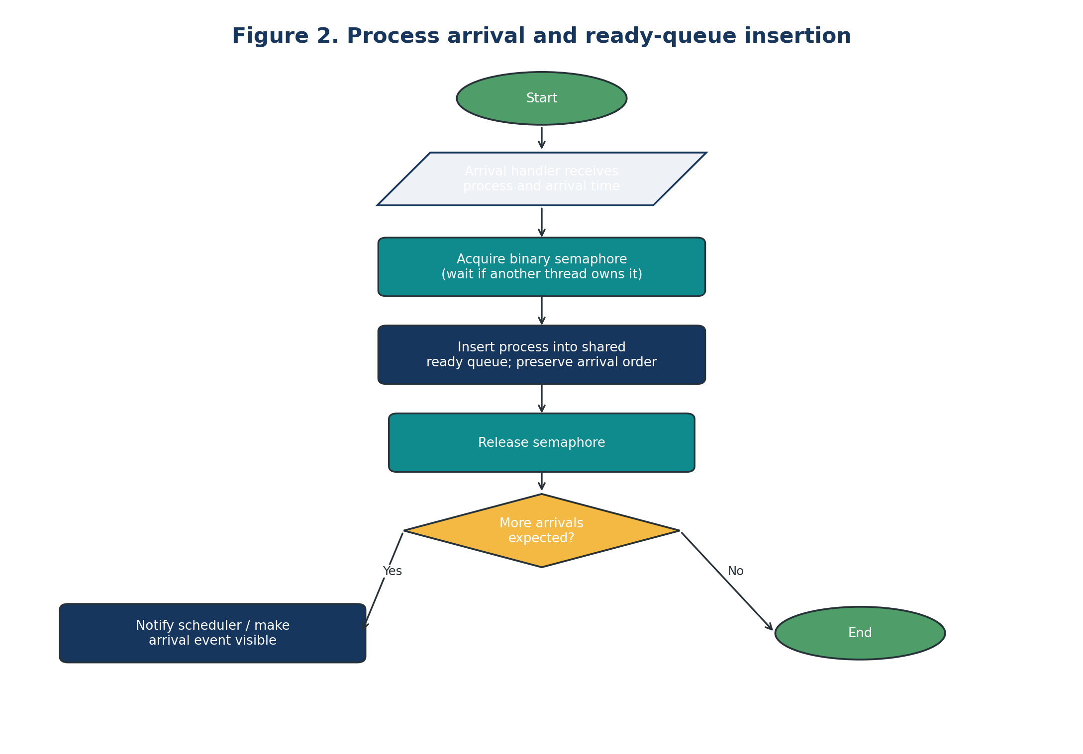
Figure 2. Process arrival and ready-queue insertion.
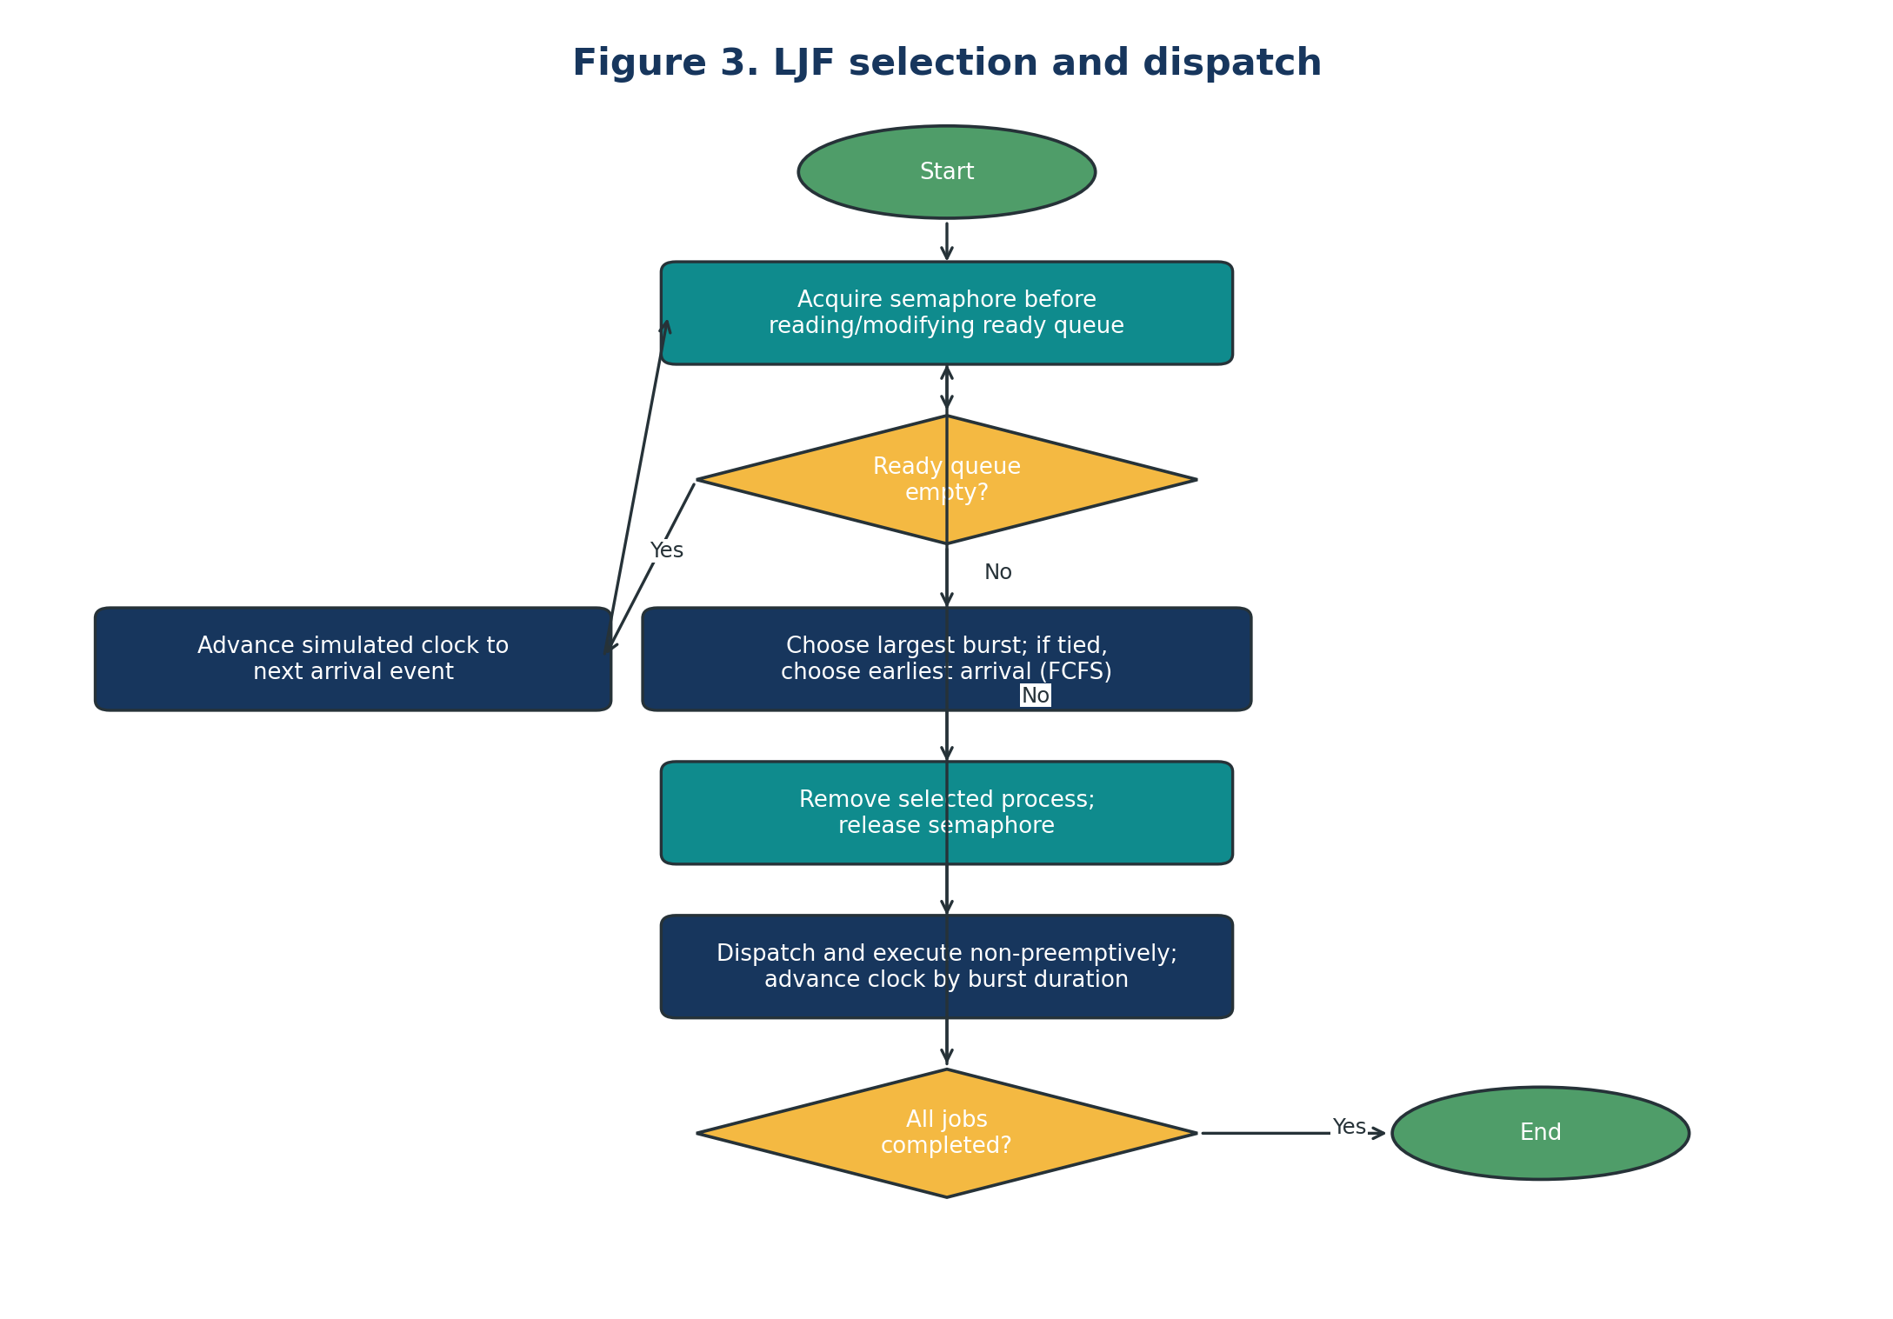
Figure 3. LJF selection and dispatch.

7. Numerical Example and Gantt Chart
All processes arrive at time 0. The ready queue initially contains P1 (burst 3), P2 (burst 7), and P3 (burst 5). LJF selects P2 first because 7 is the largest burst, then P3 (5), then P1 (3). Each job runs to completion.
Process | Arrival time | CPU burst
P1 | 0 | 3
P2 | 0 | 7
P3 | 0 | 5

Table 1. Principal example input.
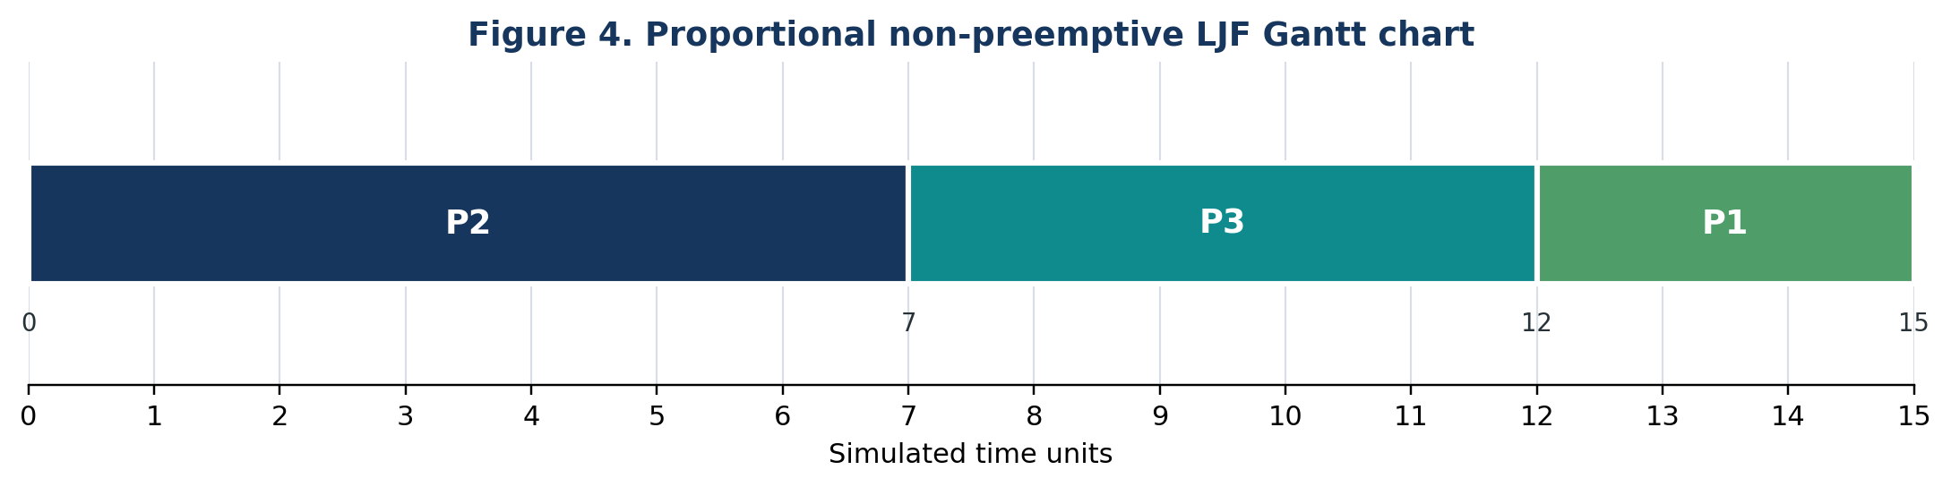
Figure 4. Proportional Gantt chart; block widths are proportional to CPU burst duration.

7.1 Step-by-step scheduling trace
Step | Clock before dispatch | Ready jobs (burst) | Selected | Execution interval | Clock after
1 | 0 | P1(3), P2(7), P3(5) | P2 | 0–7 | 7
2 | 7 | P1(3), P3(5) | P3 | 7–12 | 12
3 | 12 | P1(3) | P1 | 12–15 | 15

Table 2. LJF scheduling trace.

7.2 Completion, turnaround, and waiting time
Process | Arrival Aᵢ | Burst Bᵢ | Start | Completion Cᵢ | Turnaround Cᵢ−Aᵢ | Waiting TATᵢ−Bᵢ
P1 | 0 | 3 | 12 | 15 | 15 | 12
P2 | 0 | 7 | 0 | 7 | 7 | 0
P3 | 0 | 5 | 7 | 12 | 12 | 7
Total | — | 15 | — | — | 34 | 19

Table 3. Per-process metrics (time units).
For P2, completion time is 7, turnaround time is 7 − 0 = 7, and waiting time is 7 − 7 = 0. For P3, completion time is 12, turnaround time is 12 − 0 = 12, and waiting time is 12 − 5 = 7. For P1, completion time is 15, turnaround time is 15 − 0 = 15, and waiting time is 15 − 3 = 12.
Average waiting time = (12 + 0 + 7) / 3 = 19/3 ≈ 6.33 time units. Average turnaround time = (15 + 7 + 12) / 3 = 34/3 ≈ 11.33 time units.

7.3 Utilization and throughput
Total CPU busy time is 3 + 7 + 5 = 15 time units. The measurement interval is [0, 15], with no idle interval because all jobs are ready at time zero. CPU utilization = 15/15 × 100% = 100%. Throughput = 3 completed processes / 15 time units = 0.2 processes per time unit. These values exclude dispatch overhead, context switching, synchronization cost, and any idle time outside the stated interval.
Metric | Formula | Result
Average waiting time | (12 + 0 + 7) / 3 | 6.33 time units
Average turnaround time | (15 + 7 + 12) / 3 | 11.33 time units
CPU utilization | Busy time / elapsed time × 100% | 100%
Throughput | Completed processes / elapsed time | 0.20 processes/time unit

Table 4. LJF performance summary for the given workload.
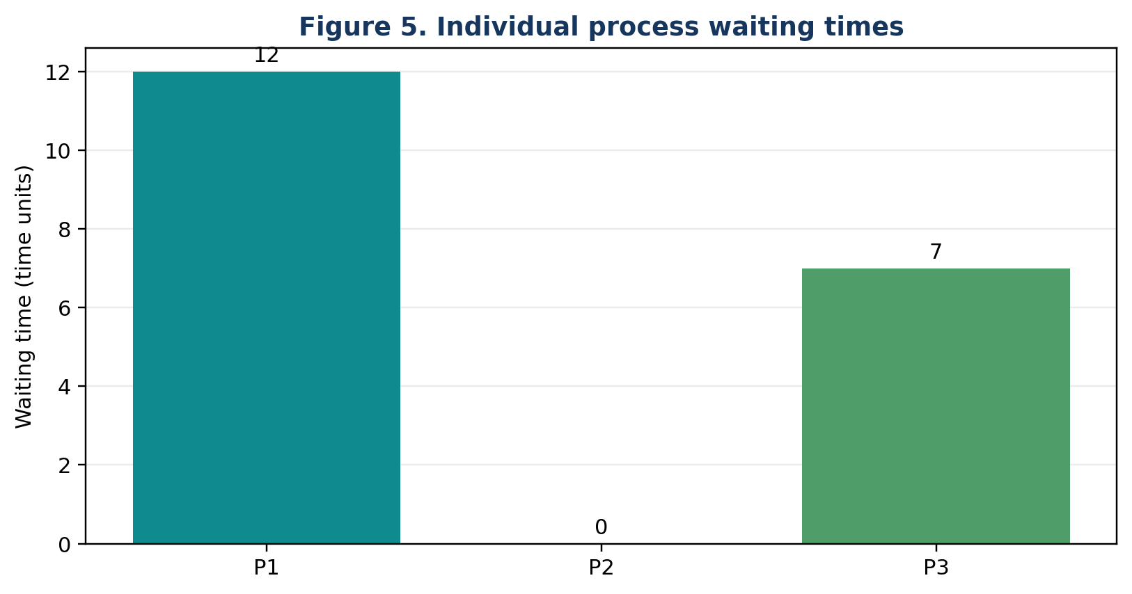
Figure 5. Individual process waiting times, derived from Table 3.
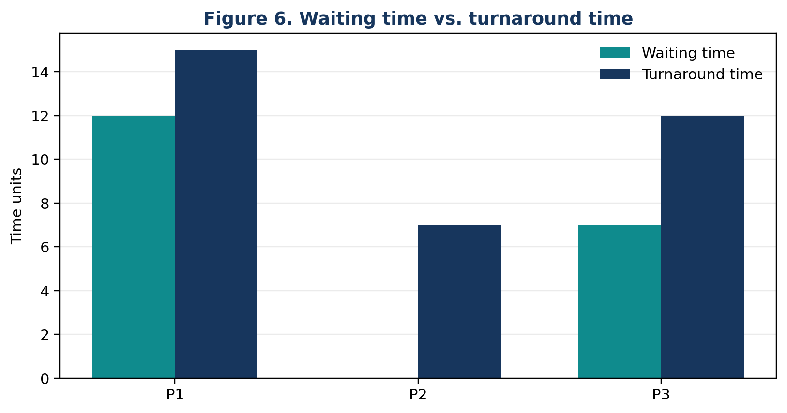
Figure 6. Waiting time and turnaround time by process, derived from Table 3.

8. Semaphore Operations and Critical-Section Analysis
Operation | Semaphore effect | Protected work | Design note
Initialize | count = 1 | No shared access yet | Binary semaphore is initially available.
acquire() | Atomically decrement or block | Enter queue critical section | May wait if another operation owns the queue.
Insert | No count change | Append arriving process | Do not execute the process while holding the semaphore.
Select/remove | No count change | Inspect bursts and remove chosen process | Queue must be non-empty before selection.
release() | Atomically increment / unblock waiter | Leave critical section | Must occur on every normal exit path.

Table 5. Semaphore initialization and operation semantics [3].
Critical section | Shared object | Risk without protection | Protected operation
Arrival insertion | ready_queue | Lost or corrupted insertion; inconsistent queue state | Acquire → push_back → release
LJF selection | ready_queue | Selection based on a changing queue; invalid iterator | Acquire → scan and erase → release
Queue metadata | sequence / membership state | Duplicate insertion or inconsistent ready count | Update under same lock or use a separate sound protocol
Statistics | completion metrics | Conflicting writes if multiple writers exist | Single-writer ownership here; lock/atomics if shared

Table 6. Critical-section analysis.
Risk | How it can arise | Mitigation / applicability
Race condition | Arrival thread and scheduler concurrently modify the queue. | Use the same semaphore discipline for all queue reads and writes.
Deadlock | A path acquires a semaphore and fails to release it, or locks are acquired in inconsistent order. | Keep critical sections short; use scoped/exception-safe release patterns in production code; define lock ordering.
Starvation | A short job repeatedly loses to newly arriving longer jobs under LJF. | LJF does not promise bounded waiting; use aging or a different policy if fairness is required.
Priority inversion | A high-priority task waits for a lower-priority task holding a resource. | Not demonstrated by this single-CPU LJF example; real-time implementations may require priority inheritance/ceiling protocols.
Contention | Many arrival handlers try to acquire the same binary semaphore. | Batch arrivals where semantics permit; minimize protected work; measure overhead separately.

Table 7. Synchronization and scheduling risks.

9. Comparison with EDF and RM
LJF, EDF, and RM are not interchangeable. LJF orders ready jobs by descending CPU-burst length. EDF (Earliest Deadline First) selects the ready job with the earliest absolute deadline and is commonly analyzed as a dynamic-priority real-time policy. RM (Rate Monotonic) assigns fixed task priorities based on period, with shorter periods receiving higher priority under the classical model. Foundational real-time scheduling analysis by Liu and Layland discusses fixed-priority scheduling and dynamic deadline-based priority assignment [4].
Property | LJF (this report) | EDF | RM
Selection rule | Largest ready CPU burst | Earliest absolute deadline | Fixed priority: shorter period ⇒ higher priority
Priority type | Dynamic ranking by burst among ready jobs | Dynamic; depends on absolute deadlines | Fixed per periodic task
Preemption | Non-preemptive in this report; variants exist | Often preemptive in classic uniprocessor analysis | Often preemptive in classic analysis
Primary objective | A burst-based heuristic; not inherently deadline-aware | Meet deadlines under suitable task/model assumptions | Predictable fixed-priority real-time scheduling
Typical workload | General batch-style teaching example; known/estimated bursts | Deadline-constrained jobs | Periodic real-time tasks
Main limitation | Can delay short jobs and ignore deadlines | Needs correct deadlines, execution estimates, and model assumptions | Classical utilization bound is sufficient, not necessary, for arbitrary task sets

Table 8. Conceptual comparison of LJF, EDF, and RM.
A numerical EDF/RM comparison is not calculated from the principal example because it specifies CPU bursts and arrivals but no deadlines or task periods. Inventing those attributes would create a different workload and could mislead the reader. A fair real-time comparison must define a common task set containing execution times, periods, relative deadlines, and release times, then generate each schedule under explicitly stated preemption and overhead assumptions. Synchronization overhead should be measured separately from policy-level waiting and turnaround metrics.

9.1 Suitability for real-time workloads
Non-preemptive LJF is generally unsuitable as a stand-alone hard-real-time policy because it does not consider deadlines and a running long job cannot be preempted in the model. EDF and RM are designed around real-time timing attributes and have established schedulability analyses, but neither is automatically safe without checking its assumptions, task model, execution-time bounds, blocking, and overhead. Real systems may combine a scheduling policy with resource-access protocols to control blocking.

10. Results and Discussion

10.1 Analytically established results
The worked example confirms the selection rule: at time zero P2 has the largest ready burst, after its completion P3 is the longest remaining ready process, and P1 runs last. The computed completion times are 7, 12, and 15 for P2, P3, and P1 respectively. The aggregate metrics follow directly from the formulas and input values; they are not measurements from a physical computer.

10.2 Mutual exclusion and queue consistency
The binary semaphore serializes queue insertion and selection/removal. Under the assumption that every concurrent queue access obeys the same semaphore discipline, the queue cannot be modified by two such operations at the same instant. The LJF choice must be made against a stable view of the ready queue, which is why the scan and removal are kept inside one critical section. The selected process is copied out and the semaphore released before simulated execution begins.

10.3 Contention and overhead
A single shared semaphore can become a contention point if many producer threads frequently publish arrivals. For this small reference workload, correctness and clarity are more important than throughput. A performance study would measure acquisition latency, waiting time to enter the critical section, queue operation duration, and end-to-end wall-clock time over repeated trials, while keeping the scheduling workload fixed. Those values should not be inferred from the analytical Gantt chart.

10.4 Fairness, starvation, and deadlock
LJF can starve short jobs if longer jobs continue to arrive and the policy repeatedly selects them first. The finite example has no starvation because there are only three jobs and arrivals stop at time zero. Deadlock is not expected in the reference program because it uses one semaphore, does not nest locks, and releases the semaphore before executing a job. Production code should still use exception-safe release patterns and avoid early returns while holding a synchronization primitive.

10.5 Simulated time versus wall-clock time
The simulation clock advances by the selected process's burst length. No operating-system thread sleeps for the simulated burst, and no multiple jobs execute in parallel. Wall-clock runtime of the program is implementation overhead and is not equal to simulated completion time. CPU utilization and throughput in this report are model metrics, not host-machine utilization or a measured benchmark.

10.6 Limitations
- CPU bursts are assumed known exactly; practical schedulers often estimate remaining execution.
- The model is single-CPU and non-preemptive, with no I/O blocking or context-switch cost.
- The sample uses a single scheduler owner; the semaphore protects queue operations but does not by itself implement a fully concurrent dispatch/event-notification protocol.
- Only a three-process workload is evaluated; the example is illustrative rather than statistically representative.
- No EDF/RM schedule is computed because deadlines and periods are not provided in the principal task set.

11. Conclusion and Future Work
This report presented a semaphore-protected implementation model for non-preemptive LJF scheduling. The central technical distinction is that LJF determines which ready process should run, whereas the binary semaphore protects shared queue state during concurrent insertion and selection. For the given workload, the schedule is P2 → P3 → P1, average waiting time is 6.33 time units, average turnaround time is 11.33 time units, utilization is 100% over the idealized interval, and throughput is 0.20 processes per time unit.
The results are analytically derived and do not constitute a measured concurrency benchmark. LJF's burst-based rule does not provide deadline guarantees and may disadvantage short jobs under sustained arrivals of long jobs. Future work should include preemptive variants, larger randomized workloads, explicit real-time task sets with periods and deadlines, wall-clock measurements of semaphore contention, and comparisons with mutexes, condition variables, and alternative queue designs. Such experiments should report workload parameters, compiler/runtime environment, repetitions, and measurement uncertainty.

References
[1] A. Silberschatz, P. B. Galvin, and G. Gagne, Operating System Concepts, 10th ed. Hoboken, NJ, USA: Wiley, 2021.
[2] W. Stallings, Operating Systems: Internals and Design Principles, 9th ed. Harlow, UK: Pearson, 2018.
[3] cppreference.com, “std::counting_semaphore, std::binary_semaphore,” C++ standard library reference. [Online]. Available: https://en.cppreference.com/w/cpp/thread/counting_semaphore. Accessed: Oct. 29, 2026.
[4] C. L. Liu and J. W. Layland, “Scheduling Algorithms for Multiprogramming in a Hard-Real-Time Environment,” Journal of the ACM, vol. 20, no. 1, pp. 46–61, Jan. 1973, doi: 10.1145/321738.321743.

Appendix A. Expected output for the supplied example
Non-preemptive LJF (simulated time)
PID Arrival Burst Start Completion Waiting Turnaround
P2 0 7 0 7 0 7
P3 0 5 7 12 7 12
P1 0 3 12 15 12 15
Average waiting time: 6.33
Average turnaround time: 11.33
CPU utilization: 100.00%
Throughput: 0.20 processes/time unit

Appendix B. Reproducibility note
The code, charts, and tables use the same three input records. The Gantt chart uses widths 7, 5, and 3, corresponding to the burst lengths and intervals 0–7, 7–12, and 12–15. The reported waiting and turnaround values were checked from the definitions and sums shown in Section 7. No experimental benchmark values are claimed.

