Design, Implementation, and Analysis of the
Longest Job First (LJF) Scheduling Algorithm Using Monitors
A Technical Research Report
Operating Systems • Concurrent Programming • CPU Scheduling
Prepared as an analytical and executable implementation study

Abstract
This report designs, implements, and analyzes a non-preemptive Longest Job First (LJF) CPU scheduler using a monitor-like synchronization abstraction. LJF selects, from the jobs that have arrived and are ready, the job with the largest CPU-burst estimate; equal bursts are resolved by first-come, first-served (FCFS) order. The monitor encapsulates process metadata, the ready queue, the running-job state, completion records, and synchronization. A C++ implementation uses a mutex, a condition variable, and guarded methods to provide monitor-style mutual exclusion and condition synchronization. The condition-variable wait is predicate-based, so wake-ups—including spurious wake-ups—are followed by a fresh test of the ready-queue condition. A deterministic workload of three jobs is used to verify ordering, completion, turnaround, waiting time, throughput, and idealized CPU utilization. Flowcharts, invariants, error-prevention tables, and a policy-level comparison with Earliest Deadline First (EDF) and Rate Monotonic (RM) scheduling accompany the implementation. The report distinguishes correctness arguments from performance claims: the former can be reasoned about from the state invariants, whereas synchronization overhead and contention require controlled measurement. The example is educational rather than a production kernel scheduler; it assumes known CPU bursts, one logical CPU, and a closed workload whose jobs are submitted before execution.
Keywords: CPU scheduling; Longest Job First; monitor; mutual exclusion; condition variable; C++; concurrency.

Table of Contents

If the table of contents is not populated automatically by the Word viewer, select it and choose Update Field / Update entire table.

1. Introduction and Literature Background

1.1 CPU scheduling and policy objectives
CPU scheduling determines which ready computation receives a processor when the CPU becomes available. A scheduler may be evaluated using waiting time, turnaround time, response time, throughput, utilization, predictability, fairness, and deadline satisfaction. These objectives can conflict: a policy that improves one metric for a particular workload may worsen another. The ready queue is therefore both a policy data structure and shared state that must remain consistent when multiple threads submit work or request dispatch [1].

1.2 Longest Job First
Longest Job First (LJF) chooses the ready process with the greatest estimated CPU-burst duration. In its non-preemptive form, once a job is dispatched, it continues until completion; newly arriving jobs do not interrupt it. LJF is sometimes useful as a teaching contrast to Shortest Job First (SJF), but it tends to make short jobs wait behind long ones and can produce poor average waiting time. The policy is meaningful only if burst durations are known or estimated. In this report, durations are assumed known exactly, which avoids prediction error but is not generally realistic in an operating system.

1.3 Monitors as synchronization abstractions
A monitor combines shared data with operations that are permitted to access that data under a mutual-exclusion discipline. Conceptually, at most one thread executes a monitor operation at a time. Condition variables add coordination: a thread waits when a predicate is false, temporarily releasing the associated lock; another thread changes the state and notifies waiters. A notification is not itself proof that the predicate is true. The waiting thread must re-check the predicate after reacquiring the lock, because notifications may be consumed by another thread and implementations may permit spurious wake-ups [2], [3].

1.4 Encapsulation, mutual exclusion, and condition synchronization
Encapsulation prevents callers from directly mutating the ready queue, running-job slot, or completion counters. Mutual exclusion protects compound operations such as validating an identifier, inserting a job, changing its state, and notifying a waiter. Condition synchronization prevents a scheduler thread from busy-waiting when no job is ready. The mutex and condition variable solve different problems: the mutex protects state, while the condition variable lets a thread sleep until state may have changed.

1.5 Synchronization is not the scheduling policy
The monitor does not automatically choose the longest job merely because it is a monitor. Its synchronization responsibilities are safe state access, atomic state transitions, and coordination between submitters and the dispatcher. The LJF policy is implemented separately by the selection rule: maximize burst duration among READY jobs, breaking ties by submission sequence. This distinction is fundamental: another policy could reuse the same monitor architecture by changing only the selection comparator.

1.6 Theoretical monitors and language-specific implementations
A monitor in the programming-language literature is an abstract synchronization construct with protected procedures and condition synchronization. C++ has no dedicated built-in `monitor` keyword. The implementation below explicitly realizes a monitor-like object using `std::mutex`, `std::condition_variable`, and encapsulated methods. The predicated overload of `wait` is equivalent to repeatedly waiting while its predicate is false; it releases and reacquires the lock as part of the wait operation [2]. This is an implementation pattern, not a claim that C++ natively provides a monitor type.

2. Scheduling Model and Assumptions
The model is a single logical CPU, non-preemptive LJF scheduler. Each process has an identifier, arrival time, and positive CPU-burst duration. Only jobs whose arrival event has occurred and whose state is READY may be selected. The longest burst wins; equal burst lengths are resolved FCFS using a monotonically increasing submission sequence. A dispatched job runs to completion. Scheduler state and the ready queue are private to the monitor.
Assumption | Operational meaning
Single CPU | At most one process is in RUNNING state at a time.
Non-preemptive | A running job is not interrupted by later arrivals.
Known positive burst | The burst value is supplied by the caller and validated as greater than zero.
Arrival eligibility | A job enters READY only when its arrival time is reached; the demo submits jobs with arrival time 0.
LJF ordering | Select maximum burst; use lower submission sequence for equal bursts.
Monitor safety | All shared-state reads and writes occur while holding the monitor mutex.
Condition semantics | `condition_variable::wait(lock, predicate)` releases the lock while waiting, reacquires it before returning, and rechecks the predicate.
Termination | The demonstration uses a closed workload and explicit `closeSubmissions()` signal so the dispatcher can distinguish “temporarily empty” from “no more jobs will arrive.”

2.1 Empty queue and concurrent arrivals
An empty ready queue has two possible meanings: jobs may arrive later, or the workload may be complete. The monitor therefore keeps a `closed` flag. If the queue is empty and submissions remain open, the dispatcher waits on the predicate `closed || !ready.empty()`. If the queue is empty and submissions are closed, the dispatcher returns an end-of-stream result and terminates. Submissions, closure, and predicate checks all use the same mutex; this prevents a missed-notification race between checking the queue and entering the wait. If several processes arrive concurrently, their monitor entries serialize. The sequence number records the order in which successful submissions acquire the monitor, providing a well-defined FCFS tie-break for this implementation.

3. Monitor-Based Architecture
The proposed object is conceptually named `LJFSchedulerMonitor`. Its public methods form the only supported access path to shared scheduler state. The runnable C++ interface uses idiomatic names but maps directly to the conceptual operations.
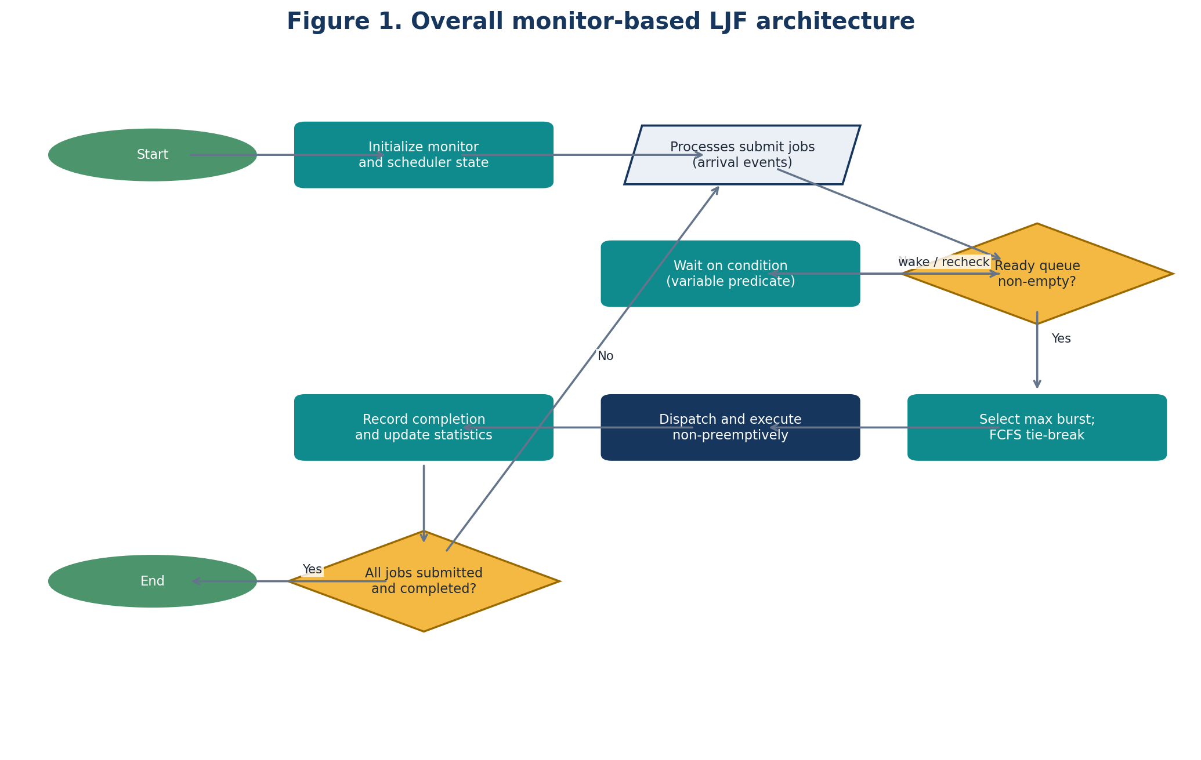
Figure 1. Overall monitor-based LJF architecture. The monitor mediates shared-state access; selection remains an explicit policy operation.
Conceptual operation | C++ implementation | Responsibility
initialize() | Constructor | Establishes empty queue, open submissions, zero counters, and no running job.
submitProcess(process) | submit(Process) | Validates ID/burst, assigns sequence, inserts READY job, and notifies a waiter.
hasReadyProcess() | hasReadyProcess() | Returns a synchronized snapshot of queue non-emptiness.
selectLongestJob() | takeNext() | Waits for a ready job or closure, selects maximum burst with FCFS tie-break, marks it RUNNING, and returns it.
waitForReadyProcess() | Integrated in takeNext() | Waits on `closed || !ready.empty()` using predicate-based condition-variable waiting.
completeProcess(processId) | complete(id, completionTime) | Verifies the running ID, marks it complete, records metrics, and clears the running slot.
getStatistics() | statistics() | Returns a synchronized snapshot of completion count and aggregate metrics.

3.1 Encapsulated state and invariants
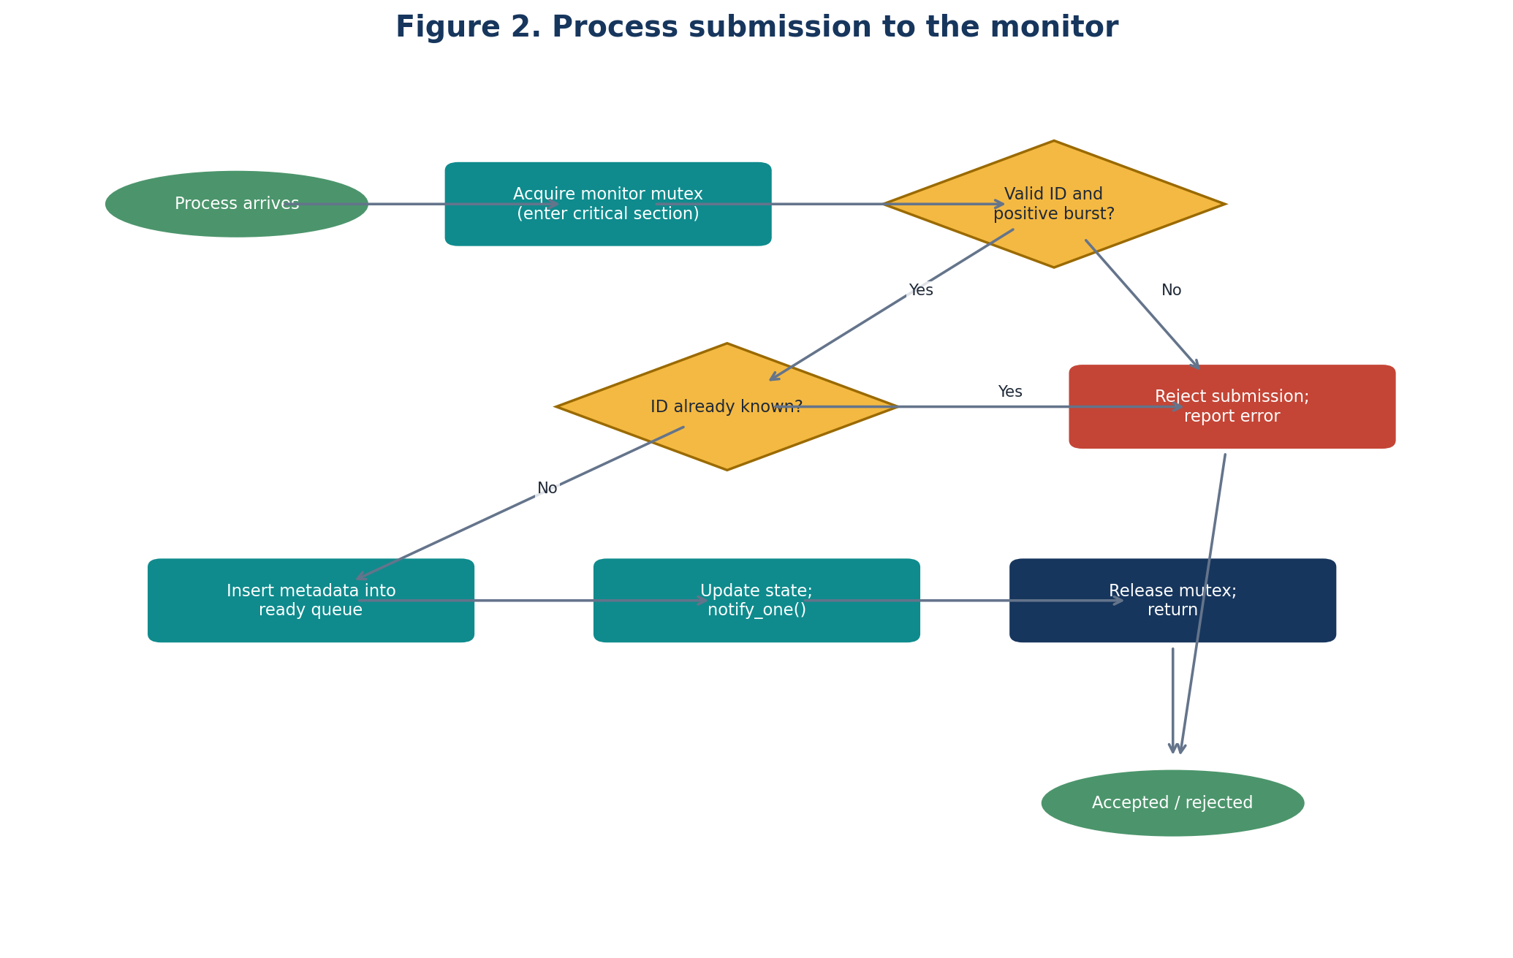
Figure 2. Process submission path through the monitor, including validation, insertion, and notification.
State element | Invariant | Why it matters
Ready queue | Contains only READY jobs; each submitted ID appears at most once. | Prevents duplicate dispatch and invalid states.
Process map | Every accepted ID maps to one process record and one lifecycle state. | Provides identity and state-transition validation.
Running slot | Contains zero or one RUNNING process; it is not also in READY. | Enforces single-CPU semantics.
Submission sequence | Unique, increasing integer assigned under lock. | Defines deterministic FCFS tie-breaking.
Completion records | Only completed jobs have completion time and derived metrics. | Prevents statistics from being reported prematurely.
Closed flag | Once true, no later submission is accepted. | Makes end-of-stream observable and prevents shutdown races.
Aggregate counters | Updated in the same critical section as completion state. | Keeps snapshots consistent.

The key safety invariants are inductive. They hold after initialization. `submit` checks identity and burst validity before adding one READY record; `takeNext` removes exactly one queue entry and changes it to RUNNING while holding the mutex; `complete` accepts only the current running identifier and changes that record to COMPLETED before clearing the running slot. Because no caller can mutate these fields directly, each public transition preserves the invariants.

4. Monitor Pseudocode
monitor LJFSchedulerMonitor:
private readyQueue, processMap, runningJob, closed
private nextSequence, completionRecords
condition readyAvailable

initialize():
readyQueue := empty
processMap := empty
runningJob := NONE
closed := false
nextSequence := 0

submitProcess(p):
enter monitor
require p.id is unique and p.burst > 0
p.sequence := nextSequence; nextSequence := nextSequence + 1
p.state := READY
processMap[p.id] := p
readyQueue.insert(p)
readyAvailable.signal()
exit monitor

selectLongestJob():
enter monitor
while readyQueue is empty AND NOT closed:
readyAvailable.wait() // releases monitor; reacquires before return
if readyQueue is empty AND closed:
exit monitor; return END_OF_STREAM
p := arg max over readyQueue by (burst, -sequence)
remove p from readyQueue
p.state := RUNNING; runningJob := p
exit monitor
return p

completeProcess(id, completionTime):
enter monitor
require runningJob exists and runningJob.id = id
p := runningJob
p.state := COMPLETED
p.completion := completionTime
p.turnaround := completionTime - p.arrival
p.waiting := p.turnaround - p.burst
append p to completionRecords
runningJob := NONE
exit monitor

getStatistics():
enter monitor
result := consistent snapshot of completionRecords and aggregates
exit monitor
return result

4.1 Linearization points
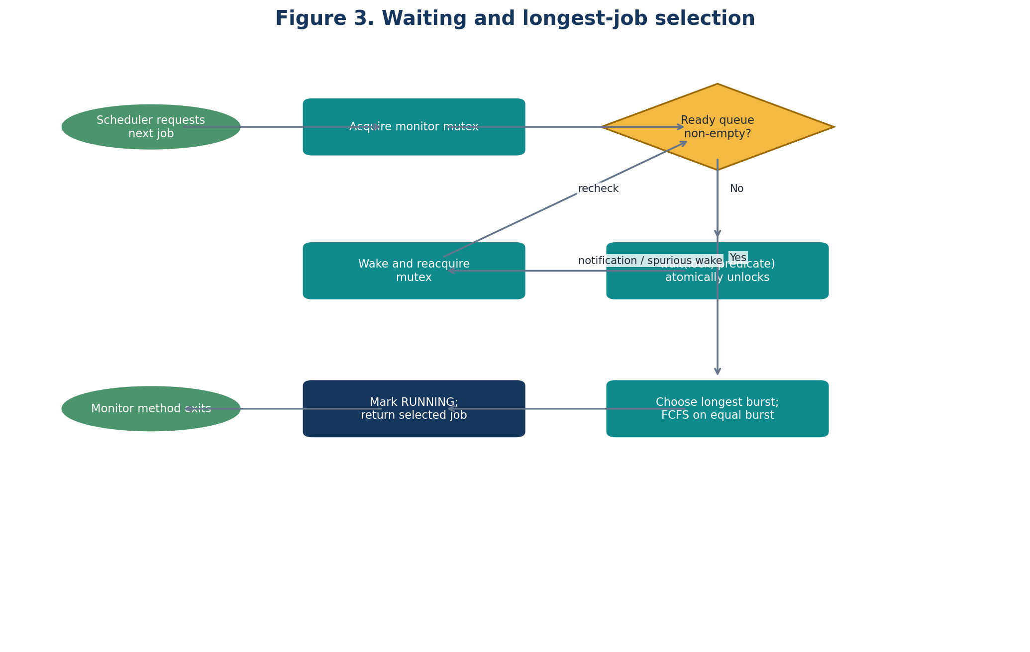
Figure 3. Waiting and longest-job selection; the ready-queue predicate is rechecked after every wake-up.
Each successful `submit` takes effect at insertion into the process map/ready queue while the mutex is held. `takeNext` takes effect when the chosen job is removed from READY and marked RUNNING. `complete` takes effect when the current job is marked COMPLETED and the running slot is cleared. These state changes are indivisible to other callers because the mutex excludes concurrent monitor entries. The CPU execution itself occurs outside the monitor lock; holding the lock during a long burst would prevent arrivals and defeat the design.

5. Executable C++ Implementation
The program below targets C++17 or later. It models execution time as logical time rather than sleeping for wall-clock seconds. A dispatcher obtains one job from the monitor, advances logical time by its burst, then reports completion. For clarity, the sample submits the closed workload before dispatch begins; the monitor itself supports concurrent submission and waiting. In a real system, arrival events would be submitted by producer threads at their arrival times, and the dispatcher would advance or wait according to a clock model.
#include <algorithm>
#include <condition_variable>
#include <iomanip>
#include <iostream>
#include <mutex>
#include <optional>
#include <iterator>
#include <stdexcept>
#include <string>
#include <unordered_map>
#include <vector>

enum class State { READY, RUNNING, COMPLETED };

struct Process {
std::string id;
int arrival;
int burst;
unsigned long long sequence = 0;
State state = State::READY;
int start = -1;
int completion = -1;
int waiting = -1;
int turnaround = -1;
};

struct Statistics {
std::vector<Process> completed;
double averageWaiting = 0.0;
double averageTurnaround = 0.0;
double throughput = 0.0;
double cpuUtilizationPercent = 0.0;
};

class LJFSchedulerMonitor {
public:
LJFSchedulerMonitor() = default; // initialize empty, open monitor state

void submit(Process p) {
std::lock_guard<std::mutex> guard(mutex_);
if (closed_) throw std::logic_error("submissions are closed");
if (p.id.empty()) throw std::invalid_argument("process ID must not be empty");
if (p.burst <= 0) throw std::invalid_argument("burst must be positive");
if (processes_.count(p.id)) throw std::invalid_argument("duplicate process ID");
p.sequence = nextSequence_++;
p.state = State::READY;
processes_.emplace(p.id, p);
ready_.push_back(p.id);
readyAvailable_.notify_one();
}

bool hasReadyProcess() const {
std::lock_guard<std::mutex> guard(mutex_);
return !ready_.empty();
}

// Returns false only when submissions are closed and no ready job remains.
bool takeNext(Process& out) {
std::unique_lock<std::mutex> lock(mutex_);
readyAvailable_.wait(lock, [this] { return closed_ || !ready_.empty(); });
if (ready_.empty() && closed_) return false;

auto best = ready_.begin();
for (auto it = std::next(ready_.begin()); it != ready_.end(); ++it) {
const Process& candidate = processes_.at(*it);
const Process& incumbent = processes_.at(*best);
if (candidate.burst > incumbent.burst ||
(candidate.burst == incumbent.burst &&
candidate.sequence < incumbent.sequence)) {
best = it;
}
}
const std::string id = *best;
ready_.erase(best);
Process& selected = processes_.at(id);
if (runningId_.has_value()) {
throw std::logic_error("dispatch attempted while another job is running");
}
selected.state = State::RUNNING;
runningId_ = id;
out = selected;
return true; // lock releases automatically on return
}

void complete(const std::string& id, int completionTime) {
std::lock_guard<std::mutex> guard(mutex_);
if (!runningId_.has_value() || *runningId_ != id)
throw std::logic_error("completion does not match running process");
Process& p = processes_.at(id);
p.completion = completionTime;
p.turnaround = p.completion - p.arrival;
p.waiting = p.turnaround - p.burst;
if (p.waiting < 0)
throw std::logic_error("negative waiting time: inconsistent time model");
p.state = State::COMPLETED;
completedIds_.push_back(id);
runningId_.reset();
}

void closeSubmissions() {
std::lock_guard<std::mutex> guard(mutex_);
closed_ = true;
readyAvailable_.notify_all();
}

Statistics statistics(int totalElapsed) const {
std::lock_guard<std::mutex> guard(mutex_);
Statistics s;
int sumW = 0, sumT = 0, totalBurst = 0;
for (const auto& id : completedIds_) {
const Process& p = processes_.at(id);
s.completed.push_back(p);
sumW += p.waiting;
sumT += p.turnaround;
totalBurst += p.burst;
}
const auto n = s.completed.size();
if (n > 0) {
s.averageWaiting = static_cast<double>(sumW) / n;
s.averageTurnaround = static_cast<double>(sumT) / n;
}
if (totalElapsed > 0) {
s.throughput = static_cast<double>(n) / totalElapsed;
s.cpuUtilizationPercent =
100.0 * static_cast<double>(totalBurst) / totalElapsed;
}
return s;
}

private:
mutable std::mutex mutex_;
std::condition_variable readyAvailable_;
std::vector<std::string> ready_;
std::unordered_map<std::string, Process> processes_;
std::vector<std::string> completedIds_;
std::optional<std::string> runningId_;
unsigned long long nextSequence_ = 0;
bool closed_ = false;
};

int main() {
LJFSchedulerMonitor monitor;
monitor.submit({"P1", 0, 3});
monitor.submit({"P2", 0, 7});
monitor.submit({"P3", 0, 5});
monitor.closeSubmissions();

int logicalTime = 0;
Process p;
while (monitor.takeNext(p)) {
p.start = logicalTime;
logicalTime += p.burst;
monitor.complete(p.id, logicalTime);
}

const Statistics s = monitor.statistics(logicalTime);
std::cout << "Process Arrival Burst Completion Turnaround Waiting\n";
for (const auto& x : s.completed) {
std::cout << std::left << std::setw(9) << x.id
<< std::right << std::setw(8) << x.arrival
<< std::setw(7) << x.burst
<< std::setw(12) << x.completion
<< std::setw(12) << x.turnaround
<< std::setw(9) << x.waiting << '\n';
}
std::cout << std::fixed << std::setprecision(3)
<< "Average waiting: " << s.averageWaiting << '\n'
<< "Average turnaround: " << s.averageTurnaround << '\n'
<< "Throughput: " << s.throughput << " processes/time-unit\n"
<< "CPU utilization: " << s.cpuUtilizationPercent << "%\n";
}

5.1 Compilation and execution
g++ -std=c++17 -O2 -Wall -Wextra -pedantic ljf_monitor.cpp -o ljf_monitor
./ljf_monitor
The code is intended to be copied into `ljf_monitor.cpp`. It uses `std::optional` for the running-job slot and requires C++17. `takeNext` uses `std::unique_lock` because condition-variable waiting must be able to release and reacquire the mutex. `submit` uses `std::lock_guard` for a critical section with no wait. The `closed_` flag and queue predicate distinguish shutdown from temporary emptiness.

5.2 Wake-up and notification policy
A successful submission calls `notify_one()` after the queue state has been updated while the mutex is held. Only one dispatcher is assumed in this implementation, so one notification is sufficient for the ordinary submission path. `closeSubmissions()` uses `notify_all()` because closure must release any waiters so they can observe the terminal predicate. The condition-variable wait is predicate-based; it tolerates spurious wake-ups and avoids a missed notification because both the predicate state and the wait transition are synchronized by the same mutex. If the design were extended to multiple dispatchers, it would need an explicit policy for the single-CPU running slot and may need additional notifications when a running slot becomes available.

6. Numerical Example and Performance Metrics
The workload below is the exact workload specified for this report. Every process arrives at time 0, so all three are eligible when the first dispatch decision occurs.
Process | Arrival time | CPU burst
P1 | 0 | 3
P2 | 0 | 7
P3 | 0 | 5

Table 1. Input workload.
LJF compares the burst durations 7, 5, and 3 and therefore executes P2, P3, and P1. The chart uses proportional segment widths, with the time axis marked at 0, 7, 12, and 15.
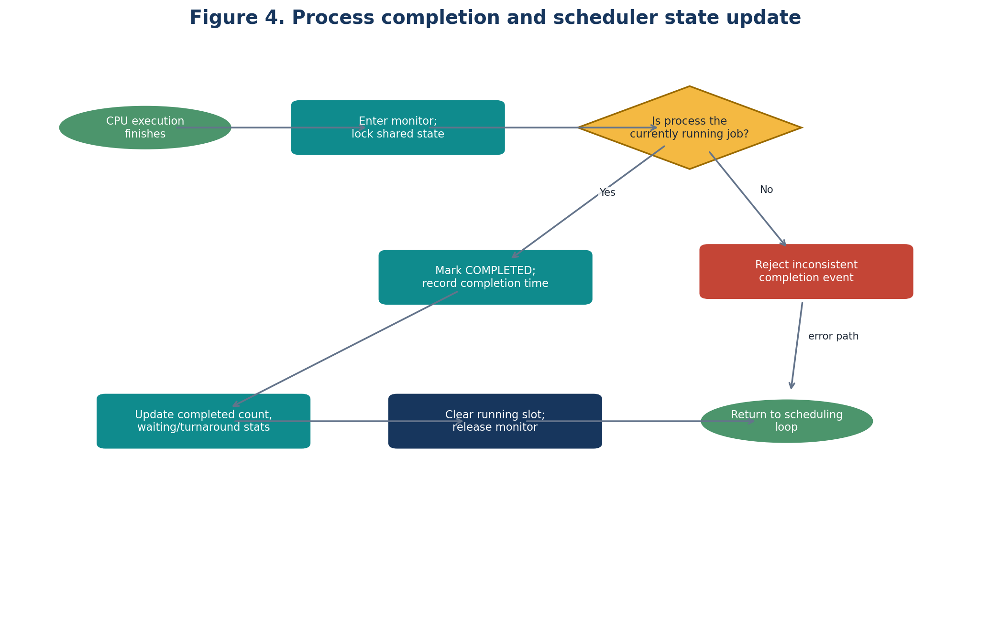
Figure 4. Process completion and scheduler state update.
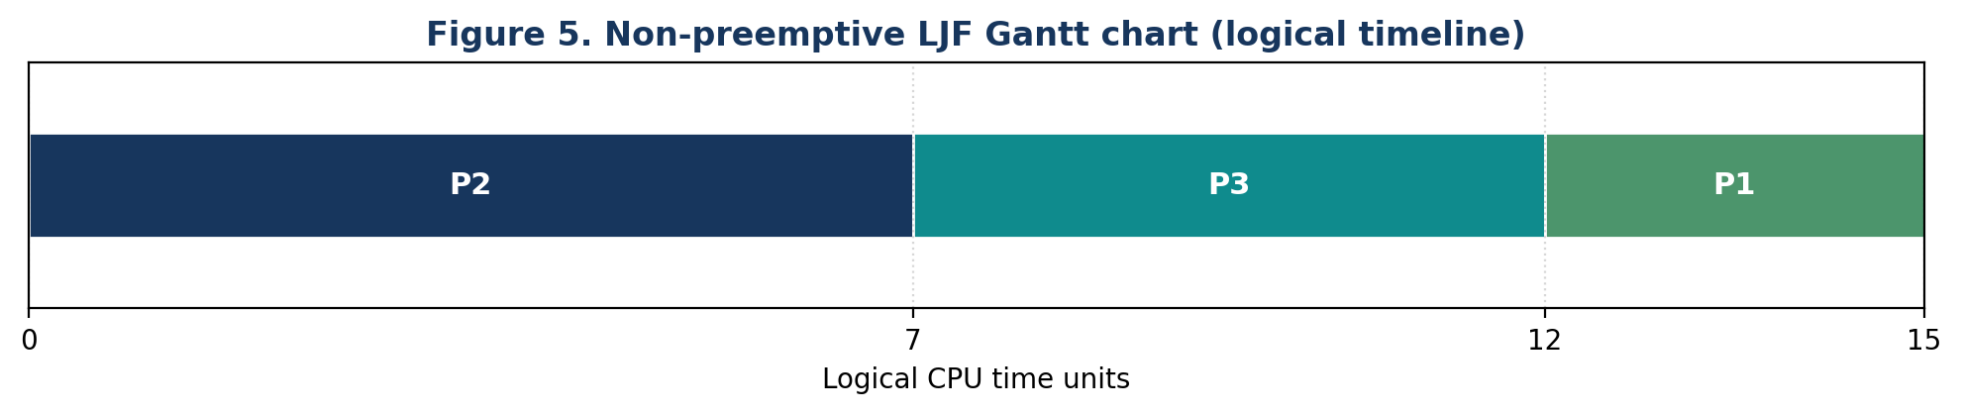
Figure 5. The logical scheduling timeline. It represents CPU work and excludes monitor execution overhead, context-switch costs, and measurement noise.

6.1 Step-by-step scheduling trace
Decision / event | Ready jobs before decision | Selection / action | Logical time
Initial dispatch | P1(3), P2(7), P3(5) | Choose P2 (largest burst) | 0
P2 completes | P1(3), P3(5) | P2 ran from 0 to 7 | 7
Second dispatch | P1(3), P3(5) | Choose P3 | 7
P3 completes | P1(3) | P3 ran from 7 to 12 | 12
Third dispatch | P1(3) | Choose P1 | 12
P1 completes | Empty | Workload complete | 15

6.2 Metrics and formulas
For each process i, completion time Cᵢ is its finish time; turnaround time Tᵢ = Cᵢ − Aᵢ; waiting time Wᵢ = Tᵢ − Bᵢ, where Aᵢ is arrival time and Bᵢ is burst duration. Average values are arithmetic means over the three completed jobs. Throughput is completed jobs divided by elapsed logical time. CPU utilization is busy CPU time divided by elapsed time; the example has no idle interval and assumes zero overhead.
Process | Start | Completion Cᵢ | Turnaround Cᵢ−Aᵢ | Waiting Tᵢ−Bᵢ
P2 | 0 | 7 | 7 − 0 = 7 | 7 − 7 = 0
P3 | 7 | 12 | 12 − 0 = 12 | 12 − 5 = 7
P1 | 12 | 15 | 15 − 0 = 15 | 15 − 3 = 12

Table 2. Completion, turnaround, and waiting-time calculations in execution order.
Metric | Calculation | Result
Average waiting time | (0 + 7 + 12) / 3 | 19/3 = 6.333 time units
Average turnaround time | (7 + 12 + 15) / 3 | 34/3 = 11.333 time units
Throughput | 3 completed jobs / 15 time units | 0.200 jobs per time unit
CPU utilization | (7 + 5 + 3) / 15 × 100% | 100% (idealized)

The waiting-time and turnaround-time figures are analytically derived from the specified schedule. They are not benchmark measurements. A real implementation would add synchronization, dispatch, logging, and possibly context-switch overhead; these costs are deliberately excluded from the logical Gantt chart.
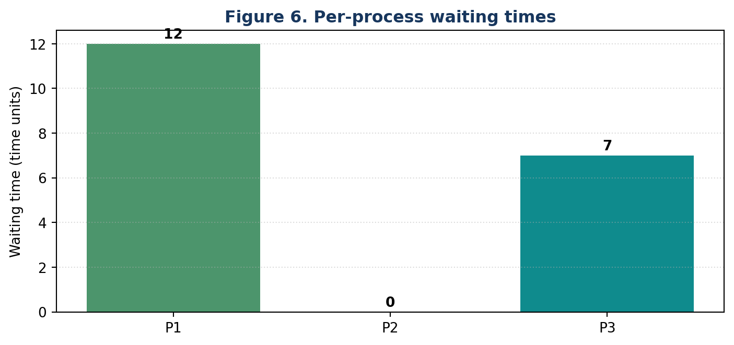
Figure 6. Waiting time by process, ordered by process identifier.
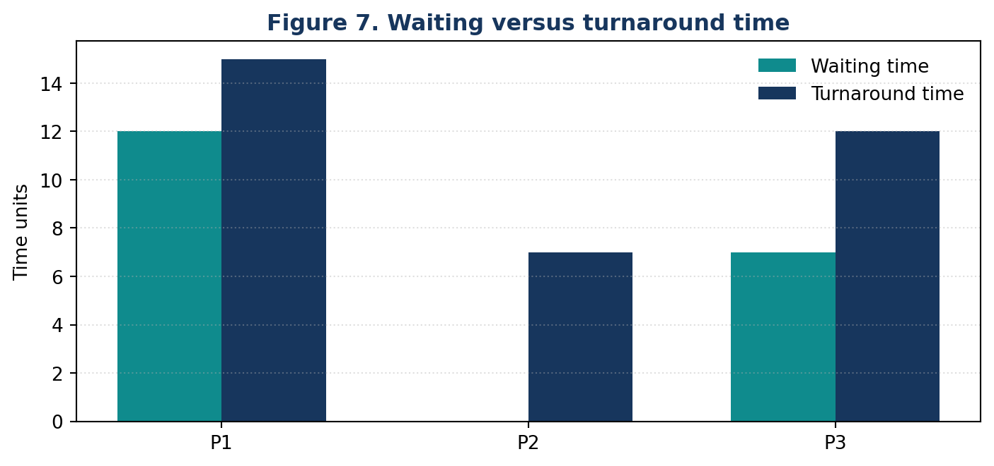
Figure 7. Waiting and turnaround time by process.

7. Condition Variables and Concurrency Correctness
Situation | Required behavior | Implementation response
Queue empty; submissions open | Dispatcher must sleep, not spin or terminate. | Wait predicate is `closed_ || !ready_.empty()`.
Job submitted before dispatcher waits | The job must not be lost due to a missed notification. | Predicate is checked while mutex is held; non-empty queue makes wait return immediately.
Spurious wake-up | Do not assume a job exists. | Predicate overload loops until queue non-empty or closed.
Several simultaneous arrivals | All queue updates and sequence assignments must be serialized. | One mutex protects ID validation, sequence, process map, and queue.
Closure while dispatcher waits | Dispatcher must wake and terminate when no work remains. | Set `closed_` under mutex and call `notify_all()`.
Wake-up but another dispatcher consumed the job (future extension) | Recheck state; a wake-up is not a reservation. | Predicate is re-evaluated after mutex reacquisition.
Completion for wrong process | Do not corrupt running state or metrics. | `complete` checks `runningId_` and throws on mismatch.

7.1 Synchronization correctness properties
Property | What can be argued | Evidence / caveat
Mutual exclusion | Only one thread can mutate monitor state at a time. | All shared-state methods acquire the same mutex.
No missed notification for queue readiness | A waiter cannot atomically miss the transition from empty to non-empty under this protocol. | Predicate mutation and wait enrollment coordinate through the same mutex.
Spurious wake-up safety | A wake-up alone cannot cause dispatch from an empty queue. | Predicated wait checks the state again.
Queue consistency | A selected job is removed and marked RUNNING in one critical section. | No other monitor call can observe an intermediate state.
Single running job | The running slot is checked before dispatch and only cleared by matching completion. | One dispatcher is the intended configuration; multi-dispatcher extension needs explicit reservation logic.
Deadlock freedom | No nested locks or blocking I/O are performed while holding the mutex in the current code path. | This is a design argument, not a proof against all future modifications.
Fairness | FCFS resolves equal-burst ties only among jobs simultaneously present in the ready queue. | LJF itself can starve short jobs under a continuing stream of longer jobs.

8. Implementation Errors and Prevention
Potential error | Consequence | Prevention in this design
Wait without predicate loop | Spurious wake-up may lead to invalid queue access. | Use `wait(lock, predicate)`.
Check queue outside mutex | Data race or stale observation. | All queue accesses occur under `mutex_`.
Notify before publishing queue state | Waiter may wake and still observe no job. | Insert/update state while locked, then notify.
Duplicate process IDs | Ambiguous identity and wrong completion update. | Reject duplicate IDs in `submit`.
Non-positive burst | Invalid schedule or meaningless metrics. | Validate burst > 0.
Release mutex manually on some paths | Lock leaks or double-unlock errors. | Use RAII (`lock_guard` / `unique_lock`).
Hold monitor lock during CPU execution | Submissions block for the full burst; contention grows. | Return the selected job and execute outside the monitor.
Complete a non-running job | Corrupt lifecycle state and statistics. | Require ID to match the running slot.
Forget closure state | An empty queue cannot distinguish idle from finished workload. | Use `closed_` and notify all on closure.
Claim timing benchmark from logical trace | Overstates measured performance. | Label schedule values as analytical; benchmark overhead separately.

9. Comparison with EDF and Rate Monotonic Scheduling
LJF, Earliest Deadline First (EDF), and Rate Monotonic (RM) use different information to determine priority. LJF orders ready jobs by descending CPU burst. EDF chooses the job with the earliest absolute deadline, typically dynamically updating priorities as deadlines approach. RM is a fixed-priority policy for periodic tasks: tasks with shorter periods receive higher priority. EDF and RM are classically analyzed in real-time scheduling under explicit assumptions about periodic releases, execution times, deadlines, preemption, and a single processor [4].
Dimension | LJF (this report) | EDF | Rate Monotonic (RM)
Priority basis | Longest ready CPU burst | Earliest absolute deadline | Shortest period has highest fixed priority
Priority changes | At each dispatch, based on ready bursts | Can change as absolute deadlines advance | Fixed for each periodic task
Typical objective | Illustrate burst-based ordering; may affect waiting time | Meet deadlines under task-model assumptions | Predictable fixed-priority real-time scheduling
Preemption | Non-preemptive in this report | Often analyzed preemptively; non-preemptive variants exist | Classically analyzed preemptively; non-preemptive variants exist
Deadline guarantee | None implied | Conditional feasibility results under model assumptions | Conditional utilization/response-time results under model assumptions
Main limitation | Long jobs can delay short jobs; burst estimates required | Deadline misses if task set is infeasible or assumptions fail | Can be less utilization-efficient than EDF in classic models; response-time analysis matters

No numerical EDF/RM schedule is included because the specified workload contains neither absolute deadlines nor periodic task periods. Producing a numeric comparison without defining those attributes would fabricate the priority inputs. A valid future experiment should specify task execution times, periods, deadlines, release offsets, preemption assumptions, and overhead model, then generate a separate schedule for each policy. Policy-level waiting or deadline outcomes must be reported separately from monitor synchronization cost.

10. Evaluation and Discussion

10.1 Correctness of encapsulation and queue state
The monitor boundary gives the implementation one authoritative place for lifecycle transitions. A successful submission creates one process record and one ready-queue entry; dispatch removes that entry and records the running process; completion records derived metrics and clears the running slot. Since these updates are guarded by one mutex, competing calls observe state before or after each transition, rather than partially updated state. This is a safety argument under the C++ mutex and condition-variable contract [2].

10.2 Waiting, notification, and contention
The condition variable avoids active polling while the queue is empty. `notify_one` is appropriate for the stated single-dispatcher design; `notify_all` is used for closure so every waiter can observe shutdown. Notifications are hints to re-evaluate a predicate, not stored tokens. A single mutex also creates a serialization point: as arrival frequency and producer count increase, submitters may contend on queue metadata. The current vector-based ready queue scans all queued jobs during selection, requiring O(n) selection time and O(n) queue storage. A priority queue could reduce selection cost to O(log n), but stable FCFS tie-breaking would need to be encoded in the comparator.

10.3 Fairness, starvation, and non-preemption
LJF is not generally fair to short jobs. Under an unbounded stream of long jobs, a short job can remain ready for a long time; FCFS tie-breaking only resolves equal bursts and does not prevent starvation across different burst lengths. Non-preemption also means that an urgent job arriving during a long burst cannot be dispatched until the current job completes. For deadline-sensitive systems, LJF offers no automatic feasibility or deadline guarantee.

10.4 Deadlock risks and portability
The current code avoids nested monitor locks, and its critical sections do not perform CPU execution or blocking I/O. RAII ensures the mutex is released on ordinary returns and exceptions. A future extension could introduce deadlock if it acquires multiple locks in inconsistent orders or waits on an external event while holding the monitor mutex. The implementation uses standard C++ threading primitives and is portable across conforming C++17 implementations, subject to toolchain and platform support. It is still a user-space simulation, not a kernel scheduler.

10.5 What is proven versus what must be measured
The workload's ordering and time metrics can be verified analytically from the given arrival and burst times. State invariants and lock discipline support reasoning about mutual exclusion and queue consistency. However, actual mutex latency, wake-up latency, throughput under contention, and scheduler overhead depend on hardware, operating system, compiler, and workload. They require controlled benchmarking with repeated trials, disclosed environment details, warm-up where relevant, and separate measurement of baseline execution and synchronization costs. This report does not claim empirical timing results.

11. Limitations and Future Work
The example assumes exact burst knowledge, one logical CPU, non-preemptive execution, integer logical time, and a closed workload. It does not model I/O blocking, process cancellation, priority inversion, deadlines, real-time release jitter, multiprocessor affinity, or operating-system context switches. The ready queue is a vector and selection is linear in queue size. Future work could compare vector and heap implementations, add arrival-time event injection, implement a multi-producer test harness, instrument lock wait time and dispatch latency, and compare LJF with SJF, EDF, and RM under fully specified workloads. A robust extension should also define cancellation, exception recovery, and shutdown semantics before being used as a general-purpose concurrent component.

12. Conclusion
This report presented a monitor-based design for non-preemptive LJF scheduling and a runnable C++17 monitor-like implementation. The ready queue and process lifecycle are encapsulated behind synchronized operations, while a predicate-based condition variable coordinates an empty queue and safely handles wake-ups. For the specified workload, the correct order is P2 → P3 → P1, with average waiting time 6.333 time units, average turnaround time 11.333 time units, throughput 0.200 jobs per time unit, and idealized CPU utilization of 100%. These values describe the logical schedule rather than measured implementation performance. The central conclusion is that synchronization correctness and scheduling policy are separate concerns: the monitor protects scheduler state, whereas the LJF comparator determines which ready job is selected. Deadline guarantees require a different analysis and cannot be inferred from LJF or from the use of a monitor.

References
[1] A. Silberschatz, P. B. Galvin, and G. Gagne, Operating System Concepts, 9th ed. Hoboken, NJ, USA: Wiley, 2012, ch. 6, “CPU Scheduling.”
[2] cppreference.com, “std::condition_variable::wait,” C++ reference documentation. [Online]. Available: https://en.cppreference.com/w/cpp/thread/condition_variable/wait. Accessed: Oct. 29, 2026.
[3] Oracle, “Class Object (Java SE 26),” Java Platform, Standard Edition API Specification, methods wait(), notify(), and notifyAll(). [Online]. Available: https://docs.oracle.com/en/java/javase/26/docs/api/java.base/java/lang/Object.html. Accessed: Oct. 29, 2026.
[4] C. L. Liu and J. W. Layland, “Scheduling algorithms for multiprogramming in a hard-real-time environment,” Journal of the ACM, vol. 20, no. 1, pp. 46–61, Jan. 1973, doi: 10.1145/321738.321743.

Appendix A. Build and Verification Checklist
- Compile with a C++17-capable compiler and standard threading library.
- Confirm output order is P2, P3, P1.
- Confirm completion times are 7, 12, 15 in execution order.
- Confirm waiting times are 0, 7, 12 and turnaround times are 7, 12, 15.
- Confirm averages are approximately 6.333 and 11.333.
- Confirm throughput is 0.200 jobs per logical time unit and idealized utilization is 100%.
- Test invalid burst, duplicate ID, submission after closure, and mismatched completion handling.
- For concurrent tests, submit jobs from multiple producer threads while a dispatcher waits; run under ThreadSanitizer where supported.

Appendix B. Conceptual Interface Mapping
The conceptual interface is language-neutral. In the C++ version, `initialize()` is represented by construction; `submitProcess(process)` by `submit`; `hasReadyProcess()` is implemented as a synchronized query; `selectLongestJob()` and `waitForReadyProcess()` are combined in `takeNext`; `completeProcess(processId)` is implemented by `complete`; and `getStatistics()` is implemented by `statistics`. This mapping avoids presenting a conceptual monitor operation as a literal C++ language API.

