A Hybrid Monitor-and-Semaphore
Architecture for Implementing the
Longest Job First (LJF) Scheduling Algorithm
A technical research report on scheduling semantics,
concurrent design, and reproducible simulation
Prepared as an implementation-focused academic study
Version 1.0 | 29 October 2026
Language: English | Target environment: C++20
Scope note: logical scheduling calculations are analytically derived; no synchronization benchmarks are claimed.

Contents
Abstract 3
1. Introduction 3
2. Technical background 4
3. Hybrid architecture and design decision 6
4. Workload and scheduling assumptions 8
5. Hybrid pseudocode 9
6. Standardized flowcharts 11
7. Executable C++20 implementation 14
8. Numerical example and verified calculations 18
9. Semaphore initialization and operation 21
10. Concurrency correctness and failure analysis 21
11. Comparison of synchronization designs 22
12. LJF, EDF, and Rate Monotonic scheduling 22
13. Evaluation and discussion 24
14. Limitations 25
15. Conclusion and future work 26
References 26
Appendix A. Metric definitions 27
Appendix B. Review checklist 27
Contents page numbers are provided for this generated edition. In Word, update the contents manually after major edits.

Abstract
Longest Job First (LJF) is a non-preemptive scheduling policy that selects, from the ready set, the job with the greatest CPU-burst estimate. Its selection rule is distinct from the synchronization mechanisms required to implement a concurrent scheduler safely. This report presents a hybrid architecture in which a monitor—implemented using a mutex and condition variable—encapsulates the ready queue and scheduler state, while counting semaphores coordinate a separate bounded event/completion-record buffer. The separation is intentional: the semaphore protocol does not redundantly protect the monitor-owned queue, and no monitor lock is held while a thread performs a potentially blocking semaphore acquisition. The report defines invariants, synchronization boundaries, pseudocode, five standardized flowcharts, and a runnable C++20 implementation. A deterministic logical-time demonstration uses three jobs arriving at time zero and verifies the expected non-preemptive order P2 → P3 → P1, along with completion, turnaround, waiting-time, throughput, and utilization calculations. A separate periodic-task example illustrates how LJF differs from Earliest Deadline First (EDF) and Rate Monotonic (RM), without conflating a scheduling policy with a synchronization architecture. The evaluation is analytical rather than empirical: no timing benchmark is presented as measured evidence. The design is correct only under its stated assumptions, and the added complexity of a second synchronization mechanism is justified when the auxiliary bounded buffer is a real subsystem requirement.
Keywords: CPU scheduling; Longest Job First; monitor; condition variable; counting semaphore; producer–consumer; concurrency.

Research contributions and scope
- An explicit division of responsibility between monitor-protected scheduling state and semaphore-coordinated auxiliary events.
- Safety and liveness invariants for the ready queue and bounded event buffer.
- A deterministic, logical-time LJF example with independently checkable calculations.
- A C++20 reference implementation and build instructions.
- A carefully qualified comparison with EDF and RM under a stated periodic-task model.

1. Introduction
CPU scheduling chooses which ready task receives a processor. The policy affects completion order, waiting time, responsiveness, fairness, and—when deadlines exist—deadline satisfaction. The implementation must also coordinate concurrent arrivals, dispatch, completion reporting, and shared data. Scheduling policy and synchronization architecture answer different questions: LJF determines which job is chosen; a monitor and semaphores establish safe communication and state transitions [1], [2].
The design presented here deliberately uses two mechanisms for two resources. The scheduler monitor serializes modifications to the ready queue and scheduler state. A bounded event buffer carries completion records to a statistics consumer and uses counting semaphores for free slots and available records. This is a meaningful hybrid only when asynchronous event buffering is useful; if all events can be handled synchronously, a simpler monitor-only design may be preferable.

1.1 Research questions
- Can LJF selection be encapsulated without exposing scheduler internals to producers or dispatchers?
- Can a separate semaphore-based buffer be integrated without introducing lock-order cycles or duplicated protection?
- What metrics can be derived from a deterministic logical schedule, and which claims require actual measurement?

2. Technical background

2.1 CPU scheduling and LJF
A ready queue contains jobs that have arrived and are eligible to run but have not yet received the CPU. Under non-preemptive LJF, the dispatcher selects the ready job with the largest CPU burst and lets it run to completion. Unlike preemptive policies, a newly arriving job does not interrupt the running job. LJF is sometimes called a longest-processing-time-first rule in related scheduling contexts; here, CPU burst is assumed known exactly for simulation purposes. In practical operating systems, future CPU bursts are usually estimates, so exact LJF selection may not be available.
Tie-breaking is specified as first-come, first-served (FCFS): among equal bursts, earlier arrival wins; if arrival timestamps also match, a monotonically increasing submission sequence number resolves the tie deterministically. A job that has not arrived must never be selected.

2.2 Mutual exclusion, critical sections, and monitors
A critical section is a region that accesses shared state and must satisfy the required mutual-exclusion discipline. A monitor encapsulates shared state and operations behind a lock; condition variables allow a thread to sleep until a state predicate may have changed. In C++20, std::mutex, std::condition_variable, and std::unique_lock provide the building blocks for an explicit monitor pattern. Condition-variable waits must re-check a predicate because wakeups can be spurious and a notification does not itself guarantee that the predicate is true [3].
The scheduler monitor owns the ready queue, submission sequence counter, running-job marker, and shutdown state. Callers cannot mutate these objects directly. Its invariant is that every queued job is READY, no job is queued twice, and a job marked RUNNING is not simultaneously in the ready queue. The monitor lock is held only for short state transitions.

2.3 Binary and counting semaphores
A semaphore maintains a counter with atomic acquire and release operations. A binary semaphore is restricted to a single permit and can coordinate one-at-a-time access, while a counting semaphore represents a number of interchangeable permits. For a bounded buffer of capacity N, the conventional producer/consumer protocol initializes empty_slots=N and available_items=0. A producer acquires an empty slot before inserting, then releases one item permit; a consumer acquires an item permit before removing, then releases one empty-slot permit [1], [4]. A separate mutex protects the buffer container itself because counting permits represent capacity and occupancy, not exclusive access to its data structure.
In the proposed design, the semaphores protect the buffer protocol only. They do not protect the ready queue. The buffer mutex is acquired only after the relevant semaphore permit is obtained, and it is released before the opposite semaphore is released. No code holds the scheduler monitor lock while waiting on empty_slots or available_items.

2.4 Condition-variable waiting
A condition-variable wait atomically releases its associated mutex while sleeping and reacquires it before returning. The wait predicate must be checked under the monitor lock. For an online dispatcher, the predicate is “ready queue non-empty or shutdown requested.” In the deterministic discrete-event simulation below, the event loop advances logical time to the next arrival when the ready queue is empty; the monitor still exposes a predicate-based blocking take operation suitable for a threaded integration. This avoids using real-time sleeps to represent simulated CPU bursts.

2.5 Failure modes and policy/architecture distinction
- Race condition: concurrent queue or buffer mutation without the appropriate protection.
- Deadlock: a cycle of waits, potentially caused by holding one lock while blocking on a semaphore whose releaser needs that lock.
- Starvation: a job waits indefinitely because other jobs continue to be preferred. LJF can starve short jobs if long jobs continually arrive; it can also delay deadline-critical jobs.
- Synchronization overhead: mutex acquisition, context switches, cache-coherence traffic, and semaphore operations may consume time. No overhead values are assumed here.
- Policy versus mechanism: LJF, EDF, and RM define selection priorities; monitors and semaphores coordinate state and events. Changing the mechanism does not change LJF's longest-ready-burst rule.

3. Hybrid architecture and design decision
The architecture separates two independently owned resources. Boundary A is the scheduler monitor: its mutex protects the ready queue and scheduler metadata. Boundary B is the bounded completion-event buffer: two counting semaphores coordinate capacity and occupancy, and a dedicated buffer mutex serializes container access. The dispatcher removes a job from the monitor before execution. After completion, it publishes a completion record to the buffer without holding the monitor lock. The consumer removes records and updates reporting state.
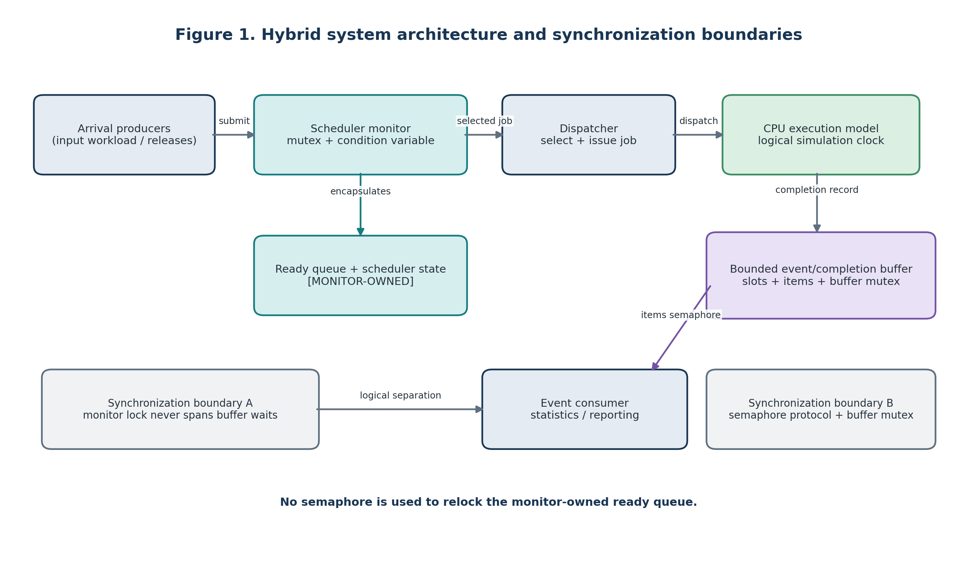
Figure 1. Hybrid system architecture and synchronization boundaries.

3.1 Component responsibilities
Component | Owned state / responsibility | Synchronization
Arrival producers | Validate descriptors and submit process arrivals. | Call monitor API; no direct queue access.
Scheduler monitor | Ready queue, sequence IDs, scheduler state, condition predicate, completion-state bookkeeping. | One mutex plus condition variable.
Dispatcher | Request the next eligible job and transition it to RUNNING. | Monitor API only; no queue mutation.
CPU execution simulation | Advance logical clock by the selected burst and produce completion records. | Single simulation thread in reference program.
Bounded event buffer | Store completion records up to capacity N. | empty_slots and available_items counting semaphores plus buffer mutex.
Event consumer | Remove completion records and aggregate statistics. | Semaphore protocol; does not hold monitor lock.
Statistics/reporting | Calculate CT, TAT, WT, throughput, utilization, and summaries. | Single consumer-owned aggregates in example.
Table 1. Hybrid architecture components, ownership, and synchronization.

3.2 Monitor versus semaphore responsibilities
Concern | Monitor | Semaphores / buffer mutex | Design rule
Ready-queue consistency | Owns and protects it. | No role. | Never relock the same queue with a semaphore.
Wait for ready work | Condition variable predicate. | No role. | Re-check predicate under monitor lock.
Buffer capacity | No role. | empty_slots counts free cells. | Acquire before insertion.
Buffer occupancy | No role. | available_items counts records. | Release after insertion; acquire before removal.
Buffer container mutation | No role. | buffer mutex gives exclusive access. | Keep critical section short.
Completion reporting | Can update scheduler state at transition boundaries. | Moves records to consumer. | Publish after leaving monitor.
Table 2. Responsibility boundaries between the scheduler monitor and semaphore subsystem.

3.3 Shared-resource inventory and invariants
Resource | Invariant | Owner / enforcement
Ready queue Q | Each queued process is READY; no duplicate process ID; only arrived jobs are eligible. | Scheduler monitor mutex.
Running marker | At most one process is RUNNING in the single-CPU model; running job is not in Q. | Scheduler monitor.
empty_slots | 0 ≤ empty_slots ≤ N; successful producer acquire reserves capacity. | Counting semaphore; protocol discipline.
available_items | 0 ≤ available_items ≤ N; each permit corresponds to a published record not yet removed. | Counting semaphore; protocol discipline.
Buffer container | At most N records; only one thread mutates container at a time. | Buffer mutex plus semaphore protocol.
Logical clock | Nondecreasing; execution interval length equals selected CPU burst. | Single simulation event loop.
Table 3. Shared-resource invariants and their enforcement mechanisms.

3.4 Why this hybrid is not inherently faster
The architecture provides modular ownership, not a performance guarantee. A monitor-only implementation can be simpler if completion events are processed inline. A semaphore-only scheduler is possible but requires explicit discipline for every queue invariant and condition predicate. The hybrid design can isolate an independently consumed bounded buffer, but introduces more moving parts, more failure modes, and additional synchronization operations. Any claim of lower latency or higher throughput would require controlled experiments on a specified platform.

4. Workload and scheduling assumptions
- Single CPU; one running process at a time.
- Non-preemptive LJF: once dispatched, a job runs until its entire CPU burst completes.
- Each job has an arrival time aᵢ and CPU burst bᵢ; the demonstration assumes these bursts are known exactly.
- Only jobs with aᵢ ≤ current logical time are ready.
- At each dispatch boundary, select maximum bᵢ. Equal bᵢ values are resolved by FCFS arrival time and then submission sequence.
- If no job is ready but jobs remain, advance logical time to the next arrival. This is idle time, not a condition-variable or semaphore delay.
- All arrivals at the same logical time are inserted before a dispatch decision, so simultaneous arrivals are compared as a group.
- Logical time models CPU work only. Real wall-clock time includes host scheduling, lock contention, logging, and runtime overhead; these are not included in the Gantt chart.

5. Hybrid pseudocode

5.1 Monitor operations
MONITOR Scheduler
state:
ready_queue Q
next_sequence := 0
shutdown := false
running := NONE
mutex M
condition_variable ready_changed

initialize():
lock M
Q := empty
next_sequence := 0
running := NONE
shutdown := false
unlock M

submit(process p):
lock M
require p.burst > 0 and p.arrival >= 0
p.sequence := next_sequence
next_sequence := next_sequence + 1
p.state := READY
insert p into Q
assert scheduler invariants
ready_changed.notify_one()
unlock M

take_longest_blocking():
lock M
wait on ready_changed until (Q not empty OR shutdown)
if Q empty AND shutdown:
unlock M
return NONE
p := arg max over Q of (burst, -arrival, -sequence)
remove p from Q
p.state := RUNNING
running := p.id
assert scheduler invariants
unlock M
return p

try_take_longest(now):
lock M
candidates := {p in Q | p.arrival <= now}
if candidates empty:
unlock M
return NONE
p := arg max candidates by (burst, -arrival, -sequence)
remove p; p.state := RUNNING; running := p.id
unlock M
return p

complete(p):
lock M
require running == p.id
p.state := COMPLETED
running := NONE
update monitor-owned completion state
unlock M

close():
lock M
shutdown := true
ready_changed.notify_all()
unlock M
END MONITOR
The reference simulation uses try_take_longest(now) so that logical time can advance deterministically to a future arrival. take_longest_blocking() specifies the threaded condition-variable operation for an online dispatcher; it waits on a predicate and never treats a notification itself as proof that work exists.

5.2 Semaphore-based bounded buffer
CONSTANT N > 0
semaphore empty_slots := N
semaphore available_items := 0
mutex buffer_mutex
buffer := empty bounded queue

producer_publish(record r):
empty_slots.acquire() // may block; no monitor lock held
lock buffer_mutex
buffer.push_back(r)
unlock buffer_mutex
available_items.release()

consumer_take():
available_items.acquire() // may block; no monitor lock held
lock buffer_mutex
r := buffer.pop_front()
unlock buffer_mutex
empty_slots.release()
return r

Protocol:
- empty_slots counts free capacity, initially N.
- available_items counts published records, initially 0.
- buffer_mutex protects container operations, not capacity.
- acquire a permit before touching the buffer; release the opposite permit after.
- never wait on either semaphore while holding buffer_mutex or Scheduler.M.

5.3 End-to-end event loop
sort workload by arrival time, then stable submission sequence
clock := 0
next_arrival := 0
completed := 0

while completed < number_of_jobs:
submit every workload item with arrival <= clock to Scheduler
job := Scheduler.try_take_longest(clock)

if job is NONE:
if next_arrival < number_of_jobs:
clock := max(clock, next workload arrival)
continue
else:
break

start := clock
clock := clock + job.burst
completion := (job.id, start, clock, job.burst)
Scheduler.complete(job)
producer_publish(completion) // after Scheduler lock has been released
completed := completed + 1

consumer drains exactly number_of_jobs records
consumer computes metrics and emits report

5.4 Locking order and deadlock argument
There is no nested lock order between Scheduler.M and buffer_mutex in the reference design. A producer first leaves the scheduler API (therefore releases Scheduler.M), then may block on empty_slots, and only after obtaining a permit acquires buffer_mutex briefly. A consumer first acquires available_items, then buffer_mutex, releases buffer_mutex, and finally releases empty_slots. No thread holds buffer_mutex while waiting for a semaphore, and no thread holds Scheduler.M while waiting for the buffer. This removes the principal circular-wait path between the two subsystems. Shutdown protocols must still ensure consumers are not left waiting forever; this finite simulation avoids that ambiguity by publishing exactly one record per job and draining exactly that many records.

6. Standardized flowcharts
The flowcharts use consistent color semantics: navy outlines and labels for general control, teal for monitor operations, amber for decisions, purple for semaphore/buffer operations, green for start/end or successful completion, and red labels only for negative decision branches. Ovals denote start/end, rectangles processing, diamonds decisions, and parallelograms input/output.
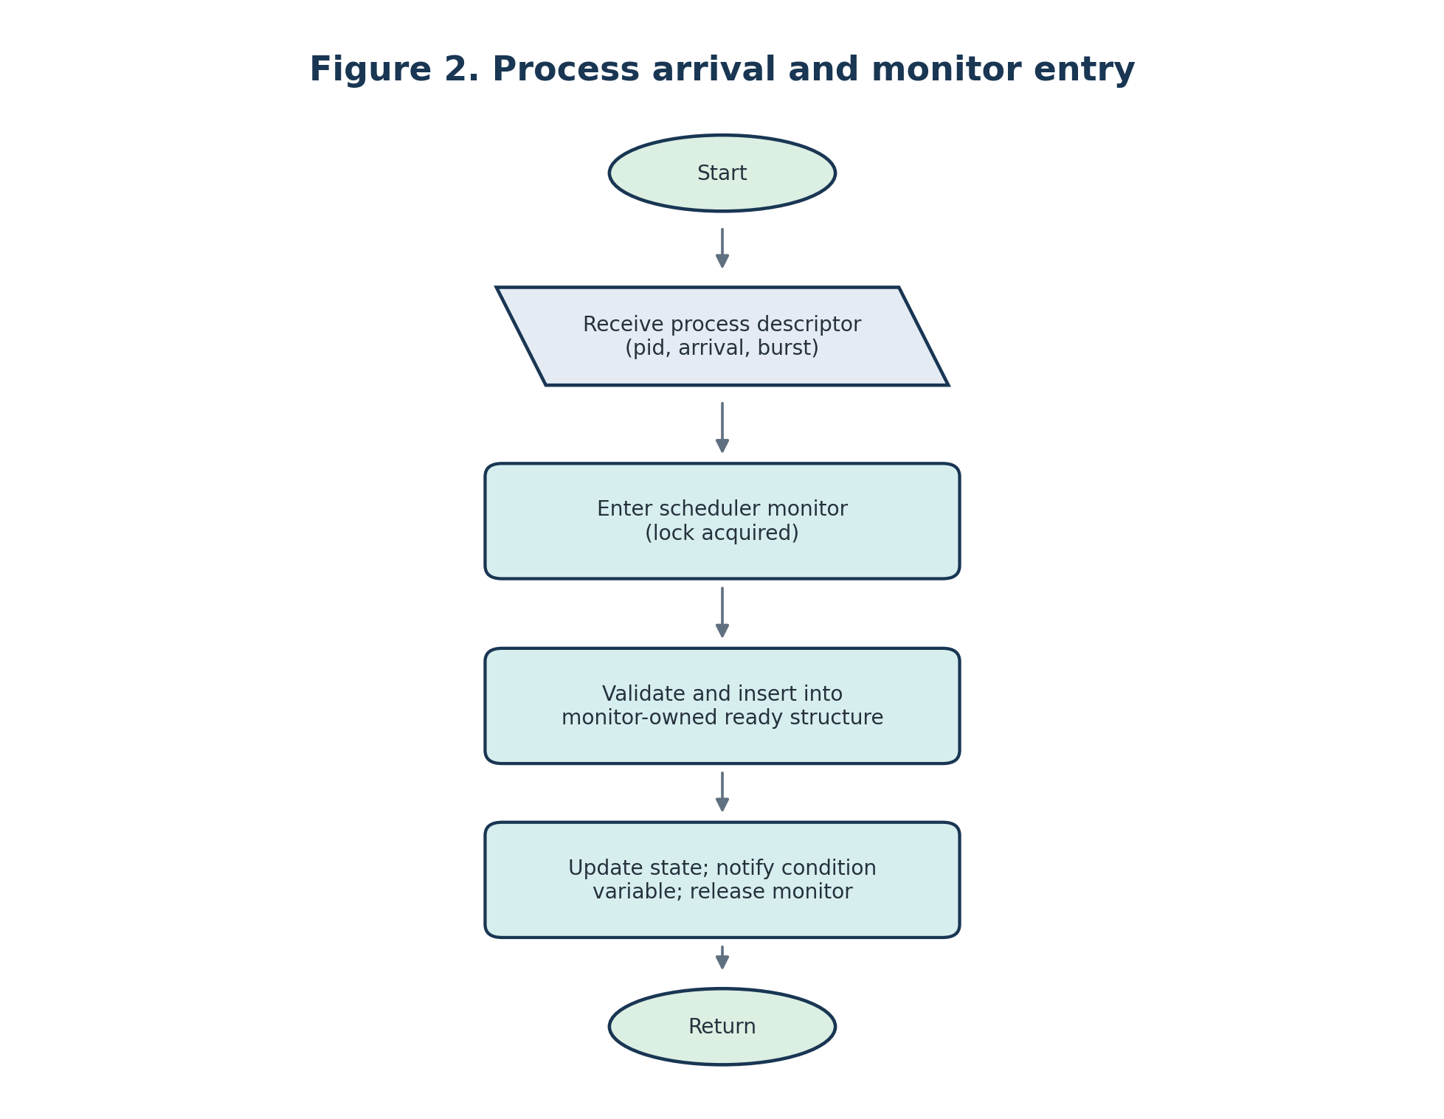
Figure 2. Process arrival and monitor entry.
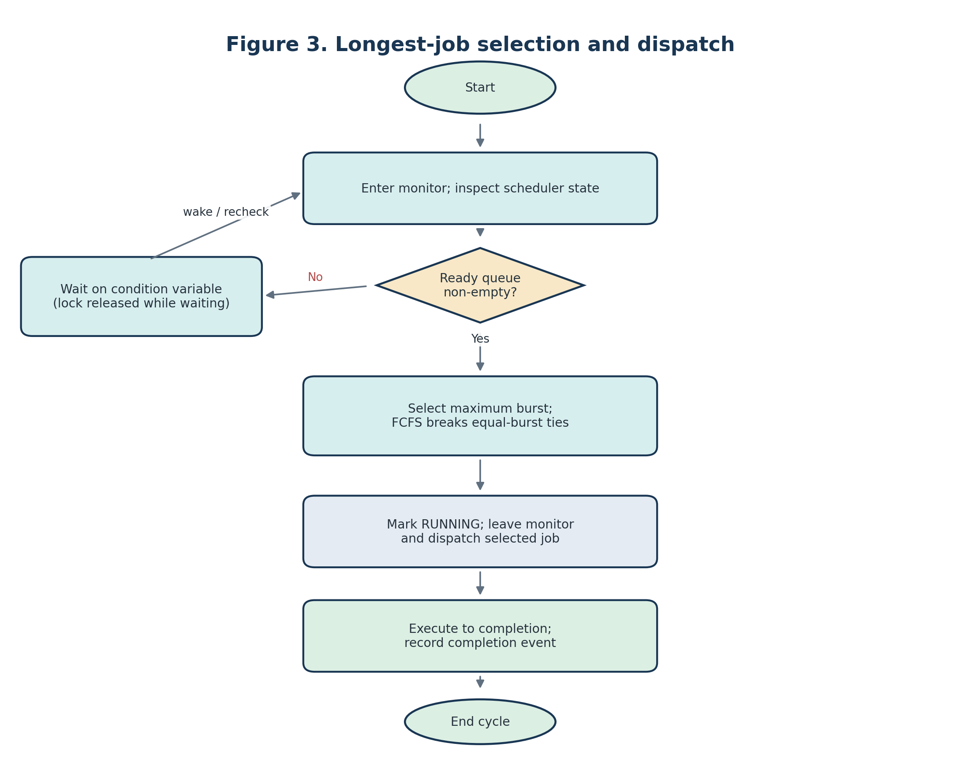
Figure 3. Longest-job selection and dispatch.
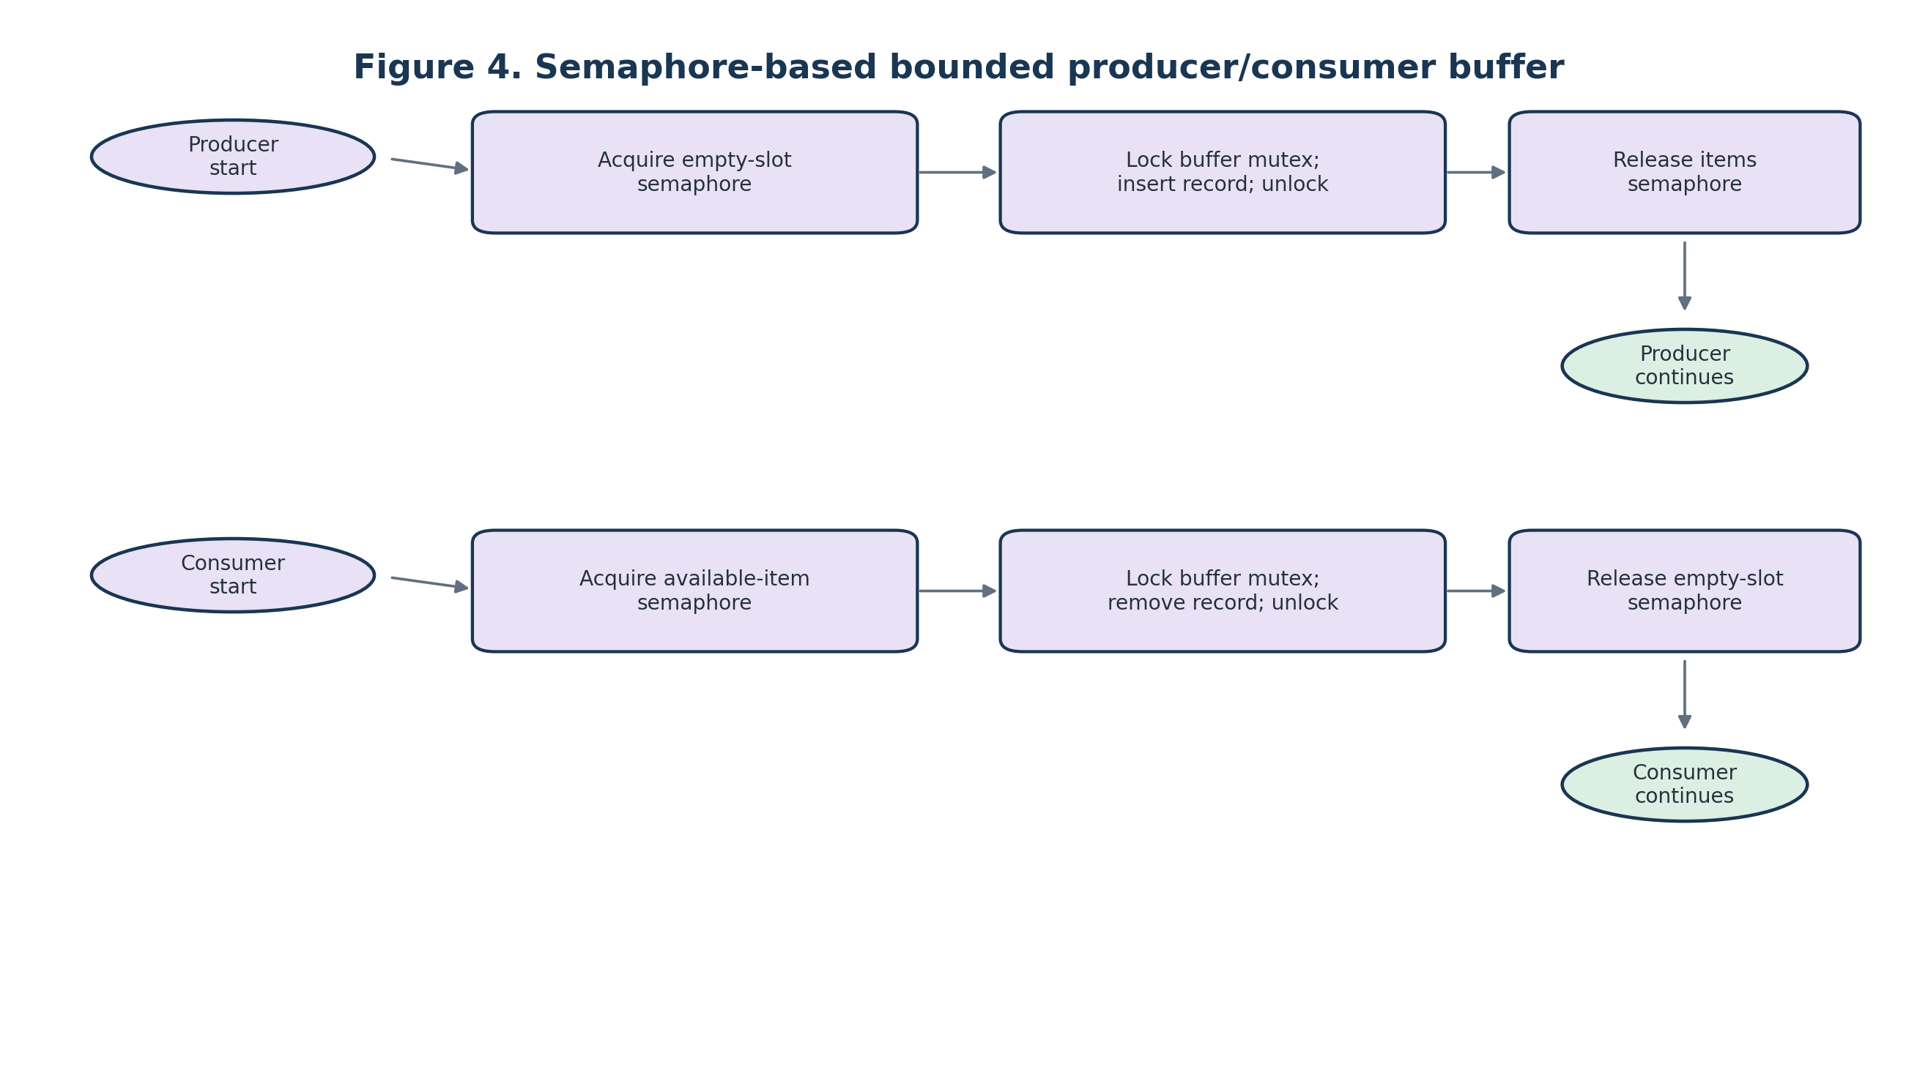
Figure 4. Semaphore-based producer/consumer buffer.
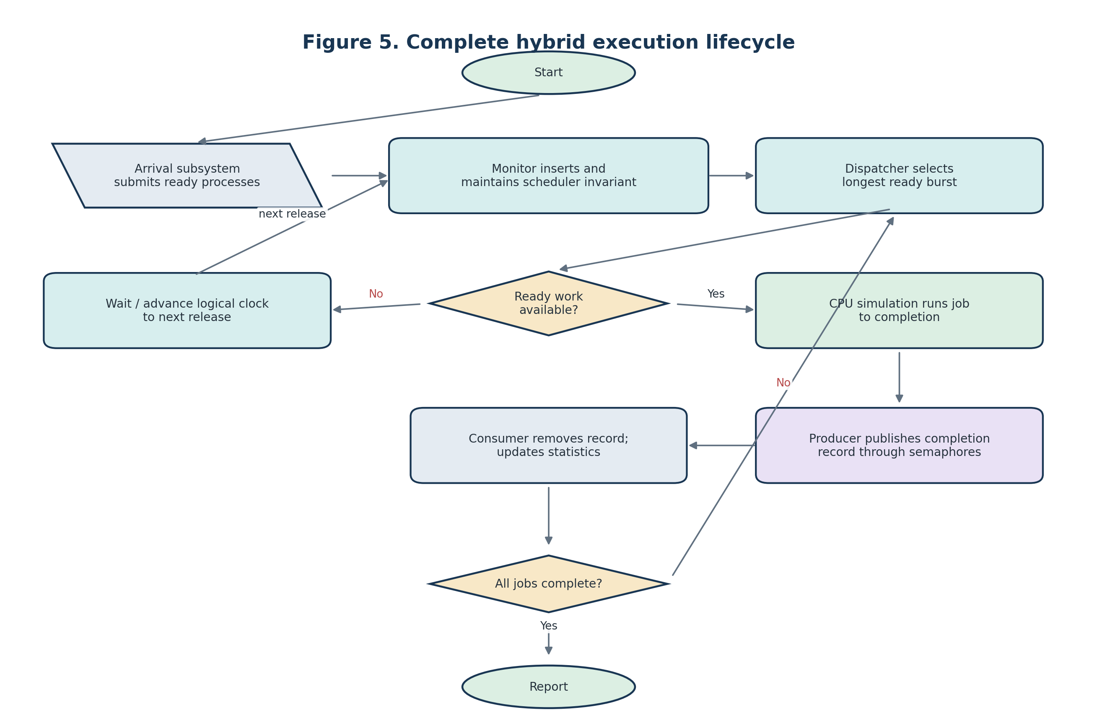
Figure 5. Complete hybrid execution lifecycle.

7. Executable C++20 implementation
The following self-contained program models scheduling in deterministic logical time and uses a real semaphore-coordinated bounded buffer with a consumer thread. The scheduler monitor encapsulates the ready queue; a mutex and condition variable protect its state. The main simulation inserts arrivals in batches at each logical time, preventing host-thread timing from changing the specified schedule. The buffer uses std::counting_semaphore from C++20 [4]. This code is provided as a reference implementation; it was compiled and run with GCC 14.2.0 on a Debian Linux environment using the stated C++20 and pthread flags; its output matched the logical results shown below. No synchronization performance benchmark was conducted.
// ljf_hybrid.cpp -- C++20 reference implementation
#include <algorithm>
#include <condition_variable>
#include <cstddef>
#include <cstdint>
#include <deque>
#include <iomanip>
#include <iostream>
#include <mutex>
#include <semaphore>
#include <stdexcept>
#include <string>
#include <thread>
#include <vector>

struct Process {
std::string id;
int arrival{};
int burst{};
std::uint64_t sequence{};
enum class State { New, Ready, Running, Completed } state{State::New};
};

struct Completion {
std::string id;
int start{};
int finish{};
int burst{};
};

class SchedulerMonitor {
public:
void submit(Process p) {
if (p.arrival < 0 || p.burst <= 0)
throw std::invalid_argument("arrival must be >= 0 and burst > 0");
std::lock_guard<std::mutex> lock(m_);
p.sequence = next_sequence_++;
p.state = Process::State::Ready;
ready_.push_back(std::move(p));
ready_changed_.notify_one();
check_invariants_locked();
}

// Deterministic logical-time API: only jobs already arrived are eligible.
bool try_take_longest(int now, Process& out) {
std::lock_guard<std::mutex> lock(m_);
auto best = ready_.end();
for (auto it = ready_.begin(); it != ready_.end(); ++it) {
if (it->arrival > now) continue;
if (best == ready_.end() ||
it->burst > best->burst ||
(it->burst == best->burst && it->arrival < best->arrival) ||
(it->burst == best->burst && it->arrival == best->arrival &&
it->sequence < best->sequence)) {
best = it;
}
}
if (best == ready_.end()) return false;
out = *best;
out.state = Process::State::Running;
ready_.erase(best);
running_id_ = out.id;
check_invariants_locked();
return true;
}

// Online blocking API. A caller should use this when arrivals are submitted
// asynchronously rather than advancing a deterministic simulation clock.
bool take_longest_blocking(Process& out) {
std::unique_lock<std::mutex> lock(m_);
ready_changed_.wait(lock, [this] { return !ready_.empty() || shutdown_; });
if (ready_.empty() && shutdown_) return false;
auto best = std::max_element(ready_.begin(), ready_.end(),
[](const Process& a, const Process& b) {
if (a.burst != b.burst) return a.burst < b.burst;
if (a.arrival != b.arrival) return a.arrival > b.arrival;
return a.sequence > b.sequence;
});
out = *best;
out.state = Process::State::Running;
running_id_ = out.id;
ready_.erase(best);
check_invariants_locked();
return true;
}

void complete(const Process& p) {
std::lock_guard<std::mutex> lock(m_);
if (running_id_ != p.id)
throw std::logic_error("completion does not match running process");
running_id_.clear();
check_invariants_locked();
}

void close() {
std::lock_guard<std::mutex> lock(m_);
shutdown_ = true;
ready_changed_.notify_all();
}

private:
void check_invariants_locked() const {
for (std::size_t i = 0; i < ready_.size(); ++i) {
if (ready_[i].state != Process::State::Ready)
throw std::logic_error("non-READY process in ready queue");
for (std::size_t j = i + 1; j < ready_.size(); ++j)
if (ready_[i].id == ready_[j].id)
throw std::logic_error("duplicate process in ready queue");
}
}
mutable std::mutex m_;
std::condition_variable ready_changed_;
std::deque<Process> ready_;
std::uint64_t next_sequence_{0};
std::string running_id_;
bool shutdown_{false};
};

template<std::ptrdiff_t N>
class BoundedEventBuffer {
public:
BoundedEventBuffer() : empty_slots_(N), available_items_(0) {
static_assert(N > 0);
}

void publish(const Completion& item) {
empty_slots_.acquire(); // no scheduler lock is held
{
std::lock_guard<std::mutex> lock(buffer_mutex_);
buffer_.push_back(item);
}
available_items_.release();
}

Completion take() {
available_items_.acquire();
Completion result;
{
std::lock_guard<std::mutex> lock(buffer_mutex_);
if (buffer_.empty())
throw std::logic_error("semaphore/buffer invariant violated");
result = buffer_.front();
buffer_.pop_front();
}
empty_slots_.release();
return result;
}

private:
std::counting_semaphore<N> empty_slots_;
std::counting_semaphore<N> available_items_;
std::mutex buffer_mutex_;
std::deque<Completion> buffer_;
};

int main() {
std::vector<Process> workload{
{"P1", 0, 3}, {"P2", 0, 7}, {"P3", 0, 5}
};
std::stable_sort(workload.begin(), workload.end(),
[](const Process& a, const Process& b) {
return a.arrival < b.arrival;
});

SchedulerMonitor scheduler;
BoundedEventBuffer<8> events;
std::vector<Completion> results;
results.reserve(workload.size());

// Consumer owns results; producer publishes only after leaving monitor APIs.
std::thread consumer([&] {
for (std::size_t i = 0; i < workload.size(); ++i)
results.push_back(events.take());
});

int clock = 0;
std::size_t next = 0;
std::size_t completed = 0;
while (completed < workload.size()) {
while (next < workload.size() && workload[next].arrival <= clock) {
scheduler.submit(workload[next]);
++next;
}

Process job;
if (!scheduler.try_take_longest(clock, job)) {
if (next < workload.size()) {
clock = std::max(clock, workload[next].arrival);
continue;
}
break;
}

const int start = clock;
clock += job.burst; // logical CPU time, not sleep()
scheduler.complete(job); // monitor lock released on return
events.publish({job.id, start, clock, job.burst});
++completed;
}

consumer.join(); // exactly one record per job
std::sort(results.begin(), results.end(),
[](const Completion& a, const Completion& b) {
return a.start < b.start;
});

std::cout << "Process Start Finish Burst Waiting Turnaround\n";
double sum_wait = 0.0, sum_tat = 0.0;
for (const auto& c : results) {
auto it = std::find_if(workload.begin(), workload.end(),
[&](const Process& p) { return p.id == c.id; });
const int turnaround = c.finish - it->arrival;
const int waiting = turnaround - it->burst;
sum_wait += waiting;
sum_tat += turnaround;
std::cout << std::setw(7) << c.id << std::setw(7) << c.start
<< std::setw(8) << c.finish << std::setw(7) << c.burst
<< std::setw(9) << waiting << std::setw(12) << turnaround << '\n';
}
const double total_burst = 3 + 7 + 5;
const double makespan = clock; // first arrival is at t=0 here
std::cout << std::fixed << std::setprecision(2)
<< "Average waiting: " << sum_wait / workload.size() << '\n'
<< "Average turnaround: " << sum_tat / workload.size() << '\n'
<< "Throughput: " << workload.size() / makespan << " jobs/unit\n"
<< "CPU utilization: " << 100.0 * total_burst / makespan << "%\n";
return 0;
}

7.1 Build and run
Requirements: C++20 compiler and standard library implementation with <semaphore>.
Example with GCC 11+ on a platform where the toolchain supports C++20 semaphores:
g++ -std=c++20 -O2 -pthread ljf_hybrid.cpp -o ljf_hybrid
./ljf_hybrid

Expected logical results (record print order may be sorted by start time):
P2: start 0, finish 7, waiting 0, turnaround 7
P3: start 7, finish 12, waiting 7, turnaround 12
P1: start 12, finish 15, waiting 12, turnaround 15
Average waiting = 19/3 = 6.33
Average turnaround = 34/3 = 11.33
Throughput = 3/15 = 0.20 jobs per time unit
CPU utilization = 15/15 = 100%
Implementation note: the program uses a bounded buffer of capacity 8 for a three-record workload, so no producer is expected to block on capacity in this demonstration. The semaphores remain semantically active and the consumer runs concurrently. A capacity-stress test should use a larger workload and a smaller buffer, and should measure wall-clock time separately from the logical schedule. The sample's blocking monitor API is provided for online use; the deterministic example uses try_take_longest to preserve event-time semantics.

8. Numerical example and verified calculations
Process | Arrival Aᵢ | CPU burst Bᵢ
P1 | 0 | 3
P2 | 0 | 7
P3 | 0 | 5
Table 4. Workload used for the principal LJF demonstration.

All three jobs are ready at t = 0. LJF selects P2 (burst 7), then at t = 7 selects P3 (burst 5), and finally P1 (burst 3). Because jobs are non-preemptive and all arrive at time zero, the CPU remains busy for the complete makespan of 15 time units.
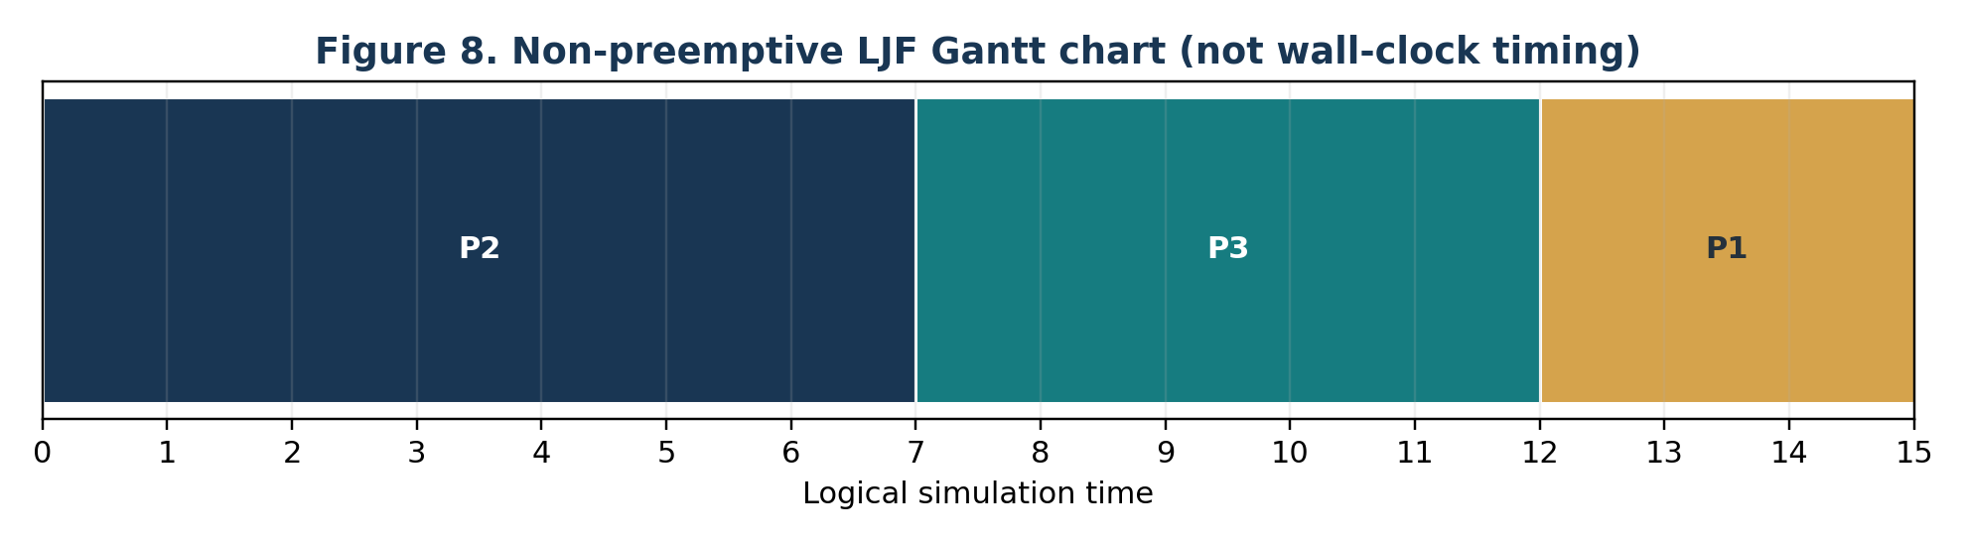
Figure 6. Proportional logical-time Gantt chart for non-preemptive LJF.

8.1 Detailed scheduling trace
Decision time | Ready set (burst) | Selected job | Execution interval | Reason
0 | P1(3), P2(7), P3(5) | P2 | 0–7 | Maximum ready burst = 7
7 | P1(3), P3(5) | P3 | 7–12 | Maximum ready burst = 5
12 | P1(3) | P1 | 12–15 | Only ready job
Table 5. Detailed LJF scheduling trace at each dispatch boundary.

8.2 Completion, turnaround, and waiting time
Process | Arrival Aᵢ | Burst Bᵢ | Start | Completion Cᵢ | Turnaround Cᵢ−Aᵢ | Waiting TAT−Bᵢ
P2 | 0 | 7 | 0 | 7 | 7 | 0
P3 | 0 | 5 | 7 | 12 | 12 | 7
P1 | 0 | 3 | 12 | 15 | 15 | 12
Table 6. Completion, turnaround, and waiting-time calculations.

Turnaround time is TATᵢ = Cᵢ − Aᵢ. Waiting time is WTᵢ = TATᵢ − Bᵢ under the single-burst model without I/O blocking. Thus WT(P2)=0, WT(P3)=12−5=7, and WT(P1)=15−3=12.

8.3 Summary metrics
Metric | Calculation | Result | Interpretation
Average waiting | (0 + 7 + 12) / 3 | 6.33 time units | Mean ready-queue delay.
Average turnaround | (7 + 12 + 15) / 3 | 11.33 time units | Mean arrival-to-completion time.
Throughput | 3 completed / 15 time units | 0.20 jobs/time unit | Measured over [0, 15).
CPU utilization | CPU busy time / makespan = 15/15 | 100% | Assumes no idle interval or modeled overhead.
Makespan | last completion − first arrival | 15 time units | Logical simulation horizon.
Table 7. Summary of analytically derived scheduling metrics.

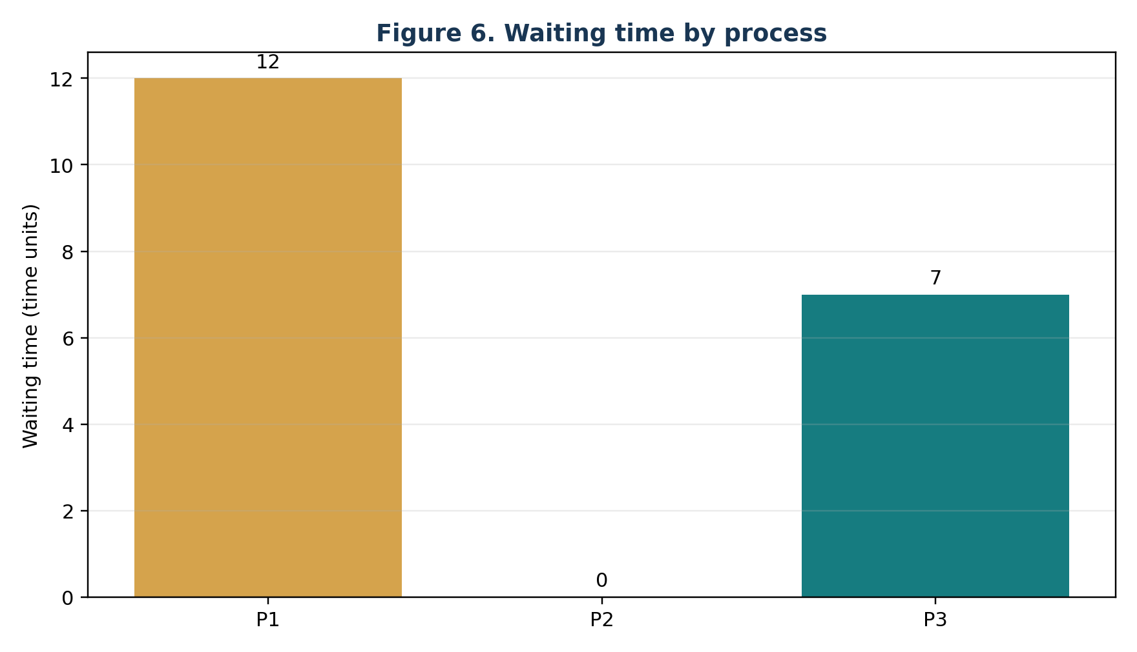
Figure 7. Waiting time by process.
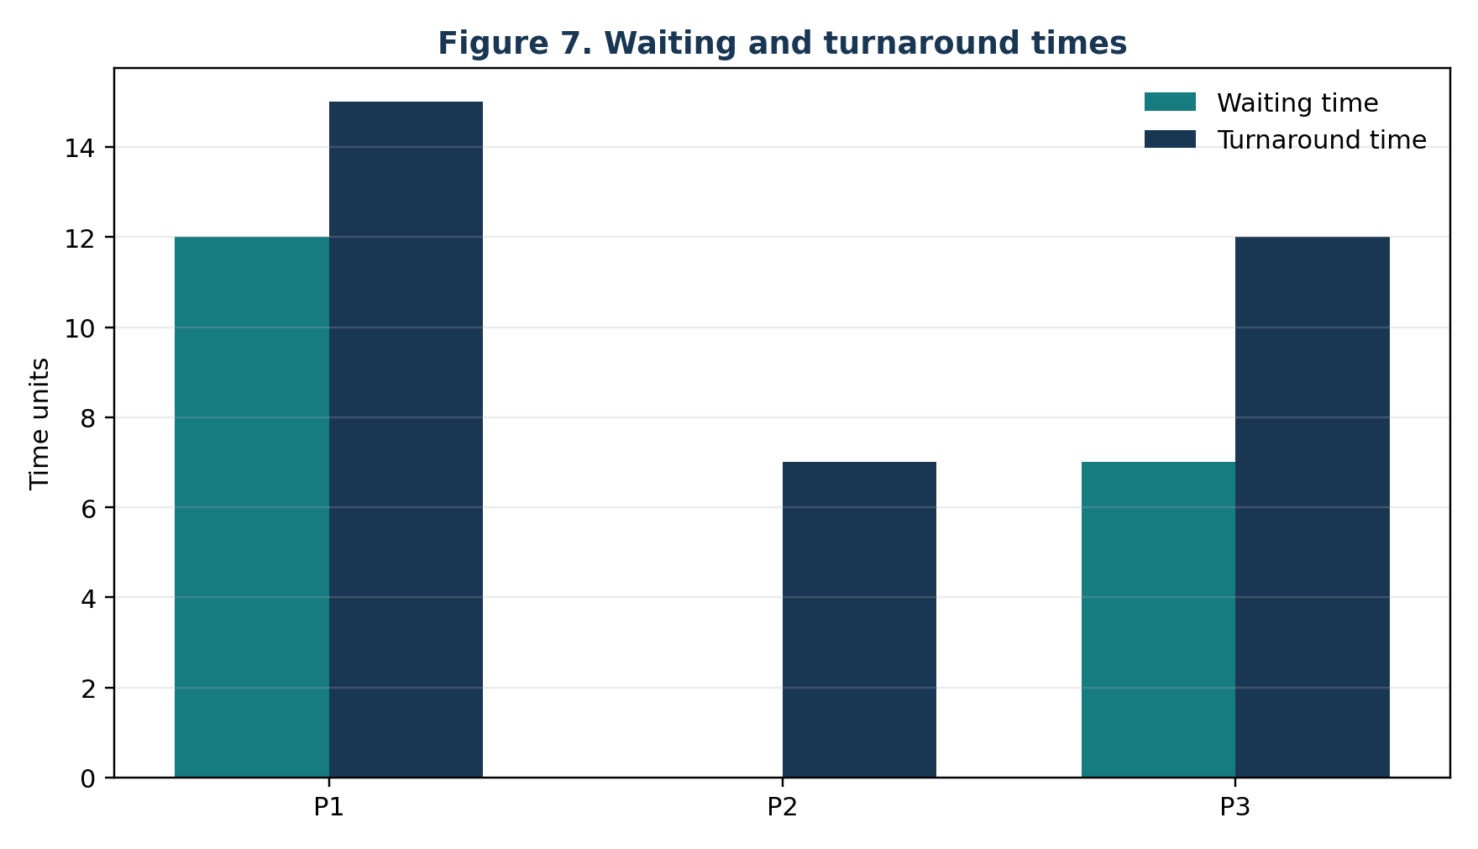
Figure 8. Waiting and turnaround times by process.

8.4 Interpretation
The example confirms the expected selection rule but does not establish that LJF is optimal for a particular operational objective. It intentionally excludes context-switch time, monitor contention, semaphore blocking time, and CPU execution variance. If real synchronization overhead is measured, it should be reported in a separate experiment with compiler, OS, CPU, workload size, buffer capacity, repetitions, warm-up, timer resolution, and summary statistics stated. Those wall-clock measurements must not be added to the logical Gantt chart unless the simulation model explicitly includes them.

9. Semaphore initialization and operation
Primitive | Initial value | Acquire / wait | Release / signal | Meaning
empty_slots | N | Producer before insertion | Consumer after removal | Available buffer capacity.
available_items | 0 | Consumer before removal | Producer after insertion | Published records available.
buffer_mutex | Unlocked | Around push/pop only | After container operation | Exclusive mutation of the container.
Scheduler monitor mutex | Unlocked | On monitor API entry | On API exit / condition wait | Protects scheduler state only.
ready_changed condition variable | No count | Wait with predicate under monitor lock | Notify after queue/shutdown state change | Wake a dispatcher to re-check state.
Table 8. Semaphore initialization and operation semantics.

10. Concurrency correctness and failure analysis
Hazard | Possible cause | Mitigation in this design | Residual consideration
Ready-queue race | Producer and dispatcher mutate Q concurrently. | All Q access is inside SchedulerMonitor methods. | All new methods must preserve encapsulation.
Buffer race | Producer push and consumer pop concurrently. | buffer_mutex protects each container operation. | Semaphore protocol must match actual inserts/removals.
Missed condition notification | Wait without predicate or check outside lock. | wait(lock, predicate); predicate and state share monitor mutex. | Shutdown must notify all waiters.
Deadlock / circular wait | Hold monitor lock while blocking on full buffer. | Publish only after monitor API returns; no nested monitor/buffer lock order. | Other extensions must retain the rule.
Buffer overflow | Insert without capacity permit. | empty_slots acquired before push. | Permit leaks if exceptions occur between acquire and release; production code should use RAII or exception-safe rollback.
Consumer underflow | Pop without item permit. | available_items acquired before pop. | A protocol bug or permit mismatch is an invariant violation.
Starvation | Long jobs continually arrive and LJF favors them. | Document policy limitation; consider aging or bounded waiting if fairness is required. | Aging changes the strict LJF policy.
Nondeterministic simultaneous arrivals | Concurrent arrival order differs across runs. | Batch arrivals at the same logical time; stable sequence tie-break. | Online version must define timestamp and ordering semantics.
Shutdown hang | Consumer waits for a record that will never arrive. | Finite example drains exactly one record per job. | General service needs sentinel/cancellation protocol.
Table 9. Concurrency hazards, mitigations, and residual considerations.

10.1 Safety and liveness properties
Safety means that something bad never happens; liveness means that something good eventually happens under stated assumptions. The monitor enforces mutual exclusion and ready-queue invariants. The bounded buffer enforces capacity and occupancy through permit accounting plus container mutual exclusion. Liveness additionally assumes that scheduled threads eventually run, the consumer continues draining the buffer, every submitted job eventually becomes eligible, and no exception permanently interrupts the protocol. Standard semaphores do not necessarily guarantee FIFO fairness, so strict starvation freedom is not claimed.

11. Comparison with semaphore-only and monitor-only designs
Design | Expected strengths | Expected costs / risks | Appropriate when
Semaphore-only scheduler | Primitive building blocks; explicit permit accounting can be useful for resource pools. | Queue invariants and wait predicates are manual; easy to create permit mismatch or complex lock protocols. | A low-level design needs permit-based resource accounting and the team can verify invariants.
Monitor-only scheduler | Encapsulation makes queue invariants and condition predicates easier to audit; fewer mechanisms. | An inline consumer may couple reporting to scheduling; a separate asynchronous bounded queue still needs capacity/occupancy coordination or a monitor-based alternative. | Scheduler and event handling are simple, or a monitor-protected queue is sufficient.
Hybrid (this report) | Distinct ownership: monitor for scheduler state; semaphores for bounded buffer capacity/occupancy. | Additional primitives, lock boundaries, shutdown logic, and potential contention; no inherent speed or reliability advantage. | An auxiliary bounded producer/consumer channel is a real requirement and benefits from semaphore semantics.
Table 10. Qualitative trade-offs among semaphore-only, monitor-only, and hybrid designs.

The comparison is qualitative and theoretical. No timing data are supplied, and no ranking by performance is justified without controlled measurements.

12. LJF, EDF, and Rate Monotonic scheduling
LJF prioritizes the largest ready CPU burst and is not deadline-aware. EDF prioritizes the job with the earliest absolute deadline and is commonly analyzed as a preemptive dynamic-priority policy on a uniprocessor. RM assigns fixed task priorities based on period, with shorter periods receiving higher priority; classical utilization bounds and guarantees rely on explicit assumptions, including periodic independent tasks, preemption, and deadline/period relationships [5]. A synchronization architecture does not transform LJF into EDF or RM and does not itself establish hard real-time guarantees.
Policy | Priority rule | Typical assumptions | Deadline implications
Non-preemptive LJF | Largest ready burst; FCFS ties. | Known/estimated burst; non-preemptive jobs. | No inherent deadline guarantee; long jobs may delay urgent short jobs.
EDF | Earliest absolute deadline among ready jobs. | Often preemptive uniprocessor; independent periodic/sporadic tasks in classical analysis. | Optimal among preemptive dynamic-priority algorithms under standard uniprocessor assumptions; blocking and overhead matter.
RM | Shortest task period gets highest fixed priority. | Usually preemptive periodic tasks with deadlines equal to periods for classic bound. | Fixed-priority schedulability analysis; classical sufficient utilization bound is conservative.
Table 11. Scheduling-policy rules and their real-time implications.

12.1 Common periodic task set
For a compact comparison, consider two independent periodic tasks on one CPU with implicit deadlines, zero release jitter, zero context-switch cost, and integer execution units: task τA has C=1, T=D=4; task τB has C=2, T=D=5. Both release at time 0 and then periodically. Utilization is U = 1/4 + 2/5 = 0.65. The schedule horizon shown is [0, 20). LJF is interpreted as non-preemptive longest-job-first over ready job instances; EDF is preemptive earliest absolute deadline; RM is preemptive fixed priority with τA above τB because 4 < 5. Ties are resolved by earlier release, then task name. These are illustrative discrete-unit schedules, not a proof of general schedulability.
Task | Execution C | Period T | Relative deadline D | Releases in [0,20)
τA | 1 | 4 | 4 | 0, 4, 8, 12, 16
τB | 2 | 5 | 5 | 0, 5, 10, 15
Table 12. Common periodic task set used to illustrate LJF, EDF, and RM.

12.2 LJF schedule over [0, 20)
Segments: 0–2: B; 2–3: A; 3–4: IDLE; 4–5: A; 5–7: B; 7–8: IDLE; 8–9: A; 9–10: IDLE; 10–12: B; 12–13: A; 13–15: IDLE; 15–17: B; 17–18: A; 18–20: IDLE.
Deadline misses in the discrete model: 0. Job releases and completions are evaluated at integer boundaries; the schedule is generated under the policy assumptions above.

12.2 EDF schedule over [0, 20)
Segments: 0–1: A; 1–3: B; 3–4: IDLE; 4–5: A; 5–7: B; 7–8: IDLE; 8–9: A; 9–10: IDLE; 10–12: B; 12–13: A; 13–15: IDLE; 15–17: B; 17–18: A; 18–20: IDLE.
Deadline misses in the discrete model: 0. Job releases and completions are evaluated at integer boundaries; the schedule is generated under the policy assumptions above.

12.2 RM schedule over [0, 20)
Segments: 0–1: A; 1–3: B; 3–4: IDLE; 4–5: A; 5–7: B; 7–8: IDLE; 8–9: A; 9–10: IDLE; 10–12: B; 12–13: A; 13–15: IDLE; 15–16: B; 16–17: A; 17–18: B; 18–20: IDLE.
Deadline misses in the discrete model: 0. Job releases and completions are evaluated at integer boundaries; the schedule is generated under the policy assumptions above.
Important limitation: the non-preemptive LJF policy is not directly comparable to preemptive EDF/RM as a real-time guarantee. Non-preemptive blocking can cause a short-deadline job to wait behind a long job. EDF and RM schedules depend on the preemption model, deadline convention, and overhead assumptions. A hybrid monitor/semaphore implementation only implements coordination; schedulability still requires a policy-specific analysis.

13. Evaluation and discussion

13.1 Correctness of LJF selection
At every dispatch boundary, the deterministic implementation examines only jobs whose arrival time is no later than the logical clock. It selects the maximum burst, then the earliest arrival, then the lowest submission sequence. The worked example's ready sets and schedule trace make the selection independently verifiable. The event loop does not dispatch a future-arrival job merely because it has a large burst.

13.2 Encapsulation and synchronization boundaries
The monitor is the only owner of the ready queue and scheduler metadata. Public operations are narrow: submit, try_take_longest, take_longest_blocking, complete, and close. The buffer is a separate abstraction with its own capacity and occupancy protocol. The separation makes it possible to reason locally about queue invariants and buffer permits. It also prevents the common mistake of holding a scheduler lock while blocking on a full buffer.

13.3 Contention, overhead, and maintainability
The design may incur monitor-lock contention when arrivals and dispatch occur concurrently, and buffer contention when producers and consumers operate at high rates. The buffer mutex critical section is intentionally short. A semaphore-based buffer can decouple event production from reporting, but it adds two permit counters and a shutdown protocol. If reporting can occur synchronously after each completion without affecting scheduling, a simpler monitor-only design may be easier to maintain. If the buffer is required for backpressure and decoupled consumers, the hybrid division is defensible.

13.4 Starvation and fairness
LJF is not fair in the sense of bounded waiting: a short job may be postponed by a stream of longer arrivals. FCFS tie-breaking resolves equal bursts only; it does not prevent starvation across unequal bursts. Aging, maximum-wait rules, or a deadline-aware policy can address some use cases but change the strict LJF selection rule. Semaphore fairness is a separate concern and depends on the implementation; the design does not assume FIFO semaphore wake-up.

13.5 Complexity and suitability
The hybrid design is suitable as a teaching and simulation architecture where scheduler state and event transport are independently meaningful. It is not by itself a production hard-real-time scheduler: the C++ runtime, host OS, dynamic memory allocation, and semaphore wake-up latency are not bounded by this report. Hard real-time use requires bounded execution and blocking analysis, platform-specific timing evidence, priority-inversion analysis, and an appropriate scheduling policy.

13.6 Evaluation plan for future empirical work
- Compare monitor-only, semaphore-only, and hybrid versions with identical workloads and semantics.
- Vary process count, burst distribution, producer count, buffer capacity, consumer delay, and arrival concurrency.
- Record compiler/version, optimization flags, CPU model, OS/kernel, thread affinity, timer source, warm-up policy, and run count.
- Report median, mean, standard deviation, and high percentiles for wall-clock completion and per-operation latency; keep logical schedule metrics separate.
- Check correctness with randomized stress tests, ThreadSanitizer where available, invariant assertions, and deterministic replay.
- Measure the cost of bounded-buffer backpressure independently from scheduler selection cost.

14. Limitations
- The implementation is a reference model, not a kernel scheduler or real-time certified component.
- CPU bursts are treated as exact integer simulation units; real systems generally estimate or measure bursts.
- The deterministic demonstration uses a single simulation event loop and a concurrent event consumer; the provided blocking monitor operation illustrates online waiting but is not used to drive the logical-time example.
- The finite buffer example avoids capacity saturation at the selected capacity; backpressure behavior should be stress-tested separately.
- No benchmark results are claimed. Charts display analytical workload metrics, not measured host performance.
- The periodic-task schedule is a finite illustrative trace and does not replace a formal schedulability proof.

15. Conclusion and future work
This report specifies a hybrid architecture in which a monitor encapsulates the ready queue and scheduling state, while counting semaphores coordinate a distinct bounded completion-event buffer. The separation is the key design decision: LJF policy logic remains independent of the synchronization used to transport completion records. Predicate-based condition-variable waiting, strict ownership of shared state, short critical sections, and the rule against blocking on semaphores while holding the scheduler monitor reduce the principal race and deadlock risks.
For the specified workload, the analytically verified non-preemptive LJF order is P2 → P3 → P1, with mean waiting time 6.33, mean turnaround time 11.33, throughput 0.20 jobs per time unit, and idealized CPU utilization of 100%. These values describe logical scheduling only. They do not establish a performance advantage for the hybrid implementation.
Future work should include controlled benchmark experiments, alternative bounded-buffer implementations, preemptive scheduling policies, larger periodic workloads, and formal verification of queue and permit invariants. The hybrid design is justified only when the event buffer is a real architectural need; otherwise, a simpler monitor-only implementation may provide better maintainability without sacrificing correctness.

References
[1] A. Silberschatz, P. B. Galvin, and G. Gagne, Operating System Concepts, 10th ed. Hoboken, NJ, USA: Wiley, 2018.
[2] A. S. Tanenbaum and H. Bos, Modern Operating Systems, 4th ed. Boston, MA, USA: Pearson, 2015.
[3] ISO/IEC, Programming Languages—C++: Working Draft, section on condition variables and mutexes; see also cppreference.com, “std::condition_variable,” online reference, accessed Oct. 29, 2026. https://en.cppreference.com/w/cpp/thread/condition_variable
[4] cppreference.com, “std::counting_semaphore, std::binary_semaphore,” C++ reference, online documentation, accessed Oct. 29, 2026. https://en.cppreference.com/w/cpp/thread/counting_semaphore
[5] C. L. Liu and J. W. Layland, “Scheduling Algorithms for Multiprogramming in a Hard-Real-Time Environment,” Journal of the ACM, vol. 20, no. 1, pp. 46–61, Jan. 1973, doi: 10.1145/321738.321743.
[6] J. W. S. Liu, Real-Time Systems. Upper Saddle River, NJ, USA: Prentice Hall, 2000.
[7] E. W. Dijkstra, “Cooperating Sequential Processes,” in Programming Languages, F. Genuys, Ed. New York, NY, USA: Academic Press, 1968, pp. 43–112.

Appendix A. Metric definitions
For process i:
Completion time: C_i
Turnaround time: TAT_i = C_i - A_i
Waiting time: WT_i = TAT_i - B_i
Average waiting: (Σ WT_i) / n
Average turnaround: (Σ TAT_i) / n
Throughput: completed jobs / observation interval
CPU utilization: busy CPU time / makespan × 100%

For the example:
C(P2)=7, C(P3)=12, C(P1)=15
WT = {0, 7, 12}; TAT = {7, 12, 15}
Mean WT = 19/3 = 6.333...
Mean TAT = 34/3 = 11.333...
Throughput = 3/15 = 0.20 jobs per time unit
Utilization = (7+5+3)/15 × 100% = 100%

