OPERATING SYSTEMS · RESEARCH ARTICLE
A Comparative Study of Classic Process Synchronization Mechanisms
Monitors, Semaphores, Peterson's and Dekker's Algorithms, and the Readers–Writers Problem
Author and course information
Article title | Comparison of Monitors, Semaphores, Peterson, Dekker and Readers–Writers
Author name | Sadegh Azodi
Course | Embedded and Real-Time Systems
Date | November 2026
Process synchronization · Critical section · Concurrency

Table of Contents
Abstract 1
1. Introduction 1
2. Background: The Critical-Section Problem 1
2.1 Race conditions 1
2.2 Structure of a solution 1
2.3 Requirements 1
2.4 Overview of the mechanisms 1
3. Dekker's Algorithm 1
3.1 History and idea 1
3.2 Pseudocode 1
3.3 How it works 1
3.4 Correctness and limits 1
4. Peterson's Algorithm 1
4.1 Idea 1
4.2 Pseudocode 1
4.3 Proof of correctness 1
4.4 Execution trace 1
4.5 Generalisation to N processes 1
4.6 Warning: modern memory models 1
5. Semaphores 1
5.1 Concept 1
5.2 Two implementations 1
5.3 Types and usage patterns 1
5.4 Pitfalls 1
6. Monitors 1
6.1 Concept 1
6.2 Condition variables 1
6.3 Example: bounded buffer as a monitor 1
7. The Readers–Writers Problem 1
7.1 Statement 1
7.2 Variant 1: reader priority with semaphores 1
7.3 Variants 2 and 3 1
7.4 Monitor solution 1
8. Comprehensive Comparison 1
8.1 Visual summary 1
8.2 Cost of waiting: spinning versus blocking 1
8.3 Why readers–writers matter: parallelism gain 1
8.4 Which one should I choose? 1
9. Worked Examples 1
Example 1: Dekker's algorithm under contention 1
Example 2: a counting semaphore guarding two printers 1
Example 3: bounded buffer with N = 3 1
Example 4: arrival order in readers–writers 1
10. Exam-Style Questions 1
10.1 Multiple choice 1
10.2 Short answer 1
10.3 Problems 1
11. Conclusion 1
References 1

Abstract
Concurrent processes that share data must coordinate their access; otherwise the result depends on the unpredictable order in which instructions interleave (a race condition). This article compares five classic answers to the critical-section problem: the pure-software algorithms of Dekker and Peterson, Dijkstra's semaphores, Hoare's monitors, and the readers–writers problem, which tests how well the other tools cope with asymmetric access. For every technique we present the idea, pseudocode, a flowchart, a correctness argument and a worked example. We then compare them on 23 parameters, among them mutual exclusion, progress, bounded waiting, starvation, deadlock, waiting style, scalability and ease of use, and summarise the trade-offs in charts. The article ends with exam-style questions and model answers.
Keywords: mutual exclusion, critical section, Dekker, Peterson, semaphore, monitor, readers–writers, deadlock, starvation.

1. Introduction
Modern operating systems run many processes and threads at once, on one core by time slicing or on many cores truly in parallel. As soon as two of them touch the same variable, file or device, the order of their steps matters. Synchronization mechanisms exist to make that order safe. Since the 1960s researchers have proposed many of them, and the five studied here form the core of every operating-systems course: each introduced an idea that later systems still use.
The goals of this article are:
- to explain each mechanism with pseudocode, a flowchart and a trace, so that its behaviour can be verified by hand;
- to compare the mechanisms systematically on correctness, cost, scalability and usability;
- to give practical guidance on which mechanism to choose, and exam-style practice material.
*A note on scope. Dekker's and Peterson's algorithms, semaphores and monitors are mechanisms. The readers–writers problem is a problem*, but its classic solutions are algorithms in their own right, built from semaphores or monitors, and they exhibit trade-offs (priority, starvation, parallelism) that the mechanisms alone do not. We therefore treat it as the fifth item of the comparison.

2. Background: The Critical-Section Problem

2.1 Race conditions
Consider two threads that each execute count = count + 1 on a shared variable. At machine level the statement is three steps: load count into a register, add one, store the register back. If both threads load the value 5 before either stores, both store 6 and one increment is lost. The final value depends on the interleaving, which is a race condition. The code region that accesses shared data is called the critical section; it must execute as if it were a single indivisible step.

2.2 Structure of a solution
Listing 1: General structure of a process that uses a critical section
do {
entry section; // ask permission to enter
critical section; // access shared data
exit section; // announce that we are done
remainder section; // everything else
} while (true);

2.3 Requirements
A correct solution must satisfy three requirements, without assuming anything about the relative speed of the processes or the number of processors:
- Mutual exclusion: at most one process is inside its critical section at any time.
- Progress: if no process is in its critical section and some want to enter, only the processes that are in their entry sections take part in deciding who enters, and the decision cannot be postponed forever.
- Bounded waiting: once a process has requested entry, the number of times others may enter before it is bounded; this rules out starvation.
Table 1: Key terms used in this article
Term | Meaning
Race condition | Result depends on the order in which concurrent steps interleave.
Atomic operation | An operation that appears indivisible to all other processes.
Busy waiting | Repeatedly testing a condition in a loop, burning CPU time (spinning).
Blocking | The process sleeps in a queue and uses no CPU until it is woken.
Deadlock | A set of processes each wait for an event only another one in the set can cause.
Starvation | A process waits indefinitely although others keep making progress.
Context switch | Saving one process state and loading another; costs time (written c below).
Condition variable | A queue on which processes inside a monitor wait for a state change.

2.4 Overview of the mechanisms
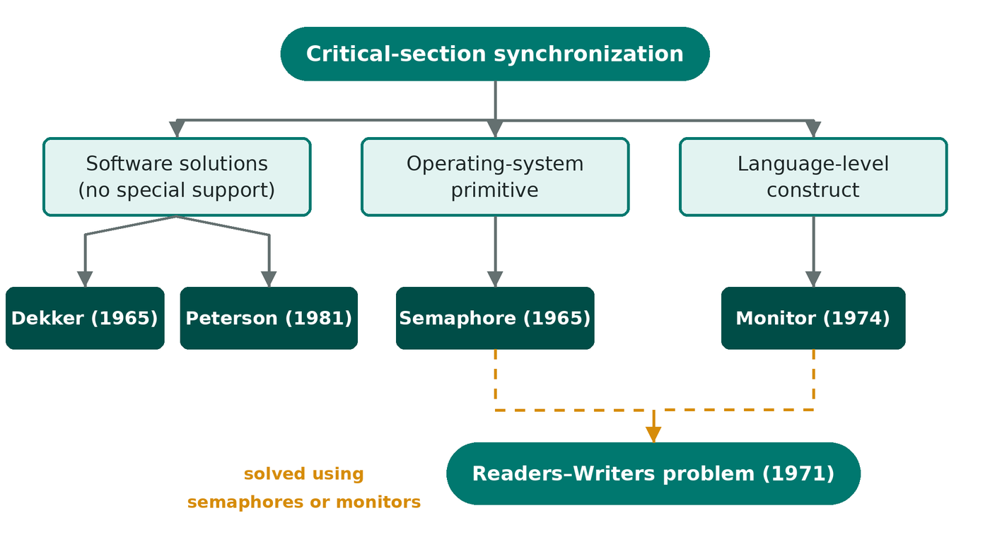
Figure 1: Classification of the five techniques by the level at which they work

3. Dekker's Algorithm

3.1 History and idea
Dijkstra (1965) credits the Dutch mathematician T. J. Dekker with the first correct software-only solution to mutual exclusion for two processes; it needs no special hardware instruction. It combines two ideas that fail separately: per-process flags ("I want to enter") can deadlock when both raise their flag and wait, and a shared turn variable forces strict alternation and violates progress. Dekker's trick is that when both want to enter, the process that does not own the turn politely lowers its flag, waits until the turn is handed to it, and then tries again.

3.2 Pseudocode
Listing 2: Dekker's algorithm for process Pi (j = 1 − i)
boolean flag[2] = {false, false}; // shared
int turn = 0; // shared

do {
flag[i] = true; // I want to enter
while (flag[j]) { // the other wants too
if (turn != i) { // not my turn: back off
flag[i] = false;
while (turn != i) ; // busy wait for my turn
flag[i] = true;
}
}
/* critical section */
turn = j; // hand the turn over
flag[i] = false;
/* remainder section */
} while (true);

3.3 How it works
- Raising flag[i] announces intent. If flag[j] is false, Pi enters at once: there is no contention.
- If both flags are up, turn breaks the tie. The owner of the turn keeps testing flag[j] and enters as soon as Pj backs off.
- The other process lowers its flag, waits for the turn and raises the flag again, so it cannot block the owner.
- On exit, Pi gives the turn to Pj and lowers its flag, which guarantees that Pj is overtaken at most once.
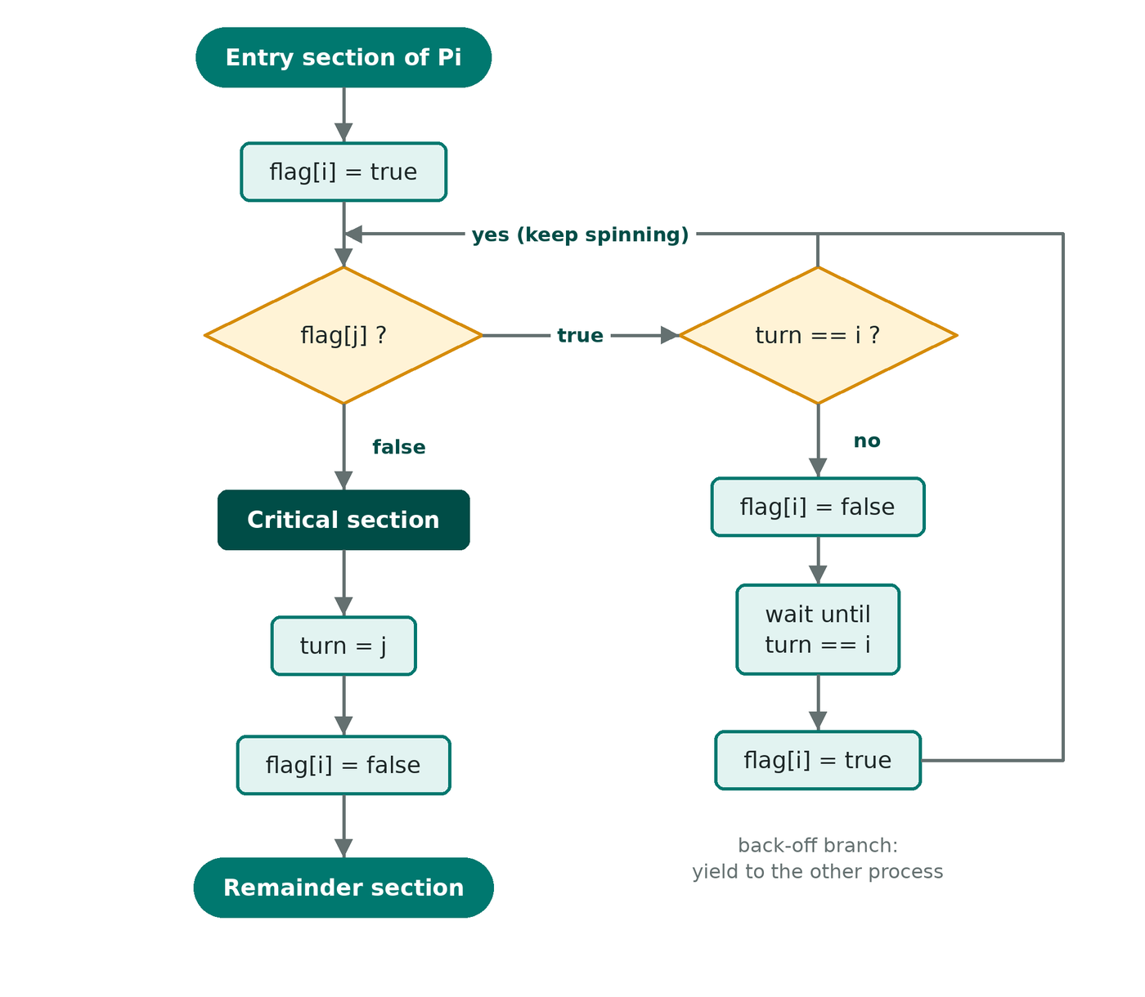
Figure 2: Flowchart of Dekker's algorithm (entry and exit sections of process Pi)

3.4 Correctness and limits
Mutual exclusion. Suppose both processes were inside the critical section. Each left its loop after seeing the other flag false, and each flag stays true until the process leaves the critical section. Let Pi be the one that made its (last) successful test first. At that moment flag[j] was false, so Pj had not yet raised its flag for this attempt; Pj raises it later, and then sees flag[i] still true, so it cannot leave its loop until Pi exits: a contradiction. Progress and bounded waiting follow from the turn variable, which is handed over on every exit.
Limits. The algorithm supports exactly two processes, wastes CPU while spinning, and is hard to extend or to prove. It also assumes sequentially consistent memory (see Section 4.6).

4. Peterson's Algorithm

4.1 Idea
G. L. Peterson published his algorithm in 1981 as a much simpler alternative. Each process first raises its flag and then gives the turn away to the other: "you go first if you want to". If both do this at the same time, the variable turn is written twice and the process that wrote it last is the one that waits. The tie is therefore broken by the order of two writes, with no need for the back-off dance of Dekker's algorithm.

4.2 Pseudocode
Listing 3: Peterson's algorithm for process Pi (j = 1 − i)
boolean flag[2] = {false, false}; // shared
int turn; // shared

do {
flag[i] = true; // I am interested
turn = j; // but you may go first
while (flag[j] && turn == j) ; // busy wait
/* critical section */
flag[i] = false; // I am done
/* remainder section */
} while (true);

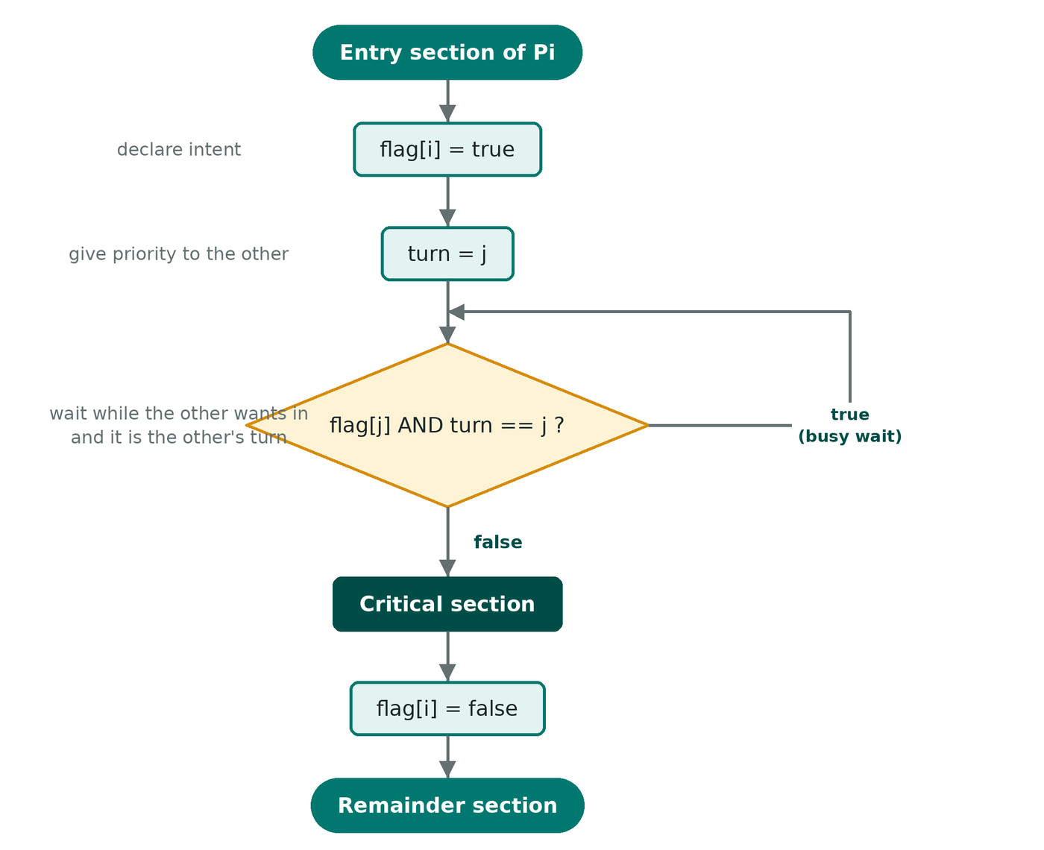
Figure 3: Flowchart of Peterson's algorithm

4.3 Proof of correctness
- Mutual exclusion. Assume Pi and Pj are both in the critical section, and that Pi executed turn = j before Pj executed turn = i (the other case is symmetric). Then turn == i for good. Pj passed its test, so it saw flag[i] == false or turn != i. But turn == i, and Pi had set flag[i] = true before writing turn and keeps it set until it leaves. Hence Pj cannot have passed: contradiction.
- Progress. If Pj is not interested, flag[j] is false and Pi passes immediately. If both are interested, turn holds exactly one value, so exactly one of them passes.
- Bounded waiting. When Pj leaves and tries again, it executes turn = i and gives priority to Pi. A waiting process is therefore overtaken at most once.

4.4 Execution trace
Figure 4 shows one interleaving in which both processes try at once (initial turn = 0). P1 writes turn = 0 and then P0 writes turn = 1; P0 wrote last, so P0 must wait and P1 enters first. After P1 clears its flag, P0 passes.
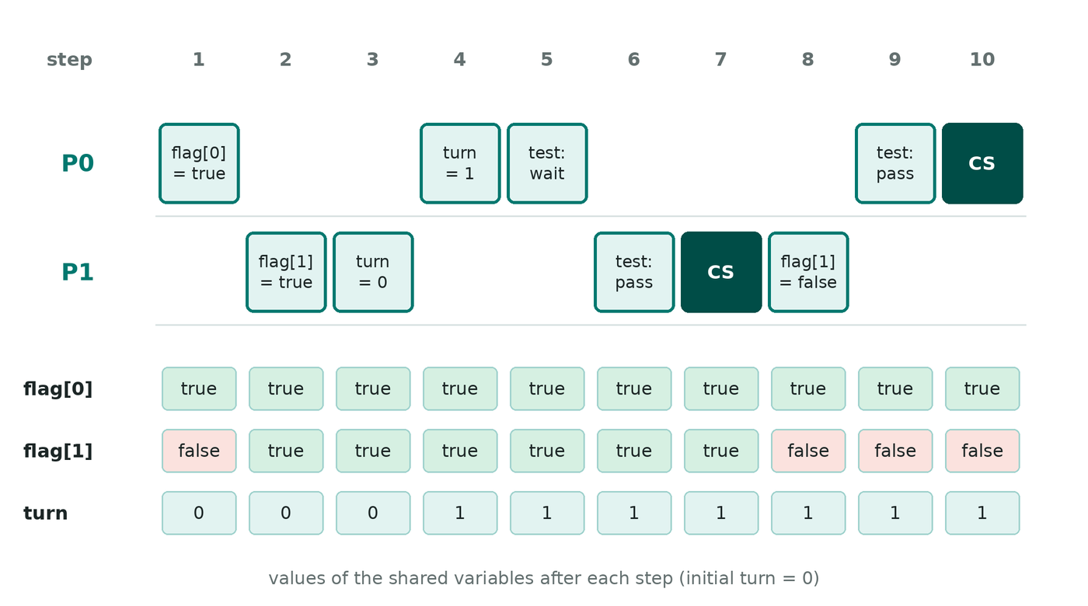
Figure 4: A trace of Peterson's algorithm: P1 enters first because P0 wrote turn last

4.5 Generalisation to N processes
Peterson's idea extends to N processes as the filter lock: a process must pass N − 1 levels, and at each level one process (the victim) is held back. At most N − L processes can be at level L or above. The price is O(N) work per entry, so it is a teaching tool rather than a practical lock.
Listing 4: Filter lock: N-process generalisation of Peterson (process i)
int level[N] = {0}; // level[k]: highest level process k has reached
int victim[N]; // victim[L]: last process to enter level L

lock(i):
for (L = 1; L < N; L++) {
level[i] = L;
victim[L] = i;
while (exists k != i with level[k] >= L && victim[L] == i) ;
}
unlock(i):
level[i] = 0;

4.6 Warning: modern memory models
Dekker and Peterson need sequential consistency
Today's CPUs and compilers reorder memory operations; in particular a store may become visible after a later load because of store buffers. In Peterson's algorithm the read of flag[j] can then happen before the write of flag[i] is visible, and both processes enter. A correct implementation needs a full memory fence between turn = j and the test, or sequentially consistent atomics (std::atomic in C++, volatile in Java).

5. Semaphores

5.1 Concept
A *semaphore (Dijkstra, 1965) is an integer variable that, apart from initialisation, is accessed only through two atomic operations: wait(S) (originally P, proberen, "to test") and signal(S) (originally V, verhogen*, "to increment"). wait decrements the value and makes the caller sleep if the resource is not available; signal increments it and wakes one sleeper. Unlike Dekker and Peterson, semaphores support any number of processes and avoid busy waiting, but they need help from the operating system and an atomic implementation.

5.2 Two implementations
Listing 5: Busy-waiting and blocking definitions of a semaphore
// (a) busy-waiting version (spinlock): operations must be atomic
wait(S): while (S <= 0) ; S--;
signal(S): S++;

// (b) blocking version: no CPU is wasted while waiting
typedef struct { int value; queue list; } semaphore;

wait(S):
S.value--;
if (S.value < 0) {
add this process to S.list;
block(); // sleep
}
signal(S):
S.value++;
if (S.value <= 0) {
remove a process P from S.list;
wakeup(P);
}

In the blocking version a negative value means "|value| processes are waiting". If the list is a FIFO queue the semaphore is strong and guarantees bounded waiting; if the wake-up order is arbitrary it is weak and starvation is possible.
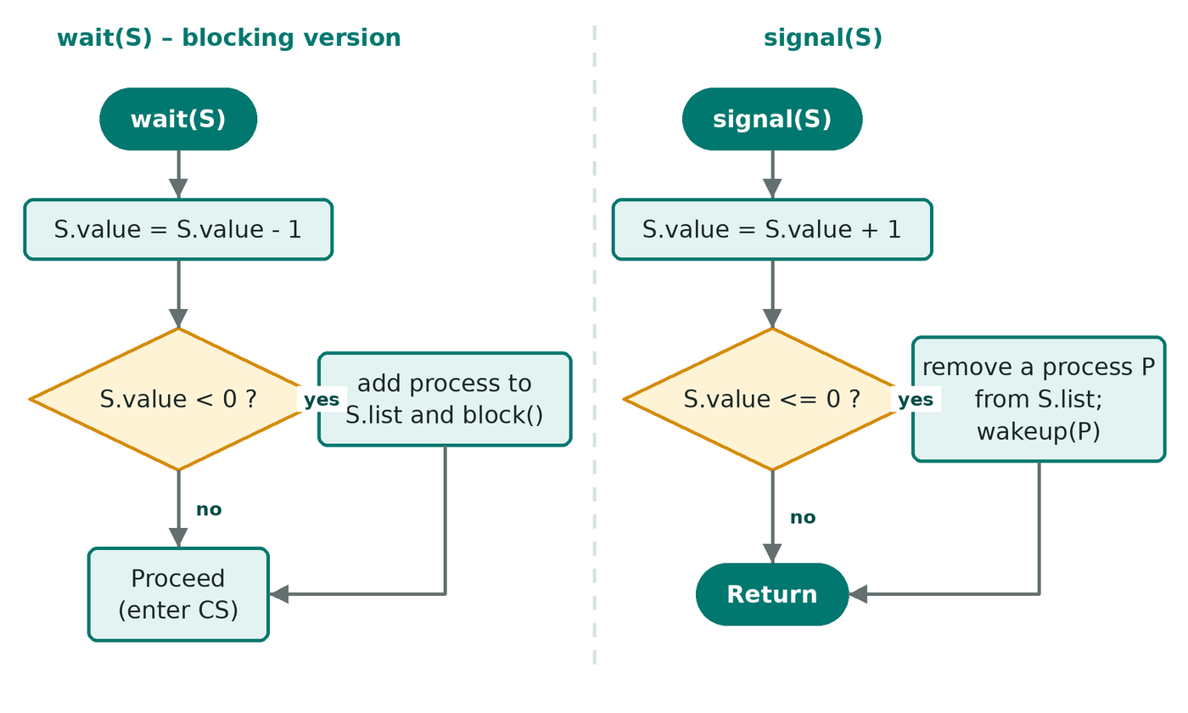
Figure 5: Flowchart of the blocking implementations of wait(S) and signal(S)

5.3 Types and usage patterns
- Binary semaphore (value 0 or 1, also called a mutex lock): guards a critical section; initial value 1.
- Counting semaphore (any non-negative initial value K): controls a pool of K identical resources, for example K printers or K buffer slots.
- Ordering (precedence): a semaphore initialised to 0 makes one process wait until another signals that an event has happened.
Listing 6: Classic bounded-buffer (producer–consumer) with three semaphores
semaphore mutex = 1; // protects the buffer
semaphore empty = N; // free slots
semaphore full = 0; // filled slots

Producer: Consumer:
do { do {
item = produce(); wait(full);
wait(empty); wait(mutex);
wait(mutex); item = remove();
insert(item); signal(mutex);
signal(mutex); signal(empty);
signal(full); consume(item);
} while (true); } while (true);

5.4 Pitfalls
- Deadlock: if P0 does wait(A); wait(B) and P1 does wait(B); wait(A), each can end up holding one semaphore while waiting for the other.
- Misuse: swapping wait(empty) and wait(mutex) in the producer deadlocks when the buffer is full; forgetting a signal blocks others forever; a spare signal breaks mutual exclusion.
- Priority inversion: a low-priority holder is preempted by a medium-priority process while a high-priority process waits for the semaphore. This happened on the Mars Pathfinder lander in 1997; the fix is priority inheritance.

6. Monitors

6.1 Concept
Semaphores leave synchronization scattered through the program, so one wrong call can break everything. Hoare (1974), building on Brinch Hansen's work, proposed the monitor: an abstract data type that bundles the shared data with the procedures that operate on it. The language guarantees that at most one process is active inside a monitor at any time; the compiler inserts the lock and unlock code, so mutual exclusion is automatic.

6.2 Condition variables
Mutual exclusion alone is not enough: a consumer must be able to wait inside the monitor until data exists. A condition variable x provides x.wait(), which releases the monitor lock and sleeps on the queue of x, and x.signal(), which wakes one waiter (or does nothing if nobody waits; unlike a semaphore, a condition signal is not remembered). x.broadcast() wakes all waiters. Two semantics exist for what happens after a signal, summarised in Table 2.
Table 2: Hoare versus Mesa signalling semantics
Aspect | Hoare (signal-and-wait) | Mesa (signal-and-continue)
After x.signal() | Signaller suspends; the woken process runs immediately. | Signaller continues; the woken process is only made ready.
Condition guaranteed on wake-up | Yes | No: another process may have changed the state
Test in the waiting code | if (cond) x.wait(); | while (cond) x.wait();
Context switches | More | Fewer
Used in | Textbooks, original proposal | Java, C#, POSIX threads, Mesa

6.3 Example: bounded buffer as a monitor
Listing 7: Bounded buffer monitor (Mesa semantics)
monitor BoundedBuffer {
int buf[N]; int count = 0, in = 0, out = 0;
condition notFull, notEmpty;

procedure put(item) {
while (count == N) notFull.wait();
buf[in] = item; in = (in + 1) % N; count++;
notEmpty.signal();
}
procedure get() {
while (count == 0) notEmpty.wait();
item = buf[out]; out = (out + 1) % N; count--;
notFull.signal();
return item;
}
}

Compare this with the semaphore version in Listing 6: there is no mutex, no pairing of wait and signal to get right, and the conditions are written in plain terms (count == N).
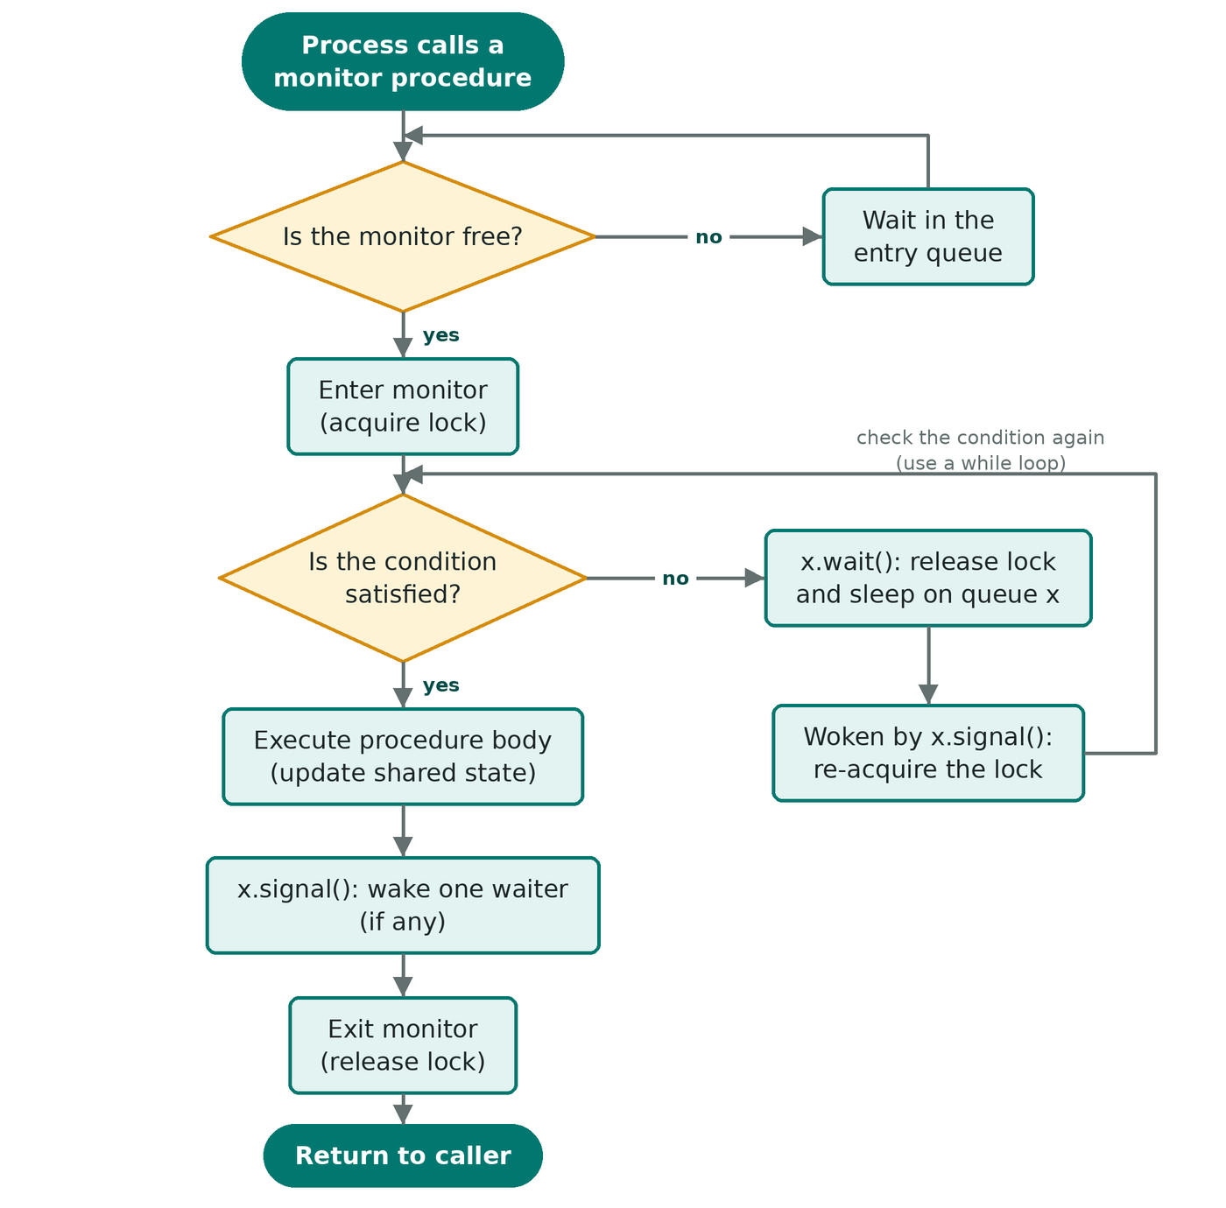
Figure 6: Flowchart of a call to a monitor procedure with a condition wait (Mesa semantics)
In practice. Java offers monitors through synchronized methods with wait(), notify() and notifyAll(); C# through lock and Monitor.Wait/Pulse; C and C++ emulate them with a pthread_mutex_t plus pthread_cond_t (always re-test the condition in a loop). Risks that remain are deadlock from nested monitor calls (a process waits inside the inner monitor while still holding the outer one) and lost wake-ups when signal is used instead of broadcast.

7. The Readers–Writers Problem

7.1 Statement
Courtois, Heymans and Parnas (1971) posed the problem for a shared database. Readers only look at the data, so any number of them may read at the same time. Writers modify it, so a writer needs exclusive access: no other writer and no reader. A plain mutex would be correct but would forbid concurrent reading and waste most of the available parallelism. The challenge is to allow concurrent readers while keeping writers safe, and to decide who waits when both kinds are present.
Table 3: The three classic variants
Variant | Rule | Advantage | Drawback
1. Reader priority | No reader waits unless a writer is already writing. | Maximum read concurrency | Writers may starve
2. Writer priority | A waiting writer goes before any new reader. | Data stays fresh | Readers may starve
3. Fair (FIFO) | Requests are served in arrival order; consecutive readers share. | No starvation | Less parallelism, more complex

7.2 Variant 1: reader priority with semaphores
The first reader locks the resource on behalf of all readers and the last reader releases it; readcount is protected by mutex, and wrt is the writers' lock.
Listing 8: Readers–writers, variant 1 (reader priority)
semaphore mutex = 1, wrt = 1;
int readcount = 0;

Writer: Reader:
wait(wrt); wait(mutex);
/* write */ readcount++;
signal(wrt); if (readcount == 1) wait(wrt); // first in
signal(mutex);
/* read */
wait(mutex);
readcount--;
if (readcount == 0) signal(wrt); // last out
signal(mutex);

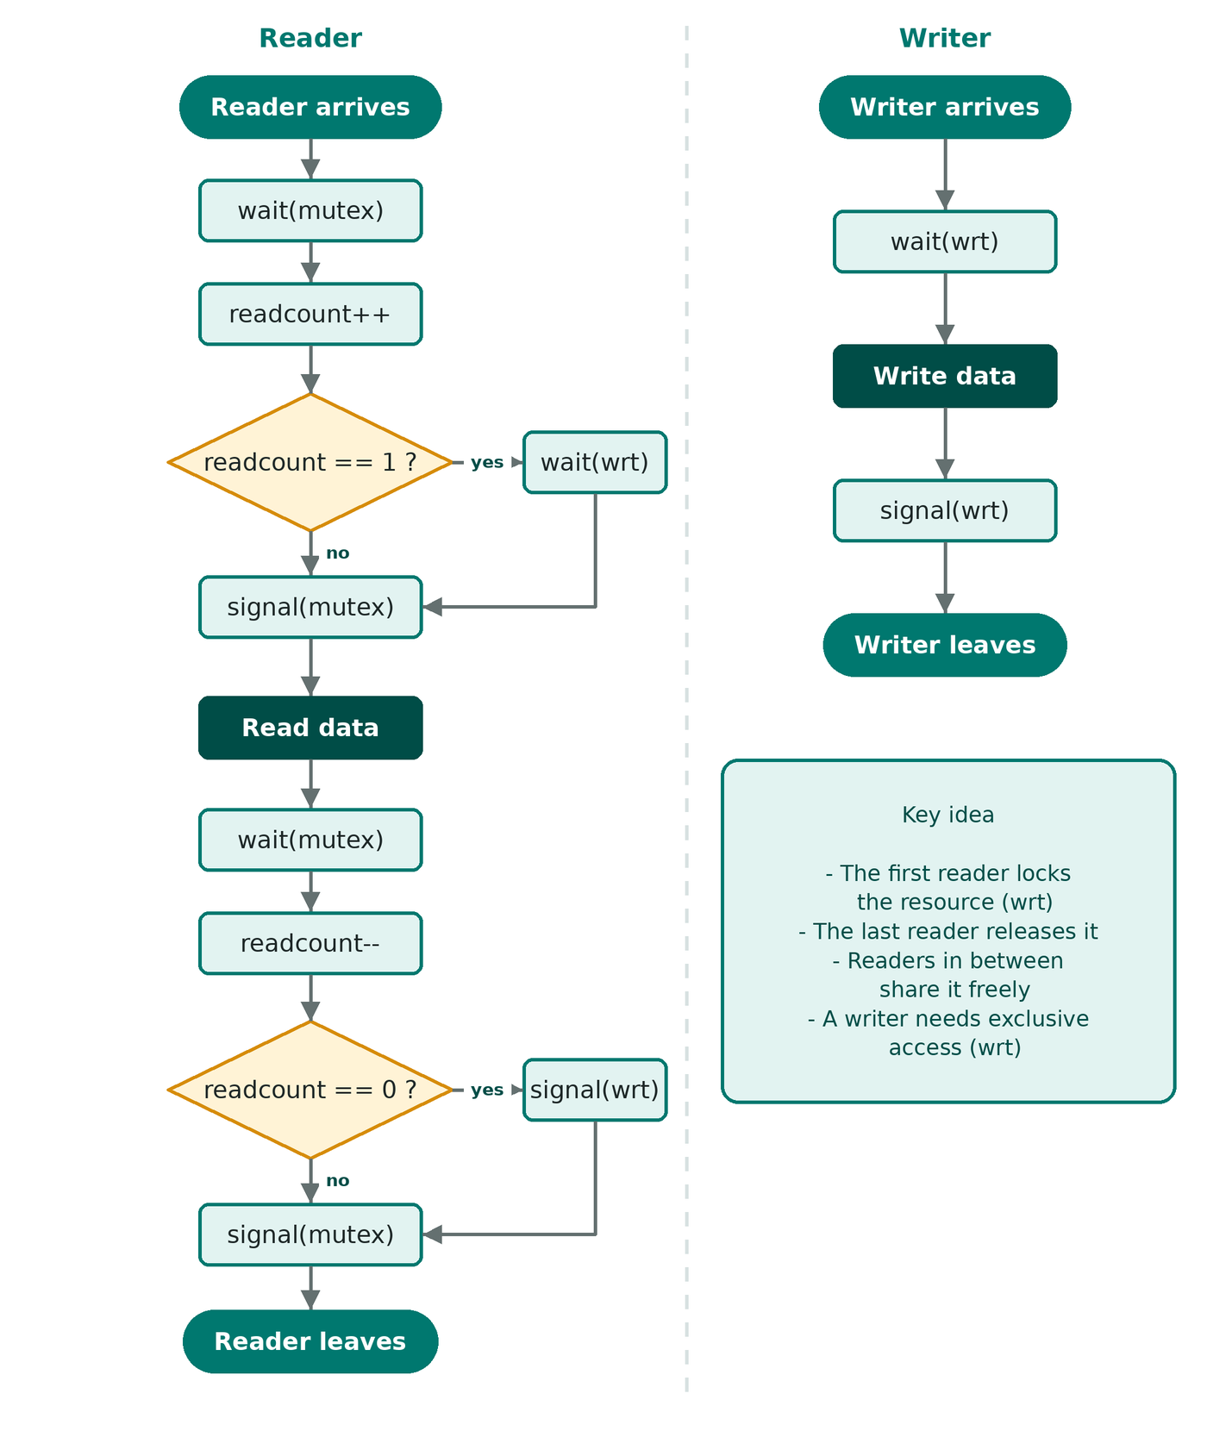
Figure 7: Flowcharts of the reader and the writer (variant 1)

7.3 Variants 2 and 3
Listing 9: Variant 2 (writer priority)
semaphore rmutex = 1, wmutex = 1, readTry = 1, resource = 1;
int readcount = 0, writecount = 0;

Reader: Writer:
wait(readTry); wait(wmutex);
wait(rmutex); writecount++;
readcount++; if (writecount == 1) wait(readTry);
if (readcount == 1) signal(wmutex);
wait(resource); wait(resource);
signal(rmutex); /* write */
signal(readTry); signal(resource);
/* read */ wait(wmutex);
wait(rmutex); writecount--;
readcount--; if (writecount == 0) signal(readTry);
if (readcount == 0) signal(wmutex);
signal(resource);
signal(rmutex);

Listing 10: Variant 3 (fair: a FIFO semaphore orders all requests)
semaphore serviceQueue = 1; // must be FIFO (strong)
semaphore mutex = 1, resource = 1; int readcount = 0;

Reader: Writer:
wait(serviceQueue); wait(serviceQueue);
wait(mutex); wait(resource);
readcount++; signal(serviceQueue);
if (readcount == 1) /* write */
wait(resource); signal(resource);
signal(serviceQueue);
signal(mutex);
/* read */
wait(mutex);
readcount--;
if (readcount == 0) signal(resource);
signal(mutex);

7.4 Monitor solution
Listing 11: Readers–writers as a monitor (Mesa semantics)
monitor ReadersWriters {
int readers = 0; boolean writing = false;
condition okToRead, okToWrite;

procedure startRead() { while (writing) okToRead.wait(); readers++; }
procedure endRead() { readers--; if (readers == 0) okToWrite.signal(); }
procedure startWrite() { while (writing || readers > 0) okToWrite.wait();
writing = true; }
procedure endWrite() { writing = false;
okToWrite.signal(); okToRead.broadcast(); }
}

Library read–write locks (pthread_rwlock_t, Java ReentrantReadWriteLock, C++ std::shared_mutex) are packaged versions of exactly these solutions.

8. Comprehensive Comparison
The next three tables compare the five techniques on 23 parameters: seven about correctness and liveness, nine about implementation and cost, and seven about usability. Readers–Writers refers to the classic semaphore solutions of Section 7.
Table 4: Comparison 1: correctness and liveness
Parameter | Dekker | Peterson | Semaphore | Monitor | Readers–Writers
Mutual exclusion | Yes (flags + turn) | Yes | Yes, if initial value is 1 and calls are paired | Yes, enforced by compiler/runtime | Writer exclusive; readers may share
Progress | Yes | Yes | Yes | Yes | Yes
Bounded waiting | Yes (other enters at most once) | Yes (other enters at most once) | Only with FIFO queue (strong semaphore) | Depends on queue discipline | Depends on the variant
Starvation | None | None | Possible with weak semaphores | Possible if signal order is unfair | Writers in variant 1, readers in 2, none in 3
Deadlock | Free | Free | Possible when misused | Possible with nested monitor calls | Free in standard solutions
Fairness | Alternation under contention | Alternation under contention | FIFO if strong | FIFO if queues are FIFO | Reader, writer or FIFO order
Priority inversion | Possible when spinning on one CPU | Possible when spinning on one CPU | Possible; use priority inheritance | Possible; use priority inheritance | Possible (reader holds the lock)

Table 5: Comparison 2: implementation and cost
Parameter | Dekker | Peterson | Semaphore | Monitor | Readers–Writers
Category | Software algorithm | Software algorithm | OS primitive | Language construct | Classic problem (uses S or M)
Inventor, year | Dekker / Dijkstra, 1965 | Peterson, 1981 | Dijkstra, 1965 | Hoare, 1974 | Courtois et al., 1971
Waiting style | Busy waiting | Busy waiting | Blocking (spin version possible) | Blocking | Blocking
Max processes | 2 | 2 (N with filter lock) | Any number | Any number | Any number
Hardware support | None, but needs sequential consistency | None, but needs sequential consistency | Atomic wait/signal (CAS, test-and-set) | Atomic lock underneath | As for S or M
OS / language support | None | None | Kernel or library | Compiler / runtime (Java, C#) | Semaphore, monitor or rwlock library
Shared data | flag[2], turn | flag[2], turn | Counter + wait queue | Lock + condition queues | readcount, mutex, wrt
Uncontended entry cost | O(1), a few memory accesses | O(1) (O(N) filter lock) | O(1), plus context switch if blocked | O(1) lock and unlock | O(1) per read/write
Memory-model issues | Fails without fences | Fails without fences | Handled inside | Handled by runtime | Handled by primitive

Table 6: Comparison 3: usability and typical use
Parameter | Dekker | Peterson | Semaphore | Monitor | Readers–Writers
Ease of programming | Very hard to reason about | Easy to remember, moderate to prove | Simple but easy to misuse | Easiest: language gives structure | Moderate to hard
Error proneness | Medium | Medium (line order matters) | High (missing signal, wrong order) | Low (Mesa: use while) | High (variants differ subtly)
Scalability | Poor: 2 processes | Poor: filter lock O(N) | Good | Good | Very good if reads dominate
Parallelism allowed | None in the critical section | None in the critical section | Up to K holders (counting) | None inside the monitor | Many concurrent readers
Typical applications | Teaching, theory | Teaching, proofs, small spinlocks | Kernels, resource pools, ordering | Java/C# objects, thread-safe queues | Databases, file systems, caches
Main advantage | First correct software-only solution | Shortest software-only solution | General, no busy waiting | Safety by construction | High throughput for reads
Main limitation | 2 processes, spinning | Spinning, needs fences | Needs programmer discipline | Needs language support | Starvation unless fair variant

8.1 Visual summary
Figure 8 gives a quick map of which properties each technique satisfies. Green means always, amber means only under a condition (a FIFO queue, careful use, the right variant), red means no.
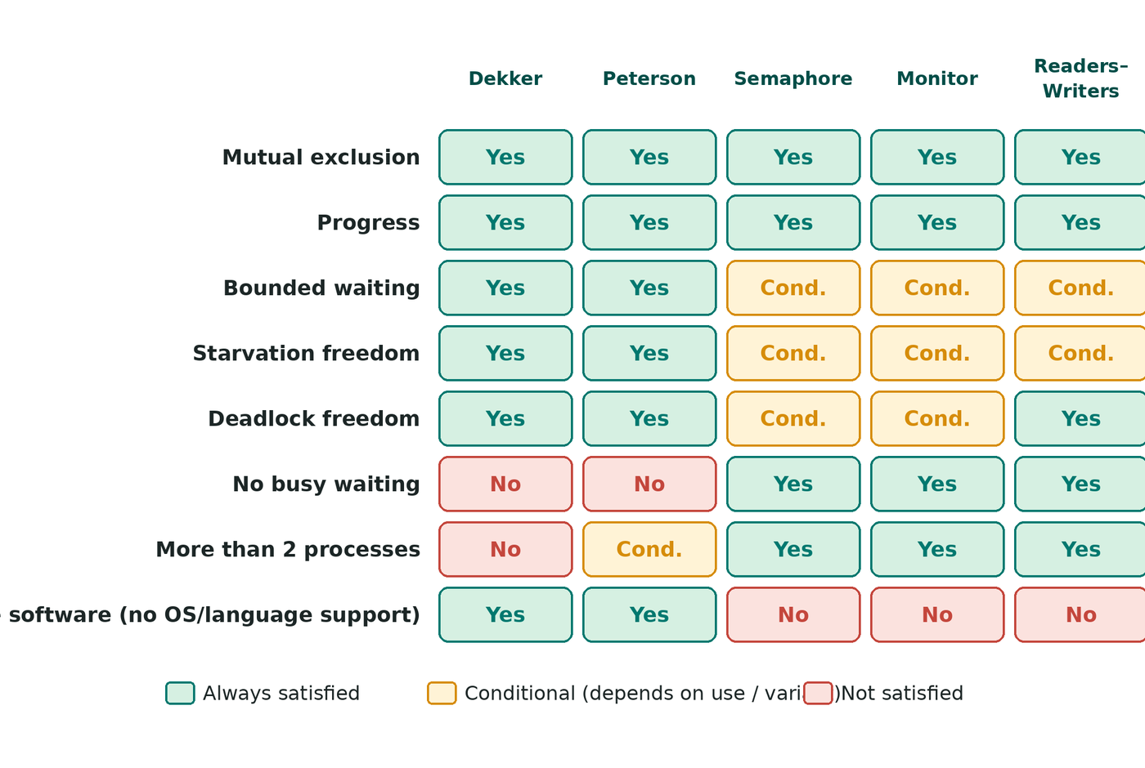
Figure 8: Property matrix of the five techniques
Figures 9 and 10 rate the techniques on six practical criteria from 1 to 5 (5 is best). These are the author's qualitative scores derived from Tables 4 to 6; they illustrate trade-offs and are not measured benchmarks. Monitors score highest overall because they combine safety with scalability, while Dekker's algorithm pays for its independence from the operating system with ease of use and scale.
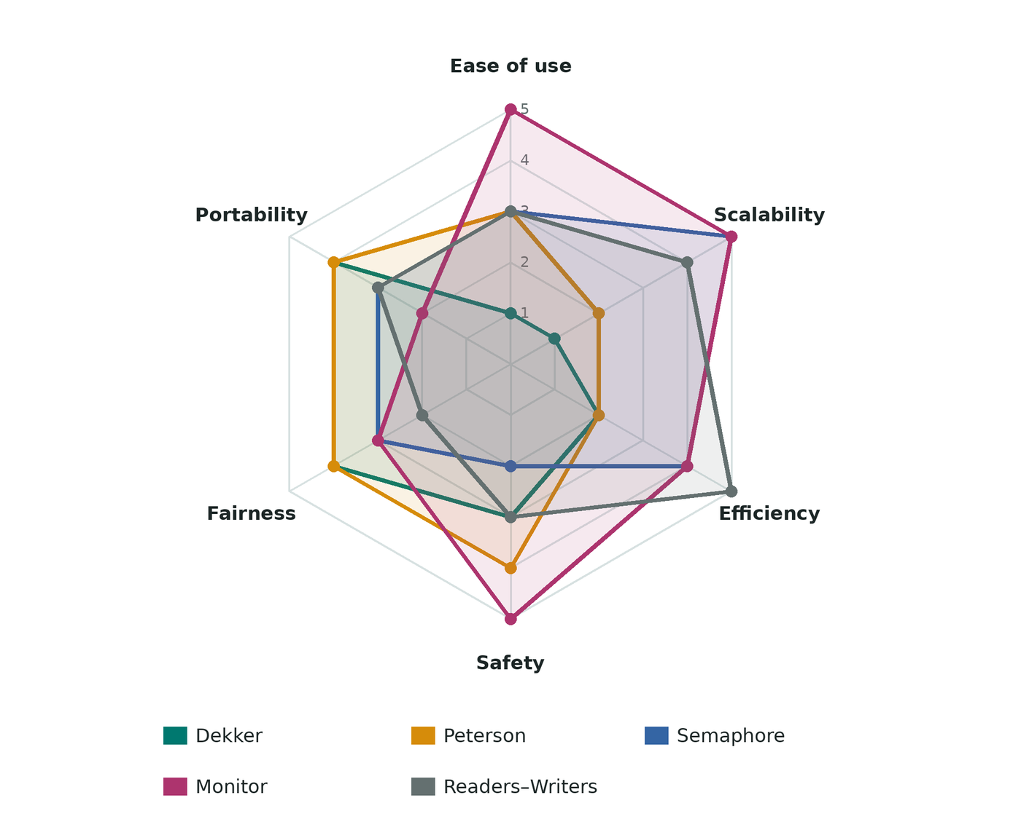
Figure 9: Radar chart of six qualitative criteria (1–5, higher is better)
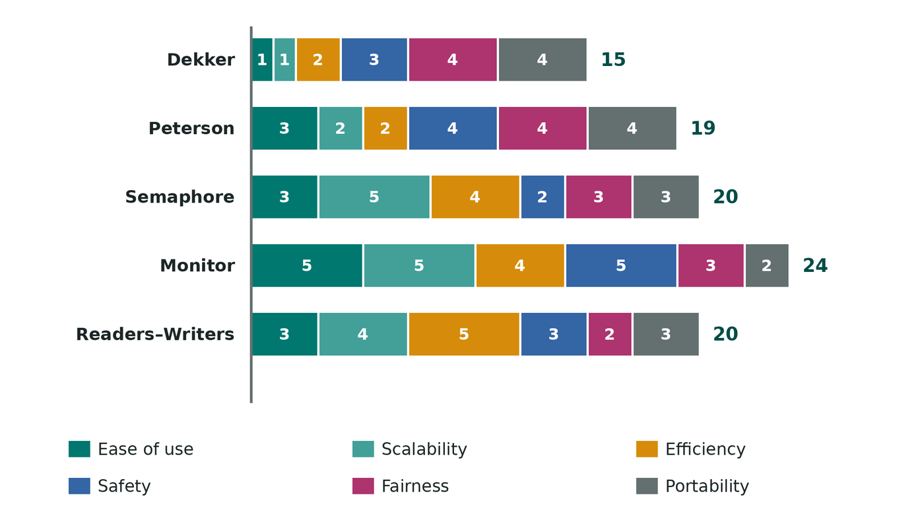
Figure 10: Total qualitative score per technique, stacked by criterion

8.2 Cost of waiting: spinning versus blocking
Dekker and Peterson spin; semaphores and monitors block. A simple model shows when each is cheaper. Spinning for a wait of length W wastes W of CPU time. Blocking costs two context switches (out and back in), about 2c, regardless of W. Spinning therefore wins when W < 2c and blocking wins when the wait is longer (Figure 11). This is why operating systems use short spinlocks inside the kernel but let user threads sleep, and why hybrid locks spin briefly before blocking.
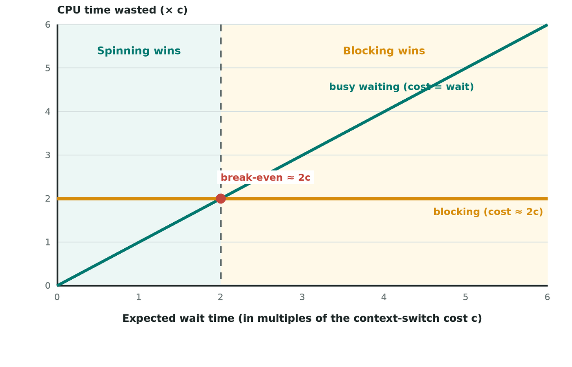
Figure 11: Theoretical CPU time wasted by busy waiting versus blocking

8.3 Why readers–writers matter: parallelism gain
With a plain mutex every operation is serialised. With a read–write lock, N cores can read together while writers still run alone. If a fraction p of the operations are reads and each takes the same time, the throughput relative to a mutex is 1 / ((1 − p) + p / N), which is Amdahl's law with the writers as the serial part (Figure 12). For read-mostly data the gain approaches N; for write-heavy data it vanishes.
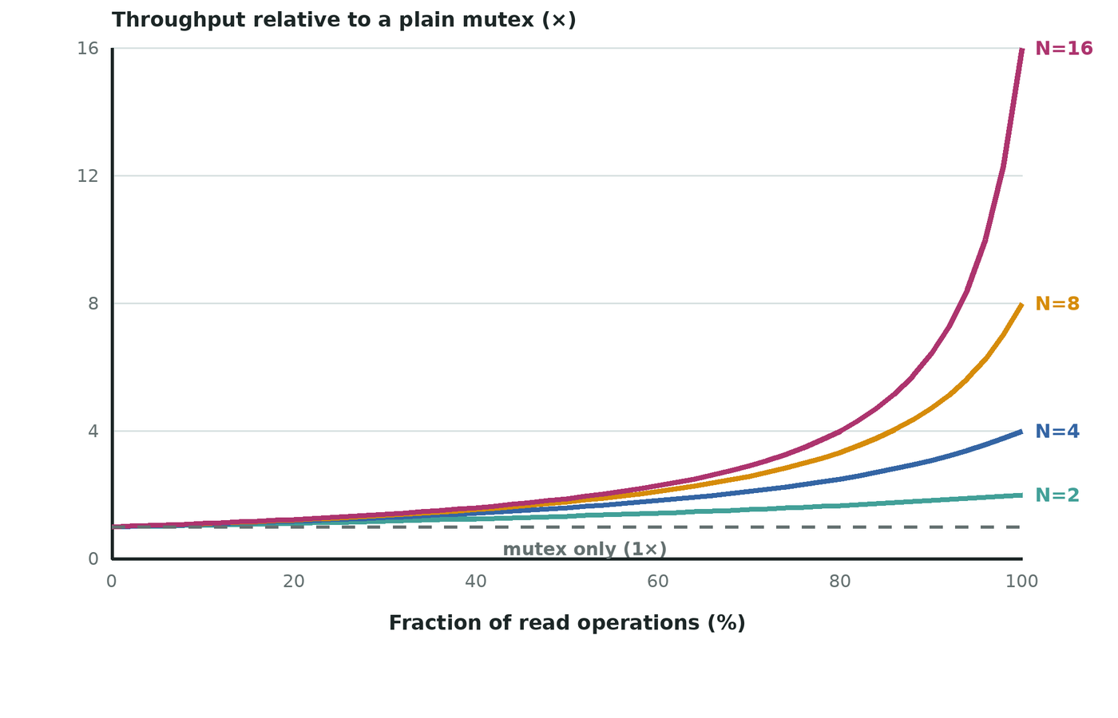
Figure 12: Theoretical throughput of a read–write lock relative to a mutex (N cores)

8.4 Which one should I choose?
Table 7: Selection guide
Situation | Recommended technique
Learning or proving mutual exclusion | Peterson's algorithm (Dekker for history)
Two threads, no OS, tiny critical section | Peterson with memory fences, or better a hardware atomic spinlock
Resource pools, ordering between processes, kernel code | Semaphores
Shared object with complex waiting conditions (Java, C#) | Monitors
Read-mostly shared data | Read–write lock; fair variant if writers matter

9. Worked Examples

Example 1: Dekker's algorithm under contention
Both processes try at the same moment and turn = 0. The trace shows P1 backing off and P0 entering first, then P1 entering after P0 hands over the turn.
Table 8: Trace of Dekker's algorithm
Step | Process | Action | flag[0] | flag[1] | turn
1 | P0 | flag[0] = true | T | F | 0
2 | P1 | flag[1] = true | T | T | 0
3 | P0 | tests flag[1] (true); turn == 0 so keeps spinning | T | T | 0
4 | P1 | tests flag[0] (true); turn != 1 so backs off: flag[1] = false | T | F | 0
5 | P0 | flag[1] is false: leaves loop, enters critical section | T | F | 0
6 | P0 | exit: turn = 1; flag[0] = false | F | F | 1
7 | P1 | turn == 1: flag[1] = true, tests flag[0] (false), enters | F | T | 1

Example 2: a counting semaphore guarding two printers
Three processes need a printer and the semaphore S starts at 2 (blocking implementation).
Table 9: Trace of a counting semaphore
Event | S.value | Waiting list | Result
start | 2 | — | both printers free
P1: wait(S) | 1 | — | P1 prints
P2: wait(S) | 0 | — | P2 prints
P3: wait(S) | -1 | [P3] | P3 blocks
P1: signal(S) | 0 | [ ] | P3 is woken and prints
P2: signal(S) | 1 | [ ] | one printer free
P3: signal(S) | 2 | [ ] | both printers free

Example 3: bounded buffer with N = 3
Table 10: Trace of the semaphore bounded buffer (empty = 3, full = 0 at start)
Step | Event | empty | full | Buffer
0 | start | 3 | 0 | [ ]
1 | producer puts A | 2 | 1 | [A]
2 | producer puts B | 1 | 2 | [A, B]
3 | consumer takes A | 2 | 1 | [B]
4 | producer puts C | 1 | 2 | [B, C]
5 | producer puts D (buffer full) | 0 | 3 | [B, C, D]
6 | producer wants E: wait(empty) blocks | -1 | 3 | [B, C, D]
7 | consumer takes B; signal(empty) wakes producer | 0 | 2 | [C, D]
8 | producer completes put E | 0 | 3 | [C, D, E]

Example 4: arrival order in readers–writers
Requests arrive in the order R1, R2, W1, R3, W2 while R1 and R2 are still reading. The variants serve them as follows.
Table 11: Service order under the three variants
Variant | Service order | Remark
1. Reader priority | {R1, R2, R3} → W1 → W2 | R3 joins the running readers; both writers wait
2. Writer priority | {R1, R2} → W1 → W2 → R3 | R3 is held back once W1 is waiting
3. Fair (FIFO) | {R1, R2} → W1 → R3 → W2 | strict arrival order

10. Exam-Style Questions

10.1 Multiple choice
1. Which requirement is violated if a process that is outside its critical section can stop others from entering?
(a) mutual exclusion (b) progress (c) bounded waiting (d) fairness of the scheduler
2. In Peterson's algorithm, what is the role of the variable turn?
(a) counts entries (b) breaks the tie when both flags are raised (c) marks the critical section (d) stores the process id of the owner
3. How many shared variables does Peterson's algorithm for two processes use?
(a) 1 (b) 2 (c) 3 (d) 4
4. To use a semaphore as a mutex lock, its initial value must be:
(a) 0 (b) 1 (c) N (d) −1
5. A counting semaphore starts at 5. Seven wait() and three signal() operations are performed (blocking implementation). Its value is:
(a) −1 (b) 0 (c) 1 (d) 2
6. Why must a Mesa-style monitor test its condition in a while loop?
(a) for speed (b) signal is only a hint and the state may change before the woken process runs (c) to avoid deadlock with the OS (d) to count waiters
7. Which readers–writers variant can starve writers?
(a) reader priority (b) writer priority (c) fair FIFO (d) none
8. Which technique needs support from the compiler or language?
(a) Dekker (b) Peterson (c) semaphore (d) monitor
9. Which algorithm generalises to N processes as the filter lock?
(a) Dekker (b) Peterson (c) monitor (d) readers–writers
10. Which property is NOT guaranteed by a semaphore whose wake-up order is arbitrary?
(a) mutual exclusion (b) bounded waiting (c) atomicity of wait (d) progress
Table 12: Answer key for the multiple-choice questions
Q | Answer | Reason
1 | b | Progress forbids processes outside the critical section from blocking others.
2 | b | The last writer of turn waits, so exactly one process passes.
3 | c | flag[0], flag[1] and turn.
4 | b | Value 1 lets exactly one process through.
5 | c | 5 − 7 + 3 = 1 (two waiters were woken).
6 | b | Mesa signal only makes the waiter ready; the condition must be re-checked.
7 | a | Readers keep joining, so writers may wait forever.
8 | d | Monitors are a language construct.
9 | b | Peterson extends to N levels (filter lock).
10 | b | Without FIFO a process may be bypassed forever.

10.2 Short answer
1. State the three requirements for a solution to the critical-section problem.
Answer: Mutual exclusion, progress and bounded waiting (see Section 2.3).
2. Compare busy waiting and blocking. When is spinning the better choice?
Answer: Busy waiting keeps the CPU running a test loop; blocking puts the process to sleep in a queue at the price of about two context switches. Spinning is better when the expected wait is shorter than two context switches, e.g. very short critical sections on multiprocessors.
3. Why can Peterson's algorithm fail on a modern processor?
Answer: Store buffers and compiler optimisations reorder memory operations, so the read of the other flag may happen before our own write is visible. A full memory fence or sequentially consistent atomics is required.
4. What is the difference between Hoare and Mesa monitor semantics?
Answer: In Hoare semantics the signaller yields and the woken process runs at once with the condition guaranteed (if is enough). In Mesa semantics the signaller continues and the woken process only becomes ready, so it must re-check the condition in a while loop.
5. What is priority inversion and how is it fixed?
Answer: A high-priority process waits for a lock held by a low-priority process that is preempted by a medium-priority one. The fix is priority inheritance: the holder temporarily gets the priority of the highest waiter.
6. Differentiate binary and counting semaphores.
Answer: A binary semaphore takes only the values 0 and 1 and implements mutual exclusion; a counting semaphore ranges over non-negative integers and controls a pool of identical resources.

10.3 Problems
1. Prove that Peterson's algorithm guarantees mutual exclusion.
Answer: See Section 4.3: if both were inside, the process that wrote turn last would have seen flag of the other true and turn pointing to itself, so it could not have passed its test.
2. In Peterson's algorithm the two lines flag[i] = true; and turn = j; are swapped. Show that mutual exclusion is violated.
Answer: Trace: P0 turn = 1; P1 turn = 0; P1 flag[1] = true; P1 tests flag[0] (false) and enters; P0 flag[0] = true; P0 tests flag[1] && turn == 1: flag[1] is true but turn is 0, so P0 also enters. Both are inside.
3. Three processes must execute statements A (in P1), B (in P2) and C (in P3) in the order A, B, C. Use semaphores.
Listing 12: Solution to Problem 3
semaphore s1 = 0, s2 = 0;

P1: A; signal(s1);
P2: wait(s1); B; signal(s2);
P3: wait(s2); C;

4. Explain why the lock while (lock == 1) ; lock = 1; does not solve the critical-section problem.
Answer: Testing and setting are two separate steps. Both processes can see lock == 0 before either sets it to 1, and then both enter. The test-and-set must be one atomic operation (a hardware instruction), which is exactly what semaphores and Peterson's turn trick work around or build on.
5. Requests R1, R2, W1, R3, W2 arrive in this order. Give the service order under reader priority and under the fair variant.
Answer: Reader priority: {R1, R2, R3}, W1, W2. Fair: {R1, R2}, W1, R3, W2 (see Example 4).

11. Conclusion
Dekker's and Peterson's algorithms prove that mutual exclusion can be achieved with ordinary reads and writes alone, and Peterson's is the clearest teaching example, but both are limited to two processes, spin, and depend on memory ordering that real hardware does not give for free. Semaphores remove busy waiting and scale to any number of processes, at the price of programmer discipline. Monitors move the discipline into the language and are the safest general-purpose choice. The readers–writers problem shows that correctness is only part of the story: how a solution treats priorities, starvation and parallelism decides its real-world performance, and read–write locks are the practical answer for read-mostly data. In practice the choice follows the environment: hardware atomics and semaphores inside kernels, monitors or locks with condition variables in application languages, and Peterson's idea as the foundation for understanding all of them.

References
[1] Dijkstra, E. W. (1965). Solution of a problem in concurrent programming control. Communications of the ACM, 8(9), 569.
[2] Dijkstra, E. W. (1968). Cooperating sequential processes (EWD123). Technological University Eindhoven.
[3] Peterson, G. L. (1981). Myths about the mutual exclusion problem. Information Processing Letters, 12(3), 115–116.
[4] Lamport, L. (1974). A new solution of Dijkstra's concurrent programming problem. Communications of the ACM, 17(8), 453–455.
[5] Hoare, C. A. R. (1974). Monitors: an operating system structuring concept. Communications of the ACM, 17(10), 549–557.
[6] Brinch Hansen, P. (1973). Operating System Principles. Prentice-Hall.
[7] Lampson, B. W., & Redell, D. D. (1980). Experience with processes and monitors in Mesa. Communications of the ACM, 23(2), 105–117.
[8] Courtois, P. J., Heymans, F., & Parnas, D. L. (1971). Concurrent control with "readers" and "writers". Communications of the ACM, 14(10), 667–668.
[9] Silberschatz, A., Galvin, P. B., & Gagne, G. (2018). Operating System Concepts (10th ed.). Wiley.
[10] Tanenbaum, A. S., & Bos, H. (2014). Modern Operating Systems (4th ed.). Pearson.
[11] Herlihy, M., & Shavit, N. (2012). The Art of Multiprocessor Programming (revised 1st ed.). Morgan Kaufmann.

