A Comprehensive Reference on Process Synchronization in Operating Systems
Peterson's Algorithm, Dekker's Algorithm, Semaphores, Monitors, and the Readers-Writers Problem
Operating Systems — Process Synchronization and Concurrency
An educational and comparative reference for university study and exam preparation
November 2026

Abstract
Synchronization of processes and threads is one of the most fundamental topics in operating systems, because concurrent execution without controlled access to shared resources leads to data inconsistency and unpredictable behavior. This article examines five classical techniques at an equal level of detail: Peterson's algorithm, Dekker's algorithm, semaphores, monitors, and the Readers-Writers problem. For each technique we present its definition and history, the assumptions of its execution model, Python-style pseudocode with a line-by-line explanation, a numerical example, a multi-process scenario, a flowchart, and a formal analysis of mutual exclusion, progress, and bounded waiting. All analyses are explicitly conditioned on the model assumptions, and the difference between the classical algorithms (which assume sequentially consistent memory) and modern implementations built on memory models and atomic operations is explained. The article closes with comparative tables, conceptual diagrams, common errors, more than twenty exam questions with detailed answers, and algorithm-design exercises.
Keywords: synchronization, mutual exclusion, critical section, Peterson, Dekker, semaphore, monitor, Readers-Writers, starvation, deadlock, memory model.

Table of Contents
Abstract 1
1 Introduction 1
1.1 Motivation and Problem Statement 1
1.2 Scope and Methodology 1
1.3 Notation and Conventions 1
1.4 Organization of the Article 1
2 Fundamental Concepts 1
2.1 Process and Thread 1
2.2 Concurrency and Race Conditions 1
2.3 Critical Section 1
2.4 Mutual Exclusion 1
2.5 Progress 1
2.6 Bounded Waiting 1
2.7 Starvation and Deadlock 1
2.8 Busy Waiting 1
2.9 Synchronization and Atomic Operations 1
2.9.1 Memory Model 1
2.10 Execution Model and Assumptions 1
2.11 Summary of the Concepts 1
3 Peterson's Algorithm 1
3.1 History and Definition 1
3.2 Purpose and Operation 1
3.3 Conditions and Assumptions 1
3.4 Step-by-Step Algorithm 1
3.5 Pseudocode and Line-by-Line Explanation 1
3.6 Worked Example with Numerical Trace 1
3.7 Multi-Process Scenarios and Generalization to n Processes 1
3.8 Analysis of ME, Progress, and Bounded Waiting 1
3.8.1 Mutual Exclusion 1
3.8.2 Progress 1
3.8.3 Bounded Waiting 1
3.9 Peterson on Modern Memory Models 1
3.10 Strengths, Weaknesses, Limitations, and Applications 1
4 Dekker's Algorithm 1
4.1 History and Definition 1
4.2 Purpose and Operation 1
4.3 Conditions and Assumptions 1
4.4 Step-by-Step Algorithm 1
4.5 Pseudocode and Line-by-Line Explanation 1
4.6 Worked Example with Numerical Trace 1
4.7 Multi-Process Scenarios: The Failed Attempts 1
4.8 Analysis of ME, Progress, and Bounded Waiting 1
4.9 Dekker on Modern Memory Models 1
4.10 Strengths, Weaknesses, Limitations, and Applications 1
5 Semaphores 1
5.1 History and Definition 1
5.2 Purpose and Operation 1
5.3 Conditions and Assumptions 1
5.4 Step-by-Step Algorithm 1
5.5 Pseudocode and Line-by-Line Explanation 1
5.6 Semaphore Invariants 1
5.7 Worked Example with Numerical Trace 1
5.8 Multi-Process Scenario: Producer-Consumer 1
5.9 Analysis of ME, Progress, and Bounded Waiting 1
5.10 Deadlock, Starvation, Race Conditions, and Priority Inversion 1
5.11 Strengths, Weaknesses, Limitations, and Applications 1
6 Monitors 1
6.1 History and Definition 1
6.2 Purpose and Operation 1
6.3 Conditions and Assumptions 1
6.4 Step-by-Step Algorithm 1
6.5 Pseudocode and Line-by-Line Explanation 1
6.6 Worked Example with Numerical Trace 1
6.7 Multi-Thread Scenarios and Nested Monitor Calls 1
6.8 Analysis of ME, Progress, and Bounded Waiting 1
6.9 Strengths, Weaknesses, Limitations, and Applications 1
7 The Readers-Writers Problem 1
7.1 History and Definition 1
7.2 Purpose and Operation 1
7.3 Conditions and Assumptions 1
7.4 Semaphore-Based Solutions 1
7.4.1 Reader Preference 1
7.4.2 Writer Preference 1
7.4.3 Fair (Starvation-Free) Solution 1
7.5 Monitor-Based Solutions 1
7.6 Numerical Example: Comparing the Three Policies 1
7.7 Analysis of ME, Progress, and Bounded Waiting 1
7.8 Strengths, Weaknesses, Limitations, and Applications 1
8 Semaphores versus Monitors 1
8.1 Overview 1
8.2 Structural and Functional Comparison 1
8.3 Important Semantic Differences 1
8.4 Implementing One with the Other 1
8.5 Choosing in Practice 1
9 Comprehensive Comparison of the Techniques 1
9.1 Peterson versus Dekker 1
9.2 Comparison of Fairness Guarantees 1
9.3 Comparison of Deadlock and Starvation Conditions 1
9.4 Use of Each Technique in Operating Systems 1
10 Flowcharts of the Algorithms 1
10.1 Standard Symbols 1
10.2 Peterson Flowchart 1
10.3 Dekker Flowchart 1
10.4 Semaphore Flowchart 1
10.5 Monitor Flowchart 1
10.6 Readers-Writers Flowchart 1
11 Conceptual and Comparative Diagrams 1
11.1 Execution Order and Entry to the Critical Section 1
11.2 Process Competition and Thread Behavior 1
11.3 Index of Other Diagrams 1
12 Pseudocode versus Executable Python 1
12.1 Fundamental Differences 1
12.2 Executable Examples 1
13 Common Errors, Failure Conditions, and Exam Tips 1
13.1 Common Errors 1
13.2 Failure Conditions 1
13.3 Important Exam Tips 1
14 Exam Questions with Detailed Answers 1
14.1 Part A: Multiple-Choice and True/False Questions 1
14.2 Part B: Descriptive Questions 1
14.3 Part C: Analytical Questions 1
14.4 Part D: Numerical and Design Problems 1
15 Comparative Exercises and Design Problems 1
15.1 Exercise 1: Removing Components of Peterson's Algorithm 1
15.2 Exercise 2: Cost of Generalizing to n Processes 1
15.3 Exercise 3: A One-Lane Bridge 1
15.4 Exercise 4: A Barrier with a Monitor 1
15.5 Exercise 5: Reader Starvation under Writer Preference 1
15.6 Exercise 6: Choosing a Technique 1
16 Conclusion 1
References 1

1 Introduction

1.1 Motivation and Problem Statement
Modern operating systems manage hundreds of processes and thousands of threads at the same time. These entities frequently operate on shared data such as the process table, kernel buffers, the file cache, and application data structures. When several flows of execution access a shared datum without coordination and at least one of them writes, the outcome depends on the exact interleaving of instructions; this phenomenon is called a race condition [1], [2]. Synchronization is the set of mechanisms that restricts the interleavings so that the result is always equivalent to some valid sequential execution.
The mutual-exclusion problem was first stated formally in the 1960s, and Dijkstra showed that even for two processes, solving it with nothing but atomic reads and writes of shared memory is subtle [4], [5]. Since then, solutions have developed along three lines: (a) software solutions based on busy waiting, such as Dekker's and Peterson's; (b) higher-level tools such as semaphores and monitors, built with hardware support and operating-system kernels; and (c) canonical problems such as Readers-Writers, which measure performance and fairness alongside correctness [10].

1.2 Scope and Methodology
This article examines the following five topics with an identical analytical structure: Peterson's algorithm (Chapter 3), Dekker's algorithm (Chapter 4), semaphores (Chapter 5), monitors (Chapter 6), and the Readers-Writers problem (Chapter 7). For each, the following is covered: history and definition; purpose and operation; conditions and assumptions; step-by-step algorithm; pseudocode; a worked example; a multi-process scenario; strengths and weaknesses; limitations and applications; analysis of ME, Progress, and Bounded Waiting; and the possibility of deadlock, starvation, and race conditions.
The methodology is based on a review of reference sources (textbooks and original papers) and on formal analysis. Every claim about the correctness of an algorithm is stated together with the assumptions of the model (Section 2.10), and no guarantee is asserted without naming those assumptions. The numerical examples were computed by hand through step-by-step tracing so that they can be verified.

1.3 Notation and Conventions
- Pseudocode: written in a Python-like notation but it is not executable code; the differences are given in Chapter 12.
- Process identifiers: in two-process algorithms, P0 and P1 are written with i and j = 1 − i.
- Abbreviations: CS (Critical Section), ME (Mutual Exclusion), BW (Bounded Waiting), SC (Sequential Consistency), TSO (Total Store Order).
- Citations: given in IEEE style as [n]; the full list appears at the end of the article.

1.4 Organization of the Article
Chapter 2 defines the basic concepts. Chapters 3 to 7 analyze the five techniques. Chapter 8 compares semaphores and monitors, and Chapter 9 presents the comprehensive comparison of all techniques in precise tables. Chapters 10 and 11 give the flowcharts and conceptual diagrams. Chapter 12 contrasts pseudocode with executable code. Chapter 13 covers common errors and exam tips, Chapter 14 the exam questions with answers, Chapter 15 the design exercises, and Chapter 16 the conclusion and references.

2 Fundamental Concepts

2.1 Process and Thread
A process is a running instance of a program that owns a virtual address space, operating-system resources (such as open files), and at least one flow of execution. A thread is the unit of scheduling inside a process; the threads of one process share the address space and resources, but each thread has its own program counter, registers, and stack [1]. For this reason synchronization among threads of one process (through shared memory) is the more natural and more common case, whereas independent processes must first establish shared memory or an inter-process communication mechanism. In this article the word "process" denotes any competing flow of execution unless the distinction between thread and process matters.

2.2 Concurrency and Race Conditions
Concurrency is the situation in which the execution intervals of several flows overlap; the overlap may arise from time slicing on one core (interleaving) or from truly simultaneous execution on several cores (parallelism). Correctness analysis must consider the worst possible interleaving, because neither the scheduler nor the hardware gives any guarantee about ordering.
A race condition is a situation in which the result of a computation depends on the relative order of execution of concurrent flows. The classical example is incrementing a shared counter: the statement counter += 1 consists, at machine level, of three steps (read, increment, write), and if two threads interleave these steps one of the updates is lost (Figure 2.1).
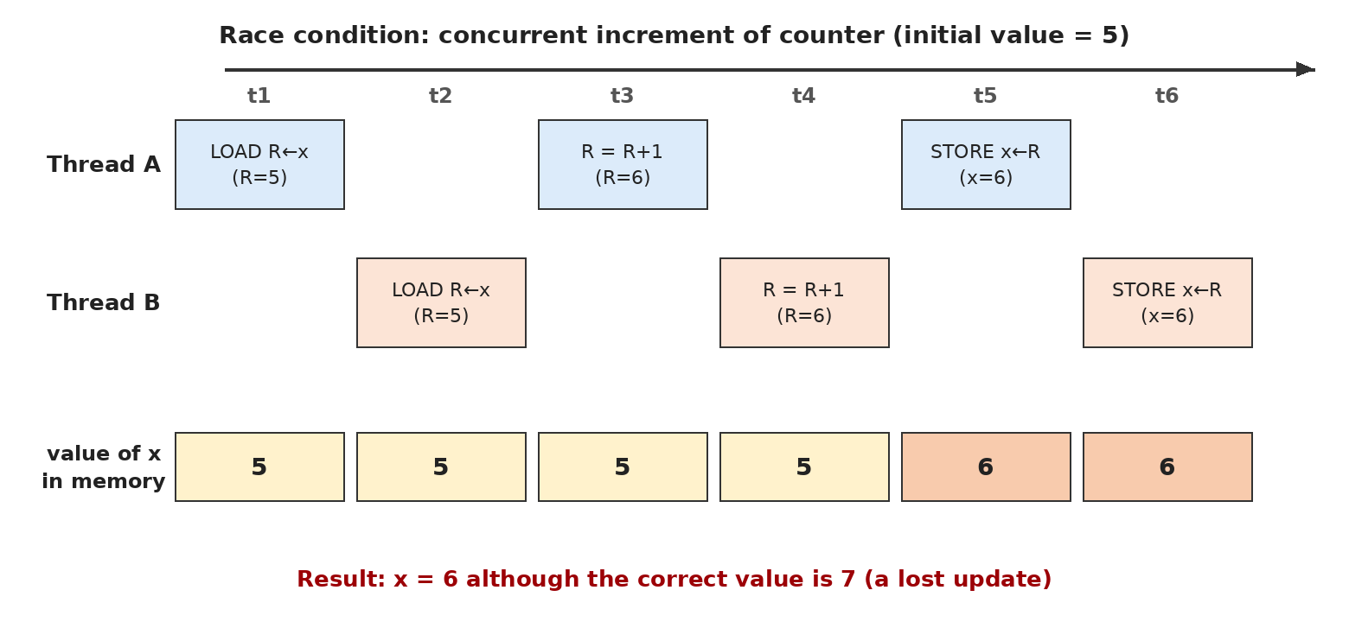
Figure 2.1: Race condition example: a lost update in the concurrent increment of a counter
If the initial value of x is 5 and both threads add one, every sequential execution yields 7, but in the interleaving of the figure above the final value is 6. In general, for N threads each incrementing the counter k times, the correct value is:
x_final = x_initial + N · k (2.1)
whereas the value observed in the presence of a race lies in the interval [x_initial + k, x_initial + N·k] (the lower bound occurs when only the updates of one thread survive; for the simple program above this is an instructional approximation).

2.3 Critical Section
A critical section is a fragment of code that accesses a shared resource or datum and must not be executed simultaneously by more than one flow (or, in the Readers-Writers problem, by an incompatible combination of flows). The general structure of every process has four parts: the entry section, the critical section, the exit section, and the remainder section [1]. Designing a solution means writing the entry and exit protocols so that the conditions of the following sections hold.
Listing 2.1: General structure of a process in the critical-section problem
1 while True:
2 entry_section() # request permission to enter
3 critical_section() # access shared data
4 exit_section() # release permission
5 remainder_section() # work that does not touch shared data

2.4 Mutual Exclusion
Definition: Mutual exclusion (ME) means that at most one process is inside the critical section at any instant. It is a safety property: nothing bad (two processes in the CS simultaneously) ever happens.

In temporal-logic notation, if pc_i denotes the execution point of process Pi:
∀ i ≠ j : □ ¬( pc_i = CS ∧ pc_j = CS ) (2.2)

2.5 Progress
Definition: Progress: if no process is in the CS and some processes wish to enter, the decision about who enters must depend only on the requesting processes and must be taken in finite time; a process in its remainder section must not block the entry of others.

Progress is a liveness property: something good (entry of one of the requesters) eventually happens. A simple violation appears in the "strict alternation" solution: if it is P1's turn and P1 stays long in its remainder section, P0 cannot enter although the CS is empty [5].

2.6 Bounded Waiting
Definition: Bounded waiting (BW): there exists a bound B such that, from the moment a process requests entry until it enters, the other processes enter the CS at most B times.

∀ i, ∀ request of Pi : #entries_of_others(request_i → entry_i) ≤ B (2.3)
This definition relies on the number of entries of others and does not depend on the relative speed of processes; therefore it is combined with an assumption on the scheduling model (for example, "every ready process is eventually scheduled"). When B = 1 the algorithm is called "1-bounded" (every process is overtaken at most once). FIFO fairness is stronger: the order of entry is exactly the order of requests.

2.7 Starvation and Deadlock
Starvation is a situation in which a process is denied access to a resource indefinitely while other processes make progress. Deadlock is a situation in which every process in a set waits for an event that only another member of the same set can cause; consequently none of them makes progress. The four necessary conditions for resource deadlock (the Coffman conditions) are [21]:
- Mutual exclusion: the resource is non-shareable.
- Hold and wait: a process holds earlier resources while waiting for a new one.
- No preemption: a resource cannot be forcibly taken away.
- Circular wait: a circular chain of waiting processes exists.

Note: Deadlock is a special case of "no progress" in which no process of the set can move; starvation may occur in a system that makes overall progress. In the two-process algorithms of this article, assessing "deadlock" means checking whether both processes can become stuck in their entry sections with neither entering the CS.

2.8 Busy Waiting
Busy waiting (spinning) means a process repeatedly tests a condition in a loop until it becomes true, without relinquishing the CPU. Its cost is wasted processor cycles, and if the scheduler runs the waiting process ahead of the lock holder (for example on a single-core system with fixed priorities) it can cause severe delays or priority inversion [22]. When the wait is very short, however, spinning is cheaper than a context switch, which is why spinlocks are used inside operating-system kernels.

2.9 Synchronization and Atomic Operations
An atomic operation is indivisible: to other flows it has either completely taken effect or not started at all. Modern hardware provides low-level atomic operations such as Test-and-Set, Compare-and-Swap (CAS), Fetch-and-Add, and Load-Linked/Store-Conditional, and locks, semaphores, and monitors are built on them [13]. The algorithms of Peterson and Dekker, in contrast, require only atomicity of single-variable memory reads and writes.

2.9.1 Memory Model
Sequential consistency, defined by Lamport, states that the result of any execution must be as if all processors' operations were executed in one global order that preserves each processor's program order [12]. Real processors and compilers do not honor this model for performance: for example, on x86-TSO a store may linger in the store buffer and a later load from a different address may complete before that store becomes visible (Store→Load reordering) [15], [16]. Consequently the correctness of the classical algorithms holds only under the SC assumption, and running them on real hardware requires memory fences or sequentially consistent atomic variables (such as std::atomic with seq_cst in C++, or volatile in Java) [13], [18], [25].

2.10 Execution Model and Assumptions
The analyses of this article rest on four model assumptions. Whenever a guarantee is stated, the assumptions needed for it are identified.
Table 2.1: Assumptions of the execution model
ID | Assumption | Explanation
M1 | Atomic reads/writes | Every read or write of a single shared variable is indivisible.
M2 | Sequential consistency (SC) | Memory behaves as one global order of operations that preserves program order.
M3 | Finite critical sections | Every process stays only a finite time in the CS and exit protocol and neither halts nor crashes there.
M4 | Weakly fair scheduling | Every continuously ready process eventually takes a step (arbitrary but positive speed).

2.11 Summary of the Concepts
Table 2.2: Summary of the basic concepts and the type of each property
Concept | Type | Short definition | Example of violation
Mutual exclusion | Safety | At most one process in the CS | Two threads run counter += 1 simultaneously
Progress | Liveness | CS empty and requester present ⇒ entry in finite time | Strict alternation with a slow process
Bounded waiting | Bounded liveness | A bound on the number of overtakes | Weak semaphore under constant contention
Deadlock | Violation of progress | A closed waiting cycle | Two semaphores acquired in different orders
Starvation | Violation of fairness | Indefinite denial for one process | A writer under reader preference

3 Peterson's Algorithm

3.1 History and Definition
Peterson's algorithm was presented by Gary L. Peterson in 1981 in a short paper titled "Myths about the mutual exclusion problem" [6]. Before that, Dekker's solution (Chapter 4) was known as the first correct software solution for two processes, but its logic was intricate. Peterson showed that the same goal can be achieved with much simpler code and a shorter proof. Like Dekker's, his algorithm uses only reads and writes of shared variables and needs no special hardware instruction.
Definition: Peterson's algorithm is an entry/exit protocol for two processes which, with two shared variables flag[2] (declaration of interest) and turn (which designates the "victim", the process that must wait), guarantees mutual exclusion, progress, and bounded waiting; these guarantees hold under assumptions M1 to M4.

3.2 Purpose and Operation
The goal is to solve the critical-section problem for two processes P0 and P1 with no tool stronger than atomic reads and writes. The key idea is "politeness": a process that wants to enter first declares its interest (flag[i] = True) and then hands the turn to its rival (turn = j). If both request simultaneously, the last process to write turn determines its value, and that process is the "victim" which waits. Because the writes occur atomically in one global order, exactly one of the two processes remains in the wait loop.

3.3 Conditions and Assumptions
- Exactly two processes with identifiers 0 and 1 (for n processes a generalization is needed, Section 3.7).
- Assumptions M1 (atomicity) and M2 (sequential consistency) are essential for the correctness of ME; M3 and M4 are required for progress and bounded waiting.
- flag and turn are shared; flag[i] is written only by Pi, whereas turn is written by both.
- Busy waiting is used and the processes are finite in the CS.

3.4 Step-by-Step Algorithm
- Entry: Pi sets flag[i] to True to announce its interest.
- Pi sets turn to j, thereby giving priority to the rival.
- Pi repeatedly evaluates flag[j] and turn == j. If true, it waits (the rival is interested and it is the rival's turn).
- When the condition becomes false, Pi enters the critical section.
- Exit: Pi sets flag[i] to False so that the rival can enter.

3.5 Pseudocode and Line-by-Line Explanation
Listing 3.1: Peterson's algorithm in Python-style pseudocode
1 flag = [False, False]
2 turn = 0
3
4 def enter_region(i):
5 j = 1 - i
6 flag[i] = True
7 turn = j
8 while flag[j] and turn == j:
9 pass
10
11 def leave_region(i):
12 flag[i] = False
13
14 # Process P_i (i = 0 or 1)
15 while True:
16 enter_region(i)
17 critical_section()
18 leave_region(i)
19 remainder_section()

Lines | Explanation
1–2 | Shared variables: flag[k] indicates that Pk wants to enter; turn designates the process that must wait.
5 | The rival's identifier is computed (1 for i=0 and vice versa).
6 | Pi declares its interest. This write must occur before the write of turn.
7 | Pi hands the turn to the rival; the last writer of turn is the victim.
8–9 | The busy-wait loop: while the rival is interested and holds the turn, pass is executed.
12 | Exit protocol: Pi withdraws its interest; this is the only write needed to release.
15–19 | Usage pattern: entry, critical section, exit, and remainder section in an infinite loop.

Warning: In real Python, the assignment turn = j inside a function creates a local variable; for real execution global turn must be declared. This is one of the differences between pseudocode and executable code (Chapter 12).

3.6 Worked Example with Numerical Trace
Assume the initial values flag = [False, False] and turn = 0 and that both processes request almost simultaneously. The table below shows a worst-case interleaving; the value columns hold the state after that step (a timeline appears in Figure 11.1).
Table 3.1: Trace of a two-process interleaving in Peterson's algorithm
Step | Process | Statement | flag[0] | flag[1] | turn | Outcome
0 | — | Initial state | F | F | 0 | —
1 | P0 | flag[0] = True | T | F | 0 | P0 declared interest
2 | P1 | flag[1] = True | T | T | 0 | P1 declared interest
3 | P0 | turn = 1 | T | T | 1 | P0 handed the turn to P1
4 | P1 | turn = 0 | T | T | 0 | P1 handed the turn to P0 (last writer)
5 | P0 | flag[1] and turn==1 → T and F = F | T | T | 0 | Loop exits; P0 enters the CS
6 | P1 | flag[0] and turn==0 → T and T = T | T | T | 0 | P1 waits (P0 is in the CS)
7 | P0 | flag[0] = False | F | T | 0 | P0 left the CS
8 | P1 | flag[0] and turn==0 → F and T = F | F | T | 0 | P1 enters the CS

Result of the trace: the two processes were never in the CS simultaneously, and P1, which wrote turn last, entered after P0. Now consider the uncontended case: if P0 is alone, after flag[0] = True and turn = 1 the value of flag[1] is False and the wait condition is immediately false; hence entry takes 3 steps (two writes and one read) with no waiting.

3.7 Multi-Process Scenarios and Generalization to n Processes
Scenario A (immediate re-entry). After P0 leaves in step 7 of the table above, assume P0 immediately requests again before P1 takes step 8. P0 writes flag[0] = True and then turn = 1. Now P1 evaluates flag[0] and turn == 0: since turn is 1 the condition is false and P1 enters. Hence P0 cannot overtake P1 more than once; this is the bound B = 1.
Scenario B (three processes with a two-process algorithm). If three processes P0, P1, and P2 use the same code (with, say, a naive generalization of j = 1 − i), the "two processes" assumption is violated and ME may fail, since each process has only two flag cells and there is no slot to represent a third identifier. For n processes the filter lock must be used, which has n−1 "levels" and designates a "victim" at each level; at every level at least one process fewer passes [13].
Listing 3.2: The filter lock (generalization of Peterson's algorithm to n processes)
1 level = [0] * n
2 victim = [0] * n
3
4 def lock(i):
5 for L in range(1, n):
6 level[i] = L
7 victim[L] = i
8 while victim[L] == i and any(level[k] >= L for k in range(n) if k != i):
9 pass
10
11 def unlock(i):
12 level[i] = 0

The filter lock guarantees ME and starvation-freedom under the same SC assumptions, but it has no FIFO fairness and its cost is O(n) levels and O(n) shared variables; hence it does not scale to large n [13]. Lamport's Bakery algorithm is another alternative that provides FIFO fairness [11].

3.8 Analysis of ME, Progress, and Bounded Waiting

3.8.1 Mutual Exclusion
Theorem 1. Under M1 and M2, P0 and P1 are never in the CS simultaneously. Proof (by contradiction). Suppose both are in the CS. Before entering, each Pi wrote flag[i] = True and then turn = j, and flag[i] stays True until its exit. Suppose P1 is the last writer of turn, i.e., the write turn = 0 by P1 happened after the write turn = 1 by P0 (the other case is symmetric). Since each process writes turn once per entry, turn stays 0 from then on. At the moment P1 tests after writing turn = 0, flag[0] is True (P0 set it before writing turn = 1 and is still in the CS) and turn == 0 holds. So P1's wait condition held and P1 could not have entered the CS; a contradiction. ∎

3.8.2 Progress
Suppose the CS is empty and Pi has requested. If flag[j] is False (Pj is in its remainder section), Pi's wait condition is false and Pi enters; thus a process outside the entry section does not block. If flag[j] is True, turn is i or j. If turn = i, Pi's condition is false and it enters. If turn = j, since the CS is empty Pj is in its entry protocol and its condition (flag[i] and turn == i) is false; so Pj enters (in finite time by M4). In every case one of the requesters enters in finite time.

3.8.3 Bounded Waiting
Suppose Pi has performed turn = j and is waiting. Pj can enter at most once (if it is already in the CS or about to enter). If Pj requests again after leaving, it necessarily writes turn = i, which makes Pi's wait condition (turn == j) false; so Pi enters after that (by M3 and M4). Hence the bound is B = 1. As a corollary, deadlock is impossible, since the wait conditions of both processes cannot hold simultaneously (that would require turn == j and turn == i at once).
Table 3.2: Summary of the analysis of Peterson's algorithm and the assumptions of each guarantee
Property | Result | Required assumptions | Reason
Mutual exclusion | Guaranteed | M1, M2 | Theorem 1; write of flag before turn
Progress | Guaranteed | M1, M2, M3, M4 | Case analysis of flag[j] and turn
Bounded waiting | B = 1 | M1–M4 | The rival's write of turn
Deadlock | Impossible | M1, M2 | Contradiction of turn == i and turn == j
Starvation | Absent | M1–M4 | Follows from bounded waiting
Race condition | None on CS data; intentional race on flag/turn | M1, M2 | Racy reads/writes must be atomic

3.9 Peterson on Modern Memory Models
The proofs above rely on sequential consistency (M2), which real processors do not provide. On x86-TSO each core has a store buffer and a load may overtake the core's own earlier stores to different addresses [15]. In that case: P0 keeps flag[0]=True and turn=1 in its buffer, then reads flag[1] from memory and sees False (P1's store is still in P1's buffer); P1 symmetrically sees flag[0] as False. Both find their wait condition false and both enter the CS; ME is violated. Moreover, the compiler may reorder statements or keep turn in a register and turn the loop into an infinite one.
Listing 3.3: Peterson with a full memory fence (for models weaker than SC)
1 def enter_region(i):
2 j = 1 - i
3 flag[i] = True
4 turn = j
5 memory_fence()
6 while flag[j] and turn == j:
7 pass

A full fence (for example mfence on x86) guarantees that earlier stores become visible before later loads. In high-level languages flag and turn must be declared as sequentially consistent atomic variables (std::atomic<T> with memory_order_seq_cst in C++, volatile or AtomicIntegerArray in Java); otherwise the program even has a data race and its behavior is undefined [13], [18], [25]. In practice operating systems use locks based on CAS or Test-and-Set and futexes [23], and Peterson's algorithm has mostly educational and theoretical value.

3.10 Strengths, Weaknesses, Limitations, and Applications
Table 3.3: Strengths and weaknesses of Peterson's algorithm
Strengths | Weaknesses
Only reads/writes; no special atomic instruction | Busy waiting wastes CPU
Short code and simple proof | Only two processes; generalization to n is costly
ME, progress, and bounded waiting (B=1) under M1–M4 | Fails on non-SC memory without fences/atomics
No deadlock and no starvation | Poor scalability; O(n) space for the filter lock

Limitations and applications. Peterson's algorithm is suitable for teaching, correctness proofs, model-checking tools, and environments without atomic instructions (for example some simple microcontrollers), provided that the memory model is respected. For the kernels of modern multicore operating systems, locks based on atomic operations are preferred [1], [13].

4 Dekker's Algorithm

4.1 History and Definition
Dekker's algorithm is attributed to the Dutch mathematician Th. J. Dekker and was described by Dijkstra in the report "Cooperating Sequential Processes" in the mid-1960s [4]. It is generally regarded as the first correct solution of the mutual-exclusion problem for two processes that uses only shared memory with atomic reads and writes. In the same report Dijkstra shows the path to this solution through a sequence of "failed attempts," each of which fixes one defect and introduces another. Studying these attempts is very instructive for understanding why Dekker's algorithm has its structure.
Definition: Dekker's algorithm is a protocol for two processes which, with the array wants[2] (interest) and the variable turn (priority), provides mutual exclusion, progress, and bounded waiting under assumptions M1 to M4; its key innovation is back-off: the lower-priority process temporarily withdraws its interest.

4.2 Purpose and Operation
There are two main traps in the design: (1) "strict alternation," which violates progress; (2) "declaring interest without a turn," where if both set wants to True at the same time both wait forever (deadlock/livelock). Dekker combines the two: turn matters only when both are requesting. In that case the process that does not hold the turn temporarily sets its wants to False so that the rival can enter, and then waits for the turn; when the rival has left and handed over the turn, it declares interest again.

4.3 Conditions and Assumptions
- Two processes with identifiers 0 and 1; wants[i] is written only by Pi and turn by both (in the exit protocol).
- M1 and M2 for ME; M3 and M4 for progress and bounded waiting.
- In Dekker turn is written only in the exit protocol, unlike Peterson where it is written on entry.
- Busy waiting with two loop levels (an outer loop on the rival's interest and an inner loop on the turn).

4.4 Step-by-Step Algorithm
- Pi sets wants[i] to True.
- While wants[j] is True (the rival is also requesting), the outer loop runs.
- If turn == j (the rival holds the turn): Pi sets wants[i] to False (back-off), waits in the inner loop until turn != j, and then sets wants[i] to True again.
- If turn == i, Pi does not back off and merely keeps looping in the outer loop until wants[j] becomes False.
- When wants[j] becomes False, Pi enters the CS.
- Exit: Pi hands the turn to the rival (turn = j) and sets wants[i] to False.

4.5 Pseudocode and Line-by-Line Explanation
Listing 4.1: Dekker's algorithm in Python-style pseudocode
1 wants = [False, False]
2 turn = 0
3
4 def enter_region(i):
5 j = 1 - i
6 wants[i] = True
7 while wants[j]:
8 if turn == j:
9 wants[i] = False
10 while turn == j:
11 pass
12 wants[i] = True
13
14 def leave_region(i):
15 turn = 1 - i
16 wants[i] = False
17
18 while True:
19 enter_region(i)
20 critical_section()
21 leave_region(i)
22 remainder_section()

Lines | Explanation
1–2 | wants[k]: Pk is requesting; turn: the process that has priority in a contention.
6 | Declaration of interest.
7 | Outer loop: continues only if the rival is also requesting (real contention).
8 | If the rival holds the turn, Pi must back off.
9 | Back-off: Pi withdraws its interest so that the rival can leave its own outer loop.
10–11 | Inner loop: busy waiting until the rival gives up turn.
12 | After the turn is received, interest is declared again and the outer loop re-checks.
15–16 | Exit protocol: the turn is handed to the rival and then interest is withdrawn.
18–22 | Usage pattern of each process.

Warning: The exit protocol writes turn before wants[i], following the classical presentation. Any reordering of statements in lock-free algorithms must be re-validated against the proof; also, in real Python global turn must be declared for assignments to turn (Chapter 12).

4.6 Worked Example with Numerical Trace
With initial values wants = [False, False] and turn = 0, assume both processes request simultaneously (a timeline appears in Figure 11.2).
Table 4.1: Trace of a two-process interleaving in Dekker's algorithm
Step | Process | Statement | wants[0] | wants[1] | turn | Outcome
0 | — | Initial state | F | F | 0 | —
1 | P0 | wants[0] = True | T | F | 0 | P0 is requesting
2 | P1 | wants[1] = True | T | T | 0 | P1 is requesting
3 | P0 | while wants[1]: turn==1? خیر | T | T | 0 | P0 holds the turn; it does not back off and keeps looping
4 | P1 | while wants[0]: turn==0? بله → wants[1]=False | T | F | 0 | P1 backs off
5 | P0 | while wants[1] → False | T | F | 0 | P0 enters the CS
6 | P0/P1 | P0 در CS؛ P1 در حلقه‌ی while turn==0 | T | F | 0 | P1 waits for the turn
7 | P0 | turn = 1; wants[0] = False | F | F | 1 | P0 left and handed over the turn
8 | P1 | while turn==0 پایان؛ wants[1] = True | F | T | 1 | P1 requests again
9 | P1 | while wants[0] → False | F | T | 1 | P1 enters the CS

The order of entry (P0 then P1) was determined by the initial value of turn. If P0 requests again immediately in step 7 (wants[0] = True), its outer loop sees wants[1] as True and, since turn == 1, it backs off; so P1 enters before P0 can enter again (bound B = 1).

4.7 Multi-Process Scenarios: The Failed Attempts
Dekker's algorithm is for two processes only and has no simple generalization; for n processes one uses Dijkstra's solution [5], Lamport's Bakery algorithm [11], or the filter lock [13]. To understand its structure, the table below compares the failed attempts with the defect of each (following the classical analysis [4], [19]).
Table 4.2: Failed attempts on the way to Dekker's algorithm and the defect of each
Attempt | Idea | Defect
1: strict alternation | Only turn; each process waits for turn == i | Violates progress; a slow process blocks its rival
2: check first, then declare | If wants[j] is False then wants[i]=True | Violates ME; both may see False simultaneously
3: declare first, then check | wants[i]=True, then wait until wants[j] is False | Deadlock: both become True and wait forever
4: back-off without a turn | While waiting, temporarily set wants[i] to False | Livelock; both may back off and re-request in lock-step
Dekker: back-off + turn | Only the process without the turn backs off | No defect (under M1–M4)

4.8 Analysis of ME, Progress, and Bounded Waiting
Mutual exclusion. Suppose Pi and Pj are in the CS simultaneously. Before entering, each process performed its last test of the outer loop and read the rival's wants as False. From before that test until it leaves the CS, the process's own wants is True, because writes of False occur only in the back-off (which precedes the last test and is compensated by writing True again) and in the exit protocol. Without loss of generality assume Pi's last test (time ti) precedes Pj's last test (time tj). Pi leaves the CS after tj (both are in the CS simultaneously and Pj's CS begins after tj). Hence on [ti, tj] the value of wants[i] is True, so Pj reads True at tj and could not have left the loop; a contradiction. This argument needs only M1 and M2 and the order "declare interest, then read the rival's interest"; the role of turn is to ensure progress, not ME.
Progress. If Pj is in its remainder section (wants[j] False), Pi enters directly. If both are requesting, turn selects one of them; the holder of the turn does not back off and enters as soon as the rival sets wants to False (or at once if it already was False), and the rival opens the way by backing off. Hence the decision depends only on the requesters and is taken in finite time (M4).
Bounded waiting. At the end of each CS a process hands turn to its rival. If the rival is requesting, it then has priority; hence the departed process cannot re-enter before the waiting rival. The bound is B = 1 (with M3 and M4). Deadlock is also impossible, since only the holder of turn never waits; both processes cannot lack turn at the same time. Compared with attempt 4 in the table above, livelock does not occur either, because back-off is asymmetric.
Table 4.3: Summary of the analysis of Dekker's algorithm and the assumptions of each guarantee
Property | Result | Required assumptions | Comment
Mutual exclusion | Guaranteed | M1, M2 | Depends on the order "declare then read"
Progress | Guaranteed | M1–M4 | A process in the remainder section does not block
Bounded waiting | B = 1 | M1–M4 | Hand-over of turn on exit
Deadlock / livelock | Impossible | M1–M4 | Asymmetric back-off
Starvation | Absent | M1–M4 | Follows from bounded waiting
Race condition | Intentional race on wants/turn which must be atomic | M1, M2 | The memory model is mandatory

4.9 Dekker on Modern Memory Models
Like Peterson's, Dekker's algorithm relies on the "write then read" (Store→Load) pattern: Pi writes wants[i] and immediately reads wants[j]. On x86-TSO this read can execute before that write becomes visible, and both processes may see each other as "False"; ME is then violated [15]. The fix is a full memory fence between wants[i] = True and the checking loop (and likewise after wants[i] = True in line 12), or declaring the variables as sequentially consistent atomics [13]. Furthermore, the inner loops that read turn must be written with an atomic/volatile variable in compiled languages so that the compiler does not turn them into infinite loops.

4.10 Strengths, Weaknesses, Limitations, and Applications
Table 4.4: Strengths and weaknesses of Dekker's algorithm
Strengths | Weaknesses
First correct software solution for two processes | Intricate logic; hard to prove and maintain
Only atomic reads/writes | Busy waiting at two levels
ME, progress, B=1, and no deadlock (M1–M4) | Two processes only; n-process generalization is complex
High historical and educational value | Fails on non-SC memory without fences

Limitations and applications. Today Dekker's algorithm is used mainly in teaching and theoretical discussions. Its historical role was to prove that mutual exclusion is possible without special hardware support; this result inspired later solutions such as those of Peterson, Lamport, and the semaphore [4], [5], [11].

5 Semaphores

5.1 History and Definition
The semaphore was introduced by Edsger W. Dijkstra in 1965 as a general, simple synchronization tool independent of the number of processes [4]. Its two operations appear in the original texts as P (from the Dutch "proberen," to test) and V (from "verhogen," to increment); in today's textbooks they are usually called wait and signal [1]. The semaphore is an operating-system-level solution: it needs no busy waiting and blocks a process that cannot proceed.
Definition: A semaphore S is an integer variable (S.value) together with a queue of blocked processes, manipulated only through the two atomic operations wait(S) and signal(S) and an initialization (with a non-negative value). A binary semaphore takes the values 0 and 1; a counting semaphore takes any non-negative initial value.

5.2 Purpose and Operation
The purpose of the semaphore is to provide three synchronization patterns: (1) mutual exclusion (a binary semaphore with initial value 1); (2) ordering and event notification (a semaphore with initial value 0, where one process announces the event with signal and another waits for it with wait); (3) management of multi-instance resources (a counting semaphore whose initial value equals the number of instances). The key idea is that wait decrements the value and, if it becomes negative, the caller blocks in the semaphore queue; signal increments the value and, if some process is still waiting (value ≤ 0), wakes one of them.

5.3 Conditions and Assumptions
- Atomicity: the execution of wait and signal must be indivisible. On a uniprocessor it is provided by disabling interrupts and on a multiprocessor by an internal spinlock or atomic instructions (CAS/Test-and-Set) [1], [2]. Hence a short busy wait may exist inside the implementation.
- Queue policy: a strong semaphore has a FIFO queue and a weak semaphore leaves the wake-up order unspecified [3]. The guarantee of bounded waiting depends on this choice.
- Correct usage: every wait must be matched by a signal, and the order of acquiring several semaphores must be consistent; the semaphore itself does not enforce these rules.
- Scheduling: for liveness, M3 (finite CS) and M4 (fair scheduling) are required.

5.4 Step-by-Step Algorithm
- wait(S): S.value is decremented by one.
- If S.value becomes negative, the caller is put into S.queue and goes to the Waiting state with block(); otherwise it continues.
- The process executes its critical section (or synchronized work).
- signal(S): S.value is incremented by one.
- If S.value ≤ 0 (some process is still waiting), one process is removed from S.queue and moved to the Ready state with wakeup().

5.5 Pseudocode and Line-by-Line Explanation
Listing 5.1: A blocking strong semaphore (FIFO queue); each method must be atomic
1 class Semaphore:
2 def __init__(self, value):
3 self.value = value
4 self.queue = deque()
5
6 def wait(self):
7 self.value -= 1
8 if self.value < 0:
9 self.queue.append(current_process())
10 block()
11
12 def signal(self):
13 self.value += 1
14 if self.value <= 0:
15 p = self.queue.popleft()
16 wakeup(p)

Lines | Explanation
3–4 | Initial value and FIFO queue of blocked processes; the FIFO queue makes the semaphore "strong."
7 | Decrement; a negative value indicates the number of blocked processes.
8–10 | If no resource is free, the caller enters the queue and block() releases the processor (no busy waiting).
13 | Increment on release.
14–16 | If a waiter remains, the oldest process is dequeued and woken; its entry follows FIFO order.

Listing 5.2: Using a binary semaphore for mutual exclusion
1 mutex = Semaphore(1)
2
3 def process_i():
4 while True:
5 mutex.wait()
6 critical_section()
7 mutex.signal()
8 remainder_section()

Lines | Explanation
1 | Initial value 1 means one process may enter.
5–7 | wait is the entry protocol and signal the exit protocol; every exit path must execute signal.

Listing 5.3: Spinning semaphore (busy-waiting version, the first Dijkstra-style definition)
1 def wait(S):
2 while S.value <= 0:
3 pass
4 S.value -= 1
5
6 def signal(S):
7 S.value += 1

Lines | Explanation
2–3 | Busy waiting until the value becomes positive; the value never goes negative.
4 | Testing and decrementing must be one atomic action; otherwise two processes may pass the while simultaneously.
7 | Atomic increment.

The two definitions above are externally equivalent but differ in important ways: the blocking version has negative values and an explicit queue; the spinning version wastes CPU but is useful in the kernel for very short waits (spinlocks) [1].

5.6 Semaphore Invariants
If s0 is the initial value, n_P the number of wait calls, and n_V the number of signal calls (in the blocking version), the following invariants hold at every instant:
S.value = s0 − n_P + n_V (5.1)
S.value < 0 ⇒ |S.value| = |S.queue| (5.2)
n_passed − n_V ≤ s0 (5.3)
where n_passed is the number of wait calls that returned successfully. The third relation says that at most s0 processes are inside the protected region simultaneously; for a binary semaphore with s0 = 1 this is exactly mutual exclusion.

5.7 Worked Example with Numerical Trace
Example 1: a binary semaphore and three processes. With mutex = Semaphore(1), the trace of the value and queue appears in Figure 5.1 and in the table below.
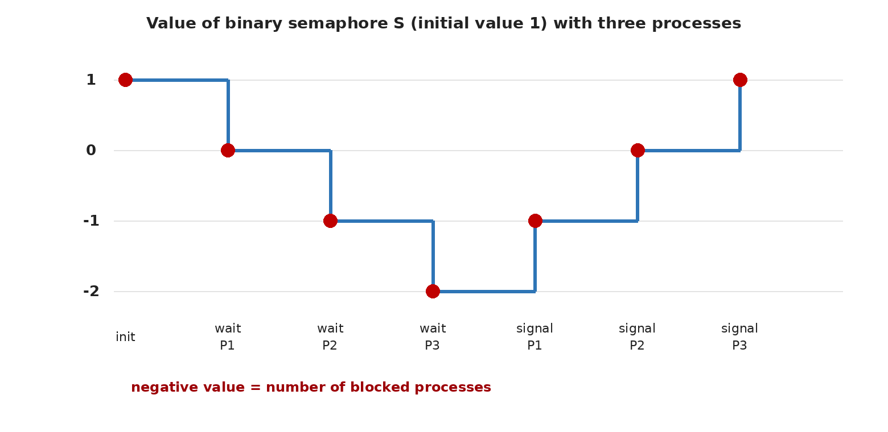
Figure 5.1: Value of the binary semaphore S in Example 1
Table 5.1: Trace of Example 1 (binary semaphore with initial value 1)
Step | Event | S.value | S.queue | Status
0 | Initial state | 1 | [ ] | —
1 | P1: wait(S) | 0 | [ ] | P1 enters the CS
2 | P2: wait(S) | −1 | [P2] | P2 blocks
3 | P3: wait(S) | −2 | [P2, P3] | P3 blocks
4 | P1: signal(S) | −1 | [P3] | P2 is woken and enters the CS
5 | P2: signal(S) | 0 | [ ] | P3 is woken and enters the CS
6 | P3: signal(S) | 1 | [ ] | CS is empty

Example 2: a counting semaphore. Three identical printers with printers = Semaphore(3) and five processes A to E that request in that order and then release in the same order. A negative value shows the number of waiters:
Table 5.2: Trace of Example 2 (counting semaphore with initial value 3)
Event | Value | Waiters | Comment
wait(A) | 2 | — | A obtains a printer
wait(B) | 1 | — | B obtains a printer
wait(C) | 0 | — | C obtains a printer; all printers are busy
wait(D) | −1 | D | D blocks
wait(E) | −2 | D, E | E blocks
signal(A) | −1 | E | D is woken (FIFO)
signal(B) | 0 | — | E is woken
signal(C) | 1 | — | One printer free
signal(D) | 2 | — | Two printers free
signal(E) | 3 | — | Initial state restored

5.8 Multi-Process Scenario: Producer-Consumer
In the bounded-buffer problem, producers write into a buffer of capacity N and consumers read from it. Three semaphores are needed: empty (number of empty slots, initial value N), full (number of full slots, initial value 0), and mutex (exclusive access to the buffer) [1], [14].
Listing 5.4: Producer-consumer with semaphores
1 empty = Semaphore(N)
2 full = Semaphore(0)
3 mutex = Semaphore(1)
4 buffer = []
5
6 def producer():
7 while True:
8 item = produce_item()
9 empty.wait()
10 mutex.wait()
11 buffer.append(item)
12 mutex.signal()
13 full.signal()
14
15 def consumer():
16 while True:
17 full.wait()
18 mutex.wait()
19 item = buffer.pop(0)
20 mutex.signal()
21 empty.signal()
22 consume_item(item)

Lines | Explanation
1–3 | empty and full are counting semaphores that count resources and mutex is binary.
9 | The producer first reserves an empty slot; if the buffer is full it blocks.
10–13 | Appending to the buffer in the critical section; then announcing one full slot.
17–21 | The consumer first waits for a full slot, then removes an item and announces an empty slot.

Trace with N = 2: the initial values are empty = 2, full = 0. The producer inserts two items: empty goes to 1 and then 0, and full to 1 and 2. The third empty.wait() drives the value to −1 and the producer blocks. When a consumer removes an item (full becomes 1), empty.signal() raises the value to 0 and, since the previous value was negative, the producer is woken. Likewise a consumer finding no item blocks on full.
Warning: Deadlock caused by reordering: if in the producer mutex.wait() is executed before empty.wait() and the buffer is full, the producer holds mutex and blocks on empty. The consumer needs mutex to free a slot and never obtains it; both wait forever. The Coffman conditions (hold and wait, circular wait) hold here.

5.9 Analysis of ME, Progress, and Bounded Waiting
Mutual exclusion: with mutex = Semaphore(1) and the invariant n_passed − n_V ≤ 1, at most one process lies between a successful wait and the matching signal; this guarantee depends on the atomicity of the semaphore operations (assumption M1 at the implementation level) and on correct usage. Progress: if the CS is empty (S.value = 1), the first wait passes without blocking and a process outside the entry/exit sections does not block; on signal, a waiter is woken if one exists. Bounded waiting: for a strong (FIFO) semaphore with N processes, the process at position k of the queue sees at most k − 1 entries before its own; hence B ≤ N − 1 (under M3). For a weak semaphore there is no guarantee and a process may be left behind in the queue forever [3].
Table 5.3: Summary of the semaphore analysis and the assumptions of each guarantee
Property | Result | Assumptions/conditions
Mutual exclusion | Guaranteed | Atomic wait/signal, initial value 1, correct usage
Progress | Guaranteed | M3; a consistent acquisition order for several semaphores
Bounded waiting | Strong: B ≤ N−1; weak: no guarantee | FIFO queue and M3, M4
Deadlock | Possible under misuse or with several semaphores | Coffman conditions
Starvation | Possible with weak semaphores and priority inversion | Wake-up policy and scheduling
Busy waiting | None (blocking version) | The spinning version has it

5.10 Deadlock, Starvation, Race Conditions, and Priority Inversion
- Deadlock: with two semaphores A and B, where one process acquires them in the order (A, B) and another in (B, A); the remedy is a fixed global acquisition order [21].
- Starvation: with a weak semaphore, or when a high-priority process always enters before a low-priority one.
- Race conditions: if wait/signal are not atomic or a wait is forgotten, a race on the CS data arises. Correctness therefore depends on programmer discipline.
- Priority inversion: a low-priority process L holds the semaphore, a medium-priority process M preempts L, and a high-priority process H waiting for the semaphore is effectively stuck behind M. Remedies such as priority inheritance exist but are harder for ownerless semaphores [22].

5.11 Strengths, Weaknesses, Limitations, and Applications
Table 5.4: Strengths and weaknesses of semaphores
Strengths | Weaknesses
Independent of the number of processes (n processes) | Low-level and error-prone (forgotten signal, wrong order)
The blocking version has no busy waiting | No structure or ownership; correctness is left to the programmer
Covers three patterns with one tool (ME, ordering, counting) | May cause deadlock, starvation, and priority inversion
Widely supported in operating systems | Hard to debug (errors depend on scheduling)

Applications: POSIX semaphores (sem_wait, sem_post), System V semaphores, struct semaphore in the Linux kernel, and semaphore objects in Windows are used for ME, resource counting (connection pools, printers), and the producer-consumer pattern [1], [2]. An important point: the wake-up order of POSIX semaphores depends on the scheduling policy, and portable code must not rely on FIFO. At user level, efficient implementations are usually built on futexes, which handle the fast path without entering the kernel and consult the kernel only under contention [23].
Exam tip: Memorize the three initial-value patterns: 1 ⇒ mutual exclusion, 0 ⇒ event notification/ordering, N ⇒ N instances of a resource. A negative value in the blocking definition equals the number of waiting processes.

6 Monitors

6.1 History and Definition
The shortcomings of semaphores (being low-level and error-prone) pushed researchers toward higher-level constructs. The monitor concept emerged from the work of Brinch Hansen [8], and C. A. R. Hoare presented it formally in the 1974 paper "Monitors: An Operating System Structuring Concept" [7]. Brinch Hansen later used it in Concurrent Pascal, and Lampson and Redell reported practical experience and a change in the meaning of signal in Mesa [9]. Today the monitor underlies synchronized and wait/notify in Java, the Monitor class in C#, and threading.Condition in Python [24].
Definition: A monitor is a concurrent abstract data type consisting of private shared data, a set of procedures, and zero or more condition variables. The fundamental rule: at most one thread is active inside the monitor at any instant; mutual exclusion is provided implicitly by the language or runtime.

6.2 Purpose and Operation
The purpose of the monitor is to encapsulate shared data and the operations on it in one unit so that users access the data only through procedures and incorrect locking becomes impossible (Figure 6.1). Every procedure begins by acquiring the monitor's implicit lock and ends by releasing it. If a thread inside the monitor cannot proceed because a condition does not hold (for example the buffer is full), it must call wait on a condition variable: the thread releases the monitor lock and sleeps in that condition's queue until another thread wakes it with signal. Two distinct mechanisms exist: the lock (exclusion) and the condition variable (waiting for a state).
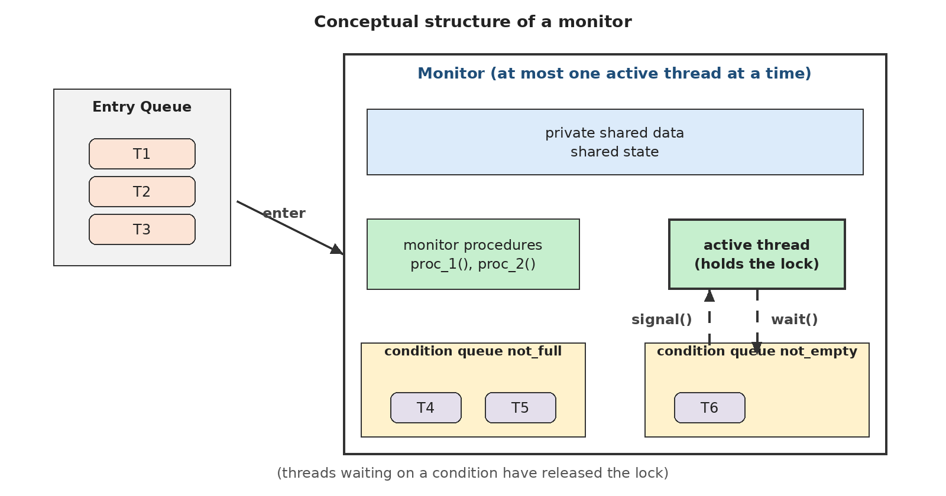
Figure 6.1: Conceptual structure of a monitor: entry queue, shared data, procedures, and condition queues

6.3 Conditions and Assumptions
- Access only through procedures: the shared data must not be accessible from outside the monitor; in languages such as Java this is programmer discipline.
- Meaning of signal: in a Hoare monitor signal immediately runs the waiting thread and suspends the signaler until it leaves; in a Mesa/Java monitor signal merely makes the waiter ready and the caller continues; in the Brinch Hansen method signal must be the last statement of a procedure [7], [8], [9].
- Queue policy: the entry queue and condition queues may be FIFO or unspecified, and this policy determines fairness.
- Assumptions M3 and M4 for liveness; the lock infrastructure depends on atomics or an internal spinlock.

6.4 Step-by-Step Algorithm
- The thread calls a monitor procedure; if the lock is not free it stays in the entry queue.
- The thread acquires the lock and enters the monitor.
- It tests the condition required to proceed. If it does not hold, it calls wait(cv): it releases the lock and sleeps in the condition queue.
- When woken (after signal), it re-acquires the lock; in the Mesa model it must test the condition again (a while loop).
- It performs the operation on the shared data and, if needed, wakes waiters with signal or notify.
- On leaving the procedure the lock is released and a thread from the entry queue may enter.

6.5 Pseudocode and Line-by-Line Explanation
Listing 6.1: Bounded-buffer monitor (Mesa semantics); the monitor lock is implicit
1 monitor BoundedBuffer:
2 buffer = []
3 N = 5
4 not_full = Condition()
5 not_empty = Condition()
6
7 procedure put(item):
8 while len(buffer) == N:
9 not_full.wait()
10 buffer.append(item)
11 not_empty.signal()
12
13 procedure get():
14 while len(buffer) == 0:
15 not_empty.wait()
16 item = buffer.pop(0)
17 not_full.signal()
18 return item

Lines | Explanation
2–3 | Private shared data: the buffer and its capacity; accessible only inside the procedures.
4–5 | Two condition variables: "buffer not full" and "buffer not empty."
7 | Entering put means acquiring the implicit monitor lock; the programmer writes no explicit lock.
8–9 | In the Mesa model while must be used: after waking, another thread may have filled the buffer before us. wait releases the lock.
10 | Adding an item; this operation is protected by the monitor lock.
11 | Notifying a waiting consumer; the waiter becomes ready but does not run until we leave.
13–18 | The get procedure is symmetric: wait for non-empty, remove, and announce "not full."

Hoare versus Mesa. In a Hoare monitor, signal hands control immediately to the waiting thread; since the condition is guaranteed to hold at wake-up, if suffices. In Mesa and Java signal is only a notification and a third thread may invalidate the condition before the waiter runs; spurious wake-ups are also permitted. For this reason code must use while [9], [24].
Table 6.1: Different meanings of signal in monitors
Model | Behavior of signal | Condition test | Example
Hoare (signal-and-urgent-wait) | The waiter runs at once; the signaler is suspended | if suffices | Hoare's paper [7]
Brinch Hansen (signal-and-return) | signal is the last statement; the procedure exits immediately | if suffices | Concurrent Pascal [8]
Mesa (signal-and-continue) | The waiter becomes ready; the signaler continues | while is mandatory | Mesa, Java, pthreads, Python [9], [24]

6.6 Worked Example with Numerical Trace
Consider the bounded-buffer monitor with capacity N = 2: a consumer C first calls get, and two producers P1 and P2 then insert three items. Trace (Mesa):
Table 6.2: Trace of the bounded-buffer monitor with N = 2
Step | Thread and action | Buffer size | Queue state
1 | C: get() ← buffer empty; not_empty.wait() | 0 | C in not_empty; lock free
2 | P1: put(a) ← insert, not_empty.signal() | 1 | C becomes ready; P1 continues
3 | P1 leaves; C acquires the lock and removes a | 0 | not_full.signal() (no waiter)
4 | P2: put(b) | 1 | —
5 | P1: put(c) | 2 | —
6 | P2: put(d) ← buffer full; not_full.wait() | 2 | P2 in not_full
7 | C: get() ← removes b, not_full.signal() | 1 | P2 becomes ready
8 | P2 acquires the lock, re-tests the condition (size 1 < 2), and inserts d | 2 | —

In step 3 the woken consumer must first obtain the lock from among the entrants; in step 8 re-testing the condition matters: if a third thread had filled the buffer between steps 7 and 8, P2 would wait again. This is exactly the reason for while.

6.7 Multi-Thread Scenarios and Nested Monitor Calls
With K producers and M consumers, all threads compete for the single lock to enter the monitor, and threads waiting for conditions sleep in separate queues. If the program uses one condition variable for several different conditions, signal may wake an unsuitable thread (for example a producer instead of a consumer); in that case notify_all must be used or separate condition variables defined. The well-known nested monitor call problem arises when a thread inside monitor M1 calls a procedure of monitor M2 and waits on a condition there: wait releases only M2's lock while M1's lock remains held. If the waking thread must first enter M1 to reach M2, deadlock occurs [3].

6.8 Analysis of ME, Progress, and Bounded Waiting
Mutual exclusion is guaranteed by design: only one thread holds the monitor lock, and wait always releases the lock and re-acquires it on wake-up; hence two threads never execute monitor code simultaneously (assuming a correct lock implementation and respect for encapsulation). Progress: if the monitor is empty and a thread requests entry, it enters; after waits, if all threads sleep on conditions and nobody signals, the system may suffer a "lost wake-up," which is a design error in the condition and not a weakness of the monitor. Bounded waiting: it depends on the queue policy; if the entry queue and condition queues are FIFO (as in Hoare's original monitor) a bound exists; in Java and pthreads the order of entry and of notify is not guaranteed and "barging" (overtaking by a newly arrived thread) may occur [7], [9].
Table 6.3: Summary of the monitor analysis and the assumptions of each guarantee
Property | Result | Assumptions/conditions
Mutual exclusion | Guaranteed (structural) | Correct implicit lock; data encapsulation
Progress | Guaranteed for entry; waiting conditions rest on the design | M3; correct signal/notify (no lost wake-up)
Bounded waiting | Only with FIFO queues | Entry/condition queue policy; M4
Deadlock | Possible (nested monitors, lock order) | Coffman conditions
Starvation | Possible with barging and non-FIFO policies | Scheduler and wake-up policy
Busy waiting | None at the monitor level | The lock infrastructure may spin briefly

6.9 Strengths, Weaknesses, Limitations, and Applications
Table 6.4: Strengths and weaknesses of monitors
Strengths | Weaknesses
Automatic and structured mutual exclusion | Needs language support or programmer discipline
Data encapsulation; fewer errors than with semaphores | A coarse-grained lock may limit concurrency
Separation of locking from waiting for a condition | Subtle signal semantics (Hoare/Mesa) and nested monitors
Suitable for complex problems such as Readers-Writers | Fairness depends on the implementation

Applications: synchronized + wait/notify and java.util.concurrent.locks.Condition in Java; Monitor in C#; pthread_mutex_t together with pthread_cond_t in C; threading.Condition in Python [24]. Operating-system libraries and modern kernels generally implement this pattern as "lock + condition variable" and follow Mesa semantics.
Exam tip: Three monitor rules (Mesa): (1) always test the condition in a while; (2) modify shared variables only while holding the lock; (3) a state change that may affect a condition must announce the appropriate signal/notify.

7 The Readers-Writers Problem

7.1 History and Definition
The Readers-Writers problem was posed by Courtois, Heymans, and Parnas in 1971, who gave two semaphore solutions with two priority policies [10]. The problem is a pattern for databases, file systems, and caches: there is a shared datum that "readers" only read and "writers" modify. Several readers may read simultaneously, but a writer must have exclusive access.
Definition: ME rules of the problem: (1) readers are compatible with each other; (2) a reader and a writer are incompatible; (3) two writers are incompatible. If R is the number of active readers and W the number of active writers:

(W ≤ 1) ∧ (W = 1 ⇒ R = 0) (7.1)

7.2 Purpose and Operation
The goal is to maximize read concurrency without endangering data consistency. But the ME rule alone does not determine a policy: when a writer is waiting and a new reader arrives, should the reader enter? The answer to this question defines three versions of the problem, examined below.
Table 7.1: Comparison of the Readers-Writers variants
Feature | Reader preference (first problem) | Writer preference (second problem) | Fair solution (third problem)
Rule | No reader waits unless a writer has already started writing | A ready writer writes as soon as possible; new readers wait behind a waiting writer | Order of arrival (FIFO); nobody can be postponed indefinitely
Reader concurrency | Maximal | Lower | Moderate (consecutive groups)
Writer starvation | Possible | Absent | Absent (with a strong queue)
Reader starvation | Absent | Possible | Absent (with a strong queue)
Suitable for | Read-heavy load where write latency is unimportant | Fresh data matters | Systems that need bounded latency

7.3 Conditions and Assumptions
- The numbers of readers and writers are arbitrary; each finishes its operation after finite time (M3).
- Readers do not modify the data (otherwise the compatibility rule is violated).
- The fair solution needs strong (FIFO) semaphores or an explicit FIFO queue; with weak semaphores the fairness guarantee is lost.
- The monitor solutions assume Mesa semantics (conditions in while).

7.4 Semaphore-Based Solutions

7.4.1 Reader Preference
The first reader of a group acquires rw_mutex on behalf of all readers and the last reader releases it; read_count is protected by mutex. While at least one reader is active, new readers enter without checking the writer's state and the writer stays blocked on rw_mutex [1], [10] (flowchart in Figure 10.5).
Listing 7.1: Readers-Writers with semaphores: reader preference
1 mutex = Semaphore(1)
2 rw_mutex = Semaphore(1)
3 read_count = 0
4
5 def reader():
6 mutex.wait()
7 read_count += 1
8 if read_count == 1:
9 rw_mutex.wait()
10 mutex.signal()
11 read_data()
12 mutex.wait()
13 read_count -= 1
14 if read_count == 0:
15 rw_mutex.signal()
16 mutex.signal()
17
18 def writer():
19 rw_mutex.wait()
20 write_data()
21 rw_mutex.signal()

Lines | Explanation
1–3 | mutex protects read_count and rw_mutex protects access to the data (writer exclusion).
6–10 | Reader registration; the first reader takes the "room lock" against writers.
11 | Reading happens outside mutex so that readers read concurrently.
12–16 | Deregistration; the last reader frees the room for writers.
19–21 | The writer only takes rw_mutex; it stays blocked while any reader is active.

7.4.2 Writer Preference
In the solution of Courtois et al. for writer preference, the first waiting writer closes the door to new readers with r.wait() and the last writer reopens it. Semaphore mutex3 ensures at most one reader queues behind r so that a writer can overtake waiting readers [10].
Listing 7.2: Readers-Writers with semaphores: writer preference (Courtois et al.)
1 mutex1 = Semaphore(1)
2 mutex2 = Semaphore(1)
3 mutex3 = Semaphore(1)
4 r = Semaphore(1)
5 w = Semaphore(1)
6 read_count = 0
7 write_count = 0
8
9 def reader():
10 mutex3.wait()
11 r.wait()
12 mutex1.wait()
13 read_count += 1
14 if read_count == 1:
15 w.wait()
16 mutex1.signal()
17 r.signal()
18 mutex3.signal()
19 read_data()
20 mutex1.wait()
21 read_count -= 1
22 if read_count == 0:
23 w.signal()
24 mutex1.signal()
25
26 def writer():
27 mutex2.wait()
28 write_count += 1
29 if write_count == 1:
30 r.wait()
31 mutex2.signal()
32 w.wait()
33 write_data()
34 w.signal()
35 mutex2.wait()
36 write_count -= 1
37 if write_count == 0:
38 r.signal()
39 mutex2.signal()

Lines | Explanation
1–5 | mutex1/mutex2 protect the counters; r guards the readers' entrance and w the data itself; mutex3 limits the readers queued behind r to one.
10–18 | Reader entry: passes the gate r; if a writer is waiting r is closed and the reader blocks.
20–24 | Reader exit; the last reader releases w for a writer.
27–31 | The first waiting writer closes the gate r so that no new reader enters.
32–34 | Exclusive writing with w.
35–39 | The last waiting writer reopens the gate.

7.4.3 Fair (Starvation-Free) Solution
To remove starvation for both sides, a "turnstile" is placed before every reader and writer [14]. The writer holds the turnstile until it finishes, so newly arrived readers wait behind it; readers merely pass through the turnstile. With a strong semaphore, entry to the turnstile is FIFO and every request is served after a finite number of steps.
Listing 7.3: Fair Readers-Writers with a turnstile (requires strong semaphores)
1 turnstile = Semaphore(1)
2 room_empty = Semaphore(1)
3 mutex = Semaphore(1)
4 read_count = 0
5
6 def reader():
7 turnstile.wait()
8 turnstile.signal()
9 mutex.wait()
10 read_count += 1
11 if read_count == 1:
12 room_empty.wait()
13 mutex.signal()
14 read_data()
15 mutex.wait()
16 read_count -= 1
17 if read_count == 0:
18 room_empty.signal()
19 mutex.signal()
20
21 def writer():
22 turnstile.wait()
23 room_empty.wait()
24 write_data()
25 turnstile.signal()
26 room_empty.signal()

Lines | Explanation
7–8 | The reader takes and immediately releases the turnstile; if a writer holds it the reader waits.
9–13 | Reader registration and acquiring room_empty by the first reader, as in reader preference.
22 | The writer closes the turnstile: no new reader enters.
23–24 | The writer waits for the current readers to finish, then writes.
25–26 | Releasing the turnstile and the room; the next in the queue goes on.

7.5 Monitor-Based Solutions
In a monitor, the policy is expressed by the while conditions and the order of signal, and fewer synchronization errors arise. Three versions (Mesa) follow; the variable readers is the number of active readers and writing the state of the active writer.
Listing 7.4: Readers-Writers monitor: reader preference
1 monitor ReadersWriters:
2 readers = 0
3 writing = False
4 can_read = Condition()
5 can_write = Condition()
6
7 procedure start_read():
8 while writing:
9 can_read.wait()
10 readers += 1
11
12 procedure end_read():
13 readers -= 1
14 if readers == 0:
15 can_write.signal()
16
17 procedure start_write():
18 while writing or readers > 0:
19 can_write.wait()
20 writing = True
21
22 procedure end_write():
23 writing = False
24 can_read.broadcast()
25 can_write.signal()

Lines | Explanation
8–10 | A reader waits only if a writer is active; a waiting writer does not stop it ⇒ reader preference.
13–15 | The last reader wakes a writer.
18–20 | A writer enters only when there is neither an active writer nor an active reader.
23–25 | End of writing: all readers and one writer are woken; in Mesa the run order is unspecified, but readers are never blocked by a waiting writer.

Listing 7.5: Readers-Writers monitor: writer preference
1 monitor ReadersWriters:
2 readers = 0
3 writing = False
4 waiting_writers = 0
5 can_read = Condition()
6 can_write = Condition()
7
8 procedure start_read():
9 while writing or waiting_writers > 0:
10 can_read.wait()
11 readers += 1
12
13 procedure end_read():
14 readers -= 1
15 if readers == 0:
16 can_write.signal()
17
18 procedure start_write():
19 waiting_writers += 1
20 while writing or readers > 0:
21 can_write.wait()
22 waiting_writers -= 1
23 writing = True
24
25 procedure end_write():
26 writing = False
27 if waiting_writers > 0:
28 can_write.signal()
29 else:
30 can_read.broadcast()

Lines | Explanation
9–11 | The new condition waiting_writers > 0: a new reader waits behind a waiting writer.
19–23 | The writer registers itself before waiting so that readers can see it.
26–30 | At the end of writing, wake a waiting writer if there is one; otherwise release all readers.

Listing 7.6: Readers-Writers monitor: fair ticket-based (FIFO) solution
1 monitor ReadersWriters:
2 readers = 0
3 writing = False
4 next_ticket = 0
5 now_serving = 0
6 turn_cv = Condition()
7
8 procedure start_read():
9 my = next_ticket
10 next_ticket += 1
11 while my != now_serving or writing:
12 turn_cv.wait()
13 readers += 1
14 now_serving += 1
15 turn_cv.broadcast()
16
17 procedure end_read():
18 readers -= 1
19 if readers == 0:
20 turn_cv.broadcast()
21
22 procedure start_write():
23 my = next_ticket
24 next_ticket += 1
25 while my != now_serving or writing or readers > 0:
26 turn_cv.wait()
27 writing = True
28 now_serving += 1
29
30 procedure end_write():
31 writing = False
32 turn_cv.broadcast()

Lines | Explanation
9–10 | Every request (reader or writer) takes a numbered ticket; ticket order is arrival order.
11–12 | A reader enters only in its turn and when no writer is active.
14–15 | Advancing to the next ticket (possibly another reader) lets consecutive readers run concurrently.
25–28 | A writer waits in its turn until readers finish, then advances the turn.

Because every request is served in FIFO ticket order, no writer or reader starves (with M3 and M4). The price of this fairness is reduced concurrency and more broadcast calls.

7.6 Numerical Example: Comparing the Three Policies
Consider five requests with the following times (in time units): R1 (arrival 0, duration 4), W1 (arrival 1, duration 2), R2 (arrival 2, duration 3), W2 (arrival 3, duration 2), and R3 (arrival 4, duration 1). In every policy, writers are served in arrival order.
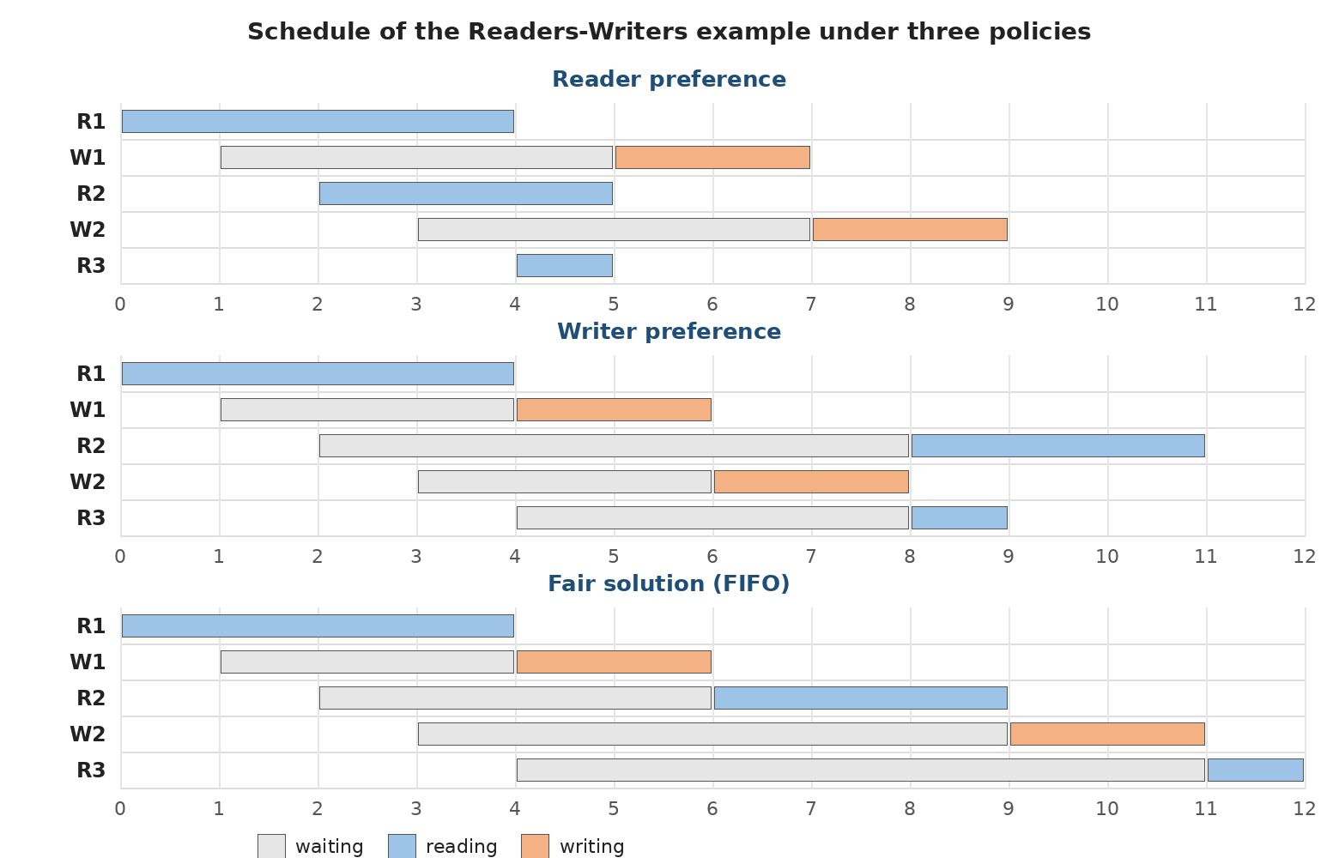
Figure 7.1: Schedule of the numerical example under reader preference, writer preference, and the fair solution
Table 7.2: Start and waiting times of the requests under the three policies (waiting time = start − arrival)
Request | Arrival | Reader pref.: start / wait | Writer pref.: start / wait | Fair: start / wait
R1 | 0 | 0 / 0 | 0 / 0 | 0 / 0
W1 | 1 | 5 / 4 | 4 / 3 | 4 / 3
R2 | 2 | 2 / 0 | 8 / 6 | 6 / 4
W2 | 3 | 7 / 4 | 6 / 3 | 9 / 6
R3 | 4 | 4 / 0 | 8 / 4 | 11 / 7
Mean of readers | — | 0.00 | 3.33 | 3.67
Mean of writers | — | 4.00 | 3.00 | 4.50

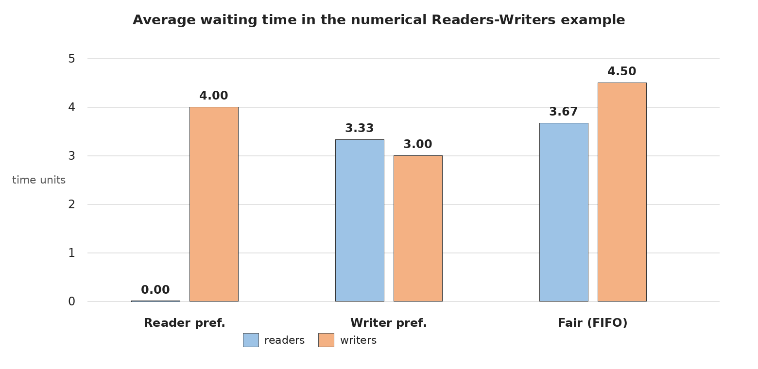
Figure 7.2: Mean waiting time of readers and writers in the numerical example
Reading the results: under reader preference all readers were served without waiting (R2 and R3 joined the active R1), but the writers waited 4 units and a continued arrival of readers could have made this wait unbounded. Under writer preference the writers were served early, but R2 suffered most with 6 units. The fair solution does not give a lower mean wait in this small example (its maximum wait is 7); its value lies in bounding the wait for infinite request streams, not in minimizing the mean of a finite example. This example is purely instructional and has no statistical generality.

7.7 Analysis of ME, Progress, and Bounded Waiting
Mutual exclusion: in all three semaphore solutions, a writer writes only while holding rw_mutex (or w or room_empty), and the group of readers holds the same semaphore via its first reader; therefore W ≤ 1 and W = 1 ⇒ R = 0. In the monitor solutions the same rule holds through the writing and readers > 0 conditions under the monitor lock. Progress: if nobody is in the CS, at least one request enters (M3, M4). Bounded waiting: it is not guaranteed for writers under reader preference nor for readers under writer preference; in the fair solution with a strong semaphore (or a FIFO ticket) a bound exists: every request runs at the latest after all earlier requests have been served.
Table 7.3: Summary of the Readers-Writers analysis
Property | Reader preference | Writer preference | Fair
Mutual exclusion | Guaranteed | Guaranteed | Guaranteed
Progress | Yes | Yes | Yes
Bounded waiting | Readers: yes; writers: no | Writers: yes; readers: no | Yes (strong FIFO)
Starvation | Writers | Readers | None
Deadlock | No (fixed order) | No, provided the semaphores are ordered correctly | No

7.8 Strengths, Weaknesses, Limitations, and Applications
Strengths: read concurrency, natural modeling of read-dominated workloads, and tunable policy. Weaknesses: every simple policy starves one group; the fair solution reduces concurrency; a read/write lock costs more than a plain lock and may not pay off for very short critical sections. Applications: rwlock_t and rw_semaphore in the Linux kernel, pthread_rwlock_t in POSIX (the preferred policy in glibc is configurable by an attribute), ReentrantReadWriteLock in Java (with an optional fair mode), SRWLock in Windows, and database lock managers [1], [2], [13].

8 Semaphores versus Monitors

8.1 Overview
Semaphores and monitors are equivalent in expressive power: each can be implemented with the other [1], [3]. The main difference is the level of abstraction: a semaphore is a simple, data-independent "synchronization object" which the programmer must link correctly to data and orderings; a monitor is a "program structure" that encapsulates data, operations, and synchronization in one unit. Semantically, a semaphore has memory (a signal with no waiter is stored in the value), whereas a condition variable in a monitor is memoryless: a signal is lost when nobody waits [3], [7].

8.2 Structural and Functional Comparison
Table 8.1: Comparison of semaphores and monitors in structure, operation, concurrency control, complexity, and safety
Criterion | Semaphore | Monitor
Structure | Integer + queue; two operations wait/signal; independent of data | Abstract data type: private data + procedures + condition variables
Abstraction level | Low (system level) | High (language/structure level)
Mutual exclusion | Explicit and manual: wait ... signal written by the programmer | Implicit and automatic: entering a procedure takes the lock
Waiting for a condition | Done through the semaphore value (counting) | Via wait on a condition variable; the lock is released
Memory of signal | Yes (the value is incremented) | No (lost when nobody waits)
Ownership | None; any process may signal | The lock has an owner (the holding thread)
Concurrency control | Flexible: resource counting, ordering, and ME with one tool | A single coarse lock; conditions for fine coordination
Programming complexity | High: the order of waits and forgotten signals are error-prone | Lower; but one must understand signal semantics and while
Safety | Weak: no protection against misuse | Stronger: encapsulation prevents lock-free access (in languages with support)
Deadlock | Semaphore ordering; forgotten signal | Nested monitors; lock order of several objects
Implementation cost | Simple in the kernel; needs atomics and a queue | Needs compiler/runtime support or a lock+condition library
Examples | POSIX sem_t, Linux kernel semaphore | Java synchronized, C# Monitor, threading.Condition

8.3 Important Semantic Differences
- Binary semaphore ≠ mutex: a mutex has an owner and only the holder may release it, which enables priority inheritance. A binary semaphore has no owner and is also used to send notifications between processes [1], [22].
- Lost `signal`: if signal is executed before wait, its effect remains in the semaphore value (safe ordering), but it is lost in a condition variable; therefore a monitor must keep the state in a shared variable (a while on the condition).
- Atomic lock release in `wait`: in a monitor wait atomically releases the lock and puts the thread to sleep; with semaphores one must write signal(mutex) and wait(sem) separately, accepting the risk of the time window between them, which may lead to complications such as the "baton-passing" pattern.
- Fairness: FIFO for a strong semaphore; for a monitor it depends on the queue policies and the signal semantics.

8.4 Implementing One with the Other
Listing 8.1: Implementing a semaphore with a monitor (Mesa)
1 monitor Semaphore:
2 value = 0
3 positive = Condition()
4
5 procedure wait():
6 while value == 0:
7 positive.wait()
8 value -= 1
9
10 procedure signal():
11 value += 1
12 positive.signal()

Lines | Explanation
2–3 | The counter value lives in private data; condition "value is positive."
6–8 | Waits until the value is positive and then decrements; this is the "non-negative" version of the semaphore.
11–12 | Increments the value and wakes a waiter; the memory of signal is stored in value.

Conversely, a monitor can be built from semaphores: a binary semaphore mutex for entry and, for each condition variable, a semaphore condsem with a counter of waiters; wait must release mutex, block on condsem, and then re-acquire mutex. The exact construction (especially for Hoare semantics, which needs an "urgent" semaphore) is given in [7].

8.5 Choosing in Practice
- Resource counting or simple ordering between processes (even separate processes) ⇒ semaphore.
- Shared data with several complex conditions (buffers, Readers-Writers, queues) ⇒ monitor or lock + condition variable.
- Need for priority inheritance or ownership ⇒ mutex/monitor, not a semaphore.

9 Comprehensive Comparison of the Techniques
The tables of this chapter put the analyses of Chapters 3 to 8 side by side. Each cell is read under assumptions M1 to M4, and where the answer depends on the implementation this is stated explicitly. The independent tables for Semaphore/Monitor and for the Readers-Writers variants appear in Chapters 8 and 7.
Table 9.1: Master comparison table of the algorithms
Algorithm | Mutual Exclusion | Progress | Bounded Waiting | Deadlock Possibility | Starvation Possibility | Busy Waiting | Scalability | Complexity | Advantages | Disadvantages
Peterson | Guaranteed (M1, M2); two processes | Yes | Yes, B = 1 | No | No | Yes | Poor: 2 only; n processes via filter lock O(n) | Space O(1) (3 variables); uncontended entry O(1) | Simple; only reads/writes; short proof | Busy waiting; needs SC or fences
Dekker | Guaranteed (M1, M2); two processes | Yes | Yes, B = 1 | No | No | Yes (two loops) | Poor: 2 only | Space O(1); more intricate logic | First correct software solution | Complex; busy waiting; needs SC
Semaphore | Guaranteed with initial value 1 and correct use | Yes (M3) | Strong: B ≤ N−1; weak: no | Possible (wrong order, several semaphores) | Possible with weak semaphores/priority inversion | No (blocking); the spinning version has it | Good: N processes | O(1) per operation; queue O(blocked) | General; ME, ordering, counting | Low-level; error-prone; no ownership
Monitor | Structurally guaranteed | Yes (for entry); conditions depend on design | Only with FIFO queues | Possible (nested monitors) | Possible (barging/non-FIFO) | No (at monitor level) | Good, but a coarse lock | O(1) entry; needs language support | Encapsulation; fewer errors | Subtle signal semantics; single lock
Readers-Writers | Guaranteed (R/W incompatible; R/R compatible) | Yes | Reader/writer preference: no; fair: yes | No (with correct ordering) | Reader pref.: writers; writer pref.: readers; fair: none | No (semaphore/monitor) | Very good for read-heavy loads | O(1) per operation; reader counter | Read concurrency | Starvation in simple policies; costlier than a plain lock

9.1 Peterson versus Dekker
Table 9.2: Comparison of Peterson and Dekker
Criterion | Peterson | Dekker
Year/source | 1981 [6] | Mid-1960s [4]
Shared variables | flag[2], turn | wants[2], turn
When turn is written | In the entry protocol (after declaring interest) | In the exit protocol
Contention resolution | The last writer of turn is the victim | The process without the turn backs off
Loop structure | One loop with a compound condition | Two nested loops and an if
Lines of code (approx.) | About 5 statements | About 9 statements
ME / Progress / BW | Yes / Yes / B=1 | Yes / Yes / B=1
Generalization to n | Filter lock [13] | Dijkstra [5], Lamport [11]
Memory-model sensitivity | High (Store→Load) | High (Store→Load)
Difficulty of proof/understanding | Low | High

9.2 Comparison of Fairness Guarantees
Table 9.3: Fairness guarantees of the techniques
Technique | Type of guarantee | Bound/order | Condition
Peterson | Bounded waiting (1-bounded) | B = 1; no explicit FIFO | M1–M4
Dekker | Bounded waiting (1-bounded) | B = 1 | M1–M4
Strong semaphore | FIFO | B ≤ N−1 | FIFO queue, M3
Weak semaphore | None | Unbounded | —
Hoare monitor | FIFO queues | Queue-dependent | Signal-and-urgent-wait semantics
Mesa/Java monitor | No general guarantee | Barging possible | —
Readers-Writers (preference) | One-sided | Starvation of one group | Continuous stream of the preferred group
Readers-Writers (fair) | FIFO over requests | Bounded | Strong semaphore or ticket

9.3 Comparison of Deadlock and Starvation Conditions
Table 9.4: Comparison of deadlock and starvation
Aspect | Deadlock | Starvation
Definition | A set of processes each waiting for an event of another member | A process is denied the resource indefinitely
System progress | Members of the set make no progress | The system progresses; only one process does not
Necessary conditions | ME, hold and wait, no preemption, circular wait | Unfair policy, fixed priority, non-FIFO queue
Prevention | Fixed resource order; eliminating one condition | FIFO queue, aging, strong semaphore
Example in this article | mutex/empty semaphores in reverse order | A writer in reader-preference Readers-Writers
Peterson/Dekker | Absent (M1–M4) | Absent (B=1)

9.4 Use of Each Technique in Operating Systems
Table 9.5: Use of the techniques in operating systems and system software
Technique | Typical use | Examples
Peterson / Dekker | Teaching, correctness proofs, model checking; rarely on hardware without atomics | Textbook example; filter lock in research texts [13]
Semaphore | Resource counting, producer-consumer, ordering | POSIX sem_t, System V, Linux struct semaphore, Windows semaphores [1], [2]
Monitor | Protecting complex data structures with wait conditions | Java synchronized, C# Monitor, pthread_mutex + pthread_cond, Python Condition [24]
Readers-Writers | File caches, configuration tables, database locks | rw_semaphore, pthread_rwlock_t, ReentrantReadWriteLock, SRWLock [1], [13]
Spinlock (reference) | Very short critical sections in the kernel and interrupt handlers | Linux spinlock_t, based on CAS/Test-and-Set [1]

10 Flowcharts of the Algorithms

10.1 Standard Symbols
The flowcharts are drawn with standard ISO 5807 / ANSI symbols. Colors serve legibility only and carry no other meaning, except that the critical section is marked by a thick green frame and blocking operations by orange.
Table 10.1: Symbols used in the flowcharts
Symbol | Meaning | Use in this chapter
Terminator (rounded) | Start or end | "Start" and "End" of a process
Rectangle | Process/statement | Assignments and calls
Diamond | Decision (condition) with yes/no exits | Busy-wait or blocking condition
Parallelogram | Input/output or external part | Remainder section
Arrow | Control flow; dashed = event from another process | Loop-back and wake-up

10.2 Peterson Flowchart
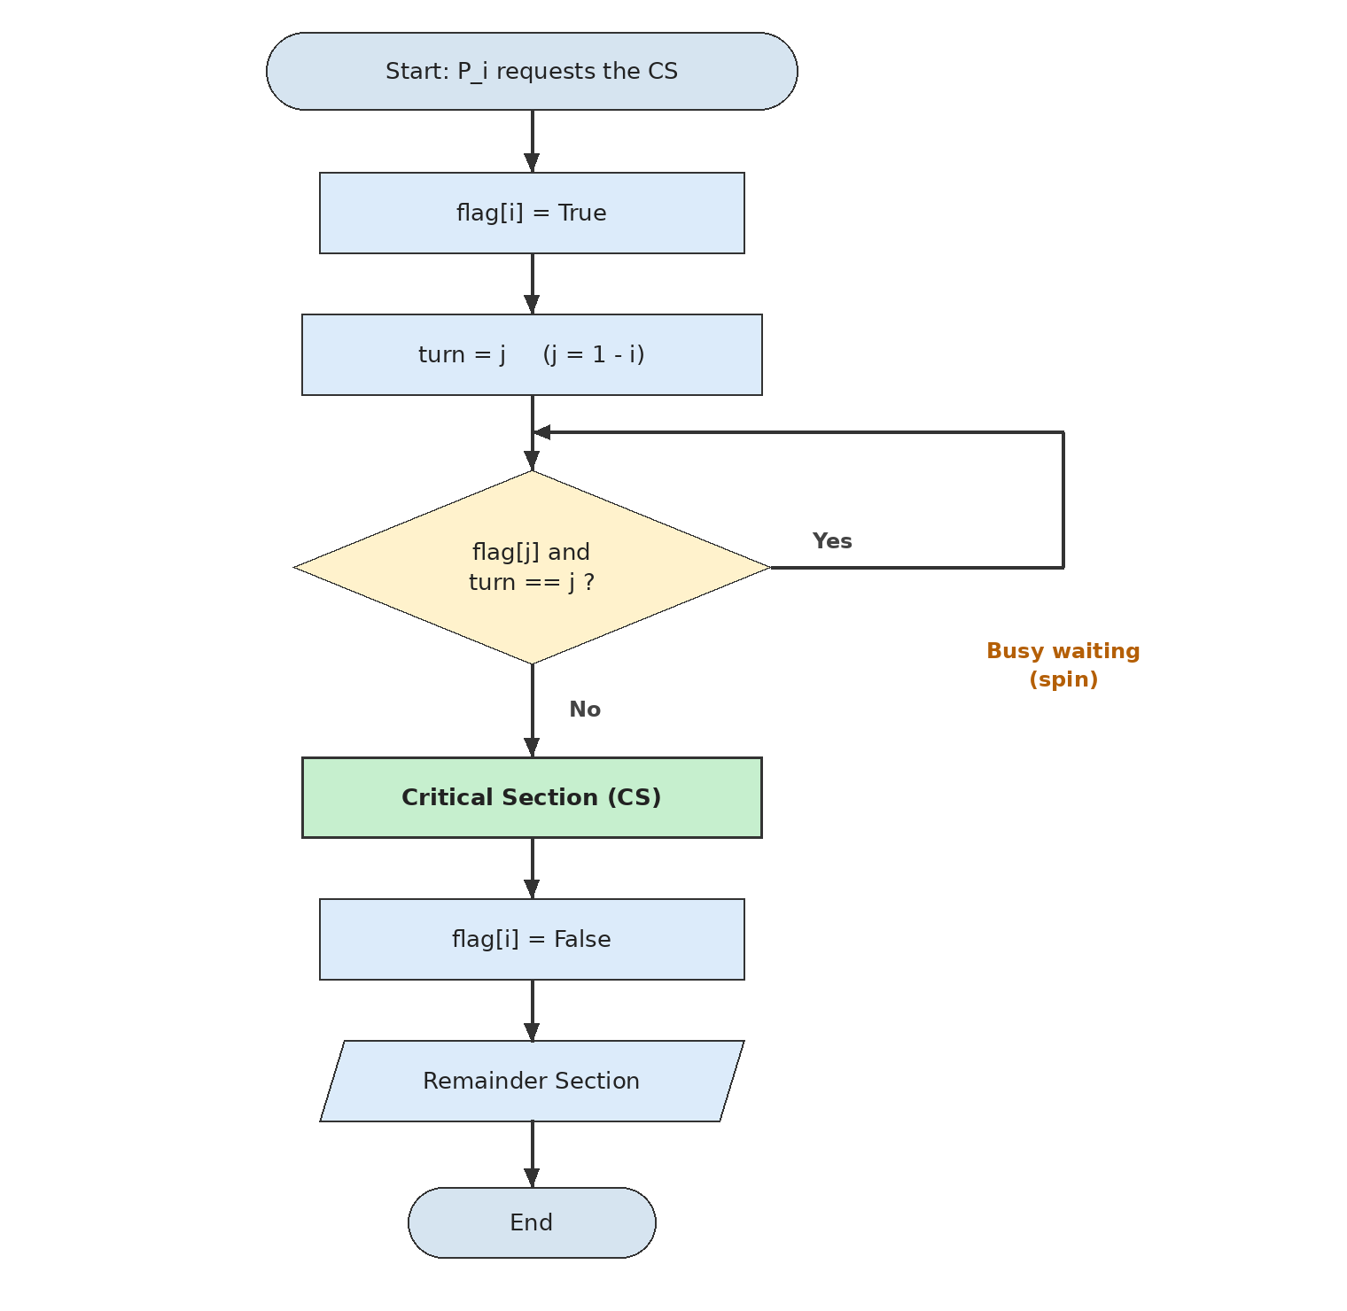
Figure 10.1: Flowchart of Peterson's algorithm for process Pi
- The process starts and declares its interest with flag[i] = True.
- It hands the turn to the rival with turn = j.
- The diamond tests the wait condition: if "yes" (the rival is interested and holds the turn), control returns to the test (busy waiting).
- If "no," the process enters the critical section.
- On exit flag[i] = False is executed and the process moves to its remainder section.

10.3 Dekker Flowchart
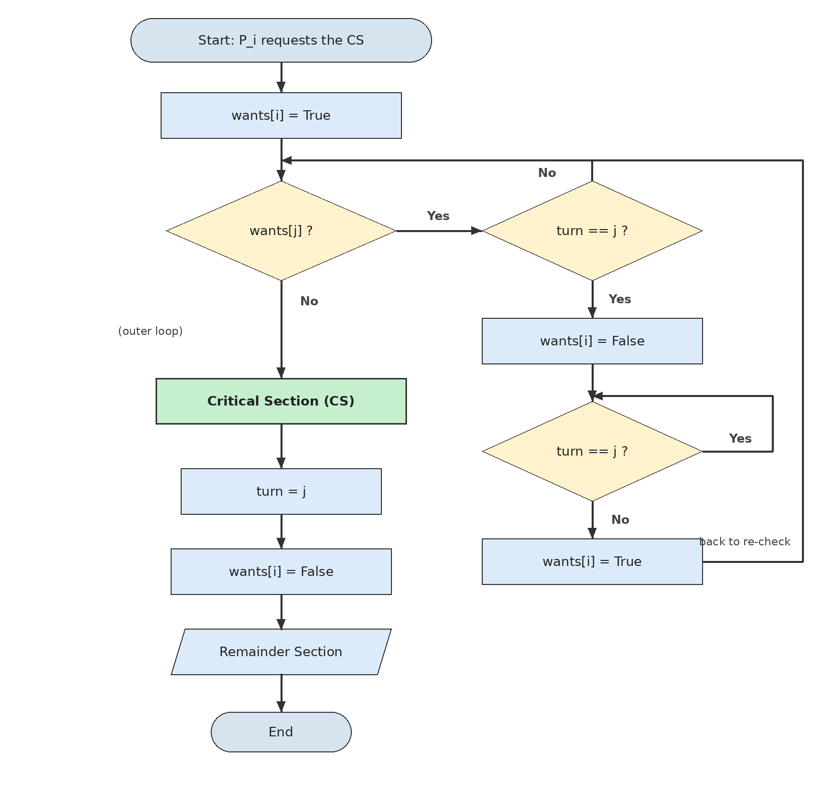
Figure 10.2: Flowchart of Dekker's algorithm for process Pi
- wants[i] = True declares interest.
- First diamond: if wants[j] is "no," the rival is not requesting and the process enters the CS directly.
- If "yes," the second diamond tests the turn: if the process itself holds the turn ("no"), it returns to the first test and keeps spinning.
- If the rival holds the turn: back-off (wants[i] = False), wait in the third diamond until turn != j, then wants[i] = True and return to the first test.
- After the CS, turn = j and then wants[i] = False are executed.

10.4 Semaphore Flowchart
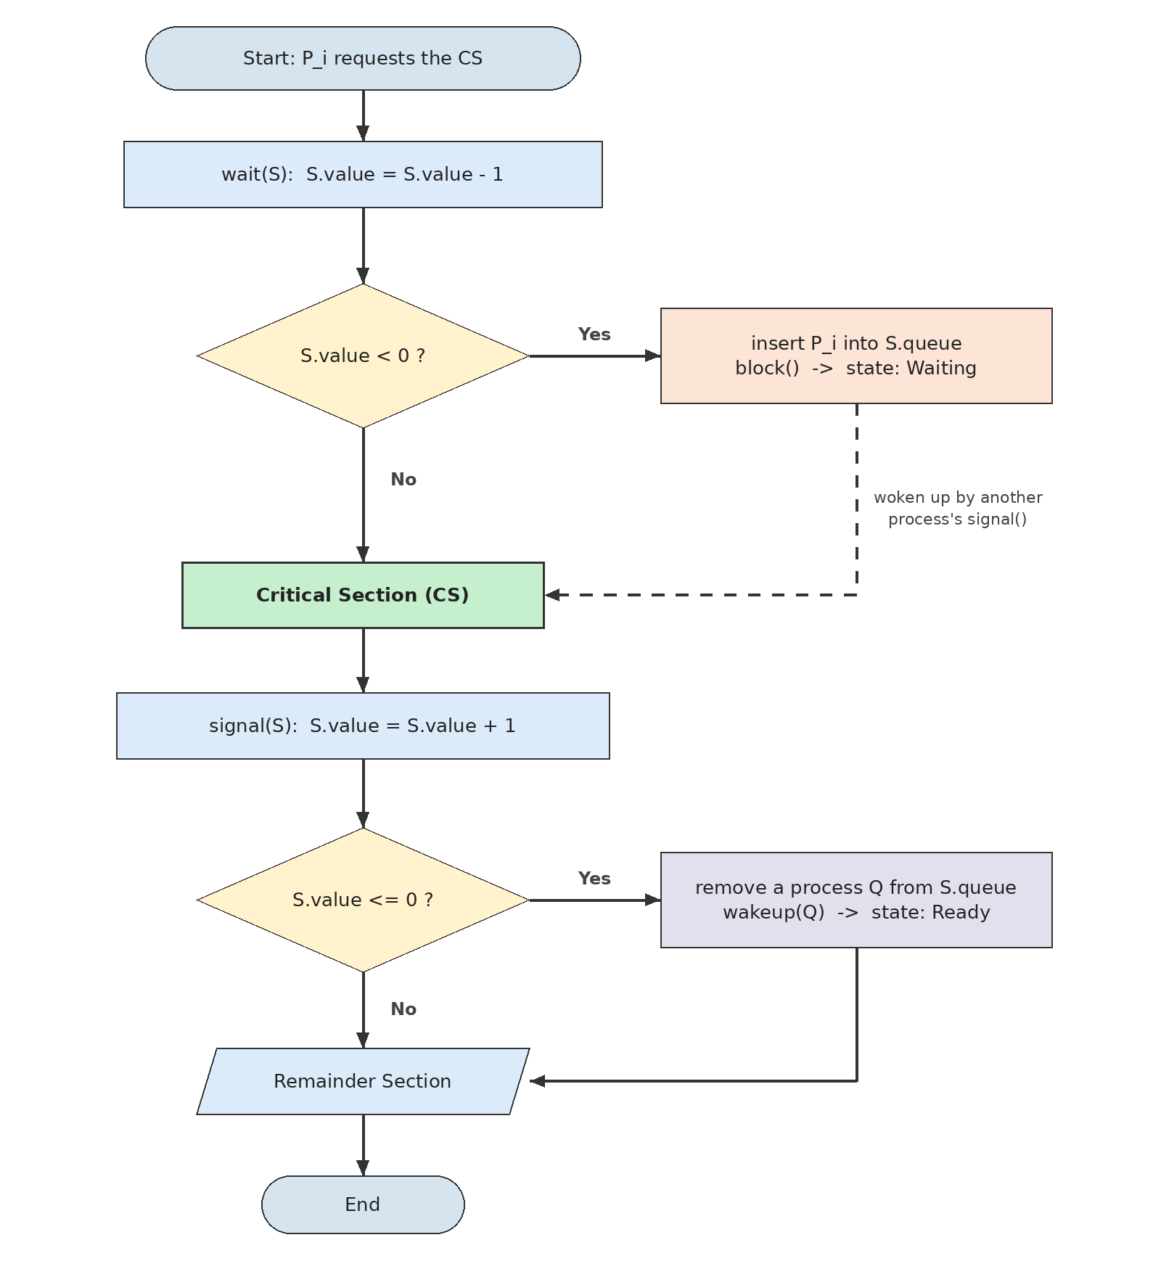
Figure 10.3: Flowchart of wait and signal for a blocking semaphore
- wait(S) decrements the value.
- If S.value < 0, the process is queued and blocked (orange box); it is woken by another process's signal (dashed arrow) and goes to the CS.
- If S.value ≥ 0, the process enters the CS without waiting.
- signal(S) increments the value; if S.value ≤ 0, one waiting process is dequeued and woken.

10.5 Monitor Flowchart
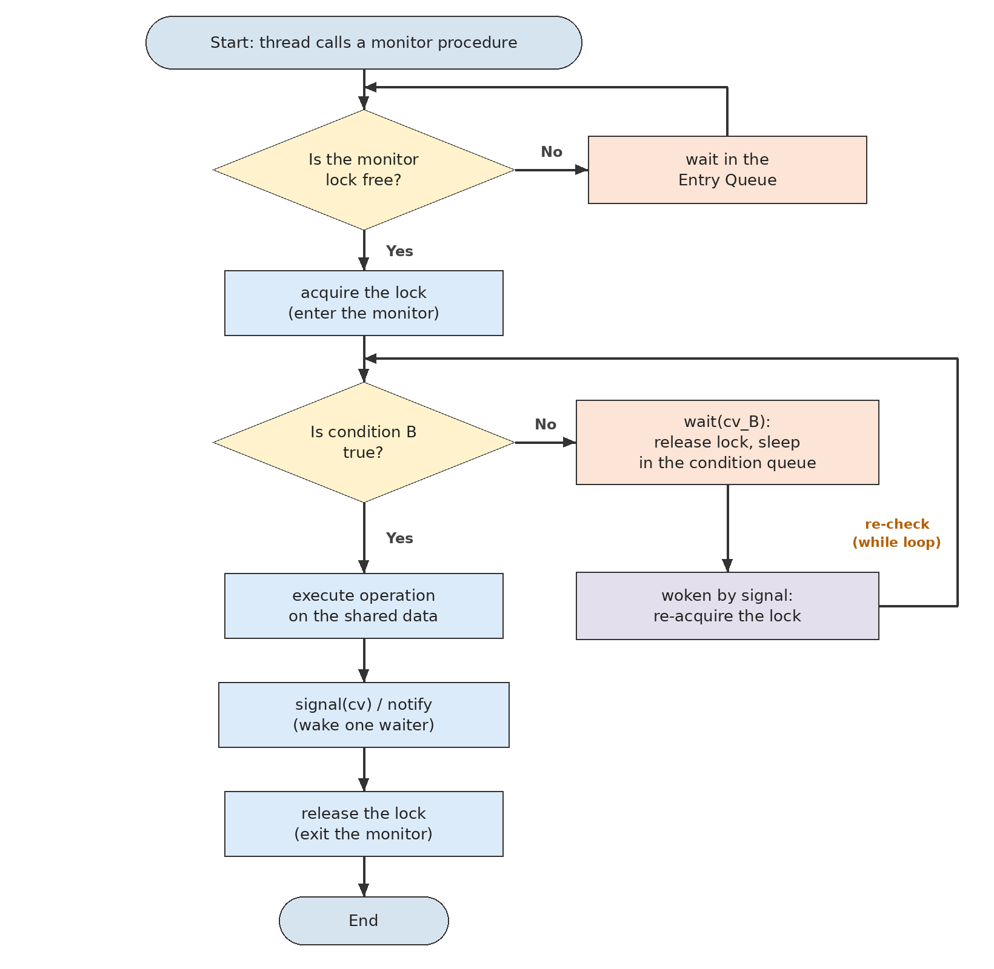
Figure 10.4: Flowchart of entry, condition waiting, and exit in a monitor (Mesa semantics)
- The thread calls a procedure; if the lock is busy it waits in the entry queue.
- It acquires the lock and tests condition B.
- If the condition does not hold, wait(cv_B) releases the lock and sleeps the thread; after waking it re-acquires the lock and re-tests the condition (the while loop).
- If it holds, the operation runs, waiters are notified, and the lock is released.

10.6 Readers-Writers Flowchart
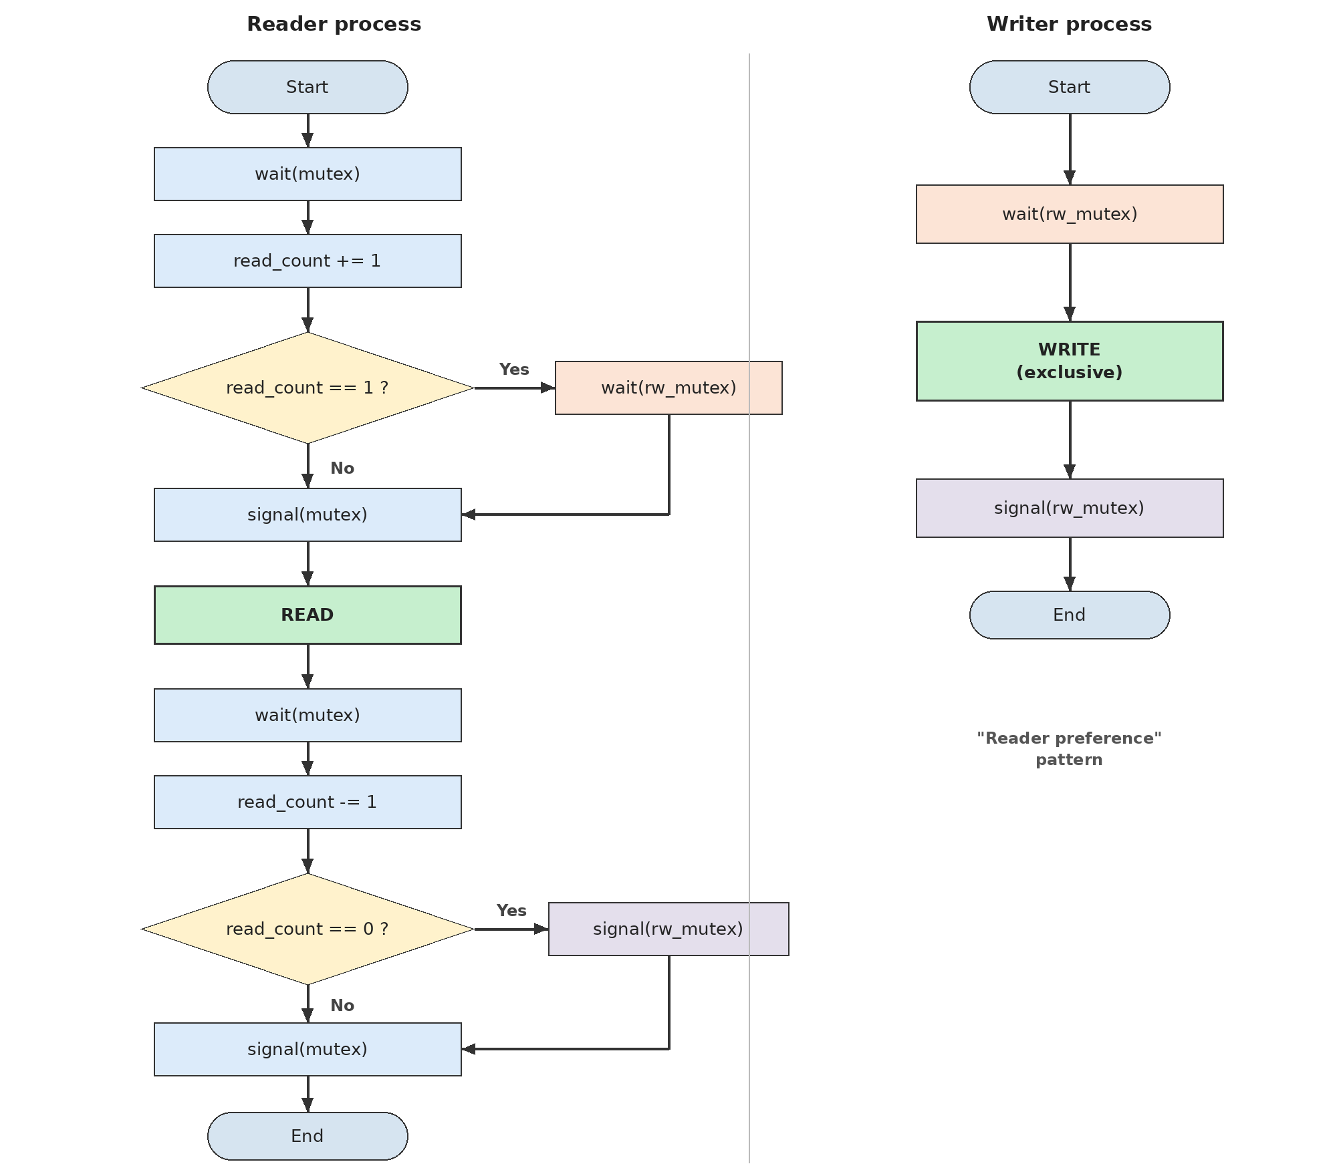
Figure 10.5: Flowcharts of the reader and writer processes in the semaphore solution with reader preference
- The reader updates the counter under mutex; the first reader takes rw_mutex (and may block).
- Reading takes place outside mutex and concurrently with other readers.
- On exit, the last reader releases rw_mutex.
- The writer merely takes rw_mutex, writes, and releases it.

11 Conceptual and Comparative Diagrams
This chapter presents diagrams that show the order of execution, the competition among processes, entry to the critical section, and the behavior of threads. Other diagrams that appeared in earlier chapters are listed in Table 11.1.

11.1 Execution Order and Entry to the Critical Section
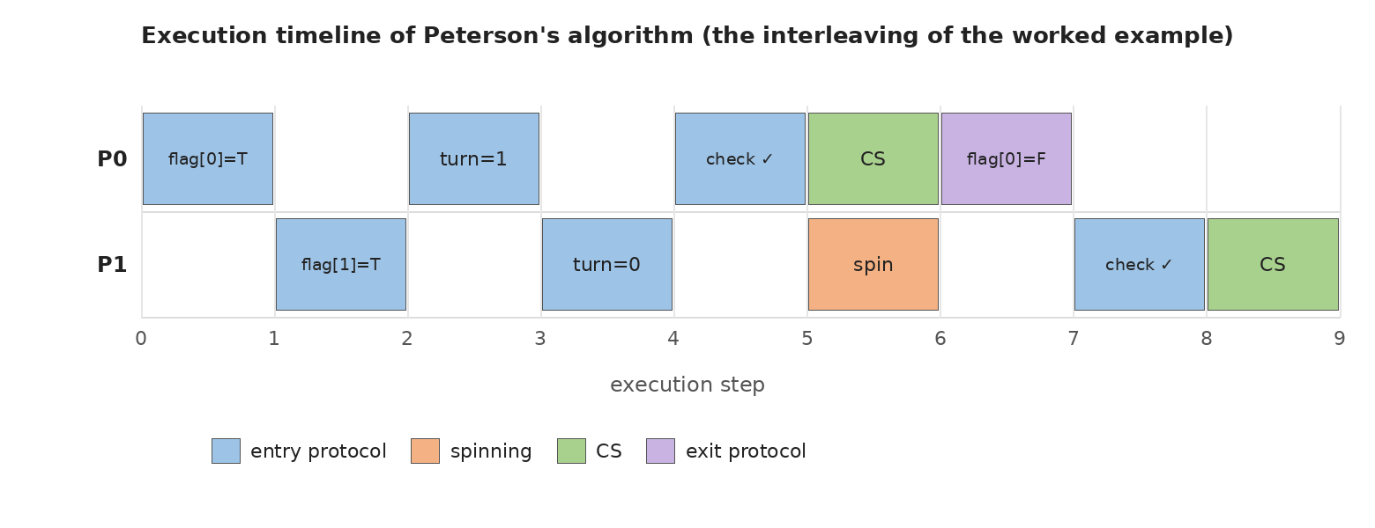
Figure 11.1: Peterson timeline; P1, which wrote turn last, enters after P0
In Figure 11.1 each column is one execution step. Both processes interleave their entry protocols in steps 1 to 4; only in step 5 does P0 pass the test. In step 6 both processes are active but one is in the CS and the other spins (orange), i.e., two green segments never overlap; this is ME.
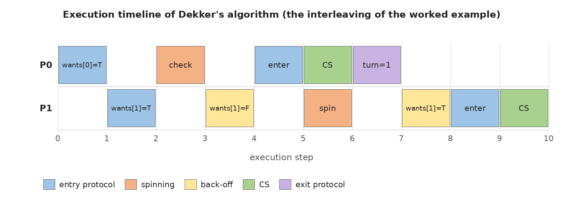
Figure 11.2: Dekker timeline; the back-off of P1 opens the way for P0
Figure 11.2 shows how Dekker's algorithm differs from Peterson's: in step 4 P1 temporarily withdraws its interest (yellow) and re-enters the contention after P0 hands over turn.

11.2 Process Competition and Thread Behavior
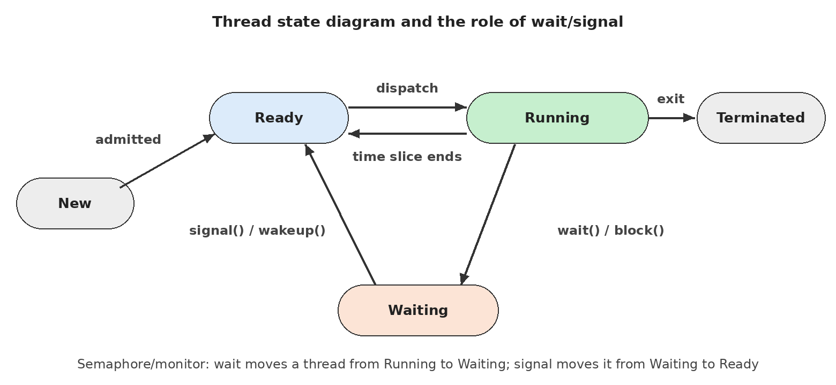
Figure 11.3: Thread state diagram; wait and signal move a thread among Running, Waiting, and Ready
Figure 11.3 shows why semaphores and monitors involve no busy waiting: a thread that cannot proceed goes to the Waiting state and frees the CPU; signal returns it to the Ready queue. With busy waiting, the thread remains in the Running state and consumes processor cycles.

11.3 Index of Other Diagrams
Table 11.1: Index of the conceptual and comparative diagrams throughout the article
Diagram | Subject | Teaching point
Figure 2.1 | Data race and lost update | Why synchronization is needed
Figure 5.1 | Value changes of a binary semaphore | Negative value = number of waiters
Figure 6.1 | Monitor structure | Entry queue versus condition queues
Figure 7.1 | Readers-Writers schedule under three policies | Preferences and starvation
Figure 7.2 | Mean reader/writer waiting | Numerical comparison of the policies

12 Pseudocode versus Executable Python

12.1 Fundamental Differences
The pseudocode of this article is an instructional algorithm written in Python notation for readability but not designed for execution. Executable code must be adapted to the real memory model, scheduler, and library. The table below shows the most important differences.
Table 12.1: Pseudocode versus executable Python
Aspect | Instructional pseudocode | Executable Python
Variable scope | turn = j modifies the shared variable | global turn must be declared, otherwise a local variable is created
Atomicity | Assumed: reads/writes and wait/signal are atomic | x += 1 is not atomic; Lock/Semaphore must be used
Memory model | Sequential consistency (M2) | Implementation-dependent; in standard CPython the GIL simplifies behavior but is not a language guarantee, and free-threaded builds (PEP 703) exist [24]
Busy waiting | pass in a loop | Burns CPU and the spinning thread delays others for a while; prefer time.sleep(0) or blocking objects
Creating processes/threads | Abstract: "process Pi" | threading.Thread(target=..., args=...) with start()/join()
Wake-up | Hypothetical block() and wakeup(p) | Library: Semaphore.acquire/release, Condition.wait/notify
Spurious wake-ups | Not mentioned | In Condition the predicate must be tested in a while

12.2 Executable Examples
Listing 12.1: Real mutual exclusion with threading.Lock (equivalent to a binary semaphore)
1 import threading
2
3 counter = 0
4 lock = threading.Lock()
5
6 def worker(n):
7 global counter
8 for _ in range(n):
9 with lock:
10 counter += 1
11
12 threads = [threading.Thread(target=worker, args=(100_000,)) for _ in range(4)]
13 for t in threads: t.start()
14 for t in threads: t.join()
15 print(counter) # always 400000

Lines | Explanation
4 | Lock is an ownership-based locking mechanism; it corresponds to mutex.wait()/signal() in the pseudocode.
7 | global is needed to modify the shared variable.
9–10 | with lock guarantees entry and exit even on exceptions; it prevents a forgotten signal.
12–14 | Four threads are created, started, and joined; without lock the final value may be below 400000.

Listing 12.2: Bounded buffer with Condition (a Mesa-style monitor)
1 import threading
2
3 class BoundedBuffer:
4 def __init__(self, n):
5 self.buf, self.n = [], n
6 self.lock = threading.Lock()
7 self.not_full = threading.Condition(self.lock)
8 self.not_empty = threading.Condition(self.lock)
9
10 def put(self, item):
11 with self.lock:
12 while len(self.buf) == self.n:
13 self.not_full.wait()
14 self.buf.append(item)
15 self.not_empty.notify()
16
17 def get(self):
18 with self.lock:
19 while not self.buf:
20 self.not_empty.wait()
21 item = self.buf.pop(0)
22 self.not_full.notify()
23 return item

Lines | Explanation
6–8 | One lock and two condition variables sharing it; the same structure as a monitor.
11 | with self.lock corresponds to entering a monitor procedure (in Python it is not implicit and must be written).
12–13 | while because of Mesa semantics and spurious wake-ups; wait releases the lock.
15 | notify makes one waiter ready, but the consumer runs after we leave.

Listing 12.3: Peterson in Python (instructional; not recommended for production)
1 import threading
2
3 flag = [False, False]
4 turn = 0
5 counter = 0
6
7 def lock(i):
8 global turn
9 j = 1 - i
10 flag[i] = True
11 turn = j
12 while flag[j] and turn == j:
13 pass
14
15 def unlock(i):
16 flag[i] = False
17
18 def worker(i, n):
19 global counter
20 for _ in range(n):
21 lock(i)
22 counter += 1
23 unlock(i)

Lines | Explanation
3–5 | Module-level shared variables; counter is the datum protected by the critical section.
8 | global turn is one of the necessary differences from the pseudocode.
12–13 | Busy waiting; in CPython the waiting thread spins until the switch interval (default about 5 ms) expires and slows execution dramatically.

Warning: The correct execution of Peterson in CPython depends on implementation details (the GIL and bytecode scheduling), not on a language guarantee; in compiled languages without atomic/fences it is incorrect. For real code use Lock, Semaphore, or Condition.

13 Common Errors, Failure Conditions, and Exam Tips

13.1 Common Errors
Table 13.1: Common synchronization errors and the consequence of each
Error | Technique | Consequence | Fix
Writing turn = j before flag[i] = True | Peterson | Violates ME (the rival sees a false condition) | flag first, then turn
Forgetting a fence/atomic on real hardware | Peterson/Dekker | Both enter the CS | seq_cst or mfence
Using Peterson for three processes | Peterson | Violates ME | Filter lock or Bakery
Forgetting signal on an error/exception path | Semaphore | Permanent deadlock | try/finally or with
Wrong wait order (mutex before empty) | Semaphore | Deadlock | Resource counting before the lock
Wrong initial value of a semaphore | Semaphore | ME violated (value 2) or deadlock (value 0) | 1 for ME, 0 for events
if instead of while in Mesa | Monitor | Proceeding with a false condition | Always while
signal before the state change | Monitor | Lost wake-up | State first, then signal
wait inside a nested monitor | Monitor | Deadlock | Avoid nested calls
Reader preference for freshness-sensitive data | Readers-Writers | Writer starvation | Writer preference or fair
Assuming FIFO for POSIX semaphores | Semaphore | Unexpected starvation | Build an explicit queue

13.2 Failure Conditions
- Violated assumptions: if M2 (SC) or M1 (atomicity) fails, the correctness of Peterson/Dekker is lost; if M3 is violated (a process dies in the CS), all techniques without a recovery mechanism are stuck (the lock stays held forever).
- Priority and inversion: busy waiting with a priority scheduler on a single core can destroy liveness [22].
- Programmer error: semaphores and monitors do not themselves protect against misuse.

13.3 Important Exam Tips
- Write every guarantee (ME, Progress, BW) together with its assumptions; a "guarantee without assumptions" does not earn full credit.
- Peterson: two variables, two processes, B=1, turn on entry; Dekker: turn on exit, back-off.
- Semaphore: initial value 1/0/N; negative value = number of waiters; strong versus weak.
- Monitor: implicit lock, condition variable, while in Mesa; Hoare versus Mesa.
- Readers-Writers: ME in all versions; writer starvation under reader preference; reader starvation under writer preference; FIFO fairness.
- State the Coffman conditions for deadlock and distinguish deadlock from starvation.

14 Exam Questions with Detailed Answers
The twenty-eight questions below come in five categories, each with an answer and its reason. All answers assume model M1 to M4 unless stated otherwise.

14.1 Part A: Multiple-Choice and True/False Questions
Question 1 (Multiple-choice). In the "strict alternation" solution for two processes, which property is violated?
a) Mutual exclusion
b) Progress
c) Deadlock occurs but progress holds
d) None
Answer: b. If it is P1's turn and P1 stays in its remainder section, P0 cannot enter although the CS is empty; the decision depends on a non-requesting process, so Progress is violated. ME holds because only the holder of the turn enters.

Question 2 (Multiple-choice). What is the bounded-waiting bound B of Peterson's algorithm?
a) 0
b) 1
c) 2
d) Unbounded
Answer: b (B = 1). After Pi writes turn = j, the rival enters at most once; its next request writes turn = i, which makes Pi's wait condition false.

Question 3 (Multiple-choice). In Dekker's algorithm, in which part is turn written?
a) Entry protocol after declaring interest
b) Exit protocol
c) Both equally
d) Only at initialization
Answer: b. turn is handed to the rival in the exit protocol; in Peterson, in contrast, it is written on entry.

Question 4 (Multiple-choice). A semaphore with the blocking definition has the value −3. How many processes are blocked?
a) 0
b) 1
c) 3
d) Cannot be determined
Answer: c. By the invariant, if S.value < 0 then |S.value| = |S.queue|; so three processes are in the queue.

Question 5 (Multiple-choice). For process B to run only after operation X in process A finishes, what should the initial value of the synchronizing semaphore be?
a) 0
b) 1
c) 2
d) −1
Answer: a. With value 0, B's wait blocks until A executes signal (after X).

Question 6 (Multiple-choice). In a monitor with Mesa semantics, why must the condition be tested in a while?
a) For speed
b) Because after waking the condition may no longer hold
c) Because if causes a compile error
d) Because signal always wakes several threads
Answer: b. In Mesa, signal is only a notification; another thread may invalidate the condition before the woken thread runs, and spurious wake-ups are also permitted.

Question 7 (Multiple-choice). In Readers-Writers with reader preference, which group may starve?
a) Readers
b) Writers
c) Both
d) Neither
Answer: b. While a continuous stream of overlapping readers exists, rw_mutex is never released and a waiting writer never enters.

Question 8 (Multiple-choice). Which of the following is not a necessary Coffman condition for deadlock?
a) Circular wait
b) Hold and wait
c) Bounded waiting
d) No preemption
Answer: c. Bounded waiting is a desirable property of a solution, not a deadlock condition; the four Coffman conditions are ME, hold and wait, no preemption, and circular wait [21].

Question 9 (True/False). "Peterson's algorithm, as written, is correct on all modern multicore processors without any memory fence." True or false?
Answer: False. Its correctness depends on sequential consistency (M2). On x86-TSO a Store→Load reordering can make both processes see each other as non-requesting and both enter the CS; a full fence or a seq_cst atomic variable is required [15].

Question 10 (Multiple-choice). What is the main difference between a binary semaphore and a mutex?
a) A mutex can take the value 2
b) A mutex has an owner and only the holder may release it
c) A binary semaphore has busy waiting
d) There is no difference
Answer: b. Ownership enables priority inheritance and error detection; a binary semaphore has no owner and can be used to announce events.

14.2 Part B: Descriptive Questions
Question 11 (Descriptive). Define mutual exclusion, progress, and bounded waiting, and state which is a safety and which a liveness property.
Answer: ME: at most one process in the CS; a safety property (nothing bad ever happens). Progress: if the CS is empty and requesters exist, one of them enters in finite time and a process in the remainder section does not block; liveness. BW: the number of entries by others before a requester enters has a bound; a bounded liveness (a kind of fairness) that prevents starvation.

Question 12 (Descriptive). Describe the difference between Hoare and Mesa signaling in monitors and its consequence for if versus while.
Answer: In Hoare's model signal hands control immediately to the waiter and the signaler is suspended; the condition is guaranteed at wake-up and if suffices. In Mesa/Java signal only makes the waiter ready and the signaler continues; the condition may be invalidated, so while must be used. Mesa has less context-switch overhead and is common in practice [7], [9].

Question 13 (Descriptive). Compare semaphores and monitors in structure, ownership, and memory of signal.
Answer: Semaphore: a simple number+queue object, no owner, signal is stored in the value; monitor: an abstract data type with an implicit lock, the lock has an owner, and a condition-variable signal is memoryless and lost when nobody waits. The comparison table is Table 8.1.

Question 14 (Descriptive). Why do Peterson's and Dekker's algorithms use busy waiting, and why can this be problematic on a single-core kernel?
Answer: Because they have no means to block and wake and only have shared memory; the waiting process must read the condition repeatedly. On a single core, the waiting process wastes its quantum while the lock holder is not running, and with a priority scheduler the holder may never run (priority inversion/loss of liveness) [22].

14.3 Part C: Analytical Questions
Question 15 (Analytical). In Peterson, if the order of the two entry statements is swapped (turn = j before flag[i] = True), show that ME is violated.
Answer: Counterexample interleaving: P0 turn = 1; P1 turn = 0; P1 flag[1] = True; P1 tests: flag[0] is False ⇒ enters the CS. P0 flag[0] = True; P0 tests: flag[1] is True but turn == 1 is false (turn is 0) ⇒ the condition is false and P0 also enters the CS. Both are in the CS. Cause: flag must be declared before turn so that the rival can see the interest.

Question 16 (Analytical). In Peterson with initial turn = 1, the following sequence occurs: P1 flag, P1 turn, P0 flag, P0 turn, P0 test, P1 test. Who enters the CS and why?
Answer: P1: flag[1]=True, turn=0. P0: flag[0]=True, turn=1 (the last writer of turn is P0). P0's test: flag[1] and turn==1 = True ⇒ P0 waits. P1's test: flag[0] and turn==0 = True and False = False ⇒ P1 enters. Rule: the last writer of turn is the victim.

Question 17 (Analytical). In Dekker's algorithm, if turn is not handed over on exit (removing the line turn = 1 - i), which property is violated?
Answer: Suppose turn = 0 and both request; P1 backs off and waits in the inner loop for turn != 0. P0 enters, leaves, and immediately requests again; since wants[1] is False, P0 enters again. Because turn never changes, P1 stays in the loop forever: starvation and a violation of bounded waiting. ME still holds.

Question 18 (Analytical). Two semaphores A and B have initial value 1. P1: wait(A); wait(B). P2: wait(B); wait(A). Show the deadlock and fix it.
Answer: Sequence: P1 wait(A) (A=0), P2 wait(B) (B=0), P1 wait(B) blocks, P2 wait(A) blocks. Each waits for a resource held by the other: hold and wait + circular wait. Fix: a fixed global order (both acquire A first and then B), which removes circular wait [21].

Question 19 (Analytical). In the semaphore solution with reader preference, what happens if mutex is removed?
Answer: The increment/decrement of read_count would not be atomic and a data race occurs. For example, two readers may both read 0 and write 1; both then execute rw_mutex.wait() and one blocks, or an incorrect counter makes the last reader release rw_mutex early so that a writer enters while reading (violating ME).

Question 20 (Analytical). Why can a weak semaphore cause starvation? Give an example.
Answer: In a weak semaphore the wake-up order is unspecified. Three processes A, B, and C: A is in the CS while B and C wait. A leaves and C is woken; A requests again, and when C leaves the choice among waiters may again always pick A or C but never B. A strong (FIFO) semaphore removes this with the bound B ≤ N − 1 [3].

Question 21 (Analytical). Why can a nested monitor call lead to deadlock?
Answer: A thread that, inside M1, calls a procedure of M2 and waits there releases only M2's lock and keeps M1's lock. If the thread that must establish M2's condition and signal first needs M1, it never enters and the first thread is never woken [3].

Question 22 (Analytical). Briefly explain why Peterson needs a memory fence on x86-TSO and where to put the fence.
Answer: Under TSO, stores linger in the buffer and a later load from another address can overtake them; so the read of flag[j] may occur before the rival sees flag[i]=True, and both enter the CS. A full fence (mfence) must be placed between the write turn = j and the loop test, or flag/turn must be seq_cst atomics [15].

14.4 Part D: Numerical and Design Problems
Question 23 (Problem-solving). A semaphore S with initial value 2 and operations: P1 wait, P2 wait, P3 wait, P4 wait, P1 signal, P2 signal, P3 signal. Write the value and queue after each operation and the final value (strong semaphore).
Answer: Values after each operation: 1, 0, −1 (queue [P3]), −2 (queue [P3,P4]), −1 (P3 woken; queue [P4]), 0 (P4 woken; queue [ ]), 1. Final value = 1. P4 has not yet signaled.

Question 24 (Problem-solving). Using a semaphore, ensure that statement S2 of process P2 runs only after S1 of process P1.
Answer: sync = Semaphore(0). P1: S1; sync.signal(). P2: sync.wait(); S2. If P2 arrives first it blocks on wait; if P1 signals first, the value 1 is stored and the later wait passes (the memory of the semaphore).

Question 25 (Problem-solving). Design a rendezvous for two processes A and B so that neither passes the meeting point unless both have arrived.
Answer: a_arrived = Semaphore(0), b_arrived = Semaphore(0). A: a_arrived.signal(); b_arrived.wait(). B: b_arrived.signal(); a_arrived.wait(). The order "signal first, then wait" matters; if both wait first, deadlock occurs.

Question 26 (Problem-solving). Requests: R1 (arrival 0, duration 3), W1 (arrival 1, duration 2), R2 (arrival 2, duration 2). Find the start time of each request under reader preference and writer preference.
Answer: Reader preference: R1 from 0; W1 waits; R2 joins R1 at 2 and reads until 4; W1 starts at 4 (wait 3). Writer preference: R1 from 0 to 3; R2 is blocked because W1 is waiting; W1 from 3 to 5; R2 from 5 to 7 (wait 3). The fair (FIFO) solution here equals writer preference.

Question 27 (Problem-solving). In a semaphore bounded buffer (N = 3), a producer inserts 5 items and no consumer exists. Write the values of empty and full and the producer's state.
Answer: The first three items: empty goes from 3 to 0 and full from 0 to 3. The fourth empty.wait() drives the value to −1 and the producer blocks; the fourth and fifth items are not inserted. State: empty = −1, full = 3, the producer in Waiting.

Question 28 (Problem-solving). With a strong semaphore and N = 5 processes, a process requests while three processes wait in the queue and one is in the CS. How many entries occur before it? Is this consistent with the bound N − 1?
Answer: Three entries (the three waiters ahead in the FIFO queue); the process in the CS entered before the request and is not counted. 3 ≤ N − 1 = 4, so it is consistent.

15 Comparative Exercises and Design Problems
Each exercise comes with a solution. It is recommended to solve it yourself before reading the solution.

15.1 Exercise 1: Removing Components of Peterson's Algorithm
Statement: In each of the following cases, which property (ME, Progress, deadlock) is violated? (a) removing flag and keeping only turn; (b) removing turn and keeping only flag; (c) removing the wait loop.
Solution: (a) With only turn we get strict alternation: ME holds but Progress is violated (a process in the remainder section blocks). (b) With only flag: ME holds, but if both set flag to True simultaneously, both wait forever ⇒ deadlock (attempt 3 in Table 4.2). (c) Without the wait loop no process waits and both enter the CS ⇒ ME is violated.

15.2 Exercise 2: Cost of Generalizing to n Processes
Statement: For n = 4, compare the number of levels and shared variables of the filter lock with two-process Peterson.
Solution: Two-process Peterson: 3 shared variables (flag[0], flag[1], turn) and one level. Filter lock for n = 4: n − 1 = 3 levels; the level array has 4 cells and the victim array has 3 used cells (levels 1 to 3), 7 shared variables in total. Growth is O(n) in space and O(n) levels in entry steps (uncontended); hence scalability is poor [13].

15.3 Exercise 3: A One-Lane Bridge
Statement: Cars from two directions reach a one-lane bridge. Cars in the same direction may cross simultaneously but opposite directions may not. Design it with semaphores and analyze starvation.
Listing 15.1: One-lane bridge (the "lightswitch" pattern; similar to reader preference)
1 bridge = Semaphore(1)
2 mutex = [Semaphore(1), Semaphore(1)]
3 count = [0, 0]
4
5 def car(d):
6 mutex[d].wait()
7 count[d] += 1
8 if count[d] == 1:
9 bridge.wait()
10 mutex[d].signal()
11 cross()
12 mutex[d].wait()
13 count[d] -= 1
14 if count[d] == 0:
15 bridge.signal()
16 mutex[d].signal()

Lines | Explanation
1–3 | bridge provides exclusion between the two directions; each direction has its own mutex and counter.
6–10 | The first car of a direction takes the bridge and the other same-direction cars join without waiting.
12–16 | The last car frees the bridge for the opposite direction.

Solution (continued): ME between the two directions is provided by bridge. But if a continuous stream of cars comes from one direction, the opposite direction starves (as in reader preference). For fairness a shared turnstile must be added before each car: turnstile.wait(); turnstile.signal() before registration, with the turnstile held by a direction whose turn has not come, or a FIFO queue must be used.

15.4 Exercise 4: A Barrier with a Monitor
Statement: Design a reusable barrier for n threads with a monitor: no thread leaves arrive() unless all n threads have arrived.
Listing 15.2: A reusable barrier with a monitor (Mesa) and a generation counter
1 monitor Barrier:
2 n = N
3 count = 0
4 generation = 0
5 all_here = Condition()
6
7 procedure arrive():
8 my_gen = generation
9 count += 1
10 if count == n:
11 count = 0
12 generation += 1
13 all_here.broadcast()
14 else:
15 while my_gen == generation:
16 all_here.wait()

Lines | Explanation
8–9 | Every thread remembers the current generation and increments the counter.
10–13 | The last thread resets the counter, increments the generation, and wakes everybody; hence the barrier is reusable.
14–16 | The others wait until the generation changes; testing the generation in a while is safe against spurious wake-ups and overtaking by threads of the next round.

15.5 Exercise 5: Reader Starvation under Writer Preference
Statement: Show that in the Courtois writer-preference solution a reader can starve.
Solution: Suppose writers W1, W2, … arrive such that each new writer increments write_count before the previous writer finishes writing. Then write_count never reaches 0, r.signal() is never executed, and r stays closed to readers. The reader waiting behind r (and mutex3) is blocked forever; with M3 every writer finishes, but the continuous arrival of writers causes starvation. Remedy: the fair solution (Section 7.4).

15.6 Exercise 6: Choosing a Technique
Table 15.1: Choosing a suitable technique for different scenarios
Scenario | Suggested technique | Reason
A file cache with 95% reads | Read/write lock (fair or writer preference) | Read concurrency; prevents writer starvation
A pool of 10 database connections | Counting semaphore with initial value 10 | Counting a multi-instance resource
A producer-consumer queue with several conditions | Monitor / lock + condition variable | Several waiting conditions
A very short lock in an interrupt handler | Atomic-based spinlock | Cannot sleep; short wait
Course: proving ME without atomic instructions | Peterson or Dekker | Only reads/writes (under SC)

16 Conclusion
This article examined five fundamental synchronization techniques with the same structure and depth. The main conclusion is that no technique can be evaluated without naming its execution model. Peterson's and Dekker's algorithms show that ME, progress, and bounded waiting for two processes are possible with nothing but atomic reads/writes under sequential consistency, but their modern implementation needs a memory fence or an atomic variable. The semaphore, with atomic operations and a queue of blocked processes, removes busy waiting and covers the three patterns of ME, ordering, and counting, but its correctness rests on programmer discipline and the queue policy (strong/weak). The monitor reduces errors through data encapsulation and an implicit lock, and condition variables separate waiting from exclusion, but the meaning of signal and fairness must be understood carefully. The Readers-Writers problem showed that ME alone is not enough and that the policy (preference and fairness) determines starvation.
- Practical choice: in real systems use the locks, semaphores, and condition variables of the operating-system library; Peterson and Dekker have educational and theoretical value.
- State every guarantee with its assumptions: M1 to M4 and the queue policy.
- Fairness has a cost: fair solutions reduce concurrency; the policy must match the workload.
- Further reading: the Bakery algorithm, wait-free techniques, and memory-model foundations [11], [17], [18].

References
[1] A. Silberschatz, P. B. Galvin, and G. Gagne, Operating System Concepts, 10th ed. Hoboken, NJ, USA: Wiley, 2018.
[2] A. S. Tanenbaum and H. Bos, Modern Operating Systems, 4th ed. Upper Saddle River, NJ, USA: Pearson, 2015.
[3] W. Stallings, Operating Systems: Internals and Design Principles, 9th ed. New York, NY, USA: Pearson, 2017.
[4] E. W. Dijkstra, "Cooperating sequential processes," Tech. Rep. EWD-123, 1965; reprinted in Programming Languages, F. Genuys, Ed. New York, NY, USA: Academic Press, 1968, pp. 43–112.
[5] E. W. Dijkstra, "Solution of a problem in concurrent programming control," Commun. ACM, vol. 8, no. 9, p. 569, Sep. 1965.
[6] G. L. Peterson, "Myths about the mutual exclusion problem," Inf. Process. Lett., vol. 12, no. 3, pp. 115–116, Jun. 1981.
[7] C. A. R. Hoare, "Monitors: An operating system structuring concept," Commun. ACM, vol. 17, no. 10, pp. 549–557, Oct. 1974.
[8] P. Brinch Hansen, Operating System Principles. Englewood Cliffs, NJ, USA: Prentice-Hall, 1973.
[9] B. W. Lampson and D. D. Redell, "Experience with processes and monitors in Mesa," Commun. ACM, vol. 23, no. 2, pp. 105–117, Feb. 1980.
[10] P. J. Courtois, F. Heymans, and D. L. Parnas, "Concurrent control with 'readers' and 'writers'," Commun. ACM, vol. 14, no. 10, pp. 667–668, Oct. 1971.
[11] L. Lamport, "A new solution of Dijkstra's concurrent programming problem," Commun. ACM, vol. 17, no. 8, pp. 453–455, Aug. 1974.
[12] L. Lamport, "How to make a multiprocessor computer that correctly executes multiprocess programs," IEEE Trans. Comput., vol. C-28, no. 9, pp. 690–691, Sep. 1979.
[13] M. Herlihy and N. Shavit, The Art of Multiprocessor Programming, rev. 1st ed. Waltham, MA, USA: Morgan Kaufmann, 2012.
[14] A. B. Downey, The Little Book of Semaphores, 2nd ed. Needham, MA, USA: Green Tea Press, 2016.
[15] P. Sewell, S. Sarkar, S. Owens, F. Zappa Nardelli, and M. O. Myreen, "x86-TSO: A rigorous and usable programmer's model for x86 multiprocessors," Commun. ACM, vol. 53, no. 7, pp. 89–97, Jul. 2010.
[16] S. V. Adve and K. Gharachorloo, "Shared memory consistency models: A tutorial," Computer, vol. 29, no. 12, pp. 66–76, Dec. 1996.
[17] M. Herlihy, "Wait-free synchronization," ACM Trans. Program. Lang. Syst., vol. 13, no. 1, pp. 124–149, Jan. 1991.
[18] H.-J. Boehm and S. V. Adve, "Foundations of the C++ concurrency memory model," in Proc. ACM SIGPLAN Conf. Program. Lang. Des. Implement. (PLDI), Tucson, AZ, USA, 2008, pp. 68–78.
[19] M. Ben-Ari, Principles of Concurrent and Distributed Programming, 2nd ed. Harlow, U.K.: Addison-Wesley, 2006.
[20] G. R. Andrews, Foundations of Multithreaded, Parallel, and Distributed Programming. Reading, MA, USA: Addison-Wesley, 2000.
[21] E. G. Coffman, M. J. Elphick, and A. Shoshani, "System deadlocks," ACM Comput. Surv., vol. 3, no. 2, pp. 67–78, Jun. 1971.
[22] L. Sha, R. Rajkumar, and J. P. Lehoczky, "Priority inheritance protocols: An approach to real-time synchronization," IEEE Trans. Comput., vol. 39, no. 9, pp. 1175–1185, Sep. 1990.
[23] H. Franke, R. Russell, and M. Kirkwood, "Fuss, futexes and furwocks: Fast userlevel locking in Linux," in Proc. Ottawa Linux Symp., Ottawa, ON, Canada, 2002, pp. 479–495.
[24] Python Software Foundation, "threading — Thread-based parallelism," Python 3 Documentation. [Online]. Available: https://docs.python.org/3/library/threading.html
[25] J. Manson, W. Pugh, and S. V. Adve, "The Java memory model," in Proc. 32nd ACM SIGPLAN-SIGACT Symp. Principles Program. Lang. (POPL), Long Beach, CA, USA, 2005, pp. 378–391.

