Assignment Cover Sheet

Qualification |  | Module Number and Title
HD in Computing and Software Engineering
Student Name & No. |  | Assessor
T.M. Sadew Pahasara Bandara  KG/HDCSE/CMU/34/25 |  | Mr. Tharindu Bandara
Hand out date |  | Submission Date
Assessment type  WRIT1-Coursework | Length of  Assessment Type  3000 Words | Weighting of Assessment  100%

Learner declaration
I am Sadew Pahasara Bandara- KG/HDCSE/CMU/34/25, certify that the work submitted for this assignment is my own and research sources are fully acknowledged.
Marks Awarded
First assessor
IV marks
Agreed grade
Signature of the assessor |  | Date

Feedback Form

International College of Business & Technology

Module: Database Design and Development
Student: T.M. Sadew Pahasara Bandara - KG/HDCSE/CMU/34/25
Assessor: Mr. Tharindu Bandara
Assignment: Connect Me
Strong features of your work:

Areas for improvement:

Marks Awarded:

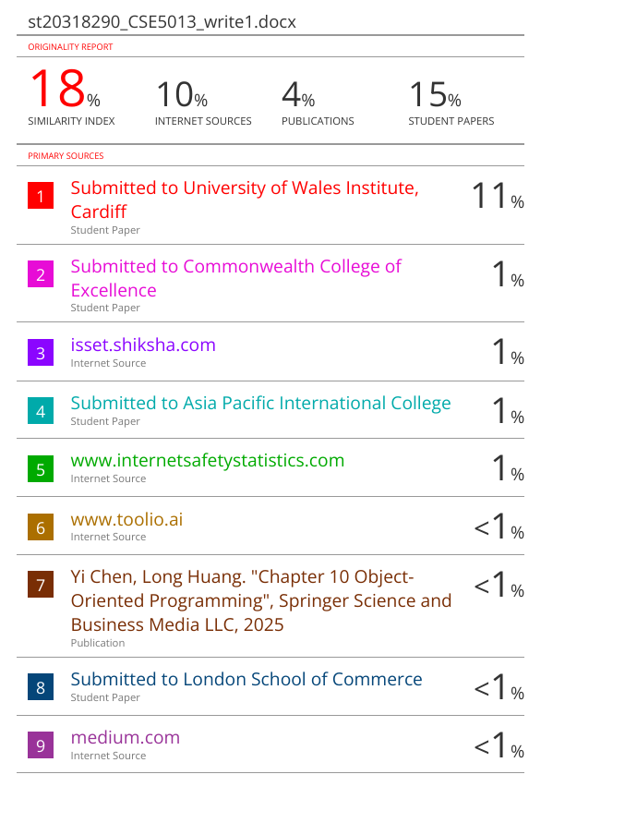

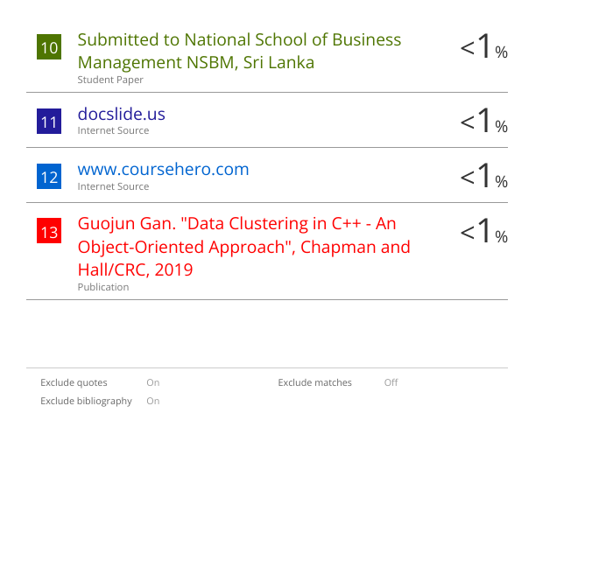

Acknowledgement

- I would like to extend my heartfelt gratitude to Mr. Tharindu Bandara my assessor, for his invaluable guidance, continuous support, and constructive feedback throughout this assignment. His expertise in networking concepts has played a crucial role in enhancing my understanding of the subject.

- I am also grateful to the International College of Business & Technology (ICBT) for providing access to essential learning resources and fostering a supportive academic environment.

- Furthermore, I sincerely appreciate my family for their unwavering encouragement and support, which have been instrumental in the successful completion of this report.

- Lastly, I would like to acknowledge the contributions of various authors and researchers whose scholarly works have significantly enriched my knowledge and helped me develop a well-rounded solution for this assignment.

Sincerely,
T.M. Sadew Pahasara Bandara
KG/HDCSE/CMU/34/25

EXECUTIVE SUMMERY
The Employee Management System (EMS) for Connect Me is a software solution designed to enhance HR operations by automating employee data management, departmental assignments, and role-based access control. It allows HR managers to efficiently add, update, and delete employee records while ensuring data security. The system also facilitates performance tracking through reports, improving workforce oversight. Built using Object-Oriented Programming (OOP) principles, it incorporates Encapsulation for data protection, Inheritance for code efficiency, Polymorphism for flexible method handling, and Abstraction to simplify complex operations. The user-friendly interface ensures seamless navigation for HR personnel. While the system effectively manages employees, it has limitations, such as the absence of payroll processing, AI-driven analytics, and a mobile application. Despite these constraints, the EMS significantly reduces manual workload, enhances accuracy, and improves workforce management. By implementing this system, Connect Me can streamline HR tasks, optimize administrative processes, and ensure efficient employee data handling.
Table of Contents

Feedback Form 2
Acknowledgement 3
EXECUTIVE SUMMERY 4
Table of Figures 6
Task 01 7
1.1. Use case Diagram 7
Actors: 8
Use Cases and Their Functionality: 8
Relationships 9
1.2. Class Diagram 10
Classes and Their Attributes 11
Methods (Operations) 12
Relationships 12
Key Observations 12
1.3. Sequence Diagram 13
Actors/Objects Involved 14
Sequence of Interactions 14
Alternative Flow 14
Key Observations 14
Task 02 15
2.1. Inheritance 15
2.2. Encapsulation 17
2.3. Polymorphism 19
Task 03 20
User Manual 20
Table of Contents 20
Introduction 20
System Requirements 22
Getting Started 23
Features & Functionalities 34
User Roles and Permissions 34
Troubleshooting & FAQs 35
References 36

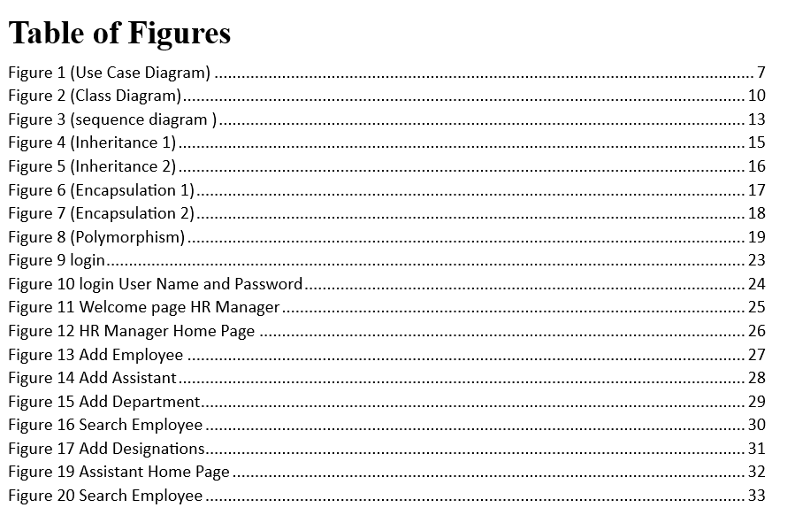

Task 01

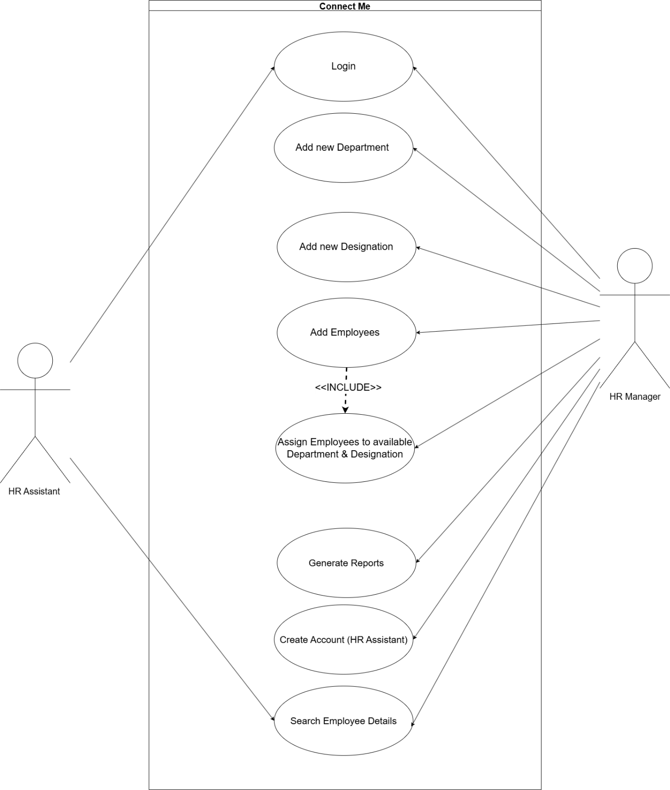
Use case Diagram

Figure 1 (Use Case Diagram)

A Use Case Diagram is a visual representation in Unified Modeling Language (UML) that depicts the interactions between users (actors) and a system to achieve specific functionalities. It consists of actors, which can be humans, external systems, or devices, and use cases, which represent the system’s functionalities. The diagram is enclosed within a system boundary to define the scope of the system being modeled. Key relationships in a use case diagram include association, which connects actors to use cases, include, indicating a mandatory dependency between use cases, extend, showing optional or conditional behavior, and generalization, illustrating inheritance between use cases. Use case diagrams are essential in requirement analysis and system design as they provide a high-level overview of system functionalities and interactions without delving into technical details. They serve as a valuable tool for stakeholder communication, ensuring that all user requirements are clearly understood and captured early in the development process. Their simplicity and clarity make them widely used in software engineering to model system behavior from a user’s perspective. ( ANDA & SJØBERG, 2005)

Actors:
- HR Manager
- HR Assistant

Use Cases and Their Functionality:
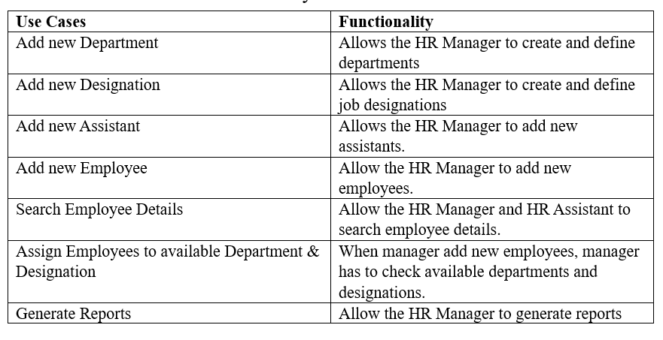

Relationships:
Association: The HR Manager interacts directly with all use cases
Dependencies: Some use cases may depend on others.

Class Diagram

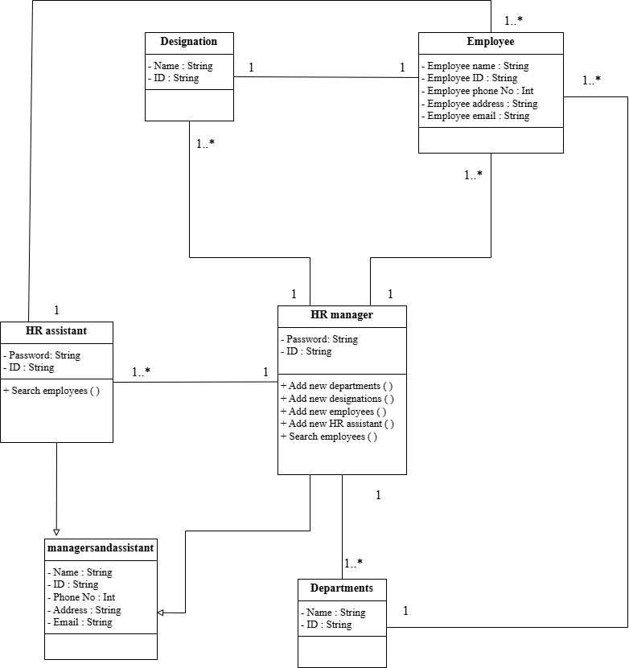

Figure 2 (Class Diagram)

A class diagram is a UML structural diagram that models the static architecture of a system by defining classes, their attributes, methods, and relationships. It represents entities as classes (with fields and operations) and connections as associations, aggregations, compositions, or inheritance. Class diagrams help visualize object-oriented design, clarifying dependencies, hierarchies, and interactions among components. They serve as a blueprint for software development, enabling efficient code generation, system documentation, and database design. By depicting the system’s structure without behavioral details, class diagrams improve stakeholder communication, ensure design consistency, and support scalability in object-oriented programming. They are essential in software engineering for modeling system architecture. (Berardi, et al., 2005)

Classes and Their Attributes

ManagersandAssistant  - Name (String)  - Phone No (Int)  - Address (String)  - Email (String) | HR Manager  -ID (String)  -Password (String)  -Address(String)  -Email (String) | Employee  - Employee name (String)  - Employee ID (String)  - Phone No (Int)  - Address (String)  - Email (String)
Designation  - Name (String)  - ID (String) | Departments  - Name (String)  - ID (String) | HR Assistant  - ID (String)  - Password (String)

Methods (Operations)

HR Manager
- Add new departments
- Add new designations
- Add new employees
- Add new HR assistant
- Search employees
HR Assistant
- Search employees

Relationships
Association
- Employees are linked to designation.
- Employees may belong to a department.
- HR Manager and HR Assistant interact with the "Connect Me" System to perform
Dependency
- The HR Manager depends on HR department.
- The HR Assistant depends on HR department.
Generalization
ManagersandAssistant is a super class and subclasses are HR Assistant and HR Manager.

Key Observations
Inheritance
HR Assistant and HR Manager share common attributes (Name, Address, Email, Password, contact details).

Sequence Diagram
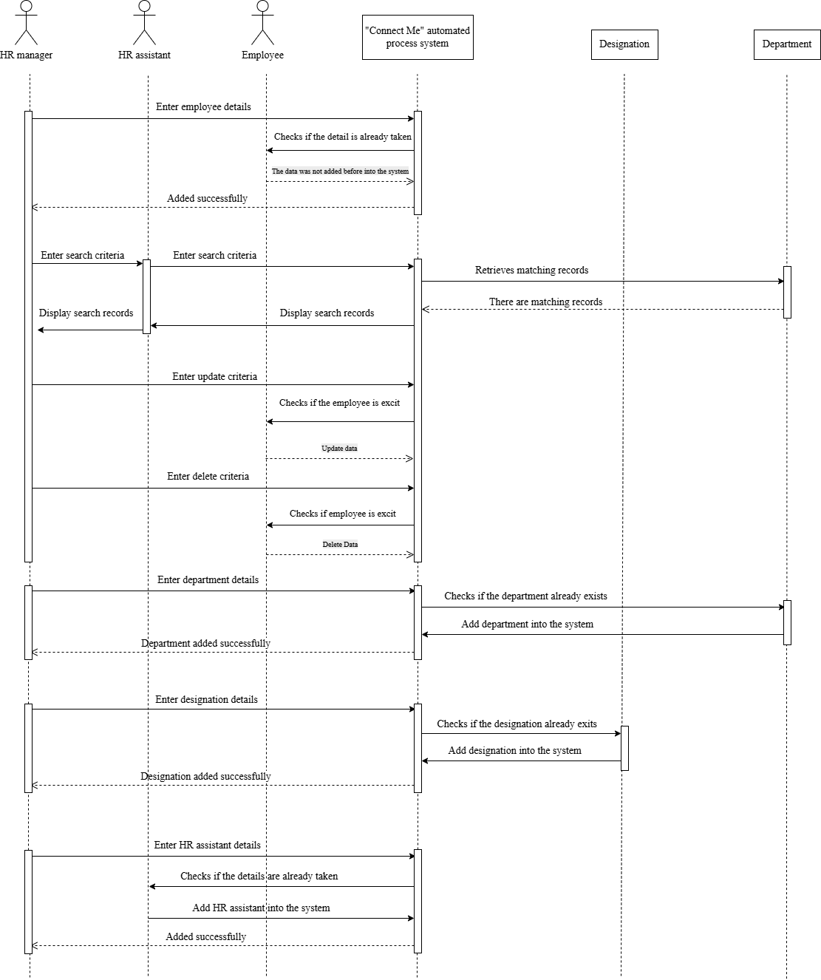

Figure 3 (sequence diagram )

A sequence diagram is a UML interaction diagram that models the dynamic behavior of a system by illustrating the order of interactions between objects over time. It captures the flow of messages between lifelines (representing objects or actors) in a sequential manner, emphasizing the timing and causality of events. Sequence diagrams are particularly useful for visualizing runtime scenarios, method calls, and system processes, making them essential for requirements analysis, system design, and debugging. By clearly depicting the interaction logic, they help stakeholders understand system behavior, validate design correctness, and ensure seamless communication between components in object-oriented and real-time systems. (Bernardi, et al., n.d.)

Actors/Objects Involved
Department
An organizational unit added to the system.
Designation
A job role created in the system.

Sequence of Interactions
Initial Check
Department Creation
Designation Creation
Success Notification

Alternative Flow
If data already exists, the system detects matching records and skips creation to avoid duplicates.

Key Observations
Automation
Error Handling
Extensions

Task 02

Inheritance

Inheritance is a fundamental object-oriented programming principle that enables a new class to derive properties and behaviors from an existing class, promoting code reuse and establishing hierarchical relationships. The paper acknowledges inheritance as a relatively accessible concept for students compared to interfaces, though it emphasizes the importance of proper application to avoid misuse. By focusing on discriminators—clear definitions of subclass characteristics, the document advocates for intentional hierarchical design that maintains logical consistency. Inheritance also facilitates polymorphism, allowing objects of different derived classes to be treated uniformly through a common interface. The paper connects this to broader design philosophies, particularly the seamless integration of analysis, design, and implementation activities. While inheritance supports extensibility, the document suggests it should be employed judiciously alongside other OOP concepts like interfaces to achieve flexible and maintainable software architectures. This aligns with the paper's overarching emphasis on object-oriented design as a structured yet adaptable approach to problem-solving. (Sicilia, 2006)

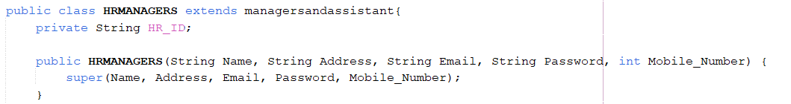
Figure 4 (Inheritance 1)

The class HRMANAGERS extends the managersandassistant class, inheriting its properties and methods.

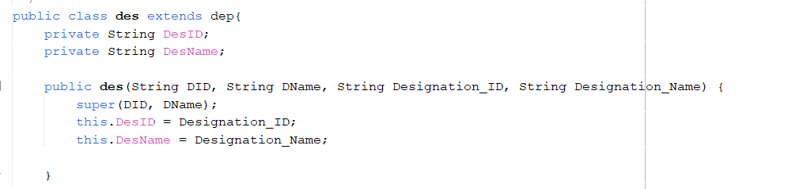
Figure 5 (Inheritance 2)

The class des extends the dep class, inheriting its properties and methods.

Encapsulation

Encapsulation in object-oriented programming (OOP) bundles data (attributes) and methods within a class, restricting direct access to internal details. By declaring fields as private and exposing controlled access via public methods (e.g., getters/setters), it ensures data integrity and modularity. The paper implicitly supports this through instance-first modeling (e.g., UML diagrams) and design-for-reuse (interfaces), emphasizing structured class design. Encapsulation aligns with the document’s focus on separating design (contracts) from implementation, promoting robust, maintainable Java programs. (Sicilia, 2006)
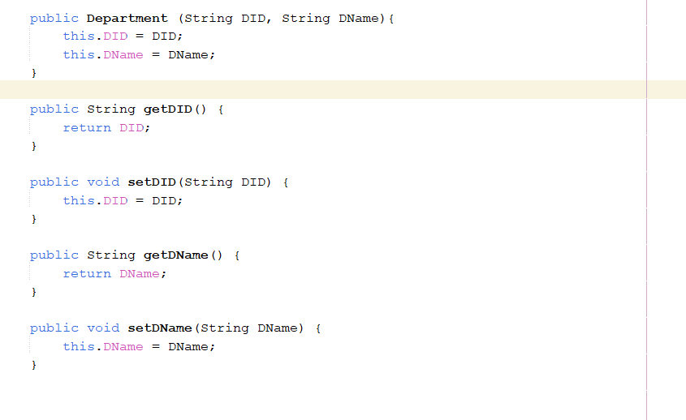
Figure 6 (Encapsulation 1)

The class uses private fields (DID, DName) to restrict direct access, exposing them via public getter/setter methods (getDID(), setDName(), etc.).

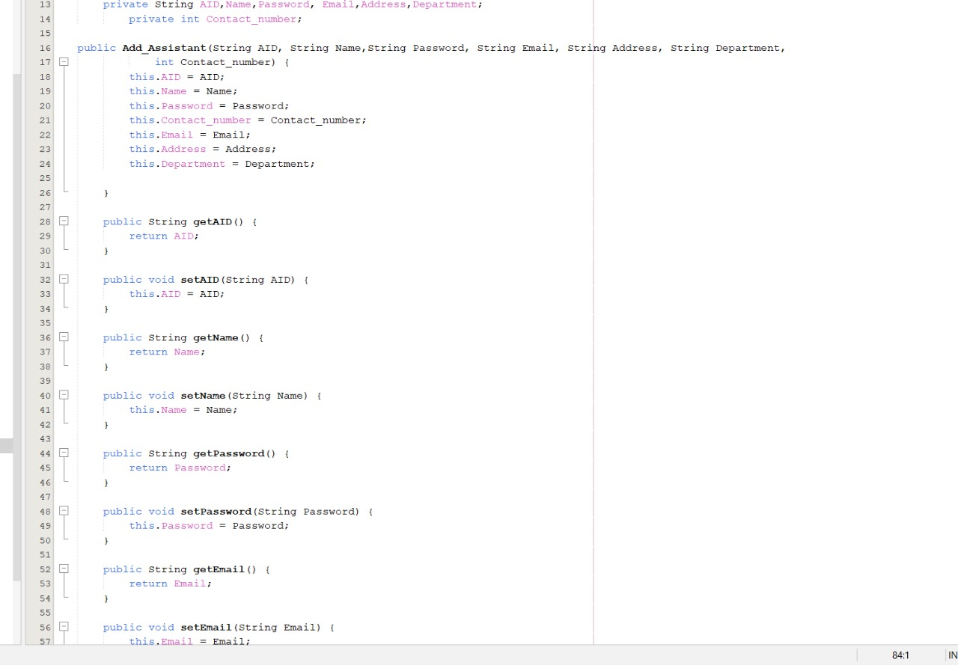
Figure 7 (Encapsulation 2)

The class uses private fields (AID, Name, Password, Contact_Number, Email, Address, Department) to restrict direct access, exposing them via public getter/setter methods (getDAD(), setName(), etc.).

Polymorphism

Polymorphism enables objects of different types to be treated uniformly through shared interfaces or inheritance. The paper presents it as a natural outcome of proper OOP design, emphasizing its role in creating flexible systems. While students typically grasp polymorphism easier than interfaces, the document stresses teaching it alongside design principles to prevent misuse. Polymorphism reduces code dependencies, supporting the paper's focus on maintainable architectures and separation of interface from implementation in Java instruction. (Sicilia, 2006)

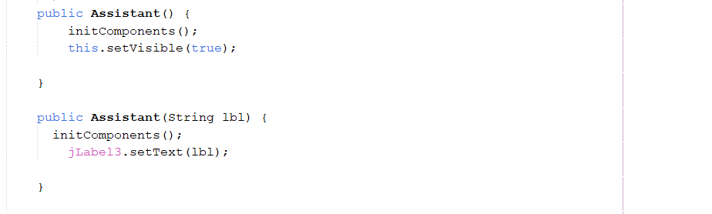
Figure 8 (Polymorphism)

Constructor Overloading (Compile-time Polymorphism):
This is an example of method overloading (a form of compile-time polymorphism), where multiple methods/constructors have the same name but different parameters.

Task 03

User Manual
Software Name: Connectme
Version: V1.0
Prepared by: T.M. Sadew Pahasara Bandara - KG/HDCSE/CMU/34/25
Date: 02.04.2025
Institution/University: International College of Business & Technology

Table of Contents
- Introduction
- System Requirements
- Installation Guide
- Getting Started
- Features & Functionalities
- User Roles and Permissions
- Troubleshooting & FAQs
- Contact Information

Introduction
The Employee Management System (EMS) for ConnectMe is a software solution designed to streamline HR operations by efficiently managing employee details, departments, and designations. It simplifies tasks such as adding new employees, updating records, assigning roles, and generating reports.

Purpose
The Employee Management System (EMS) for Connect Me is designed to help HR managers and assistants efficiently manage employee details, departmental assignments, and designations. It automates administrative tasks, reduces paperwork, and improves workforce organization by providing a centralized, user-friendly system for handling employee records and performance tracking.

Objectives

- Efficient Employee Management – Enable HR managers to easily add, update, and manage employee details.
- Department & Designation Organization – Ensure employees are correctly assigned to relevant departments and job roles.
- Data Accuracy & Security – Store employee records securely while ensuring data integrity and privacy.
- Role-Based Access Control – Restrict access based on user roles (Admin, HR Manager, Employee) to maintain security.
- Performance Tracking & Reporting – Generate reports to monitor employee performance and departmental efficiency.
- User-Friendly Interface – Provide an intuitive and easy-to-use interface for seamless navigation and operation.
- Time & Cost Efficiency – Reduce manual HR tasks, minimize paperwork, and improve overall workflow.

Intended users

- HR Manager
- HR Assistant.

Scope
The Employee Management System (EMS) is designed to assist HR managers and assistants in managing employee records efficiently within Connect Me.

Functionalities
Employee Data Management – Add, update, delete, and view employee details.
Department & Designation Management – Assign employees to departments such as Operations,Quality Assurance, and Training.
Role-Based Access Control – Restrict functionalities based on user roles (Admin, HR Manager, Employee).

Limitations

Limited to Employee Management – The system does not handle payroll, financials, or recruitment processes.
AI-Powered Analytics – Lacks advanced AI-based decision-making for employee performance predictions.
Access Control Restrictions – Only authorized users can make modifications; regular employees have limited access.

System Requirements

Hardware Requirements
Minimum RAM: 4GB
Processor: Intel i3 or higher/ AMD Ryzen 3 or higher
Storage: 100MB

Software Requirements
Operating System: Windows/Linux/Mac
Database: MySQL, SQLite, etc.
Additional Dependencies: Java, Python, etc.

Getting Started

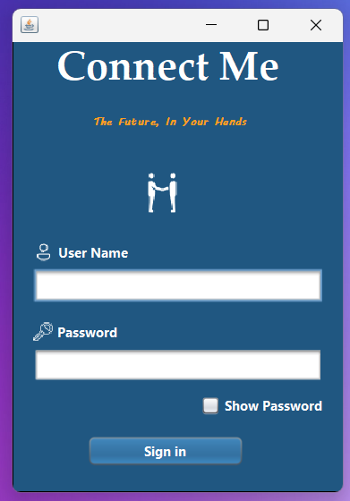
3
2
1
Figure 9 login

1 = Type User Name
2 = Type User Name
3 = Sign In Button
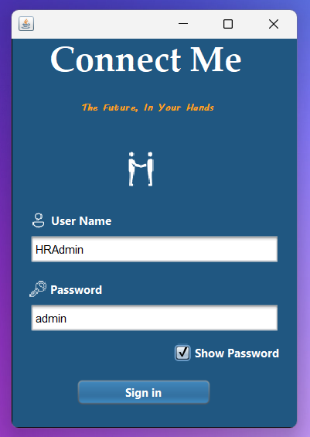
3
2
1
Figure 10 login User Name and Password

1 = HR Manager User Name
2 = HR Manager User Name
3 = Sign In Button

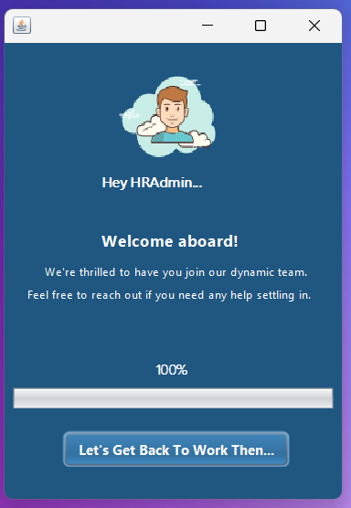
1
Figure 11 Welcome page HR Manager

1 = Home Page Button

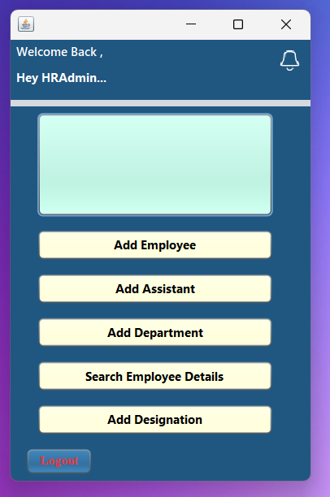
8
7
6
5
4
3
2
1
Figure 12 HR Manager Home Page

1 = Notifications
2 = Notice
3 = Add Employee Button
4 = Add Assistant Button
5 = Add Department Button
6 = Search Employee Details Button
7 = Add Designation Button
8 = Logout Button

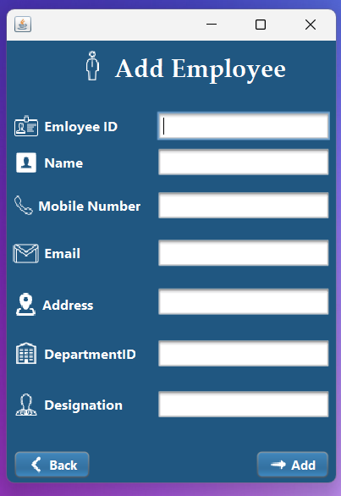
9
8
7
6
5
4
3
2
1
Figure 13 Add Employee

1 = Type Employee ID
2 = Type Employee Name
3 = Type Employee Mobile Number
4 = Type Employee Email
5 = Type Employee Address
6 = Type Department ID
7 = Type Designation ID
8 = Add Employee Button
9 = Back Button

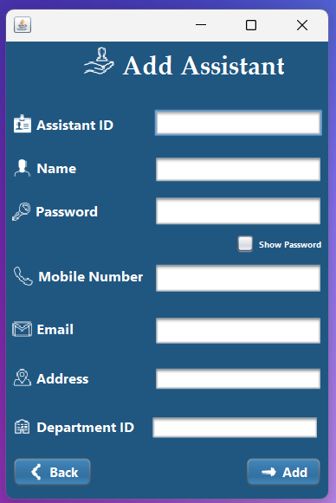
Figure 14 Add Assistant

1

2
3

4

5

6
7

9
8

1 = Type Assistant ID
2 = Type Assistant Name
3 = Type Assistant Password
4 = Type Assistant Mobile Number
5 = Type Assistant Email
6 = Type Assistant Address
7 = Type Department ID
8 = Add Assistant Button
9 = Back Button
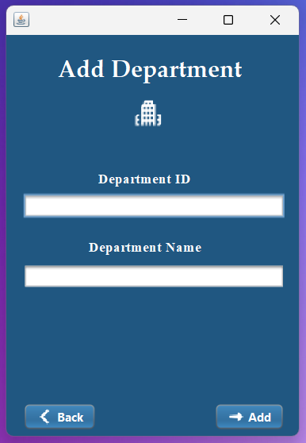
4
3
2
1
Figure 15 Add Department
1 = Type Department ID
2 = Type Department Name
3 = Add Department Button
4 = Back Button

3
2
1
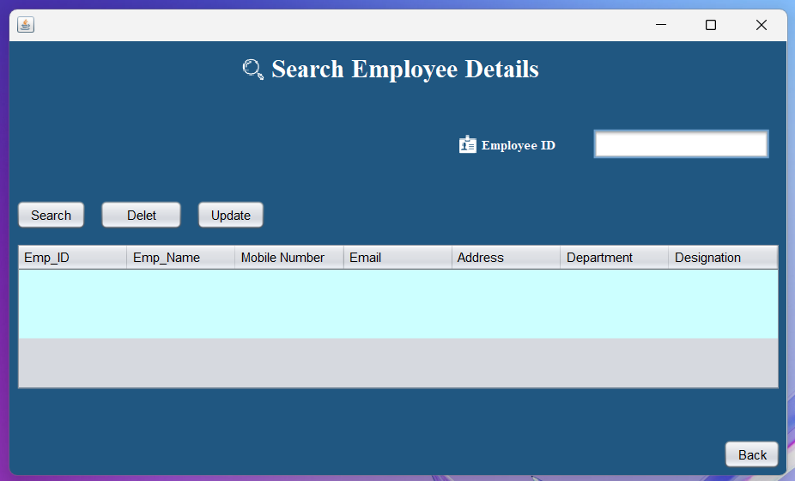
5
4
Figure 16 Search Employee

1 = Search Employee Button
2 = Delete Employee Button
3 = Update Employee Button
4 = Type Employee ID
5 = Back Button
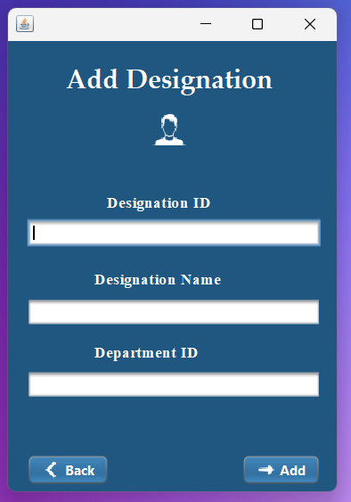
5
4
3
2
1
Figure 17 Add Designations

1 = Type Designation ID
2 = Type Designation Name
3 = Type Department ID
4 = Add Department
5 = Back Button

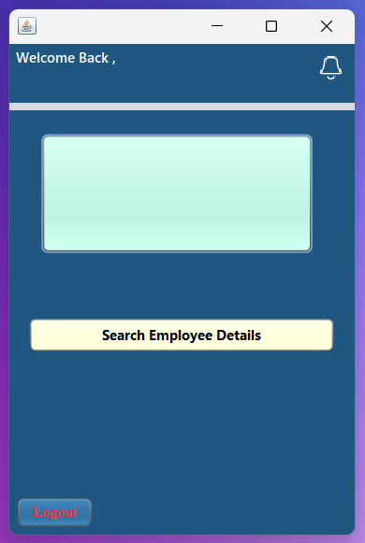
4
3
2
1
Figure 19 Assistant Home Page

1 = Notification
2= Notice
3 = Search Button
4 = Logout

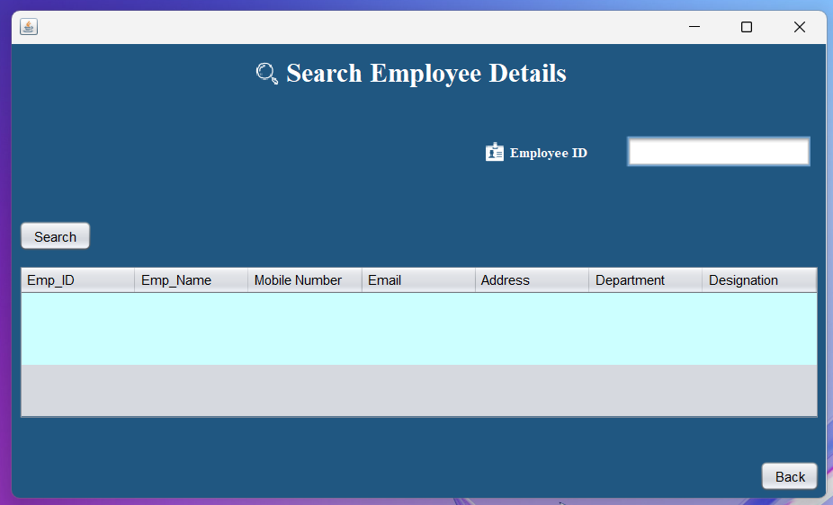
3
2
1
Figure 20 Search Employee

1 = Type Employee ID
2 = Employee Search
3 = Back

Features & Functionalities

Employee Management
Add, update, and remove employees
View employee details

Department & Designation Management
Assign employees to departments
Update job roles

User Roles and Permissions

Admin: Full access to all features.
HR Manager: Can manage employees and generate reports.

Troubleshooting & FAQs

Issue | Solution
Cannot log in | Check username/password
Data not saving | Ensure database connection is active
System crash | Restart and check logs for errors

Conclusion

The Employee Management System (EMS) for Connect Me provides a structured and efficient solution for managing employee data, departments, and designations. Built on Object-Oriented Programming (OOP) principles—Encapsulation, Inheritance, and Polymorphism—the system ensures security, reusability, and flexibility. UML diagrams, including Use Case, Class, and Sequence diagrams, clearly outline the system's functionality, interactions, and workflow, serving as a robust foundation for development.
The system simplifies HR tasks, allowing HR managers and assistants to add, update, and search employee records seamlessly. Role-based access control enhances security, ensuring only authorized personnel can modify sensitive data. The accompanying user manual provides clear instructions, facilitating smooth adoption and operation.
However, the system has limitations, such as the lack of payroll integration, AI-driven analytics, and mobile accessibility. Future enhancements could expand its capabilities by incorporating these features, further improving efficiency and decision-making.
In summary, the EMS for Connect Me successfully automates key HR processes, reducing manual effort and improving data accuracy. Its implementation will enhance workforce management, streamline administrative tasks, and contribute to organizational productivity. With further refinement, the system has the potential to become an even more comprehensive HR management tool.

References
ANDA, B. & SJØBERG, D. I. K., 2005. Investigating the Role of Use Cases in the Construction of Class Diagrams. [Online]
Available at: https://d1wqtxts1xzle7.cloudfront.net/48902224/Investigating_the_Role_of_Use_Cases_in_t20160917-1085-1c2mxh-libre.pdf?1474097745=&response-content-disposition=inline%3B+filename%3DInvestigating_the_Role_of_Use_Cases_in_t.pdf&Expires=1743702888&Signature=C
[Accessed 03 04 2025].
Berardi, D., Calvanese, D. & Giacomo, G. D., 2005. Reasoning on UML class diagrams. [Online]
Available at: https://pdf.sciencedirectassets.com/271585/1-s2.0-S0004370205X02922/1-s2.0-S0004370205000792/main.pdf?X-Amz-Security-Token=IQoJb3JpZ2luX2VjEIj%2F%2F%2F%2F%2F%2F%2F%2F%2F%2FwEaCXVzLWVhc3QtMSJHMEUCIQD7xGh1HKF60aXCUx0pHIepstvodQFo%2FsWGkzt9omlHEQIgP84IfCMgJg
[Accessed 03 04 2025].
Bernardi, S., Donatelli, S. & Merseguer, J., n.d. From UML Sequence Diagrams and Statecharts to analysable Petri Net models. [Online]
Available at: https://d1wqtxts1xzle7.cloudfront.net/7259489/10.1.1.133.2609-libre.pdf?1390850651=&response-content-disposition=inline%3B+filename%3DFrom_UML_sequence_diagrams_and_statechar.pdf&Expires=1743703617&Signature=Kzn5Z~tQLjUrpxsdShVu2c2mibaSCXmKaVzSPC5jKdfw0pg
[Accessed 03 04 2025].
Sicilia, M.-Á., 2006. Strategies for Teaching Object Oriented Concepts with Java. [Online]
Available at: https://d1wqtxts1xzle7.cloudfront.net/30778576/SICI_CSE_06-libre.pdf?1363436977=&response-content-disposition=inline%3B+filename%3DStrategies_for_teaching_object_oriented.pdf&Expires=1743702166&Signature=AtWGFiArkr5itf-fMzDxtrA-hB5nSA7rQpqf24QN-wY7GrjpmS4
[Accessed 03 04 2025].

