Q1.

* Code

package Q_01;

import javax.swing.*;

public class Q_01 {

public static void main(String[] args) {

JFrame frame = new JFrame();

frame.setSize(800,600);

frame.setTitle("Welcome to java");

frame.setVisible(true);

}

}

* Output

Q2.

* Code

package Q_02;  
  
import javax.swing.*;  
import java.util.Scanner;  
  
public class Q_02 {  
 public static void main(String[] args) {  
  
 Scanner name = new Scanner(System.*in*);  
 System.*out*.println("Enter the first name: ");  
 String firstName = name.next();  
 System.*out*.println("Enter the first name: ");  
 String secondName = name.next();  
  
 JFrame frame = new JFrame();  
 frame.setSize(800,600);  
 frame.setTitle(firstName+" "+secondName);  
 frame.setVisible(true);  
 }  
}

* Output

Q3.

* Code

package Q_03;

import java.util.Scanner;

public class Q_03 {

public static void main(String[] args) {

Scanner name = new Scanner(System.in);

System.out.println("Enter the first name: ");

String firstName = name.next();

System.out.println("Enter the middle name: ");

String middleName = name.next();

System.out.println("Enter the Last name: ");

String lastName = name.next();

String initial = middleName.substring(0,1);

System.out.println(firstName+"."+initial+"."+lastName);

}

}

* Output

Q4.

* Code

package Q_04;

import java.text.SimpleDateFormat;

import java.time.LocalDate;

import java.util.Date;

import java.util.logging.SimpleFormatter;

public class Q_04 {

public static void main(String[] args) {

/*LocalDate today = LocalDate.now();

System.out.println(today);*/

Date day = new Date();

System.out.println(day);

SimpleDateFormat sdf = new SimpleDateFormat("dd MMM yyyy");

System.out.println(sdf.format(day));

}

}

* Output

Q5.

* Code

package Q_05;  
  
import javax.swing.*;  
import java.util.Scanner;  
  
import java.text.SimpleDateFormat;  
import java.util.Date;  
  
public class Q_05 {  
 public static void main(String[] args) {  
  
 Date day = new Date();  
 SimpleDateFormat sdf = new SimpleDateFormat("EEEE, MMMM dd, yyyy");  
 System.*out*.println(sdf.format(day));  
 }  
}

* Output

Q6.

* Code

package Q_06;  
  
import javax.swing.*;  
import java.util.Scanner;  
  
public class Q_06 {  
 public static void main(String[] args) {  
  
 JFrame frame = new JFrame();  
 Scanner scanner = new Scanner(System.*in*);  
  
 System.*out*.println("Enter the width :");  
 int W = scanner.nextInt();  
  
 System.*out*.println("Enter the height :");  
 int H = scanner.nextInt();  
  
 frame.setSize(W,H);  
 frame.setTitle("Window");  
 frame.setVisible(true);  
 }  
}

* Output

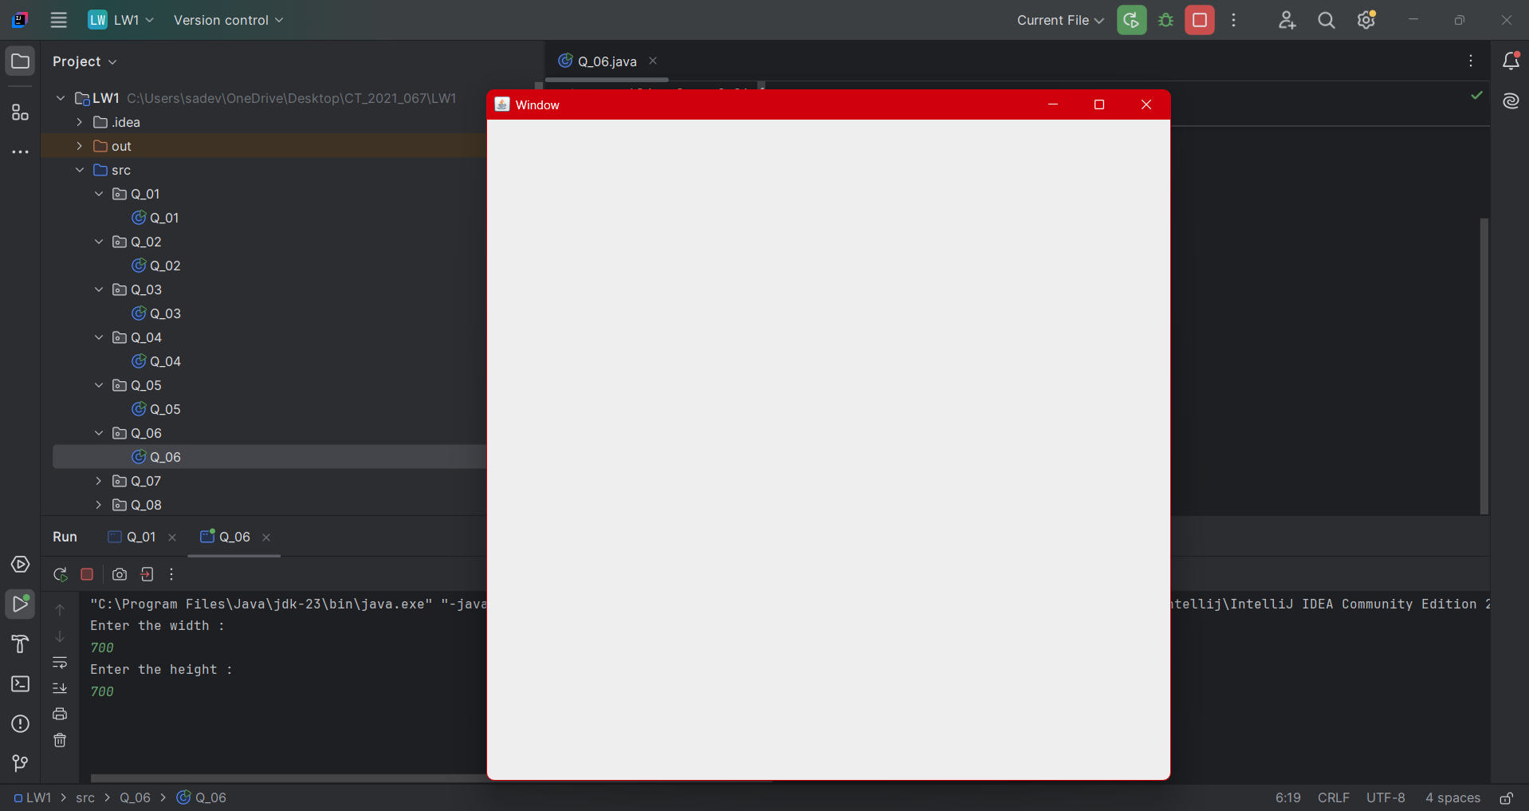

Q7.

* Code

import javax.swing.*;  
import java.text.SimpleDateFormat;  
import java.util.Date;  
  
public class Q_07 {  
 public static void main(String[] args) {  
  
 JFrame frame = new JFrame();  
 Date date = new Date();  
 SimpleDateFormat sdf = new SimpleDateFormat("HH:mm:ss a");  
  
 String title = sdf.format(date);  
  
 frame.setSize(250,150);  
 frame.setTitle(title);  
 frame.setVisible(true);  
 }  
}

* Output

Q8.

* Code

package Q_08;  
  
import java.util.Scanner;  
  
public class Q_08 {  
 public static void main(String[] args) {  
 Scanner scanner = new Scanner(System.*in*);  
 System.*out*.print("Enter a string containing an exclamation mark: ");  
 String input = scanner.nextLine();  
 scanner.close();  
  
 int index = input.indexOf('!');  
 if (index != -1) {  
 String before = input.substring(0, index).trim();  
 String after = input.substring(index + 1).trim();  
 System.*out*.println(before);  
 System.*out*.println(after);  
 } else {  
 System.*out*.println("No exclamation mark found in the input.");  
 }  
 }  
}

* Output

Q9.

* Code

package Q_09;

import java.util.Scanner;

public class Q_09 {

public static void main(String[] args) {

Scanner scanner = new Scanner(System.in);

System.out.print("Enter a string: ");

String input = scanner.nextLine();

scanner.close();

int length = input.length();

char firstChar = input.charAt(0);

char lastChar = input.charAt(length - 1);

System.out.println(length);

System.out.println(firstChar);

System.out.println(lastChar);

}

}

* Output

Q10.

* Code

package Q_10;

import java.util.Scanner;

public class Q_10 {

public static void main(String[] args) {

Scanner scanner = new Scanner(System.in);

System.out.print("Enter an odd-length word: ");

String word = scanner.nextLine();

scanner.close();

if (word.length() % 2 == 1) {

int middleIndex = word.length() / 2;

char middleChar = word.charAt(middleIndex);

System.out.println(middleChar);

} else {

System.out.println("Please enter a word with an odd length.");

}

}

}

* Output

Q11.

* Code

package Q_11;

import java.util.Scanner;

public class Q_11 {

public static void main(String[] args) {

Scanner scanner = new Scanner(System.in);

System.out.print("Enter your full name (first middle last): ");

String fullName = scanner.nextLine();

scanner.close();

String[] nameParts = fullName.split(" ");

if (nameParts.length < 3) {

System.out.println("Please enter your full name in the format: first middle last.");

} else {

String firstName = nameParts[0];

String middleName = nameParts[1];

String lastName = nameParts[2];

System.out.println(lastName + ", " + firstName + " " + middleName.charAt(0) + ".");

}

}

}

* Output

Q12.

* Code

package Q_12;

import javax.swing.*;

public class Q_12 {

public static void main(String[] args) {

JFrame frame = new JFrame("My First Frame");

frame.setSize(300, 200);

frame.setLocation(100, 50);

frame.setDefaultCloseOperation(JFrame.EXIT_ON_CLOSE);

frame.setVisible(true);

}

}

* Output

