Supply Chain Optimization and
Inventory Forecasting System
Final Project Report — Project 24
Difficulty: Advanced

Python · Flask · MySQL · Pandas · NumPy · Matplotlib · statsmodels

Analysis as of 19 October 2026 | Report generated 21 October 2026
Team: ‹member 1› · ‹member 2› · ‹member 3› · ‹member 4› · ‹member 5›

The system analysed in this report is a decision-support prototype built on a synthetic dataset. It computes reorder points and risk flags for a human planner to review and never places, approves or transmits a purchase order.

Executive summary
This project implements a supply-chain analytics system for 24 SKUs sourced from 6 suppliers. It stores master data, purchase orders, a perpetual stock ledger and daily demand in MySQL, exposes them through a validated Flask REST API, and analyses them with pandas, NumPy and statsmodels. Reorder points are calculated from documented assumptions — average demand over a 90-day window, an estimated lead time, and a safety stock that combines a service-level z-score with a days-of-demand rule — and each SKU is flagged as STOCKOUT, AT_RISK, EXCESS or OK.
At the analysis date the portfolio holds INR 7,151,593 of inventory. 2 SKU(s) are at stockout risk and 1 sit below the calculated reorder point; bringing them back to policy would need about INR 477,900 of purchases (a suggestion, not an order). 4 SKU(s) carry more than 90 days of cover. Four forecasting methods were compared on a 28-day hold-out: the selected models average 6 units/day of error against 8 for the naive baseline and improve on the baseline for 13 of 24 SKUs. The project is covered by 199 automated tests covering formulas, validation, boundaries, empty datasets and database failure.

Contents
- 1. Problem statement and objectives
- 2. Scope, users and assumptions
- 3. System architecture
- 4. Database design
- 5. REST API
- 6. Analysis methodology and formulas
- 7. Results: reorder recommendations, shortages and excess stock
- 8. Supplier delivery performance
- 9. Demand trends and forecasting
- 10. Visualisations
- 11. Testing
- 12. Limitations and future work
- 13. Conclusion
- Appendix A: setup and reproduction
- Appendix B: work division

1. Problem statement and objectives
Mid-sized distributors plan replenishment in spreadsheets. Reorder points are typed once and never recalculated, supplier reliability is remembered rather than measured, and no record explains why a quantity was ordered. The result is the two expensive failure modes this project targets: stockouts of items that matter, and cash frozen in items that do not move.

1.1 Objectives
- Model products, suppliers, purchase orders, stock movements and demand in a normalised MySQL schema with primary keys, foreign keys, CHECK constraints and indexes.
- Expose the data through a validated REST API with correct HTTP semantics and meaningful, machine-readable error messages.
- Measure supplier delivery performance (on-time rate, fill rate, lead-time variability, composite score).
- Estimate average demand, safety stock and reorder points from configurable, documented assumptions.
- Compare historical demand with simple forecasts and evaluate each model against a naive baseline on a hold-out period.
- Flag stockout and excess-stock risk with explicit, configurable thresholds and quantify the value at stake.
- Produce a reproducible reorder recommendation report, supplier summary, demand trend analysis, charts and an audit trail.
- Demonstrate correctness on invalid input, empty datasets, boundary values and database failure.
Explicit non-objective: the system never places an order. Procurement remains a human decision; the software ranks, quantifies and explains.

2. Scope, users and assumptions

2.1 In scope / out of scope
In scope | Out of scope
Single-warehouse perpetual inventory ledger | Multi-warehouse / multi-echelon allocation
Product and supplier master data | Automatic order submission to ERP/supplier
Single-line purchase orders with partial receipts | Purchase order headers with many lines
Daily demand records | Promotions, pricing, weather or market data
Descriptive statistics, ABC analysis, reorder points, risk flags | User authentication and role management
Four forecasting methods with hold-out evaluation | Real-time streaming ingestion
REST API, charts, generated reports | Web/mobile front end

2.2 Users
The primary user is an inventory planner who needs to know which SKUs require action today and why. Buyers use the supplier scorecard, the supply-chain manager uses the portfolio dashboard, and analysts reproduce every number from the pipeline scripts. No authentication layer exists because the tool runs on a trusted machine or behind an existing gateway (see limitations).

2.3 Assumptions
ID | Assumption | Impact if violated
A1 | One warehouse; one supplier per SKU | Multi-sourcing would change ROP and lead-time variability
A2 | A missing demand row means zero demand | Averages are per calendar day, not per selling day
A3 | One product per purchase order | Mixed POs would need allocation logic
A4 | On-hand stock is the ledger sum | Stock counts must be recorded as ADJUSTMENT rows
A5 | Open POs will arrive (counted in position) | A stalled PO overstates the position
A6 | Lead times in calendar days | Working-day calendars would change every ROP
A7 | Daily demand independent (σ·√L) | Correlated demand understates safety stock
A8 | Observed lead time replaces master data after 3 deliveries | Small samples are noisy
A9 | Safety stock = max(z-score, days rule) | A budget-constrained planner may prefer z-score only
A10 | Suggested quantity is an order-up-to level | MOQ, pack size and budget are ignored
A11 | 90-day demand window, 365-day PO window | Longer seasonality is invisible
A12 | A model must beat the baseline by >5% to be adopted | Small genuine gains may be discarded

3. System architecture
The system is a layered monolith: configuration and credentials are isolated from application code, the database layer owns every SQL statement, and the analysis layer is pure functions plus pandas so it can be unit tested without a web server.
- config.py — every setting, including analysis parameters and credentials, read from environment variables (.env); never hard-coded.
- db.py — pooled MySQL access, parameterised SQL, explicit transaction boundaries, driver errors translated into application errors.
- api/ — Flask application factory, blueprints for CRUD and analytics, request validators, uniform JSON error envelope, rotating file log.
- analytics/ — formulas (pure), data access (read-only SQL), demand, supplier, inventory, forecast modules and an orchestration pipeline.
- viz/charts.py — ten Matplotlib charts, each returning its own written interpretation.
- scripts/ — synthetic data generator, SQL loader, end-to-end pipeline, data dictionary dumper, document builder.
- tests/ — 199 pytest tests split into formula, validation, analysis, CRUD and analytics suites.
Request flow: client → Flask route → validator (422 on bad input) → database layer with parameterised SQL → JSON response. Analytics routes load data into pandas, apply the formulas, and return both the numbers and the parameter set that produced them; optional persistence writes an audit snapshot.

4. Database design
Six tables and two views in InnoDB/utf8mb4. A signed ledger is the single source of truth for stock; reorder snapshots are stored separately so history is never overwritten.
Table | Primary / foreign keys | Purpose
suppliers | supplier_id PK; supplier_name UNIQUE | Vendor master, promised lead time
products | product_id PK; sku UNIQUE; supplier_id FK | Item master, cost, planned lead time, manual ROP
purchase_orders | po_id PK; po_number UNIQUE; 2 FKs | Order → expected → received dates, partial receipts
stock_transactions | transaction_id PK; product_id FK | Signed perpetual ledger (RECEIPT/ISSUE/ADJUSTMENT/RETURN)
demand_records | demand_id PK; (product_id, demand_date) UNIQUE | Observed daily demand
analysis_runs | run_id PK | Parameters of each explicit analysis run
reorder_recommendations | rec_id PK; run_id FK; product_id FK | Snapshot of ROP, flags and suggestions
v_product_inventory / v_po_delivery | views | Convenience joins for reporting

Integrity is enforced twice: by the database (PRIMARY KEY, FOREIGN KEY, UNIQUE, CHECK, indexes) and by the API (business rules that a CHECK cannot express, such as “a RECEIVED order must have a received date”). Deleting a parent row that still has children is refused with HTTP 409 and a readable explanation; retiring master data uses the is_active flag instead. The full column-level data dictionary is generated from INFORMATION_SCHEMA by scripts/dump_data_dictionary.py and shipped as docs/data_dictionary.md.

5. REST API
All endpoints are JSON, all writes validated, all errors returned in one envelope: {"error": {"code", "message", "details"}}. Analytics endpoints accept the analysis parameters as query overrides so a reviewer can re-run any conclusion under different assumptions without changing code.
Method | Path | Purpose
GET | /api/health | Service + database health, row counts (503 when the DB is down)
GET | /api/config | Non-secret configuration and analysis parameters
GET/POST | /api/products | List (filter, page) / create
GET/PUT/PATCH/DELETE | /api/products/{id} | Read, replace, partial update, delete (409 if history exists)
GET/POST | /api/suppliers | Supplier master
GET/POST | /api/purchase-orders | Purchase orders (filter by status, overdue)
POST | /api/purchase-orders/{id}/receive | Goods receipt: PO + ledger in one transaction
GET/POST | /api/stock-transactions | Signed ledger entries; blocks negative balances
GET/POST | /api/demand-records | Daily demand, upsert semantics, bulk upload
GET | /api/analytics/reorder-recommendations | ROP, safety stock, flags, suggested quantity
GET | /api/analytics/suppliers | Supplier delivery summary with definitions
GET | /api/analytics/demand | Demand statistics, ABC classes, category totals
GET | /api/analytics/risks | Shortage / excess lists with value at stake
GET | /api/analytics/forecast | Forecast plus hold-out metrics vs baseline
POST | /api/analytics/run | Run and store an auditable snapshot (places no orders)
GET | /api/charts/{file} | Chart PNGs; catalogue with interpretations at /api/charts

6. Analysis methodology and formulas
Every quantity below is computed once in analytics/formulas.py, unit tested, and reused by the API, the reports and the charts. Units are stated for each line.
average daily demand mu_d = total demand / calendar days in window [units/day]
demand variability sigma_d = std dev of daily demand (zero-filled) [units/day]
lead time L = mean observed PO lead time if >= 3 deliveries,
else products.lead_time_days [days]
safety stock (z) SS_z = z(service_level) * sigma_d * sqrt(L) [units]
safety stock (days) SS_d = safety_stock_days * mu_d [units]
safety stock used SS = max(SS_z, SS_d) (policy = max) [units]
reorder point ROP = mu_d * L + SS [units]
inventory position IP = on_hand + open PO quantity [units]
order-up-to level T = ROP + mu_d * review_period_days [units]
suggested quantity Q = max(0, T - IP) [units]
days of cover DoC = on_hand / mu_d [days]
turnover TO = (units issued * unit_cost) / average stock value
[turns/year]
supplier score Score = 100*(0.6*on_time_rate + 0.4*max(0,1-CV)) [0-100]
forecast errors MAE, RMSE, MAPE, MASE, bias (MASE < 1 beats naive)

With the default policy the service level is 0.950, giving z = 1.6449; the demand window is 90 days, the review period 7 days and the excess threshold 90 days of cover. Risk classification rules: STOCKOUT when on-hand is zero or the position cannot cover lead-time demand; AT_RISK when the position is below the reorder point but covers lead-time demand; EXCESS when above the reorder point with more than the threshold days of cover; otherwise OK.

7. Results: reorder recommendations, shortages and excess stock

7.1 Portfolio overview
Metric | Value
SKUs analysed | 24
Inventory on hand (INR) | 7,151,593
Average days of cover | 44.22
Stockout risk (SKUs) | 2
At / below reorder point (SKUs) | 1
Excess stock (SKUs) | 4
OK (SKUs) | 17
Suggested order value (INR) | 477,900
SKUs where the manual reorder point is too low | 3
ABC classes (A/B/C) | 12/6/6

7.2 Reorder recommendation report
The table below is the recommendation report. “ROP calc” is the value computed from the documented assumptions; “ROP master” is the planner's manually maintained value, shown so the correction is visible and reversible.
SKU | μ_d | L (d) | SS | ROP calc | ROP master | On hand | On order | Position | Cover (d) | Flag | Suggest qty | Value (INR)
ELEC-HAR-1120 | 2.84 | 24.60 | 19.91 | 89.87 | 86 | 41.00 | 0.00 | 41.00 | 14.42 | STOCKOUT | 69.00 | 234,600.00
ELEC-MOD-1150 | 2.34 | 22.20 | 16.41 | 68.44 | 88 | 0.00 | 58.00 | 58.00 | 0.00 | STOCKOUT | 27.00 | 167,400.00
ELEC-SEN-1008 | 4.56 | 21.00 | 31.89 | 127.57 | 175 | 114.00 | 0.00 | 114.00 | 25.02 | AT_RISK | 46.00 | 75,900.00
DRV-CLP-2020 | 1.48 | 30.00 | 12.47 | 56.81 | 106 | 263.00 | 0.00 | 263.00 | 177.94 | EXCESS | 0.00 | 0.00
CON-GRS-4004 | 15.89 | 6.20 | 111.22 | 209.74 | 399 | 2,350.00 | 0.00 | 2,350.00 | 147.90 | EXCESS | 0.00 | 0.00
AUTO-CAB-0099 | 0.00 | 6.00 | 0.00 | 0.00 | 118 | 449.00 | 0.00 | 449.00 | — | EXCESS | 0.00 | 0.00
ELEC-MOD-1160 | 0.90 | 25.00 | 10.68 | 33.18 | 78 | 149.00 | 0.00 | 149.00 | 165.56 | EXCESS | 0.00 | 0.00
AUTO-BRK-0012 | 7.06 | 7.70 | 49.39 | 103.72 | 156 | 103.00 | 195.00 | 298.00 | 14.60 | OK | 0.00 | 0.00
AUTO-BRK-0021 | 21.12 | 7.90 | 147.85 | 314.72 | 432 | 380.00 | 0.00 | 380.00 | 17.99 | OK | 0.00 | 0.00
AUTO-SUS-0104 | 7.11 | 5.30 | 49.78 | 87.47 | 189 | 364.00 | 0.00 | 364.00 | 51.19 | OK | 0.00 | 0.00
AUTO-SUS-0112 | 4.31 | 6.00 | 30.18 | 56.04 | 94 | 92.00 | 0.00 | 92.00 | 21.34 | OK | 0.00 | 0.00
AUTO-FLT-0201 | 43.46 | 5.60 | 304.19 | 547.55 | 966 | 1,857.00 | 0.00 | 1,857.00 | 42.73 | OK | 0.00 | 0.00
AUTO-FLT-0207 | 22.18 | 5.70 | 155.25 | 281.66 | 567 | 481.00 | 0.00 | 481.00 | 21.69 | OK | 0.00 | 0.00
ELEC-SEN-1001 | 11.81 | 21.10 | 82.68 | 331.89 | 262 | 183.00 | 900.00 | 1,083.00 | 15.49 | OK | 0.00 | 0.00
ELEC-ECU-1102 | 1.36 | 22.10 | 10.71 | 40.68 | 56 | 34.00 | 192.00 | 226.00 | 25.07 | OK | 0.00 | 0.00
ELEC-CAM-1130 | 3.66 | 25.10 | 25.59 | 117.36 | 117 | 55.00 | 428.00 | 483.00 | 15.04 | OK | 0.00 | 0.00
DRV-UNT-2001 | 0.68 | 30.30 | 8.35 | 28.89 | 48 | 5.00 | 264.00 | 269.00 | 7.38 | OK | 0.00 | 0.00
DRV-BRG-2015 | 4.68 | 31.70 | 32.75 | 181.04 | 264 | 184.00 | 720.00 | 904.00 | 39.33 | OK | 0.00 | 0.00
PKG-BOX-3001 | 183.27 | 14.70 | 1,282.87 | 3,976.89 | 5460 | 4,611.00 | 0.00 | 4,611.00 | 25.16 | OK | 0.00 | 0.00
PKG-BOX-3007 | 137.52 | 13.50 | 962.65 | 2,819.20 | 4160 | 10,874.00 | 0.00 | 10,874.00 | 79.07 | OK | 0.00 | 0.00
PKG-FLM-3010 | 18.91 | 13.60 | 132.38 | 389.57 | 624 | 239.00 | 3,600.00 | 3,839.00 | 12.64 | OK | 0.00 | 0.00
PKG-PLT-3020 | 9.93 | 15.40 | 69.53 | 222.50 | 286 | 303.00 | 220.00 | 523.00 | 30.50 | OK | 0.00 | 0.00
CON-SEAL-4001 | 59.67 | 5.50 | 417.67 | 745.84 | 1218 | 1,328.00 | 492.00 | 1,820.00 | 22.26 | OK | 0.00 | 0.00
CON-ADH-4010 | 2.97 | 11.30 | 21.43 | 54.96 | 156 | 133.00 | 0.00 | 133.00 | 44.83 | OK | 0.00 | 0.00

Units: μ_d in units/day, lead time in days, all quantities in units, value in INR. Suggested quantity is zero for SKUs already at or above policy.

7.3 Shortage risk — act first
Out of stock, or the inventory position cannot cover demand during the lead time, so a shortage is expected before the next delivery could arrive.
SKU | Product | Supplier | μ_d | L (d) | ROP | On hand | On order | Position | Cover (d) | Suggest qty | Value (INR)
ELEC-HAR-1120 | Wiring Harness 24V | NorthStar Electronics | 2.84 | 24.60 | 89.87 | 41.00 | 0.00 | 41.00 | 14.42 | 69.00 | 234,600.00
ELEC-MOD-1150 | Telematics Module LTE | Shenzhen MotionWorks Ltd | 2.34 | 22.20 | 68.44 | 0.00 | 58.00 | 58.00 | 0.00 | 27.00 | 167,400.00

7.4 At / below the reorder point
Lead-time demand is covered but the position is below policy: order at this review.
SKU | Product | Supplier | μ_d | L (d) | ROP | On hand | On order | Position | Cover (d) | Suggest qty | Value (INR)
ELEC-SEN-1008 | Oxygen Sensor Universal | Shenzhen MotionWorks Ltd | 4.56 | 21.00 | 127.57 | 114.00 | 0.00 | 114.00 | 25.02 | 46.00 | 75,900.00

7.5 Excess stock
Stock coverage far beyond the threshold; working capital that could be released.
SKU | Product | Supplier | μ_d | L (d) | ROP | On hand | On order | Position | Cover (d) | Suggest qty | Value (INR)
DRV-CLP-2020 | Clutch Plate 240mm | EuroDrive Systems GmbH | 1.48 | 30.00 | 56.81 | 263.00 | 0.00 | 263.00 | 177.94 | 0.00 | 0.00
CON-GRS-4004 | Lithium Grease Cartridge | Bharat Industrial Fasteners | 15.89 | 6.20 | 209.74 | 2,350.00 | 0.00 | 2,350.00 | 147.90 | 0.00 | 0.00
AUTO-CAB-0099 | Cabin Air Filter (Discontinued) | Bharat Industrial Fasteners | 0.00 | 6.00 | 0.00 | 449.00 | 0.00 | 449.00 | — | 0.00 | 0.00
ELEC-MOD-1160 | Telematics Module 5G (new) | NorthStar Electronics | 0.90 | 25.00 | 33.18 | 149.00 | 0.00 | 149.00 | 165.56 | 0.00 | 0.00

7.6 Parameter sensitivity
The same data scored under different assumptions. The flags are threshold-driven decision support, not fixed truth: with a z-score policy the safety stock is smaller than with the days-of-demand rule, which the default “max” policy always dominates.
Policy | Service level | Safety stock (units) | STOCKOUT | AT_RISK | EXCESS | OK
zscore | 0.90 | 881.60 | 2 | 0 | 4 | 18
zscore | 0.95 | 1,131.50 | 2 | 1 | 4 | 17
zscore | 0.99 | 1,600.30 | 2 | 1 | 4 | 17
days | 0.95 | 3,973.80 | 2 | 1 | 4 | 17
max | 0.90 | 3,977.60 | 2 | 1 | 4 | 17
max | 0.95 | 3,985.80 | 2 | 1 | 4 | 17
max | 0.99 | 4,024.20 | 2 | 1 | 4 | 17

Generated by scripts/run_pipeline.py; the full grid is in reports/tables/parameter_sensitivity.csv.

8. Supplier delivery performance
Lead time is measured from order date to receipt date, and on-time means the goods arrived on or before the expected date. Open orders are excluded from lead-time statistics so they do not bias the average downwards. The composite score rewards both punctuality and consistency, because variability is what forces extra safety stock.
Supplier | POs | Delivered | Open | On-time | Fill rate | Avg LT (d) | LT CV | Avg delay (d) | Score | Grade
Precision Auto Components Pvt Ltd | 27 | 26 | 1 | 1.00 | 1.00 | 7.81 | 0.12 | -2.19 | 95.19 | A
Bharat Industrial Fasteners | 68 | 68 | 0 | 0.98 | 1.00 | 5.69 | 0.17 | -1.31 | 92.33 | B
NorthStar Electronics | 33 | 28 | 6 | 0.86 | 0.99 | 24.89 | 0.06 | -0.11 | 89.23 | B
Shenzhen MotionWorks Ltd | 55 | 45 | 10 | 0.56 | 0.99 | 21.62 | 0.10 | 0.62 | 69.36 | D
EuroDrive Systems GmbH | 32 | 19 | 12 | 0.32 | 1.00 | 31.11 | 0.09 | 1.10 | 55.36 | D
Krishna Plastics & Packaging | 49 | 42 | 6 | 0.43 | 1.00 | 14.07 | 0.33 | 2.07 | 52.41 | D

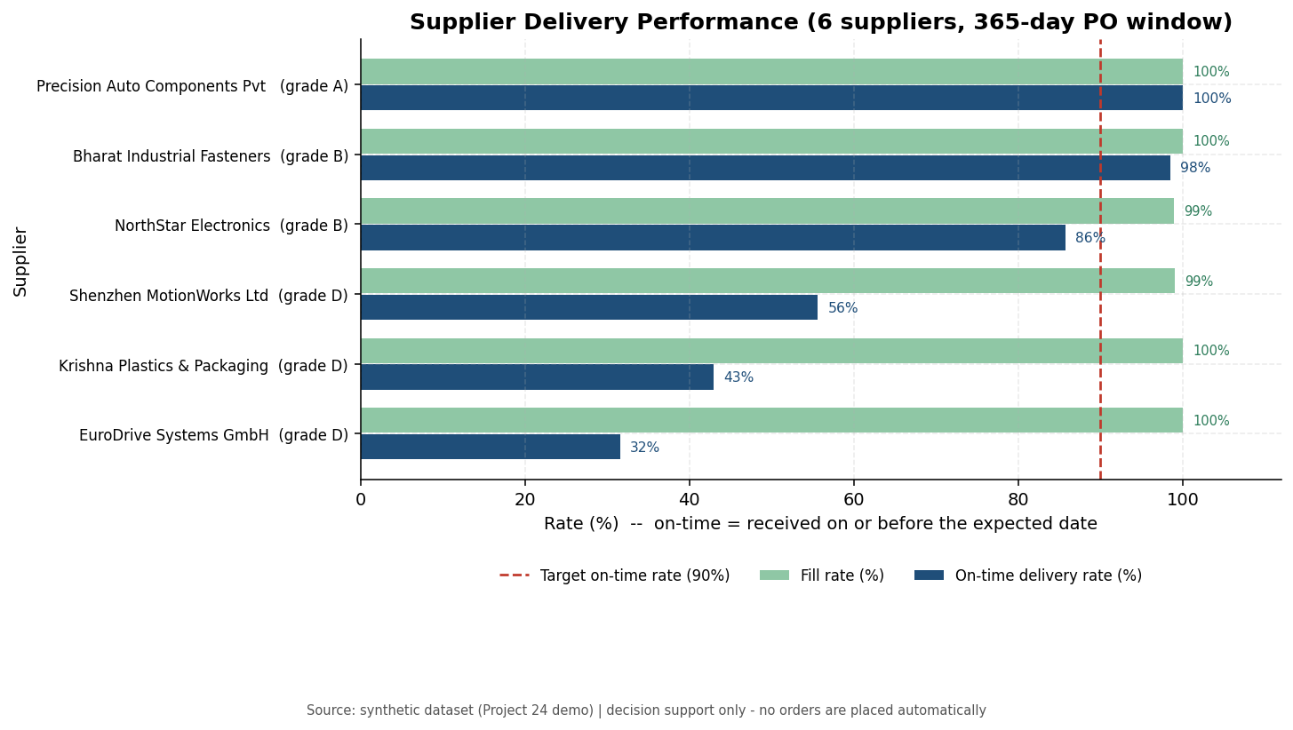
Figure 4 — On-time and fill rate per supplier, with the 90% target line.
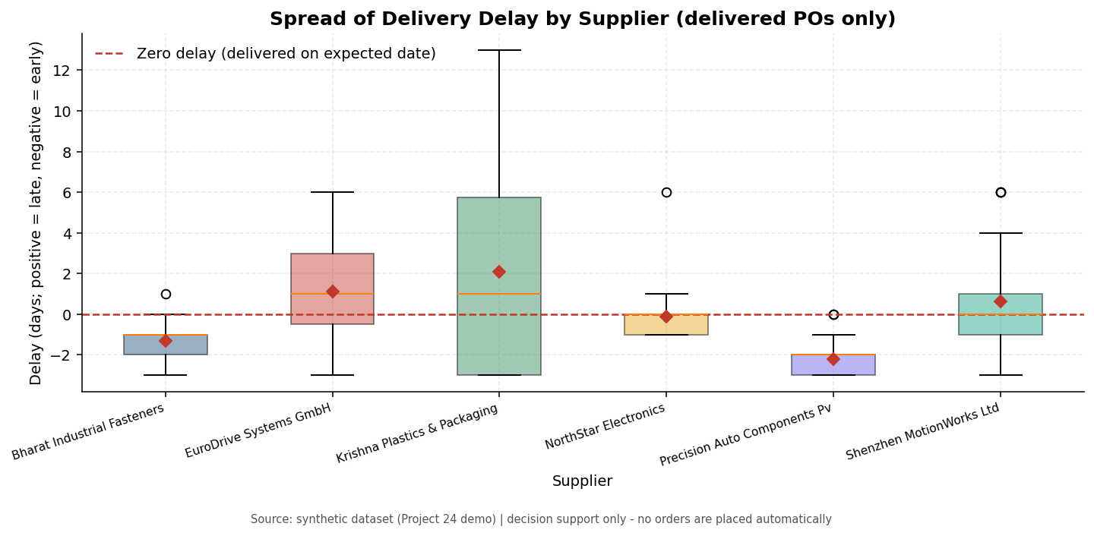
Figure 5 — Spread of delivery delay per supplier (delivered orders only).

9. Demand trends and forecasting
Demand is analysed on a zero-filled daily calendar, so a product sold on 20 of 90 days is not mistaken for a product sold every day. ABC classification uses demand value (units × unit cost) to separate the SKUs that deserve the closest attention.
SKU | Category | μ_d | σ_d | CV | Total | Last 28d μ | Change % | ABC
AUTO-BRK-0012 | Braking | 7.06 | 3.54 | 0.50 | 635 | 7.82 | 19.67 | A
AUTO-BRK-0021 | Braking | 21.12 | 10.38 | 0.49 | 1901 | 30.14 | 91.82 | A
AUTO-SUS-0104 | Suspension | 7.11 | 3.21 | 0.45 | 640 | 7.29 | 14.61 | A
AUTO-SUS-0112 | Suspension | 4.31 | 2.42 | 0.56 | 388 | 3.68 | -14.88 | C
AUTO-FLT-0201 | Filtration | 43.46 | 12.67 | 0.29 | 3911 | 40.14 | -5.78 | A
AUTO-FLT-0207 | Filtration | 22.18 | 8.05 | 0.36 | 1996 | 22.39 | -0.95 | A
ELEC-SEN-1001 | Electronics | 11.81 | 6.25 | 0.53 | 1063 | 17.39 | 70.28 | A
ELEC-SEN-1008 | Electronics | 4.56 | 2.54 | 0.56 | 410 | 4.86 | 13.33 | B
ELEC-ECU-1102 | Electronics | 1.36 | 1.39 | 1.02 | 122 | 1.11 | -6.06 | A
ELEC-HAR-1120 | Electronics | 2.84 | 1.98 | 0.70 | 256 | 2.46 | -16.87 | A
ELEC-CAM-1130 | Electronics | 3.66 | 2.46 | 0.67 | 329 | 3.11 | -22.32 | A
DRV-UNT-2001 | Drivetrain | 0.68 | 0.92 | 1.36 | 61 | 0.71 | 33.33 | A
DRV-BRG-2015 | Drivetrain | 4.68 | 2.53 | 0.54 | 421 | 4.79 | 1.52 | B
DRV-CLP-2020 | Drivetrain | 1.48 | 1.38 | 0.94 | 133 | 1.64 | 53.33 | B
PKG-BOX-3001 | Packaging | 183.27 | 57.76 | 0.32 | 16494 | 179.68 | -4.61 | A
PKG-BOX-3007 | Packaging | 137.52 | 33.20 | 0.24 | 12377 | 134.46 | 0.37 | C
PKG-FLM-3010 | Packaging | 18.91 | 8.67 | 0.46 | 1702 | 18.25 | 1.79 | C
PKG-PLT-3020 | Packaging | 9.93 | 3.88 | 0.39 | 894 | 10.14 | 7.17 | B
CON-SEAL-4001 | Consumables | 59.67 | 23.50 | 0.39 | 5370 | 82.50 | 66.43 | B
CON-GRS-4004 | Consumables | 15.89 | 6.32 | 0.40 | 1430 | 14.64 | -12.77 | C
AUTO-CAB-0099 | Filtration | 0.00 | 0.00 | — | 0 | 0.00 | — | C
ELEC-MOD-1150 | Electronics | 2.34 | 2.00 | 0.85 | 211 | 2.43 | 13.33 | A
ELEC-MOD-1160 | Electronics | 0.90 | 1.30 | 1.44 | 81 | 1.75 | 53.13 | B
CON-ADH-4010 | Consumables | 2.97 | 3.88 | 1.31 | 267 | 2.93 | 3.80 | C

Forecast evaluation: each of the four methods is fitted on the window minus the final 28 days and scored on those 28 unseen days. The naive 28-day mean is the baseline; a more complex model replaces it only if it improves MAE by more than 5%.
ID | Selected method | Forecast μ_d | Forecast total | Residual σ
1 | naive_mean | 7.82 | 219.00 | 4.27
2 | naive_mean | 30.14 | 844.00 | 18.36
3 | holt_winters | 7.20 | 201.55 | 2.91
4 | moving_average | 3.29 | 92.00 | 1.99
5 | holt_winters | 40.25 | 1,126.98 | 7.25
6 | holt_winters | 23.02 | 644.70 | 7.72
7 | holt_winters | 19.40 | 543.14 | 8.42
8 | holt_winters | 4.59 | 128.61 | 2.64
9 | naive_mean | 1.11 | 31.00 | 1.29
10 | naive_mean | 2.46 | 69.00 | 1.60
11 | naive_mean | 3.11 | 87.00 | 2.11
12 | naive_mean | 0.71 | 20.00 | 0.97
13 | naive_mean | 4.79 | 134.00 | 2.40
14 | naive_mean | 1.64 | 46.00 | 1.79
15 | holt_winters | 183.99 | 5,151.84 | 33.24
16 | holt_winters | 130.12 | 3,643.45 | 21.78
17 | naive_mean | 18.25 | 511.00 | 8.02
18 | holt_winters | 9.79 | 274.11 | 4.32
19 | naive_mean | 82.50 | 2,310.00 | 40.57
20 | holt_winters | 15.56 | 435.58 | 4.70
21 | naive_mean | 0.00 | 0.00 | 0.00
22 | holt_winters | 2.22 | 62.27 | 2.01
23 | moving_average | 1.93 | 54.00 | 1.38
24 | holt_winters | 2.80 | 78.37 | 3.62

Summary: 13 of 24 SKUs beat the baseline; mean hold-out MAE 6 units/day versus 8 for the naive model (mean improvement 10.5%). Selected methods: naive mean 11, holt winters 11, moving average 2.

10. Visualisations
Ten charts are produced. Each carries a title, axis labels with units, a legend where several series are plotted, and a written interpretation that is also returned by the API so a chart and its explanation can never drift apart.
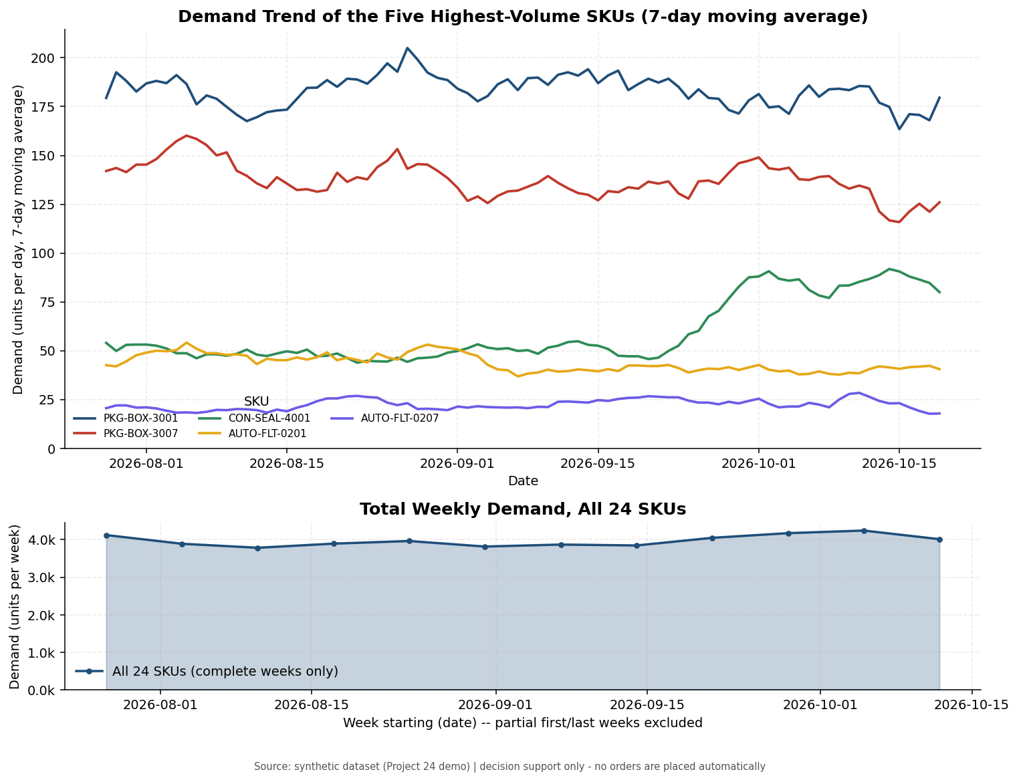
Figure 1 — Demand trend of the five highest-volume SKUs (7-day moving average) and total weekly demand.
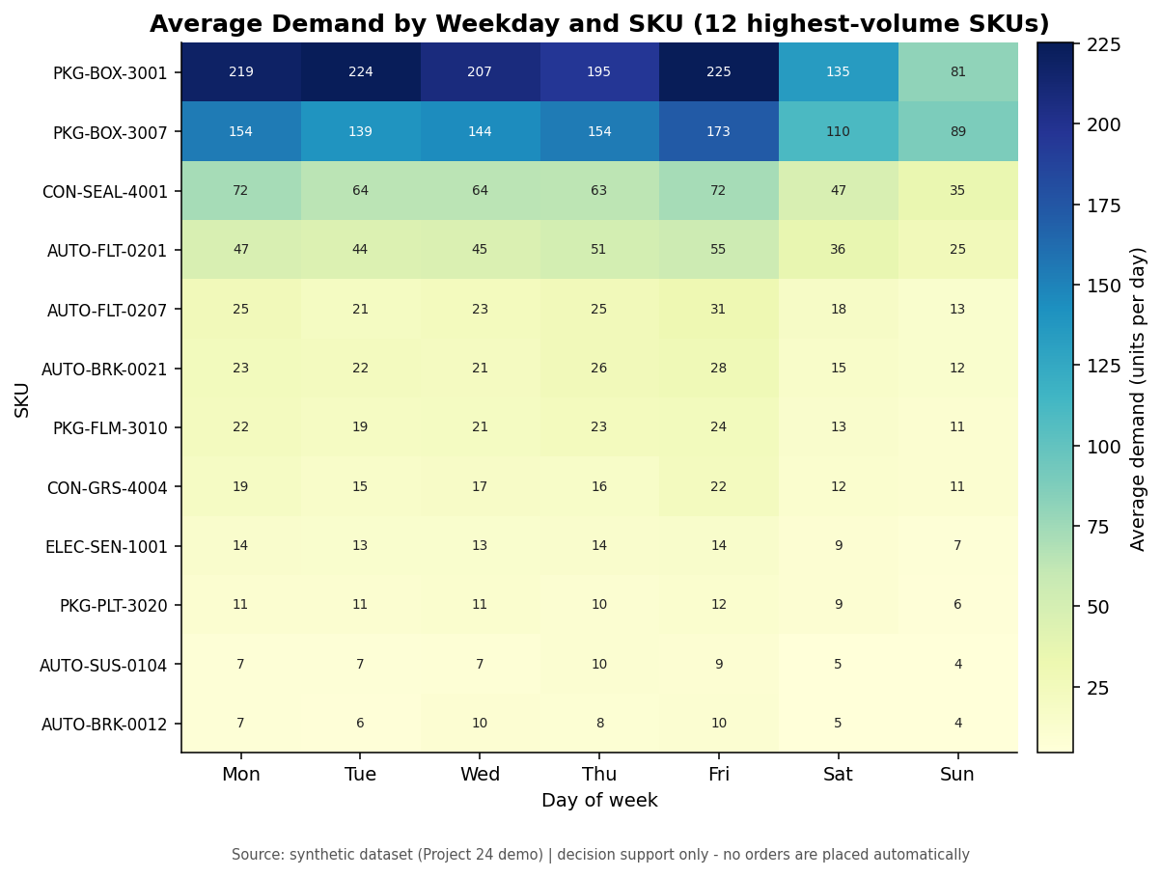
Figure 2 — Average demand by weekday and SKU: the weekly cycle that motivates the seasonal forecast component.
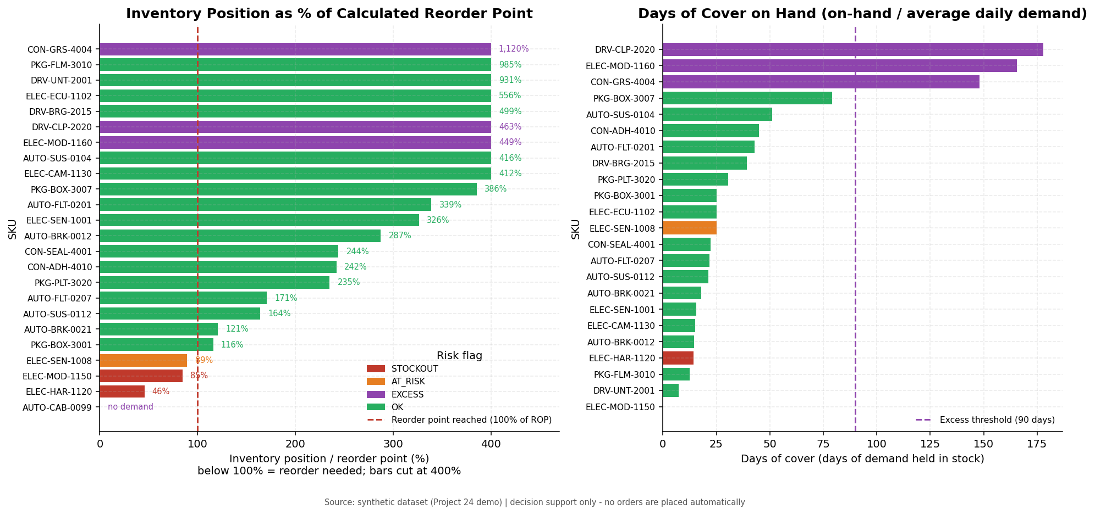
Figure 3 — Inventory position as a percentage of the calculated reorder point, and days of cover on hand.
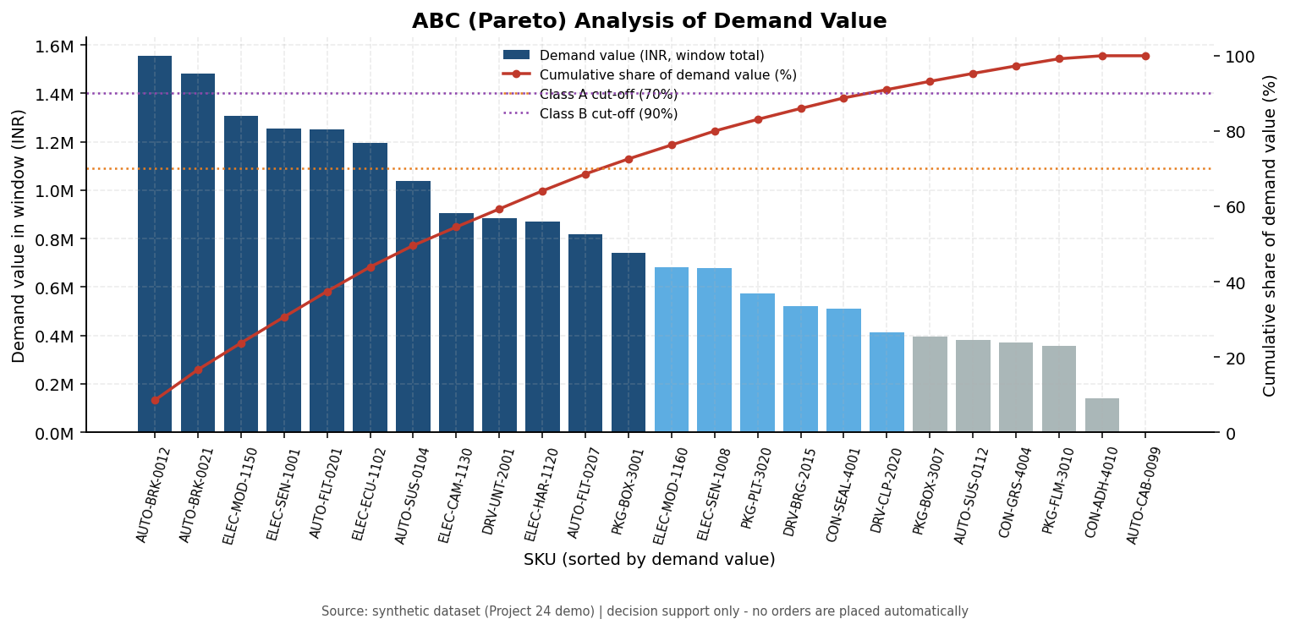
Figure 6 — ABC (Pareto) analysis of demand value.
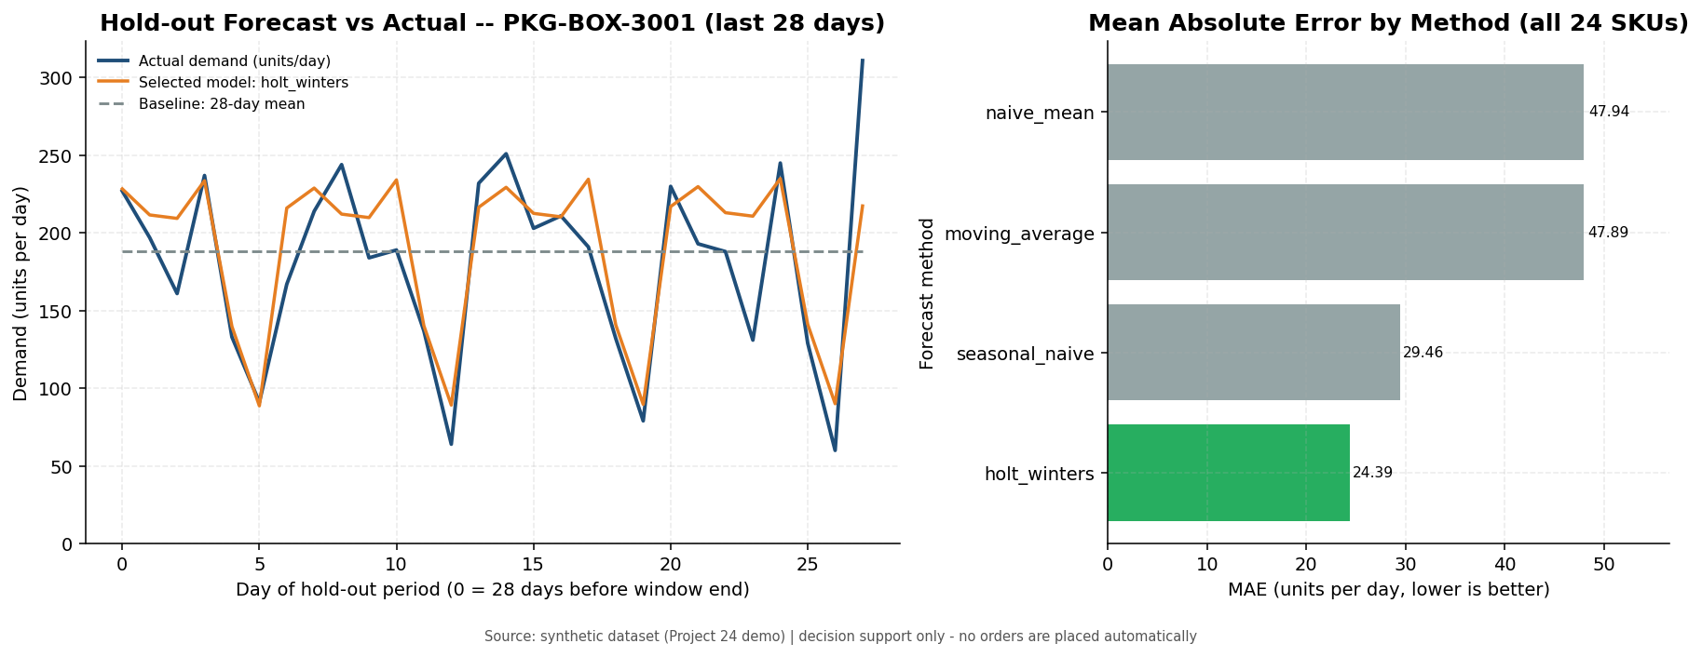
Figure 7 — Hold-out forecast versus actual demand and mean absolute error by method.
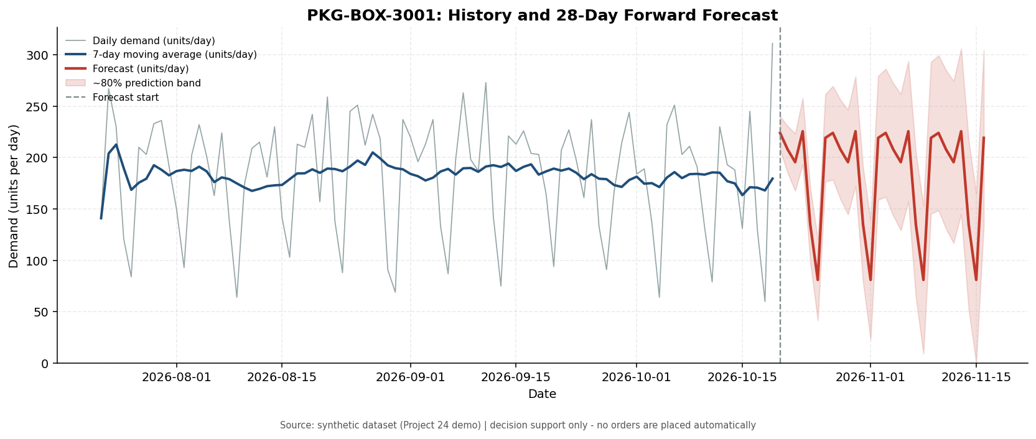
Figure 8 — Forward forecast with an approximate 80% prediction band.
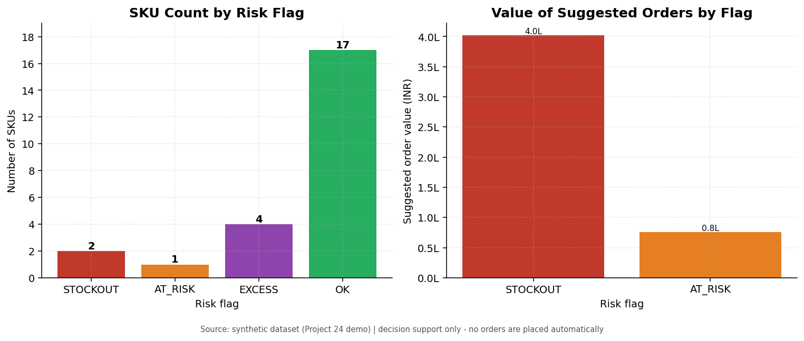
Figure 9 — SKU counts and suggested order value by risk flag.
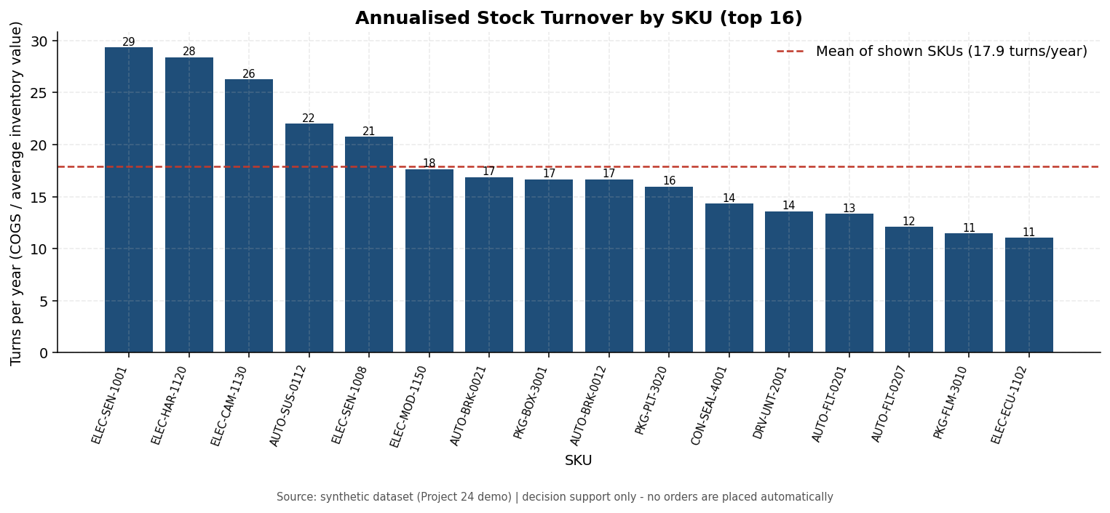
Figure 10 — Annualised stock turnover by SKU.

11. Testing
The suite contains 199 pytest tests in five groups. Integration tests create their own rows and clean up afterwards, and they skip with an explicit reason when MySQL is unreachable, so the pure-logic tests still run on any machine.
File | Tests | Coverage
tests/test_formulas.py | 42 | Every formula against hand calculations; boundary and invalid inputs
tests/test_validators.py | 38 | Type confusion, ranges, dates, enums, cross-field business rules
tests/test_analysis.py | 33 | Zero-fill, statistics, ABC, reorder engine, turnover, supplier KPIs, forecasting
tests/test_api_crud.py | 45 | CRUD contracts, duplicates, foreign keys, receipts, ledger signs, conflicts
tests/test_api_analytics.py | 41 | Analytics parameters, boundaries, empty results, DB-down, 'no orders placed'

Evidence of execution:
$ python -m pytest tests
199 passed in 55.89s
$ DB_PORT=65001 python -m pytest tests # database unreachable
113 passed, 85 skipped in 1.45s
Notable defects found and fixed during testing include a 500 error caused by a malformed cache key, Decimal money values serialised as strings, an ABC classification that labelled a dominant SKU as class C, and a turnover calculation distorted by a two-point inventory average. The full defect table is in docs/05_test_report.md.

12. Limitations and future work
- Safety stock ignores lead-time variability (σ_L). Next step: SS = z·√(L·σ_d² + μ_d²·σ_L²), which the stored PO history already supports.
- The suggested quantity is an order-up-to level; MOQ, pack size, container loads and budget are not modelled.
- Open purchase orders are trusted, so a stalled order understates risk.
- Forecasts are univariate and evaluated on a single hold-out period; a rolling-origin backtest would be more robust.
- Single warehouse, one supplier per SKU, single-line purchase orders.
- No authentication, rate limiting or shared cache; the tool assumes a trusted host and a small portfolio.
- All data is synthetic; results demonstrate the method rather than a real business outcome.

13. Conclusion
The project delivers a complete, tested pipeline from relational storage to decision-ready recommendations: a normalised MySQL schema with enforced integrity, a validated Flask API, documented and unit-tested formulas, four forecasting methods honestly scored against a naive baseline, ten labelled charts with interpretations, and a reproducible report with an audit trail. The most useful operational output is not a single number but the combination of the reorder point, the supplier's reliability grade and the days of cover: together they tell a planner what to order, from whom, and where cash is sitting idle — while leaving the decision, and the purchase order, with the human.

Appendix A — Setup and reproduction
python -m venv .venv && source .venv/bin/activate
pip install -r requirements.txt
cp .env.example .env # set DB_USER / DB_PASSWORD
python scripts/load_sql.py sql/schema.sql
python scripts/generate_seed_data.py --load
python scripts/run_pipeline.py --persist
python run.py # REST API on :5000
python -m pytest tests -q # 199 tests

Appendix B — Work division
Member | Responsibility | Main files
M1 — Data & database | Schema, constraints, synthetic generator, SQL loading, data dictionary | sql/, scripts/generate_seed_data.py
M2 — Backend / API | Flask factory, CRUD routes, validators, error envelope, health/config | api/, run.py, db.py, config.py
M3 — Analytics | Reorder engine, supplier KPIs, ABC, turnover, formula documentation | analytics/
M4 — Forecasting & visuals | Four forecast models with hold-out evaluation, all charts | analytics/forecast.py, viz/
M5 — QA & documentation | Test suite, test report, README, demo plan, presentation | tests/, docs/, presentation/

