SQL Constraints Practice - companyDB

1. Create database
CREATE DATABASE companyDB;
USE companyDB;

2. Create employees table with constraints
CREATE TABLE employees(
id INT PRIMARY KEY,
name VARCHAR(50) NOT NULL,
salary DECIMAL(10,2) DEFAULT 30000
);

3. Add UNIQUE constraint on email
ALTER TABLE employees
ADD CONSTRAINT unique_email UNIQUE(email);

4. Insert 5 employee records
INSERT INTO employees
VALUES
(1,'John','john@gmail.com',45000),
(2,'Sara','sara@gmail.com',35000),
(3,'Mike','mike@gmail.com',40000),
(4,'David','david@gmail.com',50000),
(5,'Alex','alex@gmail.com',DEFAULT);
SELECT * FROM employees;

5. Duplicate email example
INSERT INTO employees
VALUES
(6,'Tom','john@gmail.com',38000);

6. Drop and recreate with CHECK constraint
DROP TABLE employees;
CREATE TABLE employees(
id INT PRIMARY KEY,
name VARCHAR(50) NOT NULL,
email VARCHAR(50) UNIQUE,
salary DECIMAL(10,2)
CHECK (salary > 0)
);
INSERT INTO employees
VALUES
(1,'John','john@gmail.com',-1000);

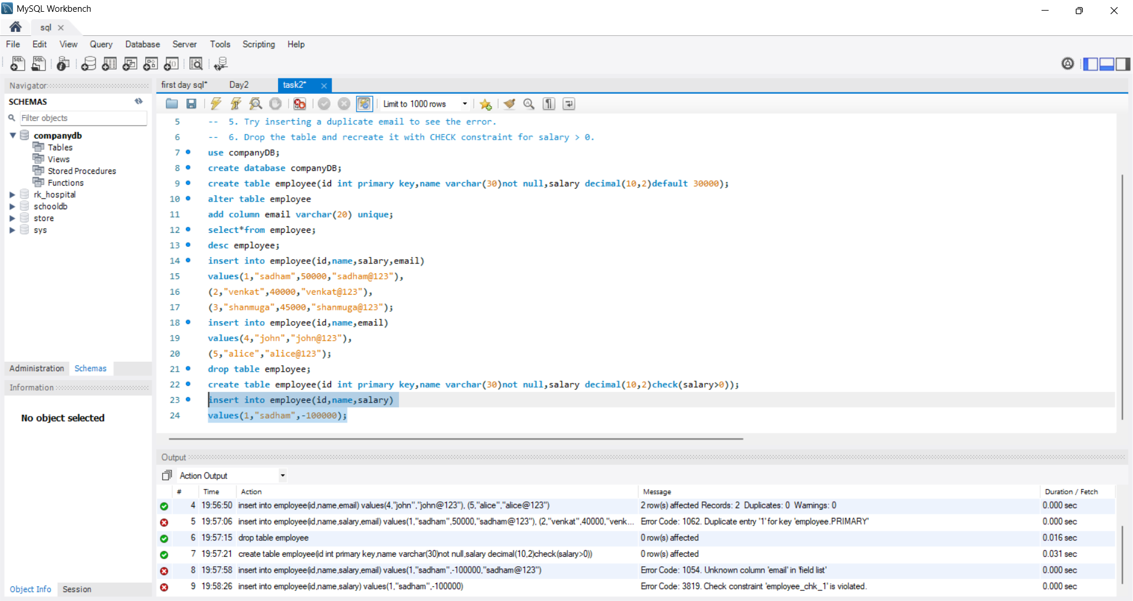
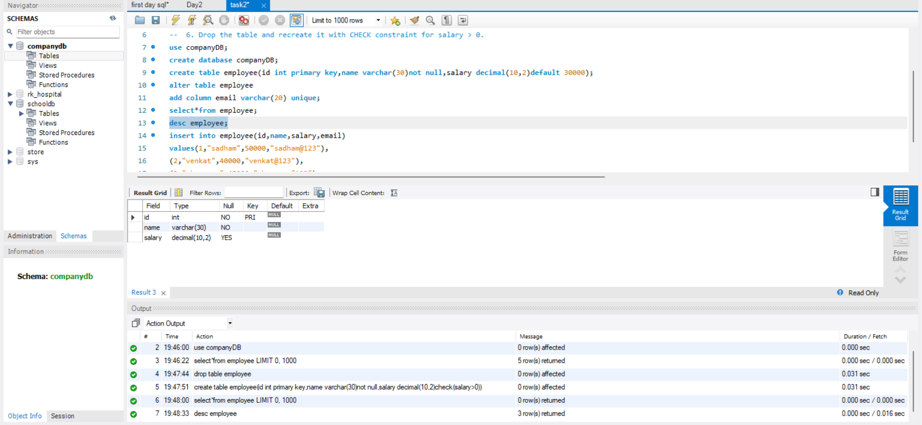
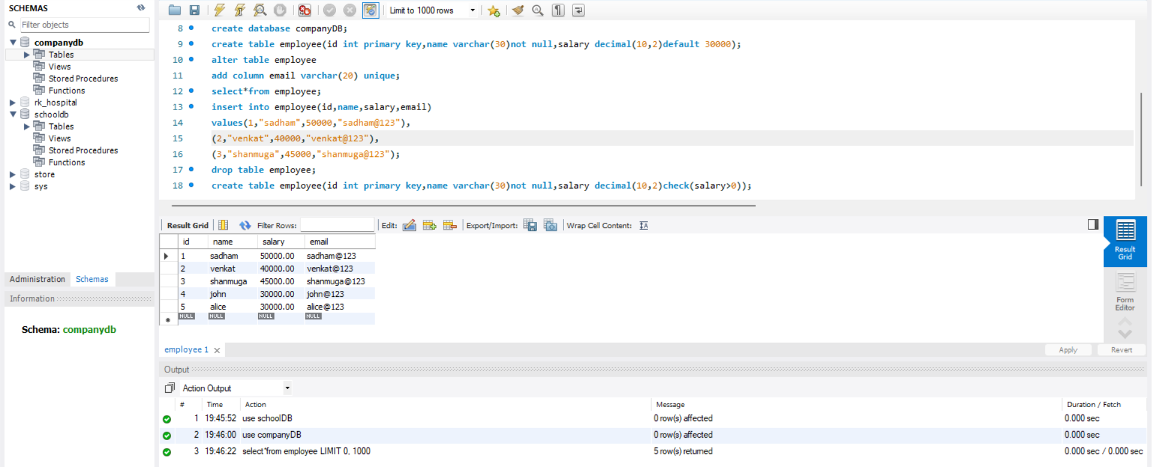
OUTPUT:

