SQL Orders Table - Queries

1. Create Table Orders
CREATE TABLE orders(
id INT PRIMARY KEY,
product_name VARCHAR(50),
quantity INT,
price DECIMAL(10,2)
);

2. Insert 5 Orders
INSERT INTO orders
VALUES
(1,'Apple Juice',3,150),
(2,'Laptop',1,45000),
(3,'Android Phone',2,12000),
(4,'Adapter',5,250),
(5,'Keyboard',4,450);

Output After Insert
id | product_name | quantity | price
1 | Apple phone | 3 | 150
2 | Laptop | 1 | 45000
3 | Android Phone | 2 | 12000
4 | Adapter | 5 | 250
5 | Keyboard | 4 | 450

3. Quantity > 2
SELECT * FROM orders
WHERE quantity > 2;

Output
id | product_name | quantity | price
1 | Apple phone | 3 | 150
4 | Adapter | 5 | 250
5 | Keyboard | 4 | 450

4. Price Between 100 and 500
SELECT * FROM orders
WHERE price BETWEEN 100 AND 500;

Output
id | product_name | quantity | price
1 | Apple phone | 3 | 150
4 | Adapter | 5 | 250
5 | Keyboard | 4 | 450

5. Product Name Starts With A
SELECT * FROM orders
WHERE product_name LIKE 'A%';

Output
id | product_name | quantity | price
1 | Apple Juice | 3 | 150
3 | Android Phone | 2 | 12000
4 | Adapter | 5 | 250

6. Sort By Quantity Descending
SELECT * FROM orders
ORDER BY quantity DESC;

Output
id | product_name | quantity | price
4 | Adapter | 5 | 250
5 | Keyboard | 4 | 450
1 | Apple phone | 3 | 150
3 | Android Phone | 2 | 12000
2 | Laptop | 1 | 45000

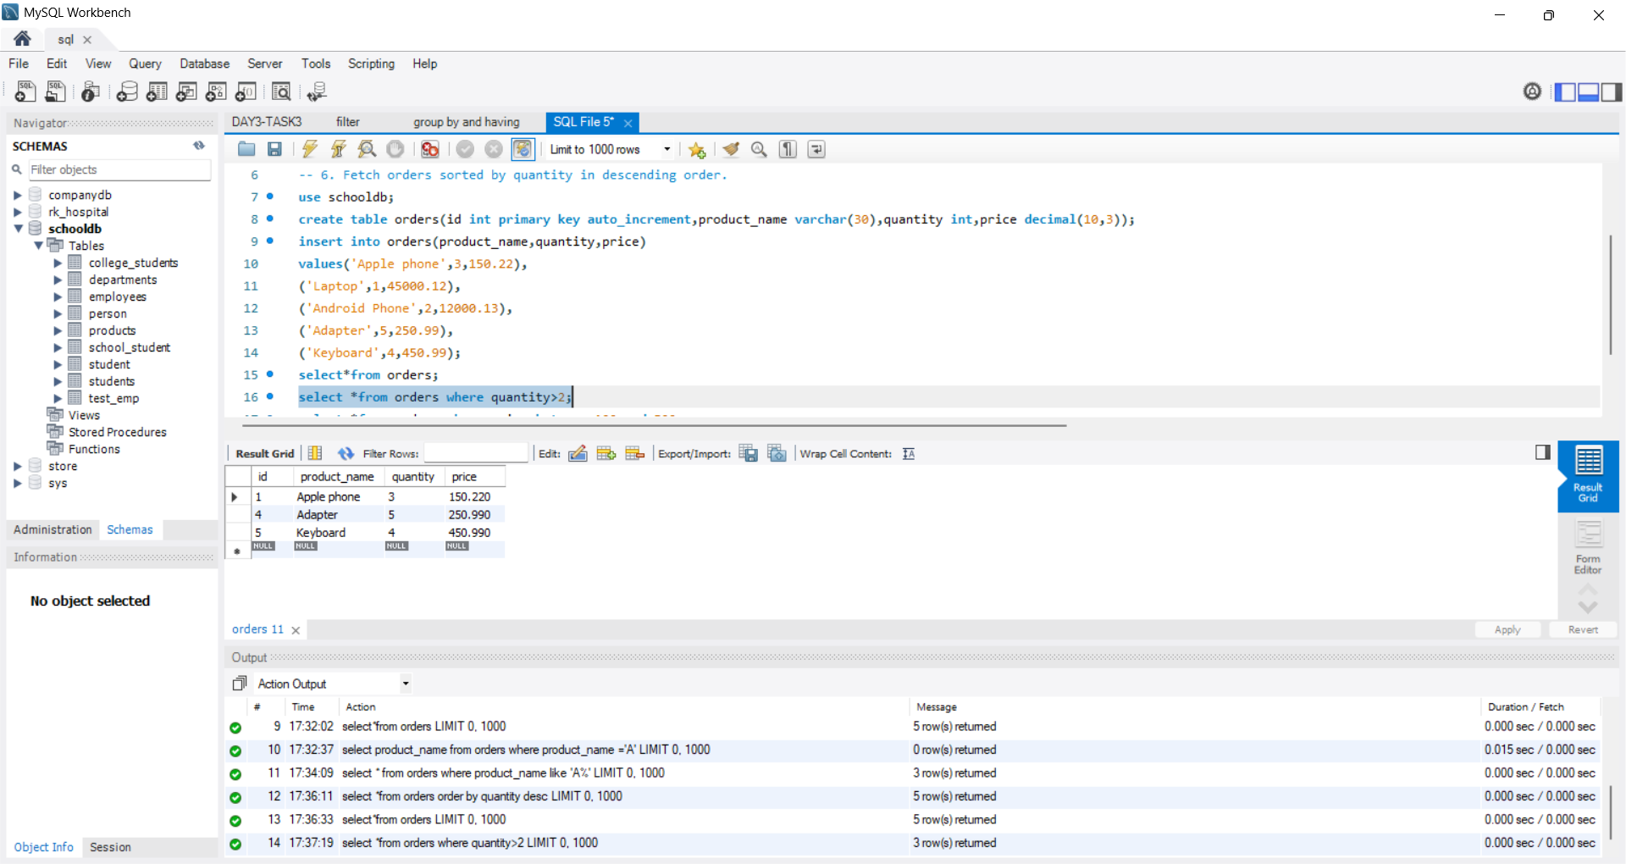
OUTPUT SCREENSHOT:
