MySQL Practice Task

Step 1: Create database
CREATE DATABASE schoolDB;

Step 2: Select database
USE schoolDB;

Step 3: Create students table
CREATE TABLE students(
id INT PRIMARY KEY,
name VARCHAR(50),
age INT,
grade VARCHAR(10)
);

Step 4: Insert 5 records
INSERT INTO students(id,name,age,grade)
VALUES
(1,'sadham',23,'A'),
(2,'venkat',22,'B'),
(3,'shanmuga',25,'A'),
(4,'sherif',23,'B'),
(5,'sathiyanarayan',23,'S');

Step 5: View data
SELECT * FROM students;

Step 6: Drop database
DROP DATABASE schoolDB;

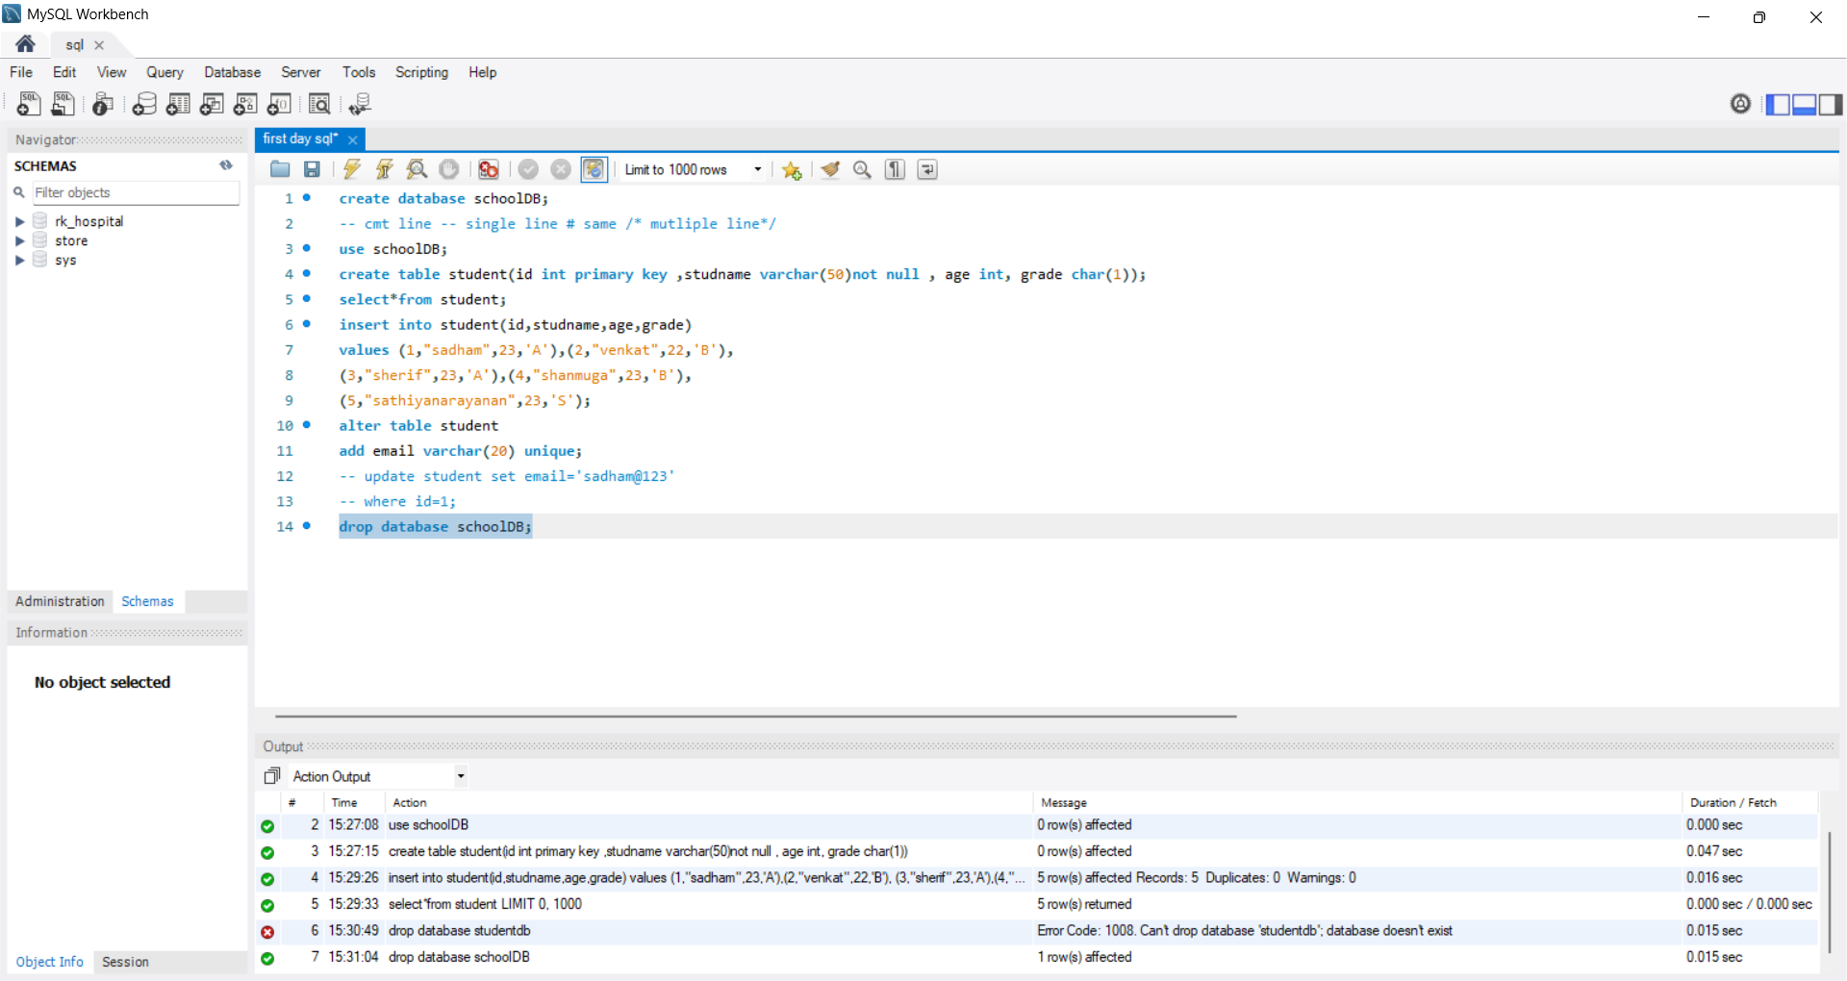
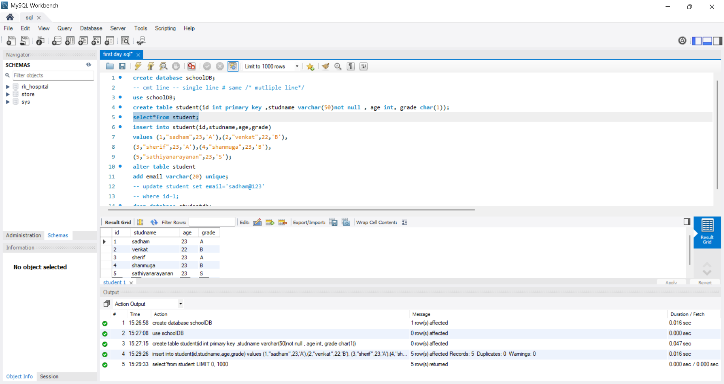
OUTPUT:

