MySQL Date and Time Functions - Events Table

Step 1: Create Table
USE schoolDB;
CREATE TABLE events_table (
id INT PRIMARY KEY AUTO_INCREMENT,
event_name VARCHAR(20),
event_date DATE
);

Step 2: Insert Records
INSERT INTO events_table (event_name, event_date)
VALUES
('Tech Conference', '2026-06-15'),
('Sports Day', '2026-07-10'),
('Cultural Fest', '2026-08-20'),
('Workshop', '2026-09-05'),
('Project Expo', '2026-10-12');

Step 3: Display Current Date & Time
SELECT NOW() AS current_date_time;

Step 4: Format Event Date
SELECT
event_date,
DATE_FORMAT(event_date, '%d-%m-%Y') AS formatted_date
FROM events_table;

Step 5: Extract Year and Month
SELECT
YEAR(event_date) AS event_year,
MONTH(event_date) AS event_month
FROM events_table;

Step 6: Concatenate Event Name and Date
SELECT
CONCAT(event_name, ' - ', event_date) AS concat_details
FROM events_table;
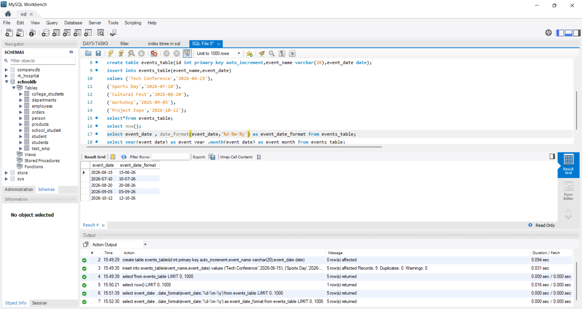
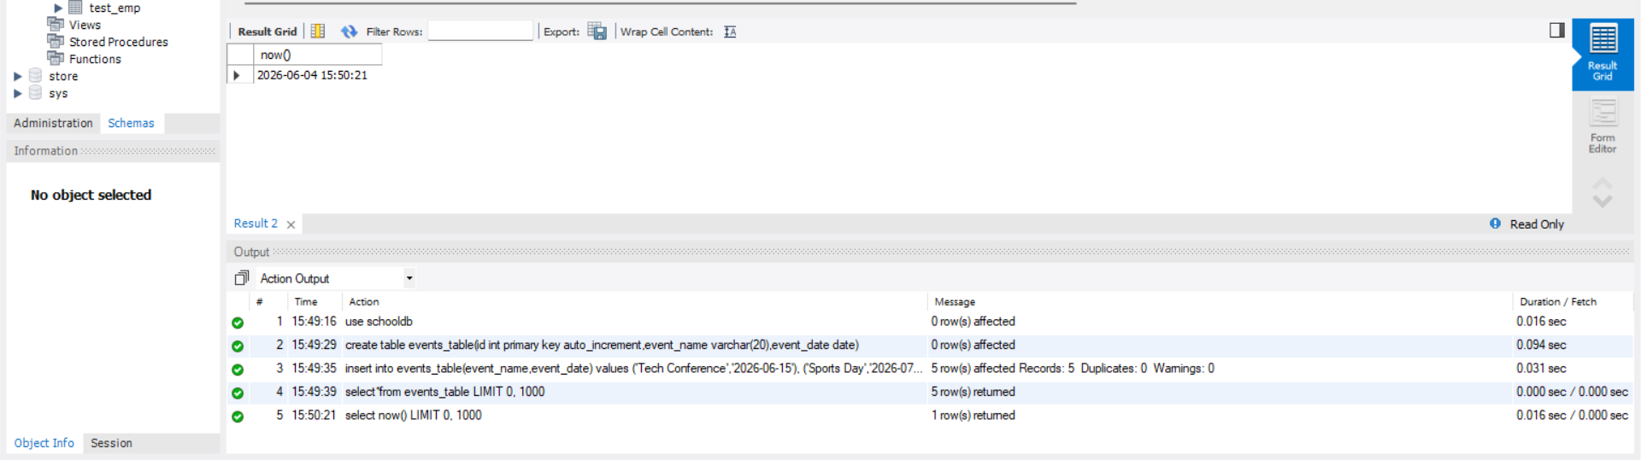
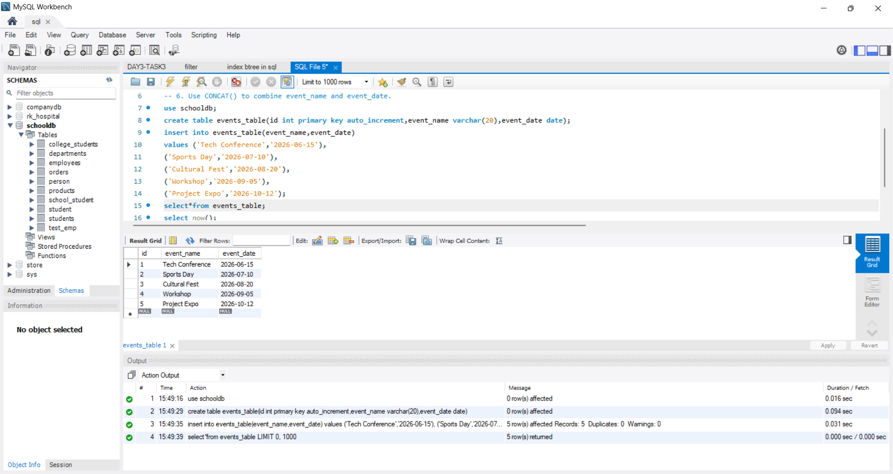
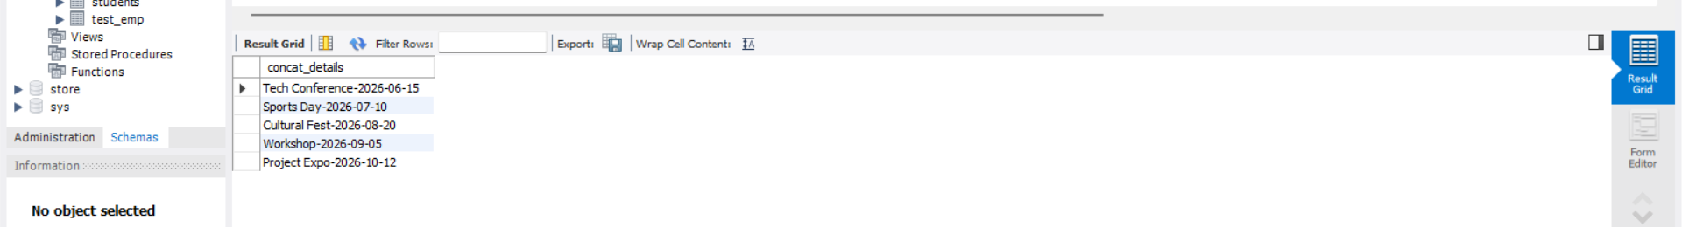
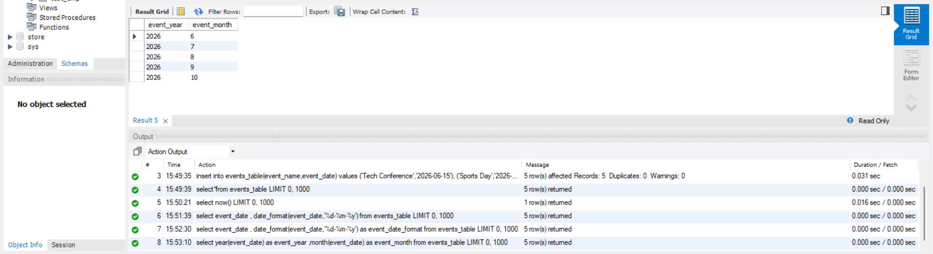
OUTPUT:

