Stored Procedures and Triggers - SQL Lab Questions

Question 1: Create a Stored Procedure to Insert a New Employee
create table employees (
emp_id int primary key,
emp_name varchar(50),
department varchar(50),
salary decimal(10,2)
);
delimiter //
create procedure insert_employee(
in p_id int,
in p_name varchar(50),
in p_department varchar(50),
in p_salary decimal(10,2)
)
begin
insert into employees
values(p_id,p_name,p_department,p_salary);
end //
delimiter ;
call insert_employee(1,'john','it',50000);
call insert_employee(2,'alice','hr',45000);
select * from employees;

Question 2: Create a Stored Procedure to Update Salary Based on ID
delimiter //
create procedure update_salary(
in p_id int,
in p_salary decimal(10,2)
)
begin
update employees
set salary = p_salary
where emp_id = p_id;
end //
delimiter ;
call update_salary(1,55000);
select * from employees;

Question 3: Write a Trigger that Updates Stock When a New Order is Placed
create table products (
product_id int primary key,
product_name varchar(50),
stock int
);
create table orders (
order_id int primary key,
product_id int,
quantity int
);
insert into products values
(101,'laptop',50);
delimiter //
create trigger update_stock
after insert
on orders
for each row
begin
update products
set stock = stock - new.quantity
where product_id = new.product_id;
end //
delimiter ;
insert into orders values
(1,101,5);
select * from products;

Question 4: Write a Trigger that Prevents Deleting the Last Admin User
create table users (
user_id int primary key,
username varchar(50),
role varchar(20)
);
insert into users values
(1,'admin1','admin');
delimiter //
create trigger prevent_last_admin_delete
before delete
on users
for each row
begin
if old.role='admin' and
(select count(*) from users where role='admin')=1
then
signal sqlstate '45000'
set message_text='cannot delete the last admin';
end if;
end //
delimiter ;
delete from users
where user_id=1;

Question 5: Call a Stored Procedure to Fetch Employees
delimiter //
create procedure get_employees()
begin
select * from employees;
end //
delimiter ;
call get_employees();

Question 6: Drop a Procedure and Trigger
drop procedure get_employees;
drop trigger update_stock;
show procedure status;
show triggers;
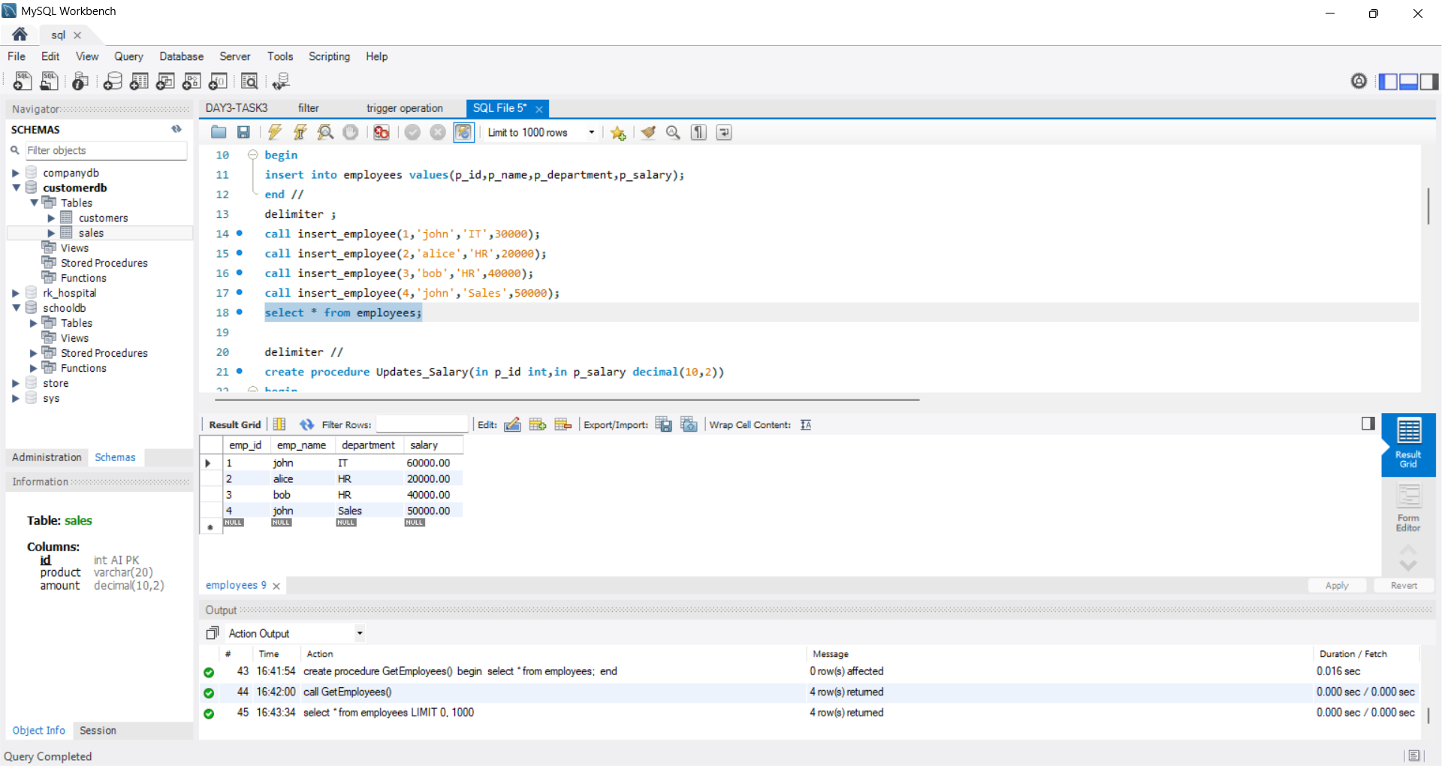
OUTPUT:
