SQL Products Table Operations
1. Create table products
CREATE TABLE products(
id INT,
name VARCHAR(50),
price DECIMAL(10,2)
);
---------------------------------------------------
2. Add new column stock
ALTER TABLE products
ADD stock INT;
---------------------------------------------------
3. Rename column price to unit_price
ALTER TABLE products
RENAME COLUMN price TO unit_price;
---------------------------------------------------
4. Insert 5 products
INSERT INTO products
VALUES
(1,'Laptop',55000,10),
(2,'Mouse',500,50),
(3,'Keyboard',1200,30),
(4,'Monitor',15000,15),
(5,'Headphones',2000,25);
---------------------------------------------------
View table data
SELECT * FROM products;
---------------------------------------------------
5. Update stock of one product
UPDATE products
SET stock = 20
WHERE id = 1;
---------------------------------------------------
6. Delete one product
DELETE FROM products
WHERE id = 5;
---------------------------------------------------
Final table data
SELECT * FROM products;
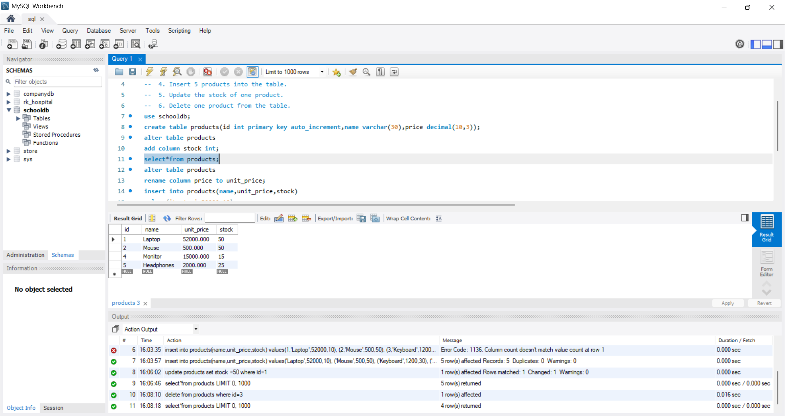
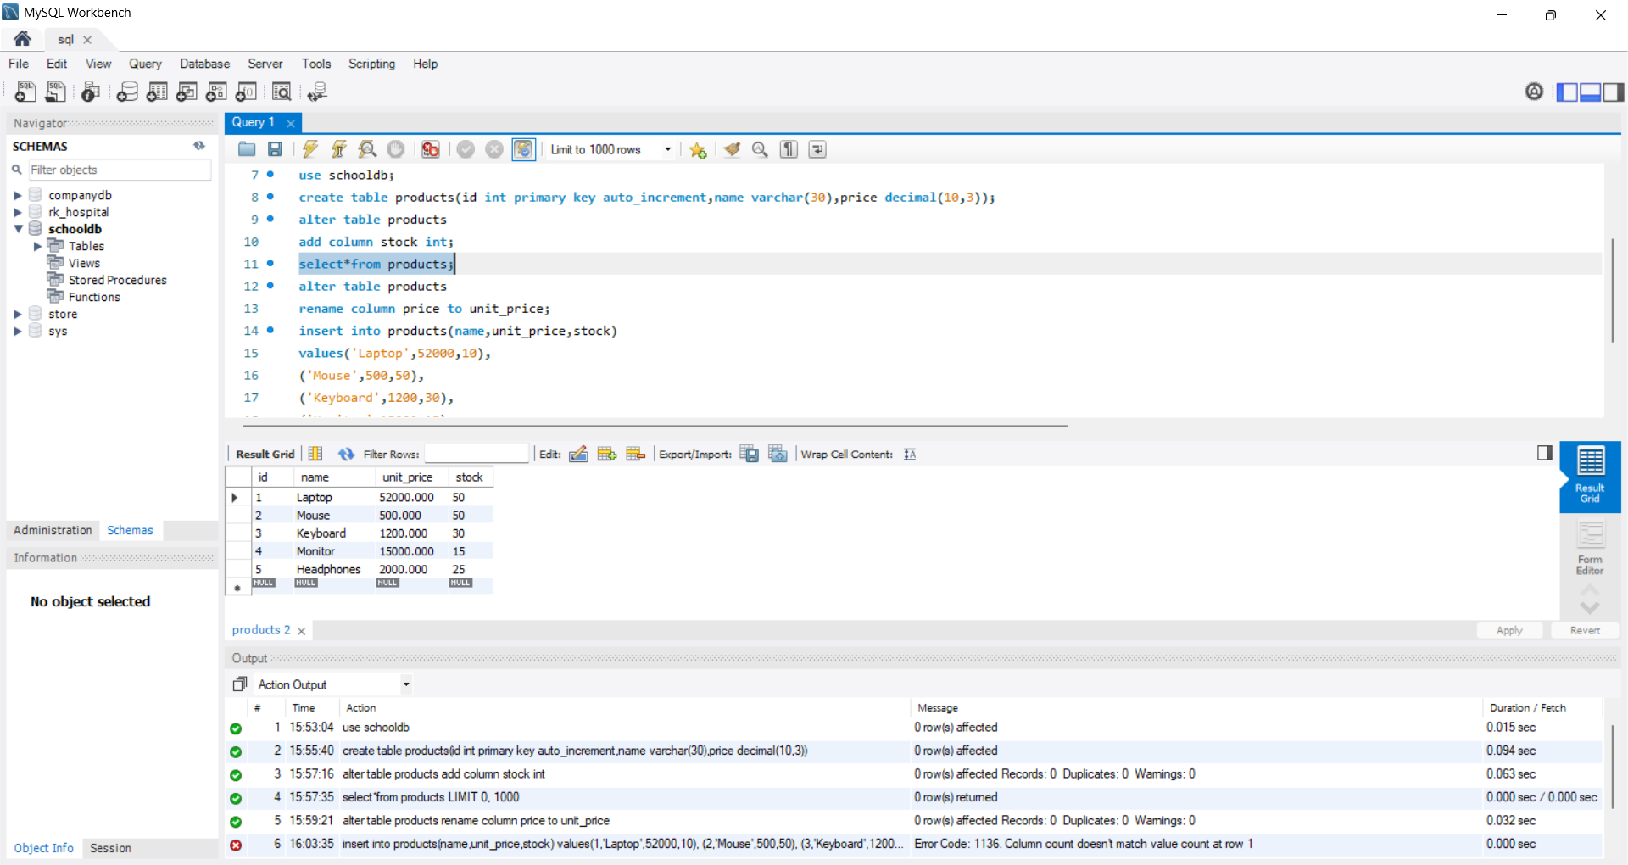
OUTPUT:

