React useState Practice Examples
This document contains React useState examples including a live text preview and dark/light mode toggle.

LivePreview.jsx
import { useState } from "react";
function LivePreview() {
const [text, setText] = useState("");
return (
<div>
<h2>Live Text Preview</h2>
<input
type="text"
placeholder="Type something..."
value={text}
onChange={(e) => setText(e.target.value)}
/>
<h3>Preview:</h3>
<p>{text}</p>
</div>
);
}
export default LivePreview;
OUTPUT:
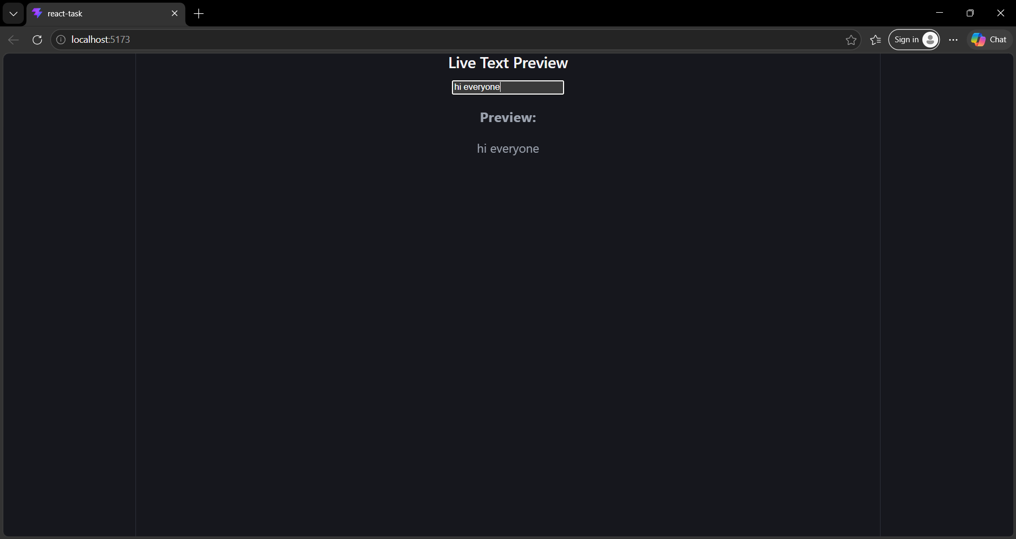

ThemeToggle.jsx
import { useState } from "react";
function ThemeToggle() {
const [darkMode, setDarkMode] = useState(false);
return (
<div
style={{
backgroundColor: darkMode ? "black" : "white",
color: darkMode ? "white" : "black",
height: "100vh",
padding: "20px",
}}
>
<h1>
{darkMode ? "Dark Mode" : "Light Mode"}
</h1>
<button onClick={() => setDarkMode(!darkMode)}>
Switch to {darkMode ? "Light" : "Dark"} Mode
</button>
</div>
);
}
export default ThemeToggle;

App.jsx
import LivePreview from "./LivePreview";
import ThemeToggle from "./ThemeToggle";
function App() {
return (
<div>
<ThemeToggle />
<hr />
<LivePreview />
</div>
);
}
export default App;
OUTPUT:
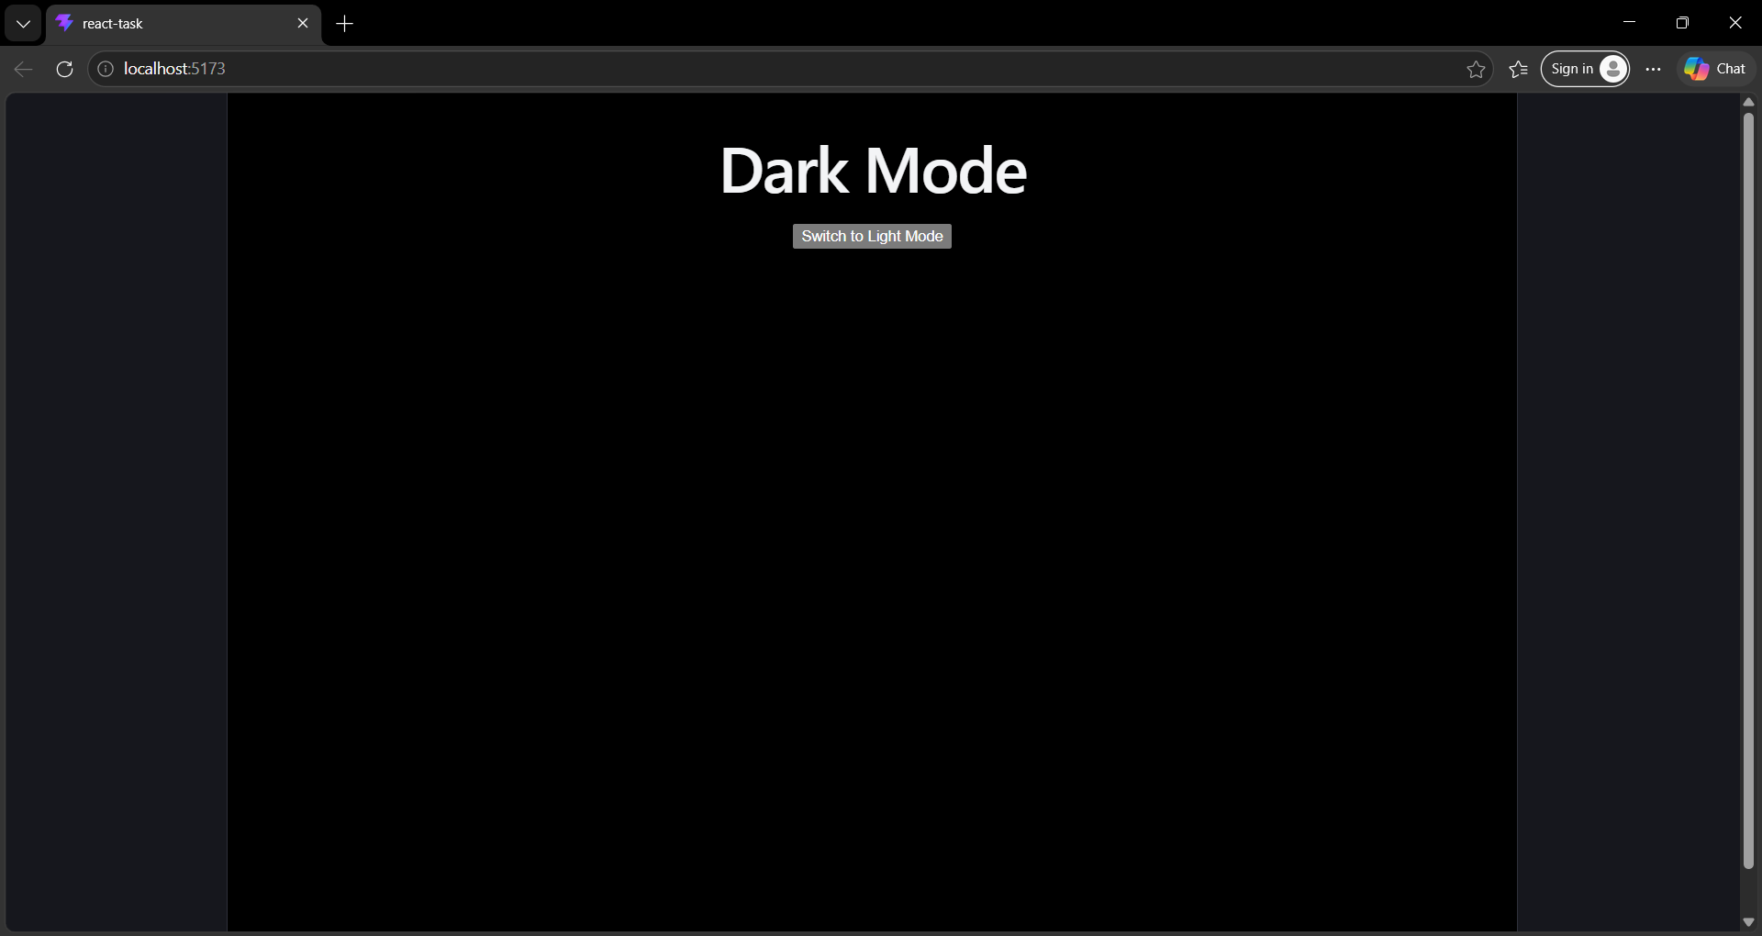

Combined output:
