OUTPUT
Home Page
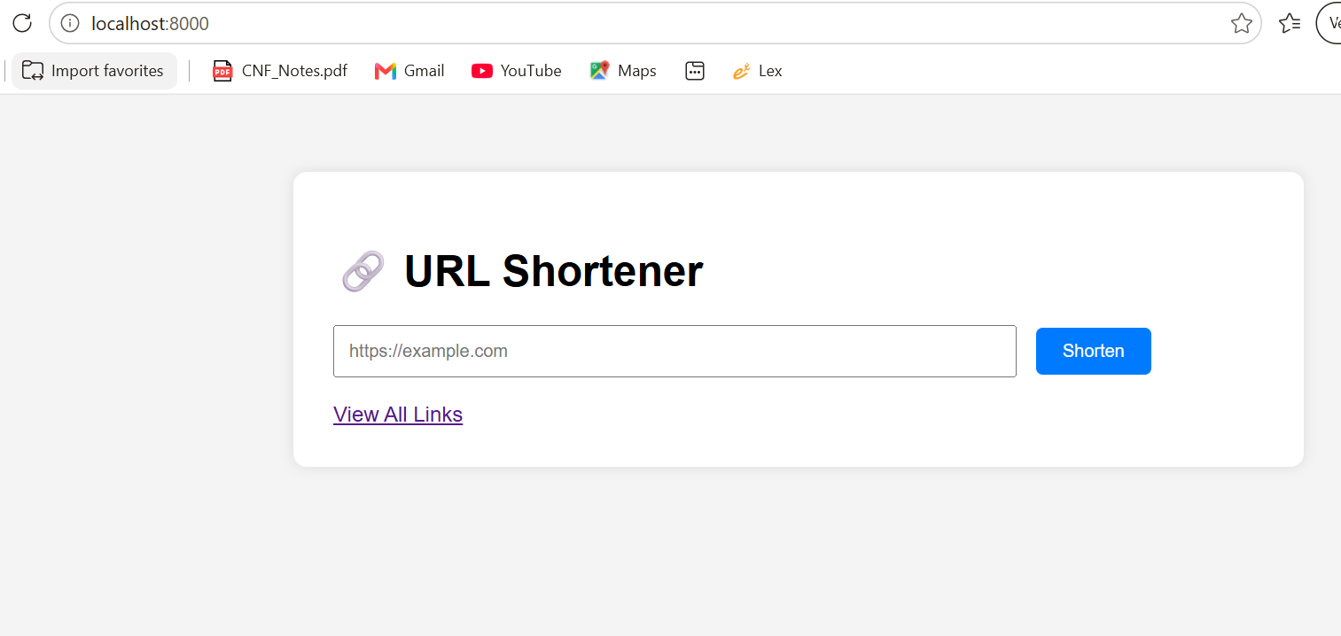

Enter URL
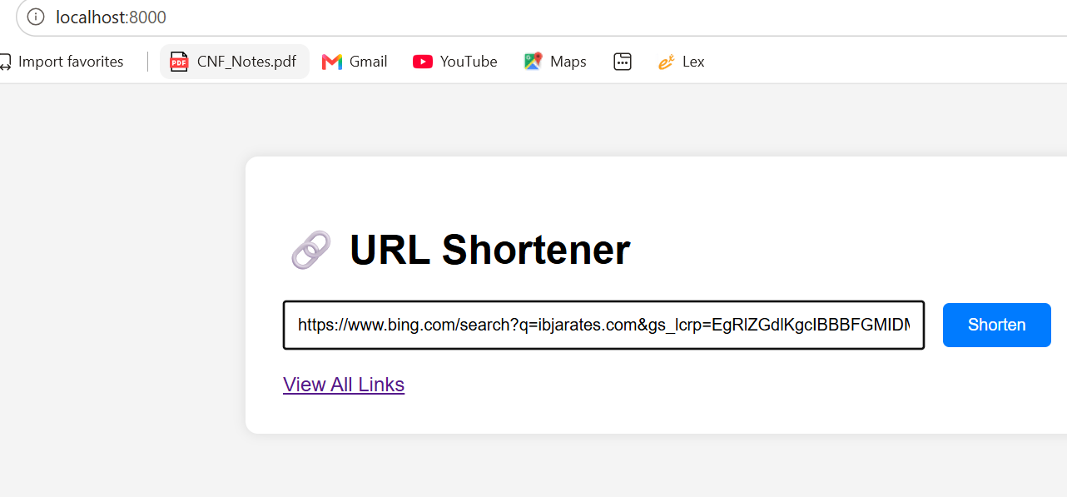

Short URL
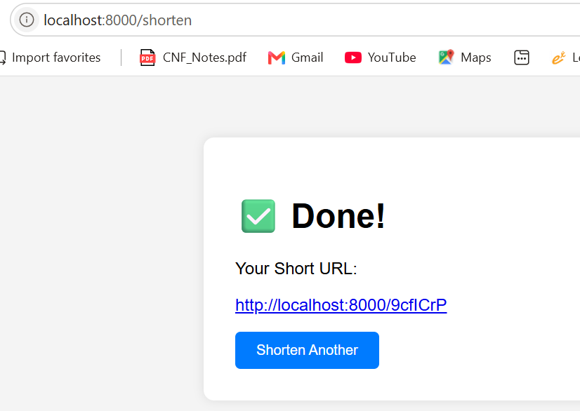

When ShortURL Clicked – Redirected to Original URL
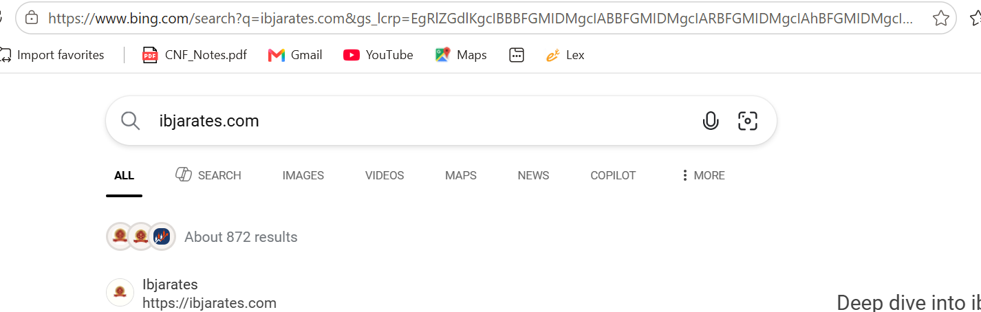

All Links
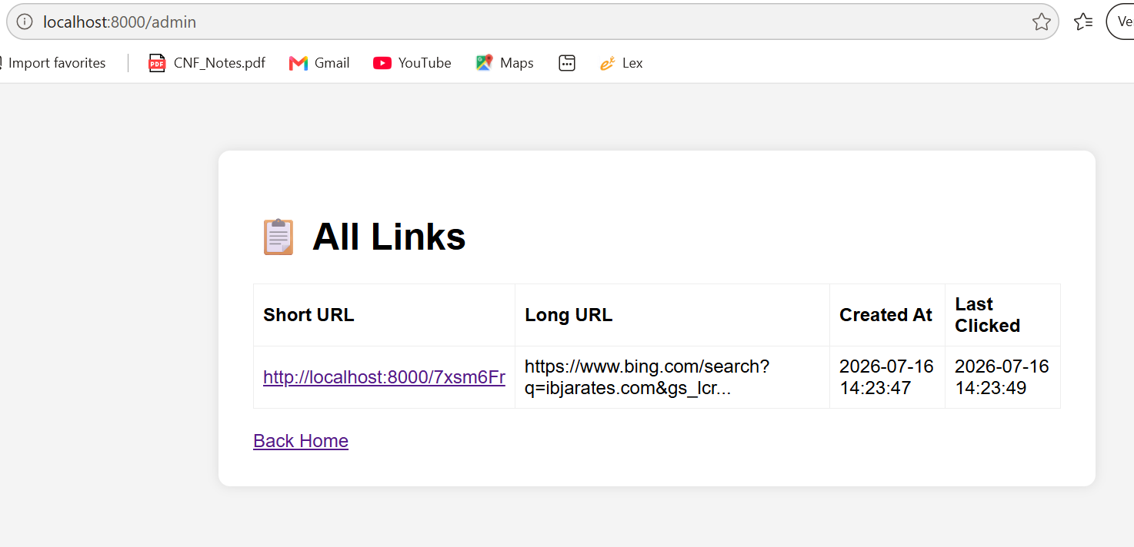

Enter URL: If TextBox is empty – error: Please fill out field.
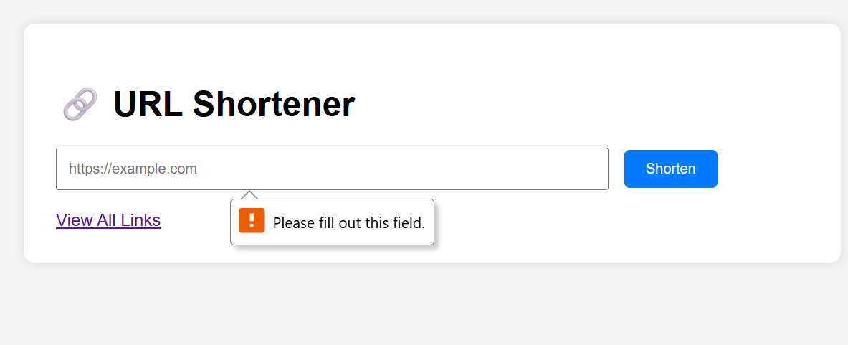

Enter URL: If invalid URL is entered – error: Please enter a URL
