**HANDSONHANDICAP**

A PROJECT REPORT

*Submitted by*

**JAYESH B. PATEL (120223131012)**

**BHAUTIK A. DALICHA (120223131010)**

*In fulfillment for the award of the degree*

*Of*

**BECHLOR OF ENGINEERING**

*In*

**Computer Science & Engineering**



**Government Engineering College, Patan**

**Gujarat Technological University, Ahmedabad**

**Computer Science & Engineering Department**

**CERTIFICATE**

**Date: 18 0ct 2014**

**This is to certify that the dissertation entitled “*HANDSONHANDICAP SYSTEM”* has beencarried out by *JAYESH B. PATEL(120223131012)*, BHAUTIK A. DALICHA(120223131010) under my guidance in fulfillment of the degree of Bachelor of Engineering in Computer Science & Engineering 7thSemester of Gujarat Technological University, Ahmedabad during the academic year 2014-15.**

**Guides:**

**Prof. P.A.BAROT**

**CSE Department**

**GEC, Patan**

**Head of the Department**

**Prof. T.J. Raval**

**CSE Department**

**GEC, Patan**

**Acknowledgement**

I feel deep sense of pleasure of submitting this report for person like me who is exposed by only to the four walls of the classroom & two sides of a page of my prescribed textbook, project work is something new and unexplored experience, I would like to take opportunity to thank to Computer Science & Engineering department, Government Engineering Collage, Patan for providing me with wonderful experience of project work.

I would like to express my deepest gratitude to my internal guide **Prof. P.A.BAROT** and external guide **Miss. Dharti Patel** for their valuable guidance. It is only with their guidance that I could take up such a large project and transfer idea into a nice product.

I am lucky to represent myself and my work under the guidance of **Prof. Tushar J. Raval (HOD)** and all the faculty members of my collage in our project work period they gave me excellent opportunity under this direction. Their guidance at every step was steeping-stones in the completion of our project.

Finally, I would like to thank everybody who was important to the successful realization of this project, as well as expressing my apology that I could not mention personally one by one.

**- PATEL JAYESH B. (120223131012)**

**-DALICHA BHAUTIK A. (120223131010)**

**Abstract**

* An **HandsonHandicap** is a system that provides connecting place for handicap people

they can get any information on just click.This Dynamic Website provide guideline for

handicap student. This website contains information about their new research invention

for handicap people. Website provide facility to discuss their problem with others.

* This website is available for everyone and usefull for Handicap people. Matrimonial service is only access login user.Institute, product and jobs details all user use information.Free product registration for any restricted user.
* The main goal of the proposed system is to,Handicap people get information easily.

Member can easily post his/her query in blog and doctor also post their new research and invention.

* This system also had auto mailing method for informing the registering user about registration and other information
* In this web based application we have modules like,

1. Admin Module
2. Member Module
3. Company Module

* Only authorized user can access the whole system as per the role of the user. User can access only those menu/contents as per his role and rights maintained by admin

**List Of Tables**

|  |  |
| --- | --- |
| **Description** | **Page No** |
| Server Side Specification | **4** |
| Client Side Specification | **4** |
| ADMIN | **25** |
| MEMBER | **26** |
| DISABILITY | **27** |
| COMPANY | **27** |
| ORDER | **27** |
| ORDER_DETAIL | **27** |
| FREE PRODUCT | **28** |
| ORDER STATUS | **28** |
| INSTITUTES | **28** |
| BLOG | **29** |
| BLOG ANSWER | **29** |
| JOBS | **29** |
| JOB APPLY | **30** |
| JOB DETAIL | **30** |
| PRODUCT | **30** |
| PRODUCT INFO | **30** |
| UNIT | **31** |
| PAYMENT | **31** |
| CAMP PROGRAM | **31** |
| CITY | **31** |
| DOCTOR | **32** |

**List Of Figures**

|  |  |
| --- | --- |
| **Description** | **Page No** |
| .NET Framework Architecture | **2** |
| Microsoft SQL Server 2008 | **3** |
| Iterative Waterfall Model | **7** |
| Context Level Diagram. | **13** |
| Level-1 Diagram for ADMIN | **14** |
| Level-1 Diagram for MEMBER | **14** |
| Level-1 Diagram for COMPANY | **14** |
| Level-2 Diagram for ADMIN | **15** |
| Level-2 Diagram for COMPANY | **15** |
| Level-2 Diagram for MEMBER | **16** |
| Use Case Diagram for Admin-Memebr | **17** |
| Use Case Diagram for Member-company | **18** |
| Activity Diagram for Admin | **19** |
| Activity Diagram for Company | **20** |
| Activity Diagram for Member | **21** |
| Sequence Digaram for Admin | **22** |
| Sequence Digaram for Company | **23** |
| Sequence Digaram for Customer-Admin | **23** |
| Sequence Digaram for User | **24** |
| Sequence Digaram for User-Job | **24** |
| Class Diagram |  |
| Entity-Relationship Diagram | **33** |
|  |  |

|  |
| --- |
| **TABLE OF CONTENTS** |

|  |  |  |
| --- | --- | --- |
|  |  |  |
|  |  |  |

|  |  |  |
| --- | --- | --- |
|  | **Acknowledgement** | I |
|  | **Abstract** | II |
|  | **List of Tables** | III |
|  | **List of Figures** | IV |
|  | **Table of Contents** | V |
|  |  |  |
| **Chapter 1** | **Introduction** | 1 |
|  | 1.1 Problem Introduction | 1 |
|  | 1.1.1 Project Profile | 1 |
|  | 1.1.2 Project Definition | 1 |
|  | 1.1.3 Corporate Overview | 2 |
|  | 1.1.3.1 Existing system | 2 |
|  | 1.1.3.2 Need For This system | 3 |
|  | 1.1.3.3 Purpose | 3 |
|  | 1.1.3.4 Scope | 4 |
|  | 1.1.4 Detailed Description of Problem | 5 |
|  | 1.1.5Benefits Of The System | 5 |
|  |  |  |
| **Chapter 2** | **System Requirement** | 9 |
|  | 2.1 User Characteristics | 9 |
|  | 2.2 Software and Hardware Requirement | 9 |
| 2.3 Constraints | 10 |
| **Chapter 3** | **System Analysis** | 11 |
|  | 3.1 Feasibility Study | 11 |
|  | 3.1.1 Technical Feasibility | 11 |
|  | 3.1.2 Economical Feasibility | 11 |
|  | 3.1.3 Schedule Feasibility | 11 |
|  | 3.1.4 Operational Feasibility | 12 |
|  | 3.2 Requirement Specification | 12 |
|  | 3.2.1 Functional Requirements | 12 |
|  | 3.2.2 Non- Functional Requirements | 13 |
|  |  |  |
| **Chapter 4** | Function of System | 15 |
|  | 4.1 System Flowchart | 15 |
|  | 4.1.1 System Flowchart For Hole System | 16 |
|  | 4.1.2 System Flowchart For Admin | 17 |
|  | 4.1.3 System Flowchart For Tender Registration | 18 |
|  | 4.1.4 System Flowchart For Data Management System | 19 |
|  | 4.1.5 System Flowchart For Work Flow | 20 |
|  | 4.2 Use Case Diagram | 21 |
|  | 4.3 Sequence Diagram | 22 |
|  |  |  |
| **Chapter 5** | **Data Modeling** | 23 |
|  | 5.1 E-R Diagram | 23 |
|  | 5.2 Activity Diagram | 24 |
|  | 5.2.1 Activity Diagram For Login | 25 |
|  | 5.2.2 Activity Diagram For Change Password | 26 |
|  | 5.2.3 Activity Diagram For Tender Registration | 27 |
|  | 5.2.4 Activity Diagram For Tender Assignment | 28 |
|  | 5.2.3 Activity Diagram For Work Flow | 29 |
|  | 5.3 Class Diagram | 30 |
|  |  |  |
| **Chapter 6** | **Function and Behavioural Modeling** | 31 |
|  | 6.1 Data Flow Diagram | 31 |
|  | 6.1.1 Context Level DFD | 32 |
|  | 6.2.2 1st Level DFD | 33 |
|  | 6.2.3 2nd Level DFD | 34 |
|  | 6.2.3.1 2nd Level DFD For Process 2.0 | 34 |
|  | 6.2.3.2 2nd Level DFD For Process 3.0 | 35 |
|  | 6.2.3.3 2nd Level DFD For Process 4.0 | 36 |
|  | 6.2.3.4 2nd Level DFD For Process 5.0 | 37 |
|  | 6.2.3.5 2nd Level DFD For Process 6.0 | 38 |
|  |  |  |
| **Chapter 7** | **System Design** | 39 |
|  | 7.1 Data Dicitonary | 39 |
|  |  |  |
| **Chapter 8** | **Conclusion and Future Work** | 56 |
|  |  |  |
| **Chapter 9** | **Reference** | 57 |
|  |  |  |
|  |  |  |
|  |  |  |
|  |  |  |
|  |  |  |
|  |  |  |
|  |  |  |
|  |  |  |

**INTRODUCTION CHAPTER 1**

* 1. **Problem Introduction**

**1.1.1 Project Profile**

|  |  |
| --- | --- |
| **Project Title** | **HANDSONHANDICAP** |
| **Company Name** | **ASPIRATION** |
| **Project Manager** | **Mr. SHYAMCHAWDA** |
| **Project Guide** | **Prof. P.A.Barot** |
| **Operating System** | **Windows 8** |
| **Technology used** | **ASP.NET With C#** |
| **Tools** | **Microsoft Visual Studio 2013** |
| **Database** | **Microsoft SQL Server 2010 Express Edition** |

**1.1.2 Project Definition**

* An **HandsonHandicap** is a system that provides connecting place for handicap people

they can get any information on just click.This Dynamic Website provide guideline for

handicap student. This website contains information about their new research invention

for handicap people. Website provide facility to discuss their problem with others

* To provide Handicap people with easy and fast access information whenever they

Required.

* This website contains information about their new research invention for handicap

people.

**1.1.3 Corporate Overview**

**1.1.3.1Existing system**

* It only Information Site.
* No such kind of helpful website for Handicap people.
* Lake of Information regarding to institute, job,matrimonial, new research invention for Handicap people.
* In Current System alert for activity progress is not provided to handicap.
* Current System is more time consuming.
* There is no any website dedicated to Handicap people.
* Handicap people facing problem in matrimonial,job,education
* Even they don’t have upto date information of research in their field.
* They don’t have any site to speak their problem , exchange thoughts with other people

**1.1.3.2 Need for This System**

* No such Systeem for the handicap people.
* The main goal of the proposed system is to,Handicap people get information easily.
* Member can easily post his/her query in blog and doctor also post their new research and invention.
* Member easily purchase equipment and instrument.
* Handicap people facing problem matrimonial,so here they can match making.
* This website helpful in applying job for handicap.
* Alert would be sent to handicap people througt sms/email.
* Provide free product camp shedaul and all their related details.

**1.1.3.3Purpose**

The Main purpose of this document is to collect and analyze all assorted ideas that have come up to define the system, its requirements with respect to marketers .Also, we shall predict and sort out how we hope this system will be used in order to gain a better understanding of the project, outline concepts that may be developed later, and document ideas that are being considered, but may be discarded as the product develops.

In short, the purpose of this SRS document is to provide a detailed overview of our software product, its parameters and goals. This document describes the project's target audience and its user interface, hardware and software requirements. It defines how our client, team and audience see the system and its functionality. Nonetheless, it helps any designer and developer to assist in software delivery lifecycle (SDLC) processes.

* The main goal of the proposed system is to,Handicap people get information easily.Member can easily post his/her query in blog and doctor also post their new research and invention and get maximum benefits.
* Handicap people facing problem matrimonial,so here they can match making.This

website helpful in applying job for handicap.

* This SRS aims to provide the detail description on the client requirements for the required application.

**1.1.3.4 Scope**

* This website is available for everyone and usefull for Handicap people.
* Matrimonial service is only access login user.
* Institute, product and jobs details all user use information.
* Free product registration for any restricted user.

**1.1.4 Detailed description of problem**

* There is no any website dedicated to Handicap people.
* Handicap people facing problem in matrimonial,job,education
* Even they don’t have upto date information of research in their field.
* They don’t have any site to speak their problem , exchange thoughts with other people.

**1.1.5 Benefits of the system**

* The main goal of the proposed system is to,Handicap people get information easily.
* Member can easily post his/her query in blog and doctor also post their new research and invention.
* Member easily purchase equipment and instrument.
* Handicap people facing problem matrimonial,so here they can match making.
* This website helpful in applying job for handicap.
* Alert would be sent to handicap people througt sms/email.
* Provide free product camp shedaul and all their related details.
* Handicap people more aware about the education,their new scheme,new invention.

**ASP.NET**

ASP.NET is a new Internet programming technology developed by Microsoft. It applies an object-oriented approach for building dynamic Web application and acts as a Web development platform that provides the features necessary for developers to create enterprise-level Web application.

ASP.NET can be used for managing large-scale business as it is ideally suited for this purpose. These application can either be used for an intranet (with an organization) or can be made accessible on the internet after applying security measures so, that internet users can safely access and update information on the Web site.

**Features of ASP.NET:**-

* + ASP.NET is a programming framework built on the common language runtime that can be used on a server to build powerful Web applications. ASP.NET offers several important advantages over previous Web development models:
  + **Enhanced Performance**:
* ASP.NET is compiled common language runtime code running on the server. Unlike its interpreted predecessors, ASP.NET can take advantage of early binding, just-in-time compilation, native optimization, and caching services right out of the box. This amounts to dramatically better performance before you ever write a line of code.
* **Power and Flexibility:**
* Because ASP.NET is based on the common language runtime, the power and flexibility of that entire platform is available to Web application developers. The .NET Framework class library, Messaging, and Data Access solutions are all seamlessly accessible from the Web. ASP.NET is also language-independent, so you can choose the language that best applies to your application or partition your application across many languages. Further, common language runtime interoperability guarantees that your existing investment in COM-based development is preserved when migrating to ASP.NET.

* **Simplicity:**

ASP.NET makes it easy to perform common tasks, from simple form submission and client authentication to deployment and site configuration. For example, the ASP.NET page framework allows you to build user interfaces that cleanly separate application logic from presentation code and to handle events in a simple, Visual Basic - like forms processing model. Additionally, the common language runtime simplifies development, with managed code services such as automatic reference counting and garbage collection.

* **Manageability:**

ASP.NET employs a text-based, hierarchical configuration system, which simplifies applying settings to your server environment and Web applications. Because configuration information is stored as plain text, new settings may be applied without the aid of local administration tools. This "zero local administration" philosophy extends to deploying ASP.NET Framework applications as well. An ASP.NET Framework application is deployed to a server simply by copying the necessary files to the server. No server restart is required, even to deploy or replace running compiled code.

* **Scalability and Availability:**
  + ASP.NET has been designed with scalability in mind, with features specifically tailored to improve performance in clustered and multiprocessor environments. Further, processes are closely monitored and managed by the ASP.NET runtime, so that if one misbehaves (leaks, deadlocks), a new process can be created in its place, which helps keep your application constantly available to handle requests.
    - **Customizability and Extensibility:**
      * ASP.NET delivers a well-factored architecture that allows developers to "plug-in" their code at the appropriate level. In fact, it is possible to extend or replace any subcomponent of the ASP.NET runtime with your own custom-written component. Implementing custom authentication or state services has never been easier.

**Why ASP.NET?**

* Since 1995, Microsoft has been constantly working to shift its focus from Windows-based platforms to the Internet. As a result Microsoft introduced ASP (Active Server Pages) in November 1996. ASP offered the efficiency of ISAPI applications along with a new level of simplicity that made it easy to understand and use.
* However, ASP script was an interpreted script and consisted unstructured code and was difficult to debug and maintain. As the web consists of many different technologies, software integration for Web development was complicated and required to understand many different technologies.
* Also, as applications grew bigger in size and became more complex, the number of lines of source code in ASP applications increased dramatically and was hard to maintain. Therefore, an architecture was needed that would allow development of Web applications in a structured and consistent way.
* The .NET Framework was introduced with a vision to create globally distributed software with Internet functionality and interoperability. The .NET Framework consists of many class libraries, includes multiple language support and a common execution platform.
* It's a very flexible foundation on which many different types of top class applications can be developed that do different things. Developing Internet applications with the .NET Framework is very easy.
* ASP.NET is built into this framework; we can create ASP.NET applications using any of the built-in languages.

Unlike ASP, ASP.NET uses the Common Language Runtime (CLR) provided by the .NET Framework. This CLR manages execution of the code we write.

**CHAPTER 2 SYSTEM REQUIREMENT**

## 2.1 User Characteristics:

* **Admin**
* Login: Admin will login in system and perform different tasks such as post Camp-sheduale, Jobs, Institute Detaile, Manage free request product.
* **User**
  + - Rregistered in the system and process.
    - Login in the system and process.
    - View & search different content of this system.
    - Update Matrimonial profile.
    - See various items on system even if not registered.
    - User can apply for job.
    - User can online purchase instrument/equipments.

**2.2 Hardware and Software Used**

***Specification at Server side:***

|  |  |
| --- | --- |
| **Hardware** | **Software** |
| * **2.0 GHz Processor** * **2 GB RAM** * **5 GB Storage Space** | • **Front End : ASP.NET with**  **C#**  • **Back End : SQL Server**  **2010** |

***Specification at Client side***

|  |  |
| --- | --- |
| **Hardware** | **Software** |
| • **1.3 GHz Processor**  • **1 GB RAM** | • **Windows XP onwards**  • **Web browser (IE,**  **Chrome, FireFox)** |

**2.3 Constraints**

* **User Interface**
* The user Interface is provided by the any kind of web browser like Internet Explorer, Mozilla Firefox, safari etc. As the project is the extension of the live project, based on the client’s requirement, the project testing will be done for the above specified four browsers so the project would be portable and will have pluggable look and feel.
* **Communication Interfaces**
* This is website so it requires HTTP protocol and Internet connection.
* **Software Interface**
* The application mainly interacts with the Microsoft SQL Server database for storing data at the back end. Other than this it does not deal with any software.

**CHAPTER 3 SYSTEM ANALYSIS**

**3.1 Feasibility Study**

The feasibility of the project is analyzed in this phase and business proposal is put forth with a very general plan for the project and some cost estimates. During system analysis the feasibility study of the proposed system is to be carried out. This is to ensure that the proposed system is not a burden to the company. For feasibility analysis, some understanding of the major requirements for the system is essential.

**3.1.1 Technical Feasibility**

It is a measure of the practicality of a specific technical solution and availability of technical solution and availability of technical resources and expertise.

* We are having necessary technology to implement the system.
* The front end used is Microsoft Visual Studio 2010 which is very powerful tool for building web applications.
* Microsoft Visual Studio 2010 is user friendly and ease to use hence developing application using it provides a less tedious task.
* The back end is Microsoft SQL Server 2010 Express edition. Which comes integrated into visual studio itself. Hence the system is technically feasible.

**3.1.2 Economical Feasibility**

It is a measure of the cost effectiveness of a project or solution.

* As far as economic feasibility is there, investment of organization comes into picture.
* The company uses Microsoft Visual Studio 2010 and the Microsoft SQL Server 2010 Express Edition which are available at company.So no personal license is needed.
* Here we do not need to invest extra funds to develop the system. Hence the system is economically feasible.

**3.1.3 Schedule Feasibility**

Schedule feasibility is concerned with time. Time is the greatest resource for developing any system. We have enough time for development of the project.

* This is a one year project in which 6 months are dedicated to tasks of project analysis, management, requirement gathering, feasibility study, requirement specification and initial system design tasks.
* In the next phase the detailed system design, code implementation, testing and maintenance will be carried out. As we were working in a group of three, we will be able to utilize this time for successful completion of our project.

**3.1.4 Operational Feasibility**

It is a measure of how well the solution will work in the organization. It is alsomeasure of how people feel about the system.

* The system is operationally feasible as it very easy for the end users to operate it.
* It only needs basic information about Windows platform.
* At organization level only a small training session is required to understand the complete functionality.

**3.2 Requirement Specification**

**3.2.1 Functional Requirements**

**(A) Functions of General User Module**

i)User can Visit Website

ii) Able to See News regarding to job and camp schedule.

iii) Check Details of institute

**(B) Functions of Registered User Module**

i) Can Login to website

ii) Update matrimonial profile,apply for job.

iii) Online purchase.

**C) Functions of Admin Module**

i) Check Details of Every Registered User

ii) Can Alter detail of company i.e add/delete Company or their product.and also remove user.

iii) Display new Updates and result on specific content of site.

iv) Manage all the databases

**3.2.2 Non-Functional Requirements**

The hardware and software for the development has been selected based on several factors such as:

* **Accessibility:**

The system would be accessible to only that person who is permitted to use the system. It would provide all type of information to the permitted user as per their access level.

* **Performance:**

The system would offer better performance in all end or intermediate process during voting. It would provide information that will allow the management to take decisions in a controlled and informed environment. It would be user friendly.

* **Reliability:**

The system would perform its required functions under stated conditions for a specified period of time.

* **Availability:**

The system would be in specified operable and committable state when used by the user.

* **Extensibility:**

The system would be flexible and capable of adapting to changes in business environment like adding new features, and carry-forward of customizations at next major version upgrade.

* **Response time**:

The system would be interactive and responds quickly to the user input.

* **Backup:**

The system would facilitate easy backing up by making copies of data which may be used to restore the original after a data loss event.

**CHAPTER4 FUCTION OF SYSTEM**

**4.1 Data Flow Diagram**

* A data flow diagram is a graphical representation that depicts information flow and the transforms that are applied as data move from input to output.
* The data flow diagram (DFD) serves two purposes:

1. To provide an indication of how data are transformed as they move through the

System.

2. To depict the functions (and sub functions) that transform the data flow.

* The DFD provides additional information that is used during the analysis of the information domain and serves as a basis for the modeling of function.

**4.1.1 Context Level Diagram**

* A level 0 DFD, also called a fundamental system model or a context model, represents the entire software element as a single bubble with input and output data indicated by incoming and outgoing arrows, respectively.

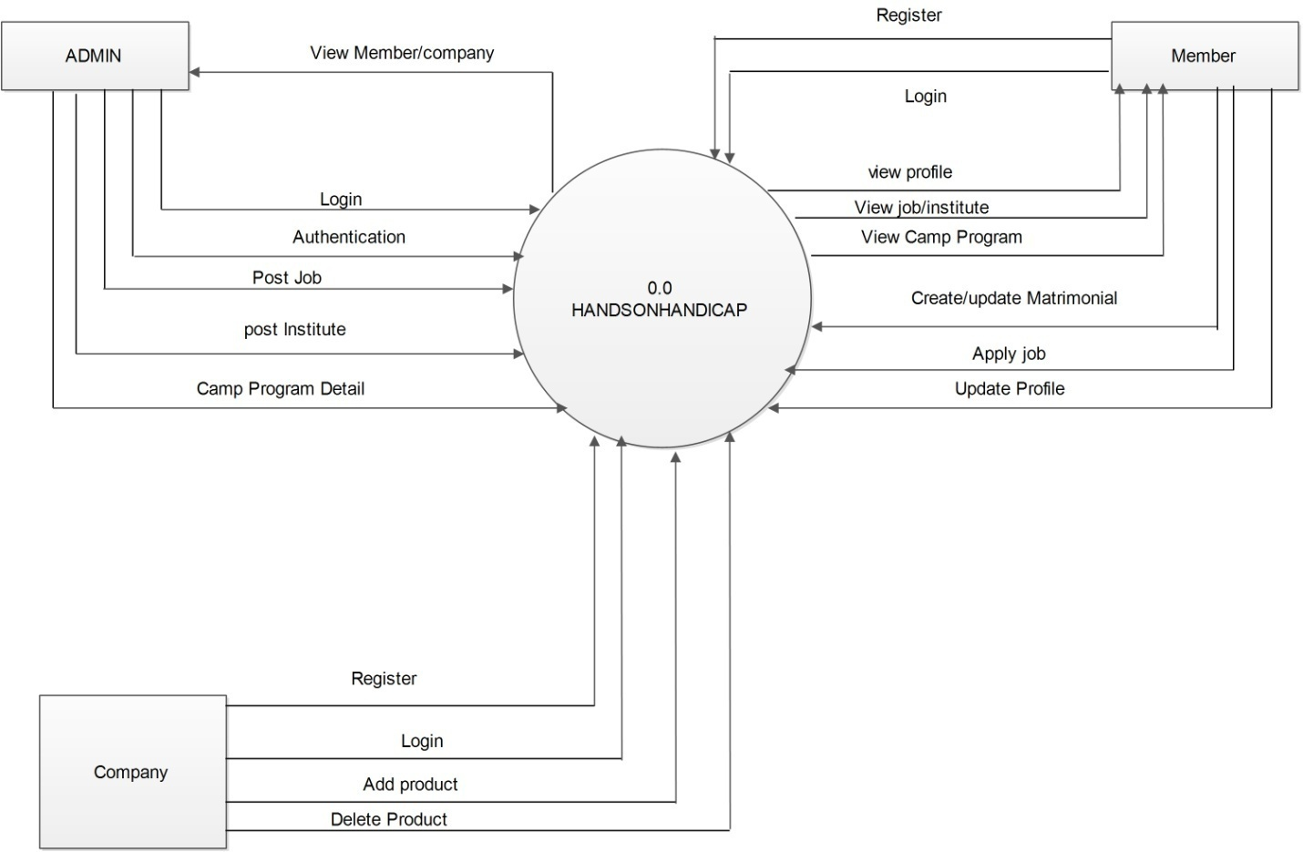

**4.1.2 Level-1 DFD**

* A level 1 DFD might contain five or six bubbles with interconnecting arrows. Each of the processes represented at level 1 is a sub function of the overall system depicted in the context model
* **LEVEL1 DIAGRAM FOR ADMIN**

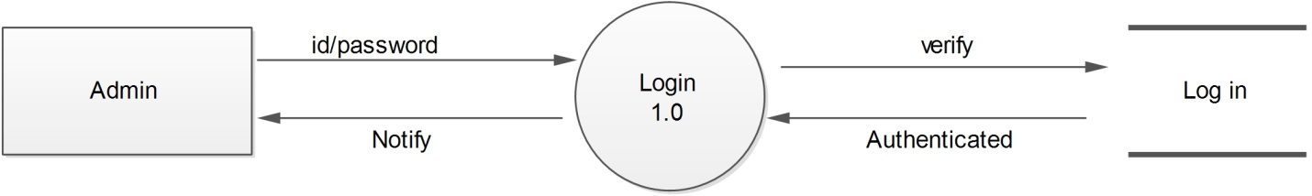

* **LEVEL1 DIAGRAM FOR MEMBER**

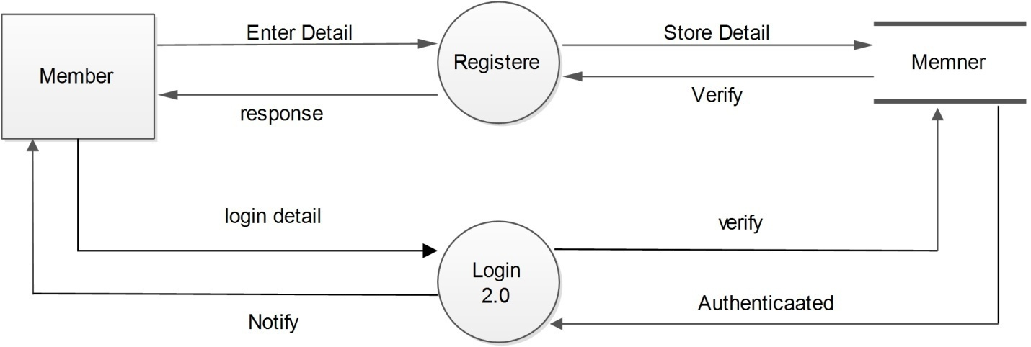

* **LEVEL1 DIAGRAM FOR COMPANY**

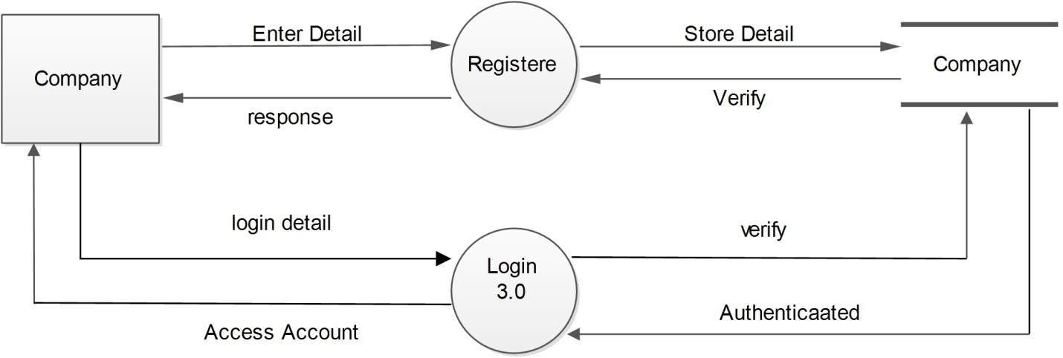

**4.1.3 Level-2 DFD**

* **ADMIN**

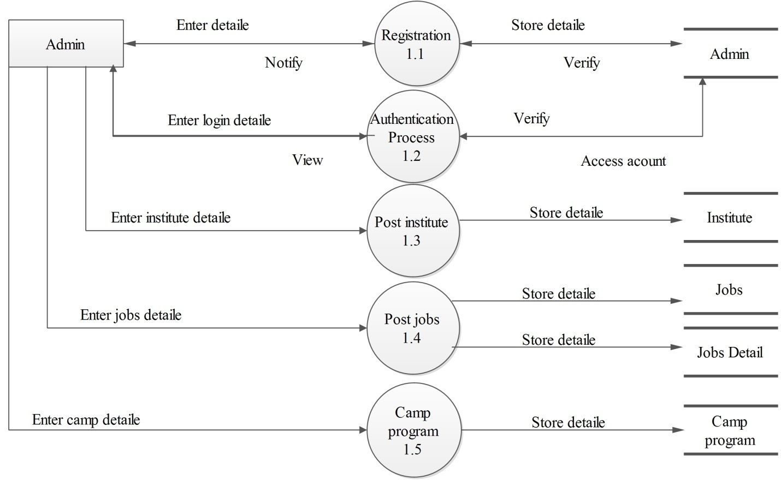

* **COMPANY**

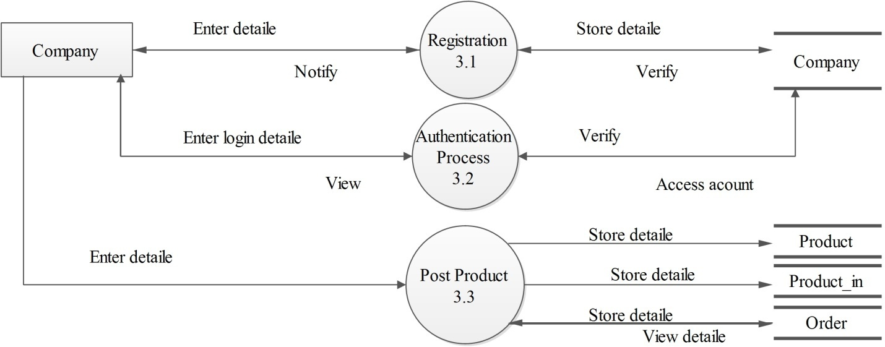

* **MEMBER**

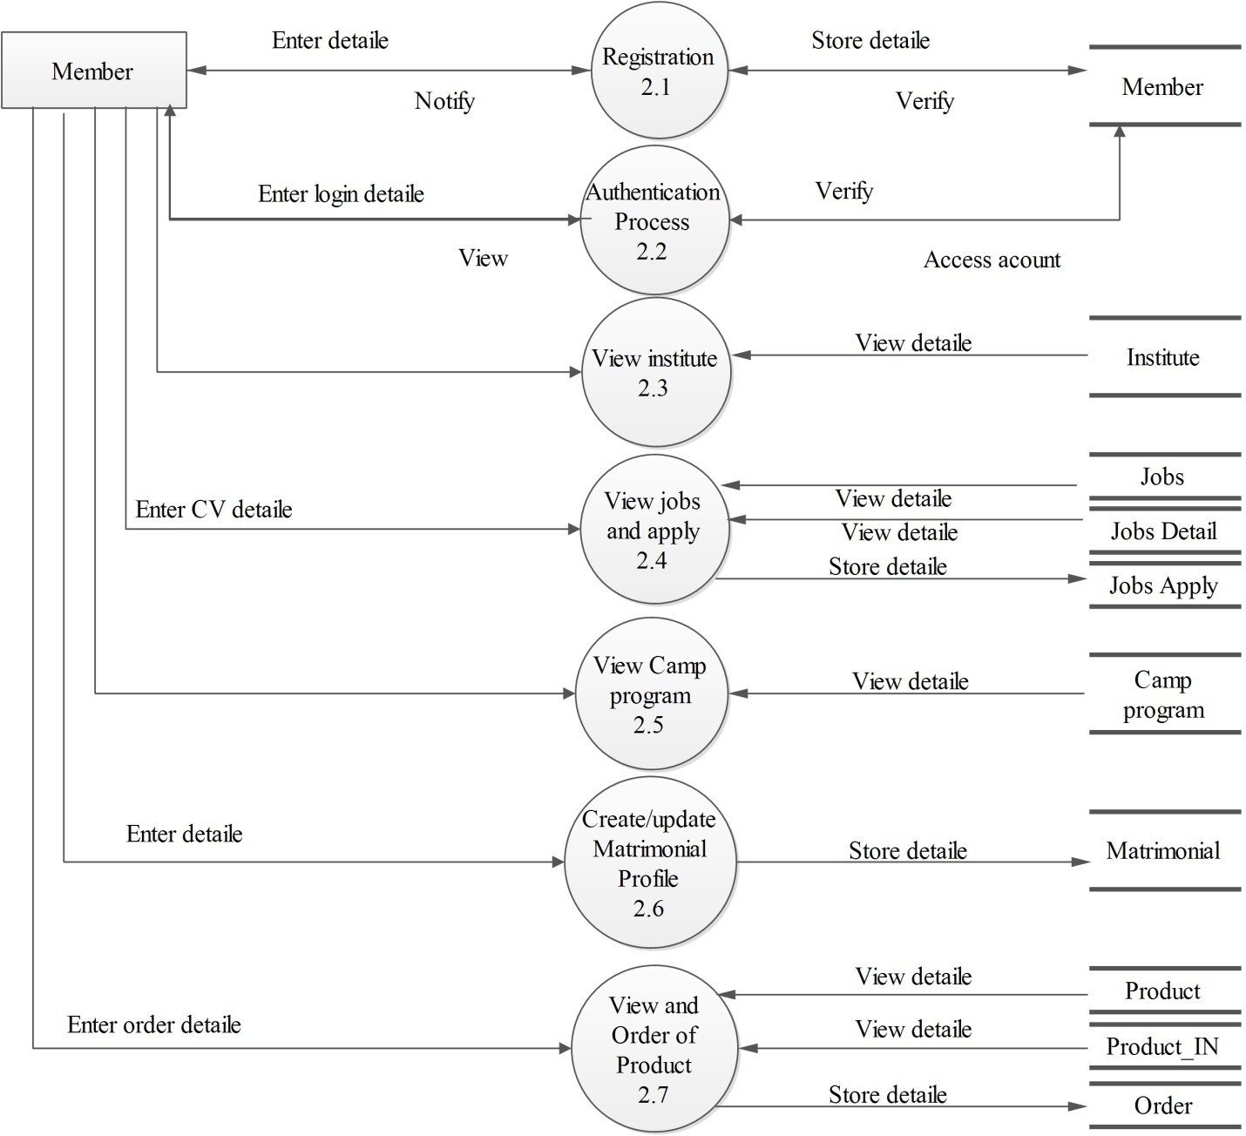

**4.2 Use case Diagram**

* A use-case is a scenario that describes how software is to be used in a given situation.
* Use-cases are defined from an actor’s point of view. An actor is a role that people (users) or devices play as they interact with the software.
* In general, a use-case is simply a written narrative that describes the role of an actor as interaction with the system occurs.
* **USE CASE OF ADMIN-MEMBER**

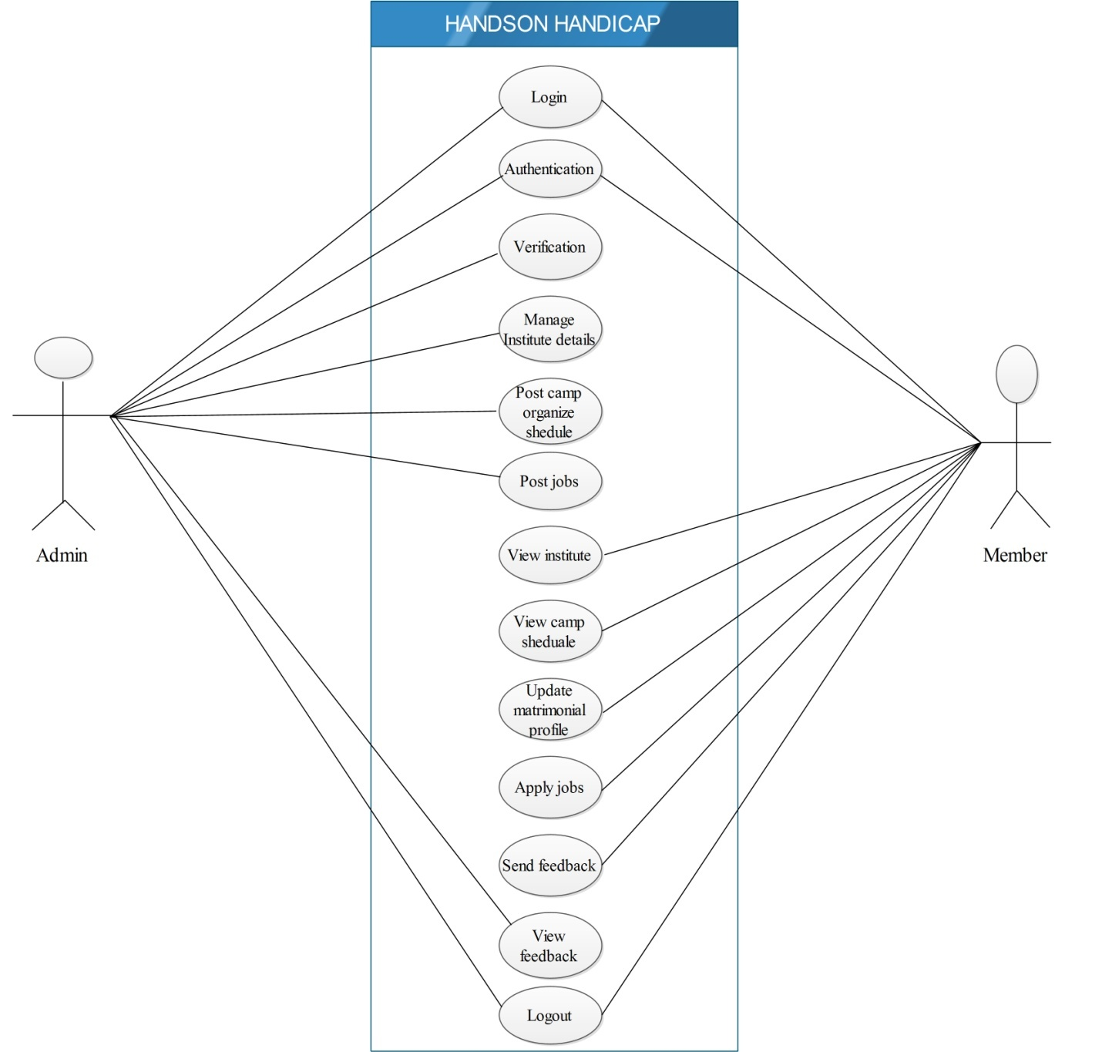

* **MEMBER-COMPANY**

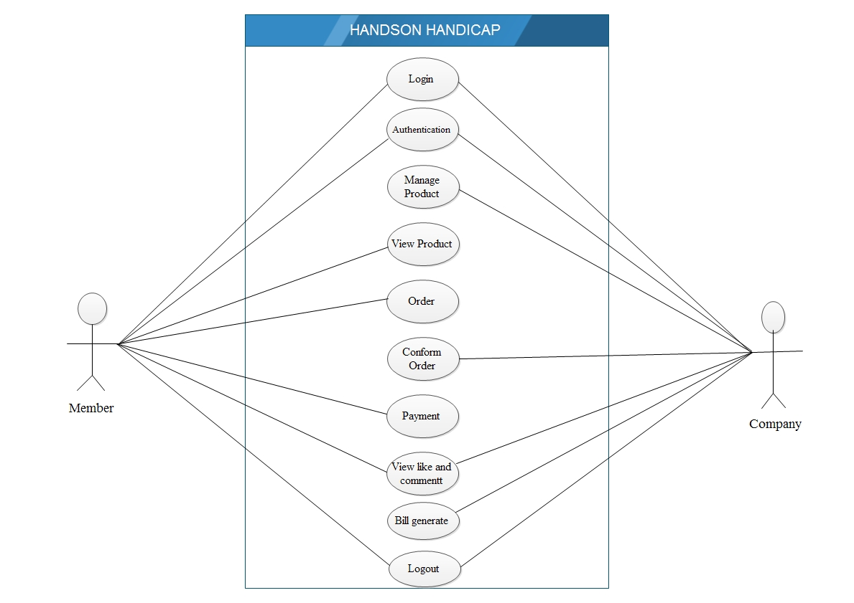

**4.3 Activity Daigram**

* **ADMIN**

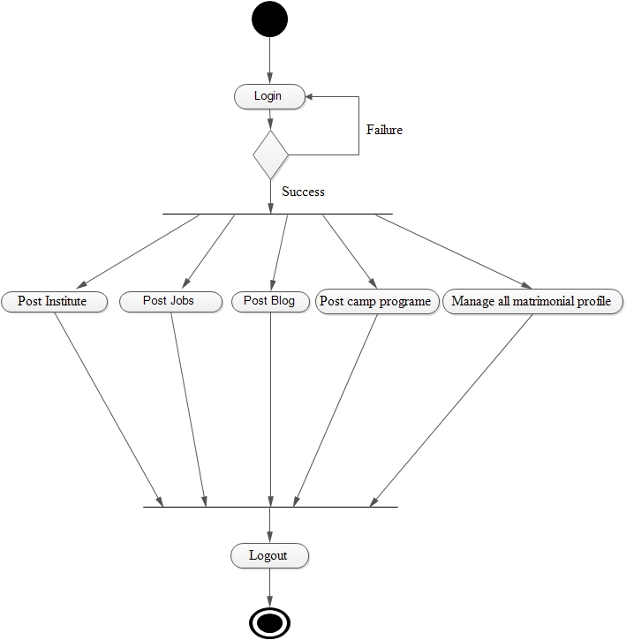

* **COMPANY**

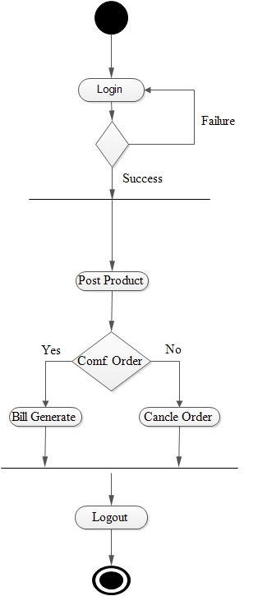

* **MEMBER**

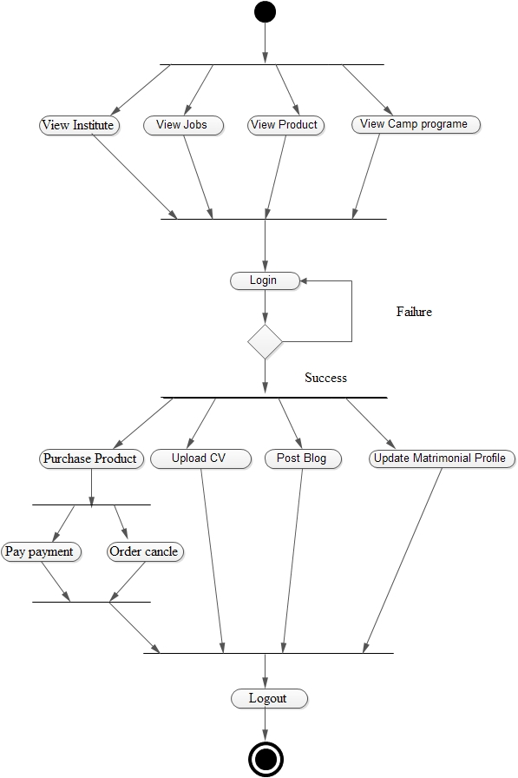

**4.4** **Sequence Diagram**

* **ADMIN**

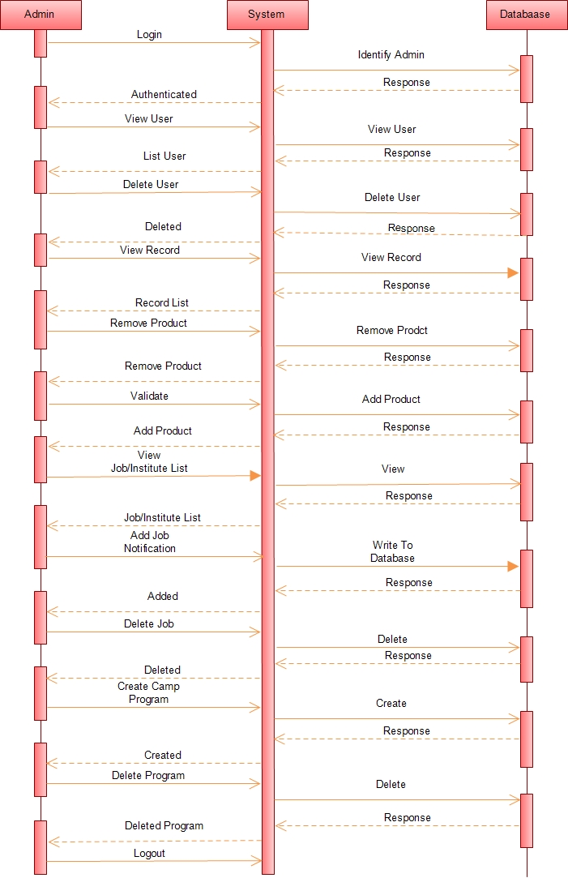

* **COMPANY**

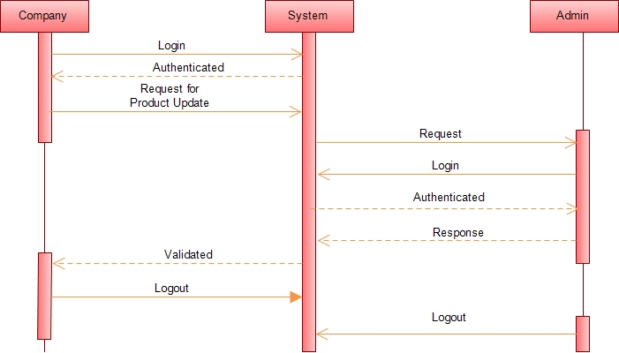

* **CUSTOMER-ADMIN**

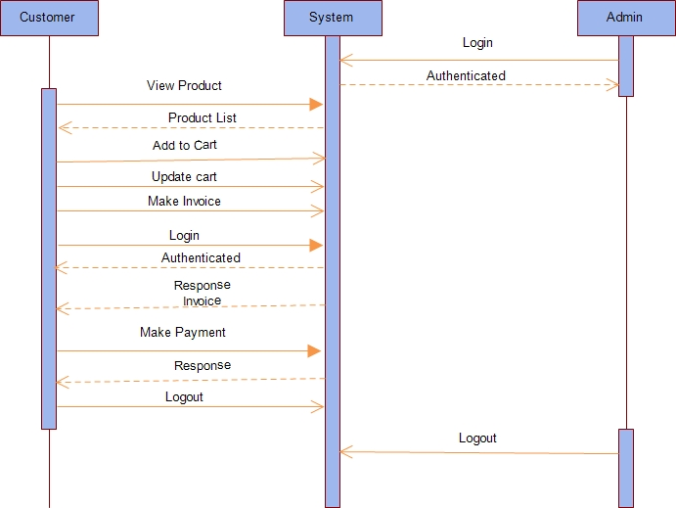

* **USER**

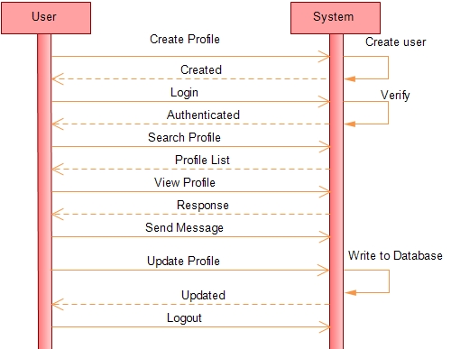

* **USER-JOB**

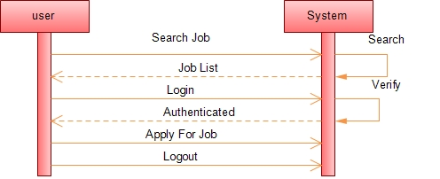

**5.1 Data Dictionary**

|  |  |  |  |  |
| --- | --- | --- | --- | --- |
| SR # : 01  TABLE : ADMIN  PRIMARY KEY : ADMIN_ID | | | | |
| FIELD | TYPE | SIZE | CONSTRAINTS | DESCRIPTION |
| ADMIN_ID | NUMBER | 5 | PRIMARY KEY (IDENTITY) | AUTO INCREMENT UNIQUE RECORD IDENTIFIER |
| ADMIN_PASS | VARCHAR2 | 40 | NOT NULL | PASSWORD |
| ADMIN_NAME | VARCHAR | 40 | NOT NULL | ADMIN NAME |
| ADMIN FIRS NAME | VARCHAR | 15 | NOTNULL |  |
| ADMIN LAST NAME | VARCHAR | 15 | NOTNULL |  |
| DOB | DATATIME |  | NOTNULL | BIRTHDATE |
| EMAIL_ID | VARCHAR2 | 15 | NOTNULL | EMAIL |
| CONTACT_NO | NUMBER | 10 | NOTNULL | NUMBER |

|  |  |  |  |  |
| --- | --- | --- | --- | --- |
| SR # : 02  TABLE : MEMBER  PRIMARY KEY : MEMBER_ID | | | | |
| FIELD | TYPE | SIZE | CONSTRAINTS | DESCRIPTION |
| MEMBER_ID | INT | 5 | PRIMARY KEY (IDENTITY) | AUTO INCREMENT UNIQUE RECORD IDENTIFIER |
| D_ID | INT | 5 | FOREIGN KEY | REFERENCE |
| MEMBER_NAME | VARCHAR | 40 | NOTNULL | MEMBER’S NAME |
| MEMBER_PASS | VARCHAR2 | 40 | NOTNULL |  |
| QUESTION | VARCHAR | 40 | NOTNULL | SECURITY QUESTION |
| ANSWER | VARCHAR2 | 20 | NOTNULL | ANSWER TO RECOVER |
| EMAIL | VARCHAR2 | 20 | NOTNULL | MEMBER’S EMAIL |
| CONTACT_NO | INT | 10 | NOTNULL |  |
| DATE_CREATED | DATETIME | 10 |  | DATE ON WHICH ACCOUNT CREATED |
| DATE_LAST_LOGIN | DATETIME | 10 |  |  |
| IS DELETED | BIT | 1 | NOTNULL |  |

|  |  |  |  |  |
| --- | --- | --- | --- | --- |
| SR # : 03  TABLE : DISABILITY  PRIMARY KEY : D_ID | | | | |
| FIELD | TYPE | SIZE | CONSTRAINTS | DESCRIPTION |
| D_ID | INT | 5 | PRIMARY KEY | DISABILITY ID |
| D_NAME | VARCHAR | 20 |  | DISABILITY NAME |

|  |  |  |  |  |
| --- | --- | --- | --- | --- |
| SR # : 04  TABLE : COMPANY  PRIMARY KEY : C_ID | | | | |
| FIELD | TYPE | SIZE | CONSTRAINTS | DESCRIPTION |
| C_ID | INT | 5 | PRIMARY KEY | IDENTIFY UNIQUE |
| C_NAME | VARCHAR | 40 | NOTNULL | COMPANYNAME |
| C_URL | VARCHAR2 | 25 | NOTNULL | COMPANY URL |
| C_LOGO | VARCHAR2 | 50 |  |  |
| C_EMAIL | VARCHAR2 | 15 | NOTNULL |  |
| CONTACT | INT | 10 | NOTNULL | NUMBER |

|  |  |  |  |  |
| --- | --- | --- | --- | --- |
| SR # : 05  TABLE : ORDER  PRIMARY KEY : O_ID | | | | |
| FIELD | TYPE | SIZE | CONSTRAINTS | DESCRIPTION |
| O_ID | INT | 5 | PRIMARY KEY | IDENTIFY UNIQUE |
| O_M_NAME | VARCHAR | 25 | NOTNULL |  |
| O_NOTE | VARCHAR | 25 |  |  |
| DATE OF ORDER | DATETIME | 10 | NOTNULL | DATE OF ORDER |
| DOD | DATETIME | 10 |  | DATE OF DISPATCH |

|  |  |  |  |  |
| --- | --- | --- | --- | --- |
| SR # : 06  TABLE : ORDER_DETAILE  PRIMARY KEY : OD_ID | | | | |
| FIELD | TYPE | SIZE | CONSTRAINTS | DESCRIPTION |
| OD_ID | INT | 5 | PRIMARY KEY | UNIQUE |
| O_ID | INT | 5 | FOREIGN KEY | REFRENCE |
| PS_ID | INT | 5 |  | PRODUCT STATUS ID |
| QUANTITY | VARCHAR | 10 | NOTNULL |  |
| OS_ID | INT | 5 | FOREIGN KEY | PENDING,CANCEL ETC. |

|  |  |  |  |  |
| --- | --- | --- | --- | --- |
| SR # : 07  TABLE : FREE PRODUCT  PRIMARY KEY : FP_ID | | | | |
| FIELD | TYPE | SIZE | CONSTRAINT | DESCRIPTION |
| FP_ID | INT | 5 | PRIMERY KEY | UNIQUE |
| PS_ID | INT | 5 | FOREIGN KEY | REFRENCE |
| MEMBER_ID | INT | 5 | FOREIGN KEY | REFRENCE |
| DOR | DATE TIME | 10 |  | DATE OF REQUEST |
| DOD | DATE TIME | 10 |  | DATE OF DISPATCH |

|  |  |  |  |  |
| --- | --- | --- | --- | --- |
| SR # : 08  TABLE : ORDER STATUS  PRIMARY KEY : OS_ID | | | | |
| FIELD | TYPE | SIZE | CONSTRAINT | DESCRIPTION |
| OS_ID | INT | 5 | PRIMERY KEY |  |
| OS_NAME | VARCHAR | 25 |  |  |
| D_ID | INT | 5 | FOREIGNKEY | REFRENCE |

|  |  |  |  |  |
| --- | --- | --- | --- | --- |
| SR # : 09  TABLE : INSTITUTES  PRIMARY KEY : IS_ID | | | | |
| FIELD | TYPE | SIZE | CONSTRAINT | DESCRIPTION |
| IS_ID | INT | 5 | PRIMERY KEY | UNIQUE |
| IS_NAME | VARCHAR | 30 | NOT NULL | NAME OF INSTITUTE |
| IS_URL | VARCHAR2 | 25 |  | INSTITUTE URL |
| IS_CONTACT | INT | 10 |  |  |
| IS_EMAIL | VARCHAR2 | 15 |  | NUMBER |

|  |  |  |  |  |
| --- | --- | --- | --- | --- |
| SR # : 10  TABLE : BLOG  PRIMARY KEY : B_ID | | | | |
| FIELD | TYPE | SIZE | CONSTRAINT | DESCRIPTION |
| B_ID | INT | 5 | PRIMARY KEY | UNIQUE |
| B_TITLE | VARHCAR | 20 |  | BLOG TITLE |
| B_DESC | VARCHAR2 | 50 |  | BLOG DESCRIPTON |
| DO_POST | DATE TIME | 10 |  | DATE OF POST |
| MEMBER_NAME | VARCHAR | 40 | NOT NULL |  |
| DR NAME | VARCHAR | 40 | NOTNULL | DOCTOR NAME |
| IS LIKE | BIT | 1 |  | POST LIKE |

|  |  |  |  |  |
| --- | --- | --- | --- | --- |
| SR # : 11  TABLE : BLOG ANSWER  PRIMARY KEY : BA_ID | | | | |
| FIELD | TYPE | SIZE | CONSTRAINT | DESCRIPTION |
| BA_ID | INT | 5 | PRIMARY KEY | UNIQUE |
| B_ID | INT | 5 | FOREIGN KEY | REFRENCE |
| ANSWEWR | VARHCAR2 | 50 |  |  |
| DOA | DATETIME | 10 |  | DATE OF ANSWER |
| MEMBER_NAME | VARCHAR | 40 |  |  |
| DOCTOR_NAME | VARCHAR | 40 |  |  |

|  |  |  |  |  |
| --- | --- | --- | --- | --- |
| SR # : 12  TABLE : JOBS  PRIMARY KEY : J_ID | | | | |
| FIELD | TYPE | SIZE | CONSTRAINT | DESCRIPTION |
| J_ID | INT | 5 | PRIMARY KEY | JOB ID UNIQUE |
| J_TITLE | VARCHAR | 20 | NO NULL | NAME OF POST |
| QUALIFICATION | VARCHAR2 | 30 | NO NULL |  |
| SALARY | INT | 5 |  |  |
| OTHER DETAIL | VARCHAR2 | 25 |  |  |
| CONTACT | INT | 10 | NOT NULL |  |
| CNAME | VARCHAR2 | 25 | NOT NULL |  |
| NOP | INT | 5 |  | NUMBER OF POST |
| AGE RANGE | VARHCAR2 | 6 | NO NULL |  |

|  |  |  |  |  |
| --- | --- | --- | --- | --- |
| SR # : 13  TABLE : JOB APPLY  PRIMARY KEY : JA_ID | | | | |
| FIELD | TYPE | SIZE | CONSTRAINT | DESCRIPTION |
| JA_ID | INT | 5 | PRIMARY KEY | JOB APPLY ID |
| J_ID | INT | 5 | FOREIGN KEY | REFRENCE |
| MEMBER_NAME | VARCHAR | 40 |  |  |
| DOA | DATETIME | 10 |  | DATE OF APPLY |
| CV | VARCHAR2 | 50 |  | RESUME |

|  |  |  |  |  |
| --- | --- | --- | --- | --- |
| SR # : 14  TABLE : JOB DETAIL  PRIMARY KEY : JD_ID | | | | |
| FIELD | TYPE | SIZE | CONSTRAINT | DESCRIPTION |
| JDID | INT | 5 | PRIMARY KEY | JOB DETAIL ID |
| J_ID | INT | 5 | FOREIGN KEY | REFRENCE |
| D_ID | INT | 5 | FOREIGN KEY | REFRENCE |

|  |  |  |  |  |
| --- | --- | --- | --- | --- |
| SR # : 15  TABLE : PRODUCT  PRIMARY KEY : P_ID | | | | |
| FIELD | TYPE | SIZE | CONSTRAINT | DESCRIPTION |
| P_ID | INT | 5 | PRIMERY KEY | PRODUCT ID |
| P_NAME | VARHCHAR | 20 | NOTNULL | PRODUCT NAME |
| P_DESC | VARHCHAR2 | 30 | NOTNULL | PRODUCT DESCRIPTION |
| UNIT_ID | INT | 5 | FOREIGN KEY |  |
| IS_AVAILABLE | BIT | 1 | NOT NULL | OUT OF STOCK |
| IS_DELETED | BIT | 1 | NOTNULL | RECORD DELETED OR NOT |
| IS_FEATURE | VARCHAR2 | 35 | NOTNULL | FEATURE OF PRODUCT |

|  |  |  |  |  |
| --- | --- | --- | --- | --- |
| SR # : 16  TABLE : PRODUCT INFO  PRIMARY KEY : IN_ID | | | | |
| FIELD | TYPE | SIZE | CONSTRAINT |  |
| IN_ID | INT | 5 | PRIMERY KEY | UNIQUE RECORD |
| P_ID | INT | 5 | FOREIGN KEY |  |
| DATE_ADDED | DATETIME | 10 | NOT NULL | DATE OF ADDED |
| QUANTITY | DECIMAL | 18,3 | NOT NULL |  |
| IS_DELETED | BIT | 1 | NOT NULL | RECORD DELETED |
| PURCHASE RATE | DECIMAL | 18,2 |  |  |
| SR # : 17  TABLE : UNIT  PRIMARY KEY : UNIT_ID | | | | |
| FIELD | TYPE | SIZE | CONSTRAINT | DESCRIPTION |
| UNIT_ID | INT | 5 | PRIMERY KEY |  |
| UNIT_NAME | VARCHAR | 25 | NOTNULL | NAMEOF UNIT |
| IS_DELETED | BIT | 1 | NOTNULL | RECORD DELETED |

|  |  |  |  |  |
| --- | --- | --- | --- | --- |
| SR # : 18  TABLE : PAYMENT  PRIMARY KEY : PAYMENT_ID | | | | |
| FIELD | TYPE | SIZE | CONSTRAINT | DESCRIPTION |
| PAYMENT_ID | INT | 5 | PRIMARY KEY | UNIQUE RECODE IDENIFIER |
| O_ID | INT | 5 | FOREIGN KEY |  |
| PAYDATE | DATETIME | 10 | NOTNULL |  |
| AMOUNT | INT | 10,2 | NOTNULL |  |
| PAY DESCRIPTION | VARCHAR2 | 50 | NOTNULL |  |

|  |  |  |  |  |
| --- | --- | --- | --- | --- |
| SR # : 19  TABLE : CAMP PROGRAM  PRIMARY KEY : CP_ID | | | | |
| FIELD | TYPE | SIZE | CONSTRAINT | DESCRIPTION |
| CP_ID | INT | 5 | PRIMERY KEY | UNIQUE RECORD IDENTIFIER |
| DOS | DATE TIME | 10 | NOTNULL | DATE OF START |
| DOE | DATETIME | 10 | NOTNULL | DATE OF END |
| ADDRESS | VARCHAR2 | 30 | NOTNULL | ADDRESS OF CAMP |
| CONTACT | INT | 10 | NOTNULL |  |
| CITY_ID | INT | 5 | FOREIGNKEY |  |

|  |  |  |  |  |
| --- | --- | --- | --- | --- |
| SR # : 20  TABLE : CITY  PRIMARY KEY : CITY_ID | | | | |
| FIELD | TYPE | SIZE | CONSTRAINT | DESCRIPTION |
| CITY_ID | INT | 5 | PRIMERYKEY | UNIQUE RECORD IDENTIFIER |
| CITY_NAME | VARCHAR | 20 | NOTNULL | NAME OF CITY |

|  |  |  |  |  |
| --- | --- | --- | --- | --- |
| SR # : 21  TABLE : DOCTOR  PRIMARY KEY : DR_ID | | | | |
| FIELD | TYPE | SIZE | CONSTRAINT | DESCRIPTION |
| DR_ID | INT | 5 | PRIMERY KEY | UNIQUE RECORD IDENTIFIER |
| DR_NAME | VARCHAR | 40 | NOTNULL | NAME OF DOCTOR |
| CONTACT | INT | 10 | NOTNULL |  |
| SPECIALIST | VARCHAR | 30 | NOTNULL |  |
| EMAIL | VARCHAR | 15 | NOTNULL |  |

**5.2 Entity Relationship Diagram**

