ShopNest Store Capstone Dashboard Report

Student Details
- Name: Sadhvi P
- Batch: 202602-1
- Institute: SkilloVilla

Introduction
The ShopNest Store Capstone project focuses on analyzing an e-commerce retail dataset using Power BI. The objective of this project is to perform data cleaning, data modeling, visualization, and business analytics to derive meaningful insights from the retail data.
The project consists of multiple datasets related to customers, orders, products, payments, reviews, sellers, and geolocation information. Using Power BI, interactive dashboards and reports were created to answer important business questions.

Datasets Used
- Customers Dataset
- Geolocation Dataset
- Order Items Dataset
- Order Payments Dataset
- Order Reviews Dataset
- Orders Dataset
- Products Dataset
- Sellers Dataset
- Product Category Dataset

Data Cleaning and Transformation
The following data cleaning operations were performed in Power BI Power Query Editor:
- Removed null and error values
- Corrected data types
- Converted date columns into Date/Time format
- Verified unique identifiers
- Created relationships between tables
- Created calculated columns and measures using DAX

- Relationships Framed:
Source Table | Target Table | Primary Join Key
Order Items dataset | orders_dataset | order_id
Order_Items_dataset | products_dataset | product_id
order_items_dataset | sellers_dataset | seller_id
orders_dataset | customers_dataset | customer_id
orders_dataset | order_payments_dataset | order_id
orders_dataset | order_reviews_dataset | order_id
products_dataset | product_category_name | product_category_name

Calculated Columns and Measures

Delivery Status
Used to classify orders as Delayed or On Time.

Month Year
Used for monthly trend analysis.

Quarter
Used for quarterly seasonal analysis.

Year
Used for yearly revenue analysis.

Total Sales
Calculated using the price column from order items dataset.

Average Rating
Calculated using review scores from order reviews dataset.

Question 1: Top Categories by Total Price
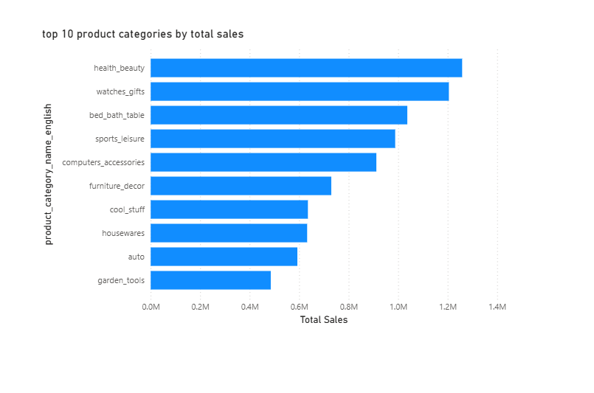

Question Statement
Identify and visually represent the top 10 product categories by total sales.

Visualization Used
Clustered Bar Chart

Explanation
This visualization highlights the top-performing product categories based on total sales revenue. The chart helps identify which categories contribute the most to overall business revenue. Categories with longer bars indicate higher sales performance.

Question 2: Delayed Order Analysis
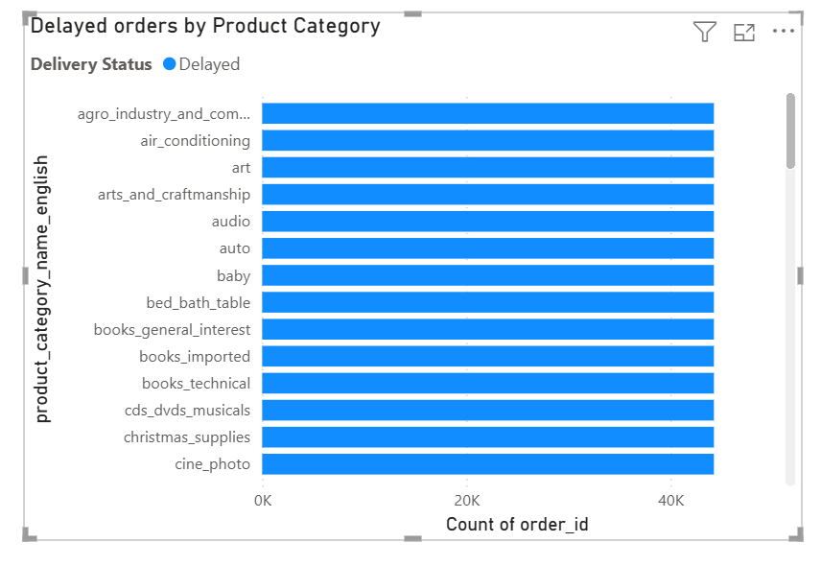

Question Statement
Determine the number of delayed orders in each category.

Visualization Used
Stacked Bar Chart

Explanation
This visual compares delayed and on-time deliveries across product categories. Orders were classified as delayed when the actual delivery date exceeded the estimated delivery date. The analysis helps identify categories facing logistics or delivery issues.

Question 3: Monthly Comparison of Delayed and On-Time Orders
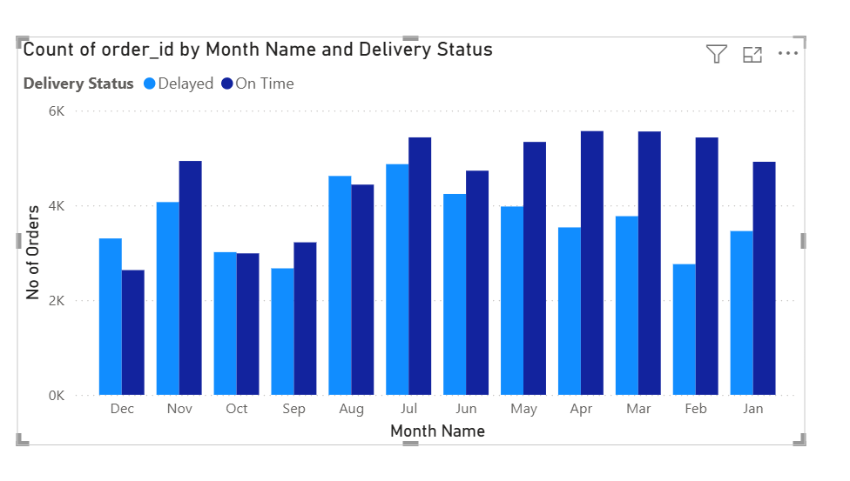

Question Statement
Create a dynamic visual comparing delayed and on-time orders for each month and implement drill-through analysis.

Visualization Used
Line and Clustered Column Chart with Drill-through Feature

Explanation
This visualization compares delayed and on-time orders month-wise, helping identify delivery trends over time. A drill-through page was implemented to provide detailed delivery information for selected categories and statuses. This improves analytical depth and interactivity.

Question 4: Payment Method Analysis
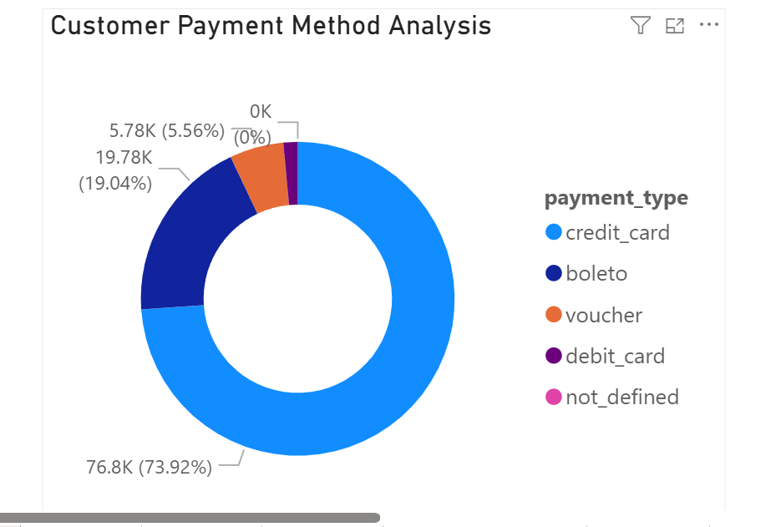

Question Statement
Analyze the most frequently used payment methods by customers.

Visualization Used
Donut Chart

Explanation
This chart represents the proportion of different payment methods used by customers. It helps understand customer payment preferences and highlights the dominant payment mode used in transactions.

Question 5: Product Rating Analysis
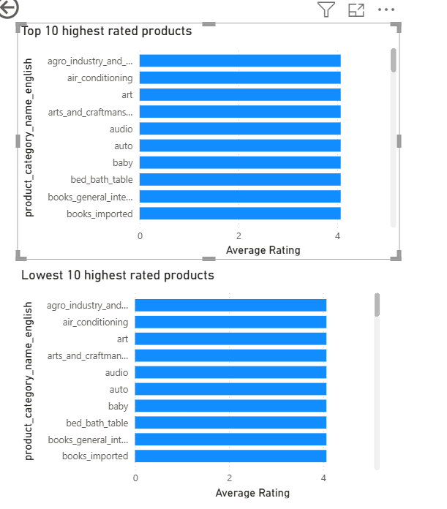

Question Statement
Determine the top 10 highest rated and bottom 10 lowest rated products/categories.

Visualization Used
Clustered Bar Charts

Explanation
Two separate visualizations were created to analyze highly rated and poorly rated product categories. This helps identify customer satisfaction trends and categories that may require improvement.

Question 6: State-wise Sales Analysis
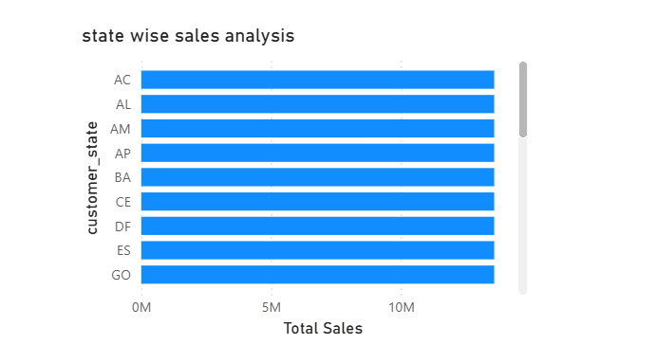

Question Statement
Identify and visually represent states with high and low sales.

Visualization Used
Clustered Bar Chart / Map Visualization

Explanation
This visualization compares sales performance across different states. It helps identify regions generating maximum revenue and regions with lower sales performance.

Question 7: Seasonal Sales Patterns
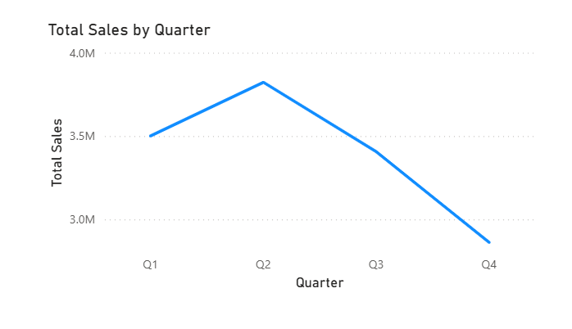

Question Statement
Investigate quarterly seasonal patterns or trends in sales data.

Visualization Used
Line Chart

Explanation
Quarterly sales trends were analyzed to identify seasonal patterns in customer purchases. The visualization helps understand periods of peak and low sales activity.

Question 8: Revenue Analysis
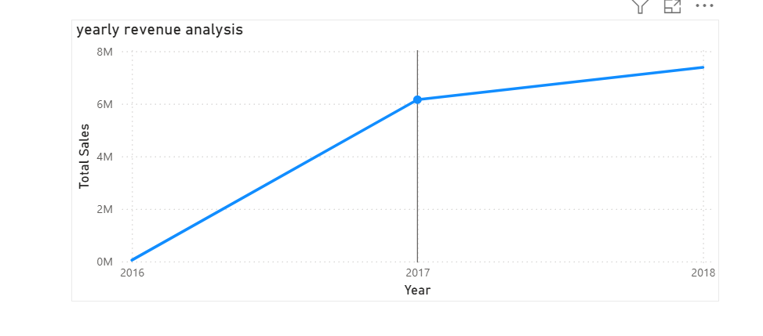

Question Statement
Determine the total revenue generated by the ShopNest store and analyze yearly trends.

Visualization Used
Area Chart / Line Chart

Explanation
This visualization shows yearly revenue growth trends for the ShopNest store. It helps evaluate overall business performance and revenue changes over time.

Dashboard Features
The dashboard includes the following interactive features:
- Drill-through functionality
- Interactive charts and visuals
- Dynamic filtering and analysis

Conclusion
The ShopNest Store Dashboard successfully provides insights into sales performance, customer behavior, delivery efficiency, payment trends, product ratings, and regional sales analysis. The project demonstrates the use of Power BI for end-to-end business intelligence and data visualization.
The dashboard enables better decision-making through interactive analytics and comprehensive reporting.

