K.Sri Manikanta Sadhwik

Tourism Data Analysis Report

# Dataset Description

## Source:

The dataset used for this project is Tourism_data.csv containing 8,489 records and 5 columns. It captures monthly visitor counts across districts, months, years, and seasons.

## Columns:

* + - District
    - Month
    - Visitors
    - Year
    - Season

## Data Quality:

* + - The dataset is clean and contains no missing values.
    - The 'Visitors' column is numeric and represents monthly visitor counts.
    - The structure supports trend analysis across time, regions, and seasons.

# Operations Performed

## Data Loading and Inspection

* + - Loaded the dataset into a pandas DataFrame and verified schema.
    - Checked for missing values and confirmed numeric conversion for 'Visitors'.
    - Computed summary statistics for visitor counts.

## Aggregations and Visualizations

* + - Grouped data by District and Season to identify top-performing regions.
    - Generated charts (line and bar) to visualize trends.
    - Applied aggregations and sorting to extract top districts and months.

# Key Insights

## Overall Visitor Volume

* + - Total visitors recorded: 715,410,282
    - Average visitors per observation: 84,275.0
    - Min: 0, Max: 9,761,776

## Top Districts

* + - Mulugu (77,297,381)
    - Hyderabad, Ranga Reddy, Medchal & Vikarabad (61,325,331)
    - Yadadri Bhongir (49,289,828)
    - Rajanna Sircilla (44,543,745)
    - Hyderabad (43,239,548)

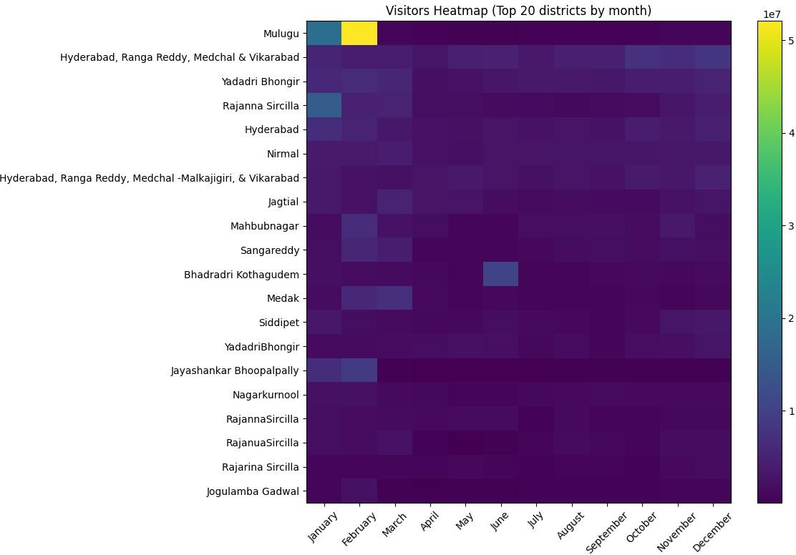

## Seasonal Patterns

* + - Summer: 196,004,551
    - Autumn: 174,939,935
    - Winter: 172,453,632
    - Monsoon: 172,012,162

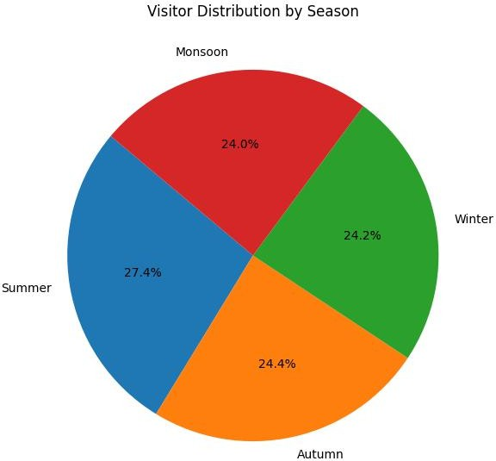

## Monthly Trends

* + - Top 5 months (by avg visitors): February, January, March, December, November

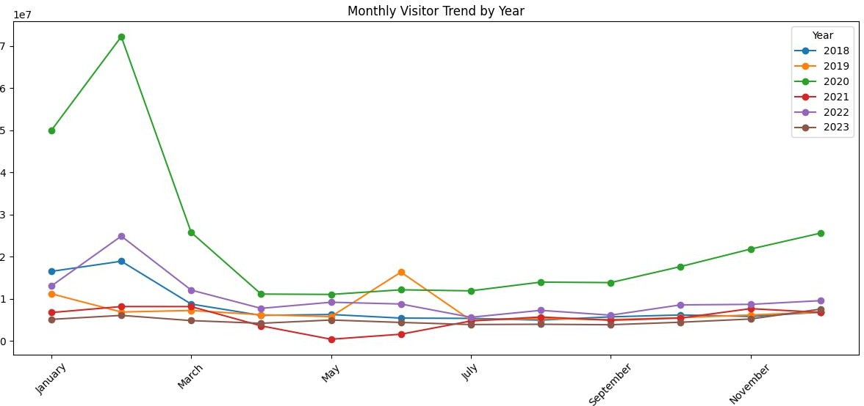

## Year Coverage

* + - Dataset spans years 2018 - Winter, supporting seasonal and year-over-year comparisons.

# Recommendations

## District-Level Focus

* + - Target marketing for top-performing districts.
    - Invest in infrastructure in high-traffic areas.

## Seasonal Readiness

* + - Allocate staff and resources ahead of peak seasons.

## Monthly Promotions

* + - Promote during low-average months to balance demand.

## Data Monitoring

* + - Establish dashboards for real-time district-level monitoring.

## Predictive Modelling

* + - Use time series or regression models for visitor forecasting.

# Future Analytics Opportunities

* Develop time-series forecasting models.
* Cluster districts by visitation patterns.
* Combine external data (weather, events, transport) to explain anomalies.

# Conclusion

* The analysis highlights clear links between season, district, and visitor volumes. Clean, structured data enables reliable aggregation and visualization. Next steps include dashboard creation and predictive modeling to drive data-informed tourism planning.