

Project: Development of a Multi-Campus Subnet-Based University Network Architecture

Course Title: Data Communication
Course Code: CSE350
Section: 1

Submitted by:
Student name: Sadia Morshed Mouri
Semester: Spring 2026

Submitted to:
Senior Lecturer,
Department of Computer Science & Engineering,

Submission Date: 2-5-2026

- Introduction:
Computer networks play an important role in academic, administrative, and communication operations at modern universities. Avalon University, like many other big universities, contains numerous campuses, each with classrooms, laboratories, offices, and service systems such as admissions, library management, and financial operations. These systems require a reliable and efficient network to allow seamless data sharing and communication.

The primary issue addressed in this research is how to construct a network that can successfully connect many campuses while maintaining consistent communication between all devices. Because each campus has its own local network, it is necessary to combine these networks into a unified system utilizing suitable IP addressing, subnetting, and routing procedures. The problem is to ensure that all hosts on various campuses can communicate with each other uninterrupted.

- Design and Experimental Results:
  - Design:
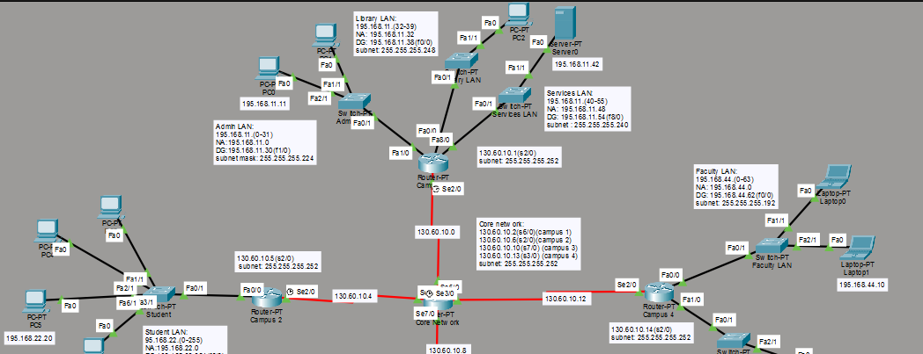
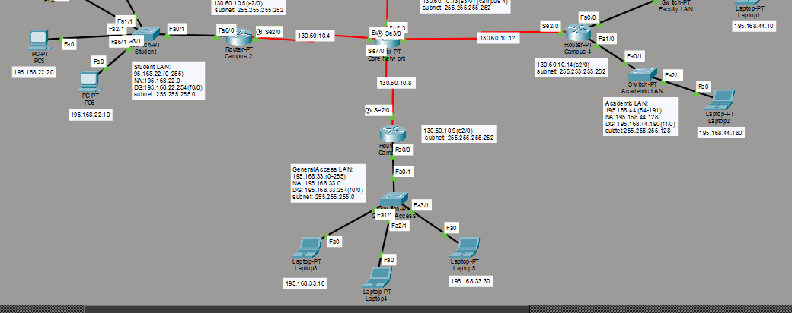
Fig 1. Design of the topology

Core Network (The Hub):
At the center of the design is the Core Network router and its role is to control congestions in the network. The router uses dedicated channels connected to Campus 1 router and similar connections to the remaining Campus routers.
The IP Address used for this core network was class B-130.60.x.x and this was divided between core-campus 1, core-campus 2, core-campus 3 and core-campus 4 using /30 mask.

Campus 1 Router:
At the top of the design, this router uses class C IP Address 195.168.11.x and it is divided into 3 blocks consisting of Academic LAN, Library LAN and Services LAN. Academic LAN-used the IP addresses 195.168.11.0/27 to 195.168.11.31/27, where 195.168.11.30 is the default gateway and 195.168.11.0 is the network address. Library LAN-uses 195.168.11.32/29 to 195.168.11.39/29, where default gateway is 195.168.11.38 and network address is 195.168.11.32. Services LAN-uses the IP Addresses 195.168.11.40/28 to 195.168.11.55/28, where default gateway is 195.168.11.54 and network address is 195.168.11.48. The router connects to the hub using the network address 130.60.10.0 via 130.60.10.1.

Campus 2 Router:
At the leftmost of the design, this router uses class C IP Address 195.168.22.x and it is only reserved for students only. It uses the IP Addresses 195.168.22.0/24 to 195.168.22.255/24, where default gateway is 195.168.22.254 and the network address is 195.168.22.0. The router connects to the hub using the network address 130.60.10.4 via 130.60.10.5.

Campus 3 Router:
At the bottom of the design, this router uses class C IP Address 195.168.33.x and it contains the General Access LAN, which is reserved for general uses for any departmental or non-departmental works. It uses the IP Addresses 195.168.33.0/24 to 195.168.33.255/24, where default gateway is 195.168.33.254 and the network address is 195.168.33.0. The router connects to the hub using the network address 130.60.10.8 via 130.60.10.9.

Campus 4 Router:
At the rightmost of the design, this router uses class C IP Address 195.168.44.x and it is divided into 2 blocks consisting of Faculty LAN and Academic LAN. Faculty LAN -used the IP addresses 195.168.44.0/26 to 195.168.44.63/26, where 195.168.44.62 is the default gateway and 195.168.44.0 is the network address. Academic LAN -uses the IP Addresses 195.168.44.64/25 to 195.168.44.191/25, where default gateway is 195.168.44.190 and network address is 195.168.44.128. The router connects to the hub using the network address 130.60.10.12 via 130.60.10.14.

  - Static Routing Protocols: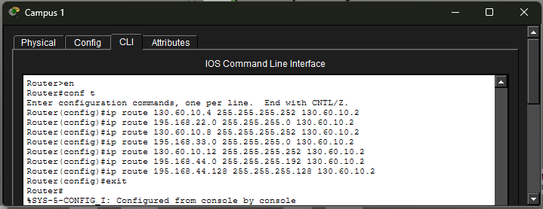Fig 2. Static Routing of Campus 1

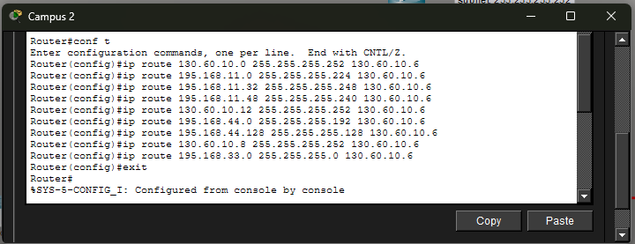
Fig 3. Static Routing of Campus 2

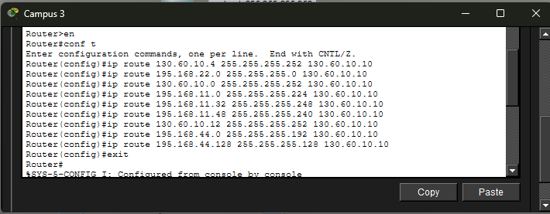
Fig 4. Static Routing of Campus 3

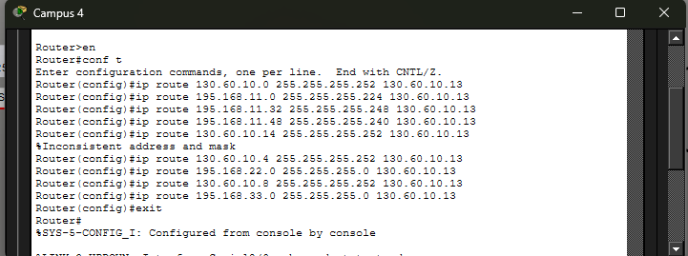
Fig 5. Static Routing of Campus 4

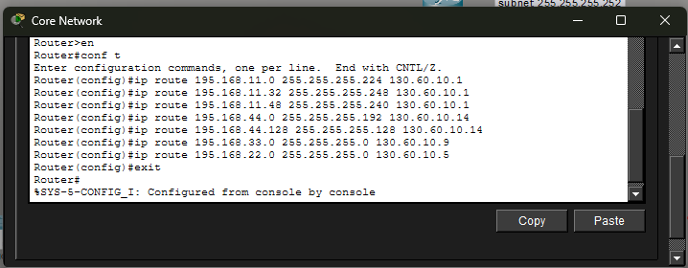
Fig 6. Static Routing of Core Network(The Hub)

The table below shows the networks, their subnet mask, next-hop and the targeted area of Core Network (The Hub)
Destination Network | Subnet Mask | Next-hop | Target Area
195.168.11.0 | 255.255.255.224 | 130.60.10.1 | Campus 1 (Admin)
195.168.11.32 | 255.255.255.248 | 130.60.10.1 | Campus 1 (Library)
195.168.11.48 | 255.255.255.240 | 130.60.10.1 | Campus 1 (Services)
195.168.44.0 | 255.255.255.192 | 130.60.10.14 | Campus 4 (Faculty)
195.168.44.128 | 255.255.255.128 | 130.60.10.14 | Campus 4 (Academic)
195.168.33.0 | 255.255.255.0 | 130.60.10.9 | Campus 3 (General)
195.168.22.0 | 255.255.255.0 | 130.60.10.5 | Campus 2 (Student)

Static routing in this architecture is implemented utilizing a Hub-and-Spoke arrangement, with the Core router serving as the central traffic management and the campus routers serving as stubs. Static routes are defined on each Campus Router (Fig 2,3,4,5), directing any traffic destined for a separate network to the Core Router's serial interface. Because these campuses only have one physical departure point, they rely on a single next-hop IP address to connect to the rest of the infrastructure, allowing local users to access centralized resources or other campuses with ease.

The Core Router (Fig 6) is responsible for traffic control as it is responsible for enabling the exchange of data between the LANs. It is manually configured using static routes for each of the four campuses' unique subnets. This means that the Core router "knows" that packets for the Admin LAN must be routed through one serial interface and packets for the Faculty or Student LANs through another. By explicitly defining these paths in the routing table, the network avoids the expense of dynamic protocols while keeping tight control over how data flows via the serial WAN links.

  - IP configurations:
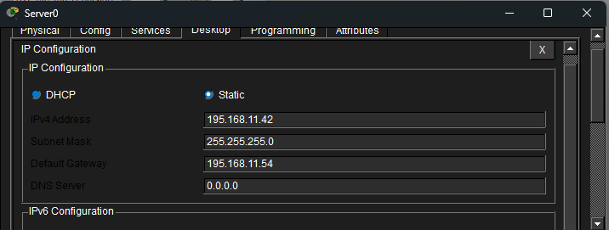
Fig 7. Server0 of Campus 1(Service LAN)

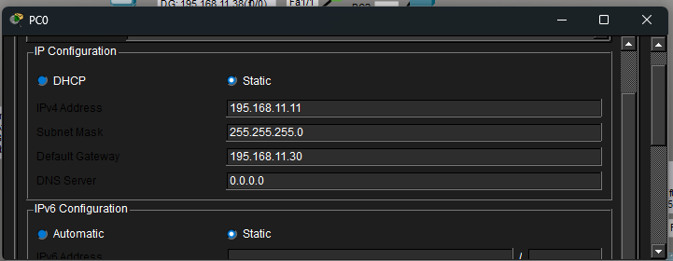
Fig 8. PC0 of Campus 1(Admin LAN)

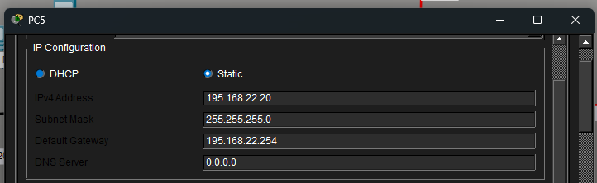
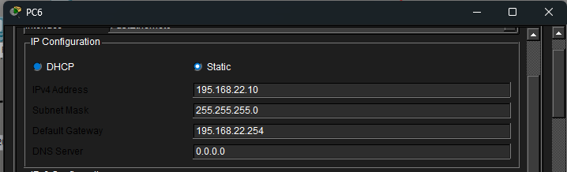
Fig 9. PC5 and PC6 of Campus 2(Student LAN)

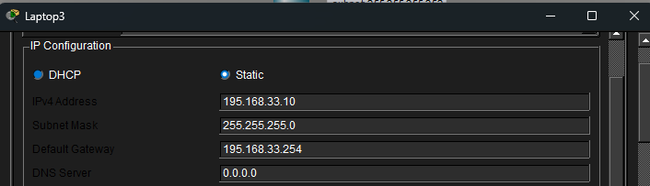
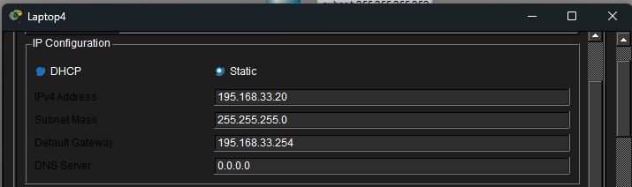
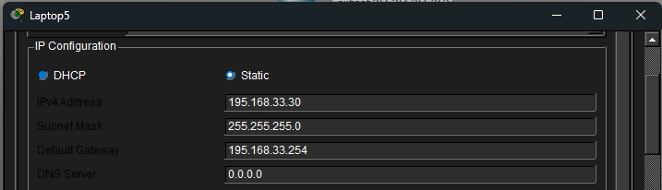
Fig 10. Laptop3, Laptop4 and Laptop5 of Campus 3(General Access LAN)

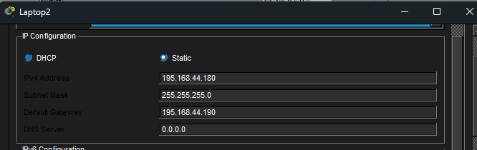
Fig 11. Laptop2 of Campus 4(Academic LAN)

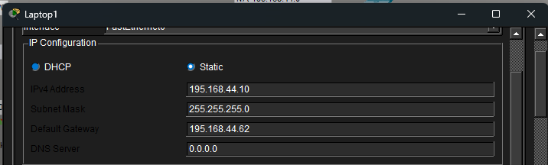
Fig 12. Laptop1 of Campus 4(Academic LAN)
From the figures above showing the IP configuration of each device explains the following:
- 1) An IP address is a device's unique identity (e.g., 195.168.11.11) that ensures data reaches the intended host. It is necessary for end-to-end communication across the network's multiple subnets.
- 2) The subnet mask (e.g., 255.255.255.0) determines the size of the local network. It enables a device to determine whether a destination is within its own "neighborhood" or if the traffic must be routed through a router to reach another school.
- The default gateway is the local router's IP address that serves as the subnet's exit point. When a device attempts to reach an IP address outside of its local range, it sends the data to this gateway, which routes it to the main network.

  - Successful ping (between 3 LANs) using command prompt:
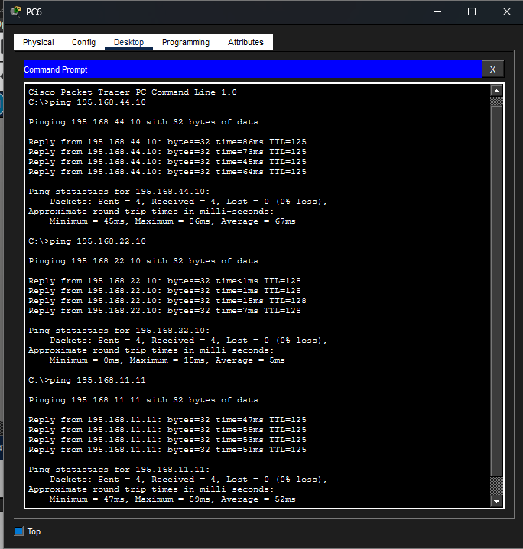
Fig 12. Ping of PC6(Campus 2-Student Lan) to other LANs

Ping to Campus 4 (faculty/academic LAN).
The ping from PC6 to 195.168.44.10 takes an average of 67 milliseconds and has no packet losses. This success demonstrates that the Campus 2 router correctly delivered the request to the Core Network via its static route, and that the Core Network successfully passed the data on to Campus 4 via its particular static route for the 195.168.44.0 network. The greater latency observed here is common for traffic passing across several serial interfaces and traversing the topology's hierarchical tiers to reach the farthest spoke.
Ping to Campus 2 (local student LAN).
The ping to 195.168.22.10 reflects communication within the same functional region, resulting in a substantially lower average latency of just 5ms. Because both the source and destination are in the 195.168.22.0/24 subnet, the traffic was most likely handled at the local switch level or by the Campus 2 router's interface, eliminating the need to use the serial WAN lines to reach the Core. This result demonstrates that the local area network (LAN) is effectively segmented and that high-speed switching works as expected for internal campus traffic.
Ping to Campus 1 (Admin/Services LAN).
The final ping to 195.168.11.11 indicates successful connectivity to the Administrative segment, with an average response time of 52ms. In order for the reply to reach PC6, the Campus 1 router had to utilize its default route to reach the Core, and the Core had to use its special static route (195.168.22.0) to deliver the data back to Campus 2. This procedure confirms the network's complete "return path" logic. This consistent 0% loss across subnets demonstrates that the variable length subnet masking (VLSM) and static routing tables are synchronized across the whole system.

- Conclusion:
In conclusion, this network design effectively uses a star topology to connect four separate campus environments(routers) via a single core(the hub). The IP configuration on each end-device establishes the essential identification and logical boundaries for communication, while Variable Length Subnet Masking (VLSM) guarantees that IP addresses are allocated efficiently depending on each department's individual requirements. Static Routing allows the network to achieve predictable and controlled traffic flow; the campus routers employ default routes to reach the core, while the core router keeps specific entries to precisely return data to each distinct LAN. The successful ping operations confirm that the logical layers are completely synced. This 0% packet loss across several subnets demonstrates that the infrastructure is reliable, fully accessible, and capable of facilitating seamless data interchange between the administrative, academic, and student segments.

