

Project: Design & Implementation of a Multi-Service Network for GreenTech Solutions Ltd. Using RIP, NAT, DNS, DHCP & Email Server

Course Title: Computer Networks
Course Code: CSE405
Section: 12

Submitted by:
Student name: Sadia Morshed Mouri
Semester: Spring 2026

Submission Date: 2-5-2026

- Introduction:
GreenTech Solutions Ltd. plans to establish a two-building campus for its software development operations. The Network Engineer's role is to design and configure the company's internal IT network.
The network must provide a number of critical services consisting of DHCP, DNS, Email Server, RIP version 2 routing, and NAT, all while maintaining successful connectivity between the two buildings. The goal is to set up a reliable and efficient network structure that satisfies the company's operating requirements
.
- Objectives:
The objectives of the projects are as following:
- IP address designing using 192.168.0.0/22 with VLSM
- Configure RIP version 2 protocol routing between the 2 buildings, followed by setting up a central server consisting of DHCP, DNS and EMAIL.
- Configure NAT on building A (router 1) using the public IP address 100.10.50.2
- Testing and verifying the configurations

- Network Overview:
The topology consists of 2 buildings: Building A (Head Office) and Building B (Development Center). Building A consists of the LANs: HR Department, IT Department and Server Room (DHCP, DNS, Email) and Building B consists of the LANs: Development Department and Testing Development.

- IP Addressing using VLSM:
Block | No. of allocated IPs | Subnet Mask | Allocated IP range
Development  (100 Hosts) | 2⁷=128 | 255.255.255.128 | 192.168.0.0/25 to  192.168.0.127/25
Testing  (50 hosts) | 2⁶=64 | 255.255.255.192 | 192.168.0.128/26 to  192.168.0.191/26
IT  (30 hosts) | 2⁵=32 | 255.255.255.224 | 192.168.0.192/27 to  192.168.0.223/27
HR  (20 hosts) | 2⁵=32 | 255.255.255.224 | 192.168.0.224/27 to  192.168.0.255/27
Servers  (8 hosts) | 2³=8 | 255.255.255.248 | 192.168.1.0/29 to  192.168.1.7/29
Building A(Router1) to Building B(Router2)  (4 hosts) | 2²=4 | 255.255.255.252 | 192.168.1.8/30 to  192.168.1.11/30
Table 1. Showing VLSM table

- Network Topology:
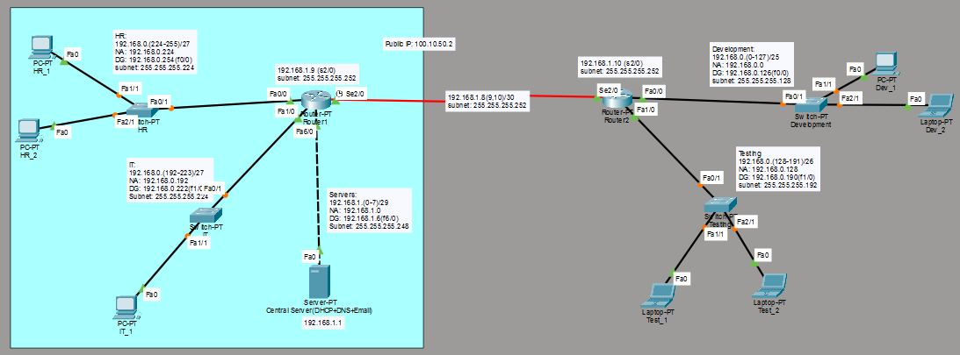
Fig1. Design
Rouer1(Building A):
This router consists of 3 LANs (HR, IT and Server Room). HR LAN uses the IP range: 192.168.0.224/27 to 192.168.0.255/27, which uses the network address is 192.168.0.224 and the default gateway is 192.168.0.254(interface Fa0/0). IT LAN uses the IP range: 192.168.0.192/27 to 192.168.0.223/27, which uses the network address is 192.168.0.192 and the default gateway is 192.168.0.222 (interface Fa1/0). Server Room uses the IP range: 192.168.1.0/29 to 192.168.1.7/29, which uses the network address is 192.168.1.0 and the default gateway is 192.168.1.6 (interface Fa6/0). The router connects to Router2 (Building B) using the IP address 192.168.1.9(Se2/0). After implementing NAT configuration, Router1 connects to Router2 using the public IP-100.10.50.2.

Rouer2(Building B):
This router consists of 2 LANs (Development and Testing). Development LAN uses the IP range: 192.168.0.0/25 to 192.168.0.127/25, which uses the network address 192.168.0.0 and default gateway is 192.168.0.126(Fa0/0). Testing LAN uses the IP range: 192.168.0.128/26 to 192.168.0.191/26, which uses the network address 192.168.0.128 and default gateway is 192.168.0.190 (Fa1/0). The router connects to Router1 (Building A) using the IP address 192.168.1.10(Se2/0).

- Configurations and Test:
  - RIP version Configuration
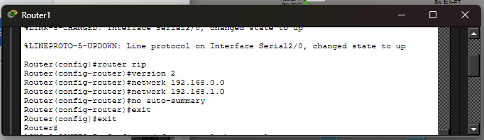
Fig2. RIP routing of Router1

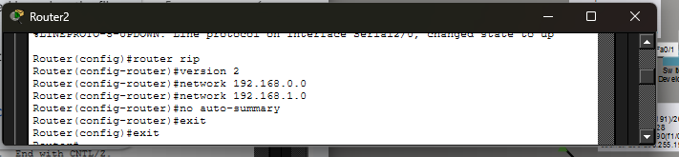
Fig3. RIP routing of Router2

Fig2 and Fig3 shows the command line setting of RIP version 2 on Router1 and Router2. The “router rip” command starts the routing protocol and version 2 enables classless routing. The network 192.168.0.0 and 192.168.1.0 are available with the network command that enables both routers to communicate routing information. The no auto-summary command is used to avoid classful summarization, resulting in accurate route propagation across subnets. These arrangements allow for dynamic routing and smooth communication between the two buildings.

  - DHCP Configuration:
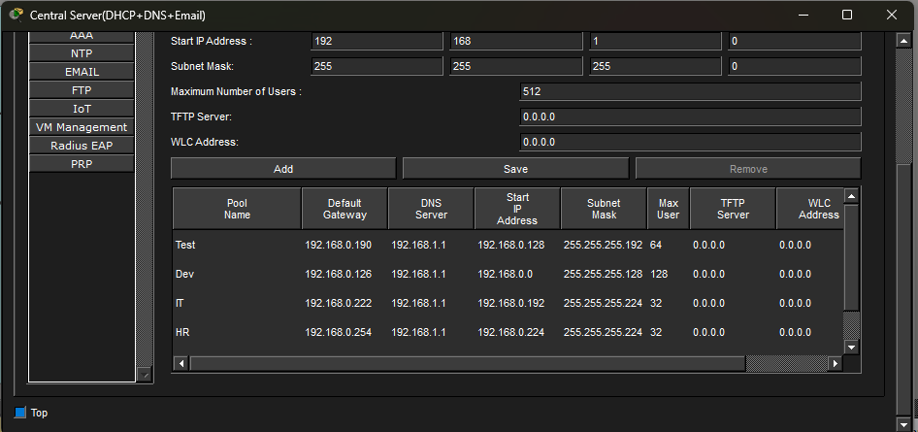
Fig4. DHCP Configuration

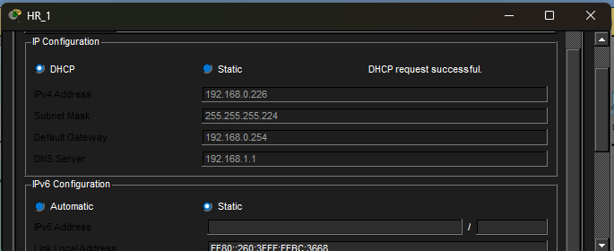
Fig5. Successful DHCP IP requestion of HR_1(HR LAN)

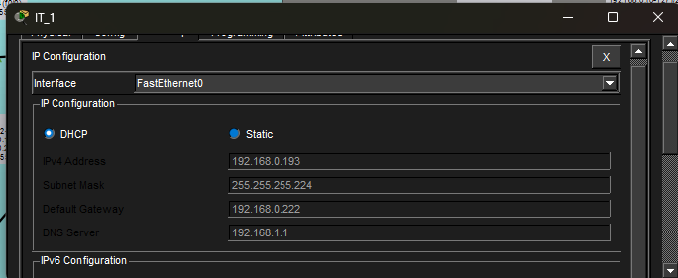
Fig6. Successful DHCP IP requestion of IT_1(IT LAN)

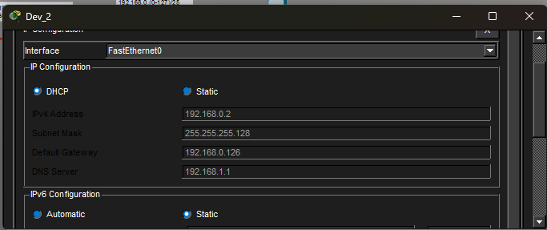
Fig7. Successful DHCP IP requestion of DEV_2(Development LAN)

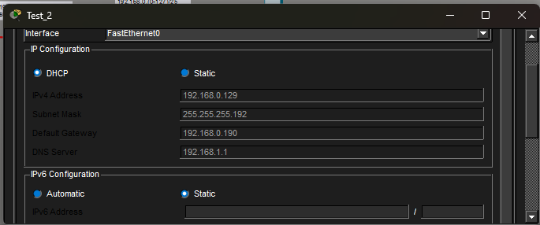
Fig8. Successful DHCP IP requestion of Test_2(Testing LAN)

Figures 5,6,7 and 8 shows Testing LAN device that was successfully allocated an IP address, showing that the DHCP service works across all the networks.

  - DNS Configuration
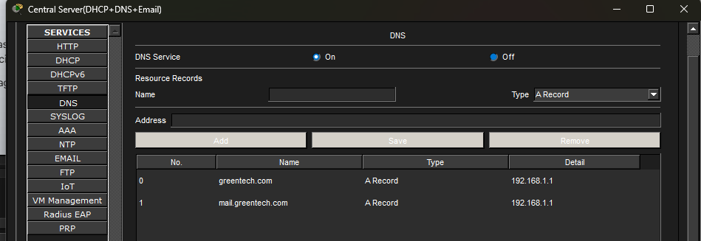
Fig9. DNS Configuration(Internal domain resolution setup)

Figure 9 depicts the configuration of an internal DNS server used for domain name resolution within the network. The DNS service is activated, and resource records are generated to map domain names like greentech.com and mail.greentech.com to their respective IP addresses. This enables users to access network services via human-readable domain names rather than numerical IP addresses, hence increasing usability and network efficiency.

  - Email Server Configuration
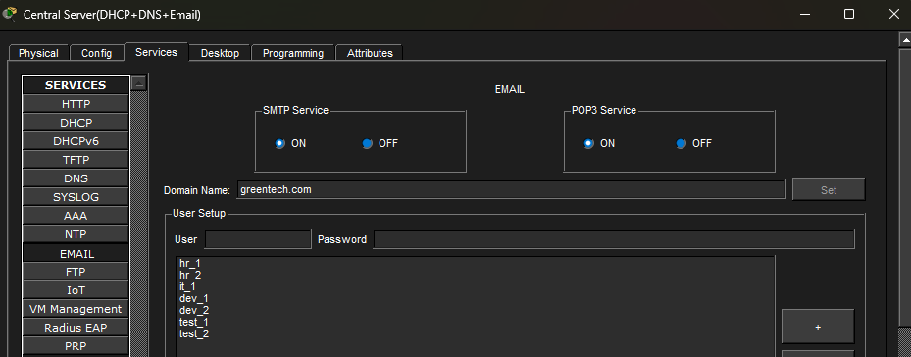
Fig10. Adding Users from different departments in email services using DNS Server(greentech.com)

Fig10 depicts the central server's email service configuration interface with SMTP and POP3 services enabled. It also shows the creation of many user accounts for various departments using the domain greentech.com, each with its own username and password.

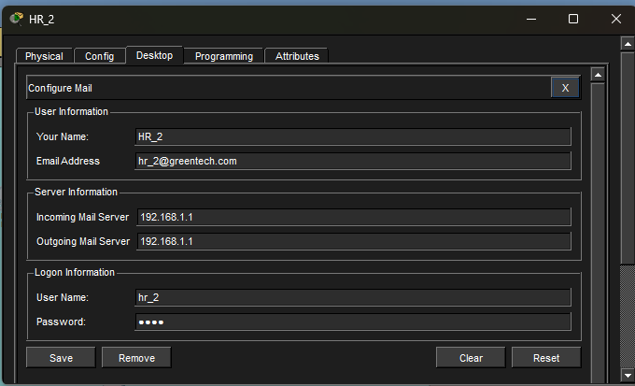
Fig11. Adding User information of HR_2 with user hr_2 and password: 1235 (HR LAN)

Fig11 presents the email configuration on a client PC (HR_2). It shows how the user enters their email address, incoming and outgoing mail server IP address, along with login credentials (username and password) to access the email service.

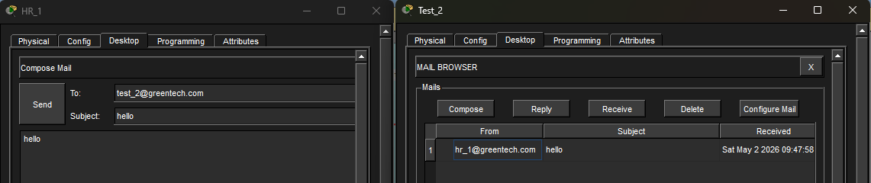
Fig12. Successful email configurations’ communication between HR_1 and Test_2

Fig12 below shows the successful communications between users based on the configurations done using Fig10 and Fig11.

  - NAT Configuration:
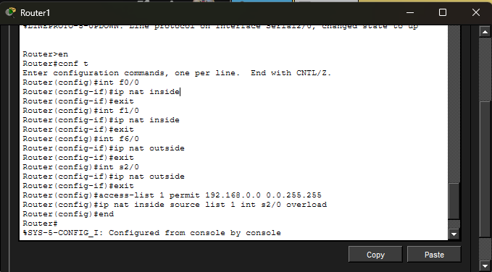
Fig13. NAT configuration on Router1(Building A)

Fig13 displays the CLI commands required to configure NAT on Router1. It entails assigning IP NAT inside to internal LAN interfaces and IP NAT outside to the external (WAN) interface. An access control list (ACL) is constructed to specify the private IP range to be translated. Finally, the ip nat inside source list 1 interface serial2/0 overload command activates PAT, which allows numerous internal devices to connect to external networks via a single public IP address.

- Conclusion
While doing the project, I faced some issues with DHCP not working across Router1 and Router2 and it was fixed using helper address (int Fa6/0, ip helper-address 192.168.11). Furthermore, I also faced more issue with RIP routing and NAT configurations. The problems mentioned were solved by doing the configurations again.

The project successfully illustrated how to construct and design a multi-service network with using VLSM, RIP version 2, DHCP, DNS, Email and NAT. It facilitates effective communication between departments and buildings while also providing necessary services.

