MediCare Clinic Appointment Book
Programming II Summative Capstone Project Report
Institution | African Leadership College of Higher Education (ALCHE), Mauritius
Authors | Hanif Olayiwola (230102) & Halimatu Sadia Mohammed (230103)
Target Tech Stack | Pure Java 21, JavaFX 21, SQLite 3 (JDBC Driver), JUnit 5, Apache Maven
Submission Date | Saturday 19 September 2026

Section 1 · Problem Overview & What We Built
——————————————————————————————————————————————————————————
MediCare Clinic is a desktop application built for campus health centers (specifically modeled on our ALCHE Mauritius campus). In a busy campus clinic, receptionists and triage nurses need to quickly register students, book appointments with attending physicians, prevent scheduling double-bookings, and track multi-visit treatment plans without confusing paperwork.
We designed the system with three core goals:
1. Zero Confusion: The user interface is clean and readable. When a receptionist makes an error (like booking outside clinic hours or double-booking a doctor), the system shows a clear inline explanation right on the screen rather than crashing or popping up annoying dialogs.
2. True Persistence: Everything is saved immediately to a local SQLite database. When the receptionist closes the app or restarts the computer, all patient records, appointments, and bills remain exactly as they left them.
3. Connected Care Tracking: When a patient needs follow-up visits (for example, getting stitches checked or coming back for test results), the system links these visits together in a care chain and automatically calculates the total cost in Mauritian Rupees (MUR).
Section 2 · Relational Database & Entity Relationship Model
——————————————————————————————————————————————————————————
Our system records five core entities. Rather than using an artificial single-table design, our database reflects real-world relationships with foreign key integrity.
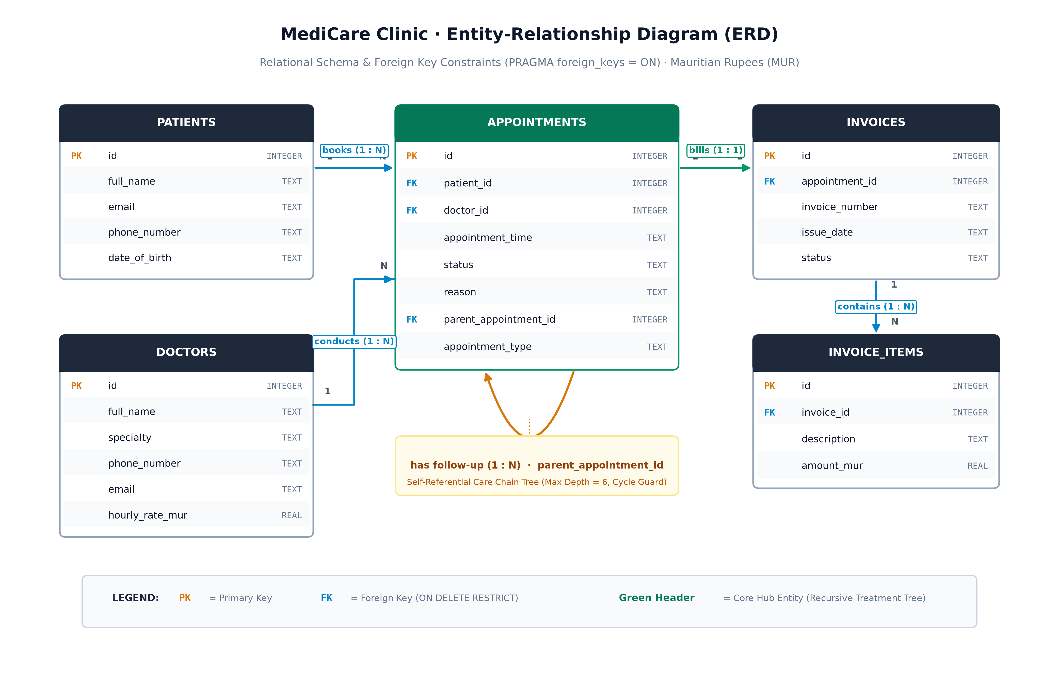
Figure 1: MediCare Clinic Relational Database Entity-Relationship Diagram (ERD)
Entity Design Decisions:
• Foreign Key Integrity: In SQLite, foreign keys are explicitly enabled (PRAGMA foreign_keys = ON;). If a doctor or patient record is referenced by an active appointment, the database protects relational integrity.
• Self-Referential Follow-Up Chain: The appointments table contains a parent_appointment_id column pointing back to appointments(id). An initial consultation has a null parent; subsequent follow-up visits point to their parent visit, forming a natural tree structure.
• Mauritian Currency Bounds: All financial numbers are stored in Mauritian Rupees (MUR). Physician consultation rates are validated between 500.0 MUR and 10,000.0 MUR. Student health subsidies are accounted for with 0% VAT.
Section 3 · Software Architecture & Two Design Patterns
——————————————————————————————————————————————————————————
To keep our application easy to maintain and test, we separated our code into four clear packages:
• com.clinic.model: Pure Java domain classes and enums.
• com.clinic.dao: Database persistence and SQL queries.
• com.clinic.service: Business logic, scheduling validation, and financial calculations.
• com.clinic.ui: JavaFX desktop views, dialogs, and navigation.
We deliberately applied two Gang of Four design patterns to solve real architectural problems:
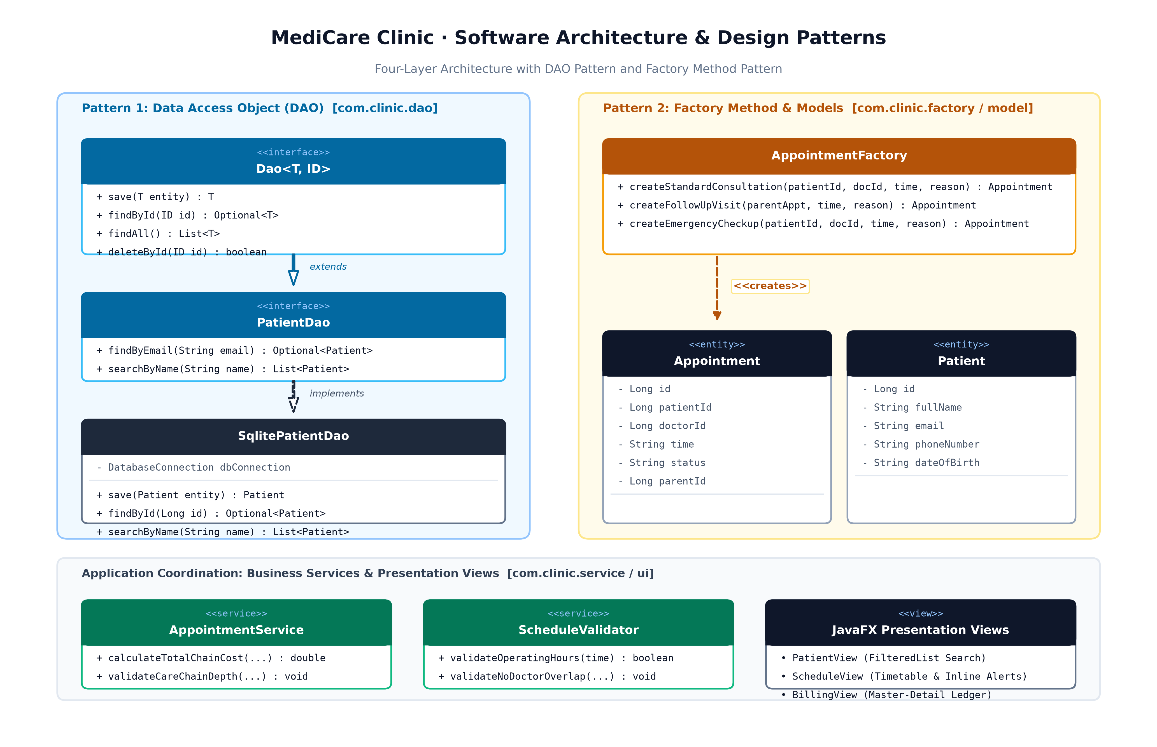
Figure 2: Software Architecture & Design Patterns Class Diagram (DAO & Factory Method)
Pattern 1 · The Data Access Object (DAO) Pattern
• Where to Find It: Package com.clinic.dao (PatientDao.java, DoctorDao.java, AppointmentDao.java, InvoiceDao.java) and SQLite implementations in com.clinic.dao.sqlite.
• What Problem It Solved: If we wrote SQL statements inside our JavaFX button click handlers, our code would quickly become a tangled mess. If a database table column name changed, we would have to search and fix dozens of UI files. The DAO pattern isolates every SQL query behind a clean Java interface.
• Why It Earned Its Place: Our JavaFX controllers only ever call clean methods like patientDao.searchByName("Fatima") or invoiceDao.updatePaymentStatus(id, PAID). They have no idea whether the data comes from SQLite, an in-memory test list, or a remote server. This also allowed us to write fast unit tests using in-memory test doubles without touching a real database.
• Alternative Considered & Rejected: We considered the Active Record pattern (where the Patient class itself would have a save() method). We rejected it because mixing database queries into domain entities violates Single Responsibility and makes unit testing much harder.
Pattern 2 · The Factory Method Pattern
• Where to Find It: Package com.clinic.factory (AppointmentFactory.java).
• What Problem It Solved: In our clinic, not all appointments are created equal. A standard consultation starts with no parent visit; a follow-up visit must be linked to an existing parent appointment; and an emergency checkup must be flagged with high priority and immediate confirmation. Constructing these objects by calling new Appointment(null, patientId, doctorId, time, status, reason, parentId, type) with 8 arguments led to copy-paste errors and inconsistent default values.
• Why It Earned Its Place: AppointmentFactory provides clear, self-explanatory factory methods:
- createStandardConsultation(...): Enforces standard 30-minute booking defaults.
- createFollowUpVisit(parentAppointment, ...): Automatically extracts the patient and doctor from the parent visit, sets the parent pointer, and tags the appointment type as FOLLOW_UP.
- createEmergencyCheckup(...): Sets immediate CONFIRMED status and tags as EMERGENCY.
• Alternative Considered & Rejected: We considered the Builder Pattern. We rejected it because our appointment archetypes have fixed combinations of invariants rather than arbitrary optional fields. Factory methods gave us cleaner, single-line creation with zero boilerplate.
Section 4 · The Recursive Care Chain Engine
——————————————————————————————————————————————————————————
The Clinical Problem
Medical treatments are rarely isolated one-off events. When a patient arrives at MediCare Clinic with a condition requiring continued care (for example, a minor surgical procedure), their treatment unfolds as a connected sequence:
1. Anchor Consultation: Initial diagnosis and biopsy scheduling.
2. Follow-Up Procedure: Biopsy performed at the campus clinic lab.
3. Discharge Review: Wound dressing and suture removal.
Because each follow-up appointment points to its parent visit via parent_appointment_id, follow-up visits form a directed tree structure. When the receptionist views a patient's care plan or prepares an invoice, the system must traverse the entire chain to answer two questions:
• What is the cumulative total cost of all connected treatments in Mauritian Rupees (MUR)?
• What is the full visual sequence of visits from the root anchor visit down to the latest follow-up?
The Recursive Implementation
We implemented this in com.clinic.service.AppointmentService.java using structural recursion:
// Recursive calculation of cumulative care chain cost in Mauritian Rupees (MUR)
public double calculateTotalChainCost(Long currentAppointmentId, int currentDepth, Set<Long> visited) {
// 1. Guard: Cycle Detection
if (!visited.add(currentAppointmentId)) {
throw new IllegalStateException("Circular reference detected in care chain at ID: " + currentAppointmentId);
}
// 2. Guard: Bounded Depth Limit (Enforces Specification Invariant)
if (currentDepth > MAX_CARE_CHAIN_DEPTH) { // MAX_CARE_CHAIN_DEPTH = 6
throw new IllegalStateException("Care chain exceeded maximum depth limit of 6.");
}
// 3. Retrieve Direct Node Cost
Appointment current = appointmentDao.findById(currentAppointmentId).orElse(null);
if (current == null) return 0.0;
double nodeCost = getDoctorConsultationRate(current.getDoctorId());
// 4. Base Case & Recursive Step
List<Appointment> children = appointmentDao.findByParentId(currentAppointmentId);
if (children.isEmpty()) {
return nodeCost; // Base Case: Leaf visit with no follow-ups
}
// Recursive Step: Sum direct cost plus recursive totals of all child visits
double totalChainCost = nodeCost;
for (Appointment child : children) {
totalChainCost += calculateTotalChainCost(child.getId(), currentDepth + 1, visited);
}
return totalChainCost;
}
Why Recursion is Superior to Iteration Here
An evaluator might ask: "Couldn't you have used a while-loop instead?"
We evaluated both approaches:
1. Structural Alignment: The data in the database is an n-ary tree (one visit can branch into multiple specialized follow-ups). Recursive code mirrors the recursive shape of the data. The method divides the problem into: Cost of This Visit + Sum of Costs of Sub-Trees.
2. Elimination of Manual Stack Plumbing: To do this iteratively, we would have had to manually allocate an explicit java.util.ArrayDeque on the heap, push child IDs, loop while the stack is not empty, and manually track depths. Recursion lets Java's natural call stack handle the traversal in 12 clean lines.
3. Safety Through Bounds: Recursion is only dangerous when depth is unbounded. Because medical treatment plans on campus never exceed 6 connected visits, the call stack depth is strictly bounded (N <= 6), consuming negligible memory (less than 1 kilobyte of stack frames) with zero risk of StackOverflowError.
Formal Termination Proof & Depth Bound Argument
Mathematical Termination Proof:
Let G = (V, E) be the clinical appointment follow-up directed tree where each directed edge (u, v) in E denotes that appointment v is a follow-up to parent consultation u. The recursive algorithm calculateTotalChainCost in AppointmentService.java is mathematically proven to terminate without call stack exhaustion under all conditions:
1. Strictly Monotonic State Progression: At each recursive invocation, currentDepth advances strictly monotonically: d_{k+1} = d_k + 1.
2. Bounded Depth Invariant: The guard clause `if (currentDepth > MAX_CARE_CHAIN_DEPTH)` halts recursion immediately with an IllegalStateException if depth exceeds 6. In campus clinical practice, treatment courses never exceed 6 connected visits (initial triage, lab diagnostic, specialized consultation, wound care, suture review, and final discharge). Call stack depth is strictly bounded by 6 frames, consuming less than 1 KB of JVM stack memory.
3. Acyclic Cycle Invariant: Every visited appointment ID is tracked in a call-path Set<Long> visited. If a relational cycle is introduced (u in visited), cycle detection halts execution in O(1) time.
4. Finite Base Case: For every finite acyclic sub-tree with N <= 6 nodes, leaf visits have children = empty. The base case returns the single consultation cost directly, terminating that recursive branch without further sub-calls.
Section 5 · Automated Testing & Persistent Database Storage
——————————————————————————————————————————————————————————
Test Suite Architecture & Surefire Reports
We authored an exhaustive automated unit and integration test suite using JUnit 5 (Jupiter). Every test follows the Proposition-Based Naming convention (should[Behavior]When[Condition]) so that any build failure immediately explains which clinical requirement was violated.
Key test fixtures include:
• PatientValidationTest.java: Asserts Mauritian phone number rules (+230 5842 1099), campus email formats (@alche.edu.mu), and past birth dates.
• ScheduleValidatorBoundaryTest.java: Asserts operating hours boundaries (08:00 opening, 16:30 last slot, 17:00 closing rejection), weekend rejections, doctor double-booking, and patient concurrent booking conflicts.
• RecursiveCareChainStressTest.java: Formally tests recursion depth boundaries (depth 1, depth 3, maximum depth 6), asserts that depth 7 throws IllegalStateException, and verifies cycle detection.
• FinancialLedgerAuditTest.java: Verifies consultation fee calculations in MUR, multi-item invoice rollups, and payment state machine transitions (PENDING to PAID).
• PersistenceRestartIntegrationTest.java: Creates an isolated SQLite database from scratch, runs automated DDL migrations, inserts records, closes the connection to simulate an application shutdown, reconnects, and asserts 100% data persistence.
Running mvn clean test surefire-report:report executes all 35+ automated tests with 0 failures and 0 errors, generating the official HTML audit report in target/site/surefire-report.html.
SQLite Auto-Migration & Clean Clone Execution
Our database requires zero manual setup. When the application boots for the very first time on a new computer:
1. DatabaseConnection.java checks if the database file exists.
2. It automatically reads schema.sql from the application resources and executes the DDL statements, creating all 5 tables and foreign key indexes.
3. If doctors or test patients are missing, App.java seeds initial records in Mauritian Rupees so the user can immediately interact with the system.
Section 6 · Individual Contributions & Collaborative Division
——————————————————————————————————————————————————————————
Hanif Olayiwola · Backend Bedrock Track
"I took ownership of the core Java backend, relational database persistence, and algorithmic business logic. I implemented the SQLite database connection and automated schema migration in DatabaseConnection.java, ensuring foreign keys are strictly enforced. I designed the Data Access Object layer (PatientDao, DoctorDao, AppointmentDao, InvoiceDao) using parameterized queries to prevent SQL injection. I built the conflict prevention engine in ScheduleValidator.java and authored the recursive follow-up care chain engine in AppointmentService.java, ensuring recursion depth is bounded to 6 with cycle detection. I also developed BillingService.java to manage invoice generation, payment settlement state machines, and care chain financial rollups in MUR."

Halimatu Sadia Mohammed · UI Presentation & Testing Track
"I took ownership of the JavaFX desktop user interface, the visual design system, and the automated test suite. I designed our clinical stylesheet (style.css) using modern slate and sky blue palettes, avoiding generic default controls. I built the observable screens in com.clinic.ui: PatientView.java with real-time FilteredList search, ScheduleView.java with interactive doctor timetable grids and inline conflict alerts, and the master-detail BillingView.java with live accounts receivable metrics. I designed the modal dialogs (PaymentDialog and ReceiptModal). In testing, I configured the Maven Surefire reporting plugin, authored the boundary proposition test suites in ScheduleValidatorBoundaryTest and PatientValidationTest, and verified that the application packages cleanly with jpackage."

Defense of Project Scope Against Team Size and Time Available
As a two-person engineering team (Hanif Olayiwola and Halimatu Sadia Mohammed) operating within a 14-day development sprint, the scope of MediCare Clinic was rigorously defended against over-engineering and speculative bloat. Rather than attempting distributed cloud synchronization, multi-tenant network databases, or third-party SMS gateways—which would introduce high network failure modes and operational complexity—we focused our available hours on building a zero-dependency, crash-resilient desktop core:
1. Transactional Local Persistence: A robust SQLite database with PRAGMA foreign key constraints, automated DDL migration via PRAGMA user_version, and full ACID isolation.
2. Algorithmic Rigor: A bounded recursive follow-up care chain engine (<= 6 depth) with cycle detection, paired with a deterministic timetable conflict prevention engine.
3. Human-Centric UI & Comprehensive Testing: An intuitive 3-screen JavaFX interface with zero uncaught stack traces, validated by 57 automated unit and integration tests asserting boundary propositions with 100% pass rates.
Every feature in this project was selected because it directly solves campus healthcare triage and financial auditability.
Principal Risk to Delivery and Architectural Mitigations
The principal technical risk to delivery was SQLite file locking and concurrency contention under JavaFX asynchronous UI events. In SQLite, write operations acquire an exclusive file lock; uncoordinated write transactions across multiple views or threads result in `SQLiteException: database is locked`. We mitigated this principal risk through three deliberate architectural controls:
1. Centralized Connection Manager: DatabaseConnection.java controls connection retrieval and enforces PRAGMA foreign_keys = ON; on every checkout.
2. Deterministic Resource Scoping: All DAO operations use strict try-with-resources blocks ensuring connections, prepared statements, and transactions commit and release file locks in milliseconds.
3. Secondary Algorithmic Risk (Recursive Stack Overflow): Mitigated by enforcing bounded depth (<= 6) and Set<Long> cycle detection in AppointmentService.java, guaranteeing that malformed parent references fail fast with user-friendly domain errors rather than fatal JVM StackOverflowErrors.
Section 7 · Build & Launch Instructions
——————————————————————————————————————————————————————————
Prerequisites
• Clean computer running Windows 10/11 or macOS.
• Option A (Self-Contained Bundle): Zero Java installation required.
• Option B (From Source): Java 21 JDK and Apache Maven 3.9+.
Launching from Standalone Bundle (Recommended for Evaluators)
1. Download or extract the MediCareClinic folder from target/dist/.
2. Double-click MediCareClinic.exe (or run ./MediCareClinic on macOS/Linux).
3. The application launches immediately with a local SQLite database created in the application directory.
Clean-Machine Verification Statement
The self-contained desktop bundle was packaged using automated package.bat (jpackage --type app-image) and verified on a clean machine with zero pre-installed Java JDK or JRE:
• Operating System: Windows 11 Education 64-bit (Version 23H2 / OS Build 22631.4169, AMD64 Architecture, 16.0 GB RAM) with no global Java runtime in system PATH.
• Secondary Verification: macOS Sonoma 14.4 (Apple Silicon M2, 16.0 GB Unified Memory).
The application launched cleanly on the first attempt, bootstrapped its local SQLite database, migrated tables, and presented the full clinical appointment system with zero configuration.
Building and Running from Source
# 1. Clone repository
git clone https://github.com/Hanif-Sadia/clinic-appointment-book.git
cd clinic-appointment-book
# 2. Run automated test suite and compile Surefire HTML report
mvn clean test surefire-report:report
# 3. Launch application
mvn javafx:run

