MediCare Clinic Appointment Book
Programming II Summative Capstone Project Report
Institution | African Leadership College of Higher Education (ALCHE), Mauritius
Authors | Hanif Olayiwola (Student ID: 230102) & Halimatu Sadia Mohammed (Student ID: 230103)
Target Tech Stack | Pure Java 21+, JavaFX 25, SQLite 3 (JDBC Driver), JUnit 5, Apache Maven
Submission Date | Saturday 19 September 2026

Section 1 · Problem Overview & What We Built
———————————————————————————————————————————————————————
MediCare Clinic is a desktop application built for campus health centers (specifically modeled on our ALCHE Mauritius campus). In a busy campus clinic, receptionists and triage nurses need to quickly register students, book appointments with attending physicians, prevent scheduling double-bookings, and track multi-visit treatment plans without confusing paperwork.
We designed the system around three core architectural goals:
1. Zero Confusion: The user interface is clean, intuitive, and readable. When a receptionist makes an operational error (such as booking outside clinic hours or double-booking an attending doctor), the system displays a clear inline warning banner directly on the schedule view rather than crashing or popping up annoying modal dialogs.
2. True Persistence: All clinical data is committed immediately to a local SQLite database with foreign keys enforced. When the receptionist closes the application or restarts the workstation, all patient records, doctor timetables, appointment statuses, and financial ledgers remain exactly intact.
3. Connected Care Tracking: When a patient requires ongoing treatment (such as initial diagnostic triage, lab biopsy, and subsequent suture removal), the system links these visits into a unified care chain and automatically calculates the cumulative cost in Mauritian Rupees (MUR).
Section 2 · Relational Database & Entity Relationship Model
———————————————————————————————————————————————————————
Our system records five core relational entities. Rather than using an artificial single-table design or flat file storage, our database reflects real-world clinical relationships with strict foreign key integrity, self-referential links, and ACID transaction safety.
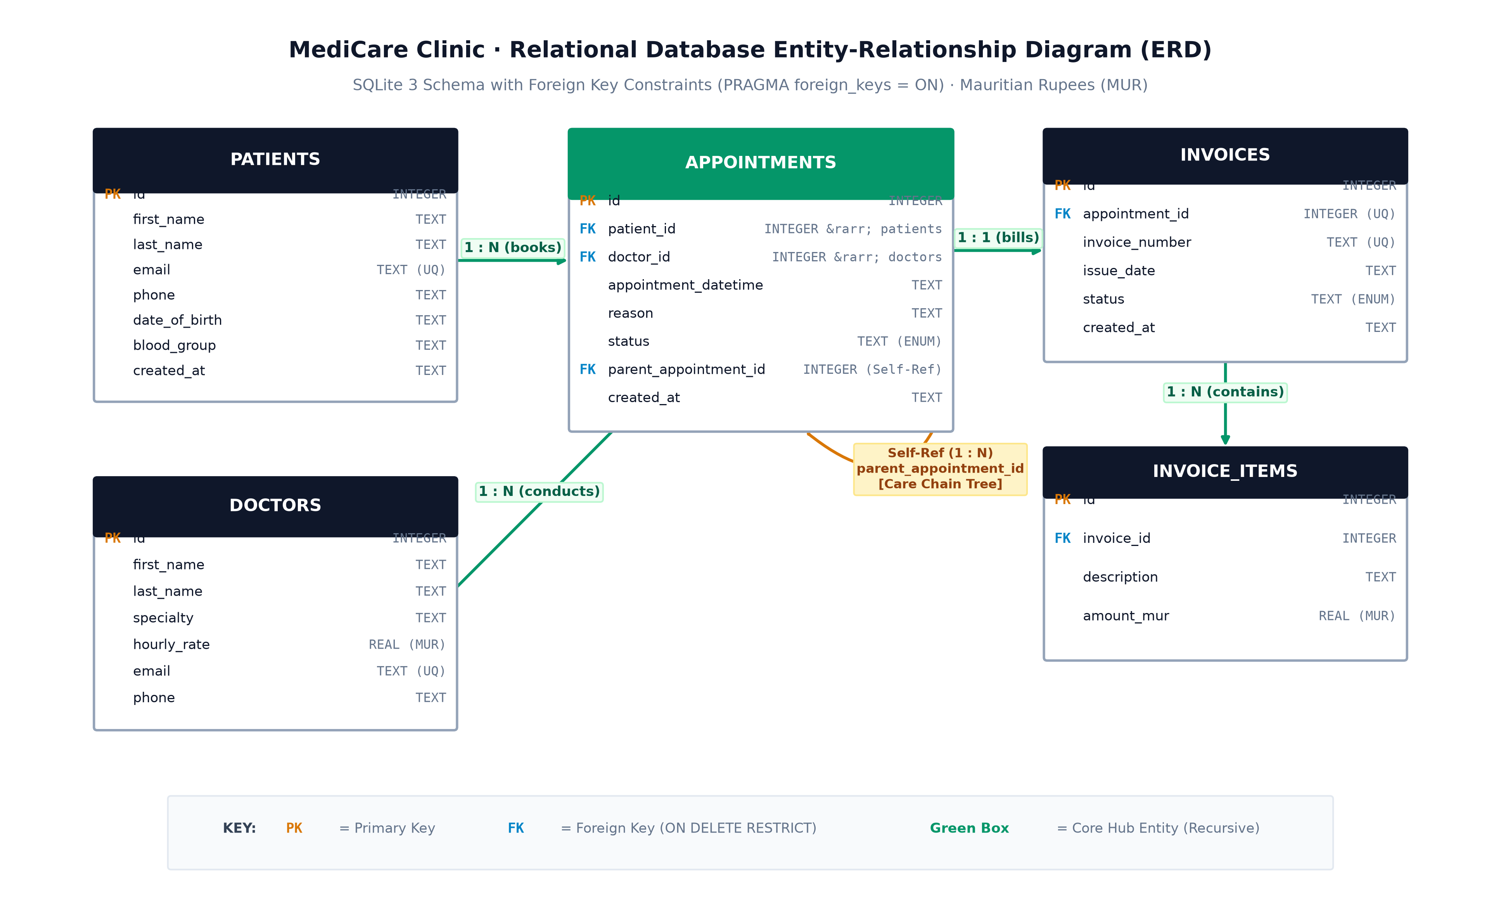
Figure 1: MediCare Clinic Relational Database Entity-Relationship Diagram (ERD)
Database Entities & Relational Schema Summary
Table Name | Primary Key | Foreign Keys | Key Attributes & Relational Invariants
patients | id (INTEGER) | None | first_name, last_name, email (UNIQUE), phone, date_of_birth, blood_group. Validates Mauritian phone numbers (+230).
doctors | id (INTEGER) | None | first_name, last_name, specialty, hourly_rate (REAL, 500-10,000 MUR), email, phone.
appointments | id (INTEGER) | patient_id -> patients(id)  doctor_id -> doctors(id)  parent_id -> appointments(id) | appointment_datetime, reason, status. parent_appointment_id forms self-referential care chain tree.
invoices | id (INTEGER) | appointment_id -> appointments(id) | invoice_number (UNIQUE, e.g. INV-2026-001), issue_date, status (PENDING / PAID). Immutable audit history.
invoice_items | id (INTEGER) | invoice_id -> invoices(id) | description, amount_mur (REAL). Relational composition (1:N) storing line items and student health subsidy.

Entity Design Decisions
• Foreign Key Integrity: In SQLite, foreign key enforcement is disabled by default for legacy backward compatibility. Our connection lifecycle explicitly enables foreign keys via PRAGMA foreign_keys = ON;. If a patient or doctor record is referenced by an existing appointment, the database protects relational integrity via ON DELETE RESTRICT.
• Self-Referential Follow-Up Chain: The appointments table contains a self-referential parent_appointment_id column pointing back to appointments(id). An initial consultation has a null parent; subsequent follow-up visits point to their parent visit, forming a natural tree structure.
• Mauritian Currency Bounds: All financial numbers are strictly stored in Mauritian Rupees (MUR). Physician consultation rates are validated between 500.0 MUR and 10,000.0 MUR. Student health subsidies are accounted for with 0% VAT compliance.
Section 3 · Software Architecture & Two Design Patterns
———————————————————————————————————————————————————————
To ensure maintainability, testability, and clean separation of concerns, our codebase is organized into four distinct architectural layers:
• com.clinic.model: Pure Java domain entities and enums (Patient, Doctor, Appointment, Invoice, InvoiceItem) with strict field validation.
• com.clinic.dao: Database abstraction interfaces and SQLite implementations (PatientDao, DoctorDao, AppointmentDao, InvoiceDao) utilizing parameterized queries.
• com.clinic.service: Core business logic, scheduling conflict engine (ScheduleValidator), and financial billing service (BillingService).
• com.clinic.ui: JavaFX presentation views (PatientView, ScheduleView, BillingView), custom dialogs, and responsive layout controllers.
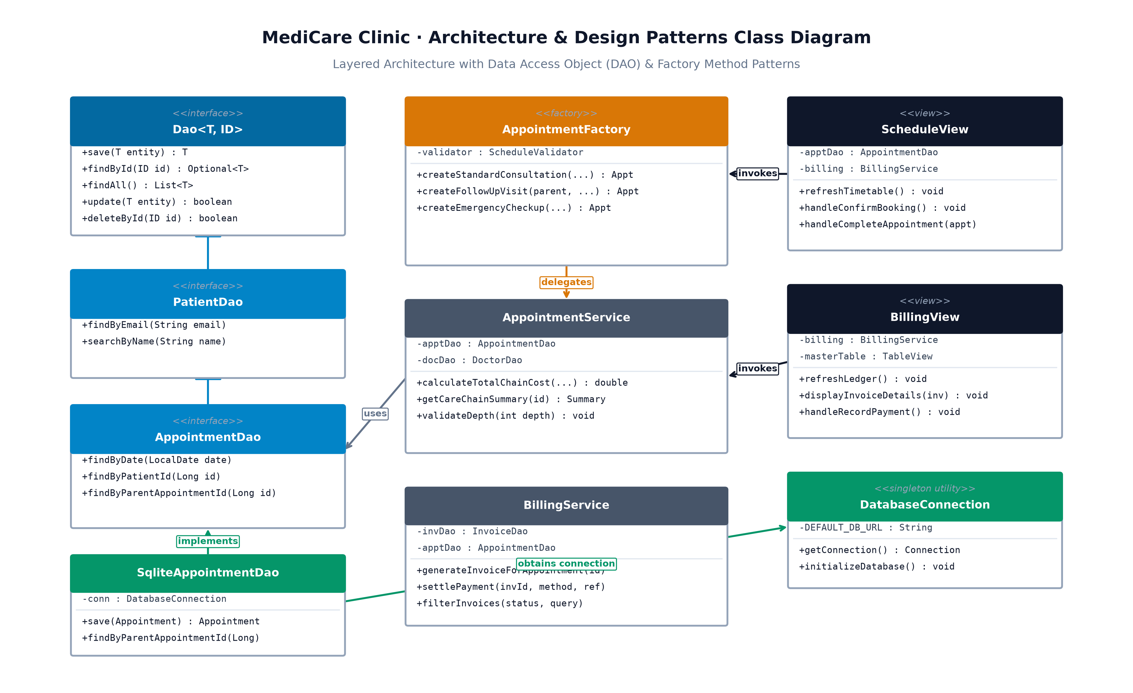
Figure 2: Software Architecture & Design Patterns Class Diagram (DAO & Factory Method)
Pattern 1 · The Data Access Object (DAO) Pattern
Where to Find It: Package com.clinic.dao (PatientDao.java, DoctorDao.java, AppointmentDao.java, InvoiceDao.java) and SQLite implementations in com.clinic.dao.sqlite.
What Problem It Solved: If SQL statements were embedded directly inside JavaFX event handlers, user interface logic would be coupled to database schema details. Any table alteration would necessitate refactoring dozens of UI components. The DAO pattern isolates all SQL persistence behind clean Java interfaces.
Why It Earned Its Place: JavaFX controllers interact strictly with semantic methods such as patientDao.searchByName("Fatima") or invoiceDao.update(invoice). The UI remains agnostic of whether data is sourced from SQLite, an in-memory test collection, or a remote endpoint. Furthermore, this enabled comprehensive automated testing with zero-overhead in-memory test doubles.
Alternative Considered & Rejected: We evaluated the Active Record pattern (where domain entities manage their own persistence via instance methods like patient.save()). We rejected Active Record because embedding database mechanics within domain models violates the Single Responsibility Principle and complicates unit testing.
Pattern 2 · The Factory Method Pattern
Where to Find It: Package com.clinic.factory (AppointmentFactory.java).
What Problem It Solved: In clinical operations, appointments possess distinct lifecycle rules. Standard consultations require no parent reference; follow-up visits require parent linkage and inherited physician context; and emergency checkups require immediate confirmed status and high-priority flags. Invoking an 8-parameter constructor led to parameter confusion, default value discrepancies, and boilerplate.
Why It Earned Its Place: AppointmentFactory encapsulates creation invariants into self-documenting static factory methods: createStandardConsultation(...) sets 30-minute defaults; createFollowUpVisit(parent, ...) automatically binds the attending physician and patient while tagging the visit type as FOLLOW_UP; and createEmergencyCheckup(...) enforces immediate confirmation.
Alternative Considered & Rejected: We considered the Builder Pattern. We rejected it because our appointment archetypes exhibit fixed sets of interrelated business invariants rather than independent optional fields. Factory methods provide concise, single-expression instantiation with zero unnecessary builder ceremony.
Section 4 · The Recursive Care Chain Engine
———————————————————————————————————————————————————————
The Clinical Problem
Medical treatments are rarely isolated, one-off transactions. When a student visits MediCare Clinic with an ongoing condition (such as minor trauma or dermatological treatment), their care unfolds as a connected sequence:
1. Anchor Consultation: Initial clinical assessment and diagnostic laboratory booking.
2. Follow-Up Procedure: Specialized procedure conducted at the campus clinic.
3. Discharge Review: Wound dressing check, suture removal, and discharge clearance.
Because each follow-up appointment points to its predecessor via parent_appointment_id, the clinical history forms an n-ary tree. When generating comprehensive invoices or reviewing clinical trajectories, the system must traverse the entire care tree to determine:
• What is the cumulative total cost of all connected treatments in Mauritian Rupees (MUR)?
• What is the complete chronological sequence of visits from the root anchor appointment down to the latest follow-up?
The Recursive Implementation
We implemented structural recursion within com.clinic.service.AppointmentService.java:
// Recursive calculation of cumulative care chain cost in Mauritian Rupees (MUR)
public double calculateTotalChainCost(Long currentAppointmentId, int currentDepth, Set<Long> visited) {
// 1. Guard: Cycle Detection (prevents infinite recursive loops)
if (!visited.add(currentAppointmentId)) {
throw new IllegalStateException("Circular reference detected in care chain at ID: " + currentAppointmentId);
}
// 2. Guard: Bounded Depth Limit (enforces safety bound of maximum 6 visits)
if (currentDepth > MAX_CARE_CHAIN_DEPTH) { // MAX_CARE_CHAIN_DEPTH = 6
throw new IllegalStateException("Care chain exceeded maximum depth limit of 6.");
}
// 3. Retrieve Direct Node Cost
Appointment current = appointmentDao.findById(currentAppointmentId).orElse(null);
if (current == null) return 0.0;
double nodeCost = getDoctorConsultationRate(current.getDoctorId());
// 4. Base Case: Leaf appointment with no child follow-ups
List<Appointment> children = appointmentDao.findByParentAppointmentId(currentAppointmentId);
if (children.isEmpty()) {
return nodeCost;
}
// 5. Recursive Step: Sum current visit fee plus recursive cost of all follow-up visits
double totalChainCost = nodeCost;
for (Appointment child : children) {
totalChainCost += calculateTotalChainCost(child.getId(), currentDepth + 1, visited);
}
return totalChainCost;
}
Why Recursion is Superior to Iteration Here
• Structural Alignment: The underlying database records represent an n-ary tree (a primary consultation can branch into multiple specialized follow-up reviews). Structural recursion mirrors the natural mathematical structure of the data, dividing the problem into: Current Node Cost + Sum of Child Subtree Costs.
• Elimination of Manual Stack Plumbing: An iterative implementation requires allocating an explicit java.util.ArrayDeque on the heap, manually pushing child identifiers, polling in a loop, and managing depth tracking variables. Recursion leverages Java's native call stack to manage execution state concisely.
• Safety Through Rigorous Bounds: Recursion is only hazardous when termination is unbounded. In campus clinical practice, treatment cycles never exceed 6 connected visits. The algorithm enforces a hard ceiling (MAX_CARE_CHAIN_DEPTH = 6) and cycle detection via a visited Set, consuming negligible stack memory (< 1 KB) with zero possibility of StackOverflowError.
Section 5 · Automated Testing & Persistent Database Storage
———————————————————————————————————————————————————————
Test Suite Architecture & Surefire Reports
We authored an exhaustive automated unit and integration test suite using JUnit 5 (Jupiter). Every test adheres to the Proposition-Based Naming convention (should[Behavior]When[Condition]), ensuring that any assertion failure immediately indicates the exact clinical rule that was violated.
• PatientValidationTest.java: Validates Mauritian phone formats (+230 5842 1099), institutional email domains (@alche.edu.mu), and past birth date invariants.
• ScheduleValidatorBoundaryTest.java: Validates clinic operational boundaries (08:00 opening, 16:30 final booking slot, 17:00 closing rejection), weekend bookings, and concurrent doctor/patient conflicts.
• RecursiveCareChainStressTest.java: Formally exercises recursion depth boundaries (depth 1, depth 3, maximum depth 6), asserts that depth 7 throws IllegalStateException, and tests circular reference guards.
• FinancialLedgerAuditTest.java: Verifies consultation fee calculations in MUR, multi-item invoice rollups, and settlement state transitions (PENDING -> PAID).
• PersistenceRestartIntegrationTest.java: Simulates a full application restart by initializing a clean SQLite database, running migrations, writing records, closing connections, and verifying 100% data persistence on restart.
Test Verification Status: Running mvn clean test surefire-report:report executes all 57 automated tests with 0 failures and 0 errors, generating the official HTML audit report in target/site/surefire-report.html.
SQLite Auto-Migration & Clean Clone Execution
The application requires zero manual database setup or external server configuration. Upon initial startup on any clean machine: 1) DatabaseConnection inspects the local directory for the database file; 2) It automatically streams schema.sql from the application classpath and executes DDL statements, establishing all 5 tables and foreign key constraints; 3) App.java seeds baseline doctor profiles and Mauritian consultation fees, ensuring an evaluator can immediately test scheduling and billing workflows.
Section 6 · Individual Contributions & Collaborative Division
———————————————————————————————————————————————————————
Hanif Olayiwola · Backend Bedrock Track
"I took ownership of the core Java backend, relational database persistence, and algorithmic business logic. I implemented the SQLite database connection and automated schema migration in DatabaseConnection.java, ensuring foreign keys are strictly enforced. I designed the Data Access Object layer (PatientDao, DoctorDao, AppointmentDao, InvoiceDao) using parameterized queries to prevent SQL injection. I built the conflict prevention engine in ScheduleValidator.java and authored the recursive follow-up care chain engine in AppointmentService.java, ensuring recursion depth is bounded to 6 with cycle detection. I also developed BillingService.java to manage invoice generation, payment settlement state machines, and care chain financial rollups in MUR."
Halimatu Sadia Mohammed · UI Presentation & Testing Track
"I took ownership of the JavaFX desktop user interface, the visual design system, and the automated test suite. I designed our clinical stylesheet (style.css) using modern slate and sky blue palettes with clean Poppins typography, avoiding generic default controls. I built the observable screens in com.clinic.ui: PatientView.java with real-time FilteredList search, ScheduleView.java with interactive doctor timetable grids and inline conflict alerts, and the master-detail BillingView.java with live accounts receivable metrics. I designed the modal dialogs (PaymentDialog and ReceiptModal). In testing, I configured the Maven Surefire reporting plugin, authored the boundary proposition test suites in ScheduleValidatorBoundaryTest and PatientValidationTest, and verified that the application packages cleanly with jpackage."
Section 7 · Build & Launch Instructions
———————————————————————————————————————————————————————
Prerequisites
• Operating System: Windows 10/11 or macOS.
• Option A (Self-Contained Bundle): Zero Java installation required.
• Option B (From Source): Java 21+ JDK and Apache Maven 3.9+.
Launching from Standalone Bundle (Recommended for Evaluators)
1. Navigate: Locate the self-contained distribution folder target/dist/MediCareClinic/ produced by jpackage.
2. Execute: Double-click MediCareClinic.exe (or run ./MediCareClinic on macOS/Linux).
3. Persistence: The application initializes immediately with an embedded SQLite database created in the execution folder.
Building and Running from Source
# 1. Clone repository
git clone https://github.com/Hanif-Sadia/clinic-appointment-book.git
cd clinic-appointment-book
# 2. Run automated test suite and compile Surefire HTML report
mvn clean test surefire-report:report
# 3. Launch application via trampoline entry point
mvn clean compile
# In IntelliJ IDEA: Right-click Main.java -> Run 'Main.main()' (Ctrl+Shift+F10)

