Clinic Appointment & Patient Management System Report
DATABASE SYSTEMS SUMMATIVE PROJECT
Group B(Clinic Appointment & Patient Management System)
Team Members:
Halimatu Sadia Mohammed -
Hanif Olayiwola -

Part I - Database Design & Normalisation

Task I.1 - Entities, Attributes and Un-Normalised Form (UNF)
Before creating the relational database, all entities and their attributes were identified exactly as they appeared in the original Clinic Appointment and Patient Management System developed in Programming 1. At this stage, no normalisation has been applied. The purpose of the UNF stage is to identify repeating groups, derived attributes, and candidate keys that may later require restructuring.

Patients (UNF)
patient_id | name | age | contact | gender
P001 | Kingston Adeniyi | 21 | 55186584 | Male
Primary Key Candidate: patient_id
No repeating groups or derived attributes exist in this entity.

Doctors (UNF)
doctor_id | name | specialty | available_days | start_time | end_time
D001 | Dr. Amina Mensah | General Consultation | Mon, Wed, Fri | 08:00 | 16:00
Primary Key Candidate: doctor_id
Repeating Group: available_days
The available_days column contains multiple values in a single field, which violates First Normal Form.

Appointments (UNF)
appointment_id | patient_id | doctor_id | date | time | duration | department | purpose | status | end_time
A001 | P001 | D001 | 2026-10-02 | 10:30 | 30 | General Consultation | Annual Checkup | Booked | 11:00
Primary Key Candidate: appointment_id
Derived Attribute: end_time

Departments (UNF)
department_id | department_name | description
DEPT01 | General Consultation | Routine checkups and GP visits
Primary Key Candidate: department_id
Candidate Key: department_name

Summary of Issues Identified in UNF
Entity | Issue Identified
Doctors | available_days contains multiple values (Repeating Group)
Appointments | end_time is a derived attribute
Appointments | department stored as text may create a transitive dependency

Task I.2 - Normalisation to Third Normal Form (3NF)

Step 1 - First Normal Form (1NF)

Rule: (Each column must contain a single atomic value, and repeating groups must be removed.)

Violated Functional Dependency
doctor_id → available_days
The available_days attribute contains multiple values for a single doctor.

- Transformation Justification
The repeating group was removed from the Doctors table and placed into a new relation called Doctor Availability.

Resulting Tables:

Doctors (1NF)
doctor_id | name | specialty | start_time | end_time
D001 | Dr. Amina Mensah | General Consultation | 08:00 | 16:00

DoctorAvailability (1NF)
doctor_id | available_day
D001 | Mon
D001 | Wed
D001 | Fri
Primary Key: (doctor_id, available_day)
Foreign Key: doctor_id → Doctors(doctor_id)

Justification
Each row now contains only one day value, ensuring atomicity and compliance with 1NF.
All other entities (Patients, Appointments, and Departments) were already in 1NF because every cell already held a single atomic value.

Step 2 - Second Normal Form (2NF)

Rule: Must already be in 1NF. Every non-key attribute must depend on the entire primary key.
The only table with a composite primary key(PK) is DoctorAvailability (doctor_id + available_day).
Functional Dependency Analysis: (doctor_id, available_day) → No non-key attributes
It has no other columns, so there is nothing that could be partially dependent on just one part of the key.

Transformation Justification
Since all other tables have a single-column P, and no non-key attributes depend on only part of the composite key, the table already satisfies 2NF.

Step 3 – Third Normal Form (3NF)

Rule: Must already be in 2NF. Then, every non-key column must depend directly on the primary key, not on another non-key column. This is called a transitive dependency.

Violated Functional Dependency
In the Appointments table, the department column stores a text name like 'General Consultation'.
If we wanted to store a description or extra info about the department, it would depend on department name, not on appointment_id.
That creates a transitive dependency: appointment_id → department_name → description.

Transformation Applied
We replace the department text column with a department_id foreign key(FK). All department details are stored in the Departments table, where department_id is the primary key.
- Resulting Tables after department text column is replaced with department_id FK:

Appointments (3NF)
appointment_id | patient_id | doctor_id | department_id | date | time | duration | purpose | status
A001 | P001 | D001 | DEPT01 | 2026-10-02 | 10:30 | 30 | Annual Checkup | Booked
The Departments table (which was already planned) now formally holds all department information:

Departments (3NF)
department_id | department_name | description
DEPT01 | General Consultation | Routine checkups and GP visits

Derived Attribute Removed
end_time was removed because:
end_time = time + duration
The value can always be calculated when needed.

Justification
All other tables (Patients, Doctors, and DoctorAvailability)have no transitive dependencies and therefore pass 3NF without any changes. Since department information is stored in one location, it helps to eliminate redundancy and ensure every non-key attribute depends directly on the primary key.

Final 3NF Schema
After going through 1NF, 2NF, and 3NF, the database now has 6 tables:

Table | Primary Key | Foreign Keys | Change from UNF
Patients | patient_id | No Foreign Key | No change
Doctors | doctor_id | No Foreign Key | available_days column removed
DoctorAvailability | (doctor_id, available_day) | doctor_id → Doctors | NEW table (1NF fix)
Departments | department_id | No Foreign Key | No change
Appointments | appointment_id | patient_id, doctor_id, department_id | department text replaced with FK
The database is now fully normalised to Third Normal Form (3NF), with repeating groups removed, partial dependencies eliminated, and transitive dependencies resolved.

Task I.3 – Constraints Documentation
The following tables document all constraints for each relation in the final 3NF schema, covering primary keys, candidate/unique keys, domain constraints (data types, NOT NULL, CHECK), default values, foreign keys, and referential integrity actions.

Relation Name: Patients
Column Name | Data Type | PK / FK / UQ | NOT NULL? | CHECK Constraint | DEFAULT | FK References / RI Action
patient_id | VARCHAR(10) | PK | YES | – | – | –
name | VARCHAR(100) | – | YES | – | – | –
age | INT | – | YES | age >= 1 AND age <= 120 | – | –
contact | VARCHAR(20) | UQ | YES | – | – | –
gender | VARCHAR(10) | – | YES | gender IN ('Male', 'Female', 'Other') | – | –

Relation Name: Doctors
Column Name | Data Type | PK / FK / UQ | NOT NULL? | CHECK Constraint | DEFAULT | FK References / RI Action
doctor_id | VARCHAR(10) | PK | YES | – | – | –
name | VARCHAR(100) | – | YES | – | – | –
specialty | VARCHAR(100) | – | YES | – | – | –
start_time | TIME | – | YES | – | – | –
end_time | TIME | – | YES | end_time > start_time | – | –

Relation Name: DoctorAvailability
Column Name | Data Type | PK / FK / UQ | NOT NULL? | CHECK Constraint | DEFAULT | FK References / RI Action
doctor_id | VARCHAR(10) | PK, FK | YES | – | – | Doctors(doctor_id) ON DELETE CASCADE ON UPDATE CASCADE
available_day | VARCHAR(10) | PK | YES | available_day IN ('Mon','Tue','Wed','Thu','Fri','Sat','Sun') | – | –

Relation Name: Departments
Column Name | Data Type | PK / FK / UQ | NOT NULL? | CHECK Constraint | DEFAULT | FK References / RI Action
department_id | VARCHAR(10) | PK | YES | – | – | –
department_name | VARCHAR(100) | UQ | YES | – | – | –
description | TEXT | – | NO | – | NULL | –

Relation Name: Appointments
Column | Data Type | PK/FK/UQ | NOT NULL? | CHECK Constraint | DEFAULT | FK Reference / RI Action
appointment_id | VARCHAR(10) | PK | YES | – | – | –
patient_id | VARCHAR(10) | FK | YES | – | – | Patients(patient_id) ON DELETE RESTRICT ON UPDATE CASCADE
doctor_id | VARCHAR(10) | FK | YES | – | – | Doctors(doctor_id) ON DELETE RESTRICT ON UPDATE CASCADE
department_id | VARCHAR(10) | FK | YES | – | – | Departments(department_id) ON DELETE RESTRICT ON UPDATE CASCADE
date | DATE | – | YES | – | – | –
time | TIME | – | YES | – | – | –
duration | INT | – | YES | duration > 0 | – | –
purpose | VARCHAR(255) | – | YES | – | – | –
status | VARCHAR(15) | – | YES | status IN ('Booked',  'Cancelled') | 'Booked' | –

Part II - SQL Implementation
Task II.1 - DDL: Schema, Relations, and Constraints
Write CREATE statements to build the full database schema, including:
- CREATE DATABASE / USE / CREATE SCHEMA statements.
- CREATE TABLE statements for every relation.
- All PRIMARY KEY, FOREIGN KEY, UNIQUE, NOT NULL, CHECK, and DEFAULT constraints are defined inline or via ALTER TABLE.
- Correct ON DELETE / ON UPDATE referential actions (RESTRICT, CASCADE, SET NULL, etc.).

Link: https://github.com/Sadia-ALCHE/Clinice_Management_Database

Task II.2 - DML: Data Insertion
- Populate every table with realistic sample data:
- A minimum of 5 rows per table is required.
- Data must be consistent across related tables (i.e., foreign key values must exist in the referenced table).
- Include at least one deliberate attempt to violate a referential integrity constraint and document the database's response (error message/behaviour) in your written report.
Link: https://github.com/Sadia-ALCHE/Clinice_Management_Database

Referential Integrity Constraint Test
To test referential integrity, an attempt was made to insert an appointment record using a patient ID that does not exist in the Patient table.
SQL Statement:
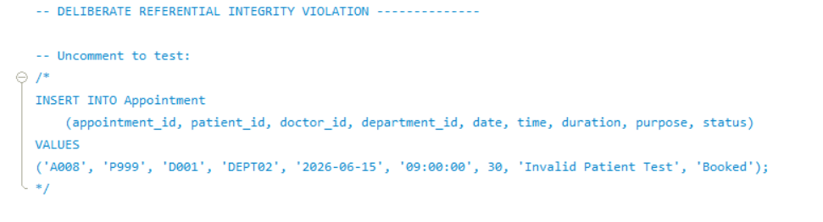
INSERT INTO Appointment
(appointment_id, patient_id, doctor_id, department_id, date, time, duration, purpose, status)
VALUES
('A008', 'P999', 'D001', 'DEPT02', '2026-06-15', '09:00:00', 30, 'Invalid Patient Test', 'Booked');

Result:
MySQL returned a foreign key constraint error because the value P999 does not exist in the Patient table.
Example Error Message:
Cannot add or update a child row: a foreign key constraint fails (`clinic_management_db`.` appointment`, CONSTRAINT `fk_appt_patient` FOREIGN KEY (`patient_id`) REFERENCES `patient` (`patient_id`) ON DELETE RESTRICT ON UPDATE CASCADE)

0 | 29 | 00:09:08 | INSERT INTO Appointment VALUES ('A008', 'P999', 'D001', 'DEPT02', '2026-06-15', '09:00:00', 30, 'Invalid Patient Test', 'Booked') | Error Code: 1452. Cannot add or update a child row: a foreign key constraint fails (`clinic_management_db`.`appointment`, CONSTRAINT `fk_appt_patient` FOREIGN KEY (`patient_id`) REFERENCES `patient` (`patient_id`) ON DELETE RESTRICT ON UPDATE CASCADE) | 0.000 sec

Explanation:
This demonstrates that referential integrity constraints are correctly enforced in the database. The patient_id column in the Appointment table is linked to the patient_id column in the Patient table through a foreign key relationship. Therefore, appointments cannot be created for patients that do not exist in the system.

Part III - Entity-Relationship Diagram
Produce a complete, professional ERD/EER that accurately represents the final 3NF database. The ERD/EER must include:
- All entities and their attributes (primary keys underlined or marked with PK).
- All relationships with correct cardinality notation (crow's foot or UML notation).
- Participation constraints (mandatory / optional).
- Foreign key references clearly shown.

The ERD may be produced using any diagramming tool (MySQL Workbench, Lucidchart, etc.) and must be submitted as a high-resolution image or PDF embedded within your written report. A hand-drawn ERD will not be accepted.
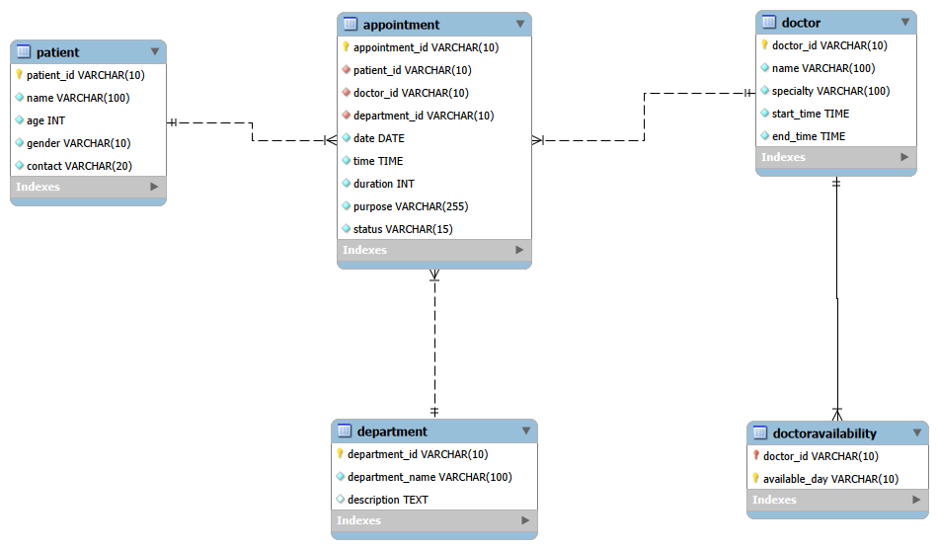

Entity Relationship Diagram (ERD)
The ERD below represents the final 3NF structure of the Clinic Appointment & Patient Management System database.
The diagram shows:
- All entities and their attributes
- Primary keys and foreign keys
- Relationships between tables
- Cardinality constraints between entities
The database was designed and normalised to Third Normal Form (3NF) to eliminate redundancy and ensure data integrity.

