WEB LAB 02
NAME: SADIA FATIMA
CMS: 023-24-0213
SECTION: G

ACTIVITY A:
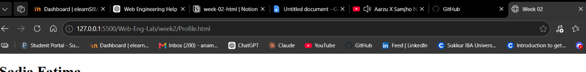

ACTIVITY B:
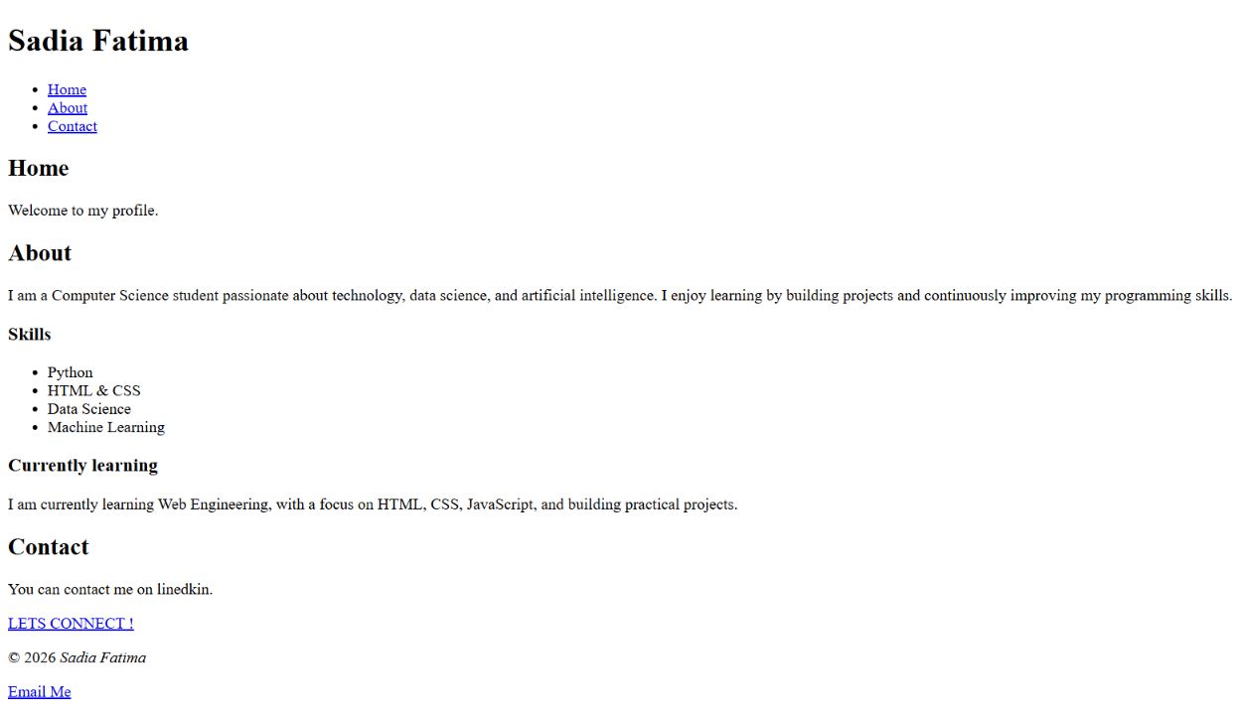
<!DOCTYPE html>
<html lang ="en">
<head>
<meta charset="UTF-8">
<meta name="viewport" content="width=device-width, initial-scale=1.0">

<title> Week 02</title>
</head>
<body>
<header>
<h1>Sadia Fatima</h1>

<nav>
<ul>
<li><a href="#home">Home</a></li>
<li><a href="#about">About</a></li>
<li><a href="#contact">Contact</a></li>
</ul>
</nav>
</header>

<main>
<section id="home">
<h2>Home</h2>
<p>Welcome to my profile.</p>
</section>

<article>
<h2 id="about">About</h2>
<p> I am a Computer Science student passionate about technology, data science, and artificial intelligence.
I enjoy learning by building projects and continuously improving my programming skills.</p>

<section id="skills">
<h3>Skills</h3>
<ul>
<li>Python</li>
<li>HTML & CSS</li>
<li>Data Science</li>
<li>Machine Learning</li>
</ul>
</article>

<aside>
<h3>Currently learning</h3>
<p> I am currently learning Web Engineering, with a focus on HTML, CSS, JavaScript, and building practical projects.</p>
</aside>
</main>
<section id="contact">
<h2>Contact</h2>
<p>You can contact me on linedkin.</p>
<a href="https://www.linkedin.com/in/sadia-fatima-4334a9373/">LETS CONNECT !</a>
</section>

<footer>
<p>&copy; 2026 <em>Sadia Fatima</em></p>
<a href="mailto:sadiafarooque06@gmail.com">Email Me</a>
</footer>
</body>

</html>

ACTIVITY C:
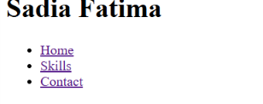
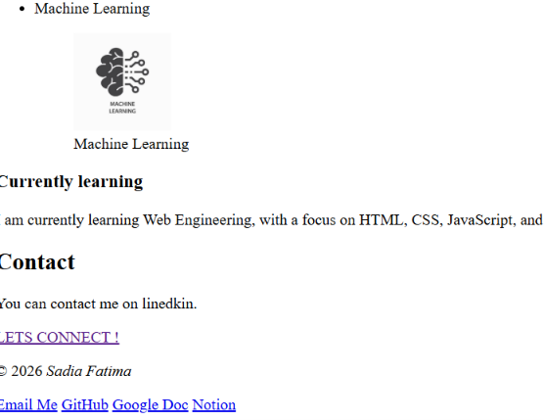

ACTIVITY D:
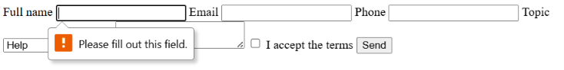

ACTIVITY E:
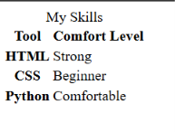
<table>

<caption>My Skills</caption>
<thead>
<tr>
<th scope="col">Tool</th>
<th scope="col">Comfort Level</th>
</tr>
</thead>
<tbody>
<tr>
<th scope="row">HTML</th>
<td>Strong</td>
</tr>
<tr>
<th scope="row">CSS</th>
<td>Beginner</td>
</tr>
<tr>
<th scope="row">Python</th>
<td>Comfortable</td>
</tr>
</tbody>

</table>

ACTIVITY F:

<!DOCTYPE html>
<html lang="en">
<head>
<meta charset="UTF-8">
<meta name="viewport" content="width=device-width, initial-scale=1.0">

<title>Week 02</title>
</head>

<body>

<!-- Header starts here -->

<header>
<h1>Sadia Fatima</h1>

<nav>
<ul>
<li><a href="#home">Home</a></li>
<li><a href="#skills">Skills</a></li>
<li><a href="#contact">Contact</a></li>
<li><a href="#about">About</a></li>
</ul>
</nav>
</header>

<!-- Main content starts here -->

<main>

<section id="home">
<h2>Home</h2>
<p>Welcome to my profile.</p>
</section>

<article class="card">
<h2 id="about">About</h2>

<p class="muted">
I am a Computer Science student passionate about technology, data science, and artificial intelligence.
I enjoy learning by building projects and continuously improving my programming skills.
</p>

<section id="skills">
<h3>Skills</h3>

<ul>
<li>Python</li>

<section>
<figure>
<img src="https://tse4.mm.bing.net/th/id/OIP.mcDM32dcz8M_EliALCY1JAHaEK?r=0&rs=1&pid=ImgDetMain&o=7&rm=3"
alt="Python Logo" width="100" height="100">
<figcaption>Python</figcaption>
</figure>
</section>

<li>HTML & CSS</li>

<section>
<figure>
<img src="https://tse1.mm.bing.net/th/id/OIP.dAyDga1P-Y4MjYWFKgGNDQHaGJ?r=0&rs=1&pid=ImgDetMain&o=7&rm=3"
alt="HTML and CSS Logo" width="100" height="100">
<figcaption>HTML & CSS</figcaption>
</figure>
</section>

<li>Data Science</li>

<section>
<figure>
<img src="https://tse4.mm.bing.net/th/id/OIP.Yq27CqtVBlHcmod7WKWSZwHaGa?r=0&rs=1&pid=ImgDetMain&o=7&rm=3"
alt="DS Logo" width="100" height="100">
<figcaption>Data Science</figcaption>
</figure>
</section>

<li>Machine Learning</li>

<section>
<figure>
<img src="https://th.bing.com/th/id/OIP.3djflu7TWrjIjtN1DI76KwHaHa?r=0&o=7rm=3&rs=1&pid=ImgDetMain&o=7&rm=3"
alt="ML Logo" width="100" height="100">
<figcaption>Machine Learning</figcaption>
</figure>
</section>
</ul>
</section>
</article>

<aside>
<h3>Currently learning</h3>
<p>
I am currently learning Web Engineering, with a focus on HTML, CSS, JavaScript,
and building practical projects.
</p>
</aside>

<section id="contact">
<h2>Contact</h2>
<p>You can contact me on LinkedIn.</p>
<a href="https://www.linkedin.com/in/sadia-fatima-4334a9373/">LETS CONNECT!</a>

<!-- Contact form starts here -->

<form>
<label for="name">Full name</label>
<input type="text" id="name" name="name" required>

<label for="email">Email</label>
<input type="email" id="email" name="email" required>

<label for="phone">Phone</label>
<input type="tel" id="phone" name="phone" required>

<label for="topic">Topic</label>
<select id="topic" name="topic">
<option value="">Choose one</option>
<option value="help">Help</option>
<option value="feedback">Feedback</option>
<option value="complaint">Complaint</option>
</select>

<label for="msg">Message</label>
<textarea id="msg" name="msg"></textarea>

<label>
<input type="checkbox" name="terms" required>
I accept the terms
</label>

<button type="submit">Send</button>
</form>
</section>

</main>

<footer>
<p>&copy; 2026 <em>Sadia Fatima</em></p>
<a href="mailto:sadiafarooque06@gmail.com">Email Me</a>
<a href="https://github.com/">GitHub</a>
<a href="https://docs.google.com/document/d/1cpyWXSnXNZYgv5gUsdHd88b4dpM-P5KnqS0MZIvF0IE/edit?tab=t.0">Google Doc</a>
<a href="https://app.notion.com/p/week-02-html-3b8367dc9d5d81129e4fe179dacdcf56">Notion</a>
</footer>

</body>
</html>
```

Homework:
Task1:
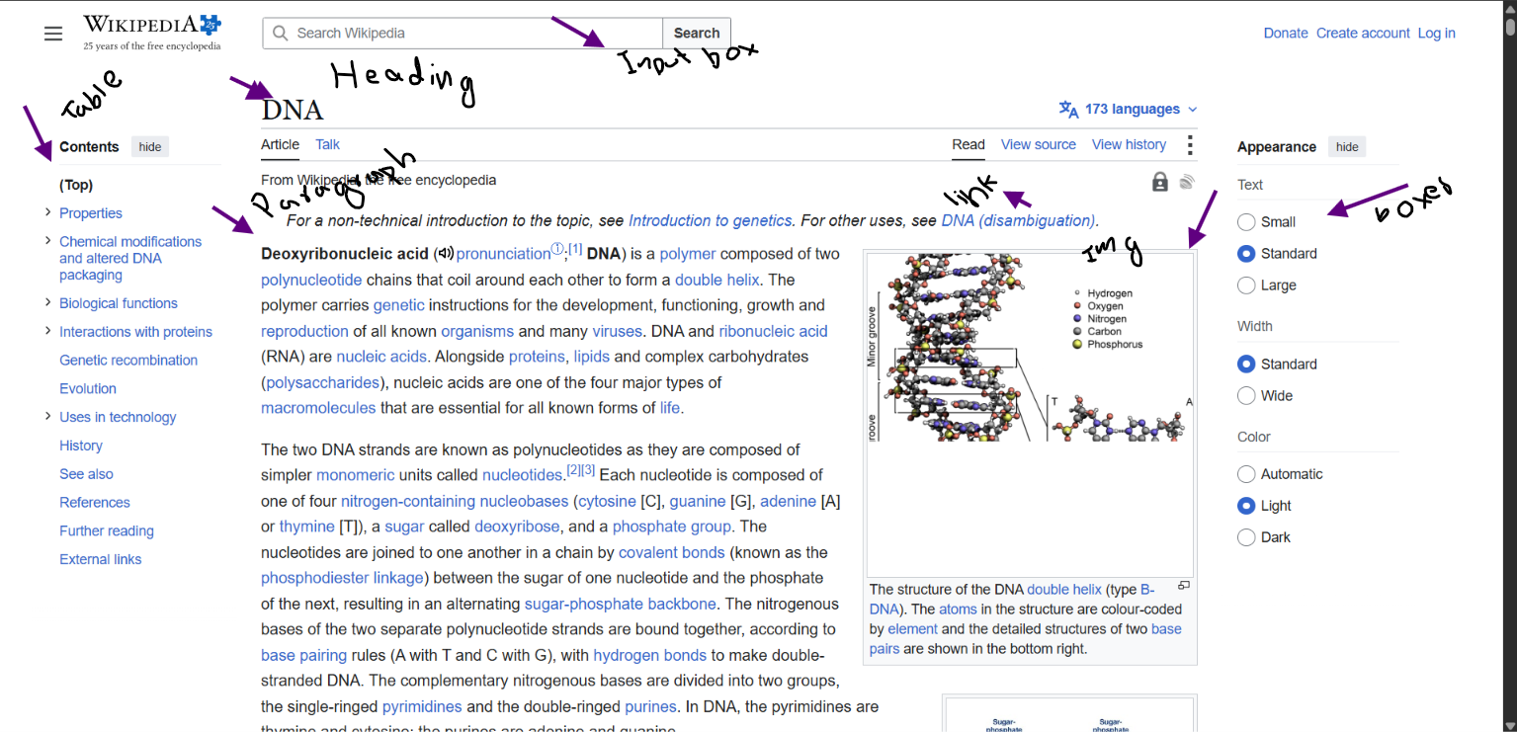

Task2:
<div class="top">
<div class="big-text">My Blog</div>
<div class="links"><span onclick="go('/')">Home</span></div>
</div>
<div class="post">
<div class="post-title">First Post</div>
<div class="post-body">Hello world</div>
<div class="date">Aug 9 2026</div>
</div>

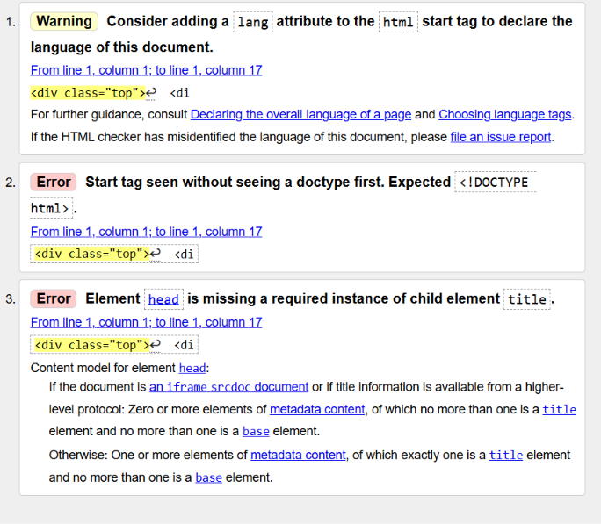
After editing file:
<!DOCTYPE html>
<html lang="en">

<head>
<meta charset="UTF-8">
<meta name="viewport" content="width=device-width, initial-scale=1.0">
<title>My Blog</title>
</head>

<body>

<header>
<h1>My Blog</h1>

<nav>
<a href="/">Home</a>
</nav>
</header>

<main>

<article>
<h2>First Post</h2>

<p>Hello world</p>

<time datetime="2026-08-09">Aug 9 2026</time>
</article>

</main>

</body>
</html>

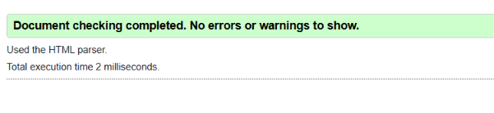

Task3:
profile.html

<!DOCTYPE html>
<html lang="en">
<head>
<meta charset="UTF-8">
<meta name="viewport" content="width=device-width, initial-scale=1.0">

<title>Week 02</title>
</head>

<body>

<!-- Header starts here -->

<header>
<h1>Sadia Fatima</h1>

<nav>
<ul>
<li><a href="#home">Home</a></li>
<li><a href="#skills">Skills</a></li>
<li><a href="contact.html">Contact</a></li>
<li><a href="#about">About</a></li>
</ul>
</nav>
</header>

<!-- Main content starts here -->

<main>

<section id="home">
<h2>Home</h2>
<p>Welcome to my profile.</p>
</section>

<article class="card">
<h2 id="about">About</h2>

<p class="muted">
I am a Computer Science student passionate about technology, data science, and artificial intelligence.
I enjoy learning by building projects and continuously improving my programming skills.
</p>

<section id="skills">
<h3>Skills</h3>

<ul>
<li>Python</li>

<section>
<figure>
<img src="https://tse4.mm.bing.net/th/id/OIP.mcDM32dcz8M_EliALCY1JAHaEK?r=0&rs=1&pid=ImgDetMain&o=7&rm=3"
alt="Python Logo" width="100" height="100">
<figcaption>Python</figcaption>
</figure>
</section>

<li>HTML & CSS</li>

<section>
<figure>
<img src="https://tse1.mm.bing.net/th/id/OIP.dAyDga1P-Y4MjYWFKgGNDQHaGJ?r=0&rs=1&pid=ImgDetMain&o=7&rm=3"
alt="HTML and CSS Logo" width="100" height="100">
<figcaption>HTML & CSS</figcaption>
</figure>
</section>

<li>Data Science</li>

<section>
<figure>
<img src="https://tse4.mm.bing.net/th/id/OIP.Yq27CqtVBlHcmod7WKWSZwHaGa?r=0&rs=1&pid=ImgDetMain&o=7&rm=3"
alt="DS Logo" width="100" height="100">
<figcaption>Data Science</figcaption>
</figure>
</section>

<li>Machine Learning</li>

<section>
<figure>
<img src="https://th.bing.com/th/id/OIP.3djflu7TWrjIjtN1DI76KwHaHa?r=0&o=7rm=3&rs=1&pid=ImgDetMain&o=7&rm=3"
alt="ML Logo" width="100" height="100">
<figcaption>Machine Learning</figcaption>
</figure>
</section>
</ul>
</section>
</article>

<aside>
<h3>Currently learning</h3>
<p>
I am currently learning Web Engineering, with a focus on HTML, CSS, JavaScript,
and building practical projects.
</p>
</aside>

<section id="contact">
<h2>Contact</h2>
<p>You can contact me on LinkedIn.</p>
<a href="https://www.linkedin.com/in/sadia-fatima-4334a9373/">LETS CONNECT!</a>

<!-- Contact form starts here -->

<form>
<label for="name">Full name</label>
<input type="text" id="name" name="name" required>

<label for="email">Email</label>
<input type="email" id="email" name="email" required>

<label for="phone">Phone</label>
<input type="tel" id="phone" name="phone" required>

<label for="topic">Topic</label>
<select id="topic" name="topic">
<option value="">Choose one</option>
<option value="help">Help</option>
<option value="feedback">Feedback</option>
<option value="complaint">Complaint</option>
</select>

<label for="msg">Message</label>
<textarea id="msg" name="msg"></textarea>

<label>
<input type="checkbox" name="terms" required>
I accept the terms
</label>

<button type="submit">Send</button>
</form>
</section>

</main>

<footer>
<p>&copy; 2026 <em>Sadia Fatima</em></p>
<a href="mailto:sadiafarooque06@gmail.com">Email Me</a>
<a href="https://github.com/">GitHub</a>
<a href="https://docs.google.com/document/d/1cpyWXSnXNZYgv5gUsdHd88b4dpM-P5KnqS0MZIvF0IE/edit?tab=t.0">Google Doc</a>
<a href="https://app.notion.com/p/week-02-html-3b8367dc9d5d81129e4fe179dacdcf56">Notion</a>
</footer>

</body>
</html>
```

contact.html
<form>
<label for="name">Full name</label>
<input type="text" id="name" name="name" required>

<label for="email">Email</label>
<input type="email" id="email" name="email" required>

<label for="phone">Phone</label>
<input type="tel" id="phone" name="phone" required>

<label for="topic" >Topic</label>
<select id="topic" name="topic">
<option> Help </option>
<option> Feedback </option>
<option> Complaint </option>
</select>

<label for="msg">Message</label>
<textarea id="msg" name="msg"></textarea>

<label>
<input type="checkbox" name="terms" required>
I accept the terms
</label>

<button type="submit">Send</button>

<a href="profile.html">get back to Profile</a>

<footer>
<p>&copy; 2026 <em>Sadia Fatima</em></p>
</footer>

</form>

Task4:
I almost used a <div> to group the navigation links together. Instead, I used the <nav> element because it clearly shows that the content is meant for navigation. This makes the HTML more meaningful and easier to understand. It also helps with accessibility and gives the page a better structure.

