WEB LAB 03
NAME: SADIA FATIMA
CMS: 023-24-0213
SECTION: G

WARM UP ACTIVITY:
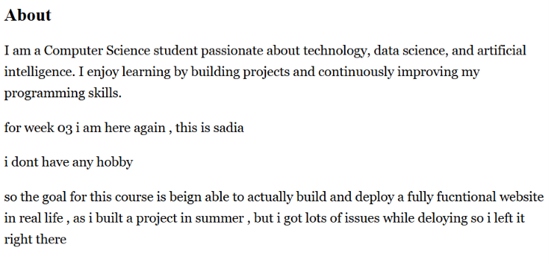
FONT CHANGED

Activity A:
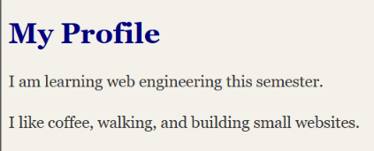
<!DOCTYPE html>
<html lang="en">
<head>
<meta charset="UTF-8"/>
<meta name="viewport" content="width=device-width, initial-scale=1.0"/>
<title>Inline to External</title>
</head>
<link rel="stylesheet" href="styles.css" />
<body>
<h1 >My Profile</h1>
<p>
I am learning web engineering this semester.
</p>
<p >
I like coffee, walking, and building small websites.
</p>
</body>
</html>

Activity B:
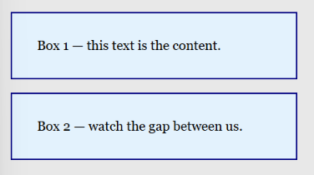
padding changed to 40
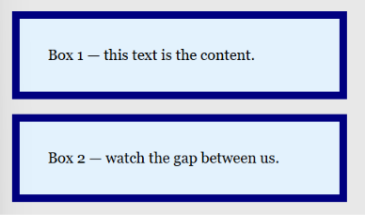
Boarder changed
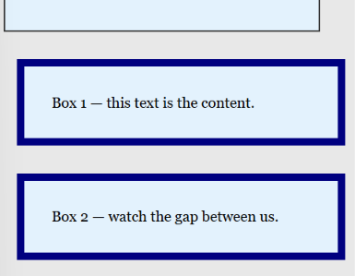
margin changed

Activity C:
1. Tag (h1)
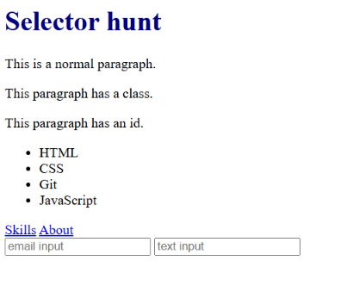
2. Class (.note)
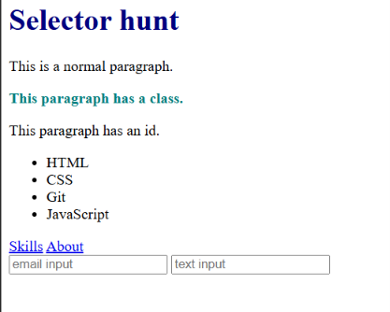
3. ID (#alert)
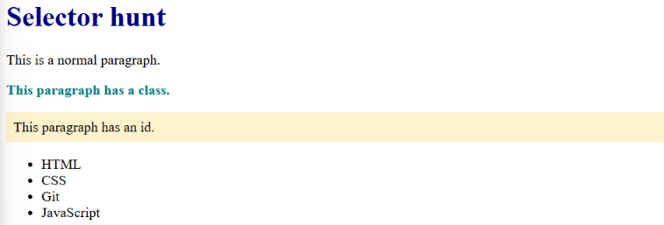
4. Attribute (input[type="email"])
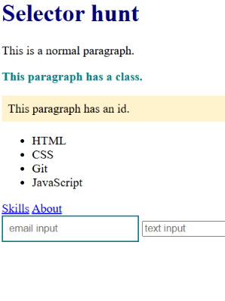
5. Hover (a:hover)
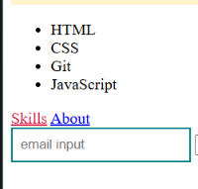
6. Odd (li:nth-child(odd))
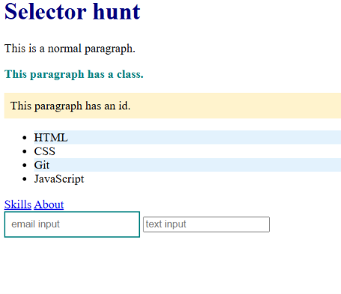
7. Even (li:nth-child(even))
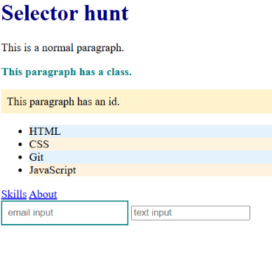

Activity D:
1)
The #main p rule wins, so the paragraph appears navy. Its specificity is (1,0,1), which is higher than p.intro (0,1,1), .intro (0,1,0), and p (0,0,1). Therefore, the ID + element selector has the highest priority.
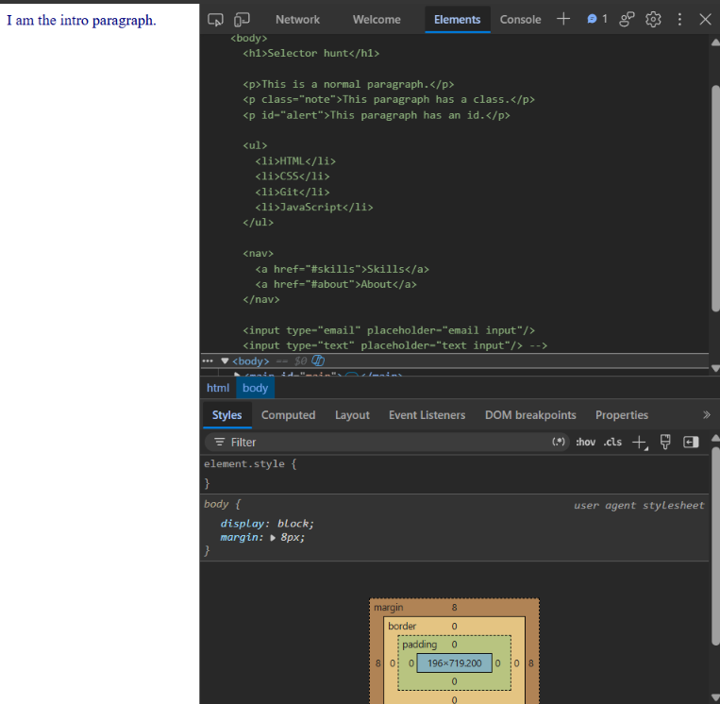

2)
After removing #main p, the p.intro rule wins, so the paragraph becomes purple. Its specificity is (0,1,1), which is higher than .intro (0,1,0) and p (0,0,1).

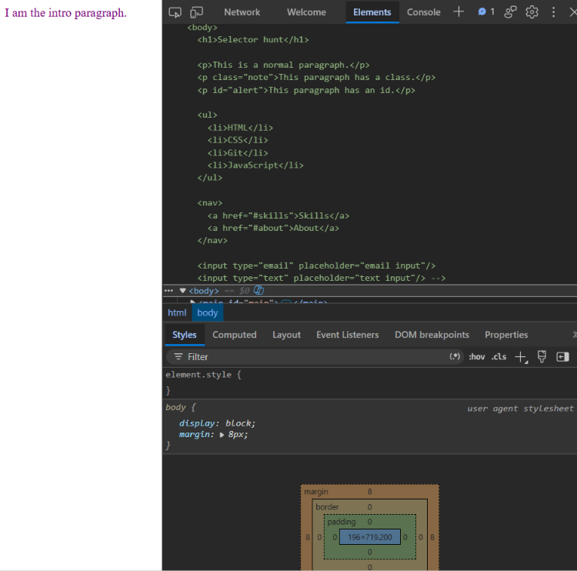

3)
Now .intro wins, so the paragraph becomes blue. The class selector has a specificity of (0,1,0), which is higher than the element selector p with (0,0,1).
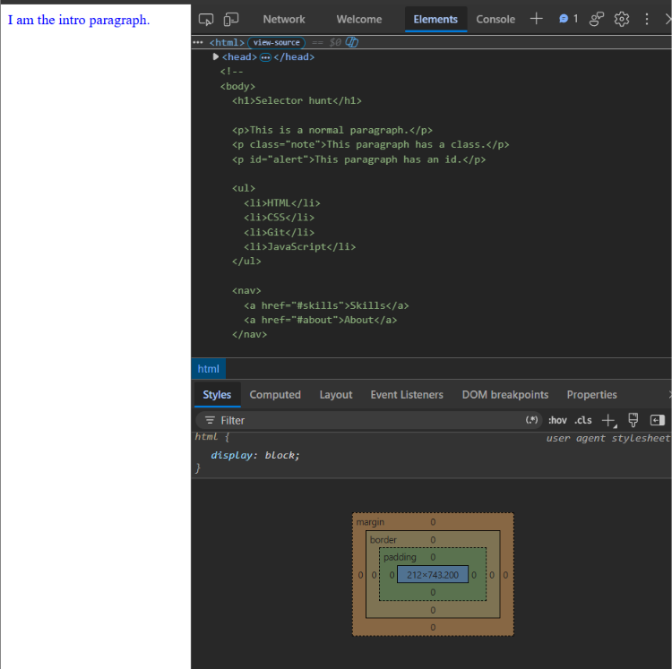

4)
Both rules use the same selector, p, so they have the same specificity of (0,0,1). Since the specificity is equal, CSS uses the rule that comes last, so p { color: crimson; } wins.
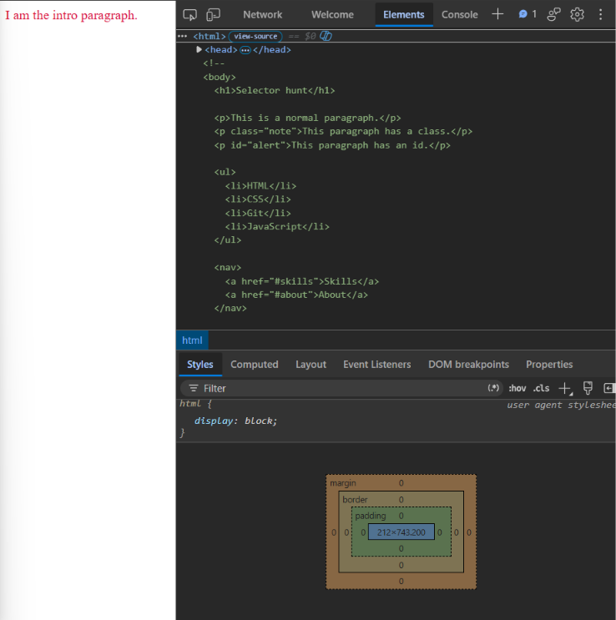

5)
The inline style wins, so the paragraph becomes hotpink. Inline styles have a higher priority than the normal ID, class, and element selectors used in this activity, so style="color: hotpink;" overrides the other color rules.
