“WEB ENG LAB 1”

Name: Sadia Fatima
CMS: 023-24-0213
Section: G

Activity A:
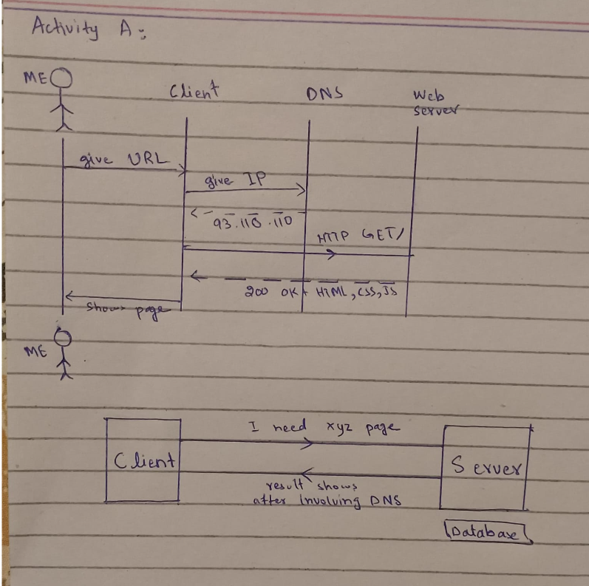

Activity B:
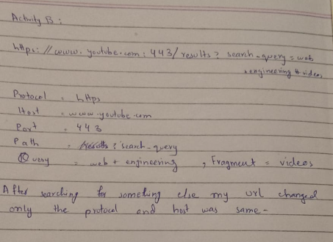

Activity C:
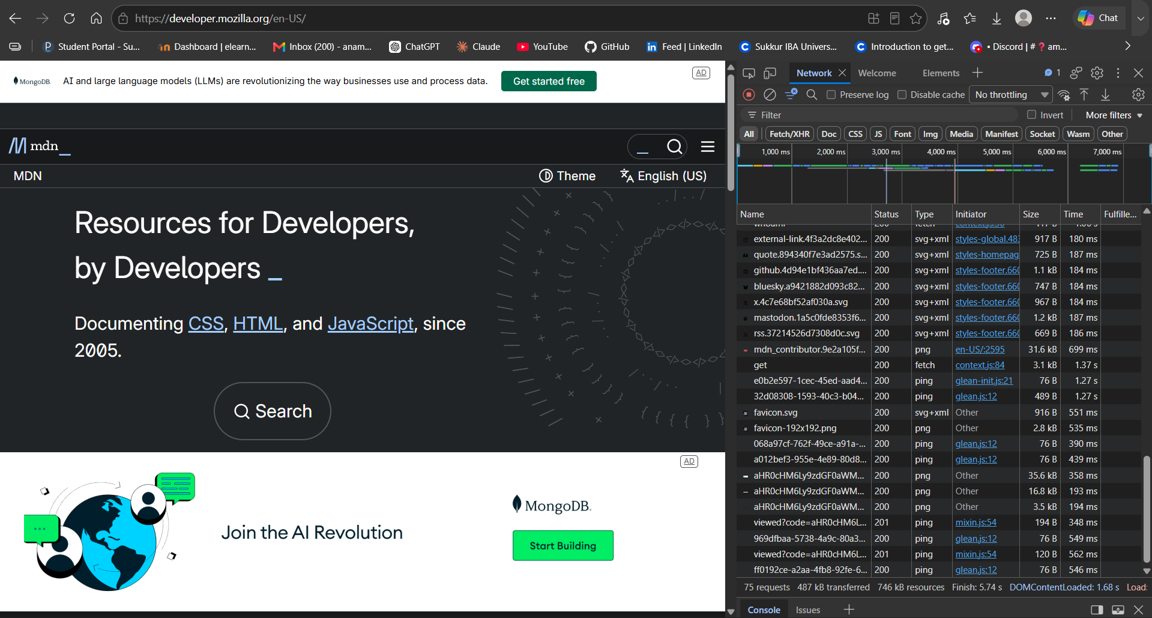
2xx:
Success: The request was successfully received and processed by the server, such as 200 OK.
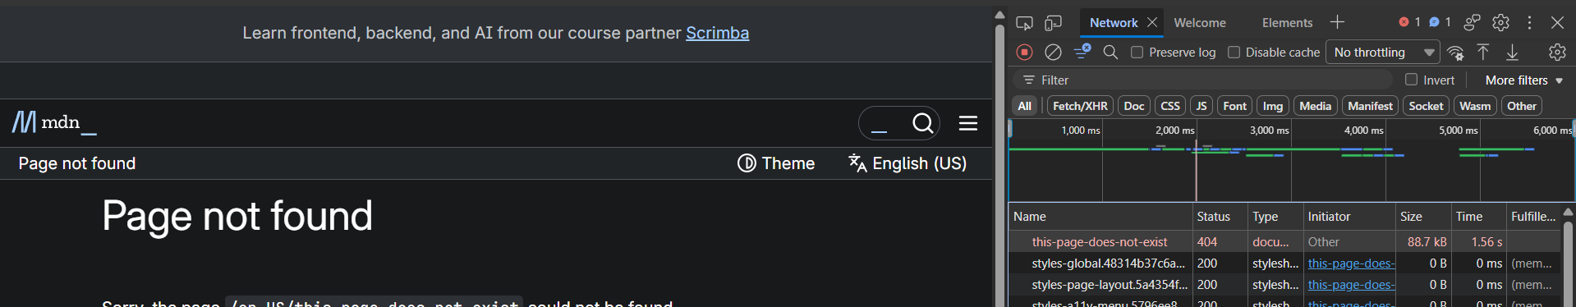
4xx:
Client Error: There is a problem with the request sent by the client, such as 404 Not Found.

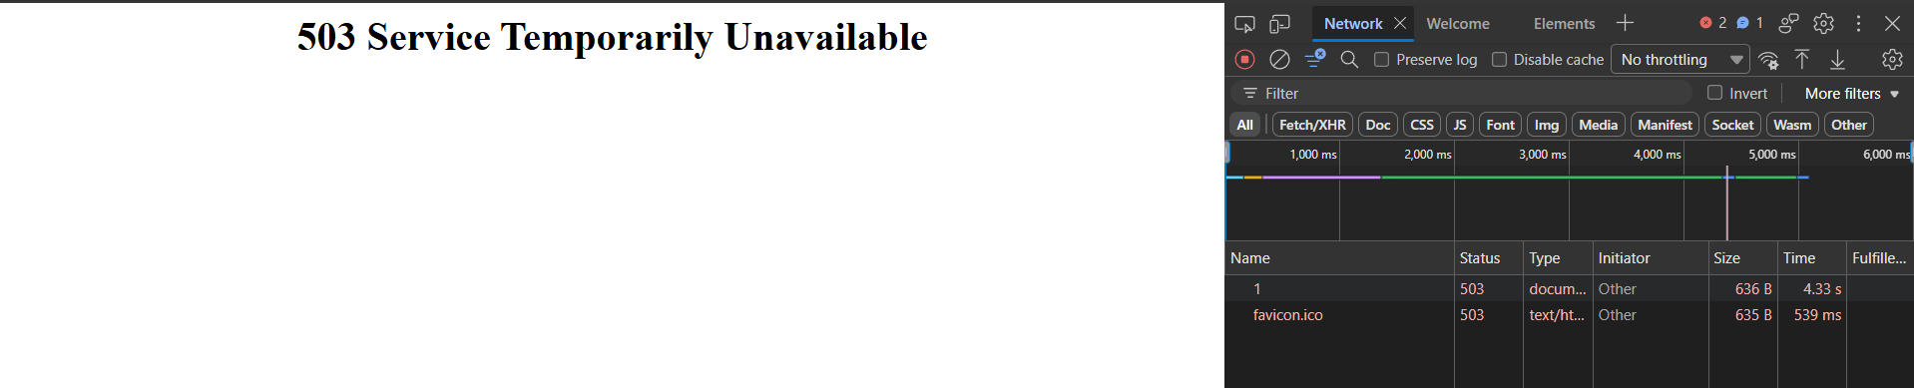
5xx:
Server Error: The server encountered a problem while trying to fulfill a valid request, such as 500, 502, or 503.

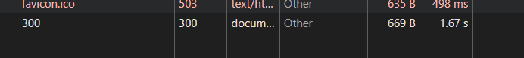
3xx:
Redirection: The client needs to follow a redirect or handle a changed resource location, such as 301 Moved.

Activity D:
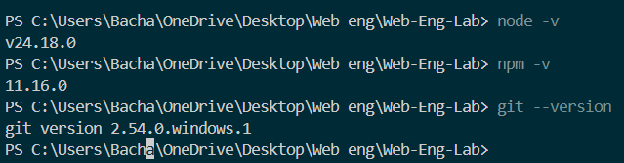
LIVE SERVER WORKING:
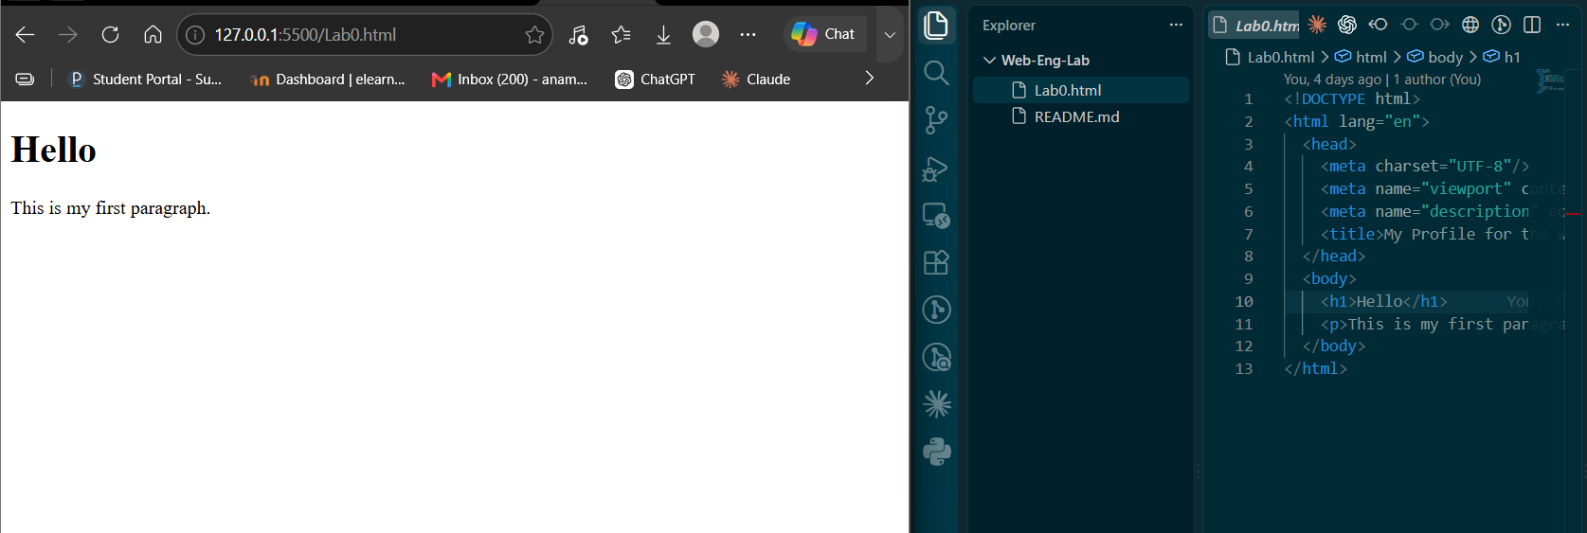
http://127.0.0.1:5500/Lab0.html

Prettier installed:
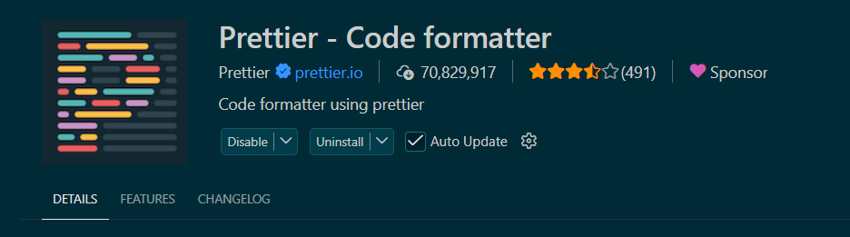

Activity E:
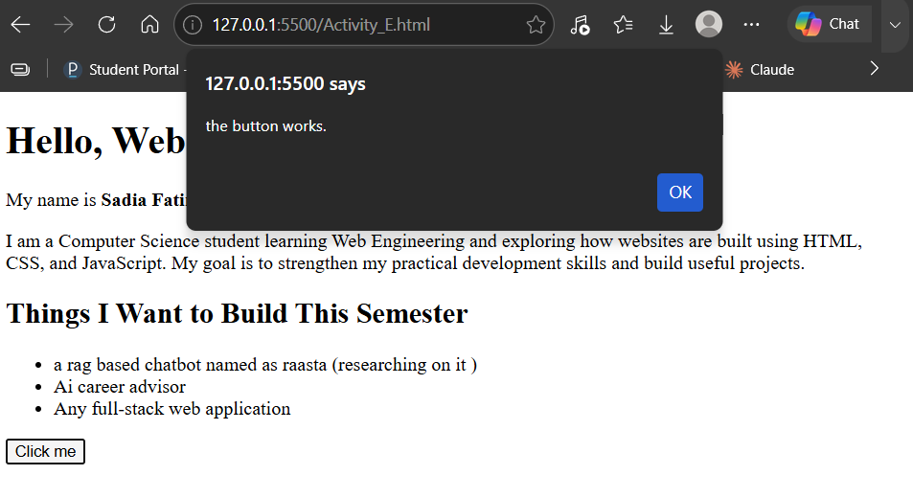
http://127.0.0.1:5500/Activity_E.html

Activity F:

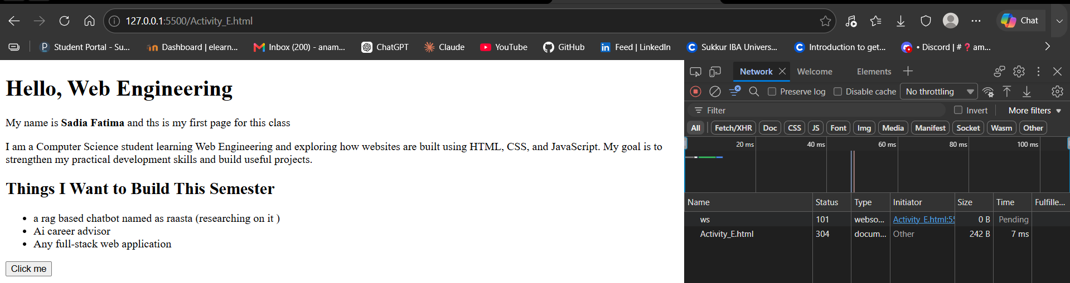document.title returns the title of the current webpage, which is Hello Web
The Elements edit was temporary because DevTools changes modify the page in the browser, not the actual index.html file, so reloading loads the original file again.

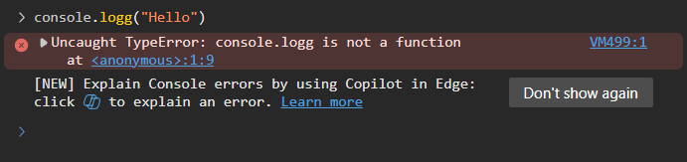
The error occurred because console.logg() is not a valid JavaScript function; the correct function is console.log().

code:
<!DOCTYPE html>
<html lang="en">
<head>
<meta charset="UTF-8"/>
<meta name="viewport" content="width=device-width, initial-scale=1.0"/>

<title>Hello web </title>
</head>
<body>
<h1>Hello, Web Engineering</h1>
<p> My name is <strong>Sadia Fatima </strong>and ths is my first page for this class </p>
<p>
I am a Computer Science student learning Web Engineering and exploring
how websites are built using HTML, CSS, and JavaScript. My goal is to
strengthen my practical development skills and build useful projects.
</p>

<h2>Things I Want to Build This Semester</h2>

<ul>
<li>a rag based chatbot named as raasta (researching on it )</li>
<li>Ai career advisor </li>
<li>Any full-stack web application</li>
</ul>
<button id ="greet">Click me</button>

<script>
document.getElementById("greet").addEventListener("click",()=>{
alert("the button works.");
});
</script>

</body>
</html>

Homework:

Task 1:
Done above

Task 2:
Network detective:
The page made 236 requests.

Screen shot of The highest size of the file in the image format
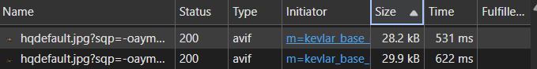

An error 404:The request returned 404 because the browser requested a resource that does not exist at that URL.
