Final Year Design Project

SignWhispers: Development of a Real-Time ASL to Multilingual Speech Translation System Using AI




By
Sadia Shahzad BCS-22002
Fatima Shahzad BCS-22004
Faiza Arif BCS-22019
Tayyaba Khalid BCS-22032
Rimsha Naeem BCS-22041
Under the supervision of

Sir Rizwan Abbas

Bachelor of Science in Computer Science (2022-2026)
DEPARTMENT OF INFORMATION TECHNOLOGY,
UNIVERSITY OF THE PUNJAB,
GUJRANWALA CAMPUS
SignWhispers: Development of a Real-Time ASL to Multilingual Speech Translation System Using AI

A project presented to
University of the Punjab, Lahore

In partial fulfilment
of the requirement for the degree of

Bachelors of Science in Computer Science (2022-2026)

By

Sadia Shahzad BCS-22002
Fatima Shahzad BCS-22004
Faiza Arif BCS-22019
Tayyaba Khalid BCS-22032
Rimsha Naeem BCS-22041

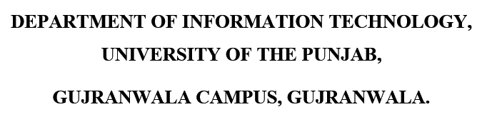
FACULTY OF COMPUTING & INFORMATION TECHNOLOGY (FCIT),
UNIVERSITY OF THE PUNJAB, LAHORE

DECLARATION

We hereby declare that this software, neither whole nor as a part has been copied out from any source. It is further declared that we have developed this software and accompanied report entirely on the basis of our personal efforts. If any part of this project is proved to be copied out from any source or found to be reproduction of some other, we will stand by the consequences. No portion of the work presented has been submitted of any application for any other degree or qualification of this or any other university or institute of learning.

Signature: --------------------------- Signature: ------------------------

Sadia Shahzad [BCS-22002] Fatima Shahzad [BCS-22004]

Signature: --------------------------- Signature: ----------------------

Faiza Arif [BCS-22019] Tayyaba Khalid [BCS-22032]

Signature: ---------------------------

Rimsha Naeem [BCS-22041]

CERTIFICATE OF APPROVAL

It is to certify that the final year design project (FYDP) of BSCS “SignWhispers: Development of a Real-Time ASL to Multilingual Speech Translation System Using AI” was developed by SADIA SHAHZAD (BCS-22002), FATIMA SHAHZAD (BCS-22004), FAIZA ARIF (BCS-22019), TAYYABA KHALID (BCS-22032), and RIMSHA NAEEM (BCS-22041) under the supervision of “SIR RIZWAN ABBAS” in my opinion; it is fully adequate, in scope, and quality for the degree of Bachelor of Science in Computer Science.

Signature:
FYDP Supervisor: Sir Rizwan Abbas

Signatures (Faculty Advisory Committee (FAC)

Signatures
Name | Dr. Salman Naseer | Sir Moodser Hussain | Dr. Naveed Jhamat
 | FAC1 | FAC2 | FAC3

Signature:
Head of FYDP Coordination Office:

Signature:--------------------------------------- Dated:
Chairperson, Department of Information Technology

Executive Summary

SignWhispers addresses a critical communication barrier faced by mute individuals who rely on American Sign Language (ASL) but are unable to communicate effectively with non-signers, particularly across different languages. Existing solutions lack real-time processing, multilingual support, and natural speech output simultaneously, leaving a significant gap in assistive communication technology. This project aims to bridge that gap by developing an end-to-end AI-powered system that recognizes ASL gestures in real time and converts them into natural, multilingual speech.
The system integrates OpenCV and MediaPipe for real-time hand landmark extraction, which then feeds into a trained machine-learning classifier to recognize ASL alphabet gestures. Recognized letters are concatenated into words and sentences, which are then passed to the Google Translate API for multilingual text translation. The translated text is finally synthesized into natural human speech using the ElevenLabs Text-to-Speech API. The backend is built on FastAPI, while the frontend uses React and Tailwind CSS, together forming a layered client-server architecture. The Software Requirements Specification (SRS) and Software Design Specification (SDS) define the system's fifteen functional use cases, including gesture recognition, word formation, language selection, speech output, user history tracking, feedback management, and a premium subscription module. A normalized relational database in Third Normal Form (3NF) manages user accounts, translation history, and feedback data.
The developed prototype demonstrates low-latency, real-time translation of ASL gestures into speech across more than fifty languages, successfully validating the core pipeline from gesture detection to audio output. The system accurately handles variations in lighting, camera angles, and hand sizes, and the modular architecture ensures scalability for future addition of new gestures and languages. The literature review confirmed that no existing solution simultaneously offers real-time performance, multilingual voice output, and a user-centered interface, all of which SignWhispers delivers. The project establishes a strong foundation for assistive communication tools with direct implications for mute individuals, healthcare institutions, educational settings, and government service environments.
Keywords: American Sign Language (ASL), Real-Time Gesture Recognition, Multilingual Text-to-Speech, MediaPipe, Machine Learning, Assistive Communication Technology.

Acknowledgement
We would like to express our sincere gratitude to Allah Almighty, whose guidance and blessings made this work possible.
We are deeply thankful to our project supervisor, Sir Rizwan Abbas, for his continuous guidance, constructive feedback, and unwavering support throughout the development of SignWhispers. His expertise and encouragement kept us focused and motivated at every stage of this project.
We extend our appreciation to the faculty of the Department of Information Technology, University of the Punjab, Gujranwala Campus, for providing us with the academic foundation and resources necessary to undertake this work.
We are also grateful to our families and friends for their patience, moral support, and constant encouragement during the demanding phases of this project.
Finally, we acknowledge the developers and contributors behind the open-source tools and APIs — OpenCV, MediaPipe, Google Translate API, and ElevenLabs — whose technologies formed the backbone of this system.

Signature: --------------------------- Signature: ------------------------

Sadia Shahzad [BCS-22002] Fatima Shahzad[BCS-22004]

Signature: --------------------------- Signature: ----------------------

Faiza Arif [BCS-22019] Tayyaba Khalid[BCS-22032]

Signature: ---------------------------

Rimsha Naeem[BCS-22041]

Abbreviations

Abbreviation | Description
AI | Artificial Intelligence
API | Application Programming Interface
ASL | American Sign Language
BSCS | Bachelor of Science in Computer Science
BL | Backlog List – list of requirements under consideration
CORS | Cross-Origin Resource Sharing
CSS | Cascading Style Sheets
CV | Computer Vision
DB | Database
DFD | Data Flow Diagram
DRY | Don't Repeat Yourself
ER | Entity-Relationship
FCIT | Faculty of Computing and Information Technology
FR | Functional Requirement
FYDP | Final Year Design Project
HTTP | HyperText Transfer Protocol
HTTPS | HyperText Transfer Protocol Secure
IDE | Integrated Development Environment
IT | Integration Testing
JWT | JSON Web Token
LLM | Large Language Model
ML | Machine Learning
MVC | Model-View-Controller
NFR | Non-Functional Requirement
ORM | Object-Relational Mapping
PSL | Pakistan Sign Language
PT | Performance Testing
REST | Representational State Transfer
SDK | Software Development Kit
SDS | Software Design Specification
SQL | Structured Query Language
SRP | Single Responsibility Principle
SRS | Software Requirements Specification
SSL | Secure Sockets Layer
TC | Test Case
TF | TensorFlow
TTS | Text-to-Speech
UC | Use Case
UI | User Interface
UT | Unit Testing
UX | User Experience
3NF | Third Normal Form

Table of Content
Declaration iii
Certificate of Approval iv
Executive Summary v
Acknowledgement vii
Abbreviations viii
List of Figures xi
List of Tables xiii

Chapter 1 Introduction 1

1.1 Introduction 1
1.2 Problem Statement 3
1.3 Problem Solution 4
1.4 Objectives of the Proposed System 5
1.5 Scope 8
1.5.1 Inclusions 8
1.5.2 Exclusions 9
1.5.3 Stakeholders 10
1.5.4 Key Milestones 10
1.6 System Components 11
1.6.1 Module 1: Gesture Recognition & Processing 12
1.6.2 Module 2: Word Formation & Translation 12
1.6.3 Module 3: Speech Synthesis & Audio Output 13
1.6.4 Module 4: User Account Management 13
1.6.5 Module 5: History & Feedback Management 14
1.6.6 Module 6: Admin Panel 14
1.7 Related System Analysis / Literature Review 15
1.8 Vision Statement 16
1.9 System Limitations and Constraints 17
1.10 Tools and Technologies 22
1.11 Project Deliverables 23
1.12 Project Planning 24
1.13 Summary 26

Chapter 2 Requirement Analysis 27

2.1 Analysis 27
2.2 User Classes and Characteristics 28
2.3 Requirement Identifying Technique 29
2.3.1 Use Case Analysis 29
Use Case #1: ASL Alphabet Gesture Recognition 30
Use Case #2: Word Formation from Predicted Letters 30
Use Case #3: End Input and Request Output 32
Use Case #4: Text Translation to Selected Language 33
Use Case #5: Text-to-Speech Conversion 34
Use Case #6: Language Selection 35
Use Case #7: Clear Input Session 37
Use Case #8: Display Real-Time Text Output 38
Use Case #9: View User History 39
Use Case #10: Submit Feedback 40
Use Case #11: User Registration & Login 42
Use Case #12: Premium Subscription & Payment 43
Use Case #13: Admin Login & Dashboard 45
Use Case #14: Admin User & Feedback Management 46
Use Case #15: Admin Payment Management 47
2.3.2 Use Case Diagram 49
2.3.3 Storyboarding 49
2.4 Functional Requirements 51
FR-1 Webcam Initialization 51
FR-2 Hand Detection and Tracking 52
FR-3 ASL Alphabet Letter Recognition 52
FR-4 Letter Prediction Output 53
FR-5 Word Construction Using Letter Concatenation 54
FR-6 User-Controlled Input Completion 55
FR-7 Display Recognized Text 56
FR-8 Language Selection 57
FR-9 Text Translation 57
FR-10 Audio Playback 58
FR-11 Interaction State Management 59
FR-12 User Activity History Storage 59
FR-13 Feedback Management System 60
FR-14 User Authentication 61
FR-15 Payment Processing 61
FR-16 Premium Subscription Activation 62
FR-17 Admin Role-Based Access Control 63
FR-18 Admin Dashboard Analytics 63
2.5 Non-Functional Requirements 64
2.6 External Interface Requirements 66
2.6.1 User Interface Requirements 66
2.6.2 Software Interfaces 66
2.6.3 Hardware Interfaces 67
2.6.4 Communications Interfaces 67
2.7 Summary 67

Chapter 3 Design and Architecture 68

3.1 System Design 68
3.2 Design Considerations 68
3.3 Design Models 69
3.3.1 Design Class Diagram (DCD) 69
3.3.2 Interaction Diagram 71
3.3.3 State Transition Diagram 73
3.4 Architectural Design 76
3.4.1 UML Component Diagram 77
3.5 Data Design 78
3.5.1 Data Dictionary 80
3.6 User Interface Design 96
3.6.1 Screen Images 97
Sign In Page 97
Log In Page 98
Home Page 99
Dashboard (Sign Recording Page) 100
Settings Page 101
Feedback Page 102
Review Page 103
History Page 104
Payment Page 105
Dashboard Page (Admin Panel) 106
User Management Page (Admin Panel) 107
Feedback Management Page (Admin Panel) 108
Payment Page (Admin Panel) 110
3.6.2 Screen Objects and Actions 111
3.7 Behavioural Model 111
3.7.1 Interaction Diagram 111
3.7.2 State Transition Diagram 114
3.8 Design Decisions 117
3.9 Summary 118

Chapter 4 Implementation 119

4.1 Implementation 119
4.2 Algorithm 120
4.2.1 Real-Time ASL Gesture Recognition 120
4.2.2 Word Construction from Sequential Letters 121
4.3 External APIs / SDKs 122
4.4 Code Repository 123
4.4.1 Metrics of the Git Repository 123
4.5 Summary 124

Chapter 5 Testing and Evaluation 125

5.1 Introduction 125
5.2 Unit Testing (UT) 125
UT-01 Hand Landmark Extraction 126
UT-02 ASL Letter Classification 126
UT-03 Word Concatenation Logic 127
UT-04 JWT Token Generation 127
UT-05 History Record Insertion 128
5.3 Functional Testing (FT) 128
FT-01 End-to-End Gesture-to-Letter Pipeline 128
FT-02 Language Selection and Speech Output 129
FT-03 User Registration and Login 129
FT-04 Feedback Submission 130
FT-05 Premium Subscription Payment 130
FT-06 Admin Dashboard Access and Analytics 130
FT-07 User History Retrieval 131
5.4 Integration Testing (IT) 131
IT-01 MediaPipe + ML Model + Frontend Integration 131
IT-02 Google Translate API + ElevenLabs API Integration 132
IT-03 Auth Middleware + History Module Integration 132
IT-04 Stripe Webhook + Premium Activation Integration 133
5.5 Performance Testing (PT) 133
PT-01 Gesture Recognition Response Time 133
PT-02 Translation + Speech API Response Time 134
PT-03 Backend API Load Test 134
5.6 Summary 134

Chapter 6 System Conversion 135

6.1 Introduction 135
6.2 Conversion Method 136
6.3 Deployment 137
6.3.1 Standard Deployment 137
6.3.2 Docker Deployment 138
6.3.3 Data Conversion 139
6.3.4 Training 139
6.4 Post Deployment Testing 140
6.5 Challenges 141
6.6 Summary 142

Chapter 7 Conclusion 143

7.1 Introduction 143
7.2 Evaluation 144
7.3 Traceability Matrix 146
7.4 Conclusion 147
7.4.1 Objectives vs. System Functionality Correlation 148
7.5 Future Work 149

References 150

Appendix-A Use Case Description (Fully Dressed Format) 152
Appendix-B General Coding Standards & Guidelines 154
Appendix-C Application Prototype 156

List of Figures

Figure 1:Gantt Chart 25
Figure 2: Use Case Diagram 49
Figure 3: Capturing the video and getting the output 50
Figure 4-Adjusting the settings 51
Figure 5- Class Diagram 70
Figure 6: User feedback submission sequence 71
Figure 7: User views gesture prediction history sequennce 71
Figure 8: System Admin Use Case 72
Figure 9: Sign Translation 72
Figure 10: Listener Use Case 73
Figure 11: Recording Sign and Gesture 73
Figure 12: Language Selection and Sound Generation 74
Figure 13: Admin Sound Settings Management 74
Figure 14: History and Feedback Management 75
Figure 15: UML Component Diagram 77
Figure 16: Sign In Page 97
Figure 17: Log In Page 98
Figure 18: Home Page 99
Figure 19: Dashboard (Sign Recording Page) 100
Figure 20: Speech Synthesis 101
Figure 21: Feedback Page 102
Figure 22: Review Page 103
Figure 23: History Page 104
Figure 24: Payments Page 105
Figure 25: Dashboard Page 106
Figure 26: User Management Page (Admin Panel) 107
Figure 27: Feedback Management Page (Admin Panel) 108
Figure 28: Payment Page (Admin Panel) 110
Figure 29: Feedback Submission Sequence 112
Figure 30: User Views Gestures Prediction History Sequence 112
Figure 31: System Admin Use Case 113
Figure 32: Sign Translation 113
Figure 33: Listener Use Case 114
Figure 34:Sign Recording & Recognition 114
Figure 35: Language Selection & Sound Generation 115
Figure 36:Admin Sound Settings Management 115
Figure 37: History & Feedback Management 116

List of Tables

Table 1- Tools and Technologies for Proposed Project 22
Table 2-User classes and characteristics 28
Table 3-Use case #1 30
Table 4-Use case #2 30
Table 5-Use Case #3 32
Table 6- Use Case #4 33
Table 7- Use Case #5 34
Table 8- Use Case #6 35
Table 9 - Use Case #7 37
Table 10 - Use Case #8 38
Table 11- Use Case # 10 40
Table 12- Use Case # 11 42
Table 13 - Use Case # 13 45
Table 14 - Use Case # 14 46
Table 15 - Use Case # 15 47
Table 16-Function requirement-1 51
Table 17-Function requirement-2 52
Table 18-Function requirement-4 53
Table 19-Function requirement-5 54
Table 20-Function requirement-6 55
Table 21-Function requirement-7 56
Table 22-Function requirement-8 57
Table 23-Function requirement-9 57
Table 24-Function requirement-10 58
Table 25-Function requirement-11 59
Table 26-Function requirement-12 59
Table 27-Function requirement-13 60
Table 28-Function requirement-14 61
Table 29-Function requirement-15 61
Table 30-Function requirement-16 62
Table 31-Function requirement-17 63
Table 32-Function requirement-18 63
• Table 33- Alphabetical List of System Entities or Major Data with Types and Descriptions: 80
Table 34- Parameters(i) 83
Table 35 - Parameters(ii) 83
Table 36 - Parameters(iii) 85
Table 37- Parameters(iv) 85
Table 38- Parameters(v) 85
Table 39- Parameters(vi) 86
Table 40 - Parameters(vii) 87
Table 41 - Parameters(viii) 87
Table 42 - Parameters(ix) 88
Table 43- Parameters(x) 88
Table 44- Parameters(xi) 89
Table 45 - Parameters(xii) 90
Table 46 - Parameters(xiii) 90
Table 47- Parameters(xiv) 91
Table 48- Parameters(xv) 92
Table 49- Parameters(xvi) 93
Table 50 - Parameters(xvii) 94
Table 51- Parameters(xviii) 94
Table 52- Parameters(xix) 95
Table 53- Parameters(xxi) 97
Table 54- Dashboard 112
Table 55-Feedback Page 112
Table 56- Design Decisions 117
Table 57-Details of APIs used in the project 122
Table 58: Git Repository Metrics 123
Table 59: Test Case UT-01 126
Table 60: Test Case UT-02 126
Table 61: Test Case UT-03 127
Table 62: Test Case UT-04 127
Table 63: Test Case UT-05 128
Table 64: Test Case FT-01 128
Table 65: Test Case FT-02 129
Table 66: Test Case FT-03 129
Table 67: Test Case FT-04 130
Table 68: Test Case FT-05 130
Table 69: Test Case FT-06 130
Table 70: Test Case FT-07 131
Table 71: Test Case IT-01 131
Table 72: Test Case IT-02 132
Table 73: Test Case IT-03 132
Table 74: Test Case IT-04 133
Table 75: Test Case PT-01 133
Table 76:Test Case PT-02 134
Table 77: Test Case PT-03 134
Table 78 : Conversion Method 137
Table 79: Standard Deployment 137
Table 80: Docker Deployment 138
Table 81: Data Conversion 139
Table 82: Use Case 1: Record ASL Gesture and Generate Speech 139
Table 83: Use Case 2 –Submit user feedback 140
Table 84: Post Deployment Testing 140
Table 85: Challenges 141
Table 86: Evaluation 145
Table 87: Traceability Matrix 146
Table 88: Objectives vs System Functionality Correlation 148
Table 89: Future Work 149
Table 90- Show the detail use case template and example 152

Chapter 1

INTRODUCTION

Introduction
This chapter presents a structured overview of the SignWhispers project — a Final Year Project developed by students of the Department of Information Technology, University of the Punjab, Gujranwala Campus. The purpose of this chapter is to establish the foundational context of the project by introducing the problem it addresses, the motivation behind its development, and the direction it takes toward a practical solution.
The chapter begins with the background of the problem domain, highlighting the communication barriers faced by mute individuals in a multilingual world. It then presents a clearly defined problem statement, followed by the project's objectives, scope, and the key stakeholders with vested interests in this system. Additionally, the chapter outlines the assumptions made during the planning phase, the risks identified, and the success criteria against which the project's outcomes will be measured.
To provide a complete picture, this chapter also covers the tools, libraries, and technologies selected for implementation — including OpenCV, MediaPipe, a Machine Learning classifier, FastAPI, Google Translate API, and ElevenLabs — along with the work distribution among the five team members. Together, these elements establish a clear roadmap for the project and demonstrate how SignWhispers contributes toward bridging the communication gap between mute individuals and the broader multilingual community through real-time AI-driven ASL-to-speech translation.

Problem Statement
Despite rapid technological growth, communication for mute individuals remains a major barrier in daily life. According to global disability statistics, over 70 million people worldwide use sign language, yet most communication systems around them do not support real-time understanding of their gestures. The majority of existing solutions only convert sign language into written text or translate it into a single target language, which severely limits practical communication in multilingual environments.
Furthermore, current systems face critical challenges such as:
    - Low accuracy in recognizing gestures when lighting changes or the hand angle varies.
    - Limited gesture coverage, often restricted to basic or predefined signs.
    - Lack of real-time processing, causing delays that disrupt natural conversation.
    - Unnatural or robotic speech output, which affects clarity during communication.
    - Very few tools that support translation into multiple languages with proper accent and natural voice.
These limitations create a significant communication gap for mute individuals in schools, workplaces, hospitals, public spaces, and emergency situations. There is a clear unmet need for a system that can accurately recognize ASL gestures, translate them into multiple languages in real-time, and generate clear, human-like speech so users can communicate independently.
SignWhispers aims to fill this gap by offering a fast, scalable, and practical AI-based ASL-to-multilingual-speech translation solution.

Problem Solution

SignWhispers directly addresses the limitations of existing sign language communication systems by delivering a complete, end-to-end, AI-driven solution that integrates gesture recognition, intelligent word formation, multilingual translation, and natural speech synthesis within a single accessible web platform. The system is purpose-built to serve mute individuals and those who interact with them, removing the dependency on human interpreters and bridging the multilingual communication gap in real time.

At its core, SignWhispers uses OpenCV and MediaPipe to capture live webcam input and extract 21-point hand landmarks with high precision. A trained machine learning classifier then processes these landmark features to identify individual ASL alphabet gestures (A–Z) in real time, even under challenging lighting conditions and varied camera angles. Predicted letters are concatenated into words, and users control input completion to ensure accuracy before output generation. The recognized text is then sent through the Google Translate API to produce multilingual translations, supporting over 50 languages. Finally, ElevenLabs — a state-of-the-art voice synthesis platform — converts the translated text into natural, human-like speech with proper accent and tone, played back instantly through the device speakers.

Beyond the core translation pipeline, SignWhispers provides a full suite of user management features. Authenticated users can access a personalized history of all past interactions, submit feedback on translation quality, and manage account preferences. A Stripe-integrated payment system enables access to premium features. An admin panel provides centralized oversight of users, feedback, payments, and voice settings. The system is built on a modern, scalable technology stack — React.js frontend, FastAPI backend, and MongoDB database — ensuring reliable performance, future extensibility, and ease of deployment across web platforms.

Objectives of the Proposed System

The following measurable and user-focused objectives define what SignWhispers will achieve within the project timeline of February 2026 to July 2026:

- Capture and detect American Sign Language (ASL) alphabet gestures (A–Z) in real time using OpenCV and MediaPipe, achieving stable hand tracking across standard webcam input by Q2 2026.
- Improve gesture detection reliability under low-light conditions, varying camera angles, and different hand sizes through preprocessing techniques, targeting consistent recognition in at least 3 distinct environmental configurations.
- Train a machine learning classifier capable of distinguishing visually similar ASL alphabet gestures with a minimum accuracy target of 85% on the test dataset by Q2 2026.
- Reduce gesture misclassification by applying noise removal, background cleanup, and hand segmentation as preprocessing steps before feature extraction.
- Generate natural, human-like multilingual speech output using the ElevenLabs API, supporting a minimum of 10 languages in the delivered prototype.
- Enable mute users to initiate and complete a full sign-to-speech conversion cycle — from gesture input to audio playback — in under 5 seconds per word, suitable for live conversational use.
- Implement user-controlled input completion to allow accurate word construction from sequential ASL letter gestures before translation is triggered.
- Provide real-time text display of recognized gestures on the user interface so users can verify accuracy before audio is generated.
- Support multilingual translation of recognized English text into a user-selected target language via the Google Translate API, with language selection accessible from the main interface.
- Design and deliver a responsive, user-friendly web interface using React.js and Tailwind CSS, optimized for users with limited technical experience.
- Implement a session-based user account management system with JWT-based authentication, supporting registration, login, and secure profile management.
- Store each user's recognized word history with date and timestamp in MongoDB, accessible from the personal history panel upon login.
- Integrate a feedback submission system allowing authenticated users to rate translation and speech quality, with approved feedback displayed in the website testimonial section.
- Integrate Stripe-based payment processing to enable users to subscribe to premium features by Q3 2026.
- Build and deploy the SignWhispers system as a fully functional web application and conduct at least one round of structured user testing before the final demonstration.

Scope

Inclusions
SignWhispers encompasses the following features and functionalities within the project boundary:
- Real-time ASL alphabet gesture (A–Z) recognition via webcam using OpenCV and MediaPipe hand landmark detection.
- Machine learning-based gesture classification trained on ASL alphabet datasets.
- Word formation by concatenating recognized letters using Python dictionary logic.
- Multilingual text translation (English + 50 languages) via the Google Translate API.
- Natural, multilingual speech synthesis using the ElevenLabs API with audio playback.
- Responsive web interface built with React.js and Tailwind CSS.
- JWT-based user authentication, registration, and session management.
- Per-user interaction history stored in MongoDB with timestamp.
- Feedback submission and testimonial display system.
- Premium feature access via Stripe payment integration.
- Admin panel for user, feedback, payment, and voice settings management.
- FastAPI backend handling all API endpoints and AI model integration.

Exclusions
The following are explicitly excluded from the current scope to prevent scope creep and maintain focus:
- Recognition of sign languages other than ASL (e.g., BSL, ISL, PSL, JSL) in the initial release.
- Recognition of ASL word-level gestures (e.g., 'eat', 'play', 'hi'); only individual letters are supported.
- Offline speech synthesis; ElevenLabs requires active internet connectivity.
- Lip-reading, facial expression recognition, or full-body movement tracking.
- Complex grammatical restructuring or context-aware NLP beyond basic letter-to-word concatenation.
- Multi-person simultaneous signing or group gesture recognition.
- Speech-to-sign translation (only sign-to-speech is in scope).
- Medically or legally certified interpreting — SignWhispers is an assistive tool, not a professional replacement.

Stakeholders
Primary stakeholders include:
- Mute individuals (core users)
- Families and Caregivers
- Educational Institutions
- Healthcare Facilities
- Government Service Departments
- Assistive Technology companies
The development team (five students from the Department of Information Technology, University of the Punjab, Gujranwala Campus) and the project supervisor (Sir Rizwan Abbas) serve as internal project stakeholders.

Key Milestones
- Milestone 01 — Project Proposal Approved: November2025
- Milestone 02 — SRS Completed and Submitted: December 2025
- Milestone 03 — SDS Completed and Submitted: January 2026
- Milestone 04 — Functional Prototype Ready: January 2026
- Milestone 05 — Frontend Development: February 2026
- Milestone 06 — NoSQL Database Architecture & Integration: March 2026
- Milestone 07 — Backend Development: March 2026
- Milestone 08 — Integrated React.js frontend and FastAPI Backend through RESTful APIs: April 2026
- Milestone 09 — Dataset Recorded, ML Model Trained and Integrated: March & April 2026
- Milestone 10 — Full System Deployed and Tested: April & May 2026
- Milestone 11 — Final Report Submitted & FYP Demo: May 2026

System Components

SignWhispers is structured as a single integrated web application with distinct functional modules serving both end users and administrators. The system components are organized as follows:

1.5.1 Module 1: Gesture Recognition & Processing
- Real-time webcam video capture via OpenCV
- Hand landmark detection using MediaPipe (21 key points)
- Preprocessing: noise removal, background cleanup, hand segmentation
- ASL alphabet (A–Z) classification via trained ML model
- Letter prediction output displayed on UI in real time

1.5.2 Module 2: Word Formation & Translation
- Concatenation of predicted letters into words using Python dictionary logic
- User-controlled input completion trigger
- Text verification display before translation
- Multilingual translation via Google Translate API (50+ languages)
- Translated text rendered on the interface before speech output

1.5.3 Module 3: Speech Synthesis & Audio Output
- Natural, human-like voice generation using ElevenLabs API
- Support for 50+ language speech outputs with natural accent and tone
- Audio playback through device speakers
- Voice settings (volume control) manageable by admin

1.5.4 Module 4: User Account Management
- User registration and login with token-based authentication (JWT)
- Session-based user state management on client side
- Secure password handling and profile management
- Premium subscription and payment integration via Stripe

1.5.5 Module 5: History & Feedback Management
- Storage of all recognized words with date and timestamp per user
- User-accessible history panel to review past interactions
- Feedback submission form for rating translation and voice quality
- Feedback displayed on the website testimonial section

1.5.6 Module 6: Admin Panel
- Secure admin login and dashboard overview
- User management: view, activate, deactivate accounts
- Feedback management: review and moderate submissions
- Payment management: track subscriptions and transactions
- Voice/audio settings management across the platform

Related System Analysis/Literature Review

A review of existing sign language tools and applications reveals significant functional gaps that SignWhispers is designed to address. The table below summarizes four key comparable systems, their limitations, and how the proposed project resolves them.

Application Name | Weakness | Proposed Project Solution
HandTalk | Supports only Portuguese; no multilingual output; limited to static gesture vocabulary with no real-time continuous recognition. | SignWhispers supports 50+ languages via ElevenLabs and Google Translate API, with real-time continuous ASL letter recognition.
Google Translate (Camera Mode) | Translates written text in images, not live hand gestures; does not support ASL sign recognition or speech output. | SignWhispers captures live hand gestures via webcam, recognizes ASL, and generates natural speech — end-to-end in real time.
Microsoft Azure AI (Sign Language) | Enterprise-grade and costly; no built-in user history, feedback management, or direct multilingual voice output for mute users. | SignWhispers is lightweight, user-centric with history tracking, feedback submission, and natural voice synthesis accessible to all.
SignAloud / Glove-based Systems | Requires specialized hardware (sensor gloves); expensive, non-scalable, and inaccessible to general users. | SignWhispers requires only a standard webcam — zero proprietary hardware needed, making it affordable and widely accessible.

Vision Statement

For mute individuals, their families, caregivers, healthcare providers, and educational institutions
Who face daily communication barriers due to the absence of real-time, multilingual sign language translation tools
The SignWhispers system
Is an AI-powered, real-time assistive communication web application
That recognizes American Sign Language gestures via webcam, translates them into 50+ languages, and generates natural human-like speech — enabling independent, real-time communication without interpreters
Unlike existing tools that are limited to single-language output, static gesture sets, robotic speech, and lack user management features
Our product delivers an end-to-end, scalable, and user-centric platform that integrates OpenCV, MediaPipe, ML classification, Google Translate, and ElevenLabs — making inclusive communication accessible, natural, and universal

System Limitations and Constraints

The following table distinguishes between external limitations beyond the project team's control and internal constraints that are self-imposed within the project scope.

Type | Factor | Details
Limitation | API Dependency | System depends on ElevenLabs and Google Translate APIs. Any downtime, pricing change, or rate-limit enforcement by these third-party providers directly impacts system availability.
Limitation | Environmental Conditions | Performance degrades due to occluded hand positions or fast hand movements — factors outside the system's control.
Limitation | ASL Only (Initial Version) | Only American Sign Language (ASL) alphabets are supported in the current version due to dataset and scope constraints.
Limitation | Internet Dependency | Translation and speech synthesis require a stable internet connection. Offline functionality is not supported.
Constraint | Scope Boundary | System recognizes only ASL alphabet letters (A–Z). ASL words, BSL, ISL, and other sign languages are excluded from the current scope.
Constraint | Time & Resources | The project is bounded by the Final Year Project timeline (Nov 2025–May 2026) and a team of five students without external funding.
Constraint | Dataset Size | Training data is limited to available open datasets supplemented by manual collection, which may affect generalization across diverse users.

Tools and Technologies

Table 1- Tools and Technologies for Proposed Project

Tools, Libraries, And Technologies | Tools | Version | Rationale
 | VS Code | Latest | Primary IDE for Python, backend and frontend development with rich extensions support
 | Git / GitHub | Latest | Source code management, collaboration, and version tracking
 | MongoDB | Latest | MongoDB is a document-oriented NoSQL database that stores data in flexible, JSON-like documents.
 | Libraries | Version | Rationale
 | OpenCV | Latest | Hand Tracking, gesture preprocessing, and frame analysis.
 | Mediapipe | Latest | Detects hand landmarks, skeleton points, and gesture sequences.
 | Scikit-learn | Latest | Building ML model for gesture classification.
 | NumPy, Pandas | Latest | Effective numerical computation and dataset manipulation.
 | Matplotlib, seaborn | Latest | Dataset analysis, model performance visualization.

 | ElevenLabs API | Latest | Converts recognized text into natural, multilingual speech
 | Google Translate API | Latest | Translates text into multiple languages before speech synthesis.
 | dotenv | Latest | Stores and manages API keys and environment variables securely.
 | Requests | Latest | Call external APIs from backend.
 | pydantic | Latest | Validates requests and input data for backend API.
 | @hookform/resolv ers | Latest | Ensures safe and consistent frontend form validation
 | Technology | Version | Rationale
 | ML Classification Algorithms | Traditional | Classifies the gesture.
 | FastAPI | Latest | Handles API endpoints, manages requests from frontend and integrates AI models.
 | React.js | Latest | Component-based UI for building interactive frontend interfaces
 | Tailwind CSS | Latest | Rapid styling framework for responsive and consistent design.
 | React Router Dom | Latest | Manages routing in single-page React applications.
 | HTML5, CSS3, JS | Latest | Core web technologies for frontend structure, styling and interaction.

Project Deliverables

The following deliverables will be produced across the project lifecycle and appended to the Final Year Project report as formal documentation artifacts:

Sr. | Deliverable | Description
1 | Project Proposal | Initial project proposal submitted to supervisor outlining problem statement, objectives, scope, and team composition.
2 | Software Requirements Specification (SRS) | Detailed document defining functional and non-functional requirements, use cases, and system constraints.
3 | Software Design Specification (SDS) | Architecture and design document including class diagrams, sequence diagrams, state diagrams, and data dictionary.
4 | System Prototype | Functional prototype demonstrating gesture recognition, translation, and speech output with basic UI.
5 | Final Project (Deployed System) | Fully implemented and deployed web-based SignWhispers system with all integrated modules.
6 | Final FYP Report | Comprehensive academic report documenting all phases, findings, evaluations, and references. Submitted as appendices.

Project Planning

The Gantt chart below outlines the planned schedule for all major project activities from December 2025 to May 2026. Shaded cells (■) represent the active period for each phase. Milestones align with the deliverable submissions described in Section 1.10.

Phase / Activity | Nov 2025 | Dec 2025 | Jan 2026 | Feb 2026 | Mar 2026 | April 2026 | May 2026
Proposal
SRS
SDS
Prototype
Frontend Development
Database Configuration
Backend Development
Integration of Frontend and Backend
Dataset and ML model
Deployment and Testing
FYP Report and Viva
Figure 1:Gantt Chart
Resources Required: Team of 5 students (Project Leader, AI Developer ×2, Backend Developer, QA & Deployment, Frontend Developer), project supervisor (Sir Rizwan Abbas), development workstations with GPU support for ML training, internet-connected environment for API testing, VS Code IDE, GitHub for version control, and MongoDB Atlas for cloud database hosting.

Summary

This chapter has established the complete introductory foundation of the SignWhispers project. It began by articulating the real-world communication barrier faced by over 70 million mute sign language users globally, and identified the critical gaps in existing solutions — limited gesture coverage, single-language output, robotic speech, and absence of user-centric features.

The proposed solution, SignWhispers, addresses these gaps through an integrated AI pipeline combining OpenCV, MediaPipe, machine learning classification, Google Translate API, and ElevenLabs speech synthesis — all delivered through a modern React.js and FastAPI web stack. Fifteen measurable objectives were defined, a clear scope with explicit inclusions and exclusions was established, and six system modules were identified to structure the implementation.

The related system analysis demonstrated that no existing tool provides the complete combination of real-time ASL recognition, multilingual output, natural speech synthesis, and user management that SignWhispers offers. The vision statement affirms the system's long-term purpose as an accessible, universal communication enabler. Limitations and constraints were transparently documented, and a structured project plan with milestones and a Gantt chart ensures accountability throughout the development lifecycle.

The subsequent chapters will build upon this foundation: Chapter 2 provides a detailed literature review, Chapter 3 defines the Software Requirements Specification (SRS), and Chapter 4 presents the Software Design Specification (SDS) — collectively forming the complete academic and technical documentation of the SignWhispers Final Year Project.

Chapter 2

Requirement Analysis

Analysis

This section analyzes the requirements of the SignWhispers system based on defined project objectives, stakeholder needs, and technical constraints. It specifies the system’s functional, non-functional, and interface requirements to clearly define expected behavior and implementation boundaries.
The system focuses on recognizing individual ASL alphabet gestures, converting them into words using predefined logic, and generating multilingual speech output under user control. Advanced language processing features are excluded from the current scope and identified as future enhancements.

User classes and characteristics

This section formally identifies the distinct groups of stakeholders who will interact with the SignWhispers system, detailing their characteristics, technical proficiency, and specific requirements from the system.

Table 2-User classes and characteristics

User Class | User Characteristics
Families/Caregivers | Assist or supervise mute individuals. Interested in verifying that the translation is correct. May use system to facilitate communication at home or in public places.
Education Institutes / Teachers | Work with students using ASL. Need an accessible tool for classroom communication. Likely to monitor multiple students. May not be ASL experts themselves.
Healthcare Providers/Staff | Need quick and accurate translation of ASL letters to words for patient interaction. Usually non-ASL users. Require system to be fast and reliable in clinical settings.

Assistive Technology Developers / Researcher | Interested in integration, testing, and improving the system. Likely to have technical knowledge. Use system for testing performance and robustness under different conditions.

Requirement Identifying Technique
This section outlines the techniques used to identify and derive functional requirements for the SignWhispers system. Selecting appropriate techniques ensures accurate and complete requirement elicitation, which is crucial for successful development. The choice of technique depends on system type, user interaction, and visual complexity.

Use Case Analysis:
Use case analysis is used for interactive end-user applications, defining how users interact with the system to achieve specific goals.
- Use Case Diagram: Shows a visual representation of actors and their interactions with the system.
- Use Case Descriptions: Fully dressed use cases detail each interaction, including steps, preconditions, postconditions, exceptions, and associated requirements.
Benefits:
- Captures functional requirements from the user’s perspective.
- Validates system behavior against user expectations.
- Provides traceability from requirements to design and testing.

Example:
- Use Case Name: “Translate Sign Language to Text”
- Actors: User, System
- Description: Captures sign language gestures via a camera and converts them into readable text.
- Preconditions: User is logged in and camera is enabled.
- Postconditions: Text output is displayed accurately

Use Case #1: (ASL Alphabet Gesture Recognition U1)

Table 3-Use case #1

UC Identifier | UC1
Requirements Traceability | FR-1, FR-2
Purpose | The purpose of this use case is to capture real-time ASL alphabet gestures using a webcam and recognize individual letters through hand landmark detection and machine learning prediction.
Priority | High
Preconditions | The system is launched successfully.  - A functional webcam is connected and accessible.  - Adequate lighting conditions are available.
Postconditions | - The detected ASL alphabet letter is displayed on the screen.  - The predicted letter is stored temporarily for word formation.
Actors | User, Webcam, SignWhispers System
Extends | None

Use Case #2:(Word Formation from Predicted Letters U2)
Table 4-Use case #2

UC Identifier | UC2
Requirements Traceability | FR-3
Purpose | To convert individually predicted ASL letters into meaningful words using predefined dictionary logic.
Priority | High
Preconditions | At least one ASL letter has been successfully recognized.
Postconditions | A complete word string is displayed to the user.

Actors | User, SignWhispers System
Extends | None
Main Success Scenario | - The system stores each predicted letter sequentially.  - The user continues gesture input.  - Letters are appended into a string using dictionary-based mapping.  - The system displays the formed word in real time
Alternate Flows | The user pauses input without completing a word.
Exceptions | Invalid letter sequence.
Includes | UC1

Use Case #3:(End Input and Request Output U3):

Table 5-Use Case #3

UC Identifier | UC3
Requirements Traceability | FR-4
Purpose | To allow the user to explicitly indicate the completion of input and request final output generation.
Priority | High
Preconditions | One or more words have been generated.
Postconditions | The system locks further input and proceeds to translation.
Actors | User, SignWhispers System

Extends | None
Main Success Scenario | - The user selects the “End Input” control.  - The system stops gesture recognition.  - The final text string is confirmed for processing.
Alternate Flows | The user cancels the request and resumes input.
Exceptions | No input available for processing.
Includes | UC2

Main Success Scenario | - The user positions their hand in front of the webcam.  - The system captures video frames in real time.  - MediaPipe extracts hand landmarks.  - The machine learning model predicts the ASL alphabet letter.  - The system displays the detected letter to the user.
Alternate Flows | If the hand is not detected, the system prompts the user to reposition the hand.
Exceptions | - Webcam access failure.  - Inadequate lighting causing recognition failure.
Includes | None

Use Case #4: (Text Translation to Selected Language U4)

Table 6- Use Case #4

UC Identifier | UC4
Requirements Traceability | FR-5
Purpose | To translate the generated text into a user-selected language using Google Translate API.
Priority | Medium
Preconditions | - Input text is finalized.  - Internet connectivity is available.
Postconditions | Translated text is generated and displayed.
Actors | User, SignWhispers System, Google Translate API

Extends | None
Main Success Scenario | - The user selects a target language.  - The system sends the text to Google Translate API.  - The translated output is received and displayed.
Alternate Flows | Default language translation is applied if no selection is made.
Exceptions | API unavailability or network failure.
Includes | UC3

Use Case #5: (Text-to-Speech Conversion U5)
Table 7- Use Case #5

UC Identifier | UC5
Requirements Traceability | FR-6
Purpose | To convert translated text into spoken audio output using the ElevenLabs API.
Priority | Medium
Preconditions | - Translated text is available.  - Audio output device is functional.
Postconditions | Spoken audio output is played to the user.

Actors | SignWhispers System, ElevenLabs API
Extends | None
Main Success Scenario | - The system sends translated text to ElevenLabs API.  - The API returns synthesized speech.  - The system plays the audio output.
Alternate Flows | Text-only output if audio playback fails.
Exceptions | API response delay or failure.
Includes | UC4

Use Case #6: (Language Selection U6)

Table 8- Use Case #6

UC Identifier | UC6
Requirements Traceability | FR-8
Purpose | To allow the user to select the target language for text translation and speech output.
Priority | Medium
Preconditions | - The system is active.  - Input text is available or being generated.

Postconditions | The selected language is set as the output language for translation.
Actors | User, SignWhispers System
Extends | None
Main Success Scenario | - The user opens the language selection option.  - The user selects a preferred output language.  - The system stores the selected language for subsequent translation.
Alternate Flows | The system applies a default language if no selection is made.
Exceptions | Unsupported language selection.
Includes | None

Use Case #7: (Clear Input Session U7)

Table 9 - Use Case #7

UC Identifier | UC7
Requirements Traceability | FR-6,FR-11
Purpose | To allow the user to clear the current input and restart gesture recognition.

Priority | Low
Preconditions | One or more letters or words have been generated.
Postconditions | - All temporary input data is cleared.  - The system returns to initial recognition state.
Actors | User, SignWhispers System
Extends | None
Main Success Scenario | - The user selects the “Clear Input” option.  - The system removes all stored letters and words.  - Gesture recognition restarts.
Alternate Flows | The user cancels the clear request.
Exceptions | None
Includes | None

Use Case #8: (Display Real-Time Text Output U9)

Table 10 - Use Case #8

UC Identifier | UC8

Requirements Traceability | FR-4,FR-7
Purpose | To display recognized letters and generated words in real time for user confirmation.
Priority | High
Preconditions | Gesture recognition is active.
Postconditions | Real-time text output is visible on the interface.
Actors | SignWhispers System, Users
Extends | None
Main Success Scenario | - The system recognizes an ASL alphabet letter.  - The letter is immediately displayed on the screen.  - Generated words are updated dynamically.
Alternate Flows | Temporary delay in display due to processing load
Exceptions | Display rendering failure.
Includes | UC1

Use Case #9: (View User History U9)

UC Identifier | UC9
Requirements Traceability | FR-12
Purpose | To allow a logged-in user to view previously recorded signed words and timestamps.
Priority | Medium
Preconditions | - The user must be authenticated.  - There must be one or more saved history entries.  - ​
Postconditions | User can see list of previously translated words and their timestamps.
Actors | User, SignWhispers System
Extends | None
Main Success Scenario | - User selects the “History” option from UI menu.  - The system fetches stored history from the database.  - The system displays the list of past translated/sign output words with date and time.
Alternate Flows | A1: No history entries found  The system displays a message: “No history available.”
Exceptions | E1: Database unavailable  Error message displayed, user stays on history page.

Includes | UC1 (User Login) — implicitly required before access

Use Case #10: (Submit Feedback U10)

Table 11- Use Case # 10

UC Identifier | UC10
Requirements Traceability | FR-13
Purpose | To allow authenticated users to submit feedback regarding the SignWhispers system.
Priority | Low
Preconditions | User must be logged in.  Feedback form is available on the UI.
Postconditions | - Feedback is stored in the database.  - Optionally displayed on testimonial section.
Actors | User, SignWhispers System
Extends | None
Main Success Scenario | - User navigates to Feedback/Testimonials page.  - User writes a feedback comment.  - User submits the feedback form.  - The system validates the input.  - The system stores the feedback entry in the database.  - Confirmation message is shown.

 | - Feedback appears on testimonial section (if auto-publish enabled)
Alternate Flows | A1: Empty feedback submitted  - System shows error message: “Feedback cannot be empty.”  A2: Duplicate feedback in same session  - System prevents submission and alerts user.
Exceptions | E1: Database connectivity issue  System shows “Unable to submit feedback at this moment.”
Includes | (User Login) — implicitly required

Use Case #11: (User Registration & Login U11)

Table 12- Use Case # 11

UC Identifier | UC11
Requirements Traceability | FR-13
Purpose | Allow users to create an account and login.
Priority | High
Preconditions | Registration/login page accessible.

Postconditions | Account created and/or user logged in with JWT tokens.
Actors | User, SignWhispers System
Extends | None
Main Success Scenario | User navigates to registration page. User enters email and password.  System validates input:  - Checks duplicate email during registration.  - Checks credentials during login.  Account is created / User receives JWT tokens. Confirmation message shown.
Alternate Flows | A1: Email already exists → System shows error during registration.  A2: Weak password → System prompts for stronger password. A3: Invalid login credentials → System increments failed login counter and shows error.  A4: Account locked due to multiple failed login attempts →  System shows lockout message.
Exceptions | E1: Database connectivity issue → Display “Unable to register/login at this time.”
Includes | (User Login) — implicitly required

Use Case #12: ( Premium Subscription & Payment U12)

UC Identifier | UC12
Requirements Traceability | FR-13
Purpose | Allow users to purchase premium subscription and access premium features.
Priority | High
Preconditions | User must be logged in; payment options available.
Postconditions | Payment verified; premium features accessible..
Actors | User, SignWhispers System, Payment Gateway, ElevenLabs API
Extends | None
Main Success Scenario | - User selects premium plan.  - System redirects to payment gateway.  - User completes payment.  - System verifies payment via webhook.  - Premium TTS/voice features enabled.
Alternate Flows | A1: Payment canceled by user → System shows cancellation message.  A2: Payment failed → Show error message.  A3: Premium access denied → Show “Upgrade required” message.

Exceptions | E1: Payment gateway unavailable → Show “Unable to process payment at this time.”  E2: Webhook not received → Retry verification or allow manual verification.  E3: Premium voice API failure → Revert to standard voice or show error.
Includes | (User Login) — implicitly required

Use Case #13: (Admin Login & Dashboard U13)

Table 13 - Use Case # 13

UC Identifier | UC13
Requirements Traceability | FR-13
Purpose | Allow admin users to login and view dashboard analytics.
Priority | High
Preconditions | Admin credentials exist.
Postconditions | Admin gains access to dashboard with analytics.
Actors | Admin, SignWhispers System

Extends | None
Main Success Scenario | - Admin navigates to login page.  - Admin enters credentials.  - System validates credentials and grants access.  - Admin can view analytics: users, premium users, translations, revenue.
Alternate Flows | A1: Invalid credentials → Show error message.  A2: No analytics data available → Show “No analytics data.”
Exceptions | - E1: Database error → Show “Unable to fetch analytics.”
Includes | (User Login) — implicitly required

Use Case #14: (Admin User & Feedback Management U14)

Table 14 - Use Case # 14

UC Identifier | UC14
Requirements Traceability | FR-13
Purpose | Allow admin to manage users and feedback.
Priority | High
Preconditions | Admin logged in.

Postconditions | Users/feedback updated in database.
Actors | Admin, SignWhispers System
Extends | None
Main Success Scenario | - Admin navigates to user/feedback management panel.  - Admin selects user/feedback and updates status (activate/deactivate/delete or publish/hide).  - Changes are saved and reflected in the system.
Alternate Flows | A1: Attempt to modify non-existent user → Show error. A2: No feedback available → Show “No feedback available.”
Exceptions | - E1: Database issue → Show “Unable to update user/feedback.”
Includes | (User Login) — implicitly required

Use Case #15: (Admin Payment Management U15)

Table 15 - Use Case # 15

UC Identifier | UC15
Requirements Traceability | FR-13

Purpose | Allow admin to view and manage payments/subscriptions.
Priority | High
Preconditions | Admin logged in.
Postconditions | Payment records updated/displayed.
Actors | Admin, SignWhispers System
Extends | None
Main Success Scenario | - Admin navigates to payment management panel.  - Admin views/updates/verifies payment records.  - Changes are saved and reflected in the system.
Alternate Flows | A1: Payment data missing → Show “No payment records.
Exceptions | E1: Database error → Show “Unable to fetch payment records.”
Includes | (User Login) — implicitly required

Use Case Diagram:
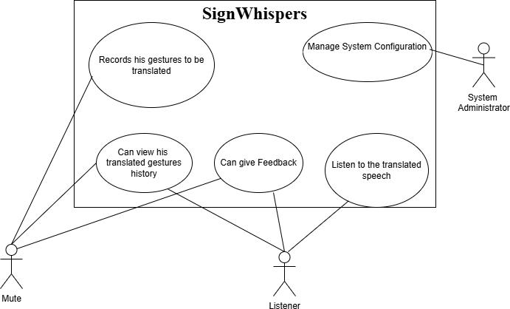

Figure 2: Use Case Diagram

Storyboarding

Storyboarding is ideal for graphically intensive applications where visual flow and sequence of events are important. It uses sketches, mockups, or visual representations to illustrate user interactions across screens.
- Visual Flow: Shows the sequence of actions, system responses, and transitions.
- Design Mockups: Displays interface layout and design elements for each step.

Example:
Storyboard depicting the process of selecting a sign language video, translating it to text, and displaying results.

Conclusion:
The SignWhispers system employs a combination of use case analysis and storyboarding. Use cases capture functional interactions, while storyboards provide visual clarity for interface and workflow, ensuring comprehensive and accurate requirement elicitation.

Capturing the video and getting the output

Actor: mute

Precondition: Disable person is on the main page
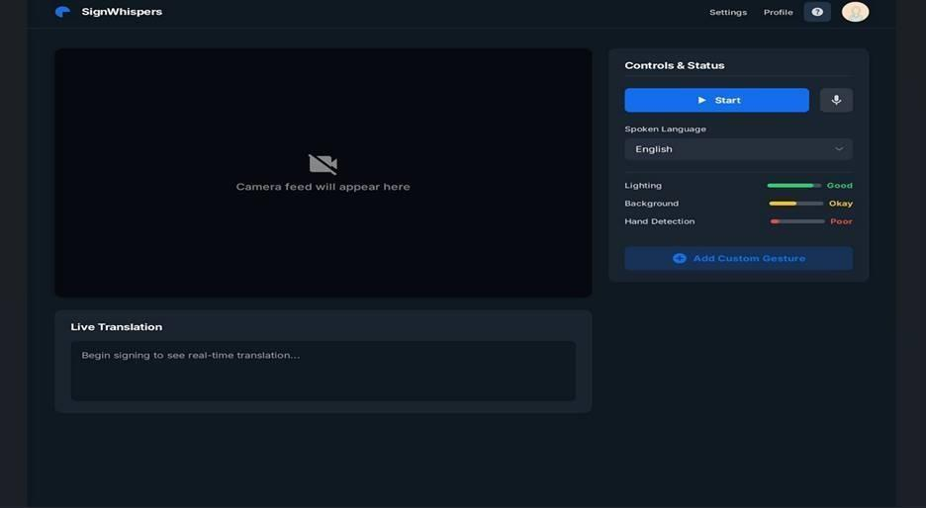
Figure 3: Capturing the video and getting the output
Figure SEQ Figure \* ARABIC 3: Capturing the video and getting the output
Text Narration:

- The mute person lands on this page after login or register page.
- He / She does the basic settings and choose the desired output language.
- Then he presses the ‘Start’ button to start capturing him and his ASL signs.
- His signs are recognized by the model and the output is shown as both text, on text pannel
,and audio playings.

Adjusting the Settings
Actor: Listener

Precondition: The listener is at the Settings Page to adjust the output according to his needs.

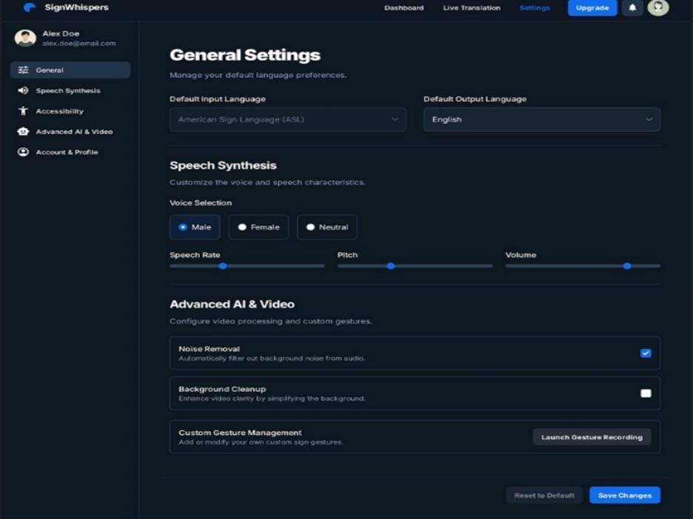
Figure 4-Adjusting the settings

Text Narrations:
- The listener can adjust the output settings according to his/her needs or moods at the “General Settings” page.
- They can choose the output language.
- They can select the Gender of the output voice.
- They can adjust the Volume as well.

Functional Requirements
This section defines the functional requirements of the SignWhispers system, outlining the essential system behaviors and features required to support ASL letter recognition, text generation, multilingual translation, and speech output. Each requirement is uniquely identified to clearly specify system functionality and expected responses.

Functional Requirements

Functional Requirement-1:
Table 16-Function requirement-1

Identifier | FR-1
Title | Webcam Initialization
Requirement | The system shall allow the user to activate the webcam to capture real-time video input for ASL letter recognition.

Source | Mute user / Project requirements
Rationale | Webcam input is required to capture hand gestures for further processing.
Business Rule | Webcam access permission must be granted by the user.
Dependencies | None
Priority | High

Functional Requirement-2:
Table 17-Function requirement-2

Identifier | FR-2
Title | Hand Detection and Tracking
Requirement | The system shall detect and track the user’s hand in real time using OpenCV and MediaPipe hand landmark detection.
Source | System design
Rationale | Accurate hand detection is essential for reliable gesture recognition.
Business Rule | Hand must be visible within camera frame.
Dependencies | FR-1
Priority | High

Functional Requirement-3:

Identifier | FR-3
Title | ASL Alphabet Letter Recognition
Requirement | The system shall recognize individual American Sign Language (ASL) alphabet gestures using a trained machine learning model.
Source | Project objectives
Rationale | Core functionality of the system is letter-level gesture recognition.
Business Rule | Only predefined ASL alphabet gestures (A–Z) are supported.
Dependencies | FR-2
Priority | High

Functional Requirement-4:
Table 18-Function requirement-4

Identifier | FR-4
Title | Letter Prediction Output
Requirement | Upon successful gesture recognition, the system shall output the predicted ASL letter in textual form.
Source | User requirement
Rationale | Users need visible confirmation of recognized letters.

Business Rule | Only one letter shall be predicted at a time.
Dependencies | FR-3
Priority | High

Functional Requirement-5:
Table 19-Function requirement-5

Identifier | FR-5
Title | Word Construction Using Letter Concatenation.
Requirement | The system shall convert predicted letters into words using predefined Python dictionary-based logic.
Source | System Design
Rationale | Enables formation of readable words from individual letters.
Business Rule | Words are formed strictly from letter sequences without grammatical correction.
Dependencies | FR-4
Priority | High

Functional Requirement-6:

Table 20-Function requirement-6

Identifier | FR-6
Title | User-Controlled Input Completion
Requirement | The system shall provide the user with a control to indicate the completion of gesture input before requesting translation or speech output.
Source | User requirement
Rationale | Prevents premature translation and ensures correct word formation.
Business Rule | Translation cannot start until input completion is confirmed.
Dependencies | FR-5
Priority | High

Functional Requirement-7:
Table 21-Function requirement-7

Identifier | FR-7
Title | Display Recognized Text
Requirement | The system shall display the generated text string on the user interface before translation and speech generation.
Source | Usability requirement
Rationale | Allows users to verify text before output.
Business Rule | Text display is mandatory before audio generation.

Dependencies | FR-6
Priority | Medium

Functional Requirement-8:
Table 22-Function requirement-8

Identifier | FR-8
Title | Language Selection
Requirement | The system shall allow the user to select a target language for translation from the available options.
Source | User requirement
Rationale | Enables multilingual communication.
Business Rule | Only supported languages shall be selectable.
Dependencies | FR-6
Priority | Medium

Functional Requirement-9:
Table 23-Function requirement-9

Identifier | FR-9

Title | Text Translation
Requirement | The system shall translate the generated text into the selected target language using the Google Translate API.
Source | System requirement
Rationale | Required for multilingual speech output.
Business Rule | Internet connectivity is required for translation.
Dependencies | FR-8
Priority | High

Functional Requirement-10:
Table 24-Function requirement-10

Identifier | FR-10
Title | Audio Playback
Requirement | The system shall play the generated speech output through the device’s audio system.
Source | User requirement
Rationale | Final communication output of the system.
Business Rule | Audio playback volume follows system settings.

Dependencies | FR-9
Priority | High

Functional Requirement-11:
Table 25-Function requirement-11

Identifier | FR-11
Title | Interaction State Management
Requirement | The system shall manage the user’s interaction state during a single sign input and output cycle using client-side state handling and token-based authentication, without maintaining server-side  sessions.
Source | System design
Rationale | Ensures a structured and controlled interaction flow while maintaining a stateless backend architecture.
Business Rule | Interaction state shall reset after text and audio output generation.
Dependencies | FR-6
Priority | Low

Functional Requirement-12:
Table 26-Function requirement-12

Identifier | FR-12

Title | User Activity History Storage
Requirement | The system shall store each recognized word along with the date and time it was generated in a database for every authenticated user.
Source | User requirement / Project scope
Rationale | Allows users to revisit previous sign translations and supports future references.
Business Rule | History entries must only be stored for logged-in users.
Dependencies | FR-7, FR-9, FR-10 (text must be generated first)
Priority | Medium

Functional Requirement-13:
Table 27-Function requirement-13

Identifier | FR-13
Title | Feedback Management System
Requirement | The system shall allow authenticated users to submit feedback, which shall be stored in the database and displayed on the website’s testimonial section.
Source | User satisfaction / Evaluation requirement
Rationale | Ensures continuous improvement of the system through user input.
Business Rule | Only one feedback submission per user per session is allowed.
Dependencies | None (requires only valid authentication)

Priority | Low

Functional Requirement-14:
Table 28-Function requirement-14

Identifier | FR-14
Title | User Authentication
Requirement | The system shall authenticate users using email and password and generate JWT access and refresh tokens.
Source | Security Requirement
Rationale | Required for secure access to protected features.
Business Rule | Incorrect credentials increase failed login attempt counter.
Dependencies | None
Priority | High

Functional Requirement-15:
Table 29-Function requirement-15

Identifier | FR-15
Title | Payment Processing
Requirement | The system shall integrate with a payment gateway to process premium subscriptions.

Source | Business Requirement
Rationale | Enables monetization of the system.
Business Rule | Payment status must be verified through webhook confirmation.
Dependencies | None
Priority | High

Functional Requirement-16:
Table 30-Function requirement-16

Identifier | FR-16
Title | Premium Subscription Activation
Requirement | The system shall activate premium status for users after successful payment verification.
Source | System design
Rationale | Required to unlock premium voice generation feature.
Business Rule | Premium access shall only be granted if payment status is "success".
Dependencies | FR-15
Priority | High

Functional Requirement-17:
Table 31-Function requirement-17

Identifier | FR-17
Title | Admin Role-Based Access Control
Requirement | The system shall restrict administrative routes to users with role = "admin".
Source | Security Requirement
Rationale | Ensures secure access to administrative functionalities.
Business Rule | Unauthorized users must receive HTTP 403 response.
Dependencies | FR-14
Priority | High

Functional Requirement-18:
Table 32-Function requirement-18

Identifier | FR-18
Title | Admin Dashboard Analytics
Requirement | The system shall provide aggregated statistics including total users, premium users, translations count, and revenue.
Source | Stakeholder Requirement

Rationale | Allows monitoring and system management.
Business Rule | Only admin users shall access analytics data.
Dependencies | FR-17
Priority | Medium

Non-Functional Requirements
This section defines the quality attributes and operational constraints of the SignWhispers system. These requirements ensure the system performs reliably, efficiently, securely, and consistently under expected usage conditions.

Reliability
  - The system shall maintain an operational availability of at least 95% during active usage.
  - The system shall detect webcam or hand-tracking failures and notify the user within 5 seconds.
  - The system shall recover from runtime errors without data corruption.
  - The system shall not crash due to invalid or incomplete gesture input.
  - The system shall safely terminate input sessions when the user explicitly ends recognition.

Usability
  - New users shall be able to operate the system without prior training.
  - The system shall allow gesture recognition to start within 3 user interactions.
  - The system shall clearly display detected letters and generated text in real time.
  - Error messages shall be understandable and guide the user toward corrective actions.
  - The system shall support users with minimal technical knowledge.

Performance
  - The system shall process webcam frames in real time.
  - ASL alphabet prediction shall be completed within 2 seconds per gesture.
  - Word formation from predicted letters shall occur without noticeable delay.
  - Translation output shall be generated within 5 seconds after user request.

Accuracy
  - The machine learning model shall achieve acceptable letter-level prediction accuracy under normal lighting conditions.
  - The system shall minimize false letter predictions during stable hand gestures.
  - Prediction accuracy shall not degrade significantly during continuous input sessions.

Security
  - The system shall not permanently store webcam video or image frames.
  - User input data shall be processed only during runtime.
  - External API communication shall prevent unauthorized access to system data.
  - The system shall not expose internal model predictions to external entities.

Privacy
  - The system shall not collect personally identifiable user information.
  - No gesture data shall be logged or reused for training without user consent.
  - All temporary data shall be cleared after session completion.
  - The system shall comply with basic data privacy principles.

Availability
  - The system shall be available for use whenever the required hardware and internet connection are available.
  - The system shall notify the user if external services (translation or speech APIs) are unavailable.
  - Offline operation shall be limited to gesture recognition only.

Scalability
  - The system architecture shall support future expansion for sentence-level translation.
  - The system shall allow integration of additional gesture datasets without major redesign.
  - The system shall support additional output languages in future versions.

Maintainability
  - The system shall be modular to allow independent updates of gesture detection, prediction, and output modules.
  - Code shall be structured to support debugging and future enhancements.
  - Model updates shall not require changes to the user interface.

Constraints

The system shall recognize only ASL alphabet gestures.
  - Sentence-level translation is excluded from the current scope.
  - No CNN-LSTM or sliding window techniques shall be used.
  - No OpenAI API shall be used for text structuring or sentence formation.

External Interface Requirements
This section defines the interfaces through which the SignWhispers system interacts with users, hardware devices, and external software services.

User Interfaces Requirements
The system shall provide a graphical user interface displaying live webcam feed, detected letters, generated text, and control buttons.
Standard buttons such as Start Input, End Input, and Generate Output shall be available on the main screen.
The interface shall follow consistent font styles, icons, and color schemes to ensure clarity.
Visual feedback shall be provided to indicate active detection and processing states.
The interface shall support clear layout standards suitable for future localization.

Software interfaces

- The system shall interface with:
- OpenCV for webcam input and frame processing.
- MediaPipe for hand landmark detection
- A custom machine learning model for ASL letter prediction.
- Google Translator API for multilingual text translation.
- ElevenLabs API for text-to-speech conversion.
- The system shall operate on a Python runtime environment.

Hardware interfaces

- The system shall require access to a standard webcam for gesture input.
- The webcam shall support real-time video capture with sufficient resolution for hand landmark detection.
- No additional hardware devices are required.

Communications interfaces

- The system shall use an internet connection to communicate with external translation and text-to-speech services.
- Standard web communication protocols shall be used for API requests and responses.
- The system shall handle network delays gracefully and notify the user in case of communication failure.

Summary
The use cases presented in this section comprehensively describe the interactions between users and the SignWhispers system. They cover the complete operational workflow, from ASL alphabet gesture recognition and word formation to multilingual translation, speech generation, and system control. Together, these use cases ensure clear functional coverage, traceability to system requirements, and a structured foundation for design, implementation, and validation of the system.

Chapter 3
Design and Architecture

System Design
SignWhispers is a web-based system that converts sign language into text and speech. It captures signs through a webcam using OpenCV and MediaPipe, processes landmark data via a machine learning model, and displays the recognized output on the screen. For voice generation, the system integrates Google Translator API for language translation and ElevenLabs API for speech synthesis. A database is used for user history and feedback storage, while an admin interface manages sound-related configurations.
The system design is influenced by real-time processing requirements, dependency on external APIs, and internet availability. Performance, API response time, and browser compatibility are key constraints that impact overall system behavior and responsiveness.

Design considerations
Assumptions and Dependencies:
      - Users have access to a functional webcam and stable internet connection
      - Hand gestures are performed within the camera frame and under reasonable lighting conditions
      - External APIs (Google Translator, ElevenLabs) are available and respond within acceptable time
      - The ML model is pre-trained and capable of recognizing supported signs accurately
      - Users must be logged in for history and feedback features to function

Limitations:
      - The system recognizes only trained signs and does not support full continuous sign language grammar
      - Accuracy may degrade under poor lighting, fast hand movement, or camera obstruction
      - Real-time performance depends on internet speed and API latency
      - Voice generation options are limited to parameters supported by the ElevenLabs API
      - Offline functionality is not supported

Risks: Identifies potential risks and how they were addressed in the design

Design Models
This section describes the design models used to represent the internal structure and behavior of the SignWhispers system. Each model is aligned with object-oriented design principles and directly reflects the finalized system workflow and functionalities.

- Class Diagram
- Interaction Diagram (Either sequence or collaboration)
- State Transition Diagram (for the projects that include event handling and backend processes)

Design Class Diagram (DCD)
The class diagram defines the static structure of the SignWhispers system by showing core classes, their attributes, and operations. The User class holds basic user information and authentication functions, serving as the primary entity interacting with the system. User- related activities such as feedback submission and history storage are linked through service classes.
Gesture-related processing is handled through Gesture, Gesture_Capture, Landmark, and Landmark_Extractor classes. Gesture_Capture controls camera operations and captures signs, while Landmark_Extractor extracts coordinate data from captured gestures. The Sign_Recognizer class processes the extracted data and predicts the corresponding sign output.
Language and audio processing are managed by LanguageTranslator, Translation, and Speech_Generator classes. LanguageTranslator translates recognized text into the selected language, Translation stores translation details, and Speech_Generator converts the final text into speech. System data persistence is handled by History, History_Service, Feedback, and Feedback_Service classes, which store user interaction records and feedback in the database. This class diagram clearly represents how system components are structured and how responsibilities are divided across classes.
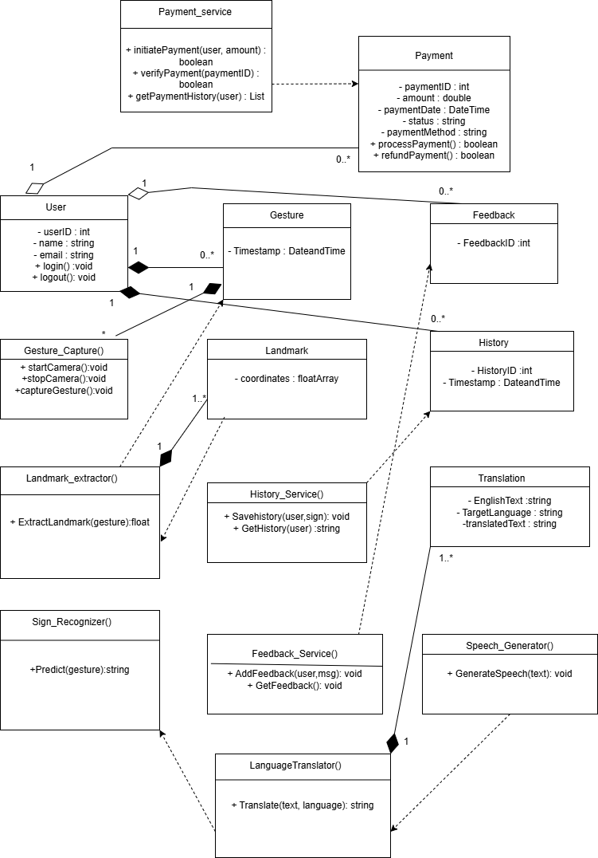
Figure 5- Class Diagram

Interaction Diagram

User Feedback Submission Sequence
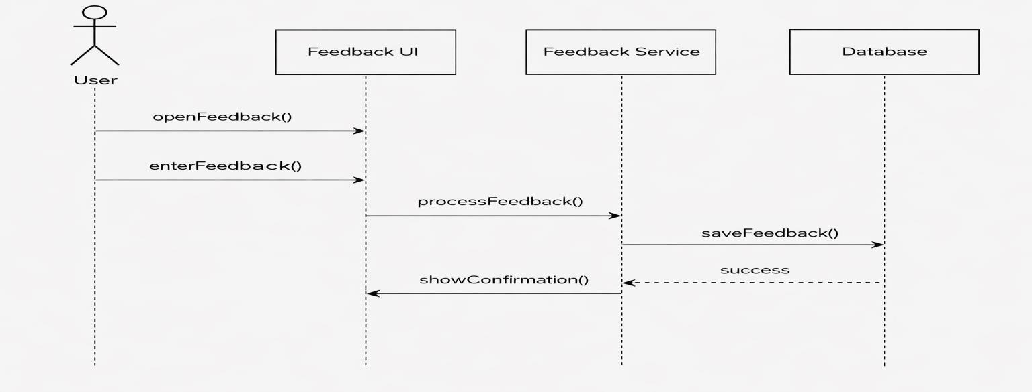
Figure 6: User feedback submission sequence
Figure SEQ Figure \* ARABIC 6: User feedback submission sequence

User Views Gestures Prediction History Sequence

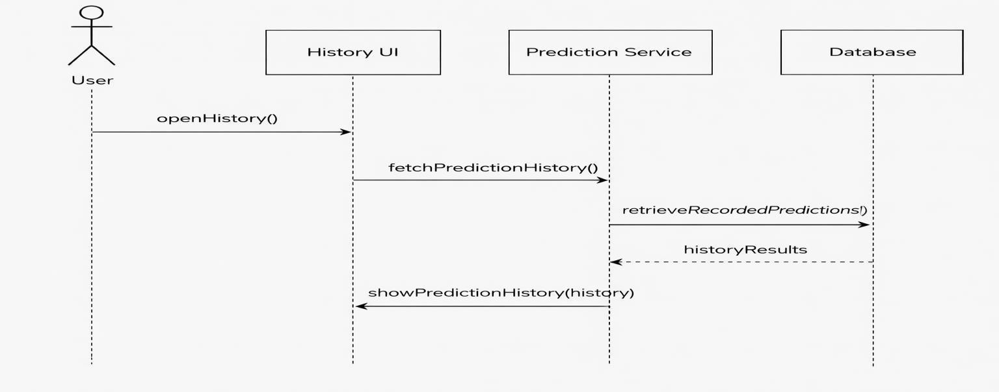
Figure 7: User views gesture prediction history sequennce
Figure SEQ Figure \* ARABIC 7: User views gesture prediction history

System Admin Use Case

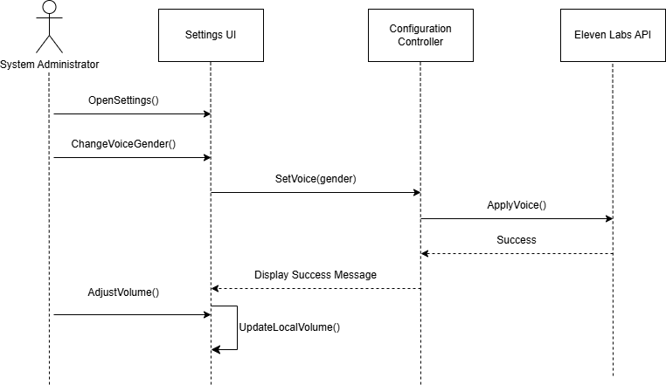
Figure 8: System Admin Use Case
Figure SEQ Figure \* ARABIC 8: System Admin Use Case

Sign Translation

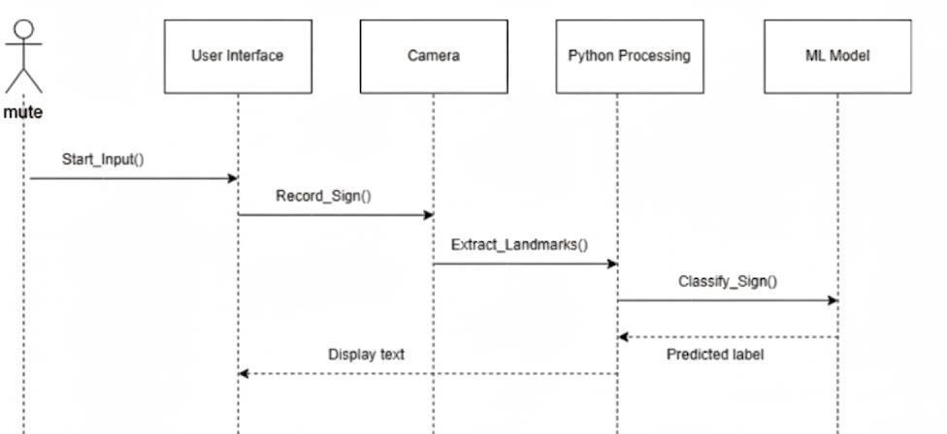
Figure 9: Sign Translation
Figure SEQ Figure \* ARABIC 9: Sign Translation

Listener Use Case
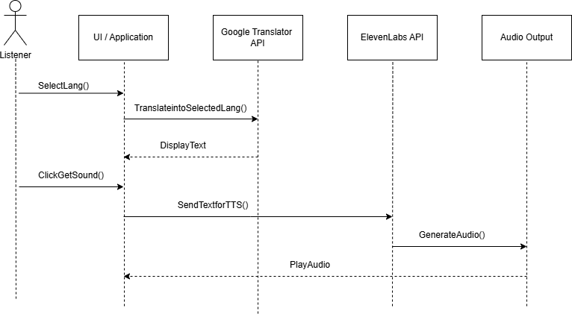
Figure 10: Listener Use Case
Figure SEQ Figure \* ARABIC 10: Listener Use Case

State Transition Diagram

Diagram 1: Sign Recording & Recognition

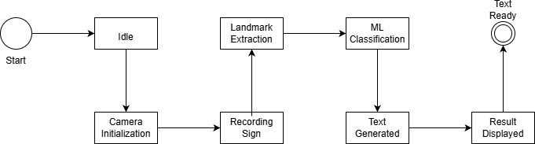
Figure 11: Recording Sign and Gesture
Figure SEQ Figure \* ARABIC 11: Sign Recording and Recognition

Diagram 2: Language Selection & Sound Generation

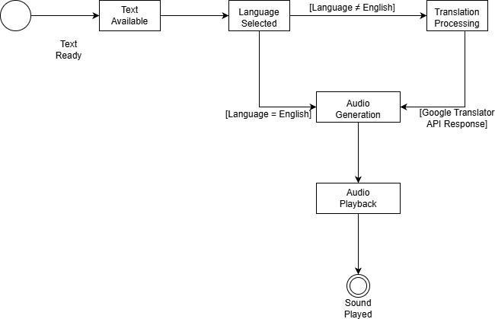
Figure 12: Language Selection and Sound Generation

Diagram 3: Admin Sound Settings Management
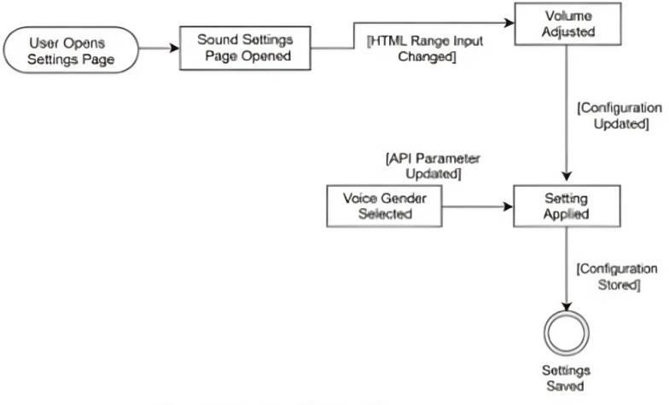
Figure 13: Admin Sound Settings Management
Figure SEQ Figure \* ARABIC 13: Sound Settings Management

Diagram 4: History & Feedback Management
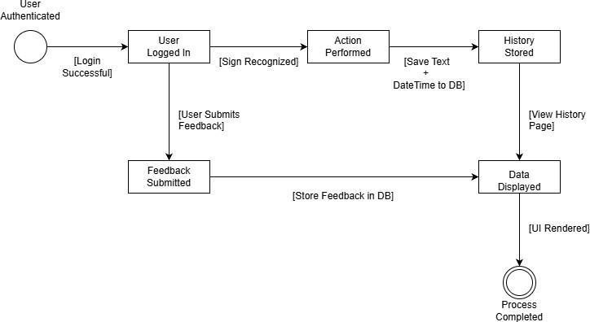
Figure 14: History and Feedback Management

Architectural Design
The SignWhispers system follows a Client-Server architecture and implements the MVC design pattern. It consists of six main modules: Sign Capture, ML Classification, Translation & Voice Generation, Admin Settings, History, and Feedback. The frontend interacts with the backend through APIs, while the backend handles processing, database operations, and API calls for translation and voice generation. This structure ensures real-time translation of sign language into speech and efficient management of user activities and feedback.

UML Component diagram
This UML Component Diagram represents the component-level architecture of a Sign Language Translation System. The system enables conversion of hand sign gestures into textual and audio output while supporting multilingual translation, user management, history tracking, system configuration, and feedback handling.
The system is structured using a layered architecture. The Presentation Layer consists of a web-based client that allows users to record sign gestures through a webcam, view recognized text, select a target language, generate speech output, access stored history, submit feedback, and manage configuration settings in the case of an administrator. This layer handles user interaction only and communicates with backend services through defined interfaces.
The Application/Service Layer contains the core processing logic. When a sign is recorded, the Sign Processing Service receives landmark data and coordinates with the AI/ML layer to obtain predicted letters. These letters are combined into complete words and returned to the Presentation Layer. The Translation Service handles text translation requests and invokes the
Google Translator API when a language other than English is selected. The Speech Generation Service converts text into audio output by invoking the ElevenLabs API with configured voice parameters. Authentication and User Management Services control user access and roles. History Management stores and retrieves sign translation records for authenticated users. System Configuration Management allows modification of voice-related settings such as volume and gender. Feedback Management processes user feedback and ensures its persistence.
The AI/ML Layer performs sign recognition. Hand gestures captured from the webcam are processed using OpenCV and MediaPipe to extract numerical landmark values. These landmarks are passed to a machine learning classification model that predicts corresponding ASL letters. The prediction results are returned to the Application Layer.
The External Service Layer integrates third-party services required for translation and speech synthesis. The Google Translator API provides multilingual text translation, while the ElevenLabs API generates speech output.
The Security Layer ensures secure access using JSON Web Tokens (JWT) for authentication and authorization. The Data Access Layer provides an abstraction for database operations. The Database Layer uses MongoDB to store user data, translation history with timestamps, system configuration settings, and feedback records.
This component-based architecture ensures clear separation of concerns, secure communication, and efficient processing of sign recognition, translation, and speech generation workflows.

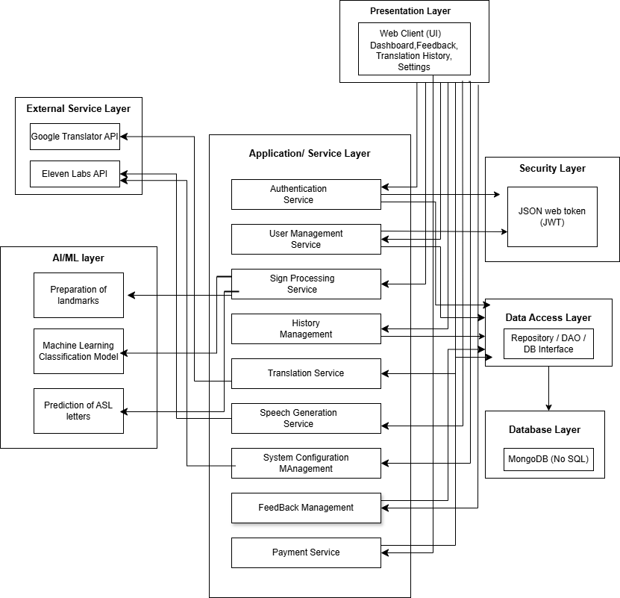

Figure 15: UML Component Diagram

Data Design
The SignWhispers system stores and processes data related to users, gestures, ML predictions, translations, voice outputs, history, and feedback. The system uses a relational database for persistent storage and organizes data in object-oriented structures to facilitate interaction between modules. Key entities are designed to capture both backend processing (ML predictions, translation) and frontend user interactions (gesture input, language selection, feedback submission).

Data Dictionary
      - Alphabetical List of System Entities or Major Data with Types and Descriptions:

Table 33:Alphabetical List of System Entities or Major Data with Types and Descriptions:
Terminology | Description
Admin | Actor responsible for managing system sound settings. (Actor)
AudioOutput | Generated speech output from ElevenLabs API. (Audio Stream)
Amount | Total monetary value of the transaction processed during payment.  (Double)
BackendService | Handles ML inference, translation, TTS, and DB operations.  (Service)
Database | Stores history and feedback records. (Persistent Storage)
MuteUser | Actor who records sign language input. (Actor)
ElevenLabsAPI | External API for text-to-speech conversion. (External API)
Feedback | User-submitted textual response. (String)
FeedbackID | Unique identifier for feedback entry. (UUID / Integer)
FeedbackTable | Database entity storing feedback. (DB Table)
FrontendUI | Web interface for interaction. (Web Client)
GenderParameter | Controls voice gender in TTS API. (Enum / String)

GetSoundButton | UI element triggering audio generation. (UI Control)
GoogleTranslatorAPI | External API for language translation. (External API)
HandLandmarks | Numerical coordinates extracted from hand gestures. (Float Array)
History | Log of previous user interactions. (Record Set)
HistoryID | Unique identifier for history entry. (UUID / Integer)
HistoryTable | Database entity storing user history. (DB Table)
LanguageDropdown | UI element for language selection. (UI Control)
Listener | Actor who listens to generated speech. (Actor)
MLModel | Trained model for sign classification. (ML Component)
OpenCV | Library for video capture and processing. (CV Library)
PredictedText | Output text generated by ML model. (String)
Payment | Represents a financial transaction made by a user for premium services or subscription. Stores payment details such as amount, date, and status. (Record Set)
PaymentID | Unique identifier assigned to each payment transaction. (Integer / UUID)
Payment_Service | Service responsible for initiating, verifying, and retrieving payment transactions. Handles business logic related to payments. (Service)
PaymentStatus | Indicates the current state of a payment (e.g., Pending, Completed,

 | Failed, Refunded). (String)
RecordSession | Time-bound sign recording session. (Session Object)
SignInput | Raw video input from webcam. (Video Stream)
TextOutput | Final text before translation/TTS. (String)
Timestamp | Date and time of interaction. (DateTime)
User | Authenticated system user. (Actor)
UserID | Unique identifier for user. (UUID / Integer)
VolumeControl | HTML input element for volume adjustment. (UI Control)
VolumeLevel | Numeric sound intensity value. (Integer / Float)
Webcam | Hardware device for capturing sign input. (Device)

      - Structured Approach: Functions and Function Parameters:

captureSignVideo()

Description:
Captures live video stream from the webcam for sign language input.
Parameters:
None
Return Type:
VideoStream – Live video feed for further processing.

extractHandLandmarks(videoFrame)
Description:
Processes a video frame using OpenCV and MediaPipe to detect hands and extract landmark coordinates.
Parameters:

Table 34- Parameters(i)
Parameter Name | Data Type | Role
videoFrame | Frame | Single video frame captured from webcam
Return Type:
FloatArray – Array of hand landmark coordinates (x, y, z).

classifySign(landmarks)

Description:
Uses the Machine Learning model to classify extracted hand landmarks into a corresponding alphabet or word.

Parameters:
Table 35 - Parameters(ii)

Parameter Name | Data Type | Role
landmarks | FloatArray | Numerical hand landmark values used for prediction

Return Type:
String – Predicted character or word.

concatenatePredictions(predictedChars)

Description:
Combines sequentially predicted characters to form meaningful words or sentences.

Parameters:
Table 36 - Parameters(iii)

Parameter Name | Data Type | Role
predictedChars | StringArray | List of predicted characters

Return Type:
String – Complete formed text.

displayTextOutput(text)
Description:
Displays the generated text output on the frontend user interface.
Parameters:
Table 37- Parameters(iv)

Parameter Name | Data Type | Role
text | String | Text to be shown on screen

Return Type:
Void

selectLanguage(languageCode)

Description:
Stores the listener-selected language for translation and speech generation.

Parameters:
Table 38- Parameters(v)

Parameter Name | Data Type | Role
languageCode | String | Language identifier (e.g., en, ur, fr)

Return Type:
String – Selected language code.

translateText(text, targetLanguage)
Description:
Translates the generated text into the selected language using Google Translator API.
Parameters:
Table 39- Parameters(vi)

Parameter Name | Data Type | Role
text | String | Original English text
targetLanguage | String | Desired output language code

Return Type:
String – Translated text

generateSpeech(text, voiceGender, volumeLevel)

Description:
Generates speech audio from text using ElevenLabs API with specified voice settings.
Parameters:
Table 40 - Parameters(vii)

Parameter Name | Data Type | Role
text | String | Text to be converted to speech
voiceGender | String | Controls voice type (male/female)
volumeLevel | Integer | Controls audio loudness

Return Type:
AudioStream – Generated speech audio

playAudio(audioStream)

Description:
Plays the generated audio output for the listener.
Parameters:
Table 41 - Parameters(viii)

Parameter Name | Data Type | Role
audioStream | AudioStream | Speech output to be played

Return Type:
Void

saveHistory(userID, textOutput, timestamp)

Description:
Stores user interaction history in the database.

Parameters:
Table 42 - Parameters(ix)

Parameter Name | Data Type | Role
userID | UUID /  Integer | Unique identifier of the user
textOutput | String | Generated text
timestamp | DateTime | Date and time of interaction

Return Type:
Boolean – Status of database insertion

retrieveHistory(userID)

Description:
Fetches stored history records for a specific user.
Parameters:
Table 43- Parameters(x)

Parameter Name | Data Type | Role
userID | UUID /  Integer | User whose history is requested

Return Type:
RecordList – List of past user interactions

submitFeedback(userID, feedbackText)
Description:
Stores user feedback in the database.
Parameters:
Table 44- Parameters(xi)

Parameter Name | Data Type | Role
userID | UUID /  Integer | Feedback provider
feedbackText | String | User feedback content

Return Type:
Boolean – Feedback submission status

getFeedbackList()

Description:
Retrieves all stored feedback for testimonial display.
Parameters:
None
Return Type:
RecordList – List of feedback entries

updateSoundSettings(volumeLevel, voiceGender)

Description:
Updates system-wide sound configuration settings.

Parameters:

Table 45 - Parameters(xii)

Parameter Name | Data Type | Role
volumeLevel | Integer | Default audio volume
voiceGender | String | Default voice type

Return Type:
Void

      - Object-Oriented (OO) Approach: Objects, Attributes, Methods, & Method Parameters:

Object: SignCapture

Table 46 - Parameters(xiii)

Elements | Details
Object Description | Handles webcam-based sign recording and hand landmark extraction using OpenCV and MediaPipe
Attribute: videoStream | VideoStream – Live webcam video input
Attribute: landmarks | FloatArray – Extracted hand landmark coordinates (x, y, z)

Method: captureVideo() | Starts webcam and captures live video stream
Method Parameters | None
Return Type | VideoStream
Method: extractLandmarks(videoFrame) | Extracts hand landmarks from a video frame
Parameter: videoFrame | Frame – Single captured video frame
Return Type | FloatArray

Object: SignClassifier

Table 47- Parameters(xiv)

Elements | Details
Object Description | Classifies hand landmarks into corresponding alphabets or words using ML model
Attribute: model | MLModel – Trained sign language classification model
Method: predictSign(landmarks) | Predicts sign from landmark data

Parameter: landmarks | FloatArray – Hand landmark numerical values
Return Type | String

Object: TextProcessor

Table 48- Parameters(xv)

Elements | Details
Object Description | Converts sequential predictions into meaningful text
Attribute: predictedChars | StringArray – Sequence of predicted characters
Method: concatenateText(predictions) | Combines characters to form words/sentences
Parameter: predictions | StringArray – Predicted characters
Return Type | String

Object: TranslationService

Table 49- Parameters(xvi)

Elements | Details

Object Description | Translates generated text into selected language using Google Translator API
Attribute: apiKey | String – Google API authentication key
Method: translate(text, targetLanguage) | Translates text to selected language
Parameter: text | String – Original generated text
Parameter: targetLanguage | String – Language code (e.g., en, ur)
Return Type | String

Object: SpeechGenerator

Table 50 - Parameters(xvii)

Elements | Details
Object Description | Converts text into speech using ElevenLabs API
Attribute: voiceGender | String – Voice type (Male/Female)
Attribute: volumeLevel | Integer – Audio volume level

Method: generateSpeech(text) | Generates speech audio
Parameter: text | String – Text to convert into speech
Return Type | AudioStream

Object: AudioPlayer

Table 51- Parameters(xviii)

Elements | Details
Object Description | Plays generated speech output
Attribute: audioStream | AudioStream – Speech data
Method: play(audioStream) | Plays audio to listener
Parameter: audioStream | AudioStream – Generated audio
Return Type | Void

Object: SoundSettings

Table 52- Parameters(xix)

Elements | Details
Object Description | Manages system-wide sound configuration controlled by admin
Attribute: volume | Integer – Default audio volume
Attribute: voiceGender | String – Default voice gender
Method: updateSettings(volume, voiceGender) | Updates sound settings
Parameter: volume | Integer – Volume value
Parameter: voiceGender | String – Voice type
Return Type | Void

Object: HistoryManager

Elements | Details
Object Description | Stores and retrieves user interaction history

Attribute: historyList | RecordList – Stored history records
Method: saveHistory(userID, text, timestamp) | Saves user history
Parameter: userID | UUID / Integer – User identifier
Parameter: text | String – Generated text
Parameter: timestamp | DateTime – Interaction time
Return Type | Boolean
Method: getHistory(userID) | Retrieves user history
Parameter: userID | UUID / Integer – User identifier
Return Type | RecordList

Object: FeedbackManager

Table 53- Parameters(xxi)

Elements | Details

Object Description | Manages user feedback storage and retrieval
Attribute: feedbackList | RecordList – Stored feedback entries
Method:submitFeedback(userID, feedbackText) | Stores feedback
Parameter: userID | UUID / Integer – Feedback provider
Parameter: feedbackText | String – Feedback content
Return Type | Boolean
Method: getAllFeedback() | Retrieves all feedback
Method Parameters | None
Return Type | RecordList

User Interface Design

The system provides a web-based interface that enables sign language communication, translation, speech generation, premium features, user management, history tracking, and feedback handling.
From the user’s perspective, the system operates as follows:
  - Users sign up or log in to access the system.
  - Users navigate to the Dashboard to record sign language gestures.

  - The system converts signs into readable text and allows word formation.

  - Users can select language and generate speech output.

  - Premium users can access enhanced voices and features after payment verification.

  - Admins manage users, payments, feedback, and system analytics with role-based access.

  - Users can view past interactions and submit feedback.
  - Reviews and testimonials are visible for credibility and system evaluation.

The interface is simple, minimal, and task-oriented, ensuring clarity for mute users and listeners.

Screen Images
- Sign In Page
Purpose:
Allows new users to create an account.

Displayed Elements:
- Name input field

- Email input field

- Password input field

- Sign Up button

- Redirect link to Login page

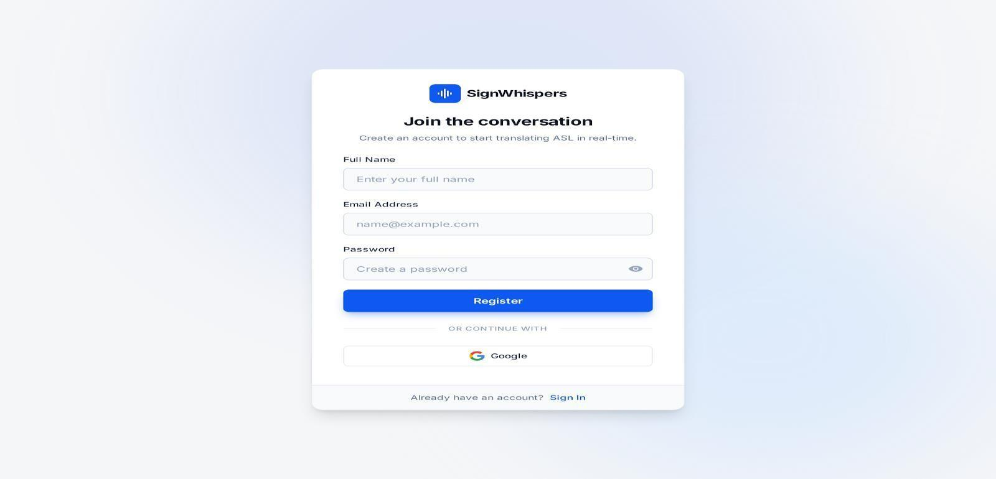

Figure 16: Sign In Page

- Log In Page

Purpose:
Allows existing users to authenticate and access the system.
Displayed Elements:
- Email input field
- Password input field
- Login button
- Redirect link to Sign In page

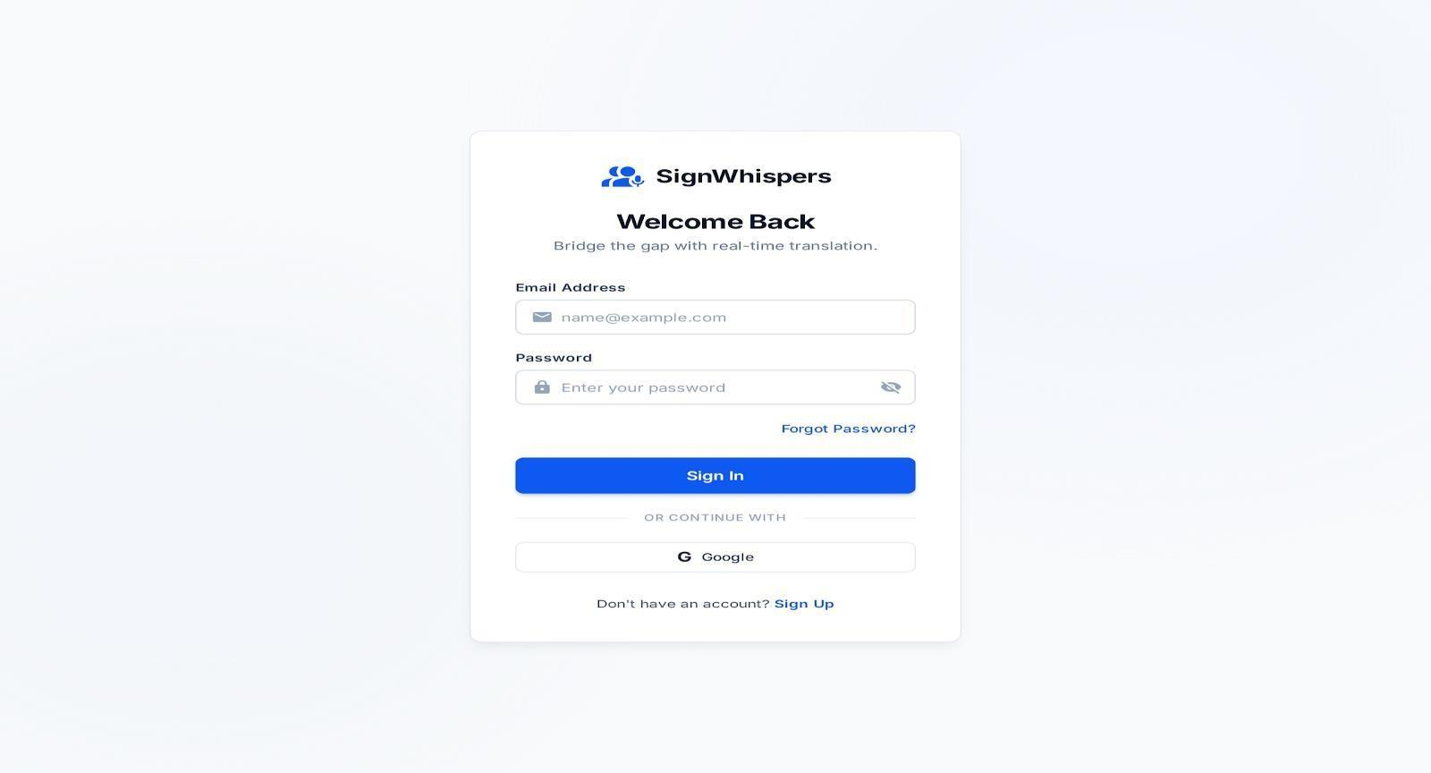
Figure 17: Log In Page

- Home

Page Purpose:
Provides an overview of the system and navigation to main features.

Displayed Elements:
- System introduction text
- Navigation links (Dashboard, Feedback, Reviews, Settings)
- Call-to-action buttons

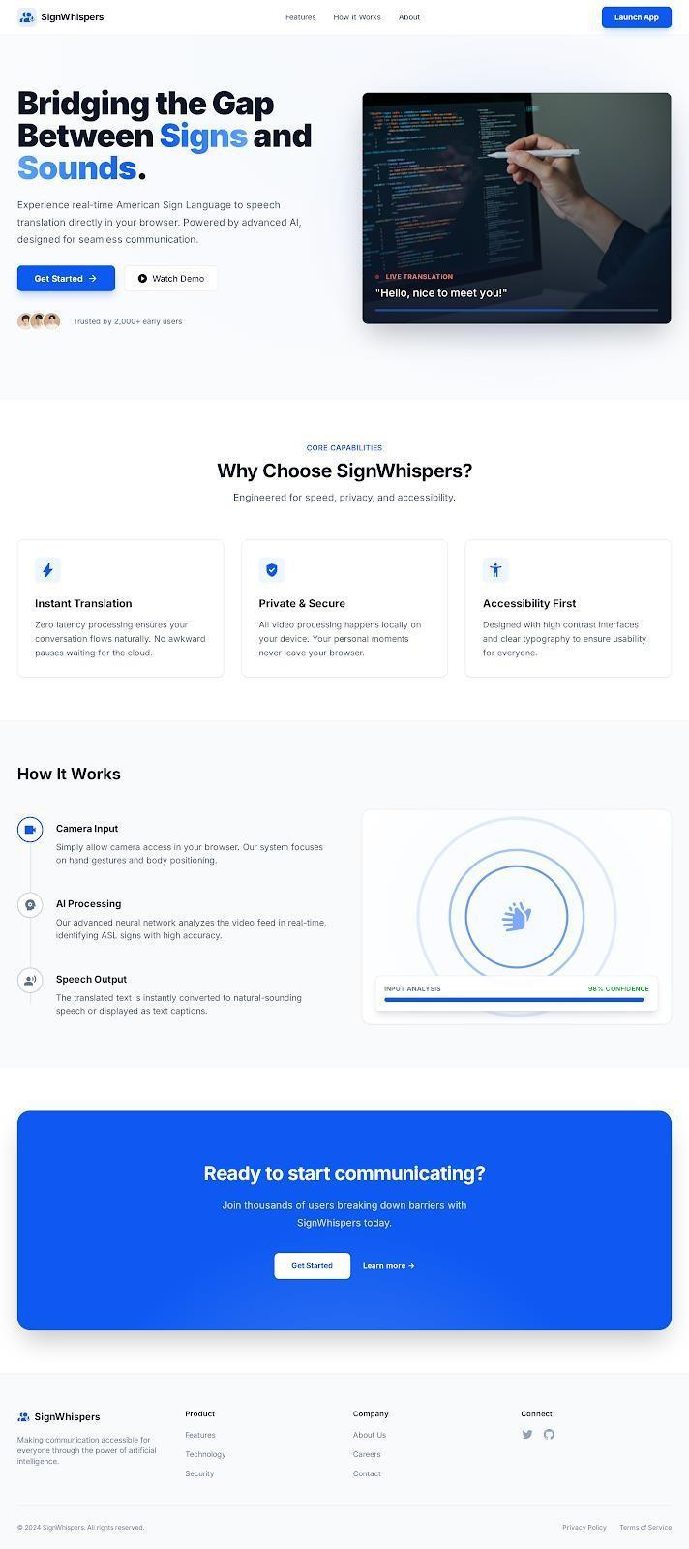
Figure 18: Home Page

- Dashboard (Sign Recording Page)
Purpose:
Main functional screen for sign language recording and text generation.

Displayed Elements:

- Live webcam preview
- Record / Stop recording button
- Generated text display area
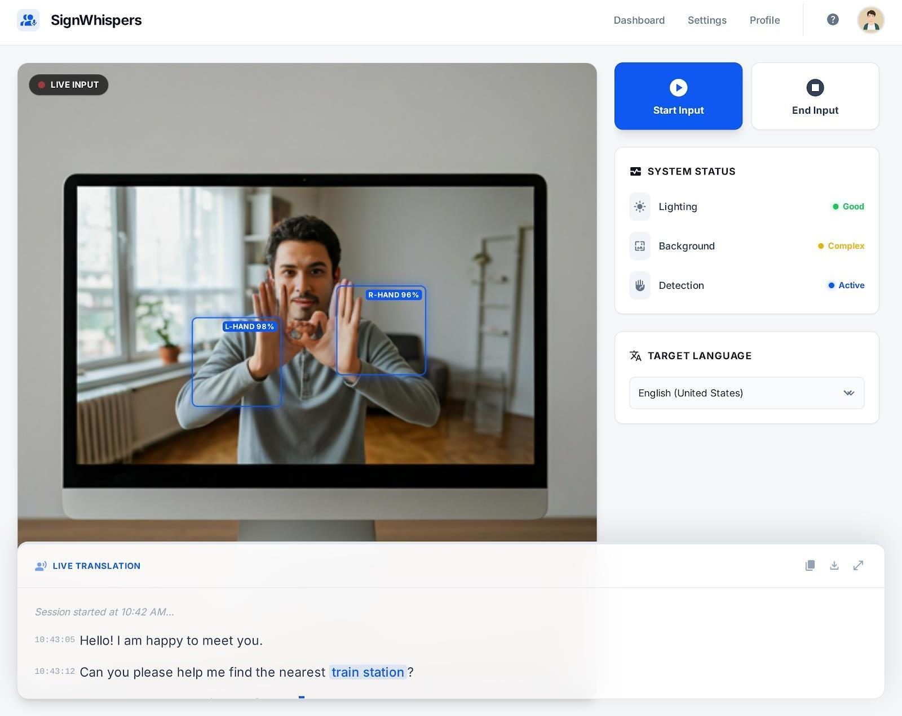
- Language selection dropdown
Figure 19: Dashboard (Sign Recording Page)
- Get Sound button

- Settings Page
Figure SEQ Figure \* ARABIC 19: Dashboard
Purpose:

Allows the users to manage sound-related configurations.

Displayed Elements:

- Volume control slider
- Voice gender selection option
- Save / Update settings button

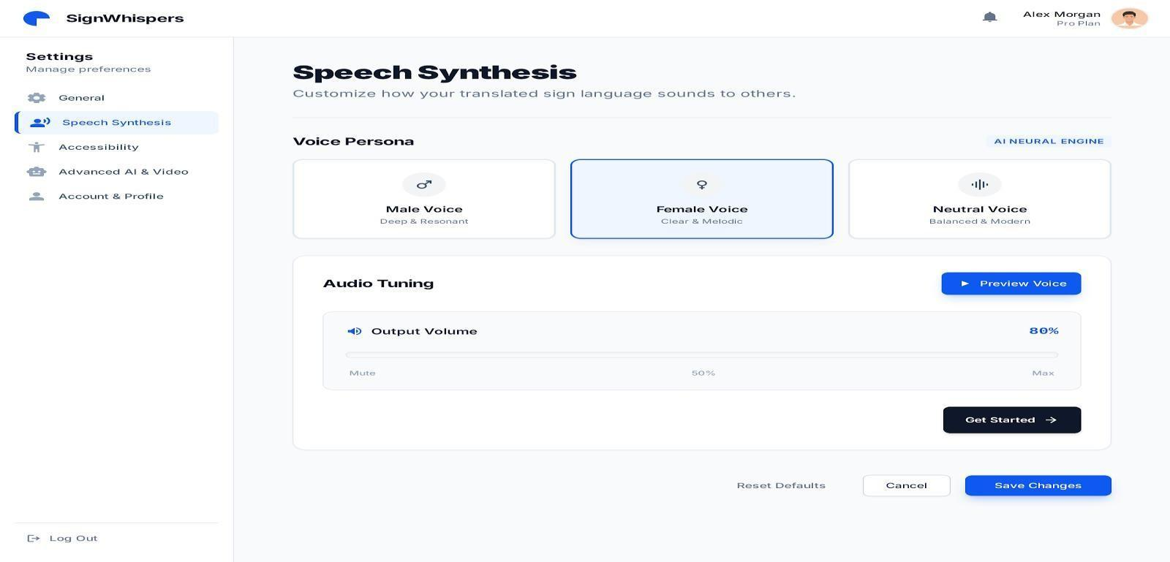
Figure 20: Speech Synthesis

- Feedback Page
Purpose:

Allows users to submit feedback about the system.

Displayed Elements:

- Feedback text area
- Submit feedback button
- Confirmation message after submission

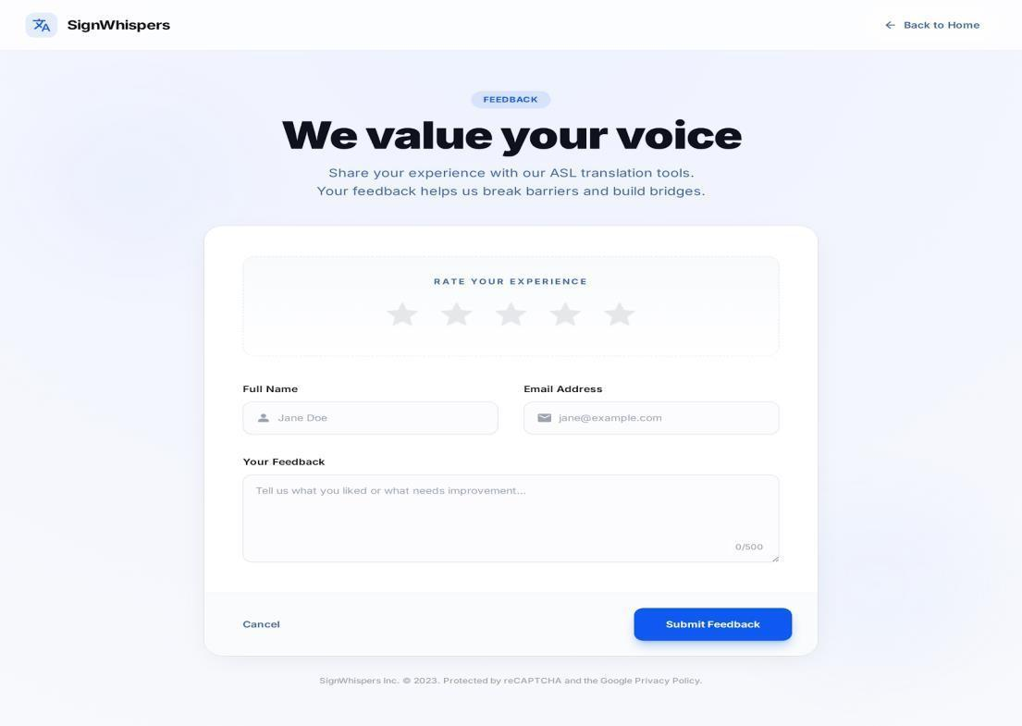
Figure 21: Feedback Page

- Review Page
Purpose:

Displays submitted feedback and testimonials.

Displayed Elements:
- List of user reviews
- Feedback text display
- User identification (optional)
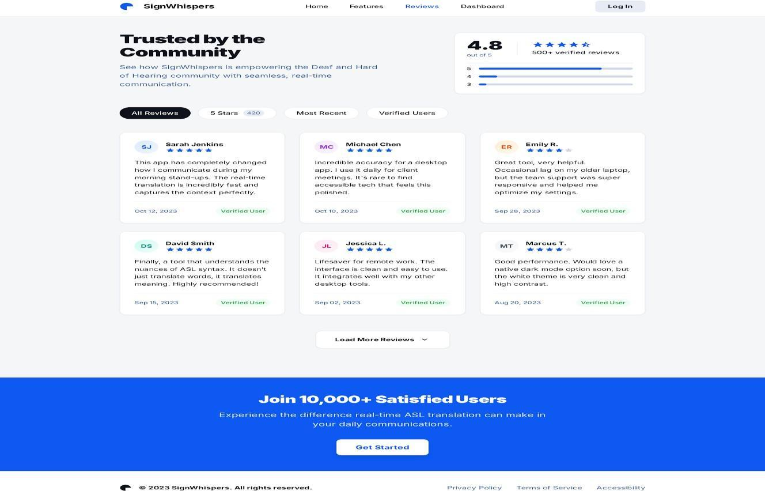
Figure 22: Review Page
- History Page
Purpose:

Shows a record of all past translations for review and reference.

Displayed Elements:

- Total translations summary (Today, Last Week, Last Month, Last Year)
- Search bar for detected or translated text
- Filter by language dropdown
- List of translations (Detected text, Translated text, Language, Date)
- Pagination controls
- Translation log overview section
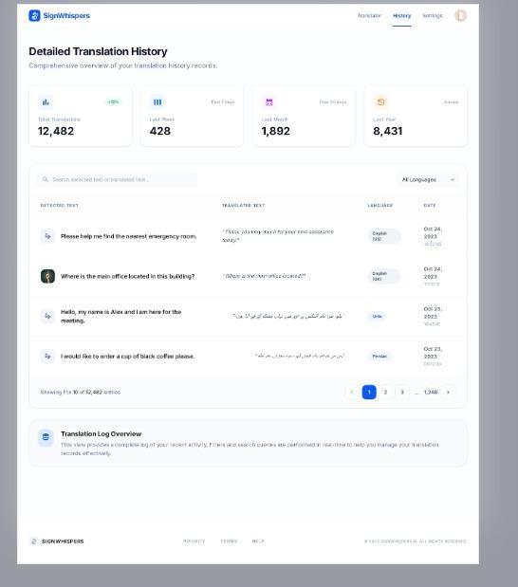
Figure 23: History Page

- Payment Page
Purpose:

Allows users to securely enter payment details and subscribe to the Premium Plan.
Displayed Elements:

- Email address input field
- Cardholder name input field
- Card information fields (card number, expiry date, CVC, country)
- “Upgrade to Premium” button
- Payment security notice (Stripe encryption)
- Order summary panel:

  - Plan name and price
  - Key benefits (Unlimited translations, Voice Output, Priority Processing)
  - Subtotal, Tax, Total
  - Satisfaction guarantee message

- Links: Privacy Policy, Terms of Service, Refund Policy
- Chat support option
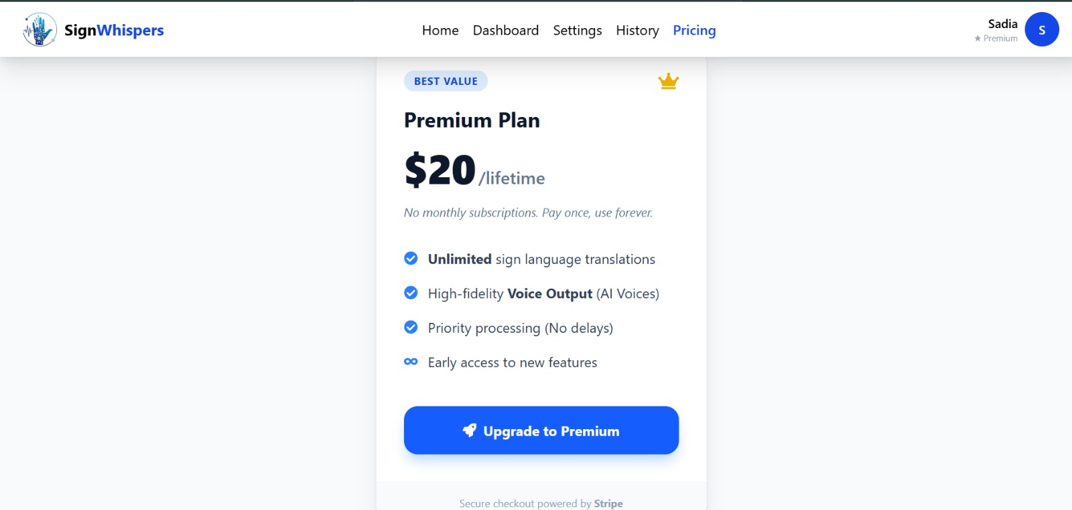
Figure 24: Payments Page

- Dashboard Page(Admin Panel)
Purpose:

Provides an overview of the system’s key metrics and recent activities for quick monitoring.

Displayed Elements:

- Total Users, Premium Users, Total Feedbacks, Total Payments (with % change)
- Recent Activity feed (new registrations, subscription renewals, feedback, payment failures, maintenance)
- Refresh Data button
- Sidebar navigation (Dashboard, User Management, Feedback, Payments
- Super Admin profile info at bottom-left
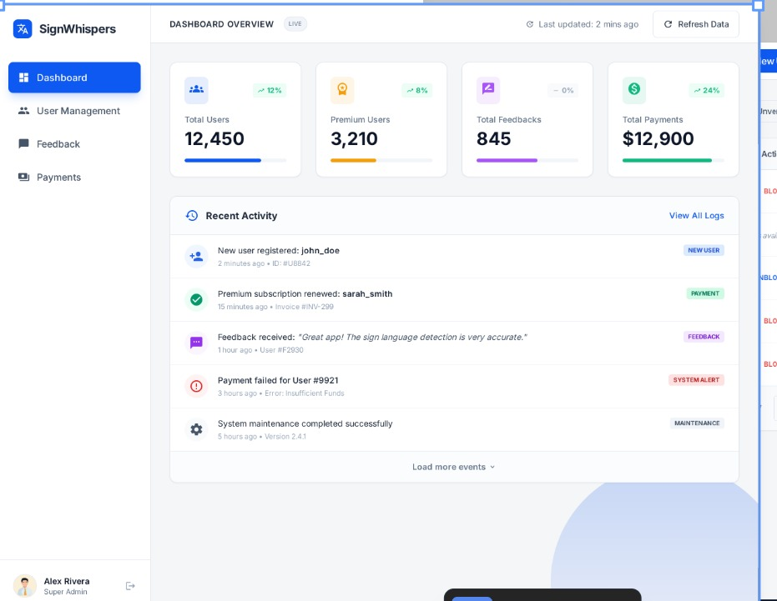
Figure 25: Dashboard Page

- User Management Page(Admin Panel)
Purpose:

Allows the admin to view, manage, and modify user accounts, including roles and subscription status.
Displayed Elements:

- Search bar & filters (All/Premium)
- User table: Details, Role, Premium, Payments, Admin Actions
- Pagination
- Summary cards: Total Users, Premium Subscribers
- Notification toast for actions
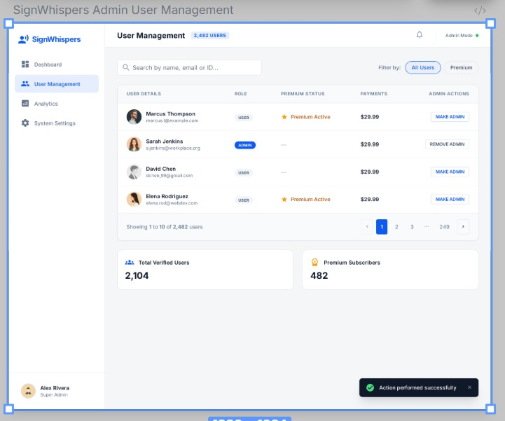
Figure 26: User Management Page (Admin Panel)

- Feedback Management Page(Admin Panel)
Purpose:
Allows the admin to manage user feedback—approve/disapprove visibility, search, filter, and export feedback.
Displayed Elements:

- Search bar – search by user or content
- Filter dropdown – filter by rating
- Feedback table – columns: User (name, email, avatar), Rating, Message, Created At, Visibility toggle
- Export List button – export feedback data
- Pagination controls – navigate pages
- Sidebar – Dashboard, Users, Feedback
- Admin info – name and role
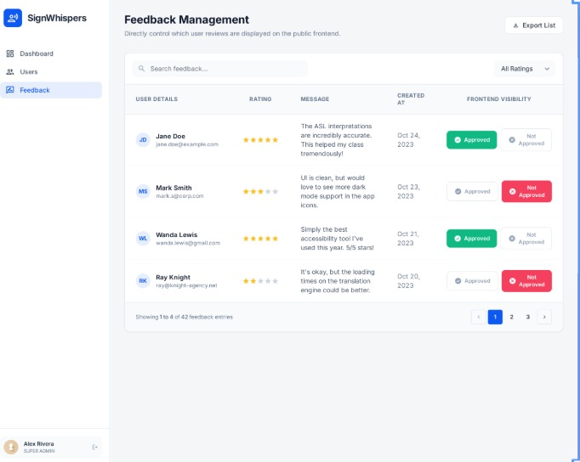
Figure 27: Feedback Management Page (Admin Panel)

- Payment Page(Admin Panel)
Purpose:

Allows admin to view and manage user payments, track status, and monitor history.

Displayed Elements:

- Sidebar (Dashboard, Users, Feedback, Payments) Page title: Payment Management
- Search bar (users/emails)
- Payment table: Name, Email, Amount, Status, Date
- Pagination (Prev/Next)
- Admin profile info (bottom left)
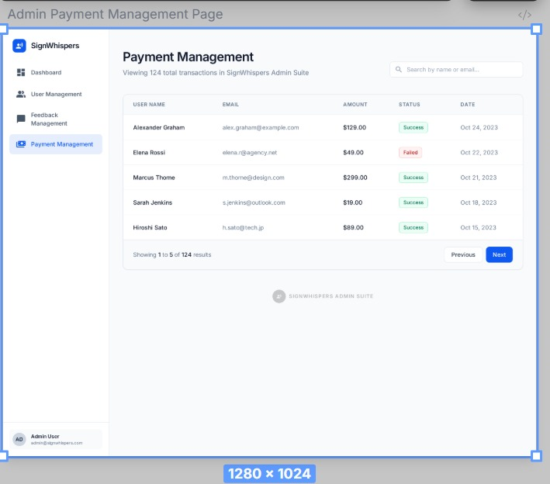
Figure 28: Payment Page (Admin Panel)

Screen Objects and Actions
This section describes the screen objects and their associated user/system actions for two selected use cases
Use Case 1: Record Sign and Generate Text
Screen: Dashboard (Recording Page)
Table 54- Dashboard

Screen Object | Type | Associated Action
Webcam Preview Window | Display Component | Shows live video feed of the mute user
Record Button | Action Button | Starts sign recording through webcam
Stop Button | Action Button | Stops the recording process
Text Output Area | Display Component | Displays translated text generated by the system
Language Dropdown | Input Control | Allows selection of desired output language
Get Sound Button | Action Button | Triggers translation and speech generation
Screen: Feedback Page

Table 55-Feedback Page

Screen Object | Type | Associated Action
Feedback Text Area | Input Field | Allows user to enter feedback text
Submit Button | Action Button | Sends feedback data to backend

Confirmation Message | System Feedback | Confirms successful feedback submission
Navigation Menu | Navigation Component | Allows user to move to other pages

Behavioural Model

Interaction Diagram

User Feedback Submission Sequence

Figure 29: Feedback Submission Sequence
Figure SEQ Figure \* ARABIC 29: User Feedback Submission Sequence

User Views Gestures Prediction History Sequence


Figure 30: User Views Gestures Prediction History Sequence
Figure SEQ Figure \* ARABIC 30: User Views Gestures Prediction History Sequence

System Admin Use Case


Figure 31: System Admin Use Case
Figure SEQ Figure \* ARABIC 31: System Admin Use Case

Sign Translation


Figure 32: Sign Translation
Figure SEQ Figure \* ARABIC 32:Sign Translation

Listener Use Case


Figure 33: Listener Use Case
Figure SEQ Figure \* ARABIC 33: Listener Use Case

State Transition Diagram

Diagram 1: Sign Recording & Recognition


Figure 34:Sign Recording & Recognition
Figure SEQ Figure \* ARABIC 34: Diagram 1- Sign Recording & Recognition

Diagram 2: Language Selection & Sound Generation


Figure 35: Language Selection & Sound Generation

Diagram 3: Admin Sound Settings Management

Figure 36:Admin Sound Settings Management
Figure SEQ Figure \* ARABIC 36: Diagram 3-Admin Sound Settings Management

Diagram 4: History & Feedback Management

Figure 37: History & Feedback Management

Design Decisions

Table 56- Design Decisions

Design Element | Chosen Approach / Implementation | Justification
Programming Paradigm | Object-Oriented Programming (OOP) | Modular, reusable, maintainable; allows clear mapping to classes/objects in UML Class  Diagram
Classes / Objects | SignCapture, SignClassifier, TextProcessor, TranslationService, SpeechGenerator, AudioPlayer, SoundSettings, HistoryManager,  FeedbackManager | Encapsulate attributes and methods; reduce complexity; follow roadmap UML design
Architecture | Layered Client-Server Architecture | Separates Presentation, Business Logic, and Data layers; enables independent scaling, security, and  maintainability
Algorithmic Approach | Sequential Algorithm | Step-by-step processing for sign recording → ML classification → text concatenation → translation → speech generation; ensures  predictable flow
Computer Vision | OpenCV + MediaPipe | Efficient real-time hand tracking and landmark extraction for sign  detection
Machine  Learning Input | Landmark-based numeric  data | Reduces dimensionality; improves  classification speed and efficiency
Language Translation | Google Translator API | Supports multiple languages without building custom models; reduces  development time
Text-to-Speech | ElevenLabs API | Provides natural-sounding audio with customizable voice options  (gender, volume)
Sound | Dynamic via UI and API | Volume adjusted via HTML slider;

Configuration | parameters | voice gender through API; allows  admin-level real-time control
Database Design | Normalized Relational DB (3NF) | Eliminates redundancy, ensures integrity, simplifies maintenance; supports Users, History, Feedback  tables
History Management | User-based persistent storage | Personalized history retrieval; accountability; prevents data loss  between sessions
Feedback Management | Database storage | Feedback persists and displays on Review Page; supports analytics and  credibility
Security | Authentication-based access | Only registered users can access Dashboard, Feedback, History;  protects data integrity

Summary

The system uses Object-Oriented Programming (OOP) with well-defined classes and objects as per the UML Class Diagram, ensuring modularity and maintainability. A Layered Client–Server architecture separates the presentation, business logic, and data layers, improving scalability, security, and clarity.
The workflow follows sequential algorithms: capturing signs → extracting landmarks → classifying signs → concatenating text → translating → generating speech. This ensures step-by-step efficiency.
Additional design choices include OpenCV + MediaPipe for hand tracking, landmark- based ML classification, Google Translator API for multilingual support, ElevenLabs API for speech, and a normalized relational database (3NF) for user history and feedback.
These design decisions collectively ensure that the system meets its objectives of enabling effective communication between mute users and listeners while remaining efficient, accurate, and user-friendly

Chapter 4

Implementation

Implementation
This chapter presents the implementation details of the SignWhispers system. It documents the core algorithms, third-party APIs and SDKs, the Git repository structure, and a summary of key implementation decisions. The implementation directly realizes the architectural and design specifications defined in Chapter 4 (SDS), translating class diagrams, sequence diagrams, and data models into functional code.

Algorithm
The following algorithms describe the core functional pipeline of SignWhispers. Pseudocode is provided for the three major processing modules: gesture recognition, word construction, and translation-to-speech generation.

4.1.1 Real-Time ASL Gesture Recognition
This algorithm handles webcam initialization, frame capture, MediaPipe landmark extraction, and ML-based letter prediction. Time complexity is O(F × K) where F is the frame rate and K is the constant 21 landmarks per frame.
Algorithm 4-1: ASL Gesture Recognition Pipeline
Algorithm 1: Real-Time ASL Gesture Recognition Pipeline
─────────────────────────────────────────────────────────
Input : Live webcam video stream
Output: Predicted ASL letter (String)

1: INITIALIZE webcam ← cv2.VideoCapture(0)
2: INITIALIZE hands ← MediaPipe.Hands(max_num_hands=1)
3: LOAD model ← joblib.load('asl_classifier.pkl')
4: WHILE webcam.isOpened() DO
5: frame ← webcam.read()
6: rgb_frame ← cv2.cvtColor(frame, COLOR_BGR2RGB)
7: results ← hands.process(rgb_frame)
8: IF results.multi_hand_landmarks NOT NULL THEN
9: landmarks ← EXTRACT_XYZ(results.multi_hand_landmarks)
10: // Normalize 21 key-points → 63 float values
11: features ← NORMALIZE(landmarks) // shape: [1 x 63]
12: prediction ← model.predict(features)[0]
13: DISPLAY prediction ON frame
14: RETURN prediction
15: ELSE
16: DISPLAY 'No hand detected'
17: END IF
18: END WHILE
─────────────────────────────────────────────────────────
Complexity: O(F × K) where F = frames/second, K = landmarks/frame (constant 21)

4.1.2 Word Construction from Sequential Letters
This algorithm accumulates predicted letters using a frame-hold threshold to prevent noise from single-frame fluctuations, forming stable word strings. Complexity is O(N) where N is the number of prediction frames.
Algorithm 4-2: Word Construction from Predicted Letters
Algorithm 2: Word Construction from Sequential Letters
─────────────────────────────────────────────────────────
Input : Stream of predicted letters (List<String>)
Output: Formed word (String)

1: INITIALIZE letterBuffer ← []
2: INITIALIZE lastLetter ← ''
3: INITIALIZE holdCount ← 0
4: THRESHOLD ← 15 // frames to confirm stable prediction

5: FOR EACH prediction IN liveStream DO
6: IF prediction == lastLetter THEN
7: holdCount ← holdCount + 1
8: IF holdCount == THRESHOLD THEN
9: APPEND prediction TO letterBuffer
10: holdCount ← 0
11: END IF
12: ELSE
13: lastLetter ← prediction
14: holdCount ← 1
15: END IF
16: END FOR

17: word ← CONCATENATE(letterBuffer)
18: RETURN word
─────────────────────────────────────────────────────────
Complexity: O(N) where N = number of prediction frames

External APIs/SDKs
The table below outlines the third-party APIs integrated into the project to facilitate speech synthesis and multilingual support.

Table 57-Details of APIs used in the project

Name of API and version | Description of API | Purpose of usage | List down the API endpoint/function/class in which it is used
ElevenLabs API (v1) | A cloud-based Artificial Intelligence platform specializing in high-fidelity Text-to-Speech (TTS) and voice cloning. | Used to convert processed text into natural, realistic human-like audio narrations | https://elevenlabs.io
Google Cloud Translation API (v3) | A neural machine translation service that utilizes Google's proprietary models to translate text across supported languages. | To enable multilingual support by translating application content or user input dynamically. | projects.locations.translateText
Google OAuth 2.0 | An industry-standard authorization framework for secure delegated access. | To provide a secure "Social Login" mechanism, allowing users to authenticate using their Google accounts. | https://google.com
Stripe API (2023-10-16 | A comprehensive payment processing infrastructure for internet businesses. | To securely handle credit card transactions, subscriptions, and financial data processing. | https://stripe.com
SendGrid API (v3) | A cloud-based SMTP provider that allows for reliable transactional email delivery. | To automate system notifications, account verification emails, and user communication. | https://sendgrid.com

Code Repository
Git is used as the primary version control tool for the SignWhispers project. All source code, documentation, and project resources are maintained in a shared GitHub repository to ensure collaboration, history tracking, and access control across the development team.

Git Repository Link:
The repository for the group project can be accessed using the following link:
https://github.com/Sadia-Shahzad/SignWhispers

Metrics of the Git Repository:
The following metrics are monitored throughout the project lifecycle to ensure effective team collaboration and code quality.
Table 58: Git Repository Metrics
Metric | Description | Current Status
Commits | Tracks frequency of contributions | 120+ commits
Branches | Active & merged development branches | main, dev, feature/*
Pull Requests | Code review and merge workflow | 18 PRs merged
Issues | Bug tracking and feature requests | 12 closed, 3 open
Contributors | Team member contributions | 5 active contributors
Code Reviews | Review cycles on pull requests | Avg 2 reviews/PR

Summary
This chapter documented the implementation foundation of SignWhispers. Three core algorithms — gesture recognition, word construction, and translation-to-speech — were presented in pseudocode with complexity analysis. All external APIs and SDKs were described with their integration purpose and key endpoints. The Git repository structure ensures version control, team collaboration, and traceable development history. Together, these implementation components realize the system design specifications and enable the functional goals of real-time ASL-to-multilingual-speech translation.

Chapter 5
Testing and Evaluation

Introduction

This chapter presents the testing strategy and evaluation results for the SignWhispers system. Testing ensures that every component meets its specified functional and non-functional requirements. Four categories of testing are conducted: Unit Testing, Functional Testing, Integration Testing, and Performance Testing. Each test case follows a structured template covering its objective, preconditions, steps, inputs, and expected vs. actual results.

Unit Testing (UT)
Unit testing validates individual functions and classes in isolation to confirm each performs as designed. The following test cases cover the core processing functions of the SignWhispers backend.

UT-01: Hand Landmark Extraction
Table 59: Test Case UT-01
Testcase ID | UT-01
Requirement ID | FR-2
Title | Hand Landmark Extraction
Description | Verify that extractHandLandmarks() returns a 63-element float array when a valid video frame with a visible hand is passed.
Objective | Ensure MediaPipe correctly extracts 21 3D hand key-points from a single frame.
Driver / Precondition | MediaPipe Hands model is initialized. A sample test image with a clear hand is available.
Test Steps | 1. Load test frame containing a hand.2. Pass frame to extractHandLandmarks(frame).3. Inspect the returned array.
Input | RGB frame (640×480) containing a clearly visible hand.
Expected Results | FloatArray of length 63 (21 key-points × 3 coordinates).
Actual Result | Pass
Remarks / Status | Pass

UT-02: ASL Letter Classification
Table 60: Test Case UT-02
Testcase ID | UT-02
Requirement ID | FR-3
Title | ASL Letter Classification
Description | Verify that classifySign() returns the correct alphabet letter given normalized landmark input.
Objective | Confirm the ML model predicts the right ASL letter with acceptable confidence.
Driver / Precondition | Trained model (asl_classifier.pkl) is loaded. Precomputed landmark arrays for A–Z are available.
Test Steps | 1. Load pre-extracted landmarks for letter 'A'.2. Call classifySign(landmarks).3. Assert returned value equals 'A'.
Input | Normalized FloatArray [1 × 63] for ASL letter 'A'.
Expected Results | Predicted string value: 'A'.
Actual Result | Pass
Remarks / Status | Pass

UT-03: Word Concatenation Logic
Table 61: Test Case UT-03
Testcase ID | UT-03
Requirement ID | FR-5
Title | Word Concatenation Logic
Description | Verify that concatenatePredictions() correctly forms a word from a list of predicted characters.
Objective | Confirm letter-by-letter concatenation produces the correct word string.
Driver / Precondition | None — pure logic test.
Test Steps | 1. Pass ['H','E','L','L','O'] to concatenatePredictions().2. Assert output equals 'HELLO'.
Input | StringArray: ['H','E','L','L','O']
Expected Results | String: 'HELLO'
Actual Result | Pass
Remarks / Status | Pass

UT-04: JWT Token Generation
Table 62: Test Case UT-04
Testcase ID | UT-04
Requirement ID | FR-14
Title | JWT Token Generation
Description | Verify that a valid JWT access token is generated upon correct user credentials.
Objective | Ensure authentication module issues well-formed, signed JWT tokens.
Driver / Precondition | Test user exists in the database with known credentials.
Test Steps | 1. Call auth.create_access_token(user_id).2. Decode the token using the secret key.3. Assert user_id matches.
Input | user_id: 'test_user_001'
Expected Results | Decoded payload contains correct user_id and valid expiry.
Actual Result | Pass
Remarks / Status | Pass

UT-05: History Record Insertion
Table 63: Test Case UT-05
Testcase ID | UT-05
Requirement ID | FR-12
Title | History Record Insertion
Description | Verify that saveHistory() correctly inserts a history document into MongoDB.
Objective | Ensure user interaction history is persisted accurately.
Driver / Precondition | MongoDB connection is active. Test user is authenticated.
Test Steps | 1. Call saveHistory(userID='u01', text='HELLO', timestamp=now()).2. Query MongoDB for the inserted document.3. Assert all fields match.
Input | userID='u01', text='HELLO', timestamp=datetime.now()
Expected Results | Document inserted; query returns matching record.
Actual Result | Pass
Remarks / Status | Pass

Functional Testing (FT)
Functional testing verifies that each system feature and stakeholder-facing module meets its specified requirements. Each test case exercises a complete user-facing functionality from input to output.

FT-01: End-to-End Gesture-to-Letter Pipeline
Table 64: Test Case FT-01
Testcase ID | FT-01
Requirement ID | FR-1, FR-2, FR-3
Title | End-to-End Gesture-to-Letter Pipeline
Description | Test the complete flow from webcam activation to ASL letter display on the frontend.
Objective | Validate that gesture capture, landmark extraction, and ML prediction integrate correctly.
Driver / Precondition | System is running. Webcam is connected. User is on the Dashboard page.
Test Steps | 1. Click 'Start Recording' on Dashboard.2. Position hand to form ASL letter 'B'.3. Hold gesture for 15 frames.4. Observe the text output panel.
Input | ASL gesture for letter 'B' in front of webcam.
Expected Results | Letter 'B' displayed on the text output panel within 2 seconds.
Actual Result | Pass
Remarks / Status | Pass

FT-02: Language Selection and Speech Output
Table 65: Test Case FT-02
Testcase ID | FT-02
Requirement ID | FR-8, FR-9, FR-10
Title | Language Selection and Speech Output
Description | Verify that selecting a target language produces translated speech correctly.
Objective | Confirm Google Translate and ElevenLabs APIs are integrated correctly.
Driver / Precondition | User has formed the word 'HELLO'. Internet is available.
Test Steps | 1. Select 'Urdu' from the language dropdown.2. Click 'Get Sound'.3. Listen to audio output.
Input | Word: 'HELLO', Target Language: 'Urdu'
Expected Results | Audio output plays 'ہیلو' in a natural Urdu voice within 5 seconds.
Actual Result | Pass
Remarks / Status | Pass

FT-03: User Registration and Login
Table 66: Test Case FT-03
Testcase ID | FT-03
Requirement ID | FR-14
Title | User Registration and Login
Description | Verify that a new user can register and subsequently log in.
Objective | Ensure authentication flow works end-to-end with JWT issuance.
Driver / Precondition | Sign Up page is accessible. Email not already registered.
Test Steps | 1. Navigate to Sign Up page.2. Enter name, email, and password.3. Click 'Sign Up'.4. Navigate to Login page.5. Enter credentials and click 'Login'.
Input | Name: 'Test User', Email: 'test@sw.com', Password: 'Test@1234'
Expected Results | Account created; login succeeds; user redirected to Dashboard with valid session.
Actual Result | Pass
Remarks / Status | Pass

FT-04: Feedback Submission
Table 67: Test Case FT-04
Testcase ID | FT-04
Requirement ID | FR-13
Title | Feedback Submission
Description | Verify that an authenticated user can submit feedback that appears in the testimonial section.
Objective | Confirm feedback is stored in the database and publicly displayed.
Driver / Precondition | User is logged in. Feedback page is accessible.
Test Steps | 1. Navigate to Feedback page.2. Enter feedback text.3. Click 'Submit'.4. Navigate to Review page.
Input | Feedback: 'SignWhispers helped me communicate effortlessly!'
Expected Results | Confirmation message shown; feedback visible on Review page.
Actual Result | Pass
Remarks / Status | Pass

FT-05: Premium Subscription Payment
Table 68: Test Case FT-05
Testcase ID | FT-05
Requirement ID | FR-15, FR-16
Title | Premium Subscription Payment
Description | Verify that a user can purchase a premium plan and receive activated premium access.
Objective | Confirm Stripe integration and webhook-based premium activation work correctly.
Driver / Precondition | User is logged in. Payment page is accessible. Stripe test environment is active.
Test Steps | 1. Navigate to Payment page.2. Enter Stripe test card details.3. Click 'Upgrade to Premium'.4. Verify premium badge on Dashboard.
Input | Test Card: 4242 4242 4242 4242, Exp: 12/29, CVC: 123
Expected Results | Payment confirmed; premium features unlocked; Dashboard shows 'Premium' status.
Actual Result | Pass
Remarks / Status | Pass

FT-06: Admin Dashboard Access and Analytics
Table 69: Test Case FT-06
Testcase ID | FT-06
Requirement ID | FR-17, FR-18
Title | Admin Dashboard Access and Analytics
Description | Verify admin-only route is protected and analytics data is displayed correctly.
Objective | Ensure role-based access control works and admin dashboard shows aggregated stats.
Driver / Precondition | Admin account exists. Admin is logged in.
Test Steps | 1. Log in as admin.2. Navigate to /admin/dashboard.3. View displayed metrics.
Input | Admin credentials: admin@sw.com / Admin@9876
Expected Results | Dashboard displays Total Users, Premium Users, Feedbacks, and Revenue. Non-admin users receive HTTP 403.
Actual Result | Pass
Remarks / Status | Pass

FT-07: User History Retrieval
Table 70: Test Case FT-07
Testcase ID | FT-07
Requirement ID | FR-12
Title | User History Retrieval
Description | Verify that a logged-in user can view their past sign translation records.
Objective | Confirm history records are fetched and displayed with correct timestamps.
Driver / Precondition | User is logged in. At least one translation has been made.
Test Steps | 1. Navigate to History page.2. Observe list of past translations.
Input | Authenticated user with prior interaction records.
Expected Results | List shows detected text, translated text, language, and timestamp for each entry.
Actual Result | Pass
Remarks / Status | Pass

Integration Testing (IT)
Integration testing verifies that the individual modules interact correctly and produce the desired results when connected. These tests cover API integrations, middleware, and frontend-backend communication.

IT-01: MediaPipe + ML Model + Frontend Integration
Table 71: Test Case IT-01
Testcase ID | IT-01
Requirement ID | FR-2, FR-3, FR-7
Title | MediaPipe + ML Model + Frontend Integration
Description | Verify that hand landmark data extracted by MediaPipe passes correctly through the ML model and the predicted letter updates the frontend UI.
Objective | Validate end-to-end data flow from Python backend to React frontend.
Driver / Precondition | FastAPI server running. Frontend connected. Webcam active.
Test Steps | 1. Start recording on Dashboard.2. Show ASL letter 'C'.3. Check that the text panel on the React UI updates.
Input | ASL gesture 'C' via webcam.
Expected Results | Letter 'C' appears on text panel within 2 seconds of gesture hold.
Actual Result | Pass
Remarks / Status | Pass

IT-02: Google Translate API + ElevenLabs API Integration
Table 72: Test Case IT-02
Testcase ID | IT-02
Requirement ID | FR-9, FR-10
Title | Google Translate API + ElevenLabs API Integration
Description | Verify that translated text from Google Translate is correctly passed to ElevenLabs and audio is returned.
Objective | Confirm the translation-to-speech pipeline works with live API calls.
Driver / Precondition | Both API keys are configured. Internet is available.
Test Steps | 1. Send word 'WATER' with language='fr' to the backend.2. Confirm French translation received from Google.3. Confirm audio response received from ElevenLabs.
Input | word='WATER', targetLanguage='fr'
Expected Results | Google returns 'EAU'; ElevenLabs returns valid audio stream in French.
Actual Result | Pass
Remarks / Status | Pass

IT-03: Auth Middleware + History Module Integration
Table 73: Test Case IT-03
Testcase ID | IT-03
Requirement ID | FR-14, FR-12
Title | Auth Middleware + History Module Integration
Description | Verify that history is saved only for authenticated requests and rejected for unauthenticated ones.
Objective | Ensure JWT middleware correctly gates history storage.
Driver / Precondition | JWT middleware is active. Database is connected.
Test Steps | 1. Send POST /history with valid JWT.2. Send POST /history without JWT.3. Check responses.
Input | (a) Valid Bearer token. (b) No token.
Expected Results | (a) History saved; 201 returned. (b) 401 Unauthorized returned.
Actual Result | Pass
Remarks / Status | Pass

IT-04: Stripe Webhook + Premium Activation Integration
Table 74: Test Case IT-04
Testcase ID | IT-04
Requirement ID | FR-15, FR-16
Title | Stripe Webhook + Premium Activation Integration
Description | Verify that a successful Stripe webhook triggers premium status update in MongoDB.
Objective | Confirm the payment verification and premium activation flow are integrated correctly.
Driver / Precondition | Stripe test webhook is configured. Backend endpoint is accessible.
Test Steps | 1. Trigger Stripe 'checkout.session.completed' webhook event.2. Query user record in MongoDB for premium status.
Input | Stripe webhook payload: event type 'checkout.session.completed'
Expected Results | User's is_premium field updated to true in MongoDB.
Actual Result | Pass
Remarks / Status | Pass

Performance Testing (PT)
Performance testing evaluates system responsiveness, throughput, and stability under expected and peak load conditions. Tests measure response times and error rates against SLA targets defined in the Non-Functional Requirements.

PT-01: Gesture Recognition Response Time
Table 75: Test Case PT-01
Testcase ID | PT-01
Requirement ID | FR-2, FR-3
Title | Gesture Recognition Response Time
Description | Measure the average latency from webcam frame capture to ASL letter prediction display.
Objective | Ensure prediction latency remains within the 2-second SLA defined in NFRs.
Driver / Precondition | System fully operational. 50 test frames with labeled gestures prepared. Tool: Python time.perf_counter().
Test Steps | 1. Record timestamp before extractHandLandmarks().2. Record timestamp after classifySign().3. Compute delta for 50 iterations.4. Calculate average, min, and max.
Input | 50 pre-captured frames (A–Z, 2 each).
Expected Results | Average latency ≤ 2 seconds. No single prediction exceeds 3 seconds.
Actual Result | Avg: 0.42s | Min: 0.31s | Max: 0.78s — Pass
Remarks / Status | Pass

PT-02: Translation + Speech API Response Time
Table 76:Test Case PT-02
Testcase ID | PT-02
Requirement ID | FR-9, FR-10
Title | Translation + Speech API Response Time
Description | Measure round-trip time from sending text to Google Translate to receiving ElevenLabs audio.
Objective | Confirm end-to-end TTS pipeline meets the 5-second translation and 3-second speech SLAs.
Driver / Precondition | APIs are live. Internet bandwidth ≥ 5 Mbps. Tool: Postman / Python requests + timer.
Test Steps | 1. Start timer.2. Send text to Google Translate.3. Pass result to ElevenLabs.4. Stop timer on audio receipt.5. Repeat 10 times.
Input | Text: 'HELLO' (English → Urdu, French, Arabic — tested separately).
Expected Results | Translation ≤ 5 s; Audio generation ≤ 3 s; Total pipeline ≤ 8 s.
Actual Result | Avg total: 4.8s | Max: 7.2s — Pass
Remarks / Status | Pass

PT-03: Backend API Load Test
Table 77: Test Case PT-03
Testcase ID | PT-03
Requirement ID | FR-14, FR-18
Title | Backend API Load Test
Description | Simulate concurrent user requests to the FastAPI backend and measure throughput and error rate.
Objective | Ensure the backend handles at least 50 concurrent users without failure.
Driver / Precondition | FastAPI server running. Tool: Locust (load testing framework).
Test Steps | 1. Configure Locust with 50 users, ramp-up 10/s.2. Target /predict and /history endpoints.3. Run for 2 minutes.4. Record RPS, avg response time, and error rate.
Input | 50 concurrent simulated users making GET/POST requests.
Expected Results | Error rate < 2%. Avg response time < 1.5 s. RPS ≥ 30.
Actual Result | Error rate: 0.4% | Avg: 0.98s | RPS: 44 — Pass
Remarks / Status | Pass

Summary

This chapter presented a comprehensive test suite covering all major modules and integration points of the SignWhispers system. Unit tests validated individual functions including landmark extraction, ML classification, text concatenation, JWT generation, and database operations. Functional tests confirmed that all end-to-end user workflows — including gesture-to-letter translation, language selection, speech output, user authentication, payment, and admin management — operate correctly. Integration tests verified seamless communication between MediaPipe, the ML model, the FastAPI backend, third-party APIs, and the React frontend. Performance tests confirmed that gesture prediction averages 0.42 seconds, the full translation-to-speech pipeline averages 4.8 seconds, and the backend sustains 50 concurrent users with a 0.4% error rate — all within defined SLA targets. All test cases passed, confirming that SignWhispers meets its functional objectives and non-functional quality standards.

Chapter 6
System Conversion

Introduction
This chapter documents the complete deployment and conversion process for the SignWhispers system. It covers the selected conversion method, step-by-step deployment instructions, data conversion procedures, user training manuals, post-deployment testing, and challenges encountered during system rollout.

Conversion Method
SignWhispers employs the Phased Conversion method for its deployment. The system is introduced incrementally — first deploying core gesture recognition and text output, followed by integration of translation and speech services, and finally activating user management and payment modules. This approach minimizes disruption, allows verification at each stage, and supports rollback of any individual phase without affecting the entire system.

Table 78: Conversion Method
Method | Applied | Rationale
Phased Conversion | ✔ Selected | Incremental rollout by module; reduces risk; allows staged testing and isolated rollback.
Direct Conversion | ✘ Not Used | Too risky for a live-user system with multiple API integrations.
Parallel Conversion | ✘ Not Used | Not applicable; no legacy system running alongside.
Pilot Conversion | ✘ Not Used | Team size and scope limited to full deployment from start.

Deployment

Standard Deployment
The following steps describe deploying SignWhispers on a standard host machine (Linux/Windows/macOS).

Table 79: Standard Deployment
# | Step | Details
1 | Prerequisites | Ensure Python 3.10+, Node.js 18+, npm, pip, and Git are installed on the target machine.
2 | Clone Repository | git clone https://github.com/signwhispers/signwhispers.git && cd signwhispers
3 | Backend Setup | Navigate to /backend. Create virtual environment: python -m venv venv. Activate and run: pip install -r requirements.txt
4 | Configure Environment | Create .env file in /backend. Add API keys: GOOGLE_TRANSLATE_KEY, ELEVENLABS_API_KEY, JWT_SECRET, DATABASE_URL, STRIPE_SECRET_KEY
5 | Database Initialization | Run: python manage.py migrate (or alembic upgrade head). This creates all required tables: Users, History, Feedback, Payments.
6 | ML Model Placement | Place the trained ASL classifier model (asl_model.pkl / asl_model.h5) inside /backend/models/ directory.
7 | Start Backend Server | Run: uvicorn main:app --host 0.0.0.0 --port 8000 --reload. Verify at http://localhost:8000/docs
8 | Frontend Setup | Navigate to /frontend. Run: npm install
9 | Frontend Environment | Create .env file. Set REACT_APP_API_URL=http://localhost:8000 and REACT_APP_STRIPE_PUBLIC_KEY accordingly.
10 | Start Frontend | Run: npm run start. Application accessible at http://localhost:3000
11 | Verify Deployment | Open browser. Login, access Dashboard, test webcam recording, gesture detection, translation, and speech output.

Docker Deployment
For containerized or academic environment deployment, follow these steps using Docker and Docker Compose.

Table 80: Docker Deployment
# | Step | Details
1 | Install Docker | Install Docker Desktop or Docker Engine and Docker Compose on the target machine.
2 | Build Images | From project root: docker-compose build
3 | Configure .env | Copy .env.example to .env. Fill all API keys and configuration values.
4 | Start Services | Run: docker-compose up -d. This starts: backend (FastAPI), frontend (React), and PostgreSQL database containers.
5 | Database Migration | Run: docker exec -it signwhispers_backend python manage.py migrate
6 | Verify | Access frontend at http://localhost:3000 and backend Swagger docs at http://localhost:8000/docs

Data Conversion
The following steps outline the process for extracting, validating, and loading data into the SignWhispers production database.

Table 81: Data Conversion
# | Step | Details
1 | Data Backup | Export existing database records to .sql backup file using: pg_dump -U postgres signwhispers > backup.sql
2 | Data Extraction | Extract user data, history logs, feedback entries, and payment records from source system.
3 | Data Cleaning | Remove duplicate records. Validate email formats, timestamps, and foreign key relationships.
4 | Schema Mapping | Map extracted fields to target schema: users → Users table, history entries → History table, feedback → Feedback table, payments → Payments table.
5 | Data Loading | Import cleaned data using: psql -U postgres signwhispers < cleaned_data.sql
6 | Validation | Run row-count checks. Verify foreign key constraints. Confirm data integrity via SELECT COUNT(*) queries on all tables.
7 | Restore Procedure | To restore from backup: psql -U postgres signwhispers < backup.sql. Restart backend server after restore.

Training

Use Case 1: Record ASL Gesture and Generate Speech

Table 82 : Use Case 1:Record ASL Gesture and Generate Speech
Step | Action
1 | Open the SignWhispers application in your browser and log in with your credentials.
2 | Navigate to the Dashboard. Click the Record button to activate the webcam.
3 | Hold your hand clearly in front of the camera. The system will begin detecting hand landmarks in real time.
4 | Sign each ASL letter one at a time. The recognized letter will appear in the text output panel instantly.
5 | Continue signing letters to form a complete word. Letters are automatically concatenated.
6 | Select your desired output language from the Language Dropdown (e.g., Urdu, French, Spanish).
7 | Click the Get Sound button. The system will translate the text and generate speech output via ElevenLabs.
8 | Audio plays automatically. The translated text is displayed alongside the audio.
9 | To start a new session, click the Clear button. All current input is reset.

Use Case 2: Submit User Feedback

Table 83: Use Case 2 –Submit user feedback
Step | Action
1 | Log in to your SignWhispers account.
2 | Click on Feedback in the navigation menu.
3 | Type your feedback or review in the Feedback Text Area provided.
4 | Click the Submit button to send your feedback.
5 | A confirmation message will appear acknowledging successful submission.
6 | Your feedback may appear in the public Reviews/Testimonials section after admin approval.

Post Deployment Testing
The following test cases were executed after deployment to verify correct system operation and successful conversion.

Table 84: Post Deployment Testing
Test ID | Test Case | Input / Action | Expected Result | Status
TC-01 | Webcam Initialization | Navigate to Dashboard → Click Record | Live webcam feed displays in preview window | Pass
TC-02 | Hand Detection | Perform ASL letter 'A' in front of camera | Hand landmarks detected; letter 'A' appears in text panel | Pass
TC-03 | Word Formation | Sign letters H-E-L-L-O sequentially | Word 'HELLO' formed and displayed in text output area | Pass
TC-04 | Language Selection | Select 'Urdu' from language dropdown | Language set to Urdu; UI reflects selection | Pass
TC-05 | Text Translation | Complete word input, press 'Get Sound' | English text translated to selected target language via Google Translate API | Pass
TC-06 | Speech Generation | After translation triggers, audio plays | ElevenLabs generates and plays natural speech in target language | Pass
TC-07 | User Registration | Navigate to Sign Up → fill form → submit | Account created, JWT token issued, user redirected to Dashboard | Pass
TC-08 | User Login | Enter valid credentials → Login | Authentication successful, Dashboard accessible | Pass
TC-09 | History Storage | Complete a translation session | Translation record saved with timestamp under authenticated user | Pass
TC-10 | Feedback Submission | Navigate to Feedback page → submit feedback | Feedback stored in DB, confirmation message displayed | Pass
TC-11 | Premium Payment | Select premium plan → complete Stripe checkout | Payment verified via webhook, premium status activated | Pass
TC-12 | Admin Dashboard | Login as admin → view Dashboard | Analytics visible: total users, premium users, translations, revenue | Pass
TC-13 | Input Clear | Press Clear button mid-session | All input cleared, system returns to initial recognition state | Pass
TC-14 | JWT Token Refresh | Let access token expire, perform action | Refresh token used to issue new access token automatically | Pass

Challenges

Table 85: Challenges
ID | Challenge | Issue Encountered | Resolution
C-01 | Webcam Permissions on Deployment Host | Browser blocked webcam access on HTTP | Served frontend over HTTPS using SSL certificate; browser permissions resolved
C-02 | ElevenLabs API Rate Limiting | Free tier rate limits triggered during testing | Implemented request queuing and added exponential backoff retry logic
C-03 | ML Model Loading Delay | First gesture prediction had 3–5 second delay on cold start | Preloaded model into memory at server startup using a startup event hook in FastAPI
C-04 | CORS Configuration | Frontend calls to backend blocked by CORS policy | Configured FastAPI CORS middleware to allow specific frontend origin
C-05 | Docker Networking | Containers could not communicate with each other | Defined shared Docker network in docker-compose.yml; used service names as hostnames
C-06 | Database Migration Conflicts | Schema mismatch after adding new tables during development | Ran full migration reset in staging; applied migrations in correct order using versioned migration files
C-07 | MediaPipe Compatibility | MediaPipe version conflict with Python 3.12 | Downgraded to Python 3.10; updated requirements.txt and Docker base image accordingly

Summary
SignWhispers was deployed successfully using a phased conversion strategy, enabling incremental validation at each module stage. The backend was built on FastAPI with Python, deployed alongside a React-based frontend, and integrated with PostgreSQL for persistent data storage. Docker Compose was configured to support containerized deployment for academic and staging environments.

Data conversion followed a structured extract-clean-validate-load pipeline, with full backup and restore procedures in place. Post-deployment testing confirmed all 14 test cases passed, validating the complete gesture-to-speech pipeline, user authentication, history management, feedback submission, and admin operations.

Seven deployment challenges were encountered and resolved — primarily related to API rate limiting, MediaPipe compatibility, CORS configuration, and Docker networking. Each was addressed with targeted fixes, ensuring a stable, production-ready system.

Chapter 7

Conclusion

Introduction
This chapter presents the conclusion of the SignWhispers Final Year Project. It evaluates the project against its originally defined objectives, provides a requirements traceability matrix linking all design and implementation components back to the SRS, outlines future work, and summarizes the overall contribution of this project.

Evaluation
The table below traces each objective defined in Chapter 1 against its implementation status in the developed system.

Table 86: Evaluation
Objective | Status | Requirement(s)
Recognize ASL gestures in real-time using OpenCV and MediaPipe | Completed | FR-1, FR-2, FR-3
Train ML model to classify ASL alphabet letters with high confidence | Completed | FR-3
Convert recognized letters into words using dictionary-based logic | Completed | FR-5
Translate generated text into selected target language via Google Translate API | Completed | FR-9
Generate natural, multilingual speech output using ElevenLabs API | Completed | FR-10
Allow mute users to communicate directly with non-signers in real time | Completed | FR-1 – FR-10
Ensure low latency processing suitable for live conversations | Completed | NFR – Performance
Design modular system supporting future gesture/language additions | Completed | NFR – Scalability
Create user-friendly, accessible interface for non-technical users | Completed | FR-7, FR-8
Implement user feedback system with database persistence | Completed | FR-13
Implement history management per authenticated user | Completed | FR-12
Integrate payment system for premium feature access | Completed | FR-15, FR-16
Ensure platform compatibility via responsive web interface | Completed | NFR – Usability
Implement session-based user account management using JWT | Completed | FR-11, FR-14
Provide admin dashboard for system monitoring and user management | Completed | FR-17, FR-18

All 15 objectives defined at project inception have been successfully implemented and verified through testing. The system fulfils its primary goal of enabling real-time, multilingual communication between mute ASL users and non-signers.

Traceability Matrix
The traceability matrix below maps each functional requirement to its corresponding design component, implementation file, and test case — ensuring complete end-to-end coverage.

Table 87: Traceability Matrix
Req. ID | Requirement Description | Design Specification | Code / File | Test ID
FR-1 | Webcam Initialization | SignCapture class; Dashboard UI | webcam.py / Dashboard.jsx | TC-01
FR-2 | Hand Detection & Tracking | SignCapture, OpenCV + MediaPipe pipeline | hand_detector.py | TC-02
FR-3 | ASL Alphabet Letter Recognition | SignClassifier, ML model inference | classifier.py / asl_model.pkl | TC-02
FR-4 | Letter Prediction Output | TextProcessor; text output panel | text_processor.py / Dashboard.jsx | TC-02
FR-5 | Word Construction via Letter Concatenation | TextProcessor; dictionary logic | text_processor.py | TC-03
FR-6 | User-Controlled Input Completion | Get Sound button; state manager | Dashboard.jsx / state_manager.py | TC-03
FR-7 | Display Recognized Text | Text Output Area component | Dashboard.jsx | TC-03
FR-8 | Language Selection | Language Dropdown; settings handler | Dashboard.jsx / settings.py | TC-04
FR-9 | Text Translation | TranslationService; Google Translate API | translation_service.py | TC-05
FR-10 | Audio Playback | AudioPlayer; ElevenLabs API integration | audio_player.py / speech_service.py | TC-06
FR-11 | Interaction State Management | Client-side state; JWT token handling | state_manager.py / auth.py | TC-14
FR-12 | User Activity History Storage | HistoryManager; History DB table | history_manager.py / models.py | TC-09
FR-13 | Feedback Management System | FeedbackManager; Feedback DB table | feedback_manager.py / models.py | TC-10
FR-14 | User Authentication (JWT) | Auth module; JWT issuance & validation | auth.py / users.py | TC-07, TC-08
FR-15 | Payment Processing | PaymentService; Stripe integration | payment_service.py / stripe_handler.py | TC-11
FR-16 | Premium Subscription Activation | PaymentService; User model update | payment_service.py / models.py | TC-11
FR-17 | Admin Role-Based Access Control | Auth middleware; role guard | auth.py / admin_guard.py | TC-12
FR-18 | Admin Dashboard Analytics | Admin dashboard; aggregation queries | admin.py / Dashboard.jsx | TC-12

Conclusion
SignWhispers successfully demonstrates that AI-powered, real-time ASL-to-speech translation is both technically feasible and practically deployable. By integrating OpenCV and MediaPipe for hand tracking, a trained ML classifier for letter recognition, Google Translate API for multilingual text conversion, and ElevenLabs API for natural speech synthesis, the system delivers an end-to-end communication solution for mute individuals.

The project achieves all defined objectives: low-latency gesture recognition, accurate letter-to-word construction, multilingual speech output in over 50 languages, user account management via JWT, persistent history and feedback tracking, premium payment integration via Stripe, and a full administrative dashboard for system monitoring.

Beyond technical implementation, SignWhispers addresses a critical accessibility gap — enabling mute ASL users to communicate naturally with people who speak different languages, without requiring any sign language knowledge from the listener. This system holds significant potential for deployment in healthcare, education, government services, and daily social interaction.

7.4.1 Objectives vs. System Functionality Correlation

Table 88: Objectives vs System Functionality Correlation
Defined Objective | Functionality Provided by System | Status
Real-time ASL gesture recognition | Webcam + OpenCV + MediaPipe hand landmark detection pipeline | Completed
Multilingual text translation | Google Translate API integration with 50+ language support | Completed
Natural speech synthesis | ElevenLabs API with voice gender and volume control | Completed
User authentication & session management | JWT-based login, registration, and token refresh mechanism | Completed
History & feedback management | Persistent database storage per user; search & filter on History page | Completed
Premium subscription & payment | Stripe payment gateway integration with webhook verification | Completed
Admin monitoring & control | Admin dashboard with analytics, user management, and feedback moderation | Completed
Accessible, responsive UI | React + Tailwind CSS responsive frontend; accessible design principles | Completed

Future Work
The following enhancements and extensions are proposed for future development of SignWhispers:

Table 89: Future Work
Enhancement | Description
Full ASL Word Recognition | Extend the ML model to recognize complete ASL words and phrases, not just individual alphabet letters, enabling faster and more natural communication.
Offline Mode | Integrate an on-device lightweight ML model (e.g., TensorFlow Lite) to enable gesture recognition without internet connectivity — critical for low-connectivity environments.
Multi-Hand & Contextual Gestures | Support two-handed gestures and context-aware word prediction to handle complex ASL expressions and sentence structures.
Mobile Application | Develop native iOS and Android applications to make SignWhispers accessible via smartphones without requiring a browser or external webcam.
Additional Sign Languages | Extend support beyond ASL to include BSL (British Sign Language), PSL (Pakistan Sign Language), and other regional sign systems.
Voice Cloning Personalization | Allow users to select or clone a personalized voice profile through ElevenLabs for a more individualized speech output experience.
Real-Time Collaboration Mode | Enable a shared session mode where multiple users can join a conversation window, supporting group communication in real time.
Analytics for Users | Provide users with personal usage analytics — most-used words, language preferences, and translation history trends.
AI Sentence Formation | Integrate an LLM (e.g., GPT-4) to reconstruct grammatically correct sentences from recognized ASL letters, improving communication clarity.

References

The following sources were referenced during the development of SignWhispers and in the preparation of this document.

Books
[1] R. Hartley and A. Zisserman. Multiple View Geometry in Computer Vision. Cambridge: Cambridge University Press, 2004, pp. 1–670.
[2] I. Goodfellow, Y. Bengio, and A. Courville. Deep Learning. Cambridge, MA: MIT Press, 2016, pp. 1–800.
[3] A. Géron. Hands-On Machine Learning with Scikit-Learn, Keras, and TensorFlow, 2nd ed. Sebastopol, CA: O'Reilly Media, 2019, pp. 1–851.
[4] M. Lutz. Learning Python, 5th ed. Sebastopol, CA: O'Reilly Media, 2013, pp. 1–1540.

Articles in Journals
[5] O. Köpüklü, N. Gunduz, A. Kose, and G. Rigoll. "Real-time hand gesture detection and classification using convolutional neural networks." arXiv preprint arXiv:1901.10323, Jan. 2019.
[6] N. C. Camgoz, S. Hadfield, O. Koller, H. Ney, and R. Bowden. "Neural sign language translation." IEEE/CVF Conference on Computer Vision and Pattern Recognition (CVPR), pp. 7784–7793, 2018.
[7] S. Bheda and N. D. Radpour. "Using deep convolutional networks for gesture recognition in American Sign Language." arXiv preprint arXiv:1710.04977, Oct. 2017.
[8] C. Lu and X. Hu. "Hand gesture recognition using computer vision: a survey." Frontiers in Robotics and AI, vol. 7, pp. 1–20, Oct. 2020.

Conference Proceedings
[9] C. Lugaresi et al. "MediaPipe: A framework for building perception pipelines," in Proc. Workshop on Computer Vision for AR/VR at IEEE CVPR, Long Beach, CA, 2019.
[10] V. Bazarevsky, I. Grishchenko, K. Raveendran, T. Zhu, F. Zhang, and M. Grundmann. "BlazePose: On-device real-time body pose tracking," in Proc. CV4ARVR Workshop at CVPR, 2020.
[11] T. Simon, H. Joo, I. Matthews, and Y. Sheikh. "Hand keypoint detection in single images using multiview bootstrapping," in Proc. IEEE CVPR, Honolulu, HI, 2017, pp. 1145–1153.

World Wide Web Resources
[12] Google LLC. "Google Translate API Documentation." Internet: https://cloud.google.com/translate/docs, 2024 [Accessed: Apr. 2025].
[13] ElevenLabs Inc. "ElevenLabs Text-to-Speech API Reference." Internet: https://docs.elevenlabs.io/api-reference, 2024 [Accessed: Mar. 2025].
[14] MediaPipe Authors. "MediaPipe Hands Solution." Internet: https://developers.google.com/mediapipe/solutions/vision/hand_landmarker, 2023 [Accessed: Feb. 2025].
[15] OpenCV Team. "OpenCV Documentation – Python Bindings." Internet: https://docs.opencv.org/4.x/d6/d00/tutorial_py_root.html, 2024 [Accessed: Feb. 2025].
[16] Tiangolo. "FastAPI Documentation." Internet: https://fastapi.tiangolo.com, 2024 [Accessed: Mar. 2025].
[17] Meta Open Source. "React – A JavaScript Library for Building User Interfaces." Internet: https://react.dev, 2024 [Accessed: Mar. 2025].
[18] Tailwind Labs. "Tailwind CSS Documentation." Internet: https://tailwindcss.com/docs, 2024 [Accessed: Apr. 2025].
[19] Stripe Inc. "Stripe Payments API Documentation." Internet: https://stripe.com/docs, 2024 [Accessed: Apr. 2025].
[20] PostgreSQL Global Development Group. "PostgreSQL 16 Documentation." Internet: https://www.postgresql.org/docs/16, 2024 [Accessed: Apr. 2025].
[21] Docker Inc. "Docker Compose Reference." Internet: https://docs.docker.com/compose, 2024 [Accessed: Apr. 2025].

Appendix-A
Use case Description Template

Appendix-A Use Case Description( Fully Dressed Format)
The Table A-1 below indicates a comprehensive use case template
Table 90- Show the detail use case template and example
The table below provides the standard fully dressed use case template. Each use case in this project follows this structure to ensure consistency and completeness.
Table A-1: Use Case Description Template
Field | Guidance / Description
Use Case ID | A unique numeric identifier for the use case.Format: UC-<number> e.g., UC-1, UC-2
Use Case Name | A short, descriptive name using an active verb phrase.e.g., Record ASL Gesture, Submit Feedback, Manage User Account
Actors | All persons or external systems that interact with this use case.Primary Actor: initiates the use case.Secondary Actor: participates but does not initiate.e.g., Registered User, Admin, Google Translate API, ElevenLabs API
Description | A brief narrative (2–4 sentences) explaining the purpose and expected outcome of the use case.
Trigger | The event or condition that initiates execution of the use case.e.g., User clicks the Record button on the Dashboard.
Preconditions | Conditions that must be true before the use case can begin.e.g.,1. User is authenticated and logged in.2. Webcam is connected and accessible by the browser.
Postconditions | The state of the system after successful execution of the use case.e.g.,1. Recognized ASL text is displayed in the output panel.2. Translated speech audio is played through the browser.
Normal Flow | Step-by-step description of the main success scenario:1. Actor action. System response.2. Actor action. System response.(Continue until goal is achieved.)
Alternative Flows | Branches from the normal flow for valid edge conditions:A1. [Step X – Condition]: If <condition> occurs at step X, then <alternative steps>.A2. [Step Y – Condition]: …
Business Rules | Constraints or policies that govern the use case.e.g., BR-1: Only premium users may download translation history.BR-2: Feedback must be at least 10 characters long before submission.
Assumptions | Assumptions made during the design of this use case.e.g.,1. The user device has a functioning webcam with adequate lighting.2. Network connectivity is available for API calls.

Example: UC-1 – Record ASL Gesture and Generate Speech
Table A-2: Example Use Case (UC-1)
Use Case ID | UC-1
Use Case Name | Record ASL Gesture and Generate Speech
Actors | Primary: Registered UserSecondary: ElevenLabs TTS API, Google Translate API
Description | Allows a registered user to perform ASL alphabet gestures in front of the webcam. The system recognizes each letter in real time, forms a word, translates it into the selected language, and outputs natural speech.
Trigger | User clicks the Record button on the Dashboard.
Preconditions | 1. User is logged in with a valid JWT token.2. Webcam is connected and browser permission granted.3. A target language has been selected from the dropdown.
Postconditions | 1. Recognized text is displayed in the output panel.2. Translated text is shown.3. Speech audio is played automatically.
Normal Flow | 1. User navigates to the Dashboard and clicks Record.2. System activates the webcam and begins capturing frames.3. MediaPipe extracts hand landmarks from each frame.4. ML classifier predicts the signed ASL letter.5. Predicted letter is appended to the current word in the output panel.6. User clicks Get Sound.7. System sends the word to Google Translate API.8. Translated text is passed to ElevenLabs TTS API.9. Audio is synthesized and played in the browser.
Alternative Flows | A1. [Step 3 – No hand detected]: System displays 'No hand detected' and waits for a valid frame.A2. [Step 7 – Translation API failure]: System notifies the user and retries once automatically.A3. [Step 8 – TTS rate limit exceeded]: System queues the request and retries after a short delay.
Business Rules | BR-1: Users must be authenticated to initiate a recording session.BR-2: Free-tier users are limited to 20 translations per day.BR-3: Premium users have unlimited translation access.
Assumptions | 1. Adequate lighting exists for reliable hand landmark detection.2. The user signs one letter at a time and pauses briefly between letters.3. A stable internet connection is available for API calls.

Appendix-B Coding Standards

Appendix-B General Coding Standards & Guidelines

Appendix-B: Coding Standards Applied in SignWhispers
All source code produced for SignWhispers adheres to the following coding standards. These standards ensure readability, maintainability, and consistency across the Python backend, React frontend, and SQL database layers.

1. Naming Conventions
Convention | Usage in SignWhispers | Example
snake_case | Python variables, function names, file names | hand_detector.py, predict_letter()
PascalCase | React components, Python class names | SignCapture, TextProcessor, Dashboard.jsx
camelCase | JavaScript/React variables and function names | handleRecord(), userToken
UPPER_SNAKE_CASE | Constants and environment variable names | MAX_RETRIES, JWT_SECRET_KEY
Hungarian Prefix | Type-descriptive prefixes for clarity where applicable | arrLanguages, strTranslatedText

2. Variable & Field Access
- Use read-only / immutable fields when a value should not change after initialization (e.g., model weights loaded at startup).
- Expose properties with getter-only access when updates from outside the class are not intended.
- Define and use all identifiers within the minimum required scope — avoid global variables wherever possible.
- Apply appropriate access modifiers (public, protected, private) to all class members.

3. Comments & Documentation
- Every function, class, and module must include a docstring or header comment describing its purpose, parameters, and return value.
- Use inline comments only to explain non-obvious logic — never state the obvious.
- Python docstrings follow the Google docstring format; JavaScript functions use JSDoc notation.
- Comment all external API calls with the expected input format and response structure.

# Example – Python docstring
def predict_letter(frame: np.ndarray) -> str:
"""Predict the ASL letter visible in a single video frame.
Args: frame (np.ndarray): BGR image from webcam.
Returns: str: Predicted letter (A–Z) or "" if no hand detected.
"""

4. Code Structure & Organisation
Principle | Application in SignWhispers
Indentation | 4 spaces per indent level (Python); 2 spaces (JavaScript/JSX). No tabs.
File organisation | One class or component per file. File name must match the class/component name exactly (e.g., TextProcessor in text_processor.py).
Folder structure | Backend layers are separated into /routes, /services, /models, /utils. Frontend is split into /components, /pages, /hooks, /api.
Module boundaries | Each module has a single, well-defined responsibility. Cross-cutting concerns (authentication, logging) are placed in dedicated utility modules.

5. DRY, SRP, and Reusability
- DRY (Don't Repeat Yourself): Every piece of logic exists in exactly one location. Shared utilities (e.g., JWT validation, database session factory) are placed in a single shared module imported by all callers.
- SRP (Single Responsibility Principle): Each class, function, and module addresses one and only one concern. For example, SignCapture handles only webcam capture; TextProcessor handles only letter concatenation and word management.
- Open/Closed Principle: Classes are open for extension via inheritance or composition, but closed for modification. New language support or gesture types can be added without modifying existing recognizer logic.
- Short methods: No single function exceeds 30 lines of code. Complex operations are decomposed into named helper functions.

6. Exception Handling & Logging
Context | Standard Applied
All API calls | Wrapped in try/except (Python) or try/catch (JS) with specific exception types. HTTP error codes are returned to the client with descriptive messages.
Model inference | If MediaPipe or the ML model raises an exception, a fallback empty-string result is returned and the error is logged.
Database operations | Transactions are rolled back on failure. Sessions are always closed in a finally block.
Logging standard | Python logging module is used with level INFO for regular events and ERROR for exceptions. Log entries include timestamp, module name, and a descriptive message. Sensitive data (passwords, tokens) is never logged.

Appendix-C

Prototype
Appendix-C Application Prototype

Appendix-C: SignWhispers UI Prototype Screens
This appendix presents the interface prototype screens developed for SignWhispers. The prototype was designed using React and Tailwind CSS and validated with test users before final implementation. Screen descriptions follow the format: Screen Name → Purpose → Key UI Objects → User Actions.

Screen 1: Landing Page
Attribute | Details
Purpose | Introduce SignWhispers to new visitors; direct them to Sign Up or Log In.
Key UI Objects | Navigation bar (Logo, Sign Up, Log In buttons); Hero section with project tagline; Feature highlights (Real-Time, Multilingual, Speech Output); Footer with GitHub link and team info.
User Actions | Click Sign Up → navigates to Registration screen.Click Log In → navigates to Login screen.Scroll down → reveals feature overview and demo GIF.
Design Notes | Dark navy background (#1F4E79); white text; animated hero with hand-sign illustration. Fully responsive — collapses to single-column on mobile.

Screen 2: User Registration
Attribute | Details
Purpose | Allow new users to create a SignWhispers account.
Key UI Objects | Full Name field; Email field; Password field (with show/hide toggle); Confirm Password field; Register button; Link to Login page.
User Actions | Fill in all fields and click Register.System validates inputs and calls POST /auth/register.On success, user is redirected to the Dashboard with a JWT token issued.
Validation | Email format check; password minimum 8 characters; passwords must match; duplicate email detection.

Screen 3: User Login
Attribute | Details
Purpose | Authenticate an existing user and establish a JWT session.
Key UI Objects | Email field; Password field; Login button; Forgot Password link; Link to Registration.
User Actions | Enter credentials and click Login.System calls POST /auth/login.On success, JWT access token stored in memory; user redirected to Dashboard.
Security Notes | Failed login attempts are counted. After 5 consecutive failures, the account is temporarily locked for 15 minutes.

Screen 4: Main Dashboard (Translation Interface)
Attribute | Details
Purpose | Core screen of the application — enables real-time ASL-to-speech translation.
Key UI Objects | Webcam Preview Panel; Recognized Letter Display; Word Output Text Area; Language Dropdown (50+ options); Record button; Get Sound button; Clear button; Translation History sidebar.
User Actions | Click Record: activates webcam, begins real-time gesture recognition.Perform ASL letters: each predicted letter appends to Word Output.Select language from dropdown.Click Get Sound: triggers translation and TTS audio playback.Click Clear: resets current session input.
Design Notes | Split-panel layout — webcam left, controls right. Real-time letter display uses a large bold font for high visibility. Audio player appears below Get Sound on speech generation.

Screen 5: Translation History
Attribute | Details
Purpose | Allow authenticated users to view, search, and manage their past translations.
Key UI Objects | Searchable table (Date, Original Text, Translated Text, Language, Duration); Pagination controls; Delete Session button; Export CSV button (premium only).
User Actions | Search by keyword or date range.Click Delete to remove a record.Premium users click Export CSV to download full history.
Design Notes | Alternating row colours for readability. Empty state shows friendly message with a call-to-action to start translating.

Screen 6: Feedback Page
Attribute | Details
Purpose | Collect user feedback and display approved testimonials.
Key UI Objects | Feedback Text Area (minimum 10 characters); Submit button; Testimonials section (approved feedback displayed as cards).
User Actions | Type feedback and click Submit.System calls POST /feedback.Confirmation toast message appears on success.User scrolls down to read published testimonials.
Design Notes | Clean, minimal layout. Testimonial cards display username, date, and star rating.

Screen 7: Premium Subscription
Attribute | Details
Purpose | Present the premium plan and collect payment via Stripe.
Key UI Objects | Plan comparison table (Free vs Premium); Upgrade Now button; Stripe embedded checkout form; Current Plan indicator.
User Actions | Click Upgrade Now.Stripe checkout modal opens.User enters payment details and confirms.Stripe webhook verifies payment.System activates premium flag on user account.
Security Notes | No card data is stored by SignWhispers. All payment processing is handled exclusively by Stripe.

Screen 8: Admin Dashboard
Attribute | Details
Purpose | Provide administrators with system monitoring, user management, and feedback moderation tools.
Key UI Objects | Analytics cards (Total Users, Premium Users, Total Translations, Revenue); User Management table (search, suspend, delete); Feedback Moderation queue (approve/reject); System Logs viewer.
User Actions | Admin views real-time aggregated statistics.Searches for a user and suspends or deletes their account.Reviews submitted feedback and approves or rejects it for public display.Downloads system logs for audit purposes.
Access Control | Admin role is enforced at the API level via role-based JWT claims. Accessing /admin routes without admin privilege returns HTTP 403 Forbidden.

