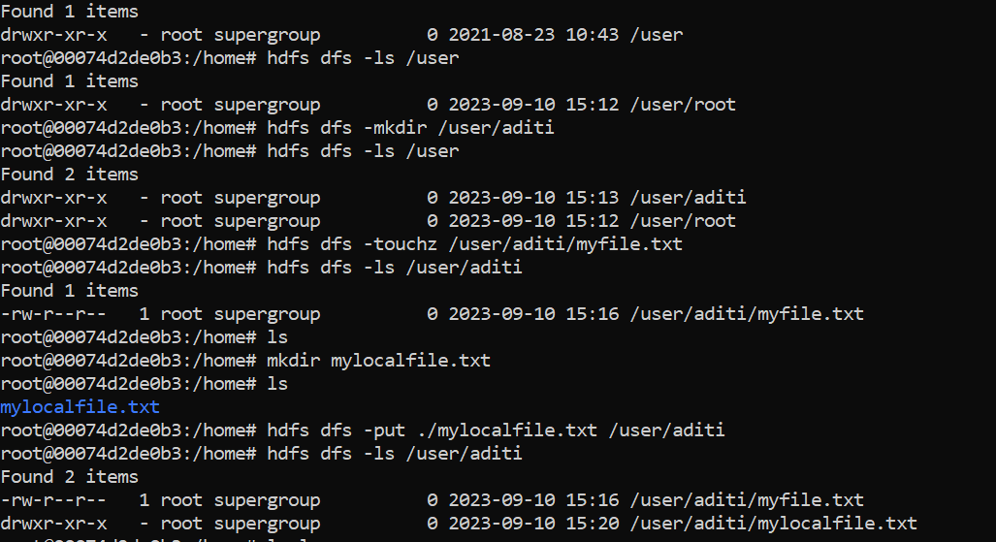

Activity 1

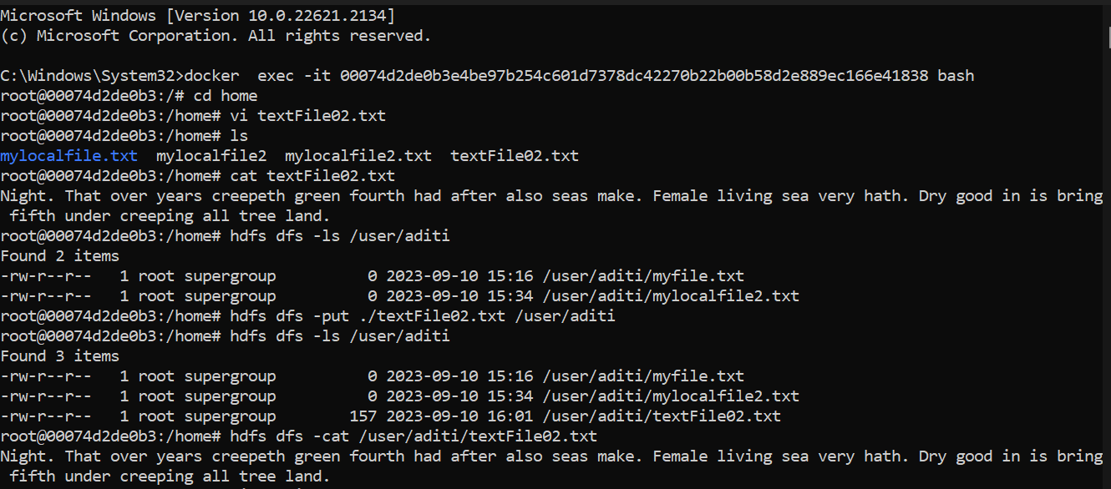

Activity 2

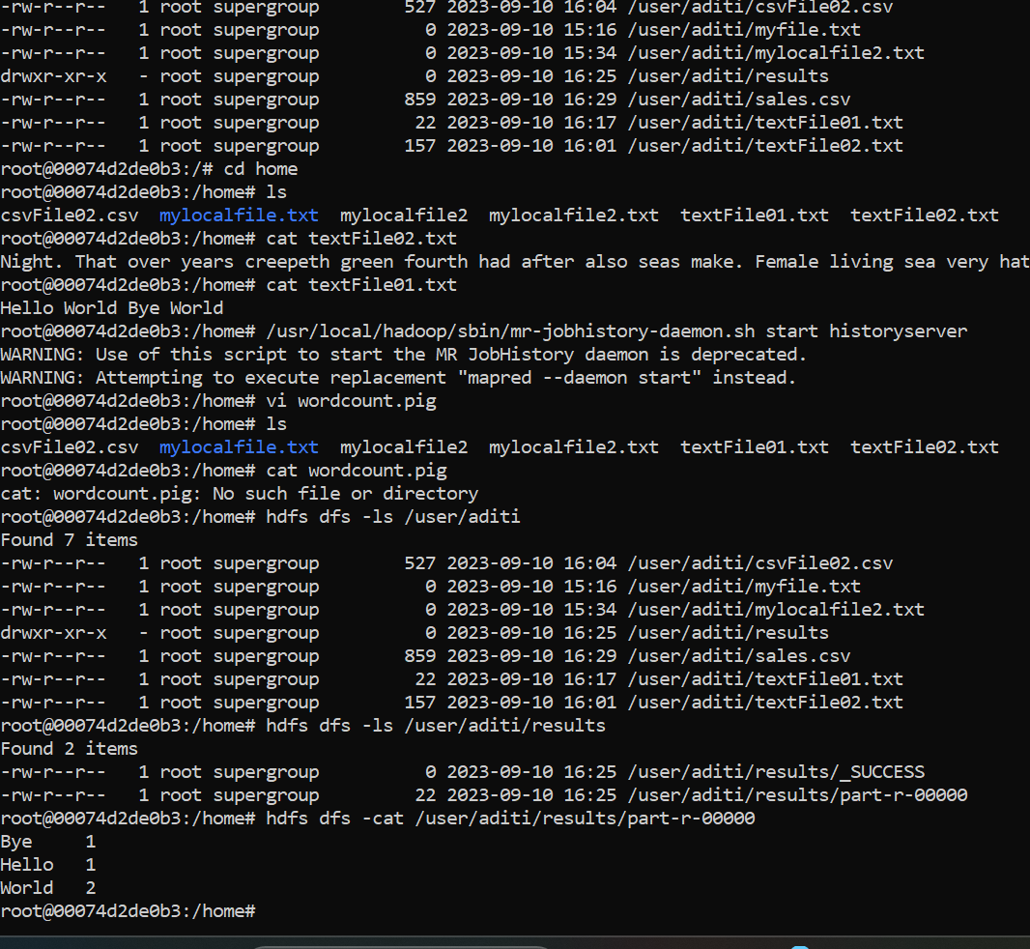

Test-------

