

**North South University**

**Project Report On**

**E Health Care Management System**

Course Code: CSE215L

Section: 04

Fall 2020

Faculty: ABH

**Submitted By**

**Group-C**

|  |  |
| --- | --- |
| **Name** | **ID:** |
| **Sadia Afrin** | **1632080042** |
| **Mofijul Alam Ovi** | **1821202642** |

Department of Electrical and Computer Engineering

Date of Submission: 7/10/2020

**Abstract**

Aim of our simple project is to maintain the hospital management. In our project, a user can register and then log into the system. After logging user can add patient property like name, gender, age, contact number, disease, consultant, ward number. We use different function to maintain patient information. Use our system a user can login into the system. After login user can add patient record, diagnosis information into the system and Calculate Bill. User can input data using GUI. GUI is created using javFX. All input data will be stored in .txt fill.

**Introduction**

Hospital staff can do their job easily and accurately. This project adds the details of every individual patient.

**Proposed System**

We want to build E health care management system. Using our application hospital management will be faster, secure and reliable.

**Feature**

1. User can Register to the system using username and password
2. User can log in to the system using registered username and password
3. Store the patient information
4. Store patient diagnosis information
5. Calculate Bill
6. Exit the system using close button

**Description**

In our project, we built six different Class to maintain HealthCare System. Each class has different functionality.

The details of every Class given below:

1. **ChooseManu.java:** This class is to display the choice of all activity like input patient record, input Diagnosis information, and calculate the total patient bill. By choosing, a valid user can record all information in .txt file.
2. **DiagnosisInformation.java:** This class display to the user all diagnosis information for a particular patient. All information record in .txt file.
3. **EHealthCareSystem.java:** This is the driver class.
4. **LogIn.java:** This class for log into the system. Only registered user can log into the system. Registered username and password is required to log into the system.
5. **PatientRecord.java:** Inserted patient information like Patient name, age, Gender, Contact number Store in the file when user press the enter button. There is a Close button to close the system.
6. **Register.java:** A new system user can register through this class. Username and password is required to register new user.

**Software Environment**

1. The application is designed using Net Bean IDE 8.2
2. Java programing language is used
3. .txt file is used to store data

**Screenshot of our system**

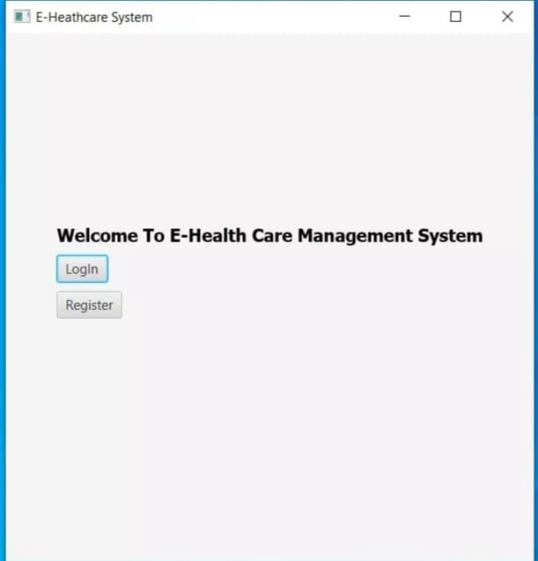

**Figure1: User dashboard**

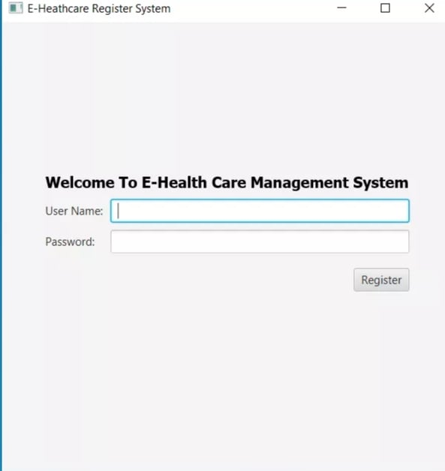

**Figure2 : Register**

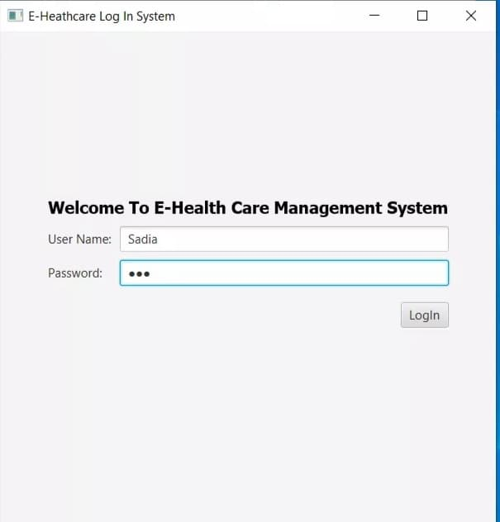

**Figure3: log in**

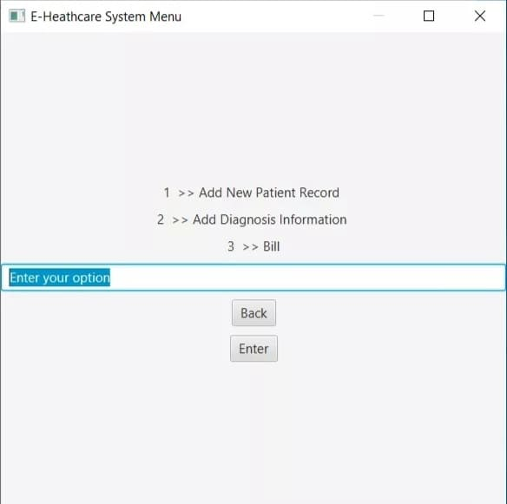

**Figure4: System menu**

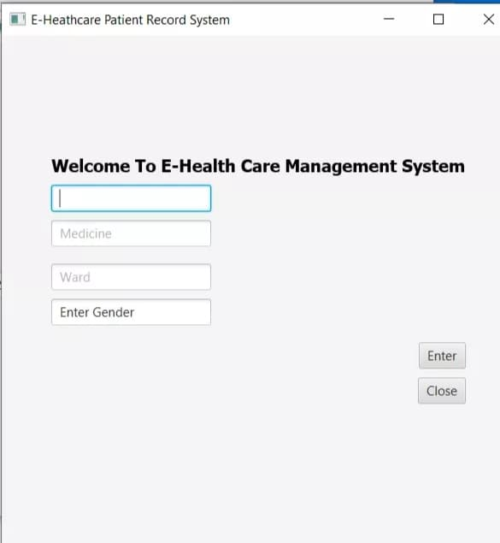

**Figure5: patient record.**

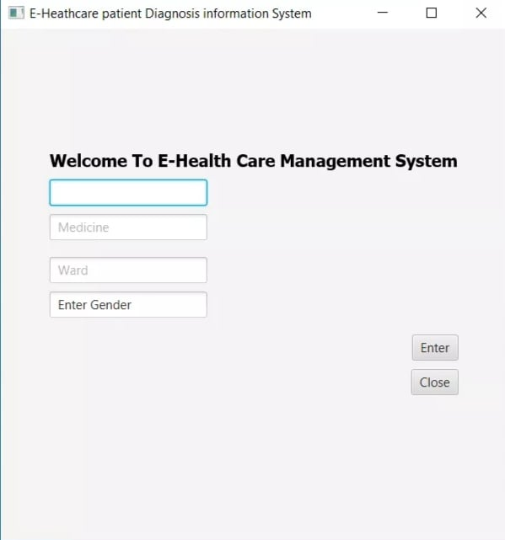

**Figure6: Diagnosis information**

**Conclusion**

We try to make a user friendly E-Health Care Management System. Our system has feature to add patient Information, Patient diagnosis information, all of these feature make the Hospital management system comfortable, Accurate and easier.

**Future perspective**

In future, we want to complete the bill system in our project and also want to add more feature to our system and want to add security. In addition, want make our system practical useable.

**Reference**

**https://docs.oracle.com/javafx/**

**https://stackoverflow.com/**

**https://www.kashipara.com/project/java/3453/e-health-care-management-systrem**