

**Student Performance Monitoring System**

**Database Management**

**Group-4**

**Group Members**

**Misbahur Rashid – 1721911**

**Rafid Al Ahsan – 1722006**

**Sadia Afroz Alma - 1730407**

**Md.Sakimuzzaman – 1721527**

**Puja Bhowmik – 1730791**

**Md.Musfiqur Rahaman – 1721684**

**Elan Md Taseen - 1831050**

Background of the organization :

Independent University, Bangladesh (IUB) is one of the leading and oldest private university in Bangladesh where academic excellence is a tradition, teaching a passion and lifelong learning a habit .It was established in 1993. It has an explicit focus on Research and Global partnerships. The IUB campus sprawling over 3 acres, has an amphitheater, the state-of-the-art laboratories, well-equipped library with online access to journals and books, above 70 classrooms, lecture galleries, auditorium, gymnasium, food court, playground, medical Center, counseling Center and an alumni office.

IUB has world-class undergraduate and graduate program accredited by professional national 7 international accreditation bodies, such as University Grants Commission of Bangladesh (UGC), Accreditation Council for Business Schools and Programs (ACBSP), USA, and Institution of Engineers, Bangladesh (IEB). IUB prepares graduates for a successful career and this is central to the design of courses and the support we provide. The programs and the courses are designed in such a way that prepare the students for a successful career. The faculty members of IUB are actively engaged in research and publish regularly in peer-reviewed journals. Along with conventional classroom based teaching, students are engaged in research relatively early in their studies. IUB has academic research collaborations with various universities including Harvard University, Stanford University, University of Colorado at Boulder, Brown University, McMaster University, University of Heidelberg . IUB also participate in various national level inter-university sports, robotics, debates and similar competitions.

Background of the project:

The Student Performance Monitoring System focuses on performance monitoring of student’s continuous assessment (tests) and examination scores in order to predict their final achievement status upon graduation.

The main theme of this project is to find the systemic problems and limitation we have in our current system in few areas and how can we improve it . The aim of our project is to design, build and deliver a developed software that we believe will help universities everywhere to promote a more productive and effective way of evaluating students. Also there need to be some functional changes in the system and department . We also analyze individual processes that take place under the current system of monitoring student performance and the concerns and problems with those process from start to finish.

Objective of the project :

We want to develop the the existing software iras in such way that can be more user friendly and helpful .it will help the institution to improve the quality of education . where the students and the faculty can use the system and find information more easily .in a short passage of time they can find all the information related to student enrollment , student grades , students CGPA and also CO and PLO.it will also benefit all the departments of the institution . this development will boost the the workrate of everyone .. it will be more productive and effective .not only the iras but also in different aspect few things need to be changed where we worked on . Monitoring semester wise student performance report by an Instructor and also analyze how to Department head submit grades of the students instead of faculty.

Scope of the project:

Project scope is a prerequisite to guarantee the success of a project. We have to make sure that the new system can be more successful than the present one when we are modifying an existing system.

We build an interface for faculties to able to see grades of another courses of a Student . Department can also access the systems for uploading grades instead of Instructor. If for some reason the instructor cannot upload the grade, then the Department can do it . On the other hand,Department head will be able to view different activities according to the different courses and sections of the instructor like Instructor’s Attendance,

Course wise Student performance etc .

Data will also, be protected and each user will be shown only that data which is relevant to them.

RICH PICTURE(AS-IS)

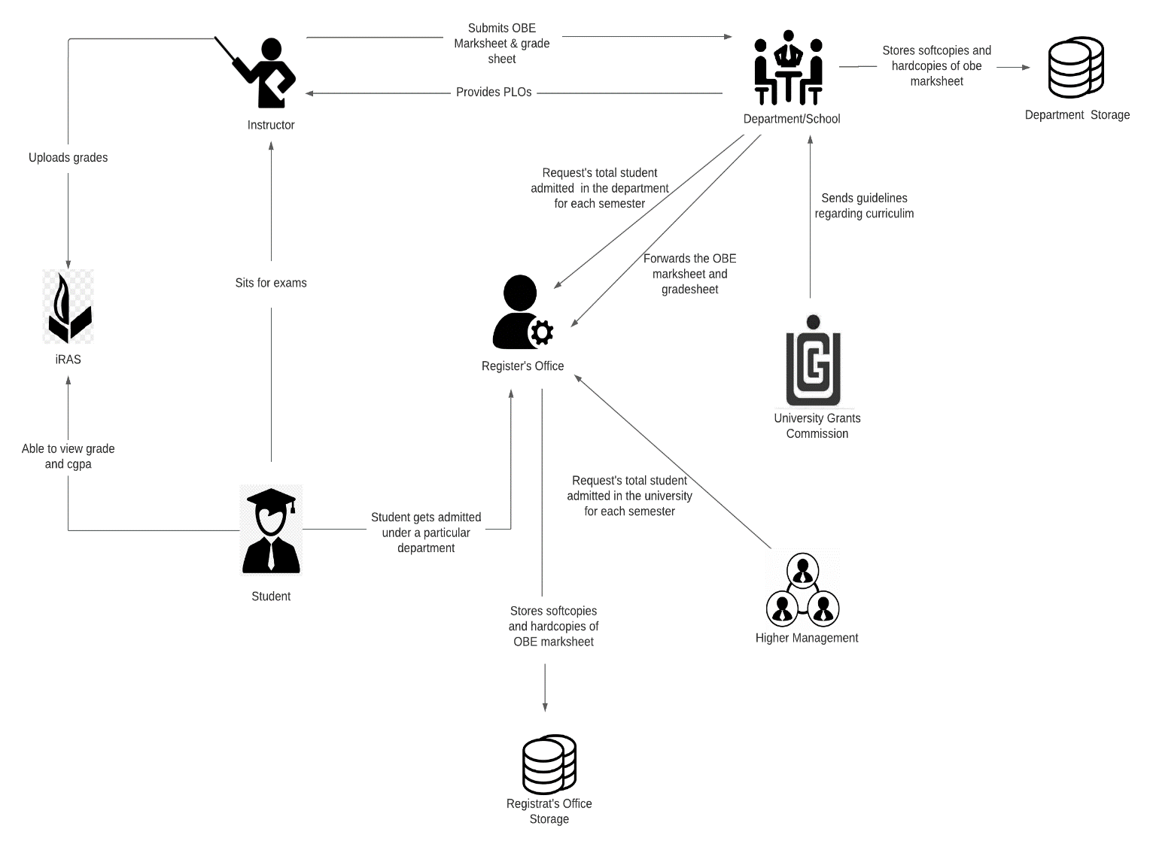

SIX ELEMENT(AS-IS)

|  |  |  |  |  |  |  |
| --- | --- | --- | --- | --- | --- | --- |
| **Process** | **System Roles** | | | | | |
| **Human** | **Non-Comp**  **Hardware** | **Computing**  **Hardware** | **Software** | **Database** | **Network &**  **Commination** |
| Student sits for exam | **Instructors**  1) Prepare question for the students  2) Give a particular time and date for the exam  3) Mange a classroom with chairs for all students  4) Prepare SODs and invigilators  **Students**  1) Attempt the examination | **Stationery**  1) Pen and paper for writing.  2) Compass, ruler and other stationery for drawing diagrams  **Chairs and Table**  1) For using during exam.  **Classroom**  1) A space for conducting the exams  **Stapler**  1) For attaching all the extra paper, rough work and answers | **Computer/**  **Laptop**  1) Some courses require a computer for coding or open book exam.  **Calculators**  1) Some exams require the use of calculators  **Printers & photocopy machine**  1) Instructors use it for printing question papers | **Microsoft Word**  1) Typing the question and generating a printable pdf.  **Operating System**  1) Any OS may be used. e.g. Windows, MacOS.  **Adobe Acrobat Reader**  1) For viewing the question paper in pdf format | **Microsoft Excel**  1) Used for storing exam marks and calculating final grade | **Internet**  1) Used by students during open book exam |

|  |  |  |  |  |  |  |
| --- | --- | --- | --- | --- | --- | --- |
| **Process** | **System Roles** | | | | | |
| **Human** | **Non-Comp**  **Hardware** | **Computing**  **Hardware** | **Software** | **Database** | **Network &**  **Commination** |
| Student are able to view grades, cgpa and download transcript | **Student**  1) Students have to login to iras by entering the student id and password  2) Select a specific semester  3) View grades for specific semester  4) Click on the transcript button to download a copy of transcript | **Paper**  1) Used for printing and keeping a hardcopy of transcript | **Computer/**  **Smart Phone**  1) Used for accessing iras.  **Printer**  1) For printing the transcript | **iRAS**  1) Provides user interface for view grades and download transcript.  **Browser**  1) Any browser an be used to access iras. e.g. edge, chrome, Firefox  **Adobe Acrobat Reader**  1) For viewing the transcript which is in pdf format.  **Operating System**  1) Any OS may be used. e.g. Windows, MacOS. | **iRAS database server**  1) iras database server is used for storing and receiving student grade information in iras | **Internet**  1) Internet is required for accessing iras |

|  |  |  |  |  |  |  |
| --- | --- | --- | --- | --- | --- | --- |
| **Process** | **System Roles** | | | | | |
| **Human** | **Non-Comp**  **Hardware** | **Computing**  **Hardware** | **Software** | **Database** | **Network &**  **Commination** |
| Instructors uploads grades to iras | **Instructors**  1) Instructors types in user id and password for logging into the system  2) The instructor clicks to the submit grade section and is taken into the grade submission page  3) The instructor selects grade for each of the student  4) Clicks on the submit button to submit the grades |  | **Computer/**  **Smart Phone**  1) Used for accessing iras and submitting the grade | **iRAS**  1) Provides user interface for submitting the grades  **Browser**  1) Any browser an be used to access iras. e.g. edge, chrome, firefox  **Operating System**  1) Any OS may be used. e.g. Windows, MacOS | **iRAS database server**  1) iras database server stores all the grades | **Internet**  1) Internet is required for accessing iras and submitting the grades |

|  |  |  |  |  |  |  |  |  |  |  |  |  |
| --- | --- | --- | --- | --- | --- | --- | --- | --- | --- | --- | --- | --- |
| **Process** | | **System Roles** | | | | | | | | | | |
| **Human** | | **Non-Comp**  **Hardware** | | **Computing**  **Hardware** | **Software** | | **Database** | | **Network &**  **Commination** | |
| Instructors produce OBE marksheet and grades sheet and submits it to the department | | **Instructors**  1) Instructor takes quizzes and exam  2)Checks the exam script  3) Records the mark for each exam in an excel sheet  4) Calculates the final grades and    5) Calculate total marks received for each CO  6) Declare if a student has achieved a specific CO  7) Declare if a student has received a PLO for a related CO  8) Make a verdict and analysis of how many students were able to receive a certain CO and PLO  9) Sends the final version of OBE marksheet to department office  **Department**  1) Receives a copy of the OBE marksheet and grade sheet from the instructors  2) Stores a copy of the OBE marksheet and grade sheet in department storage  3) Sends a copy of the OBE marksheet to the register’s office  **Register’s Office**  1) Receives the OBE marksheet from department  2) Store the OBE marksheet in register’s office storage | | **Paper**  1) Used for storing hardcopies of OBE marksheet | | **Computer**  1) Computer is used for making softcopies of OBE marksheets  **Printer**  1) To print the hardcopies of the OBE marksheet and grade sheet | **Microsoft Excel**  1) Used by instructors to calculate the PLO and CO achievement | | **Department Storage**  1) A hardcopy of OBE marksheet and grade sheet is stored in the department storage  **Register’s Office Storage**  1) A hardcopy of OBE marksheet and grade sheet is stored in the register’s office storage | | **Internet**  1) Online platform such as- google sheets may be used for producing OBE marksheet | |
| **Process** | | **System Roles** | | | | | | | | | | | | |
| **Human** | | **Non-Comp**  **Hardware** | | **Computing**  **Hardware** | | | **Software** | | **Database** | | **Network &**  **Commination** | |
| Map Course Outcomes  (COs) to Program Learning Outcomes  (PLOs) | | **UGC**  1) Provides guide line to the department about the curriculum  **Department**  1) Comes with the PLOs  2) Sends the PLOs to the instructor  **Instructor**  1) List the course content and course outcome  2) Maps the course content to the COs  3)Maps the PLOs  4)Prepares question paper according to the COs | | **Pen and Paper**  1) Used for brainstorming and rough works | | **Computer/Smart devices**  1) Course coordinators use computers to make softcopies of course outcomes (COs)  **Printers**  1) Used for print hardcopies of course outcomes (COs) | | | **Microsoft Word**  1) Course coordinators use MS word for making course outline and course assessment report with COs mapping to the PLOs | |  | | **Internet**  1) Internet is used to communicate with ugc and other stakeholders to discuss topics related mapping COs and PLOs | |

|  |  |  |  |  |  |  |
| --- | --- | --- | --- | --- | --- | --- |
| **Process** | **System Roles** | | | | | |
| **Human** | **Non-Comp**  **Hardware** | **Computing**  **Hardware** | **Software** | **Database** | **Network &**  **Commination** |
| Student gets admitted under a particular department | **Student**  1) Fills up the admission form for taking admission under a particular department  2) Receive an email regarding successful admission form submission  **Register’s Office**  1) Receives the admission form  2) Analyze the admission  3) Check if the student fulfills all the requirements for getting admitted  4) If the student fulfills all the requirements then admit the student under the requested department.  6) Generate a student id number  5) Sends the total number of students enrolled in a semester under a particular department to the department.  6) Send the total number of students enrolled in the university to the higher management.  **Department**  1) Request total student enrolled in the department  2) Receive information about total student enrolled in department  **Register’s Office**  1) Request total student enrolled in the university  2) Receive information about total student enrolled in department. | **Paper**  1) Register’s office keeps a hardcopy of student information. e.g. student blood group, emergence contact number, address | **Computer**  1) Used for accessing iras and filling admission form  **Printers**  1) For printing hardcopies of student information | **iRAS**  1) Provides user interface for filling the admission form  **Browser**  1) Any browser an be used to access iras. e.g. edge, chrome, Firefox  **Operating System**  1) Any OS may be used. e.g. Windows, MacOS. | **iRAS database server**  1) iras database server is used for storing all the admission information. | **Internet**  1) Internet is required for accessing the online admission form. |

PROCESS DIAGRAM(AS-IS)

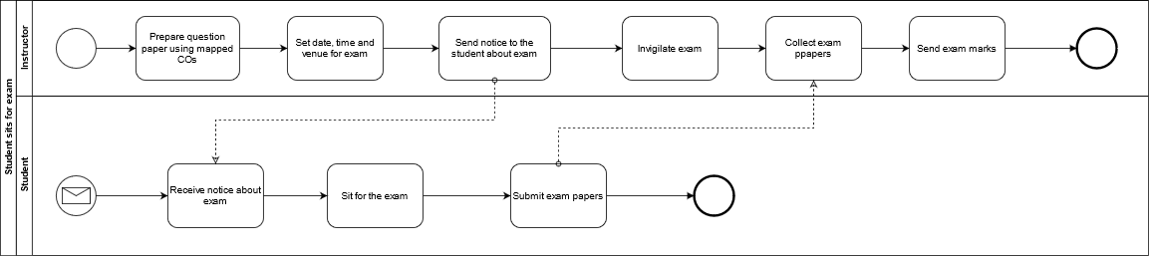

**FIGURE 2.1 Process Diagram for Student Sits for exam**

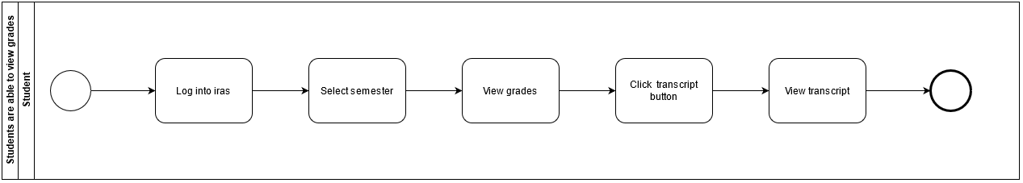

**FIGURE 2.1 Process Diagram for Student are able to view grades and CGPA**

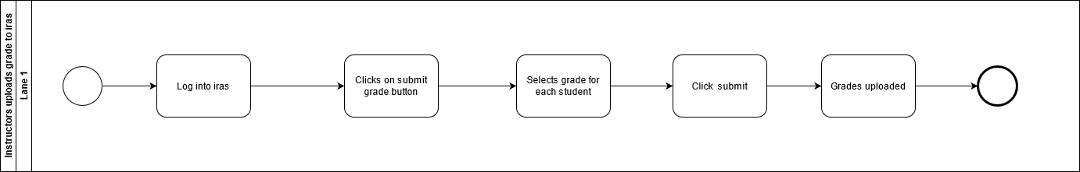

**FIGURE 2.1 Process Diagram for Instructor uploading grade to iras**

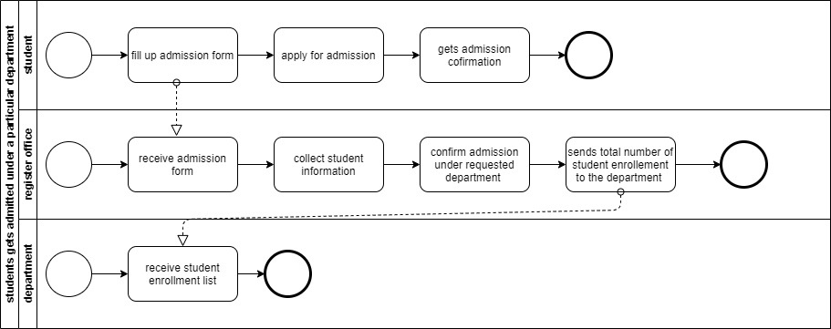

**FIGURE 2.1 Process Diagram for Instructor produces OBE marksheet**

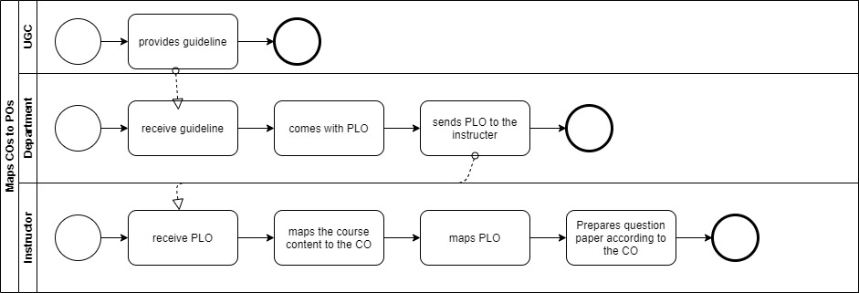

**FIGURE 2.1 Process Diagram for Map COs and POs**



**FIGURE 2.1 Process Diagram for Student gets admitted under particular department**

Problem Analysis

|  |  |  |  |  |
| --- | --- | --- | --- | --- |
| **Process Name** | **Stakeholders** | **Concern (Problems)** | **Analysis (reason of the problem)** | **Proposed Solutions** |
| Course  Assessment  Report | Instructor /  Course  Coordinator | Sending hardcopy  And softcopy  Students examination marks  And course  Assessment report  To the register office store the info  Time consumption  And delay is prime limitation. | As sending hardcopy and softcopy to the register office involve multiple  persons and different  processes, it could  easily led to confusion, loss of  important student report card. | Can be uploaded by IRAS by the faculty and viewed by interested  Persons. |
| Department should be able to see individual instructor performance | Department Head  Instructor | Instructor send the hardcopy of the semester wise student performance report to the department head | Department head need to know how students are performing under a specific instructor and whether the instructors are following the rules given by the head of department. hardcopy is time consuming and not so informative | We can create an option in IRAS where department head will be able to see course wise students’ performance by an instructor |
| |  | | --- | | instructor will be able view the semester wise CGPA and grades of a student | | Instructor  IRAS | Instructor don’t get to see  Result of a student from their previous semester | It becomes difficult for an instructor to monitor students | There will be an option in IRAS where the instructor will be able to see semester wise performance of students who enrolled in his course. |
| UGC approves  curriculum  based on PLO and CO | 1. Higher  Management (HM)  2. UGC | 1. HM needs to send the curriculum  booklet manually.  2. HM needs to send the updated  Curriculum to the  Department every time. | 1. It will take time for the UGC to receive the Curriculum booklet and process the information.  2. It is a hassle to send manually every time the curriculum is updated | We can transfer the  curriculum in our  software by which it could be accessed  easily by the members and it also could be edited real time by the HM and updated instantly whenever changes are required by the UGC. |
| CO Entry and Mapping | 1. IUB Faculties  2. Admin | 1. Faculties mapped  each PLO to COs for each course and send it to the Admin  2. Admin receives  updated COs and  update it to the excel database | They might be subjected to change each semester depending on the course question pattern etc. The process is time consuming as well as the faculties have to send the mapped COs to the Admin and wait for the update | SPM already contains the PLOs so the faculties can  directly map the Cos from their own account |

RICH PICTURE(TO-BE)

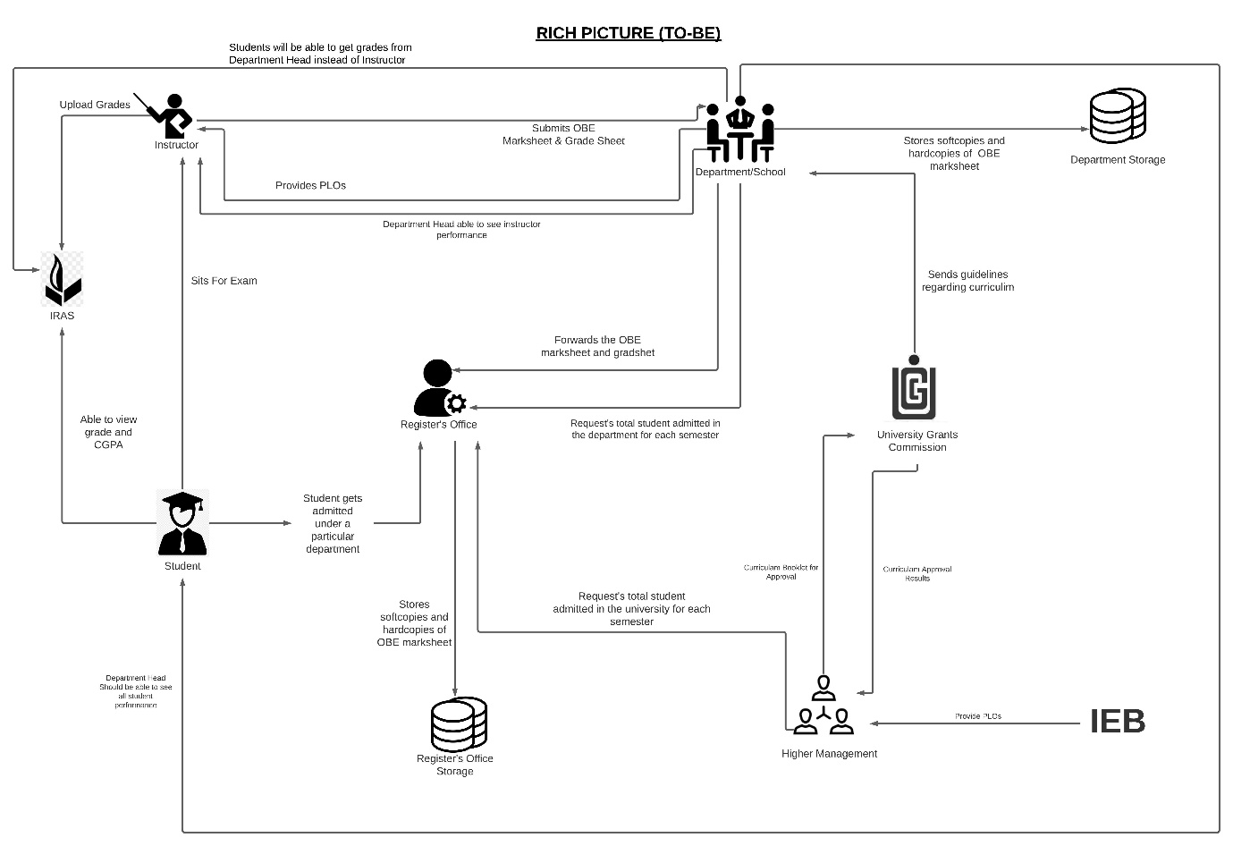

SIX ELEMENT(TO-BE)

|  |  |  |  |  |  |  |
| --- | --- | --- | --- | --- | --- | --- |
| **Process** | **System Process** | | | | | |
| **Human** | **Non-comb Hardware** | **Computing Hardware** | **Software** | **Database** | **Network and Communication** |
| **Instructor Able to see the result of another courses of a Student** | **Instructor:**  1.Login to IRAS.  2. Search that specific student's id.  3. See the grades of other courses for intended semester.  **Register Office:**  1.Access IRAS.  2.View Students grades of other courses if and when it’s necessary. | **Pen and Paper:**  Note down the grade if needed. | **Computer/Phone:**  1.Used for accessing IRAS.  2.Used Computer to make softcopies.  **Printer:**  Printout the softcopies. | **IRAS:**  1.Stores letter grades of each completed course.  2.Provides the online user interface for viewing grades.  **Networking devices (Router, Switch Bridge, Hub):**  Used by Instructor and students to access the Internet. | **IRAS Database Server:**  Instructor receive the student information in IRAS. | **Internet:**  All related data searched through internet. |
| **Students will be able to get grades from Department instead of Instructor** | **Department:**  1.Collect the student’s marks sheet.  2.Login to IRAS.  3.Search a Student I’d to upload his/her grade.  3.Select a particular course.  4. Submit the grade next to the student’s name. | **Calculator:**  Marks are calculated with a calculator. | **Computer:**  Used for accessing IRAS.  **Printer:**  Printout the softcopy of the mark sheet. | **Excel sheet:**  Marks-sheet can be created using Excel sheet, Google sheet  **Email Software:**  Used for communication between Department head and Instructor. | **IRAS Database server:**  1. IRAS uses a database server to store and maintain student grades’ information | **Internet and Gmail:**  The marks sheet can be taken through emails or any other internet messaging platforms. |
| **Department Head able to see all instructor**  **performance** | **Department:**  1.Login to IRAS.  2.Record mark about instructors and see all the activity. | **Paper:**  Instructor send the hardcopy of the semester wise student performance report to the  Department. | **Computer/Phone:**  1.Used for accessing IRAS.  2.Create softcopies of record of all assessment data  **Printer:**  2.If needed Printout the softcopies. | **Excel sheet:**  Record necessary assessment data in Excel sheet.  **IRAS:**  Update activity of Instructor.  **Printing Software:**  Used for printing Software doc.  **PDF Viewer:**  To view the transcript in PDF-form. | **Department Storage:**  Record of instructor assessment.  **IRAS server:**  Store update activity. | **Internet:**  Need to connect IRAS. |

Process Diagram (TO-BE)

