
COMSATS University Islamabad (CUI)

Software Design Description
(SDS DOCUMENT)

for
PodVerse
Version 1.0
By
Rabeea Chughtai CIIT/SP22-BCS-079/ISB
Sadia Imran CIIT/SP22-BCS-087/ISB

Supervisor
Ms. Saadia Maqbool

Bachelor of Science in Computer Science (2022-2026)

Table of Contents
Revision History iii
Application Evaluation History iv
1. Introduction 1
2. Design Methodology and Software Process Model 1
3. System Overview 1
3.1 Architectural Design 1
4. Design Models 1
5. Data Design 2
5.1 Data Dictionary 2
6. Human Interface Design 2
6.1 Screen Images 2
6.2 Screen Objects and Actions 2
7. Implementation 3
7.1 Algorithm 3
7.2 External APIs/SDKs 5
7.3 User Interface 5
7.4 Deployment 8
8. Testing and Evaluation 9
8.1 Unit Testing 9
8.2 Functional Testing 9
8.3 Business Rules Testing 10
8.4 Integration Testing 10
Appendix A 11
Appendix B 13

Revision History
Name | Date | Reason for changes | Version

Application Evaluation History

Comments (by committee)  *include the ones given at scope time both in doc and presentation | Action Taken

Supervised by
Supervisor’s Name
Signature______________

Introduction
PodVerse is an AI-powered podcast creation platform developed to simplify and modernize the podcast production journey for small business owners, entrepreneurs, and content creators. By eliminating technical barriers such as high production costs, complex editing processes, and challenges in finding credible guests, PodVerse enables creators to produce engaging, high-quality podcasts effortlessly. The system integrates advanced technologies like voice cloning, real-time AI interactions, and customizable avatars, providing users with a centralized solution for planning, recording, editing, and publishing their podcast content. With a user-friendly interface and modules tailored for automation and personalization, PodVerse ensures seamless experience, empowering creators to build consistent content and strengthen audience engagement.

Scope
The scope of PodVerse is covered under the following modules:

Module 1: User Authentication & Profile Management
This module manages authentication, profile customization, and dashboard access for secure login and content engagement.
FE-1: Account creation via email with verification.
FE-2: Secure login via email/password.
FE-3: Password recovery via email verification.
FE-4: Secure Logout.
FE-5: Creator’s dashboard for sample podcasts and AI Agent management.
FE-6: View and edit profiles.
FE-7: Activity feeds with updates from followed creators.

Module 2: Voice Cloning
This module allows users to create and manage voice samples for cloning.
FE-1: Enabling the recording or upload of voice samples for cloning.
FE-2: Allowing users to preview voice samples to check on the quality.
FE-3: Allow users to re-record or re-upload if the sample is not as desired.
FE-4: Allow the availability of a library with voices.

Module 3: Knowledge Base Setup
This module facilitates the setup and management of a knowledge base for retrieval.
FE-1: Allow users to upload data in PDFs, URLs, CSV, or JSON.
FE-2: Data is cleaned, processed, and split into meaningful chunks for easy handling.
FE-3: Tag chunks with metadata and link to original sources.
FE-4: Store chunks in a database and generate vector embeddings for better retrieval.

Module 4: RAG Retrieval
This module enhances the retrieval of accurate and relevant information from the knowledge base.
FE-1: Convert queries into vectors to determine purpose.
FE-2: Match vectors with knowledge base data for accurate responses.
FE-3: Re-rank data by relevance for better answers.
FE-4: Provides fact-based correct answers for podcasts.
FE-5: Optimized for large datasets without loss of performance.
FE-6: Allow feedback to enhance agent response quality.

Module 5: Agent Customization
This module allows users to personalize their AI agents.
FE-1: Users can assign a custom name to their AI agent.
FE-2: Users can choose from various voice options to suit their podcast.
FE-3: Users can select or upload an avatar to visually represent their AI agent.

Module 6: Podcast Audio Creation
This module provides tools for creating and publishing podcasts.
FE-1: Let users start dialogues with a customized AI agent.
FE-2: Conversations recorded for user and AI agent.
FE-3: Users allowed minimal editing to trim and splice to rearrange things.
FE-4: Allow users the ability to preview edited podcasts for flow and polish.
FE-5: Export podcasts in MP3/WAV.
FE-6: Save recordings for future use.

Module 7: AI Host
This module provides an AI host to manage the flow of podcasts.
FE-1: AI Host presents the flow of podcasts, introduces the episodes and closes with a summary.
FE-2: Tracks podcast time and gives reminders for the schedule.
FE-3: Facilitates smooth transitions between guests or topics.
FE-4: Provides summary prompts to summarize key points for clarity and engagement.

Module 8: AI Guest
This module provides an AI guest to enhance podcast discussions.
FE-1: AI Guest responds to real-time queries using dynamic responses.
FE-2: AI Guest shares appropriate stories to add depth to the discussion.
FE-3: AI Guest gives back comments/reactions to facilitate engagement.

Module 9: Podcast Video Creation & Publishing
This module enables the creation of video content for podcasts, and AI-generated text summaries.
FE-1: Users select avatars for each of the speakers.
FE-2: The system syncs based on the audio of the podcast.
FE-3: Users can choose from the pre-defined templates and visuals for the video.
FE-4: Pre-designed split-screen video template with two avatars.
FE-5: Exports the final video in MP4 format or publish the final video.
FE-6: Allow creators to rate podcast sessions.
FE-7: Provide written feedback on conversation skills, voice clarity, and AI accuracy.

Module 10: Subscription & Payment
This module manages subscription and payment processes.
FE-1: Let users access some free, limited content.
FE-2: After the limit, users are prompted to subscribe for continued access.
FE-3: Secure payment gateway integration supporting credit/debit cards.
FE-4: User can control subscriptions, see payment history, change methods.
FE-5: Give reminders before expiration with options of auto-renewal.

Module 11: FAQs Chatbot
This module provides a chatbot to answer frequently asked questions.
FE-1: Users can ask about podcasting, AI customization, or troubleshooting.
FE-2: The chatbot retrieves relevant answers from the FAQs and support materials.
FE-3: Provides concise, direct responses for quick problem resolution.

Module 12: Audience Engagement and Communication
This module enables audience interaction, providing a communication platform, and podcast feedback to enhance creator engagement.
FE-1: Notifications for creators about audience interactions.
FE-2: Highlighting top creators and trending content.
FE-3: Integrated communication platform for user-to-user messaging and calls.
FE-4: Generate and display a text-based summary of podcast episodes.

Module 13: Admin Panel & Analytics
This module provides administrative functionalities, including user management, content moderation, analytics, and system configuration.
FE-1: Allow admin to view, search, deactivate, reactivate, or delete user accounts
FE-2: Enable admin to review reported podcasts and comments.
FE-3: Display live statistics on active users, total podcasts created, trending content, user engagement heatmaps, and demographics.
FE-4: Allow admin to track active subscriptions, process refunds, and manage payment disputes.
FE-5: Provide insights into user engagement, podcast performance, and trending topics.

Design Methodology and Software Process Model

Design Methodology:
In developing PodVerse, we've chosen an object-oriented approach.

Rationale behind this approach:
Here are the main reasons for choosing this approach:

Modularity and Reusability:
For PodVerse, which has many features like user authentication and AI-driven podcast creation, having a modular structure is important. Each class can focus on a specific task, making the code easier to manage and less likely to have errors.

Efficiency in Development:
The object-oriented approach allows for rapid development. By breaking down the application into smaller, reusable classes, our team can work on different parts of the app at the same time.

Better Debugging and Testing:
Object-oriented programming allows for testing and debugging of individual classes separately. This means each part of PodVerse can be thoroughly tested before integration, reducing bugs and ensuring higher code quality.

Software Process Model:
In developing PodVerse, we are following the Incremental model.

Rationale behind this model:
Here are the main reasons for choosing this model:

Step-by-Step Progress:
The Incremental model allows the project to grow through iterative cycles. With each cycle, new features are added, tested, and refined. This ensures that the system is developed and tested in steps, enabling early delivery of core functionalities while allowing for improvements in later cycles.

Feedback Integration:
By delivering the system in steps, we can gather feedback from users at each stage. Early and continuous feedback helps identify any issues or areas for improvement, allowing us to refine and enhance the system iteratively.

Flexibility in Adding Features:
The incremental model provides flexibility in adding new features later. Modules like AI Host, AI Guest, and Podcast Video Creation can be developed and integrated one by one. This approach allows us to adapt to changing requirements.

Continuous Testing and Quality Assurance:
Each step is thoroughly tested before moving on to the next. This ensures that any bugs or issues are identified and resolved early, maintaining the overall quality of the system. Continuous testing helps in building a stable and reliable application, reducing the risk of major defects, and ensuring a smooth user experience.

System Overview
PodVerse is an innovative platform designed to simplify podcast creation and production for small business owners, entrepreneurs, and content creators. It addresses common challenges such as high production costs, technical complexities, and securing credible guests. PodVerse enables users to create high-quality podcasts effortlessly, even without extensive technical skills. The platform offers features like voice cloning, editing, and publishing, making the production process seamless. With AI voices and language models, users can create engaging and dynamic podcasts without needing real hosts or guests. PodVerse is built to help creators produce consistent content, grow their brand, and engage effectively with their audience.

Architectural Design
The architectural design of PodVerse is modular, ensuring that each component of the system works together to achieve the overall functionality. This section provides a high-level overview of how the system’s modules collaborate to deliver the desired features.

Box and Line Diagram
The following diagram shows the modules and their relationships with each other. This diagram is at a high level of abstraction and gives an overview of how different modules of the system interact to achieve the desired functionality.

DIAGRAM HERE

Layered Architecture
We have adopted a Layered Architecture for the PodVerse application. This architecture style emphasizes the separation of concerns and facilitates modularity.

Presentation Layer:

User Interface: This layer includes the user interface components that interact with the users. It handles the display of data and user inputs. For PodVerse, this includes the web interface where users can manage their profiles, create podcasts, and interact with AI Hosts and Guests.

Application Layer:

Controllers: This layer acts as a bridge between the user interface and the business logic. It processes user inputs, communicates with the business logic layer, and updates the user interface accordingly. In PodVerse, controllers manage user authentication, podcast creation, and interactions with AI Hosts and Guests.

Business Logic Layer:

Services: This layer contains the core business logic of the application. It handles data processing, validation, and business rules. For PodVerse, this includes managing podcast sessions, processing voice cloning, and handling AI interactions.

Data Access Layer:

Repositories: This layer is responsible for data access and storage. It interacts with the database to perform CRUD (Create, Read, Update, Delete) operations. In PodVerse, repositories manage user data, podcast recordings, and AI-generated content.

Database Layer:

Database: This layer includes the database where all the application data is stored. For PodVerse, this includes user profiles, podcast recordings, AI models, and metadata.

LAYERED ARCHITECTURE DIAGRAM HERE

Design Models
Create design models as are applicable to your system. Provide detailed descriptions with each of the models that you add. Also ensure visibility of all diagrams.

Design Models for Object Oriented Development Approach

The applicable models for the project using object oriented development approach may include:

- Activity Diagram
- Class Diagram
- Sequence Diagram
- State Transition Diagram (for the projects which include event handling and backend processes)

Design Models for Procedural Approach

The applicable models for the project using procedural approach may include:

- Activity Diagram
- Data Flow Diagram (data flow diagram should be extended to 2-3 levels. It should clearly list all processes, their sources/sinks and data stores.)
- State Transition Diagram (for the projects which include event handling and backend processes)

To view examples of all above models, see Appendix B

Data Design
Explain how the information domain of your system is transformed into data structures. Describe how the major data or system entities are stored, processed, and organized.

List any databases or data storage items.

Data Dictionary
Alphabetically list the system entities or major data along with their types and descriptions. If you provided a functional description, list all the functions and function parameters. If you provided an OO description, list the objects and its attributes, methods and method parameters.

Human Interface Design
Describe the functionality of the system from the user’s perspective. Explain how the user will be able to use your system to complete all the expected features and the feedback information that will be displayed for the user.

Screen Images
Display screenshots showing the interface from the user’s perspective. These can be hand-drawn, or you can use an automated drawing tool. Just make them as accurate as possible. (Graph paper works well.)

Screen Objects and Actions
A discussion of screen objects and actions associated with those objects

Implementation
This chapter will discuss implementation details of the project. You will not put your source code here, however, are required to write the core modules functionalities in pseudocode form (Following sections are required in this chapter).

Note: You are required to follow proper coding standard to write your source code. For guidelines, General Coding Standards & Guidelines are provided in Appendix D.

Algorithm
Mention the algorithm(s) used in your project to get the work done with regards to major modules. Provide a pseudocode explanation regarding the functioning of the core features. Be sure to use the correct syntax and semantics for algorithm representations. Following are few examples of algorithms/pseudocode:

Algorithm 1 Registration
Input: user_details (email, password)
Output: Registration status (success or error message)
- Initialize database_connection
- Input user_details (email, password, role).
- Check if role is valid (Applicant or Recruiter):
- If not valid, return: "Invalid role".
- Normalize the email to lowercase.
- Check if the email already exists using checkEmailExists(email):
- If it exists, return "Email already exists".
- Encrypt the password using bcrypt (encryptPassword(password)).
- Save user_details (email and password) to the database.
- Send a verification email using sendVerificationCode(email).
- Return "Registration successful. Please verify your email.".
Algorithm 1.1 checkUsernameExists |  | Algorithm 1.2: encryptPassword
Input: username |  | Input: password
Output: boolean value |  | Output: encrypted_password
1: initialize database_connection  2: input email  3: user_record ← query database for user where email = input email  4: if (user_record exists) then  5: return true  6: else  7: return false |  | 1: initialize encryption_algorithm  2: input password  3: encrypted_password ←  encryption_algorithm.encrypt(password)  4: return encrypted_password
Algorithm 2 Login
Input: email,password

Output: Login status (success or error message)

- Initialize database_connection.
- Input email and password.
- Normalize the email to lowercase.
- Query the database for a user with the given email.
- If no user is found, return "Invalid email".
- Compare the provided password with the stored password using bcrypt.compare.
- If the password is incorrect, return "Invalid password".
- Check if the user is verified (isVerified).
- If not verified, return "Email not verified".
- Generate a secure token (setUser(user)).
- Store the token as a cookie in the response.
- Return "Login successful".
Algorithm 3 Voice Cloning | Algorithm 4 TranscribePodcastAudio
Input: User's audio sample (.wav) | Input: audio_file (.wav)
Output: Cloned voice model ID | Output: Transcript text
1: Import necessary libraries (torchaudio, numpy, os, torch)  2: Function preprocess_audio(audio_sample):  3: Convert to mono channel, 16kHz if not already  4: Return cleaned_audio  5: Function extract_embedding(cleaned_audio):  6: Load Tortoise TTS encoder model  7: embedding ← encoder(cleaned_audio)  8: Return embedding  9: Function save_embedding(user_id, embedding):  10: path ← "voice_embeddings/" + user_id + ".pt"  11: Save embedding tensor to path using torch.save()  12: Return path  13: Main Function clone_voice(user_id, audio_sample):  14: cleaned_audio ← preprocess_audio(audio_sample)  15: embedding ← extract_embedding(cleaned_audio)  16: embedding_path ← save_embedding(user_id, embedding)  17: Save embedding_path in MongoDB user profile  18: Return "Voice cloned successfully", embedding_path | 1: Import required libraries (torchaudio, os, whisper or other STT model)  2: Function load_stt_model():  3: model ← load Whisper / Wav2Vec2 model locally  4: Return model  5: Function preprocess_audio(audio_file):  6: Convert audio to 16kHz mono WAV format if needed  7: Return cleaned_audio_path  8: Function transcribe_audio(model, cleaned_audio):  9: transcript ← model.transcribe(cleaned_audio)  10: Return transcript  11: Main Function transcribe_podcast(audio_file):  12: model ← load_stt_model()  13: cleaned_audio ← preprocess_audio(audio_file)  14: transcript ← transcribe_audio(model, cleaned_audio)  15: Save transcript to MongoDB with reference to podcast_id  16: Return transcript
Algorithm 5 GenerateTranscriptSummary | Algorithm 6 BasicAIUserConversation
Input: transcript_text | Input: speaker_turns, conversation_text, user_id
Output: summary_text | Output: Generated podcast audio file path
1: Import HuggingFace transformers library  2: Function load_summarizer_model():  3: model_name ← "facebook/bart-large-cnn" OR "google/flan-t5-base"  4: tokenizer ← load tokenizer for model_name  5: model ← load pre-trained model from HuggingFace  6: Return tokenizer, model  7: Function preprocess_transcript(transcript_text):  8: Clean special characters and limit to max 1024 tokens  9: Return cleaned_text  10: Function generate_summary(tokenizer, model, input_text):  11: inputs ← tokenizer(input_text, return_tensors="pt", truncation=True)  12: summary_ids ← model.generate(inputs["input_ids"], max_length=150, min_length=40)  13: summary ← tokenizer.decode(summary_ids[0], skip_special_tokens=True)  14: Return summary  15: Main Function summarize_transcript(transcript_text):  16: tokenizer, model ← load_summarizer_model()  17: input_text ← preprocess_transcript(transcript_text)  18: summary ← generate_summary(tokenizer, model, input_text)  19: Save summary in MongoDB linked to transcript_id  20: Return summary | 1: Import required libraries (TTS model, pyaudio, ffmpeg, torchaudio)  2: Function synthesize_speaker_audio(text, speaker_embedding):  3: Generate waveform using Tortoise or Tacotron with speaker_embedding  4: Return audio_waveform  5: Function merge_conversation_turns(conversation_list):  6: For each (speaker_role, sentence) in conversation_list:  7: speaker_embedding ← load_embedding(speaker_role)  8: audio ← synthesize_speaker_audio(sentence, speaker_embedding)  9: Append audio to full_session_audio  10: Return full_session_audio  11: Main Function record_ai_podcast(conversation_list, user_id):  12: full_audio ← merge_conversation_turns(conversation_list)  13: file_name ← "user_id_timestamp_ai_session.wav"  14: Save full_audio to Firebase Storage under `podcasts/user_id/`  15: Create podcast metadata (title, timestamp, duration, roles)  16: Save metadata in MongoDB `podcasts` collection  17: Return "Podcast recorded successfully", file path

External APIs/SDKs
Below are the APIs used in PodVerse :

Table 1 Details of APIs used in the project
Name of API and version | Description of API | Purpose of usage | List down the API endpoint/function/class in which it is used
Stripe (version 2020-08-27) | Credit Card payment integration | Sandbox used for the orders payment | stripe.paymentMethods.create
Cloudinary | Image and Video management solution | Uploading Product Images on Cloudinary server | https://api.cloudinary.com/v1_1/demo/image/upload

User Interface
Details about user interface with descriptions. Provide the User Interface for each sub-system (such as Mobile App, Web App, Client App, Admin App). Provide description of each User Interface explaining the details.
When inserting User Interfaces, use appropriate size of the image, for example, for mobile app, 2-4 screens can be placed on a single page.

Following are few examples of User Interfaces:

    - Login Screen Home Screen

Login screen of our mobile app where user Home screen where total, delayed and
have to choose its role and its company. Other complaints are shown.

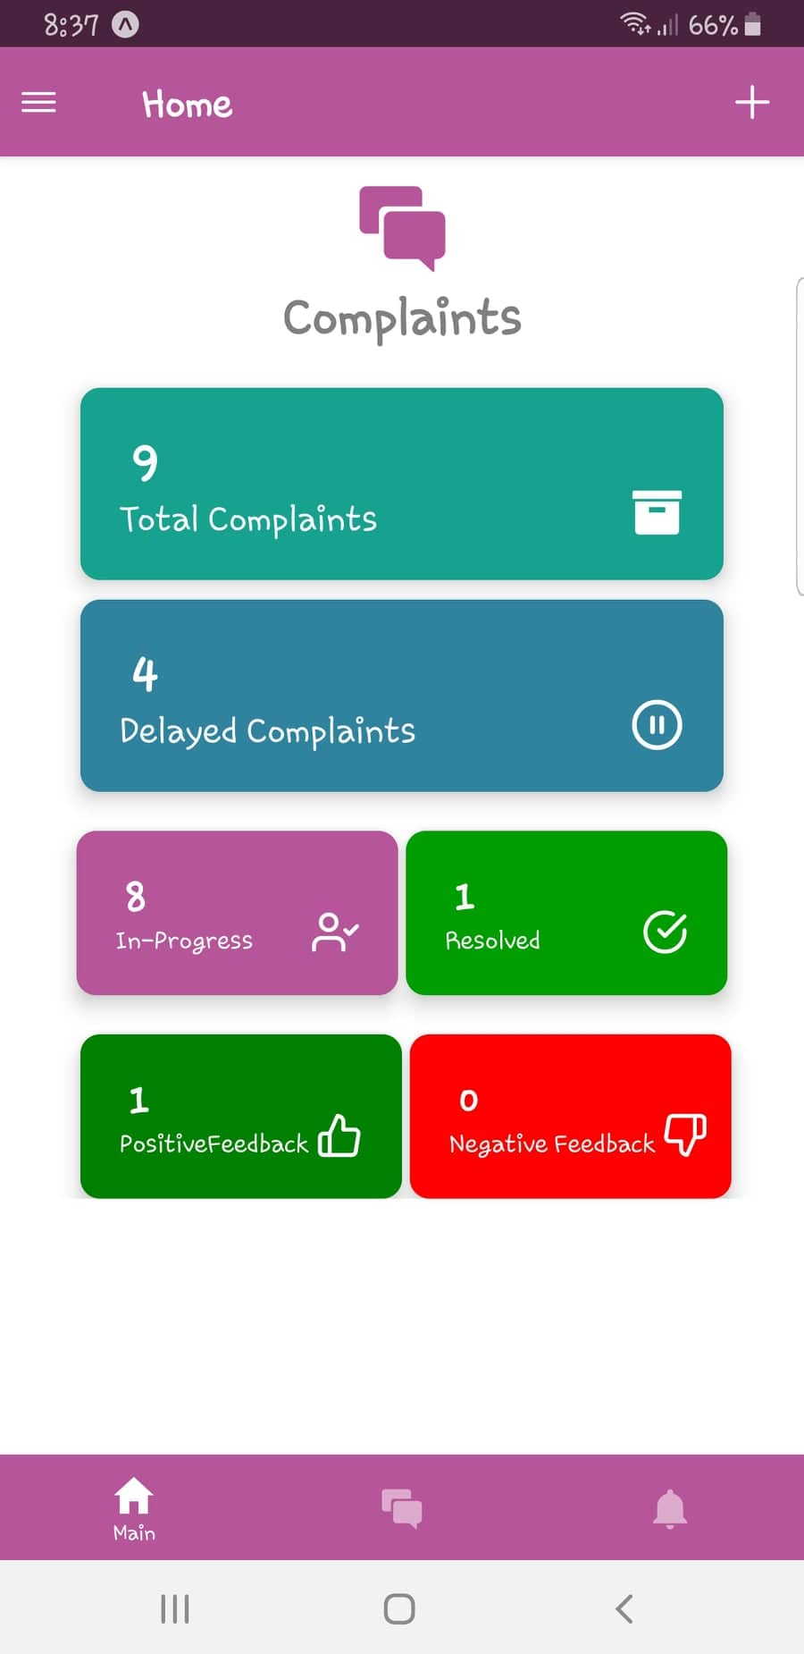
Figure 1Home Screen
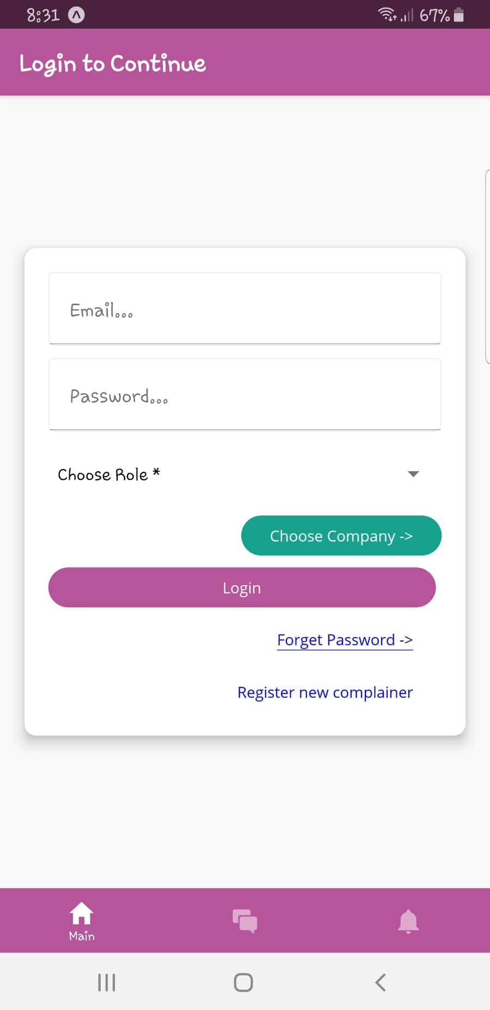
Figure 2 Login Screen

    - Assignee Dashboard
Complain Assignee can view the graphs of month-wise complains, Resolved complains, summary and a list of submitted complains.

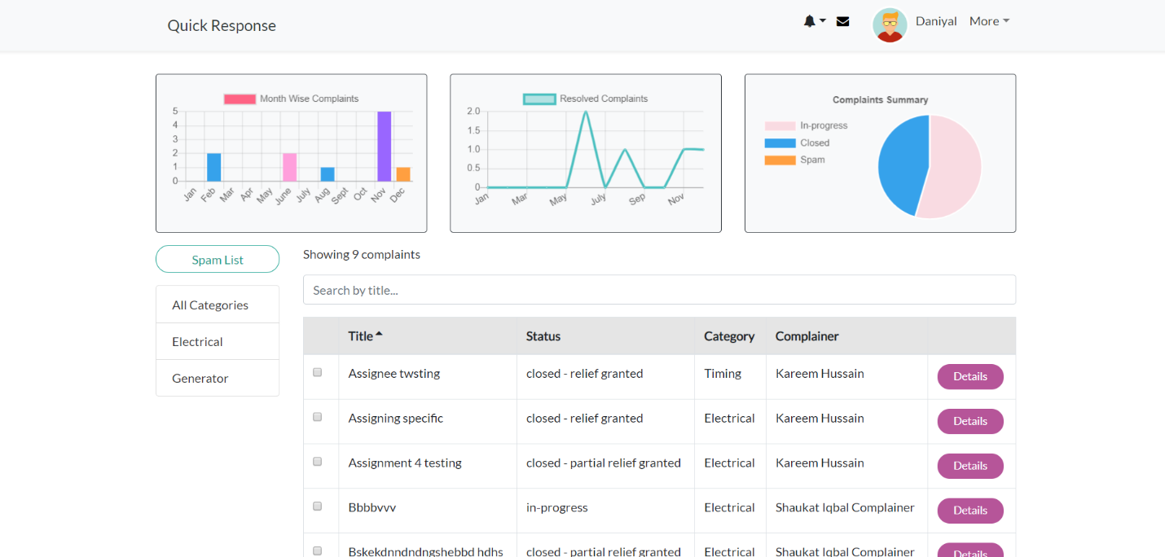
Figure 3 Assignee Dashboard
    - New Complaint
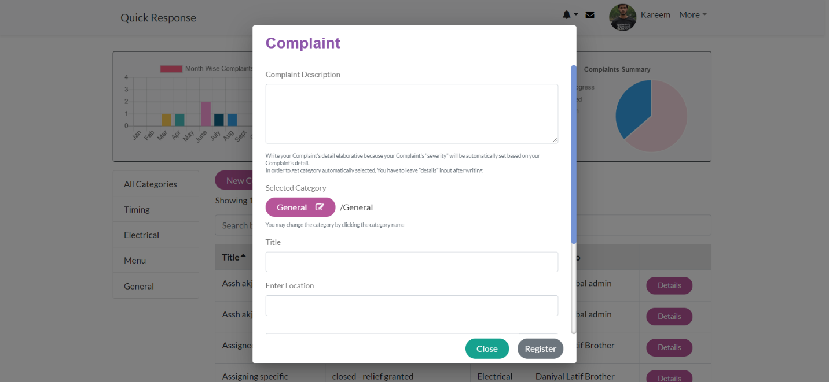
Complain Assignee and Complainer can create a new complain by providing Description, Category, Title, Location etc.
Figure 4 New Complaint

Deployment
Specify the deployment environments used for hosting and live testing of all the sub-systems of the project. Provide the details of hosting/cloud service used, set of available software and their versions used etc.

Testing and Evaluation

Once the system has been successfully developed, testing has to be performed to ensure that the system working as intended. This is also to check that the system meets the requirements stated earlier. Besides that, system testing will help in finding the errors that may be hidden from the user. The testing must be completed before it is deployed for use.

There are few types of testing which includes the unit testing, functional testing and integration testing.
You are required to perform each of these in-depth to ensure system quality.

Unit Testing

It’s a level of software testing where individual units of a software/component are tested. The purpose is to validate that each unit of the software performs as designed.

Unit Testing 1: Login as Patient with valid and invalid credentials
Testing Objective: To ensure the login form is working correctly with valid and invalid credentials/inputs.

No. | Test case/Test script | Attribute and value | Expected result | Result
1 | Check the email field of login to validate that it takes proper email | Email:  abc@gmail.com | Validates email address and moves cursor to next textbox | Pass
2 | Check the email field of login to validate that it displays error message. | Email:  abc.gmail.com | Highlights field and displays error message | Pass

Functional Testing
The functional testing will take place after the unit testing. In this functional testing, the functionality of each of the module is tested. This is to ensure that the system produced meets the specifications and requirements.

Functional Testing 1: Login with different roles (Management, Patient, Doctor)
Objective: To ensure that the correct page with the correct navigation bar is loaded.

No. | Test case/Test script | Attribute and value | Expected result | Actual result | Result
1. | Login as a ‘Management’ member. | Username: (correct username M003)  Password:  (correct password 1234) | Main page for the Management is loaded with the Management navigation bar. | Logged in and redirected to management main page. | Pass
2. | Login as a ‘Doctor’ member. | Username: D003  Password:  1234 | Main page for the Doctor is loaded with the doctor navigation bar. | Login failed – invalid credentials error | Fail

Business Rules Testing
Decision table based testing technique is used to test business rules. The business rules were defined in FRs and Use Cases
Decision based testing uses a systematic approach where input and outputs are provided in tabular form. It is a precise and compact way to model complicated logic. The table contains conditions and actions are used for test cases where conditions as inputs and actions as outputs.

Detailed example is as given in Appendix E.

Integration Testing
Integration tests assess whether a set of classes that must work together do so without error. They
ensure that the interfaces and linkages between different parts of the system work properly. At this point, the classes have passed their individual unit tests, so the focus now is on the flow of control among the classes and on the data exchanged among them. Integration testing follows the same general procedures as unit testing: The tester develops a test plan that has a series of tests, which, in turn, have a test. Integration testing is often done by a set of programmers and/or systems analysts.

Integration Testing 1: Scheduling Patient Appointment
Testing Objective: To ensure the scheduling is being done correctly and the interface between module ‘Patient/Doctor Management’ and module ‘Appointment/Scheduling’ is running correctly.

No. | Test case/Test script | Attribute and value | Expected result | Actual result | Result
1. | Make Appointment | Doctor schedule, patient preferred date and time | Successfully create doctor-patient appointment showing date and time of appointment. | Appointment created successfully | Pass
2. | Change Appointment booking | Select Date and time | Final date and time of appointment will be shown. | Appointment time changed successfully | Pass

Appendix A
Box-and-line diagram

Box-and-line diagrams are often used to describe the business concepts and processes during the analysis phase of the software development lifecycle. These diagrams come with descriptions of components and connectors, as well as other descriptions that provide common inherent interpretations.

Example:

Lines in the box-and-line diagrams indicate the relationship among components
Figure A-1 Box-and-Line Diagram for an Online Shopping Business
- The semantic of lines may refer dependency, control flow, data flow, etc
- Lines may be associated with arrows to indicate the process direction and sequence.
- A box-and-line diagram can be used as a business concept diagram describing its application domain and process concepts

Example of Architecture Pattern:

The figure A-2 shows an example of the logical package organization of the layered architecture. The top level deals with user interface, the next level is for utilities, and the one below utility provides core services. Each layer gets support from its lower adjacent layer by an interface implementation and from the related classes in the same layer.

A simple software system may consist of two layers: an interaction layer and a processing layer:
- The interaction layer provides user interfaces to clients, takes requests, validates and forwards requests to the processing layer for processing, and responds to clients.
- The processing layer receives the forwarded requests and performs the business logic process, accesses the database, returns the results to its upper layer, and lets the upper layer respond to clients since the upper layer has the GUI interface responsibility.
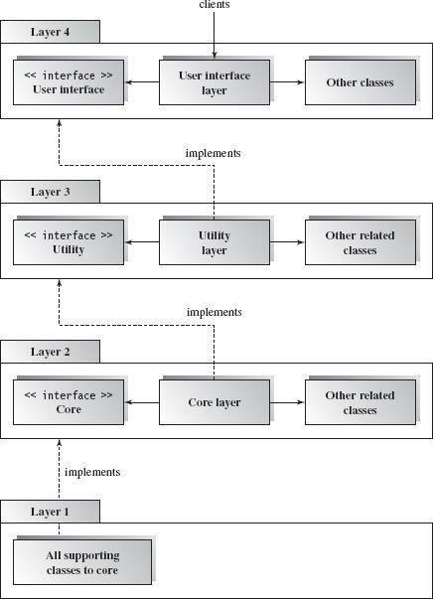
Figure A-2 Component-based Layered Architecture

Note: The Architecture pattern shall be selected according to the targeted system’s requirements and quality attributes. Above example is provided to demonstrate that how the system architecture is required to be presented.

Appendix B
Design Models

Activity Diagram

Following activity diagram is of an appointment system presenting make an appointment process in which all diagram’s elements are presented. In further in Table B-1 to the detail of activity diagram syntax is provided.

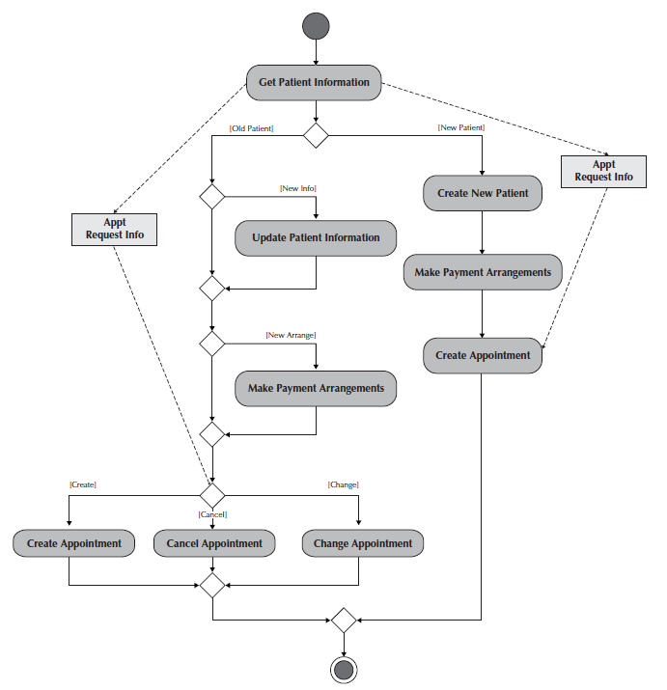
Example
Figure B-1 Activity Diagram for Make an Appointment Process

Activity Diagram Syntax
Table B- 1Activity Diagram Syntax
Term and definition | Symbol
An action:  - Is a simple, non-decomposable piece of behavior.  - Is labeled by its name. | 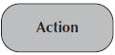
An activity:  - Is used to represent a set of actions.  - Is labeled by its name. | 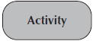
An object node:  - Is used to represent an object that is connected to a set of object flows.  - Is labeled by its class name. | 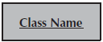
A control flow:
- Shows the sequence of execution.
An object flow:
- Shows the flow of an object from one activity (or action) to another activity (or action).
An initial node:  - Portrays the beginning of a set of actions or activities. | 
A final-activity node:  - Is used to stop all control flows and object flows in an activity (or action). | 
A final-flow node:  - Is used to stop a specific control flow or object flow. | 
A decision node:  - Is used to represent a test condition to ensure that the control flow or object flow only goes down one path.  - Is labeled with the decision criteria to continue down the specific path. | 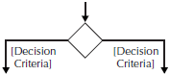
A merge node:  - Is used to bring back together different decision paths that were created using a decision node. | 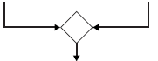
A fork node:  - Is used to split behavior into a set of parallel or concurrent flows of activities (or action) | 
A join node:  - Is used to bring back together a set of parallel or concurrent flows of activities (or action) | 
A swimlane:  - Is used to break up an activity diagram into rows and columns to assign the individual activities (or actions) to the individuals or objects that are responsible for executing the activity (or action)  - Is labeled with the name of the individual or object responsible | 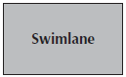
Class Diagram

Following class diagram is of an appointment system in which all class diagrams elements are presented. In further in Table B-2 to the detail of class diagram syntax is provided.

Example

Figure B-2 Class Diagram for an Appointment System
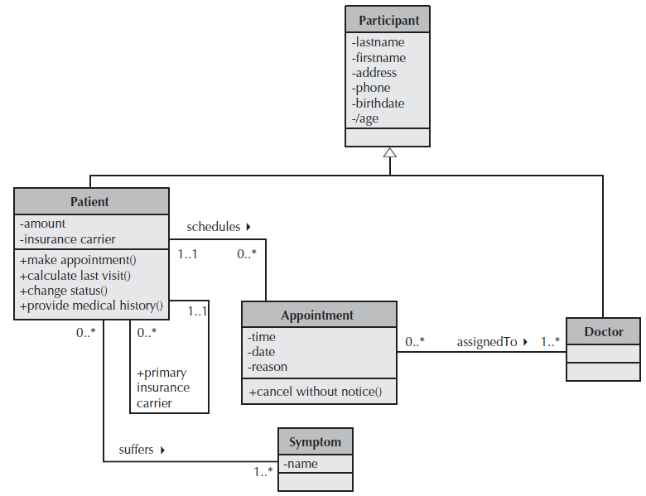

Class Diagram Syntax

Table B- 2 Class Diagram Syntax
Term and definition | Symbol
A class:  - Has a name typed in bold and centered in its top compartment.  - Has a list of attributes in its middle compartment.  - Represents a kind of person, place, or thing about which the system will need to capture and store information.  - Has a list of operations in its bottom compartment.  - Does not explicitly show operations that are available to all classes. | 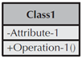
An attribute:  - Represents properties that describe the state of an object.  - Can be derived from other attributes, shown by placing a slash before the attribute’s name. | attribute name  /derived attribute name
An operation:  - Represents the actions or functions that a class can perform.  - Can be classified as a constructor, query, or update operation.  - Includes parentheses that may contain parameters or information needed to perform the operation. | 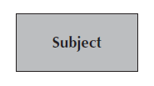  operation name ()
An association:  - Represents a relationship between multiple classes or a class and itself.  - Is labeled using a verb phrase or a role name, whichever better represents the relationship.  - Can exist between one or more classes.  - Contains multiplicity symbols, which represent the minimum and maximum times a class instance can be associated with the related class instance. |   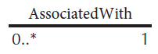
A generalization:  - Represents a-kind-of relationship between multiple classes. | 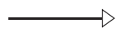
An aggregation:  - Represents a logical a-part-of relationship between multiple classes or a class and itself.  - Is a special form of an association. | 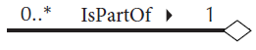
A composition:  - Represents a physical a-part-of relationship between multiple classes or a class and itself  - Is a special form of an association. | 

Sequence Diagram

Following example shows an instance sequence diagram that depicts the objects and messages for the Make Old Patient Appt use case, which describes the process by which an existing patient creates a new appointment or cancels or reschedules an appointment. In further in Table B-3 to the detail of class diagram syntax is provided.

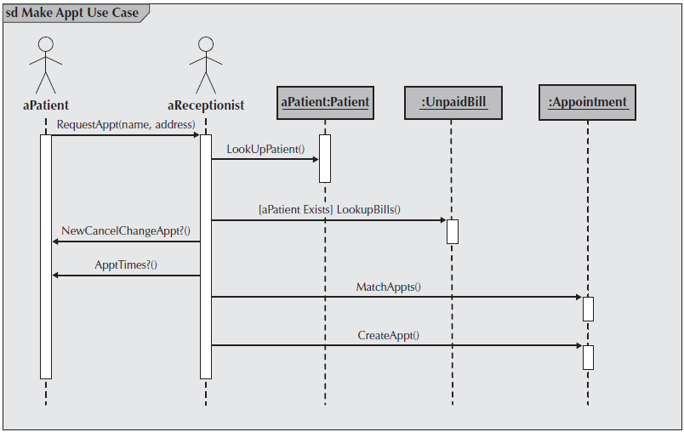
Example
Figure B-3 Example Sequence Diagram

Sequence diagram Syntax

Table B-3 Sequence Diagram Syntax
Term and definition | Symbol
An actor:  - Is a person or system that derives benefit from and is external to the system.  - Participates in a sequence by sending and/or receiving messages.  - Is placed across the top of the diagram.  - Is depicted either as a stick figure (default) or, if a nonhuman actor is involved, as a rectangle with <<actor>> in it (alternative). | 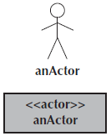
An object:  - Participates in a sequence by sending and/or receiving messages.  - Is placed across the top of the diagram. | 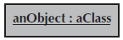
A lifeline:
- Denotes the life of an object during a sequence.
- Contains an X at the point at which the class no longer interacts.
An execution occurrence:
- Is a long narrow rectangle placed atop a lifeline.
- Denotes when an object is sending or receiving messages.
A message:  - Conveys information from one object to another one.  - An operation call is labeled with the message being sent and a solid arrow, whereas a return is labeled with the value being returned and shown as a dashed arrow. | 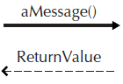
A guard condition:  - Represents a test that must be met for the message to be sent. | 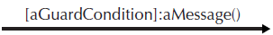
For object destruction:
- An X is placed at the end of an object’s lifeline to show that it is going out of existence.
A frame:  - Indicates the context of the sequence diagram. | 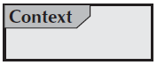

Behavioral State Machine Diagram

Following example of a behavioral state machine representing the patient class in the context of a hospital environment. From this diagram, we can tell that a patient enters a hospital and is admitted after checking in. If a doctor finds the patient to be healthy, he or she is released and is no longer considered a patient after two weeks elapse. If a patient is found to be unhealthy, he or she remains under observation until the diagnosis changes.

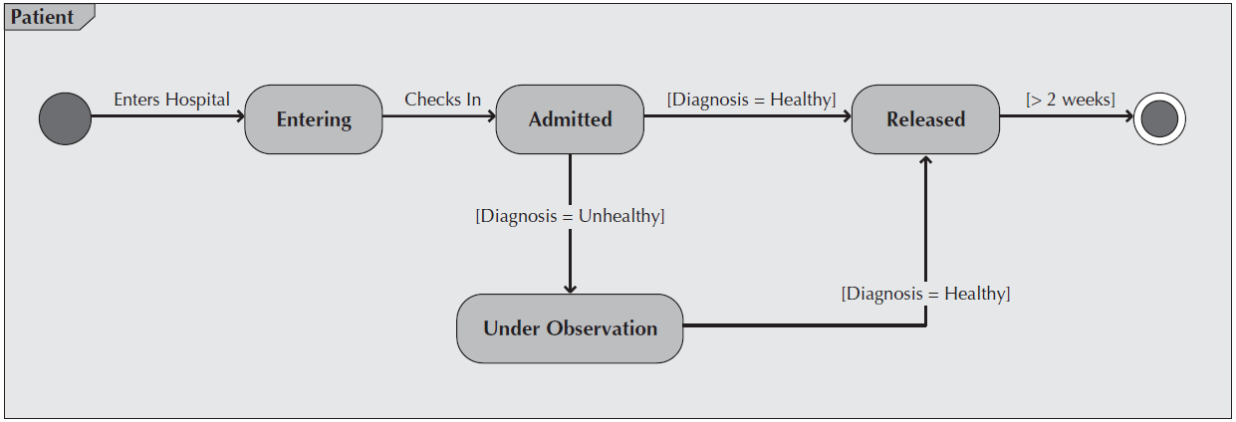
Example
Figure B-4 Sample Behavioral State Machine Diagram

Behavioral State Machine Diagram Syntax

Table B-4 Behavioral State Machine Diagram Syntax
Term and definition | Symbol
A state:  - Is shown as a rectangle with rounded corners.  - Has a name that represents the state of an object. | 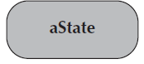
An initial state:
- Is shown as a small, filled-in circle.
- Represents the point at which an object begins to exist.
A final state:  - Is shown as a circle surrounding a small, filled-in circle (bull's-eye).  - Represents the completion of activity. | 
An event:
- Is a noteworthy occurrence that triggers a change in state.
- Can be a designated condition becoming true, the receipt of an explicit signal from one object to another, or the passage of a designated period of time.
- Is used to label a transition.
A transition:
- Indicates that an object in the first state will enter the second state.
- Is triggered by the occurrence of the event labeling the transition.
- Is shown as a solid arrow from one state to another, labeled by the event name.
A frame:  - Indicates the context of the behavioral state machine. | 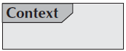

Data Flow Diagram

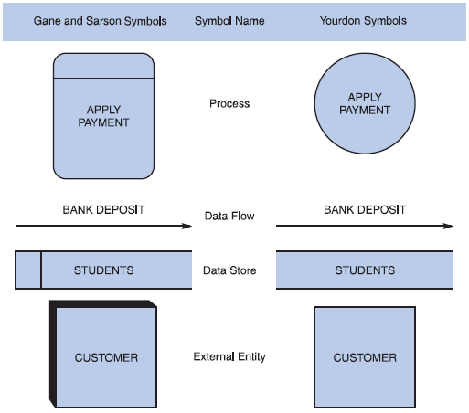
Data flow diagram symbols, symbol names, and examples
Figure B-5 Data flow diagram symbols, symbol names, and examples of the Gane and Sarson and Yourdon symbol sets.

Guidelines for Drawing DFDs

Step 1: Draw a Context Diagram: The first step in constructing a set of DFDs is to draw a context diagram. A context diagram is a top-level view of an information system that shows the system’s boundaries and scope. Data stores are not shown in the context diagram because they are contained within the system and remain hidden until more detailed diagrams are created.

Example
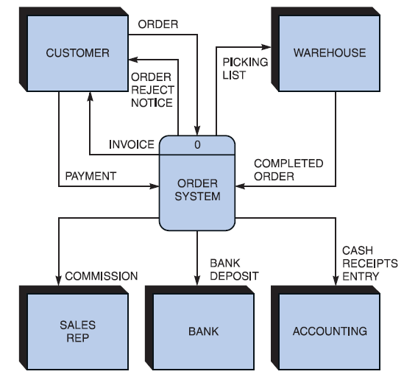

Figure B-6 Context diagram DFD for an order system.
Step 2: Draw a Diagram 0 DFD: To show the detail inside the black box, you create DFD diagram 0. Diagram 0 zooms in on the system and shows major internal processes, data flows, and data stores. Diagram 0 also repeats the entities and data flows that appear in the context diagram. When you expand the context diagram into DFD diagram 0, you must retain all the connections that flow into and out of process 0.
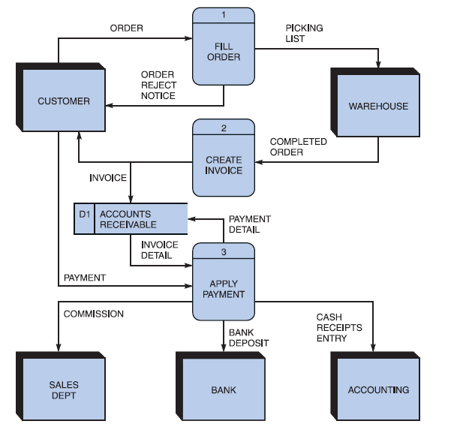
Example
Figure B-7 Diagram 0 DFD for the order system.

Step 3: Draw the Lower-Level Diagrams:
To create lower-level diagrams, you must use leveling and balancing techniques. Leveling is the process of drawing a series of increasingly detailed diagrams, until all functional primitives are identified.
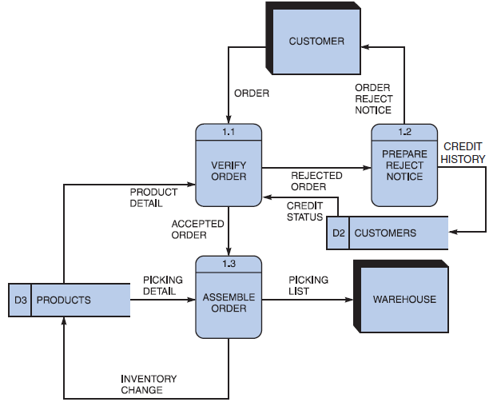
Leveling Example
Figure B-8 Diagram 1 DFD shows details of the FILL ORDER process in the order system.

Balancing maintains consistency among a set of DFDs by ensuring that input and output data flows align properly.
Balancing Example
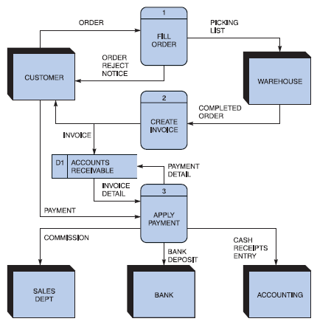
Order System Diagram 0 DFD

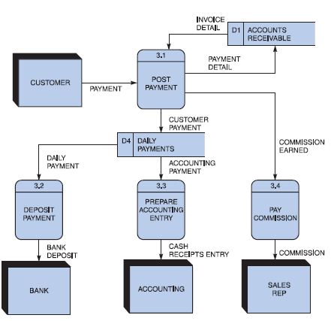
Order System Diagram 3 DFD
The order system diagram 0 is shown at the top of the figure and exploded diagram 3 DFD (for the APPLY PAYMENT process) is shown at the bottom. The two DFDs are balanced, because child diagram at the bottom has the same input and output flows as the parent process 3 shown at the top.

Appendix D: General Coding Standards & Guidelines
- Follow a consistent variable naming convention throughout the code. E.g.
  - Snakecase (words are delimited by “_” like: variable_one)
  - Pascalcase (words are delimited by capital letters like: VariableOne)
  - Camelcase (words are delimited by capital letters except the initial word like: variableOne)
  - Hungarian Notation (describes the variable type or purpose at the start of the variable name like: arrDistributeGroup)
- Use naming that visually describes scope like privateField, Const etc
- Use read only/immutable when a field’s value should not be changed after initialization
- Use only get, for properties that should not be updated from outside
- Name functions according to their functionalities.
- Insert appropriate comments to make the code understandable to any reader. Additionally follow a consistent style to do so. E.g.
/* the below function will be used for the addition of two variables*/
int Add(){
//logic of the function
}
Avoid commenting on obvious things
- Make use of indentation for indicating the start and end of the control structures along with a clear specification of where the code is between them.
- Follow consistent naming convention for files and folders.
- Follow proper structure for classes
- Group code entities logically into projects/packages/modules/folders
  - Separate logical layers of application into different modules/services/utilities etc.
  - User separate files for each class, struct, interface, enum etc. Name of the file and the enclosing entity must be same. E.g., class Employee in Employee.cs/Employee.java
- Define and use everything within the minimum scope possible
- Use proper access modifier for all code entities if required
- Code entities should have maximum cohesion and least coupling possible.
- Follow DRY law.
  - Do not repeat code.
  - A piece of knowledge should exist only in one place within the codebase/application
  - Reuse code as much as possible
  - Always write short methods
  - Single method should not have too many logic, long conditional flow or too many parameters
- Strictly follow Single Responsibility Principle (SRP) when writing methods, classes, modules, projects, packages, or any other code entities.
- Write classes and other code entities that are easy to extend without modification.
- Handle exceptions
- Log exception and other significant event details
- Follow a consistent convention for logging all over the application

Appendix E: Business rules testing

Methodology for creating decision table:

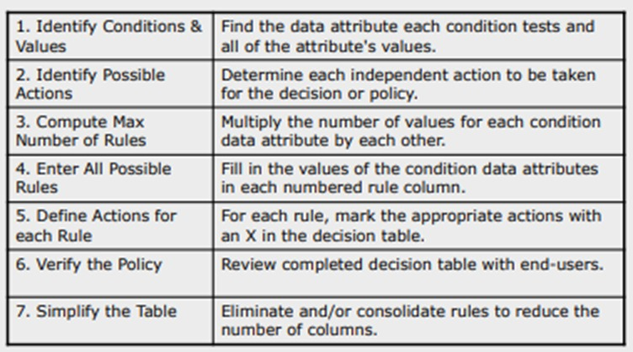

Example:

The provided example is of a super store.

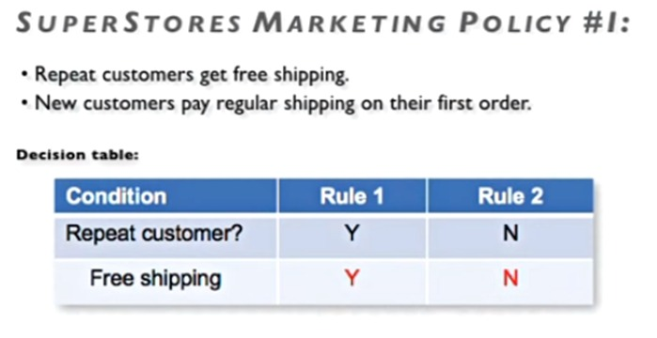

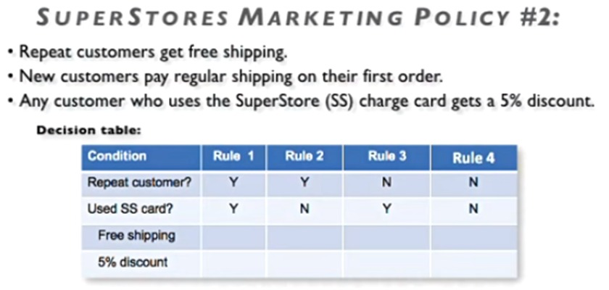
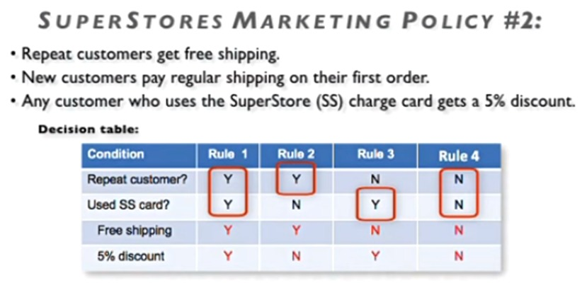

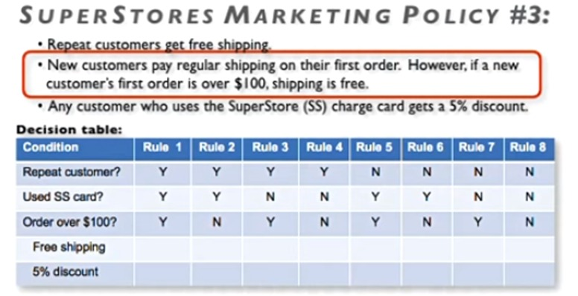

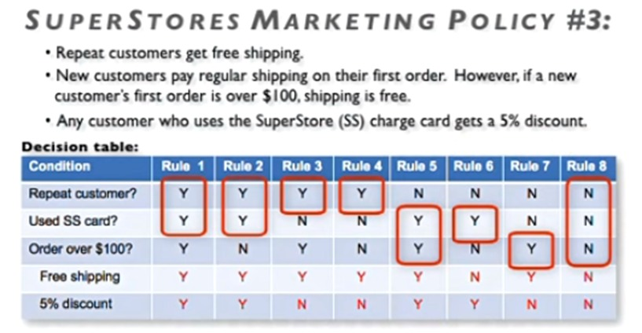

- Now Combine rules where it is apparent that an alternative does not make a difference in the outcome

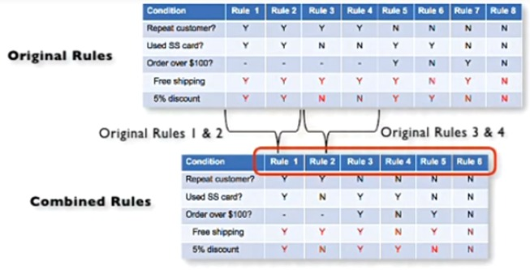

This is the final table and now you have to create test cases on every rule. In above example there are 6 rules so there shall be 6 test cases.

