
COMSATS University Islamabad (CUI)

Project Proposal
for PodVerse
Version 1.0

By
Rabeea Chughtai CIIT/SP22-BCS-079/ISB
Sadia Imran CIIT/SP22-BCS-087/ISB

Supervisor
Ms. Saadia Maqbool

Bachelor of Science in Computer Science (2022-2025)

Table of Contents
Abstract 3
1. Introduction 4
2. Problem Statement 4
3. Problem Solution/Objectives of the Proposed System 5
3.1. Problem Solution 5
3.2. Objectives 5
4. Related System Analysis/Literature Review 5
5. Vision Statement 6
6. Scope 6
7. Modules 7
7.1 Module 1: User Authentication & Profile Management 7
7.2 Module 2: Voice Cloning 7
7.3 Module 3: Knowledge Base Setup 7
7.4 Module 4: RAG Retrieval 7
7.5 Module 5: Agent Customization 8
7.6 Module 6: Podcast Audio Creation 8
7.7 Module 7: AI Host 8
7.8 Module 8: AI Guest 8
7.9 Module 9: Podcast Video Creation & Publishing 8
7.10 Module 10: Subscription & Payment 9
7.11 Module 11: FAQs Chatbot 9
7.12 Module 12: Audience Engagement and Communication 9
7.13 Module 13: Admin Panel & Analytics 9
8. System Limitations/Constraints 10
9. Data Gathering Approach 10
9.1. Brainstorming 10
9.2. Discussions 10
10. Tools and Technologies 11
11. Project Stakeholders and Roles 11
12. Module based Work Division 12
13. WBS and Gantt Chart 13
13.1 WBS 13
13.2 Gantt Chart 14
14. Mockups 16
14.1 Signup/Login Page 16
14.2 Dashboard 16
14.3 AI Agent Customization 17
14.4 Editing Page 17
15. References 18
16. Plagiarism Report 18

Project Category:
- A-Desktop Application/Information System ☑ B-Web Application/Web Application based Information System
- C-Problem Solving and Artificial Intelligence ☐ D-Simulation and Modeling
- F-Smartphone Game
Other (specify category)
- G-Networks
- E-Smartphone Application
- H-Image Processing
☑☑☑☑☑✅☑☑☑☑☑☑☑☑☑☑✅☑☑

Abstract
PodVerse is a proposed solution that would make it easy for small business owners, entrepreneurs, and content creators to record high-quality podcasts with no technical skills. Podcasting is highly expensive, requires a lot of technical knowledge, and includes other challenges such as finding credible guests and complex production tools. PodVerse offers AI-driven hosts, guests, voice simulations, and customizable multimedia content creation using pre-designed templates. This decreases the production costs and time together. This is a comprehensive, user-friendly solution that allows solo creators to truly be able to take control over the entire process of podcasting from start to end. The project's primary objectives include reducing production time by 50%, user friendly features for recording as well as publishing. It will eliminate entry barriers for even more users so that they might share their content, build their brands, and contribute to more accessible and efficient podcasts.

Introduction

PodVerse is an innovative working platform for small business owners, entrepreneurs, and content creators to create and produce effortless and smooth podcasts. Overcoming issues of costly productions, technical complexities, and getting credible guests, PodVerse can now enable users to make quality podcasts easily without extensive technical skills. It handles key processes in voice cloning, editing, and publishing, thus making the production process easy. With AI voices and language models, users can create engaging and dynamic podcasts without the need for real hosts or guests. The platform is built around creators to work towards creating consistent content through this product, helping them grow their brand and effectively engage with the right audience.

Problem Statement

It is difficult for new journalists not to secure well-known interview guests available for their shows, which restricts the amount of impactful content they can produce and build up in their portfolio. Podcasting companies also face very high production costs as often, a lot of money is spent securing a famous host, and dealing with arranging times and recording is costly. This is impossible for small businesses and entrepreneurs already short on time to consistently produce good podcasts, not knowing sufficient technical skill, thus not growing their brand. Similarly, online content creators on different social platforms, including YouTube, find it hard to scale into podcasting considering the time-consuming nature of podcast production that limits them from boosting their content. Such significant obstacles create barriers to entry and growth for the podcasting industry.

Problem Solution/Objectives of the Proposed System

Problem Solution

The disadvantages faced in podcast production can be addressed by providing a solution that automates the core processes involved, such as recording, editing, and publishing. This would mean that there would never be a dependency on external hosts or guests since customizable voices and tones could be integrated into this system, enabling the creators to produce interesting podcasts independently. The ease of use would make this interface accessible for individuals with little technical skills to allow them to create worthy content without being overwhelmed by the technical hurdles. The system, on its own, would help create a natural flow of conversation within the content, thereby making listening interesting for the target audiences. Also, a solo creator would be able to create avatar videos from audio and publish them on desired platforms. This innovative approach would ultimately make it possible for creators to establish and grow their brands with success, giving them all that they need to share their stories to the world and bring it close to its concerned audiences.

Objectives
BO-1: Make podcast creation effortless by allowing users to clone voices and host podcasts with AI, removing the hassle of finding real guests and handling technical complexities.

BO-2: Enable users to create quality podcasts without requiring technical skills or extra resources.

BO-3: Enhance accessibility to podcast production tools, making it easier for creators to produce and share content effectively.

BO-4: Support businesses in building their brand and engaging audiences with high-quality podcasts.

Related System Analysis/Literature Review

Application Name | Weakness | Proposed Project  Solution
Podcastle | Limited to editing, no guest coordination. | PodVerse simulates AI guests for seamless content creation.
Descript | Lacks AI hosts and customizable 3D avatars. | PodVerse includes AI hosts/guests and customizable avatars for enhanced personalization.
Anchor | Basic recording lacks advanced editing and AI tools. | PodVerse provides advanced editing, voice simulation, and AI-driven content for streamlined production.

Table 1 Related System Analysis

Vision Statement
For small business owners, entrepreneurs, and content creators, the PodVerse platform is a podcast creation tool that automates key processes like voice cloning, editing, and publishing. Unlike traditional podcast production methods that require technical skills and high costs, our product enables users to create audio and video podcasts easily. By using innovative AI-driven solutions, PodVerse eliminates barriers to entry for podcast creators, enabling them to produce content efficiently. Designed for ease of use, the platform caters to users with minimal technical knowledge while offering advanced options for creators, ensuring a seamless and effective podcasting experience.

Scope
PodVerse is an all-in-one system that helps business owners, entrepreneurs, content creators, and journalists make podcasts easier and better. PodVerse enables users to concentrate on content creation while utilizing advanced AI functionalities to manage technical duties by automating key aspects of production. The platform has features like voice cloning, editing, and recording podcasts with AI agents that help solo performers overcome common problems like finding reliable guests and coordinating schedules. PodVerse provides avatars and pre-designed visual templates, allowing users to produce audio and improved video podcasts. People with varying levels of technical expertise can utilize it because of its intuitive design. User profiles and engagement tools are also included in the platform, enabling users to customize their profiles, follow their favorite creators, and communicate with one another through shares, likes, and comments. An integrated communication platform supports user-to-user messaging and calls, building an active community.
With its user-centered approach, PodVerse ensures high-quality content creation, making podcasting a more feasible and useful medium for brand building and audience interactions.

Modules

Module 1: User Authentication & Profile Management
This module manages authentication, profile customization, and dashboard access for secure login and content engagement.
FE-1: Account creation via email with verification.
FE-2: Secure login via email/password.
FE-3: Password recovery via email verification.
FE-4: Secure Logout.
FE-5: Creator’s dashboard for sample podcasts and AI Agent management.
FE-6: View and edit profiles.
FE-7: Activity feeds with updates from followed creators.

Module 2: Voice Cloning
This module allows users to create and manage voice samples for cloning.
FE-1: Enabling the recording or upload of voice samples for cloning.
FE-2: Allowing users to preview voice samples to check on the quality.
FE-3: Allow users to re-record or re-upload if the sample is not as desired.
FE-4: Allow the availability of a library with voices.

Module 3: Knowledge Base Setup
This module facilitates the setup and management of a knowledge base for retrieval.
FE-1: Allow users to upload data in PDFs, URLs, CSV, or JSON.
FE-2: Data is cleaned, processed, and split into meaningful chunks for easy handling.
FE-3: Tag chunks with metadata and link to original sources.
FE-4: Store chunks in a database and generate vector embeddings for better retrieval.

Module 4: RAG Retrieval
This module enhances the retrieval of accurate and relevant information from the knowledge base.
FE-1: Convert queries into vectors to determine purpose.
FE-2: Match vectors with knowledge base data for accurate responses.
FE-3: Re-rank data by relevance for better answers.
FE-4: Provides fact-based correct answers for podcasts.
FE-5: Optimized for large datasets without loss of performance.
FE-6: Allow feedback to enhance agent response quality.

Module 5: Agent Customization
This module allows users to personalize their AI agents.
FE-1: Users can assign a custom name to their AI agent.
FE-2: Users can choose from various voice options to suit their podcast.
FE-3: Users can select or upload an avatar to visually represent their AI agent.

Module 6: Podcast Audio Creation
This module provides tools for creating and publishing podcasts.
FE-1: Let users start dialogues with a customized AI agent.
FE-2: Conversations recorded for user and AI agent.
FE-3: Users allowed minimal editing to trim and splice to rearrange things.
FE-4: Allow users the ability to preview edited podcasts for flow and polish.
FE-5: Export podcasts in MP3/WAV.
FE-6: Save recordings for future use.

Module 7: AI Host
This module provides an AI host to manage the flow of podcasts.
FE-1: AI Host presents the flow of podcasts, introduces the episodes and closes with a summary.
FE-2: Tracks podcast time and gives reminders for the schedule.
FE-3: Facilitates smooth transitions between guests or topics.
FE-4: Provides summary prompts to summarize key points for clarity and engagement.

Module 8: AI Guest
This module provides an AI guest to enhance podcast discussions.
FE-1: AI Guest responds to real-time queries using dynamic responses.
FE-2: AI Guest shares appropriate stories to add depth to the discussion.
FE-3: AI Guest gives back comments/reactions to facilitate engagement.

Module 9: Podcast Video Creation & Publishing
This module enables the creation of video content for podcasts, and AI-generated text summaries.
FE-1: Users select avatars for each of the speakers.
FE-2: The system syncs based on the audio of the podcast.
FE-3: Users can choose from the pre-defined templates and visuals for the video.
FE-4: Pre-designed split-screen video template with two avatars.
FE-5: Exports the final video in MP4 format or publish the final video.
FE-6: Allow creators to rate podcast sessions.
FE-7: Provide written feedback on conversation skills, voice clarity, and AI accuracy.

Module 10: Subscription & Payment
This module manages subscription and payment processes.
FE-1: Let users access some free, limited content.
FE-2: After the limit, users are prompted to subscribe for continued access.
FE-3: Secure payment gateway integration supporting credit/debit cards.
FE-4: User can control subscriptions, see payment history, change methods.
FE-5: Give reminders before expiration with options of auto-renewal.

Module 11: FAQs Chatbot
This module provides a chatbot to answer frequently asked questions.
FE-1: Users can ask about podcasting, AI customization, or troubleshooting.
FE-2: The chatbot retrieves relevant answers from the FAQs and support materials.
FE-3: Provides concise, direct responses for quick problem resolution.

Module 12: Audience Engagement and Communication
This module enables audience interaction, providing a communication platform, and podcast feedback to enhance creator engagement.
FE-1: Notifications for creators about audience interactions.
FE-2: Highlighting top creators and trending content.
FE-3: Integrated communication platform for user-to-user messaging and calls.
FE-4: Generate and display a text-based summary of podcast episodes.

Module 13: Admin Panel & Analytics
This module provides administrative functionalities, including user management, content moderation, analytics, and system configuration.
FE-1: Allow admin to view, search, deactivate, reactivate, or delete user accounts
FE-2: Enable admin to review reported podcasts and comments.
FE-3: Display live statistics on active users, total podcasts created, trending content, user engagement heatmaps, and demographics.
FE-4: Allow admin to track active subscriptions, process refunds, and manage payment disputes.
FE-5: Provide insights into user engagement, podcast performance, and trending topics.

System Limitations/Constraints
LI-1: Requires a stable, high-speed internet connection, limiting use in areas with poor connectivity.
LI-2: Supports basic audio/video podcasting but lacks advanced video production features.
LI-3: Voice simulation may not fully capture emotional nuance, affecting content engagement.
LI-4: Primarily designed for small to medium-sized businesses; larger organizations may need customization.
LI-5: Limited customization options for audio/video content, which may restrict users looking for highly personalized or advanced features in podcast production
LI-6: Relies on AI-generated voices, which may not fully replicate natural human speech patterns, leading to a less authentic listening experience.

Data Gathering Approach

Brainstorming
Collaborative brainstorming sessions were held with aspiring podcasters, small business owners, and entrepreneurs to identify their needs and preferences for a podcast creation tool.

Discussions
Discussions were held between experienced professionals and stakeholders regarding the requirements of the system.

Tools and Technologies

Tools And  Technologies | Tools | Version | Rationale
Tools And  Technologies | Visual Studio Code | 1.84 | IDE
Tools And  Technologies | MS Word | 365 | Documentation
Tools And  Technologies | MS PowerPoint | 365 | Presentation
Tools And  Technologies | Figma | 116.4.2 | Mockups Creation
Tools And  Technologies | MongoDB | 8.0 | Database
Tools And  Technologies | Atlas Vector Database | 8.0 | Vector Database
Tools And  Technologies | Technology | Version | Rationale
Tools And  Technologies | ReactJS | 18.2.0 | Front-End development
Tools And  Technologies | FastAPI | 4.19.2 | Back-End development
Tools And  Technologies | NodeJS | 21.7.0 | Front-End development
Tools And  Technologies | Python | 3.13.0 | Deep Learning Models

Table 2: Tools and Technologies for Proposed Project

Project Stakeholders and Roles

Project Sponsor | COMSATS University Islamabad, Islamabad Campus
Stakeholder | - Rabeea Chughtai  - Sadia Imran  - Project Supervisor Ms. Saadia Maqbool  - Final Year Project Committee: Evaluation of project

Table 3 Project Stakeholders for PodVerse

Module based Work Division

Student Name | Student Registration Number | Responsibility/ Module / Feature
Rabeea Chughtai | SP22-BCS-079 | Module 1  Module 3  Module 5  Module 7 (FE 1-3)  Module 9  Module 11  Module 13
Sadia Imran | SP22-BCS-087 | Module 2  Module 4  Module 6  Module 7 (FE 4-6)  Module 8  Module 10  Module 12

Table 4 Team Member Work Division for PodVerse

WBS and Gantt Chart

WBS

ID | Task | Duration | Resources
1 | Analysis | 15 d | Rabeea Chughtai, Sadia Imran
2 | Requirement Meetings | 5 d | Rabeea Chughtai, Sadia Imran
3 | Communication with Stakeholders | 5 d | Sadia Imran
4 | Document Current System | 5 d | Rabeea Chughtai
5 | Analysis Finished
6 | Design | 85 d | Rabeea Chughtai, Sadia Imran
7 | Design Database | 25 d | Rabeea Chughtai, Sadia Imran
8 | Software Design | 27 d | Rabeea Chughtai, Sadia Imran
9 | Interface Design | 13 d | Rabeea Chughtai, Sadia Imran
10 | Create Design Specifications | 13 d | Rabeea Chughtai
11 | Design Finished | 1 d
12 | Development | 115 d | Rabeea Chughtai, Sadia Imran
13 | Develop System Module | 86 d | Rabeea Chughtai, Sadia Imran
14 | Integrate System Module | 41 d | Rabeea Chughtai, Sadia Imran
15 | Perform Initial Testing | 14 d | Sadia Imran
16 | Development Finished | 1 d
17 | Testing | 55 d | Rabeea Chughtai, Sadia Imran
18 | Perform System Testing | 34 d | Sadia Imran
19 | Document Issues Found | 13 d | Rabeea Chughtai

20 | Correct Issues Found | 6 d | Rabeea Chughtai
21 | Testing Finished | 1 d
22 | Implementation | 20 d | Rabeea Chughtai, Sadia Imran
23 | On-Site Installation | 14 d | Sadia Imran
24 | Support Plan for the System | 6 d | Rabeea Chughtai
25 | Completion | 12 d | Rabeea Chughtai, Sadia Imran
26 | System Maintenance | 6 d | Sadia Imran
27 | Evaluation | 6 d | Rabeea Chughtai

Table A-1 – Example of a WBS for software development project

Gantt Chart

Mockups

14.1 Signup/Login Page

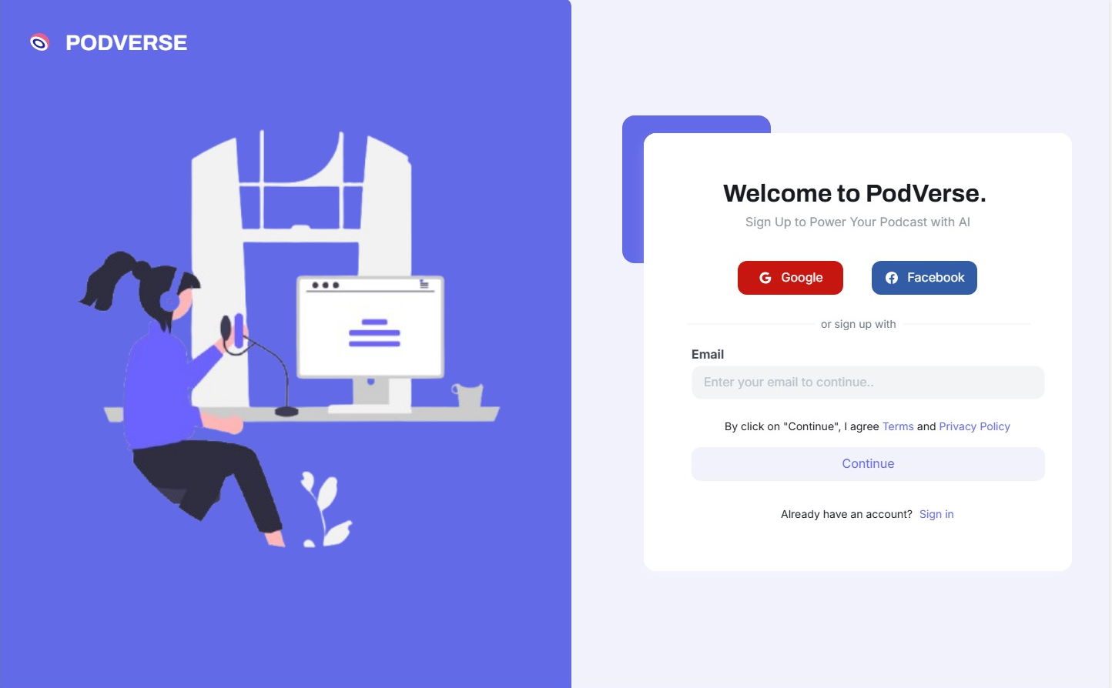

14.2 Dashboard
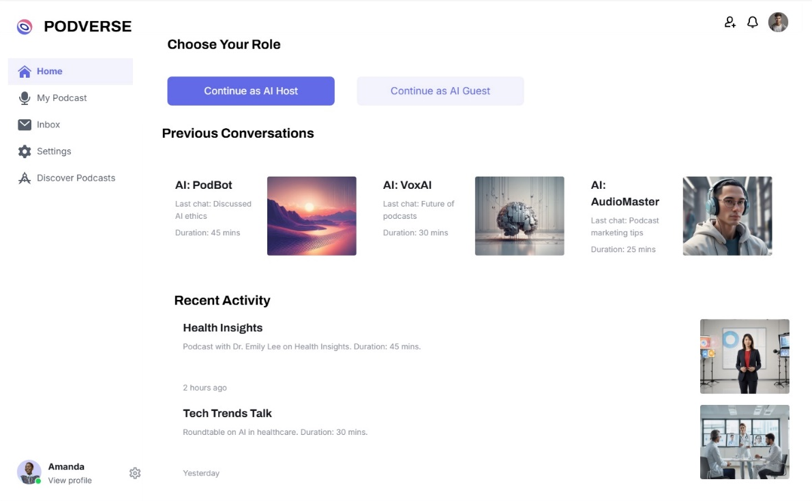

14.3 AI Agent Customization

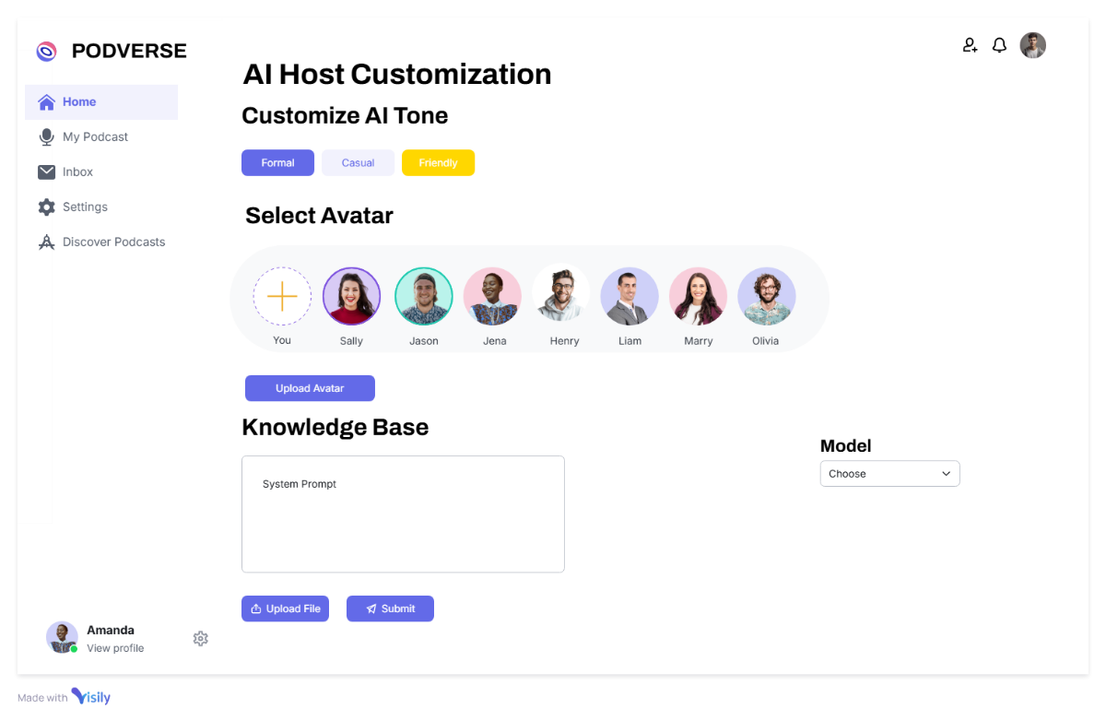

14.4 Editing Page

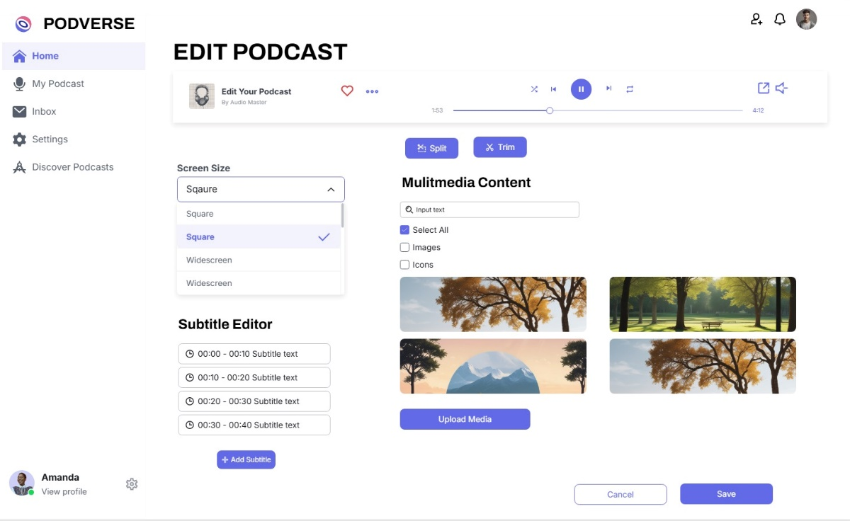

References
  - P. Nave. “Exploring RAG: Essential Steps to Implementing AI Agents and Deep Learning Strategies.” Internet: https://medium.com/@pratikabnave97/exploring-rag-essential-steps-to-implementing-ai-agents-and-deep-learning-strategies-f41ceda143c4, Mar. 10, 2024 [Nov. 10, 2024].
    - S. Smith. “The Future of Podcasting in 2024 and Beyond: Key Predictions.” Internet: https://www.opus.pro/blog/the-future-of-podcasting-in-2024-and-beyond-key-predictions, Mar. 22, 2024 [Nov. 10, 2024].
  - G. Harris. “AI Knowledge Base: Enhancing Intelligence for Smart Decisions.” Internet: https://www.getguru.com/reference/ai-knowledge-base, Apr. 5, 2024 [Nov. 10, 2024].

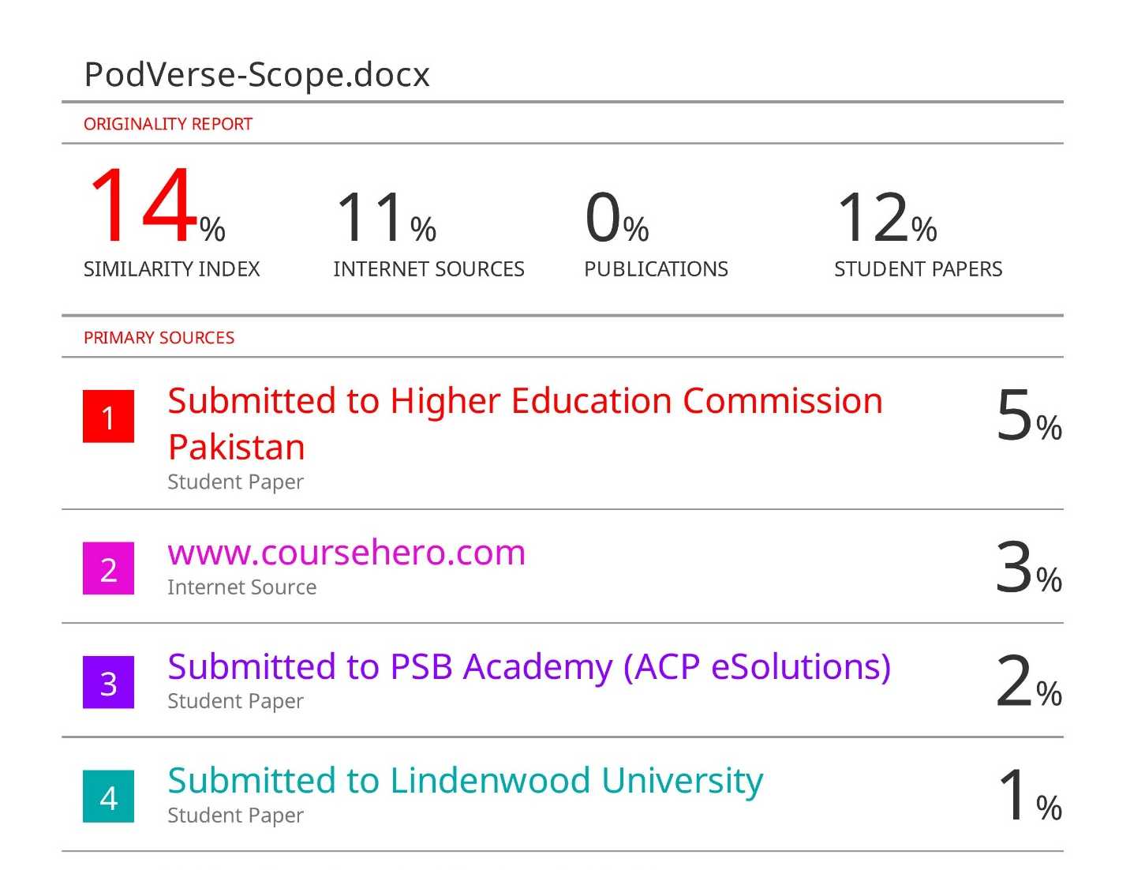

Plagiarism Report

