
COMSATS University Islamabad (CUI)

Software Requirement Specification
(SRS DOCUMENT)

for
PodVerse
Version 1.0
By
Rabeea Chughtai CIIT/SP22-BCS-079/ISB
Sadia Imran CIIT/SP22-BCS-087/ISB

Supervisor
Ms. Saadia Maqbool

Bachelor of Science in Computer Science (20xx-20xx)

Revision History
Name | Date | Reason for Changes | Version

Application Evaluation History
Comments (by committee)  *include the ones given at scope time both in doc and presentation | Action Taken

Supervised by
Supervisor’s Name
Signature______________

Table of Contents

1. Introduction 1
1.1 Purpose 1
1.2 Scope 1
1.3 Modules 1
1.4 Overview 1
2. Overall Description 1
2.1 Product Perspective 1
2.2 User classes and characteristics 1
2.3 Operating Environment 1
2.4 Design and Implementation Constraints 2
3. Requirement Identifying Technique 2
4. Functional Requirements 2
4.1 Feature <ID: Title> /Use case <ID: Title> 3
4.1.1 Functional Requirement <ID: Title> 3
5. Non-Functional Requirements 3
5.1 Reliability 4
5.2 Usability 4
5.3 Performance 4
5.4 Security 4
6. External Interface Requirements 4
6.1 User Interfaces Requirements 4
6.2 Software interfaces 5
6.3 Hardware interfaces 5
6.4 Communications interfaces 5
7. References 6

Introduction

PodVerse is an innovative working platform for small business owners, entrepreneurs, and content creators to create and produce effortless and smooth podcasts. Overcoming issues of costly productions, technical complexities, and getting credible guests, the PodVerse can now enable users to make quality podcasts easily without extensive technical skills. It automates key processes in voice cloning, editing, and publishing, thus making the production process easy. According to AI voices and language models, the user will receive an interesting and dynamic podcast in his or her possession, rather than hosts or guests. The platform is built around allowing creators to work towards creating consistent quality content through this product, helping them grow their brand and effectively engage with the right audience.

Purpose

PodVerse is a comprehensive solution designed to enhance the podcast creation process, providing a centralized platform for creators to manage their content, engage with their audience, and streamline production. PodVerse offers features such as user authentication, personalized creator dashboards, voice cloning, and knowledge base setup for AI-driven interactions. Creators can easily simulate dynamic hosts and guests, record and edit podcasts, and publish their content seamlessly. By leveraging advanced technologies such as AI and real-time communication, PodVerse aims to automate and optimize various aspects of podcast production, ensuring high-quality and engaging content. With a focus on real-time feedback and audience engagement, PodVerse aims to foster a vibrant podcasting community.

Scope

PodVerse is a comprehensive solution designed to simplify and enhance the podcast creation process for business owners, entrepreneurs, content creators, and journalists. By automating key aspects of production, PodVerse allows users to focus on content creation while leveraging advanced AI functionalities to handle technical tasks. The platform includes features such as voice cloning, real-time podcast recording, and editing, which help solo creators overcome common barriers like finding reliable guests and coordinating schedules.
PodVerse offers customizable AI avatars, pre-designed video templates, and a robust content management system, enabling users to create both audio and enhanced video podcasts. Its user-friendly design caters to individuals of all technical skill levels, while advanced customization options are available for more experienced users. The platform also includes user profiles and engagement features, allowing users to create and personalize their profiles, follow favorite creators, and interact through likes, comments, and shares. An integrated communication platform supports user-to-user messaging and calls, fostering a vibrant community.
With its user-centric approach, PodVerse ensures high-quality content creation, making podcasting a more viable and practical medium for brand-building and audience engagement.

Modules

Module 1: User Authentication
This module ensures secure access and management of accounts.
FE-1: Enable account creation by either email or social media with email verification.
FE-2: Provide secure email/password login.
FE-3: Include "Forgot Password" for secure recovery of passwords through email.
FE-4: Terminate sessions securely with logout.

Module 2: Creator's Dashboard
This module provides tools and resources for creators to manage their content and profiles.
FE-1: Access some sample podcasts for ideas.
FE-2: Begin sessions with an AI Host, AI Guest, or listen to saved podcasts.
FE-3: Use the FAQ section for quick answers.
FE-4: Allow users to view and edit profiles, personal information, and account settings.

Module 3: Voice Cloning
This module allows users to create and manage voice samples for cloning.
FE-1: Enabling the recording or upload of voice samples for cloning.
FE-2: Allowing users to preview voice samples to check on the quality.
FE-3: Allow users to re-record or re-upload if the sample is not as desired.
FE-4: Allow the availability of a library with AI-generated voices.

Module 4: Knowledge Base Setup
This module facilitates the setup and management of a knowledge base for AI retrieval.
FE-1: Allow users to upload data in PDFs, URLs, CSV, or JSON.
FE-2: Data is cleaned, processed, and split into meaningful chunks for easy handling.
FE-3: Tag chunks with metadata and link to original sources.
FE-4: Store chunks in a database and generate vector embeddings for better AI retrieval.

Module 5: RAG Retrieval
This module enhances the retrieval of accurate and relevant information from the knowledge base.
FE-1: Convert queries into vectors to determine purpose.
FE-2: Match vectors with knowledge base data for accurate responses.
FE-3: Re-rank data by relevance for better answers.
FE-4: Provides fact-based correct answers for podcasts.
FE-5: Optimized for large datasets without loss of performance.
FE-6: Allow feedback to enhance AI response quality.

Module 6: Agent Customization
This module allows users to personalize their AI agents.
FE-1: Allows a user to name the AI agent.
FE-2: Allows a user to select various voice options that can suit the podcast's style.
FE-3: Allow users the option to select or upload an avatar which is a visual representation of how their AI agent may look.

Module 7: Podcast Creation & Publishing
This module provides tools for creating and publishing podcasts.
FE-1: Let users start dialogues with a customized AI agent.
FE-2: Conversations recorded in real time for user and AI.
FE-3: Users allowed minimal editing to trim and splice to rearrange things.
FE-4: Allow users the ability to preview edited podcasts for flow and polish.
FE-5: Export podcasts in MP3/WAV.
FE-6: Save recordings for future use and publishing.

Module 8: AI Host
This module provides an AI host to manage the flow of podcasts.
FE-1: AI Host presents the flow of podcasts, introduces the episodes and closes with a summary.
FE-2: Tracks podcast time and gives reminders for the schedule.
FE-3: Facilitates smooth transitions between guests or topics.
FE-4: Provides summary prompts to summarize key points for clarity and engagement.

Module 9: AI Guest
This module provides an AI guest to enhance podcast discussions.
FE-1: AI Guest responds to real-time queries using dynamic responses.
FE-2: AI Guest shares appropriate stories to add depth to the discussion.
FE-3: AI Guest gives back comments/reactions to facilitate engagement.

Module 10: AI-Driven Podcast Video Creation
This module enables the creation of video content for podcasts.
FE-1: Users select AI-generated avatars for each of the speakers.
FE-2: The system automatically syncs lip-syncing based on the audio of the podcast.
FE-4: Users can choose from the pre-defined templates and visuals for the video.
FE-5: Pre-designed split-screen video template with two avatars.
FE-6: Generates video by syncing audio, avatars, and visuals, with smooth transitions.
FE-7: Exports the final video in MP4 format.

Module 11: Subscription & Payment
This module manages subscription and payment processes.
FE-1: Let users access some free, limited content (predetermined number of podcasts)
FE-2: After the limit, users are prompted to subscribe for continued access.
FE-3: Secure payment gateway integration supporting credit/debit cards.
FE-4: User can control subscriptions, see payment history, change methods.
FE-5: Give reminders before expiration with options of auto-renewal.

Module 12: FAQs Chatbot
This module provides a chatbot to answer frequently asked questions.
FE-1: Users could inquire about podcasting, customization using AI, or troubleshooting.
FE-2: The chatbot will reach into the FAQs database and support materials for relevant answers.
FE-3: Chatbot provides clear, to the point answers to help users find solutions quickly.

Module 13: User Feedback
This module allows users to provide feedback and rate podcast sessions.
FE-1: Users will receive feedback prompts at the end of the podcast session.
FE-2: Allow users to rate the session on scale (e.g., 1 to 5 stars).
FE-3: Allow for written comments on issues such as conversation skills, voice quality, or accuracy in knowledge.
FE-4: Display a thank-you message after feedback submission for continued use.

Module 14: User Profiles
This module allows users to create and personalize their profiles, showcasing their podcasts and activity history.
FE1: Profile creation and personalization
FE2: Following favorite creators and viewing their updates
FE3: Engagement features (likes, comments, shares)
FE4: Activity feed displaying updates from followed creators

Module 15: Audience Engagement and Communication
This module focuses on fostering interaction, visibility for creators, and providing a communication platform.
FE1: Notifications for creators about audience interactions
FE2: Highlighting top creators and trending content
FE3: Integrated communication platform for user-to-user messaging and calls.

Module 16: Podcast Summary Query
This module enables users to obtain concise summaries of podcast episodes.
FE-1: Allow users to input a query asking for a summary of any podcast episode.
FE-2: Generate and display a text-based summary based on key points from the podcast.
FE-3: Use AI to detect the main topics discussed in the podcast and summarize them accordingly.

Overview

This document describes PodVerse, detailing user interactions with the system and its responses. It also outlines the implementation technologies used in development and highlights the quality attributes associated with PodVerse. Finally, it provides an overview of all interfaces related to the system, ensuring a clear understanding of its functionalities and user experience.

Overall Description

Product Perspective

PodVerse is a new application designed to revolutionize podcast creation and content management. Unlike updates to existing tools, PodVerse is a fresh offering that simplifies and enhances the podcasting process. By leveraging advanced AI technologies, it automates key production tasks, allowing creators to focus on content. PodVerse aims to empower content creators, streamline the podcasting process, and ensure high-quality content creation and effective audience engagement. It fills a gap in the market by offering an all-in-one solution that makes podcasting more accessible and efficient.


Figure 1 : Context Diagram of System

User classes and characteristics

User class | Description
User | The main participant on PodVerse, accessing a range of features for both casual  and professional use. Users can sign up, log in, and manage subscriptions, and  they have access to the dashboard where they can explore podcast content,  interact with AI agents and provide feedback. For creators, the User role involves managing podcast content, utilizing language translation and voice cloning tools, and engaging with the AI Host and AI Guest for content creation. This role combines content exploration with interaction, allowing users to harness the platform's tools for enhanced podcasting experiences and audience engagement.

Operating Environment

OE-1: PodVerse will operate on modern web browsers such as Google Chrome, Mozilla Firefox, Apple Safari, and Microsoft Edge.
OE-2: It will be compatible with major operating systems, including Windows, macOS, iOS, and Android.

Design and Implementation Constraints

CON-1: The system shall use the MERN stack, consisting of MongoDB, Express.js, React, and Node.js, for the web application’s development.
CON-2: The web application shall use the latest stable version of React for front-end development, which is React 18.
CON-3: The backend functionality shall be developed using Node.js, as it complements the MERN stack and allows for easy integration with React on the front end.
CON-4: For AI/ML model integration, Python Scikit-learn and Flask shall be used.
CON-5: TensorFlow and Google Colab shall be used for model training.
CON-6: All user authentication and sensitive data must be handled through secure protocols (e.g., HTTPS) and stored using industry-standard encryption methods to ensure user privacy and data security.
CON-7: Integration with third-party APIs for features like payment processing shall be limited to established providers such as Stripe or PayPal to ensure reliability and security in financial transactions.

Requirement Identifying Technique
This section describes the techniques that identify PodVerse’s requirements in such a way that it maps a way for PodVerse Final Document better understanding of its functional and non-functional requirements.

Use Case Diagram
Below is the use case diagram of the users a figure a user b figure b

User A

Below is the use case diagram of Actor-User A

Figure 2 : Use Case Diagram of User A

User B

Below is the use case diagram of Actor-User B
Figure 3 : Use Case Diagram of User B

Business Rules

Detail Use Cases

UC-1: Register Account
In this use case, a user wishes to login to an application using their Google credentials. This allows for a seamless and secure login process without the need for the user to remember additional usernames or passwords.

Actors: | User
Trigger: | User selects the "Sign Up" option from the login page.
Preconditions: | PRE-1: User has a valid email.  PRE-2: User has an internet connection.
Postconditions: | POST-1: User account is created and stored.  POST-2: A verification email is sent.  POST-3: User can log in after verifying email.
Normal Flow: | - User selects "Sign Up".  - Enters email & password.  - System checks uniqueness & password strength.  - If valid, system creates the account and sends verification email.  - User verifies email.  - User is redirected to dashboard.
Alternative Flows: | AF-1: User selects Google/Facebook login instead of email/password.  System retrieves user details & skips email verification.
Exceptions: | EX-1: Email already in use.  EX-2: Weak password entered.  EX-3: Verification link expired.
Business Rules: | BR-1: Email must be unique.  BR-2: Password must meet security criteria.  BR-3: Verification is mandatory.
Assumptions: | - User has a working email.  - OAuth login is configured properly.

Event Response Table

Functional Requirements
This section describes the functional requirements of the system expressed in the natural language style. This section is typically organized by feature as a system feature name and specific functional requirements associated with this feature. It is just one possible way to arrange them. Other otional options include arranging functional requirements by use case, process flow, mode of operation, user class, stimulus, and response depend on what kind of technique has been used to understand functional requirements. Hierarchical combinations of these elements are also possible, such as use cases within user classes. For further detail see Chapter 10 “Documenting the requirements”. Let consider the feature scheme as an example.

Feature <ID: Title> /Use case <ID: Title>
Provide the feature details or the use case description through which the following set of functional requirements are mapped and derived.

Functional Requirement <ID: Title>
Itemize the specific functional requirements associated with each feature. These are the software capabilities that must be implemented for the user to carry out the feature’s services or to perform a use case. Describe how the product should respond to anticipated error conditions and to invalid inputs and actions. Uniquely label each functional requirement, as described earlier. You can create multiple attributes for each functional requirement, such as source , rationale, business rule, dependencies, etc.
Note: Use any of these attributes to support the understanability and completeness of the functional requirement, where it is required.
The following template is required to write functional requirements. For further detail see Chapter 11” Writing excellent requirements”.

Identifier | FR-1
Title | Title of requirement
Requirement | Description of requirement which may be written either from the user or system perspective e.g.  If written in a user perspective  The [user class or actor name] shall be able to [do something] [to some object] [qualifying conditions, response time, or quality statement].  If written in a system perspective  [optional precondition] [optional trigger event] the system shall [expected system response]
Source | Where this requirement comes from (who originate it)
Rationale | The motivation behind the requirement
Business Rule | Any restriction, policy, the rule that the particular requirement must be fulfilled through its functional behavior
Dependencies | Requirements ID that is dependent on this requirement
Priority | High/Medium/Low

Non-Functional Requirements
This section specifies nonfunctional requirements other than constraints, which are recorded in section 2.3, and external interface requirements, which will appear in section 7. These quality requirements should be specific, quantitative, and verifiable. Chapter 14 “beyond functionality” presents more information about these quality attribute requirements and many examples. The following are some examples of documenting guidelines.

Reliability
Requirements about how often the software fails. The measurement is often expressed in MTBF (mean time between failures). The definition of a failure must be clear. Also, don't confuse reliability with availability which is quite a different kind of requirement. Be sure to specify the consequences of software failure, how to protect from failure, a strategy for error detection, and a strategy for correction.

Usability
Usability requirements deal with ease of learning, ease of use, error avoidance and recovery, the efficiency of interactions, and accessibility. The usability requirements specified here will help the user interface designer create the optimum user experience.
Example:

USE-1: The COS shall allow a user to retrieve the previous meal ordered with a single interaction.

Performance
State specific performance requirements for various system operations. If different functional requirements or features have different performance requirements, it’s appropriate to specify those performance goals right with the corresponding functional requirements, rather than collecting them in this section.
Example:

PER-1: 95% of webpages generated by the COS shall download completely within 4 seconds from the time the user requests the page over a 20 Mbps or faster Internet connection.

Security
One or more requirements about protection of your system and its data. The measurement can be expressed in a variety of ways (effort, skill level, time, ...) to break into the system. Do not discuss solutions (e.g. passwords) in a requirements document.

External Interface Requirements
This section provides information to ensure that the system will communicate properly with users and with external hardware or software elements. A complex system with multiple subcomponents should create a separate interface specification or system architecture specification. The interface documentation could incorporate material from other documents by reference. For instance, it could point to a hardware device manual that lists the error codes that the device could send to the software.

User Interfaces Requirements
Describe the logical characteristics of each user interface that the system needs. Some possible items to include are
- References to GUI standards or product family style guides that are to be followed.
- Standards for fonts, icons, button labels, images, color schemes, field tabbing sequences, commonly used controls, and the like.
- Screen layout or resolution constraints.
- Standard buttons, functions, or navigation links that will appear on every screen, such as a help button.
- Shortcut keys.
- Message display conventions.
- Layout standards to facilitate software localization.
- Accommodations for visually impaired users.
Document the user interface design details, such as specific dialog box layouts, in a separate user interface specification, not in the SRS. Including screen mock-ups in the SRS to communicate another view of the requirements is helpful but make it clear that the mock-ups are not the committed screen designs. If the SRS is specifying an enhancement to an existing system, it sometimes makes sense to include screen displays exactly as they are to be implemented. The developers are already constrained by the current reality of the existing system, so it's possible to know up front just what the modified, and perhaps the new, screens should look like.

Software interfaces
Describe the connections between this product and other software components (identified by name and version), including other applications, databases, operating systems, tools, libraries, websites, and integrated commercial components (If any).
Example:

SI-1: Cafeteria Inventory System
SI-1.1: The COS shall transmit the quantities of food items ordered to the Cafeteria Inventory System through a programmatic interface.

Hardware interfaces
Describe the characteristics of each interface between the software components and hardware components, if any, of the system. This description might include the supported device types, the data and control interactions between the software and the hardware, and the communication protocols to be used. For more about specifying requirements for systems containing hardware, see Chapter 26, “Embedded and other real-time systems projects.”

Communications interfaces
State the requirements for any communication functions the product will use, including email, web browser, network protocols, and electronic forms.

Example:

CI-1: The COS shall send an email or text message (based on user account settings) to the Patron to confirm acceptance of an order, price, and delivery instructions.

References
List any documents or other resources to which this SRS refers, if any. These might include user interface style guides, standards, system requirements specifications, interface specifications, or the SRS for a related product. The following are a few examples of different resources.

Book
Author(s). Book title. Location: Publishing company, year, pp.
Example:
W.K. Chen. Linear Networks and Systems. Belmont, CA: Wadsworth, 1993, pp. 123-35.

Article in a Journal
Author(s). “Article title”. Journal title, vol., pp, date.
Example:
G. Pevere. “Infrared Nation.” The International Journal of Infrared Design, vol. 33, pp. 56-99, Jan. 1979.

Articles from Conference Proceedings (published)
Author(s). “Article title.” Conference proceedings, year, pp.
Example:
D.B. Payne and H.G. Gunhold. “Digital sundials and broadband technology,” in Proc. IOOC-ECOC, 1986, pp. 557-998.

World Wide Web
Author(s)*. “Title.” Internet: complete URL, date updated* [date accessed].
M. Duncan. “Engineering Concepts on Ice. Internet: www.iceengg.edu/staff.html, Oct. 25, 2000 [Nov. 29, 2003].

Appendix A

Example: Context Diagram

The Cafeteria Ordering System is a new software system that replaces the current manual and telephone processes for ordering and picking up meals in the Process Impact cafeteria. The context diagram in Figure A-1 illustrates the external entities and system interfaces.
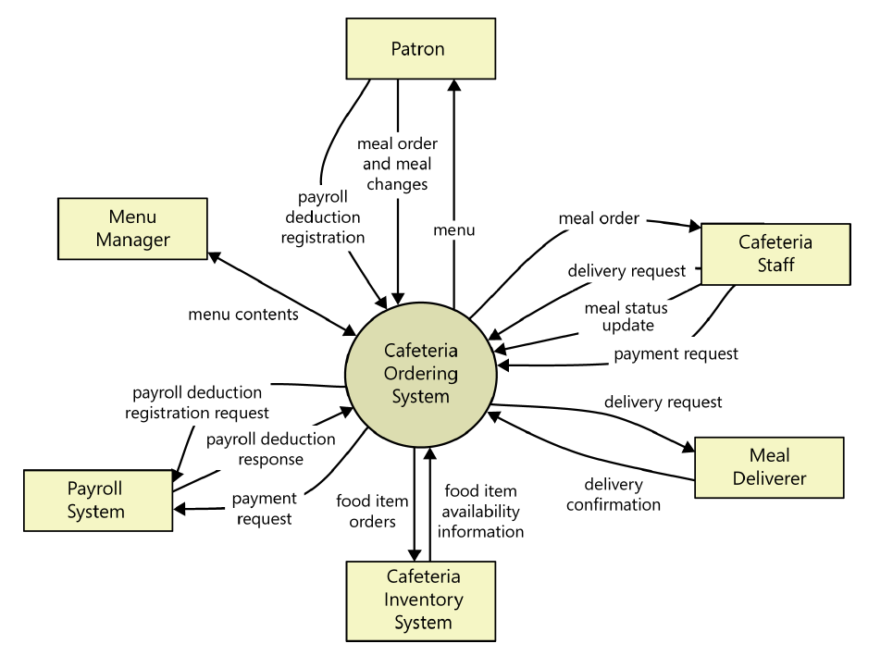

Figure A-1: Context diagram of the Cafeteria Ordering System.

Example: User Classes and Characteristics

Table A-1 Shows user classes and characteristic for Cafetaria ordering system
User class | Description
Patron | A Patron is a Process Impact employee who wants to order meals to be delivered from the company cafeteria. There are about 600 potential Patrons, of which 300 are expected to use the COS an average of 5 times per week each. Patrons will sometimes order multiple meals for group events or guests. An estimated 60 percent of orders will be placed using the corporate intranet, with 40 percent of orders being placed from home or by smartphone or tablet apps.
Cafeteria Staff | The Process Impact cafeteria employs about 20 Cafeteria Staff who will receive orders from the COS, prepare meals, package them for delivery, and request delivery. Most of the Cafeteria Staff will need training in the use of the hardware and software for the COS.
Menu Manager | The Menu Manager is a cafeteria employee who establishes and maintains daily menus of the food items available from the cafeteria. Some menu items may not be available for delivery. The Menu Manager will also define the cafeteria’s daily specials. The Menu Manager will need to edit existing menus periodically.
Meal Deliverer | As the Cafeteria Staff prepare orders for delivery, they will issue delivery requests to a Meal Deliverer’s smartphone. The Meal Deliverer will pick up the food and deliver it to the Patron. A Meal Deliverer's other interactions with the COS will be to confirm that a meal was (or was not) delivered.

Example: Use case Diagram

Following use case diagram is of an appointment system in which all the use case diagram relationships are presented. In further in Table A-2 to the detail of use case diagram sytax is provided.

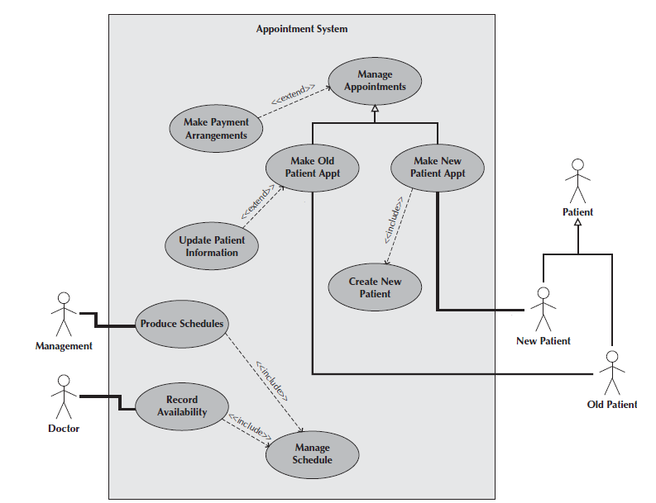

Figure A-2: Use Case Diagram of an Appointment System

Syntax for Use case Diagram

Table A-2 Syntax for Use case Diagram
An actor:  ■ Is a person or system that derives benefit from and is external to the subject.  ■ Is depicted as either a stick figure (default) or, if a nonhuman actor is involved, a  rectangle with <<actor>> in it (alternative).  ■ Is labeled with its role.  ■ Can be associated with other actors using a specialization/superclass association,  denoted by an arrow with a hollow arrowhead.  ■ Is placed outside the subject boundary. | 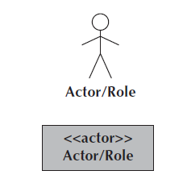
A use case:  ■ Represents a major piece of system functionality.  ■ Can extend another use case.  ■ Can include another use case.  ■ Is placed inside the system boundary.  ■ Is labeled with a descriptive verb–noun phrase. | 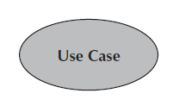
subject boundary:  ■ Includes the name of the subject inside or on top.  ■ Represents the scope of the subject, e.g., a system or an individual  business process. | 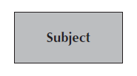
An association relationship:  ■ Links an actor with the use case(s) with which it interacts. | 
An include relationship:  ■ Represents the inclusion of the functionality of one use case within another.  ■ Has an arrow drawn from the base use case to the used use case. | 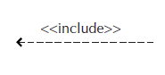
An extend relationship:  ■ Represents the extension of the use case to include optional behavior.  ■ Has an arrow drawn from the extension use case to the base use case. | 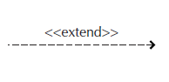
A generalization relationship:  ■ Represents a specialized use case to a more generalized one.  ■ Has an arrow drawn from the specialized use case to the base use case. | 

Detail Use Case Example
The below indicate a comprehensive use case template filled in with an example drawn from the Cafeteria ordering system (COS).
UC-1: Order a Meal
[Provide a brief description of the reason for and outcome of this use case.] e.g.
In this use case a Patron accesses the Cafeteria Ordering System from either the corporate intranet or external Internet, views the menu for a specific date, selects food items, and places an order for a meal to be picked up in the cafeteria or delivered to a specified location within a specified 15-minute time window
Actors: | [An actor is a person or other entity external to the software system being specified who interacts with the system and performs use cases to accomplish tasks.] e.g.
  Primary Actor: | Patron | Secondary Actors: | Cafeteria Inventory System
Trigger: | [Identify the event that initiates the use case.]e.g.  A Patron indicates that he wants to order a meal.
Preconditions: | [List any activities that must take place, or any conditions that must be true, before the use case can be started.  PRE-1. Patron is logged into COS.  PRE-2. Patron is registered for meal payments by payroll deduction.
Postconditions: | [Describe the state of the system at the conclusion of the use case execution.  POST-1. Meal order is stored in COS with a status of “Accepted.”  POST-2. Inventory of available food items is updated to reflect items in this order.  POST-3. Remaining delivery capacity for the requested time window is updated.
Normal Flow: | [Provide a detailed description of the user actions and system responses that will take place during execution of the use case under normal, expected conditions.  1.0 Order a Single Meal  1. Patron asks to view menu for a specific date. (see 1.0. E1, 1.0.E2)  2. COS displays menu of available food items and the daily special.  3. Patron selects one or more food items from menu. (see 1.1)  4. Patron indicates that meal order is complete. (see 1.2)  5. COS displays ordered menu items, individual prices, and total price, including taxes and delivery charge.  6. Patron either confirms meal order (continue normal flow) or requests to modify meal order (return to step 2).  7. COS displays available delivery times for the delivery date.  8. Patron selects a delivery time and specifies the delivery location.  9. Patron specifies payment method.  10. COS confirms acceptance of the order.  11. COS sends Patron an email message confirming order details, price, and delivery instructions.  12. COS stores order, sends food item information to Cafeteria Inventory System, and updates available delivery times.
Alternative Flows: | [Document legitimate branches from the main flow to handle special conditions (also known as extensions). For each alternative flow reference the branching step number of the normal flow and the condition which must be true for this extension to be executed. e.g.  1.1 Order multiple identical meals  1. Patron requests a specified number of identical meals. (see 1.1. E1)  2. Return to step 4 of normal flow.  1.2 Order multiple meals  1. Patron asks to order another meal.  2. Return to step 1 of normal flow.  Note: Insert a new row for each distinctive alternative flow. ]
Exceptions: | 1.0. E1 Requested date is today and current time is after today’s order cutoff time  1. COS informs Patron that it’s too late to place an order for today.  2a. If Patron cancels the meal ordering process, then COS terminates use case.  2b. Else if Patron requests another date, then COS restarts use case.  1.0. E2 No delivery times left  1. COS informs Patron that no delivery times are available for the meal date.  2a. If Patron cancels the meal ordering process, then COS terminates use case.  2b. Else if Patron requests to pick the order up at the cafeteria, then continue with normal flow, but skip steps 7 and 8.  1.1. E1 Insufficient inventory to fulfill multiple meal order  1. COS informs Patron of the maximum number of identical meals he can order, based on current available inventory.  2a. If Patron modifies number of meals ordered, then return to step 4 of normal flow.  2b. Else if Patron cancels the meal ordering process, then COS terminates use case.
Business Rules | Use cases and business rules are intertwined. Some business rules constrain which roles can perform all or parts of a use case. Perhaps only users who have certain privilege levels can perform specific alternative flows. That is, the rule might impose preconditions that the system must test before letting the user proceed. Business rules can influence specific steps in the normal flow by defining valid input values or dictating how computations are to be performed e.g.  BR-1 Delivery time windows are 15 minutes, beginning on each quarter hour.  BR-2 Deliveries must be completed between 11:00 A.M. and 2:00 P.M. local time, inclusive.  Note: If you are maintaining the business rule in a separate table in SRS then only mention here their IDs.
Assumptions: | [List any assumptions.  - e.g. Assume that 15 percent of Patrons will order the daily special (Source: previous 6 months of cafeteria data).

Event-Response Tables
In order to develop Event Response table fisrt it is required to identify all possible events. Following is an example of events list and event-response table of higway intersection system.

The highway intersection system described earlier has to deal with various events, including these:
- A sensor detects a car approaching in one of the through lanes.
- A sensor detects a car approaching in a left-turn lane.
- A pedestrian presses a button to request to cross a street.
- One of many timers counts down to zero.

Table A-3 presents a fragment of what an event-response table might look like for such a system. Each expected system behavior consists of a combination of event, system state, and response.
Note: You may add more information to event-response table in order to perform detail requirement analysis which includes:
- The event frequency (how many times the event takes place in a given time period, or a limit to how many times it can occur).
- Data elements that are needed to process the event.
- The state of the system after the event responses are executed.

Table A-3 Partial Event-Response Table for a Highway Intersection
Event | System State | Response
Road sensor detects  vehicle entering left-turn  lane. | Left-turn signal is red. Cross-traffic signal is green. | Start green-to-amber  countdown timer for cross-traffic  signal.
Green-to-amber  countdown timer reaches  zero. | Cross-traffic signal is green. | 1. Turn cross-traffic signal amber.  2. Start amber-to-red countdown timer.
Amber-to-red  countdown timer reaches  zero. | Cross-traffic signal is amber. | 1. Turn cross-traffic signal red.  2. Wait 1 second.  3. Turn left-turn signal green.  4. Start left-turn-signal countdown timer.
Pedestrian presses a  specific walk-request  button. | Pedestrian sign is solid Don’t Walk.  Walk-request countdown timer is not activated. | Start walk-request countdown timer.
Pedestrian presses  walk-request button. | Pedestrian sign is solid Don’t Walk.  Walk-request countdown timer is activated. | Do nothing.
Walk-request  countdown timer reaches  zero plus the amber  display time. | Traffic signal in walk  direction is green. | Change all green traffic signals to amber.
Walk-request  countdown timer reaches  zero. | Traffic signal in walk  direction is amber. | 1. Change all amber traffic signals to red.  2. Wait 1 second.  3. Set pedestrian sign to Walk.  4. Start don’t-walk countdown timer.

Story Boarding
Following is an example of story boarding which is use to identify and analyze graphically intensive applications.

