
COMSATS University Islamabad (CUI)

Project Proposal
for PodVerse
Version 1.0

By
Rabeea Chughtai CIIT/SP22-BCS-079/ISB
Sadia Imran CIIT/SP22-BCS-087/ISB

Supervisor
Ms. Saneeha Aamir

Bachelor of Science in Computer Science (2022-2026)

Table of Contents

1.Introduction 5
2. Problem Statement 5
3. Problem Solution/Objectives of the Proposed System 6
3.1. Problem Solution 6
3.2. Objectives 6
4. Related System Analysis/Literature Review 6
5. Vision Statement 7
6. Scope 7
7. Modules 8
7.1 Module 1: User Authentication 8
7.2 Module 2: Creator's Dashboard 8
7.3 Module 3: Voice Cloning 8
7.4 Module 4: Knowledge Base Setup 8
7.5 Module 5: RAG Retrieval 8
7.6 Module 6: Agent Customization 9
7.7 Module 7: Podcast Creation & Publishing 9
7.8 Module 8: AI Host 9
7.9 Module 9: AI Guest 9
7.10 Module 10: AI-Driven Podcast Video Creation 10
7.11 Module 11: Subscription & Payment 10
7.12 Module 12: FAQs Chatbot 10
7.13 Module 13: User Feedback 10
7.14 Module 14: User Profiles and Engagement 11
7.15 Module 15: Podcast Summary Query 11
8. System Limitations/Constraints 11
9. Data Gathering Approach 12
9.1. Brainstorming 12
9.2. Discussions 12
10. Tools and Technologies 13
11. Project Stakeholders and Roles 13
12. Module based Work Division 14
13. WBS and Gantt Chart 15
13.1 WBS 15
13.2 Gantt Chart 16
14. Mockups 18
14.1 Signup/Login Page 18
14.2 Dashboard 18
14.3 AI Agent Customization 19
14.4 Editing Page 19
15. References 20
16. Plagiarism Report 20

Project Category:
- A-Desktop Application/Information System ☑ B-Web Application/Web Application based Information System
- C-Problem Solving and Artificial Intelligence ☐ D-Simulation and Modeling
- F-Smartphone Game
Other (specify category)
- G-Networks
- E-Smartphone Application
- H-Image Processing
☑☑☑☑☑✅☑☑☑☑☑☑☑☑☑☑✅☑☑

Abstract
PodVerse is a proposed solution that would make it easy for small business owners, entrepreneurs, and content creators to record high-quality podcasts with no technical skills. Podcasting is highly expensive, requires a lot of technical knowledge, and includes other challenges such as finding credible guests and complex production tools. PodVerse offers AI-driven hosts, guests, voice simulations, and customizable multimedia content creation using pre-designed templates. This decreases the production costs and time together. This is a comprehensive, user-friendly solution that allows solo creators to truly be able to take control over the entire process of podcasting from start to end. The project's primary objectives include reducing production time by 50%, user friendly features for recording as well as publishing. It will eliminate entry barriers for even more users so that they might share their content, build their brands, and contribute to more accessible and efficient podcasts.

Introduction

PodVerse is an innovative working platform for small business owners, entrepreneurs, and content creators to create and produce effortless and smooth podcasts. Overcoming issues of costly productions, technical complexities, and getting credible guests, the PodVerse can now enable users to make quality podcasts easily without extensive technical skills.
It automates key processes in voice cloning, editing, and publishing, thus making the production process easy. According to AI voices and language models, the user will receive an interesting and dynamic podcast in his or her possession, rather than hosts or guests. PodVerse offers a user-friendly interface with which users can record and edit audio, use content templates, and customize the voice, hence flexibility over the content.
The platform is built around allowing creators to work towards creating consistent quality content through this product, helping them grow their brand and effectively engage with the right audience. Essentially, PodVerse is known to kill off technical and logistical barriers to create a more user-friendly experience, making it accessible for a wider range of users to easily create content.

Problem Statement

It is difficult for new journalists not to secure well-known interview guests available for their shows, which restricts the amount of impactful content they can produce and build up in their portfolio. Podcasting companies also face very high production costs as often, a lot of money is spent securing a famous host, and dealing with arranging times and recording is costly. This is impossible for small businesses and entrepreneurs already short on time to consistently produce good podcasts, not knowing sufficient technical skill, thus not growing their brand. Similarly, online content creators on different social platforms, including YouTube, find it hard to scale into podcasting considering the time-consuming nature of podcast production that limits them from boosting their content. Such significant obstacles create barriers to entry and growth for the podcasting industry.

Problem Solution/Objectives of the Proposed System

Problem Solution

The disadvantages faced in podcast production can be addressed by providing a solution that automates the core processes involved, such as recording, editing, and publishing. This would mean that there would never be a dependency on external hosts or guests since customizable voices and tones could be integrated into this system, enabling the creators to produce interesting podcasts independently. The ease of use would make this interface accessible for individuals with little technical skills to allow them to create worthy content without being overwhelmed by the technical hurdles. The system, on its own, would help create a natural flow of conversation within the content, thereby making listening interesting for the target audiences. Also, a solo creator would be able to create avatar videos from audio and publish them on desired platforms. This innovative approach would ultimately make it possible for creators to establish and grow their brands with success, giving them all that they need to share their stories to the world and bring it close to its concerned audiences.

Objectives
BO-1: Automation of voice cloning, editing, and publishing should make it easier to create podcasts for small businesses and content creators.

BO-2: Enable users to create quality podcasts without requiring technical skills or extra resources.

BO-3: Enhance accessibility to podcast production tools, making it easier for creators to produce and share content effectively.

BO-4: Support businesses in building their brand and engaging audiences with high-quality podcasts.

Related System Analysis/Literature Review
Table 1 Related System Analysis

Application Name | Weakness | Proposed Project  Solution
Podcastle | Limited to editing, no guest coordination. | PodVerse simulates AI guests for seamless content creation.
Descript | Lacks AI hosts and customizable 3D avatars. | PodVerse includes AI hosts/guests and customizable avatars for enhanced personalization.
Anchor | Basic recording lacks advanced editing and AI tools. | PodVerse provides advanced editing, voice simulation, and AI-driven content for streamlined production.

Vision Statement
For small business owners, entrepreneurs, and content creators, the PodVerse platform is a podcast creation tool that automates key processes like voice cloning, editing, and publishing. Unlike traditional podcast production methods that require technical skills and high costs, our product enables users to create audio and video podcasts easily. By using innovative AI-driven solutions, PodVerse eliminates barriers to entry for podcast creators, enabling them to produce content efficiently. Designed for ease of use, the platform caters to users with minimal technical knowledge while offering advanced options for creators, ensuring a seamless and effective podcasting experience.

Scope

PodVerse will simplify the process of podcasting and enhance its quality for small business owners, entrepreneurs, content creators, and journalists through the automation of the most important aspects of production in the podcast. Advanced functionalities of AI will minimize the need for skills in technology, with users required to concentrate on the content, using all other production elements to the platform. The platform would involve such capabilities as voice clonig, podcast recording, and editing. All of these can be designed to assist solo creators in removing those barriers for regular podcasting - finding reliable guests, coordinating schedules etc.

This encompasses customizable AI avatars, pre-designed video templates, and even a content management system. Therefore, PodVerse is not only creating audio podcasts but also has an enhanced video content option. It smoothens the process of publishing through significant interfaces.

It ensures effective reach to the audience for the creators. More than that, the interface is easy to use and accepted by users of all technical skills, while advanced customization will be available for the more experienced.

Through its user-centric design, PodVerse can ensure effective high-quality content creation, aimed to make podcasting a more viable and practical medium for brand-building and audience engagement.

Modules

Module 1: User Authentication

FE-1: Enable account creation by either email or social media with email verification.
FE-2: Provide secure email/password login.
FE-3: Include "Forgot Password" for secure recovery of passwords through email.
FE-4: Terminate sessions securely with logout.

Module 2: Creator's Dashboard

FE-1: Access some sample podcasts for ideas.
FE-2: Begin sessions with an AI Host, AI Guest, or listen to saved podcasts.
FE-3: Review previous conversations for improvement.
FE-4: Use the FAQ section for quick answers.
FE-5: Allow users to view and edit profiles, personal information, and account settings.

Module 3: Voice Cloning

FE-1: Enabling the recording or upload of voice samples for cloning.
FE-2: Allowing users to preview voice samples to check on the quality.
FE-3: Allow users to re-record or re-upload if the sample is not as desired.
FE-4: Allow the availability of a library with AI-generated voices.

Module 4: Knowledge Base Setup

FE-1: Allow users to upload data in PDFs, URLs, CSV, or JSON.
FE-2: Data is cleaned, processed, and split into meaningful chunks for easy handling.
FE-3: Tag chunks with metadata and link to original sources.
FE-4: Store chunks in a database and generate vector embeddings for better AI retrieval.

Module 5: RAG Retrieval

FE-1: Convert queries into vectors to determine purpose.
FE-2: Match vectors with knowledge base data for accurate responses.
FE-3: Re-rank data by relevance for better answers.
FE-4: Provides fact-based correct answers for podcasts.
FE-5: Optimized for large datasets without loss of performance.
FE-6: Allow feedback to enhance AI response quality.

Module 6: Agent Customization

FE-1: Allows a user to name the AI agent.
FE-2: Allows a user to select various voice options that can suit the podcast's style.
FE-3: Allow users the option to select or upload an avatar which is a visual representation of how their AI agent may look.

Module 7: Podcast Creation & Publishing

FE-1: Let users start dialogues with a customized AI agent.
FE-2: Conversations recorded in real time for user and AI.
FE-3: Users allowed minimal editing to trim and splice audio to rearrange things.
FE-4: Allow users the ability to preview edited podcasts for flow and polish.
FE-5: Export podcasts in MP3/WAV.
FE-6: Save recordings for future use and publishing.

Module 8: AI Host

FE-1: AI Host presents the flow of podcasts, introduces the episodes and closes with a summary.
FE-2: Tracks podcast time and gives reminders for the schedule.
FE-3: Facilitates smooth transitions between guests or topics.
FE-4: Provides summary prompts to summarize key points for clarity and engagement.

Module 9: AI Guest

FE-1: AI Guest responds to real-time queries using dynamic responses.
FE-2: AI Guest shares appropriate stories to add depth to the discussion.
FE-3: AI Guest gives back comments/reactions to facilitate engagement

Module 10: AI-Driven Podcast Video Creation

FE-1: Users select AI-generated avatars for each of the speakers.
FE-2: The system automatically syncs lip-syncing based on the audio of the podcast
FE-3: The use of dynamic highlights and color-codified subtitles that differentiate speakers
FE-4: Users can choose from the pre-defined templates and visuals for the video to match with their style of podcast.
FE-5: Pre-designed split-screen video template with two avatars
FE-6: Generates video by syncing audio, avatars, and visuals, with smooth transitions.
FE-7: Exports the final video in MP4 format.

Module 11: Subscription & Payment

FE-1: Let users access some free, limited content (for example, a predetermined number of podcasts)
FE-2: After the limit, users are prompted to subscribe for continued access.
FE-3: Secure payment gateway integration supporting credit/debit cards.
FE-4: User can control subscriptions, see payment history, change methods.
FE-5: give reminders before expiration with options of auto-renewal.

Module 12: FAQs Chatbot

FE-1: Users could inquire about podcasting, customization using AI, or troubleshooting.
FE-2: The chatbot will reach into the FAQs database and support materials for relevant answers.
FE-3: Chatbot provides clear, to the point answers to help users find solutions quickly.
FE-4: Chatbot learns from interactions, improving response accuracy over time.

Module 13: User Feedback

FE-1: Users will receive feedback prompts at the end of the podcast session.
FE-2: Allow users to rate the session on scale (e.g., 1 to 5 stars).
FE-3: Allow for written comments on issues such as conversation skills, voice quality, or accuracy in knowledge.
FE-4: Display a thank-you message after feedback submission for continued use.

Module 14: User Profiles and Engagement

FE-1: Allow users to create and personalize their profiles, showcasing their podcasts and activity history.
FE-2: Enable users to follow their favorite creators and view the podcasts and updates they share.
FE-3: Provide features for engagement, such as likes, comments, and the ability to share podcasts, to foster interaction.
FE-4: Implement an activity feed that displays updates from creators’ users follow, including new episodes, popular podcasts, and significant milestones.
FE-5: Notify creators about audience interactions, like comments or shares, to encourage them to participate actively.
FE-6: Highlight top creators and trending content to boost visibility and engagement.

Module 15: Podcast Summary Query

FE-1: Allow users to input a query asking for a summary of any podcast episode.
FE-2: Generate and display a text-based summary based on key points from the podcast.
FE-3: Use AI to detect the main topics discussed in the podcast and summarize them accordingly.
FE-4: Provide summaries with timestamps to highlight specific segments of interest.
FE-5: Allow users to request summaries for specific sections of the podcast.

System Limitations/Constraints

LI-1: Requires a stable, high-speed internet connection, limiting use in areas with poor connectivity.
LI-2: Supports basic audio/video podcasting but lacks advanced video production features.
LI-3: Voice simulation may not fully capture emotional nuance, affecting content engagement.
LI-4: Primarily designed for small to medium-sized businesses; larger organizations may need customization.
LI-5: Limited customization options for audio/video content, which may restrict users looking for highly personalized or advanced features in podcast production
LI-6: Relies on AI-generated voices, which may not fully replicate natural human speech patterns, leading to a less authentic listening experience.

Data Gathering Approach

Brainstorming
Collaborative brainstorming sessions were held with aspiring podcasters, small business owners, and entrepreneurs to identify their needs and preferences for a podcast creation tool.

Discussions
Discussions were held between experienced professionals and stakeholders regarding the requirements of the system.

Tools and Technologies
Table 2: Tools and Technologies for Proposed Project
Tools And  Technologies | Tools | Version | Rationale
Tools And  Technologies | Visual Studio Code | 1.84 | IDE
Tools And  Technologies | MS Word | 365 | Documentation
Tools And  Technologies | MS PowerPoint | 365 | Presentation
Tools And  Technologies | Figma | 116.4.2 | Mockups Creation
Tools And  Technologies | MongoDB | 8.0 | Database
Tools And  Technologies | Atlas Vector Database | 8.0 | Vector Database
Tools And  Technologies | Technology | Version | Rationale
Tools And  Technologies | ReactJS | 18.2.0 | Front-End development
Tools And  Technologies | FastAPI | 4.19.2 | Back-End development
Tools And  Technologies | NodeJS | 21.7.0 | Front-End development
Tools And  Technologies | Python | 3.13.0 | Deep Learning Models

Project Stakeholders and Roles

Table 3 Project Stakeholders for PodVerse

Project Sponsor | COMSATS University Islamabad, Islamabad Campus
Stakeholder | - Rabeea Chughtai  - Sadia Imran  - Project Supervisor Ms. Saneeha Amir  - Final Year Project Committee: Evaluation of project

Module based Work Division

Table 4 Team Member Work Division for PodVerse

Student Name | Student Registration Number | Responsibility/ Module / Feature
Rabeea Chughtai | SP22-BCS-079 | Module 1  Module 3  Module 5  Module 7 (FE 1-3)  Module 9  Module 11  Module 13
Sadia Imran | SP22-BCS-087 | Module 2  Module 4  Module 6  Module 7 (FE 4-6)  Module 8  Module 10  Module 12

WBS and Gantt Chart

WBS

Table A-1 – Example of a WBS for software development project

ID | Task | Duration | Resources
1 | Analysis | 15 d | Rabeea Chughtai, Sadia Imran
2 | Requirement Meetings | 5 d | Rabeea Chughtai, Sadia Imran
3 | Communication with Stakeholders | 5 d | Sadia Imran
4 | Document Current System | 5 d | Rabeea Chughtai
5 | Analysis Finished
6 | Design | 85 d | Rabeea Chughtai, Sadia Imran
7 | Design Database | 25 d | Rabeea Chughtai, Sadia Imran
8 | Software Design | 27 d | Rabeea Chughtai, Sadia Imran
9 | Interface Design | 13 d | Rabeea Chughtai, Sadia Imran
10 | Create Design Specifications | 13 d | Rabeea Chughtai
11 | Design Finished | 1 d
12 | Development | 115 d | Rabeea Chughtai, Sadia Imran
13 | Develop System Module | 86 d | Rabeea Chughtai, Sadia Imran
14 | Integrate System Module | 41 d | Rabeea Chughtai, Sadia Imran
15 | Perform Initial Testing | 14 d | Sadia Imran
16 | Development Finished | 1 d
17 | Testing | 55 d | Rabeea Chughtai, Sadia Imran
18 | Perform System Testing | 34 d | Sadia Imran
19 | Document Issues Found | 13 d | Rabeea Chughtai

20 | Correct Issues Found | 6 d | Rabeea Chughtai
21 | Testing Finished | 1 d
22 | Implementation | 20 d | Rabeea Chughtai, Sadia Imran
23 | On-Site Installation | 14 d | Sadia Imran
24 | Support Plan for the System | 6 d | Rabeea Chughtai
25 | Completion | 12 d | Rabeea Chughtai, Sadia Imran
26 | System Maintenance | 6 d | Sadia Imran
27 | Evaluation | 6 d | Rabeea Chughtai

Gantt Chart

Mockups

14.1 Signup/Login Page

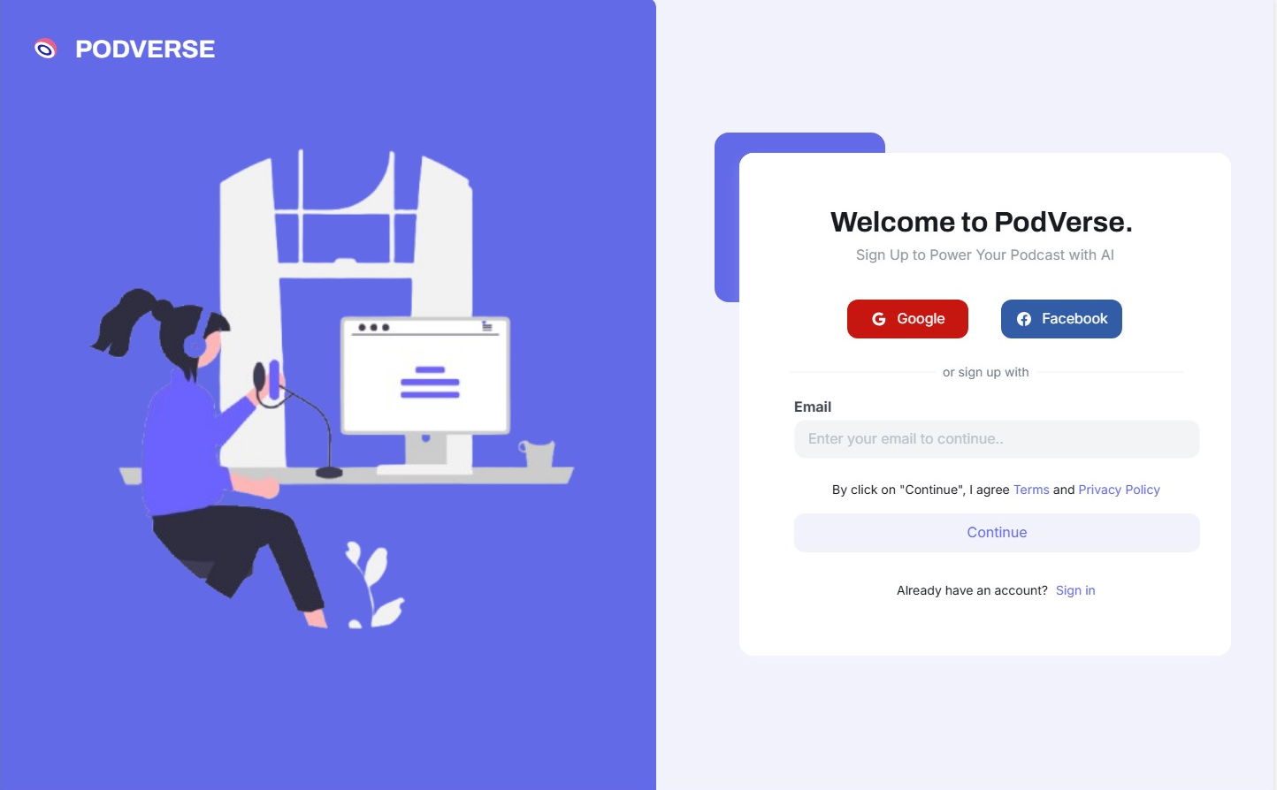

14.2 Dashboard
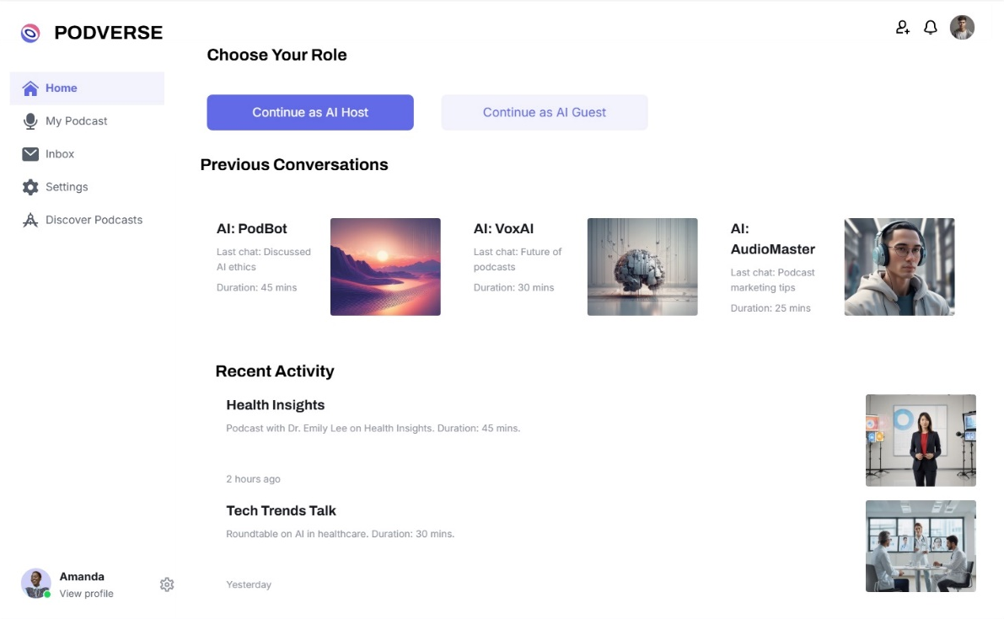

14.3 AI Agent Customization

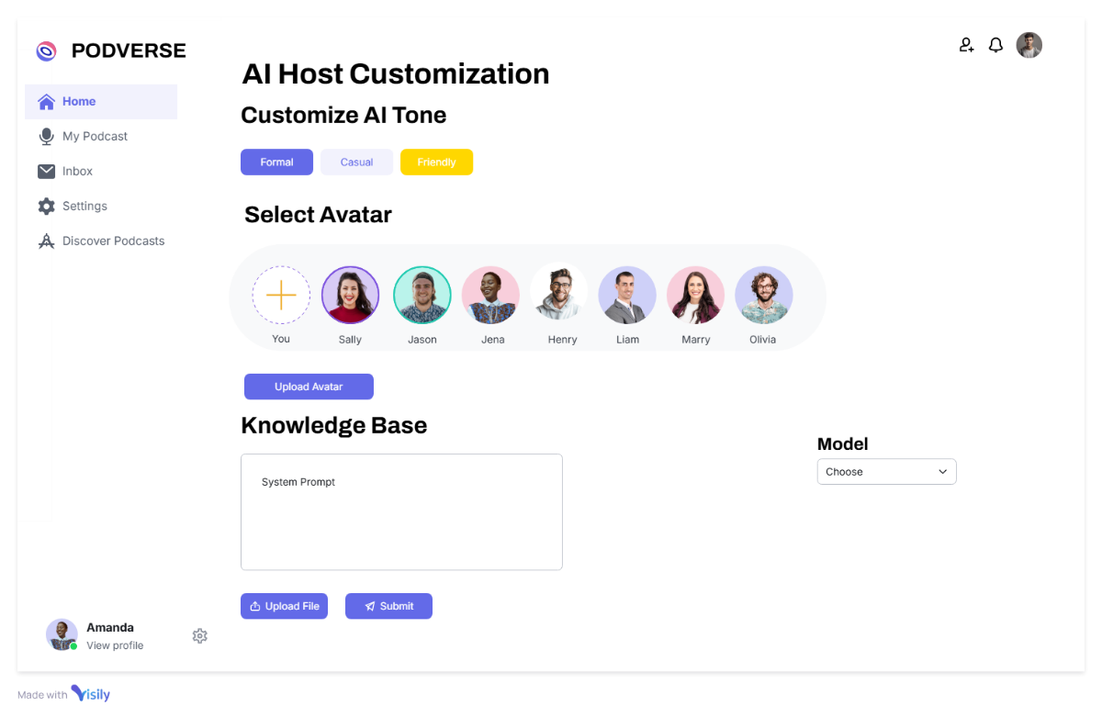

14.4 Editing Page

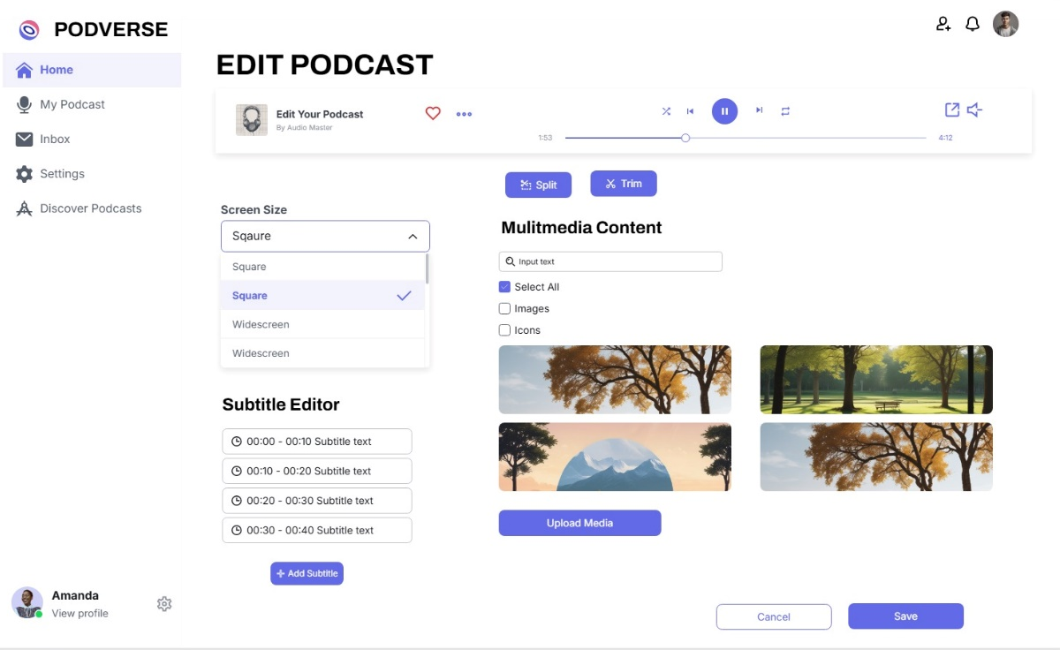

References
  - P. Nave. “Exploring RAG: Essential Steps to Implementing AI Agents and Deep Learning Strategies.” Internet: https://medium.com/@pratikabnave97/exploring-rag-essential-steps-to-implementing-ai-agents-and-deep-learning-strategies-f41ceda143c4, Mar. 10, 2024 [Nov. 10, 2024].
    - S. Smith. “The Future of Podcasting in 2024 and Beyond: Key Predictions.” Internet: https://www.opus.pro/blog/the-future-of-podcasting-in-2024-and-beyond-key-predictions, Mar. 22, 2024 [Nov. 10, 2024].
  - G. Harris. “AI Knowledge Base: Enhancing Intelligence for Smart Decisions.” Internet: https://www.getguru.com/reference/ai-knowledge-base, Apr. 5, 2024 [Nov. 10, 2024].

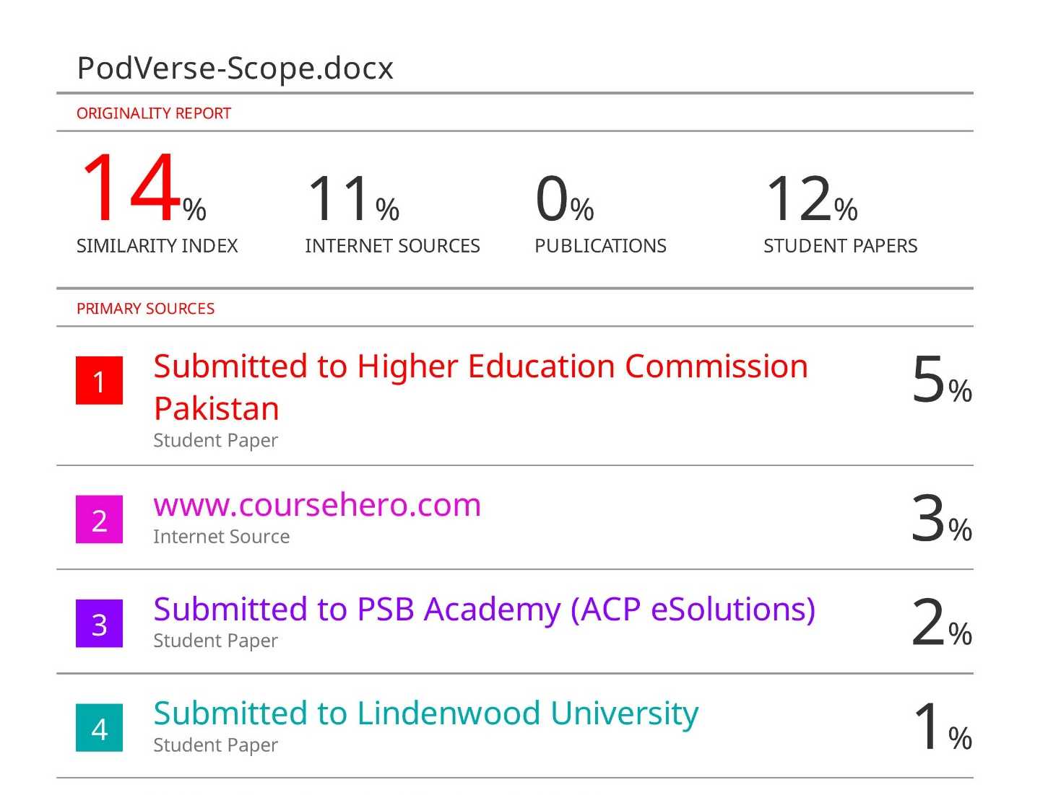
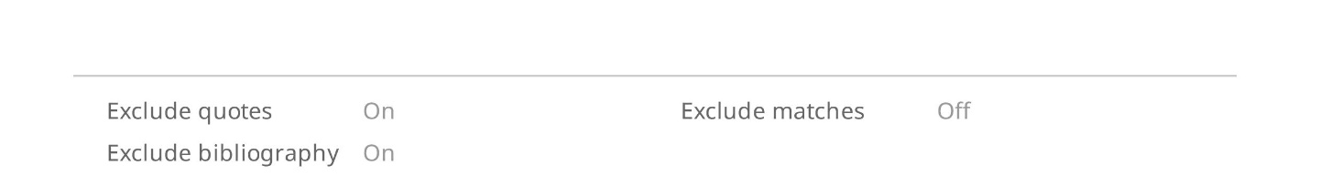
Plagiarism Report

