
COMSATS University Islamabad (CUI)

Software Design Description
(SDS DOCUMENT)

for
PodVerse
Version 1.0
By
Rabeea Chughtai CIIT/SP22-BCS-079/ISB
Sadia Imran CIIT/SP22-BCS-087/ISB

Supervisor
Ms. Saadia Maqbool

Bachelor of Science in Computer Science (2022-2026)

Table of Contents
Revision History iii
Application Evaluation History iv
1. Introduction 1
1.1 Scope 1
2. Design Methodology and Software Process Model 5
2.1 Design Methodology: 5
2.2 Software Process Model: 5
3. System Overview 6
3.1 Architectural Design 6
4. Design Models 9
4.1 Activity Diagrams 9
4.2 Class Diagram 23
4.3 Sequence Diagrams 23
4.4 State Transition Diagrams 32
5. Data Design 34
5.1 Data Dictionary 34
6. Implementation 43
6.1 Algorithm 43
6.2 External APIs/SDKs 45
6.3 User Interface 45
6.4 Deployment 49
7. Testing and Evaluation 50
7.1 Unit Testing 50
7.2 Functional Testing 54
7.3 Business Rules Testing 57
7.4 Integration Testing 58
8. References 61
9. Plagiarism Report 62

Revision History
Name | Date | Reason for changes | Version

Application Evaluation History

Comments (by committee)  *include the ones given at scope time both in doc and presentation | Action Taken
Scope should be increases, add major  modules  e.g. a usecase where these podcasts can be  used. At the moment the scope is not enough  for 2 students with pretrained models/api  usage. | - Added Social Media Integration for  podcast sharing and engagement.  - Introduced Podcast Summary Feature for  better accessibility and usability.  - Integrated Admin Panel & Analytics for  user/content management and insights.  - Expanded Audience Engagement with  messaging, notifications, and user  interactions.  - Enhanced AI Video Podcast Creation with  avatars, and visual elements
1. Students lack in knowledge of Agent/AI Agent. 2. Agent creation is unknown.  3. Tools' usage and purpose are not clear.  4. Mockups are betrayal.  5. Students' effort is unclear and unjustified with time required.  6. Prompt engineering and voice to text generation are unclear to students.  7. Lack of existing study | - Implementation demo given for speaker creation.  - Tool usage explained with updated documentation.  - User Interface revised to match implementation.

Supervised by
Supervisor’s Name
Signature______________

Introduction
PodVerse is an AI-powered podcast creation platform developed to simplify and modernize the podcast production journey for small business owners, entrepreneurs, and content creators. By eliminating technical barriers such as high production costs, complex editing processes, and challenges in finding credible guests, PodVerse enables creators to produce engaging, high-quality podcasts effortlessly. The system integrates advanced technologies like voice cloning, real-time AI interactions, and customizable avatars, providing users with a centralized solution for planning, recording, editing, and publishing their podcast content. With a user-friendly interface and modules tailored for automation and personalization, PodVerse ensures seamless experience, empowering creators to build consistent content and strengthen audience engagement.

Scope
The scope of PodVerse is covered under the following modules:

Module 1: User Authentication & Profile Management
This module manages authentication, profile customization, and dashboard access for secure login and content engagement.
FE-1: Account creation via email with verification.
FE-2: Secure login via email/password.
FE-3: Password recovery via email verification.
FE-4: Secure Logout.
FE-5: Creator’s dashboard for sample podcasts and AI Speaker management.
FE-6: View and edit profiles.
FE-7: Activity feeds with updates from followed creators.

Module 2: Voice Cloning
This module allows users to create and manage voice samples for cloning.
FE-1: Enabling the recording or upload of voice samples for cloning.
FE-2: Allowing users to preview voice samples to check on the quality.
FE-3: Allow users to re-record or re-upload if the sample is not as desired.
FE-4: Allow the availability of a library with voices.

Module 3: Knowledge Base Setup
This module facilitates the setup and management of a knowledge base for retrieval.
FE-1: Allow users to upload data in PDFs, URLs, CSV, or JSON.
FE-2: Data is cleaned, processed, and split into meaningful chunks for easy handling.
FE-3: Tag chunks with metadata and link to original sources.
FE-4: Store chunks in a database and generate vector embeddings for better retrieval.

Module 4: RAG Retrieval
This module enhances the retrieval of accurate and relevant information from the knowledge base.
FE-1: Convert queries into vectors to determine purpose.
FE-2: Match vectors with knowledge base data for accurate responses.
FE-3: Re-rank data by relevance for better answers.
FE-4: Provides fact-based correct answers for podcasts.
FE-5: Optimized for large datasets without loss of performance.
FE-6: Allow feedback to enhance AI Speaker response quality.

Module 5: AI Speaker Customization
This module allows users to personalize their AI Speaker.
FE-1: Users can assign a custom name to their AI Speaker.
FE-2: Users can choose from various voice options to suit their podcast.
FE-3: Users can select or upload an avatar to visually represent their AI Speaker.

Module 6: Podcast Audio Creation
This module provides tools for creating and publishing podcasts.
FE-1: Let users start dialogues with a customized AI Speaker.
FE-2: Conversations recorded for user and AI Speaker.
FE-3: Users allowed minimal editing to trim and splice to rearrange things.
FE-4: Allow users the ability to preview edited podcasts for flow and polish.
FE-5: Export podcasts in MP3/WAV.
FE-6: Save recordings for future use.

Module 7: AI Host
This module provides an AI host to manage the flow of podcasts.
FE-1: AI Host presents the flow of podcasts, introduces the episodes and closes with a summary.
FE-2: Tracks podcast time and gives reminders for the schedule.
FE-3: Facilitates smooth transitions between guests or topics.
FE-4: Provides summary prompts to summarize key points for clarity and engagement.

Module 8: AI Guest
This module provides an AI guest to enhance podcast discussions.
FE-1: AI Guest responds to real-time queries using dynamic responses.
FE-2: AI Guest shares appropriate stories to add depth to the discussion.
FE-3: AI Guest gives back comments/reactions to facilitate engagement.

Module 9: Podcast Video Creation & Publishing
This module enables the creation of video content for podcasts, and AI-generated text summaries.
FE-1: Users select avatars for each of the speakers.
FE-2: The system syncs based on the audio of the podcast.
FE-3: Users can choose from the pre-defined templates and visuals for the video.
FE-4: Pre-designed split-screen video template with two avatars.
FE-5: Exports the final video in MP4 format or publish the final video.
FE-6: Allow creators to rate podcast sessions.
FE-7: Provide written feedback on conversation skills, voice clarity, and AI accuracy.

Module 10: Subscription & Payment
This module manages subscription and payment processes.
FE-1: Let users access some free, limited content.
FE-2: After the limit, users are prompted to subscribe for continued access.
FE-3: Secure payment gateway integration supporting credit/debit cards.
FE-4: User can control subscriptions, see payment history, change methods.
FE-5: Give reminders before expiration with options of auto-renewal.

Module 11: FAQs Chatbot
This module provides a chatbot to answer frequently asked questions.
FE-1: Users can ask about podcasting, AI customization, or troubleshooting.
FE-2: The chatbot retrieves relevant answers from the FAQs and support materials.
FE-3: Provides concise, direct responses for quick problem resolution.

Module 12: Audience Engagement and Communication
This module enables audience interaction, providing a communication platform, and podcast feedback to enhance creator engagement.
FE-1: Notifications for creators about audience interactions.
FE-2: Highlighting top creators and trending content.
FE-3: Integrated communication platform for user-to-user messaging and calls.
FE-4: Generate and display a text-based summary of podcast episodes.

Module 13: Admin Panel & Analytics
This module provides administrative functionalities, including user management, content moderation, analytics, and system configuration.
FE-1: Allow admin to view, search, deactivate, reactivate, or delete user accounts
FE-2: Enable admin to review reported podcasts and comments.
FE-3: Display live statistics on active users, total podcasts created, trending content, user engagement heatmaps, and demographics.
FE-4: Allow admin to track active subscriptions, process refunds, and manage payment disputes.
FE-5: Provide insights into user engagement, podcast performance, and trending topics.

Design Methodology and Software Process Model

Design Methodology:
In developing PodVerse, we've chosen an object-oriented approach.

Rationale behind this approach:
Here are the main reasons for choosing this approach:

Modularity and Reusability:
For PodVerse, which has many features like user authentication and AI-driven podcast creation, having a modular structure is important. Each class can focus on a specific task, making the code easier to manage and less likely to have errors.

Efficiency in Development:
The object-oriented approach allows for rapid development. By breaking down the application into smaller, reusable classes, our team can work on different parts of the app at the same time.

Better Debugging and Testing:
Object-oriented programming allows for testing and debugging of individual classes separately. This means each part of PodVerse can be thoroughly tested before integration, reducing bugs and ensuring higher code quality.

Software Process Model:
In developing PodVerse, we are following the Incremental model.

Rationale behind this model:
Here are the main reasons for choosing this model:

Step-by-Step Progress:
The Incremental model allows the project to grow through iterative cycles. With each cycle, new features are added, tested, and refined. This ensures that the system is developed and tested in steps, enabling early delivery of core functionalities while allowing for improvements in later cycles.

Feedback Integration:
By delivering the system in steps, we can gather feedback from users at each stage. Early and continuous feedback helps identify any issues or areas for improvement, allowing us to refine and enhance the system iteratively.

Flexibility in Adding Features:
The incremental model provides flexibility in adding new features later. Modules like AI Host, AI Guest, and Podcast Video Creation can be developed and integrated one by one. This approach allows us to adapt to changing requirements.

Continuous Testing and Quality Assurance:
Each step is tested thoroughly before proceeding, allowing early detection and resolution of issues. This ensures a stable, reliable system and smooth user experience.

System Overview
PodVerse is an innovative platform designed to simplify podcast creation and production for small business owners, entrepreneurs, and content creators. It addresses common challenges such as high production costs, technical complexities, and securing credible guests. PodVerse enables users to create high-quality podcasts effortlessly, even without extensive technical skills. The platform offers features like voice cloning, editing, and publishing, making the production process seamless. With AI voices and language models, users can create engaging and dynamic podcasts without needing real hosts or guests. PodVerse is built to help creators produce consistent content, grow their brand, and engage effectively with their audience.

Architectural Design
The architectural design of PodVerse is modular, ensuring that each component of the system works together to achieve the overall functionality. This section provides a high-level overview of how the system’s modules collaborate to deliver the desired features.

Box and Line Diagram
The following diagram shows the modules and their relationships with each other. This diagram is at a high level of abstraction and gives an overview of how different modules of the system interact to achieve the desired functionality.

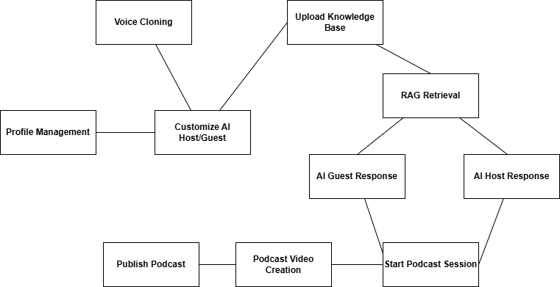

Figure 1: Box and Line Diagram of PodVerse

MVC Architecture
We have adopted a MVC Architecture for the PodVerse application. This architecture style emphasizes the separation of concerns and facilitates modularity.

Presentation Layer (View):

This layer includes the user interface components that interact with the users, such as AudioCreation_View, VideoCreation_View, and ProfileSetting_View. It captures user input and displays output, enabling smooth navigation and interaction within the system.

Application Layer (Controller):

Controllers like AudioCreation_Controller, VoiceCloning_Controller, and Auth_Controller handle user actions, process inputs, coordinate between the view and model, and manage application logic such as podcast creation and authentication.

Business Logic Layer (Model):

This layer contains core logic and data models such as User, Podcast, VoiceSample, and Rating. It manages processing rules, validations, AI interactions, and handles the overall behavior of the system.

AI Services & External Layer:
This layer integrates external services like the Voice Cloning Engine, LLMs, RAG Retrieval, and Subscription APIs. It has intelligent features such as AI guest responses, voice synthesis, and content recommendations.
Data Access Layer:

It abstracts database interactions and performs CRUD operations through repositories. It accesses data stored in relational databases, vector stores, and cloud storage to support both structured and unstructured data needs.

Database Layer:

This layer consists of the actual storage systems, including relational databases for core data, vector stores for AI embeddings, and cloud storage for media files like audio and video podcasts.

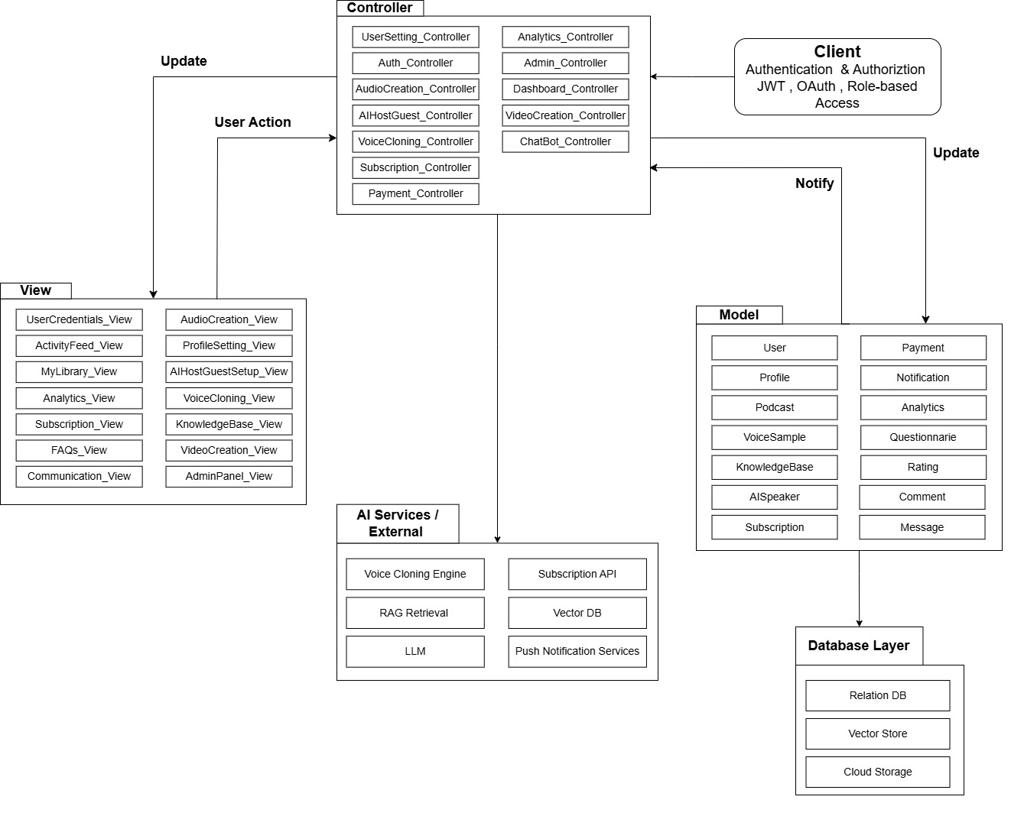

Figure 2: Architecture Diagram for PodVerse

Design Models
This section shows the design models for the system.

Activity Diagrams

Register Account

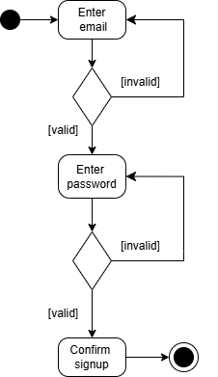

Figure 3: Activity Diagram for Sign up

Login
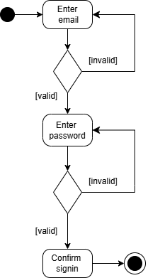

Figure 4: Activity Diagram for Sign in

Edit Profile
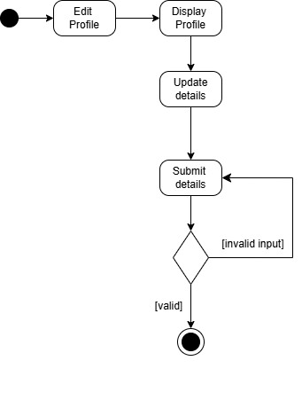

Figure 5: Activity Diagram for Edit Profile

Voice Cloning
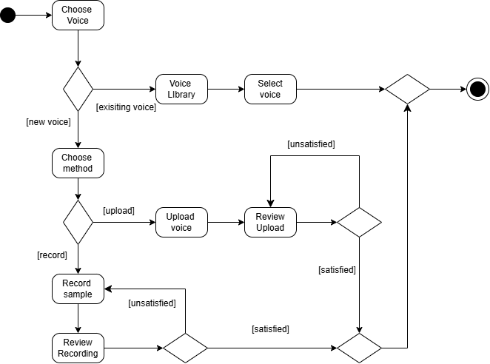

Figure 6: Activity Diagram for Voice Cloning

Knowledge Base Setup
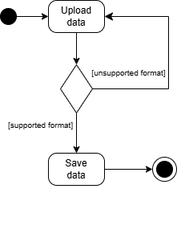

Figure 7: Activity Diagram for Knowledge Base Setup

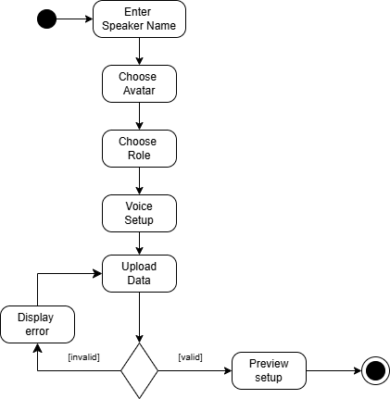
AI Speaker Customization

Figure 8: Activity Diagram for AI Speaker Customization

Podcast Audio Creation
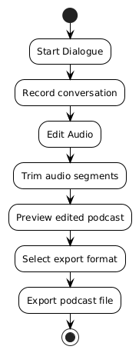

Figure 9: Activity Diagram for Podcast Audio Creation

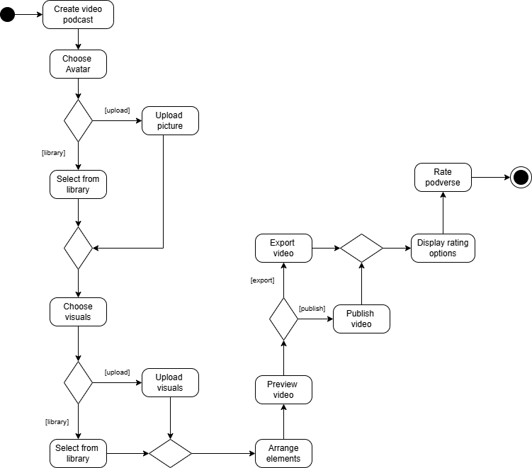
Podcast Video Creation

Figure 10: Activity Diagram for Podcast Video Creation

Request Podcast Summary

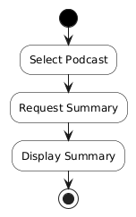

Figure 11: Activity Diagram for Podcast Summary

Subscription and Payment
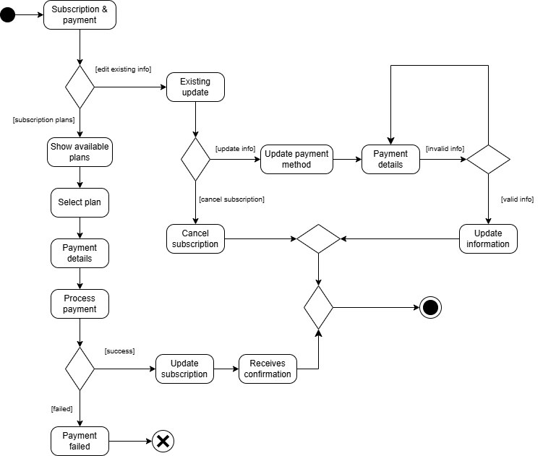

Figure 12: Activity Diagram for Subscription and Payment

FAQs Chatbot
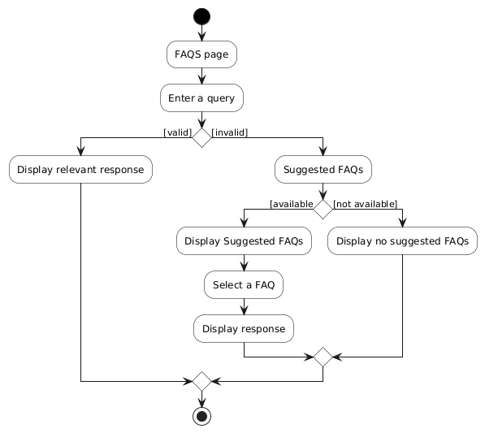

Figure 13: Activity Diagram for FAQs Chatbot

User-to-User Messaging and Calls
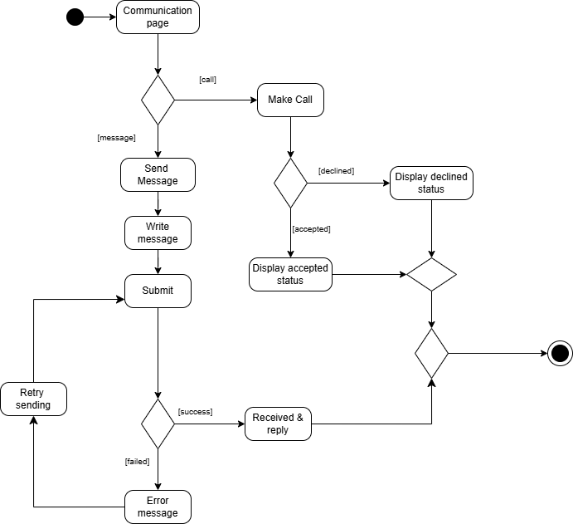

Figure 14: Activity Diagram for User-to-User Messaging and Calls

Manage Users and Subscriptions
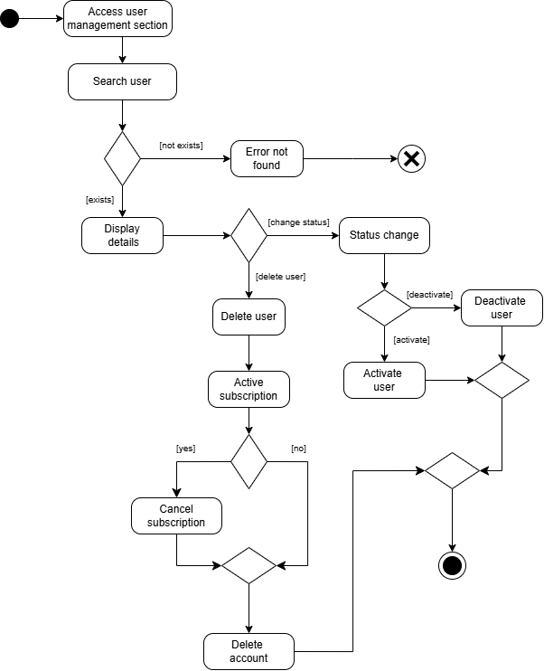

Figure 15: Activity Diagram for Managing Users and Subscriptions

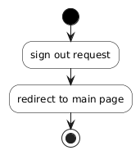
Logout

Figure 16: Activity Diagram for Sign out

Class Diagram
The following are the class entities for PodVerse:

- User
- Profile
- Podcast
- Episode
- AIHost
- AIGuest
- VoiceSample
- KnowledgeBase
- Chunk
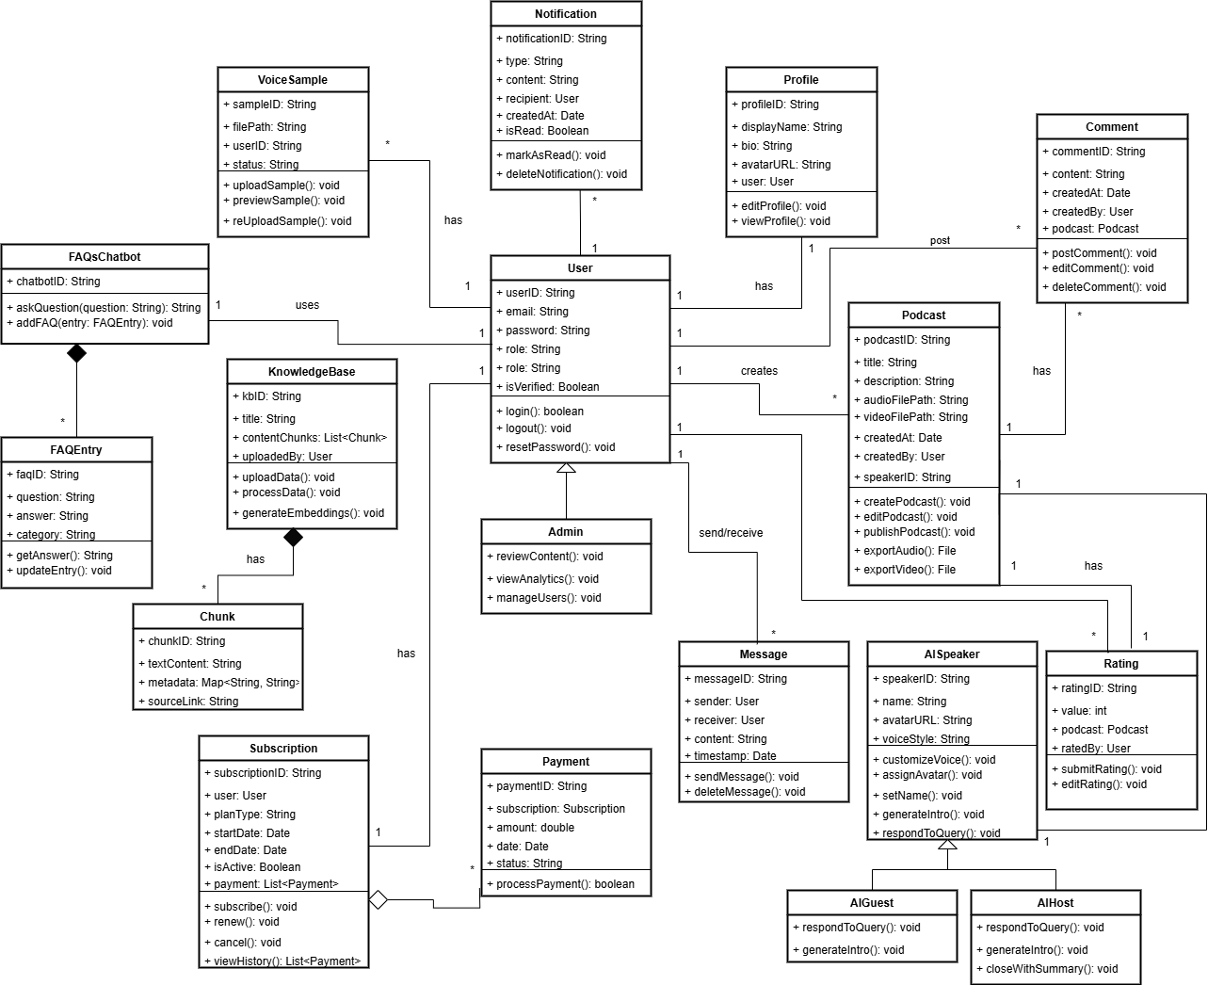
- Message
- Comment
- Rating
- Subscription
- Payment
- Notification
- FAQsChatbot
- FAQEntry
- AISpeaker
- Admin

Figure 17: Class Diagram for PodVerse

Sequence Diagrams
Following are the sequence diagrams of PodVerse:

Module 1: User Authentication
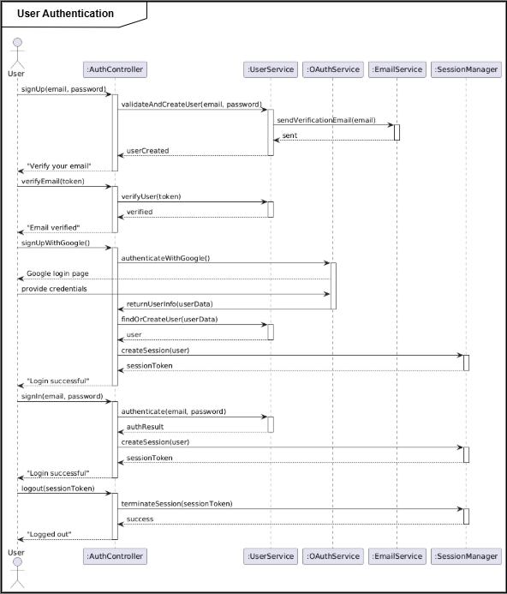
Sequence diagram of module 1.
Figure 18: Sequence diagram of module 1

Module 2: Voice Cloning
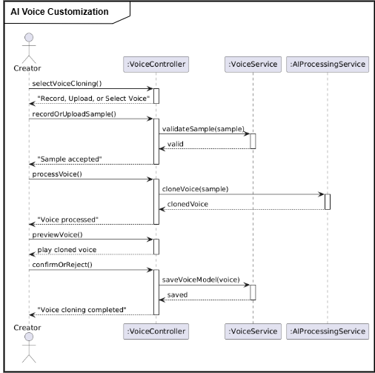
Sequence diagram of module 2.

Figure 19: Sequence diagram of module 2

Module 3: Knowledge Base Setup
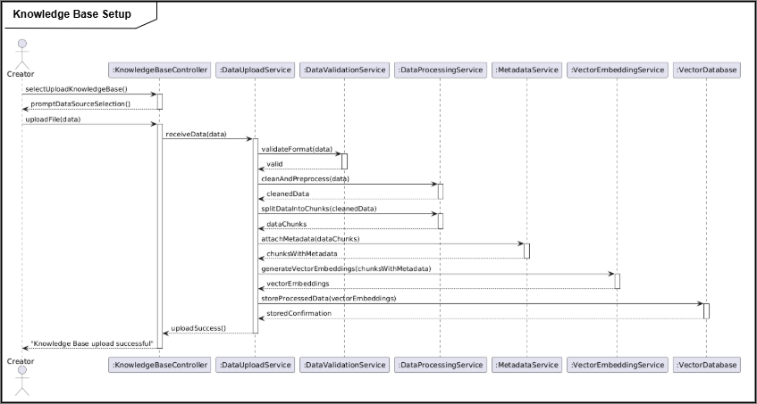
Sequence diagram of module 3.

Figure 20: Sequence diagram of module 3

Module 4: RAG Retrieval
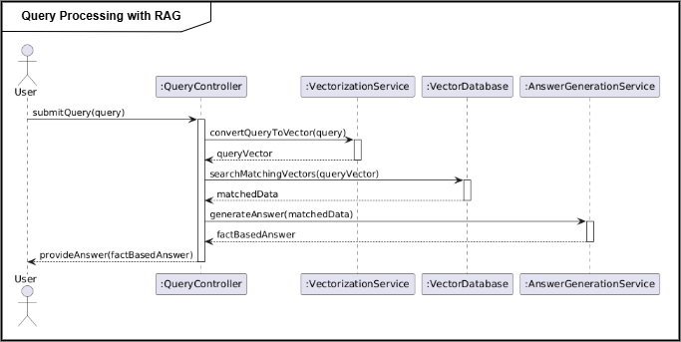
Sequence diagram of module 4.

Figure 21: Sequence diagram of module 4

Module 6: Podcast Audio Creation
Sequence diagram of module 6.
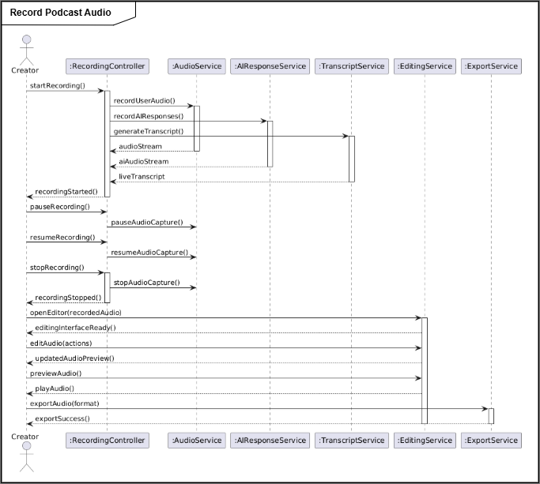

Figure 22: Sequence diagram of module 6

Module 9: Podcast Video Creation and Publishing
Sequence diagram of module 9.
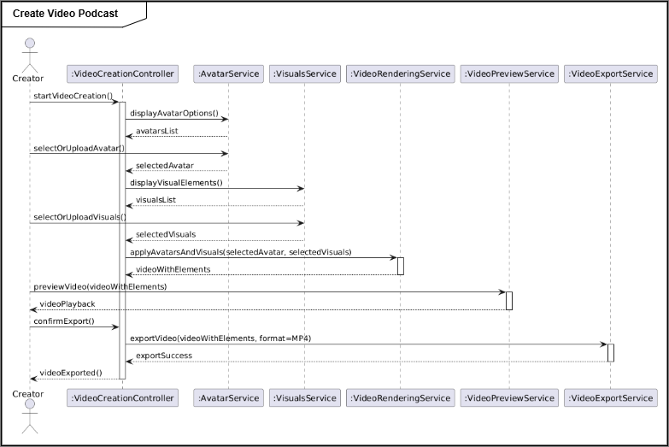

Figure 23: Sequence diagram of module 9

Module 10: Subscription and Payment
Sequence diagram of module 10.
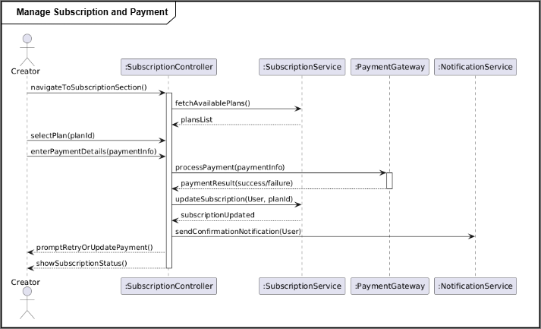

Figure 24: Sequence diagram of module 10

Module 11: FAQs Chatbot
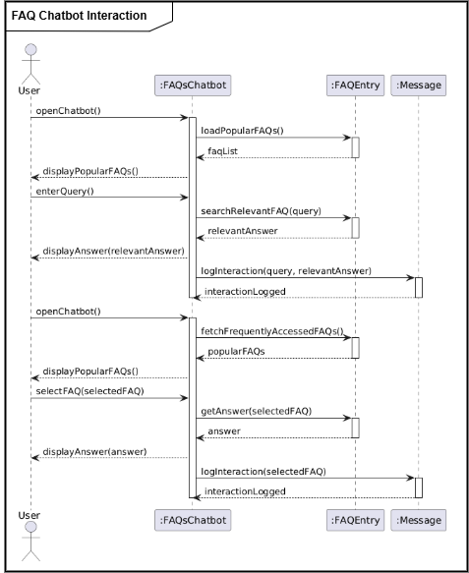
Sequence diagram of module 11.

Figure 25: Sequence diagram of module 11

Module 12: Audience Engagement
Sequence diagram of module 12.
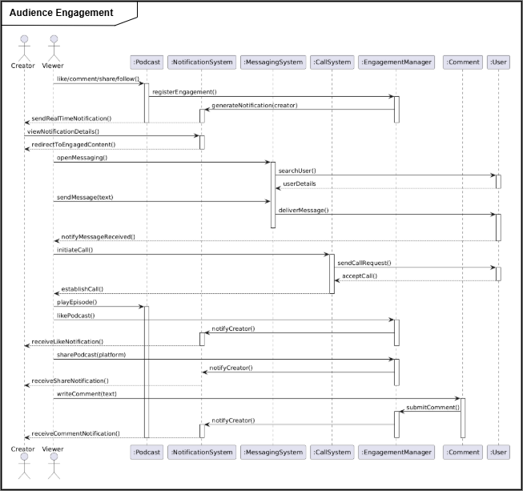

Figure 26: Sequence diagram of module 12

Module 13: Admin Panel and Analytics
Sequence diagram of module 13.
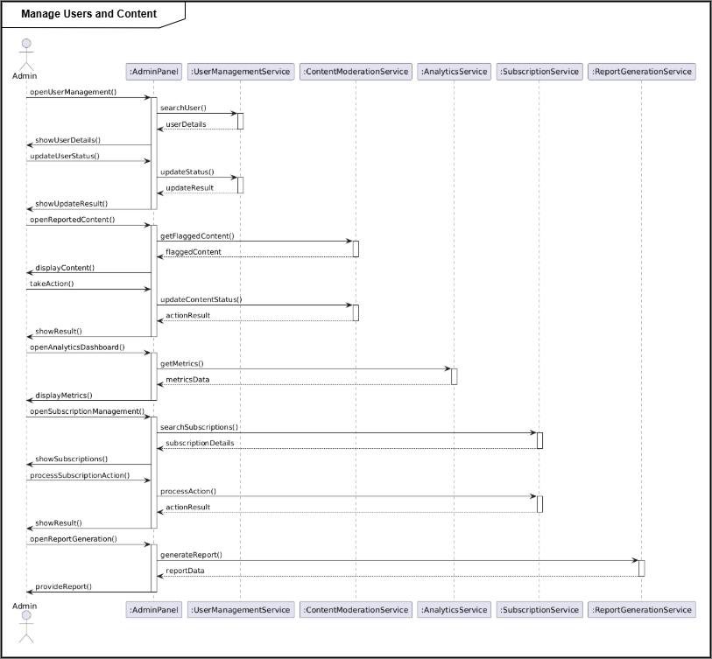

Figure 27: Sequence diagram of module 13

State Transition Diagrams
The following are the state transition diagrams of the backend processes of our system:

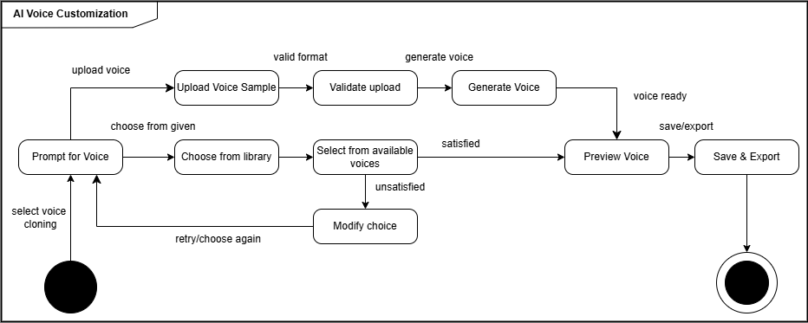

Figure 28: State transition diagram of AI Voice Customization

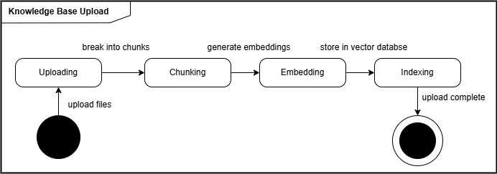

Figure 29: State transition diagram of Knowledge Base Upload

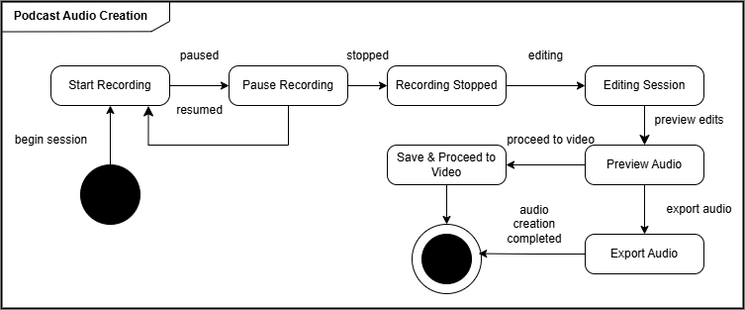

Figure 30: State transition diagram of Podcast Audio Creation
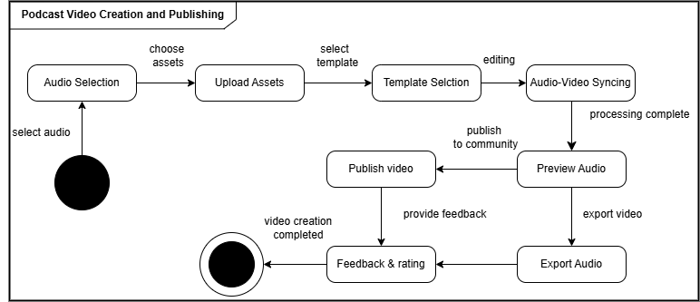

Figure 31: State transition diagram of Podcast Video Creation and Publishing

Data Design
The data design of PodVerse is as follows:

Data Dictionary
Following is the data dictionary of PodVerse:

User Collection
const userSchema = new mongoose.Schema({
fullName: { type: String },
email: { type: String, unique: true },
password: String,
isVerified: { type: Boolean, default: false },
otp: String,
provider: { type: String, enum: ["email", "google"], default: "email" },
resetPasswordToken: String,
resetPasswordExpires: Date,
profileUrl: {
type: String,
default: "https://example.com/default-profile.png"
},
});
Table 1: Data Collection of ‘User’

Field Name | Data Type | Constraints | Description
fullName | String | None | User’s full name
email | String | Unique, Not Null | User’s email address
password | String | Not Null | Hashed password for secure login
isVerified | Boolean | Default: false | Whether the user's email is verified
otp | String | None | One-Time Password for verification
provider | String | Enum: "email", "google", Default: email | Authentication provider used
resetPasswordToken | String | None | Token for password reset
resetPasswordExpires | Date | None | Expiry date/time of the password reset token
profileUrl | String | Default: https://example.com/default-profile.png | URL of the user's profile picture

Podcast Collection
{
podcastID: { type: String, required: true },
createdBy: { type: String, required: true },
title: { type: String, required: true },
description: { type: String },
category: { type: String },
videoFilePath: { type: String },
transcript: { type: String },
coverImageUrl: { type: String },
createdAt: { type: Date }
}

Table 2: Data Collection of ‘Podcast’

Field Name | Data Type | Constraints | Description
podcastID | String | Primary Key | Unique identifier for the user
creatorBy | String | Foreign Key | User ID of the podcast creator
title | String | Not Null | Title of the podcast
description | String | None | Description of the podcast
category | String | None | Category/genre of the podcast
videoFilePath | String | None | URL to the podcast video file
transcript | String | None | Transcript generated during recording
coverImageUrl | String | None | Podcast thumbnail image URL
createdAt | DateTime | None | Date and time the podcast was published

Voice Sample Collection
{
sampleID: { type: String, required: true },
uploadedBy: { type: String, required: true },
sampleAudioUrl: { type: String },
cloneModelID: { type: String },
createdAt: { type: Date } }

Table 3: Data Collection of ‘Voice Sample’

Field Name | Data Type | Constraints | Description
sampleID | String | Primary Key | Unique identifier for sample
uploadedBy | String | Foreign Key | Linked user ID
sampleAudioUrl | String | None | URL of uploaded voice sample
cloneModelID | String | None | ID of the trained clone model
createdAt | DateTime | None | Timestamp of creation

Knowledge Base Collection
for chunk in docs:
await knowledge_base_collection.insert_one({
"user_id": user_id,
"title": file.filename,
"source_type": "pdf",
"chunk": chunk.page_content,
"pdf_file_id": str(pdf_id),
"uploaded_at": datetime.utcnow()
})
Table 4: Data Collection of ‘Knowledge Base’

Field Name | Data Type | Constraints | Description
_id | ObjectID | Primary Key | Auto-generated unique knowledge base ID
user_id | String | Foreign Key | Linked user ID who uploaded the file
title | String | None | Title of the knowledge item (e.g., filename)
source_type | String | None | Type of the source (e.g., pdf, url, etc.)
chunk | Text | None | Content chunk extracted from the source
pdf_file_id | String | None | ID of the original uploaded PDF file
uploaded_at | DateTime | Not Null | Upload timestamp

AI Speaker Collection
{
speakerID: { type: String, required: true },
userID: { type: String, required: true },
avatarType: { type: String },
voiceID: { type: String },
isHost: { type: Boolean },
createdAt: { type: Date }
}

Table 5: Data Collection of ‘AI Speaker’

Field Name | Data Type | Constraints | Description
speakerID | String | Primary Key | Unique ID of the AI Speaker
name | String | Not Null | AI speaker name
language | String | Not Null | Language spoken
voiceStyle | String | Nullable | Style of speaking (e.g., Calm, Energetic)
avatarUrl | String | Nullable | Avatar image or 3D model link
createdAt | DateTime | Not Null | Creation timestamp

Subscription Collection
{
subscriptionID: { type: String, required: true },
userID: { type: String, required: true },
planType: { type: String },
startDate: { type: Date },
endDate: { type: Date },
isActive: { type: Boolean }
}

Table 6: Data Collection of ‘Subscription’

Field Name | Data Type | Constraints | Description
subscriptionID | String | Primary Key | Unique ID of the subscription
UserID | String | Foreign Key | Subscribed user's ID
planType | String | Not Null | Plan (Free, Pro, Premium)
startDate | DateTime | None | Subscription start date
endDate | DateTime | None | Subscription end/renewal date
isActive | Boolean | Default: true | Whether the subscription is currently active

Notification Collection
{
notificationID: { type: String, required: true },
userID: { type: String, required: true },
message: { type: String },
isRead: { type: Boolean },
sentAt: { type: Date }
}

Table 7: Data Collection of ‘Notification’

Field Name | Data Type | Constraints | Description
notificationID | String | Primary Key | Unique notification ID
userID | String | Foreign Key | Recipient user ID
title | String | None | Title of the notification
message | String | None | Main content of the notification
createdAt | DateTime | None | Timestamp of the notification
isRead | Boolean | Default: false | Read/unread status

Payment Collection
{
paymentID: { type: String, required: true },
userID: { type: String, required: true },
amount: { type: Number },
paymentDate: { type: Date },
paymentMethod: { type: String }
}

Table 8: Data Collection of ‘Payment’

Field Name | Data Type | Constraints | Description
paymentID | String | Primary Key | Unique ID of the payment
userID | String | Foreign Key | User who made the payment
subscriptionID | String | Foreign Key | Related subscription
amount | Float | Not Null | Amount paid
status | String | Not Null | Payment status
paymentDate | DateTime | Not Null | Date and time of payment

FAQs Chatbot Collection
{
faqBotID: { type: String, required: true },
botName: { type: String },
description: { type: String },
createdAt: { type: Date }
}

Table 9: Data Collection of ‘FAQs Chatbot’

Field Name | Data Type | Constraints | Description
chatbotID | String | Primary Key | Unique chatbot session ID
userID | String | Foreign Key | User who started the session
sessionStart | DateTime | Not Null | When the session began
sessionEnd | DateTime | Nullable | When the session ended

FAQs Entry Collection
{
faqID: { type: String, required: true },
question: { type: String },
answer: { type: String },
associatedBotID: { type: String },
createdAt: { type: Date }
}

Table 10: Data Collection of ‘FAQs Entry’

Field Name | Data Type | Constraints | Description
faqID | String | Primary Key | Unique ID of the FAQ entry
question | String | Not Null | FAQ question
answer | Text | Not Null | FAQ answer
category | String | Nullable | Category (e.g., Billing, Technical, General)
createdAt | DateTime | Not Null | Entry creation timestamp

Comment Collection
class Comment(BaseModel):
user_id: str = Field(..., description="ID of the user who commented")
content: str = Field(..., description="The actual comment text")
timestamp: datetime = Field(default_factory=lambda: datetime.now(timezone.utc), description="Time of comment")
Table 11: Data Collection of ‘Comment’

Field Name | Data Type | Constraints | Description
commentID | String | Primary Key | Unique identifier for the comment
userID | String | Foreign Key | User who made the comment
episodeID | String | Foreign Key | Episode the comment is associated with
content | Text | Not Null | The actual comment text
createdAt | DateTime | Not Null | Timestamp when the comment was created
updatedAt | DateTime | Nullable | Timestamp when the comment was last edited

Rating Collection
{
ratingID: { type: String, required: true },
podcastID: { type: String, required: true },
userID: { type: String },
ratingValue: { type: Number },
ratedAt: { type: Date }
}

Table 12: Data Collection of ‘Rating’

Field Name | Data Type | Constraints | Description
ratingID | String | Primary Key | Unique identifier for the rating
userID | String | Foreign Key | User who gave the rating
episodeID | String | Foreign Key | Episode that was rated
score | Integer | Not Null | Rating score (e.g., 1 to 5)
comment | String | Nullable | Optional comment/review associated with the rating
createdAt | DateTime | Not Null | When the rating was submitted

Message Collection
{
messageID: { type: String, required: true },
fromUserID: { type: String, required: true },
toUserID: { type: String, required: true },
content: { type: String },
sentAt: { type: Date },
isRead: { type: Boolean }
}
Table 13: Data Collection of ‘Message’

Field Name | Data Type | Constraints | Description
messageID | String | Primary Key | Unique message ID
senderID | String | Foreign Key | User who sent the message
receiverID | String | Foreign Key | User who received the message
content | Text | Not Null | Message text
sentAt | DateTime | Not Null | Timestamp when the message was sent
isRead | Boolean | Default: false | Indicates if the message has been read

Implementation
This section contains the implementation details of the system. It includes algorithms, external APIs used by the system, user interface design and deployment details.

Algorithm
The following are the algorithms used in PodVerse:

Algorithm 1 Registration
Input: user_details (email, password)
Output: Registration status (success or error message)
- Initialize database_connection
- Input user_details (email, password, role).
- Check if role is valid (Applicant or Recruiter):
- If not valid, return: "Invalid role".
- Normalize the email to lowercase.
- Check if the email already exists using checkEmailExists(email):
- If it exists, return "Email already exists".
- Encrypt the password using bcrypt (encryptPassword(password)).
- Save user_details (email and password) to the database.
- Send a verification email using sendVerificationCode(email).
- Return "Registration successful. Please verify your email.".
Algorithm 1.1 checkUsernameExists |  | Algorithm 1.2: encryptPassword
Input: username |  | Input: password
Output: boolean value |  | Output: encrypted_password
1: initialize database_connection  2: input email  3: user_record ← query database for user where email = input email  4: if (user_record exists) then  5: return true  6: else  7: return false |  | 1: initialize encryption_algorithm  2: input password  3: encrypted_password ←  encryption_algorithm.encrypt(password)  4: return encrypted_password
Algorithm 2 Login
Input: email,password

Output: Login status (success or error message)

- Initialize database_connection.
- Input email and password.
- Normalize the email to lowercase.
- Query the database for a user with the given email.
- If no user is found, return "Invalid email".
- Compare the provided password with the stored password using bcrypt.compare.
- If the password is incorrect, return "Invalid password".
- Check if the user is verified (isVerified).
- If not verified, return "Email not verified".
- Generate a secure token (setUser(user)).
- Store the token as a cookie in the response.
- Return "Login successful".
Algorithm 3 Voice Cloning | Algorithm 5 RAGBasedAIConversation
Input: User's audio sample (.wav) | Input: audio_file, user_id
Output: Cloned voice model ID | Output: response_audio_path, answer_text
1: Import required libraries (TTS.api.TTS, os, torch, functools)  2: Override torch.load to prevent weight-only loading issues  3: original_load ← torch.load  4: torch.load ← lambda *args, **kwargs: original_load(*args, **kwargs, weights_only=False)  5: Check for GPU availability  6: use_gpu ← torch.cuda.is_available()  7: Print "GPU acceleration enabled/disabled" based on use_gpu  8: Load XTTS v2 model using Coqui TTS API  9: tts ← TTS("tts_models/multilingual/multi-dataset/xtts_v2", gpu=use_gpu, progress_bar=False)  10: Function clone_voice(text_input, speaker_paths, output_path):  11: Call tts.tts_to_file with the following parameters:  12: text ← text_input  13: speaker_wav ← speaker_paths (list of WAV file paths)  14: file_path ← output_path  15: split_sentences ← True  16: language ← "en"  17: This generates cloned voice audio and saves it to output_path | 1: Import required libraries (SpeechRecognition, Whisper, FAISS, HuggingFaceEmbeddings, ChatOpenAI, gTTS)  2: Function transcribe_audio(audio_file):  3: Save audio_file temporarily  4: Convert to WAV using FFmpeg  5: Load audio into recognizer  6: Try:  7: Transcribe audio using Google Speech Recognition or Whisper  8: Return transcribed_text  9: Except transcription error:  10: Return "Could not understand audio"  11: Function retrieve_user_knowledge(user_id):  12: Query MongoDB `knowledge_base` for chunks where user_id = input user_id  13: Convert chunks to LangChain Document format  14: Generate FAISS vector store using HuggingFaceEmbeddings  15: Return retriever  16: Function generate_ai_response(query_text, retriever):  17: Define custom PromptTemplate (friendly tone, context-aware)  18: Initialize RetrievalQA with LLM (ChatOpenAI) and retriever  19: Invoke QA chain with query_text  20: Return answer_text and source_documents  21: Function synthesize_audio(answer_text, user_id):  22: Use gTTS to synthesize answer_text into MP3  23: Save as "response_userid.mp3"  24: Return audio_file_path  25: Main Function handle_audio_conversation(audio_file, user_id):  26: transcribed_text ← transcribe_audio(audio_file)  27: If transcribed_text is empty or error:  28: Return error message  29: retriever ← retrieve_user_knowledge(user_id)  30: answer_text, sources ← generate_ai_response(transcribed_text, retriever)  31: audio_file_path ← synthesize_audio(answer_text, user_id)  32: Return audio_file_path, answer_text, sources
Algorithm 6 Audio Transcription
Input: tuser_id, audio_file (uploaded audio file)
Output: Transcribed text of the audio OR error message
- Start transcription process.
- Receive user_id and audio_file from the client.
- Save the uploaded audio as a temporary file on the server.
- Filename: temp_<original_filename>
- Check if audio file is empty:
- If file size is 0 bytes, return "Uploaded audio file is empty".
- Convert audio file to WAV format (16kHz, mono) using FFmpeg:
- Input: uploaded audio file
- Output: converted.wav
- If FFmpeg conversion fails, return the error.
- Load converted.wav using speech_recognition.AudioFile.
- Record the audio data from the WAV file.
- Transcribe using Google Speech Recognition:
- If speech is recognized successfully, proceed.
- If speech is not understood, return "Could not understand audio".
- If any exception occurs, return the error.
- Delete temporary files (temp_<original_filename>, converted.wav).
- Return the transcribed text in JSON response.

External APIs/SDKs
Table 14: Details of APIs used in the project

Name of API and version | Description of API | Purpose of usage | List down the API endpoints
Stripe (version 2020-08-27) | Credit Card payment integration | Sandbox used for the orders payment | stripe.paymentMethods.create
Cloudinary | Image and Video management solution | Uploading Product Images on Cloudinary server | https://api.cloudinary.com/v1_1/demo/image/upload

User Interface

SignIn

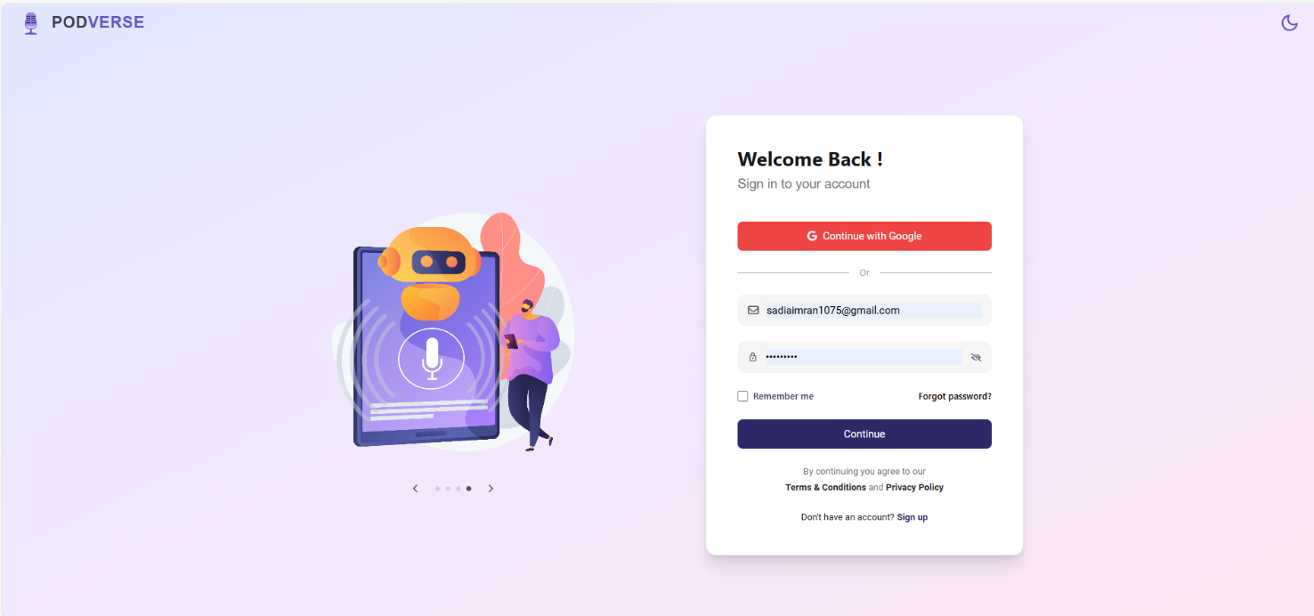

Library
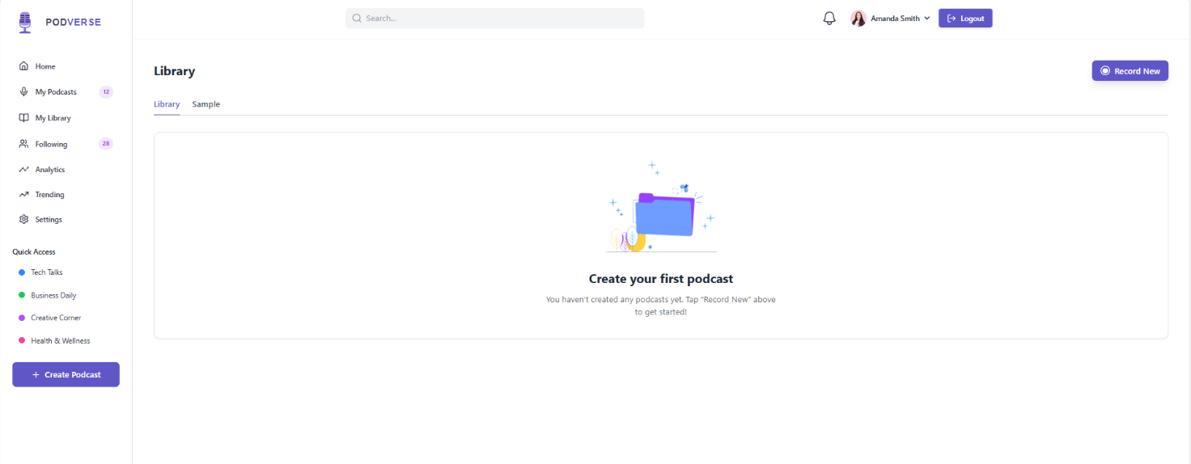

Dashboard
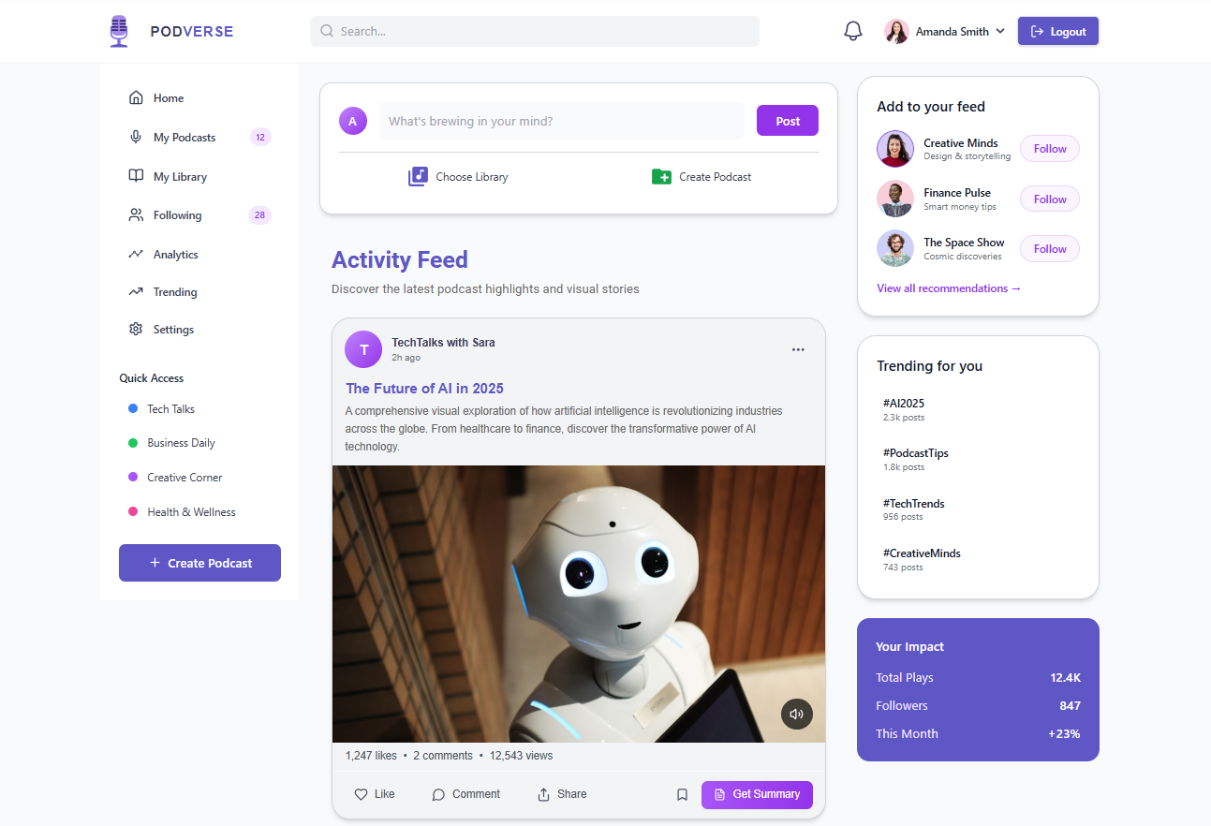

Samples

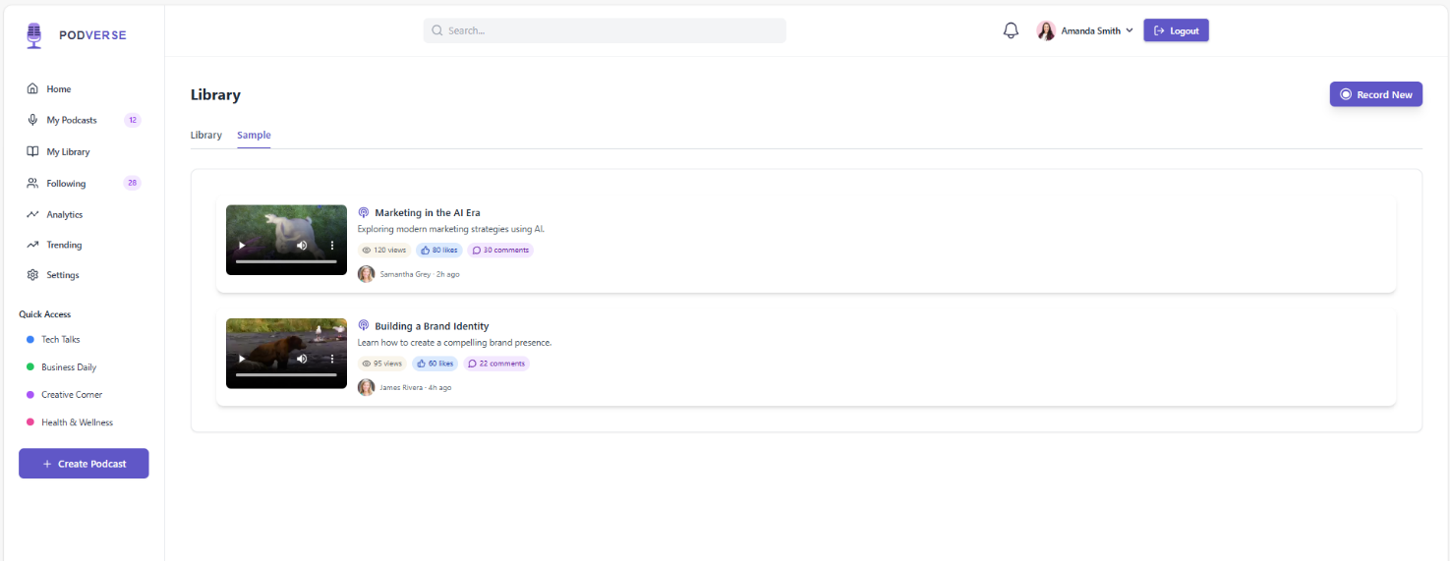

Speaker Customization

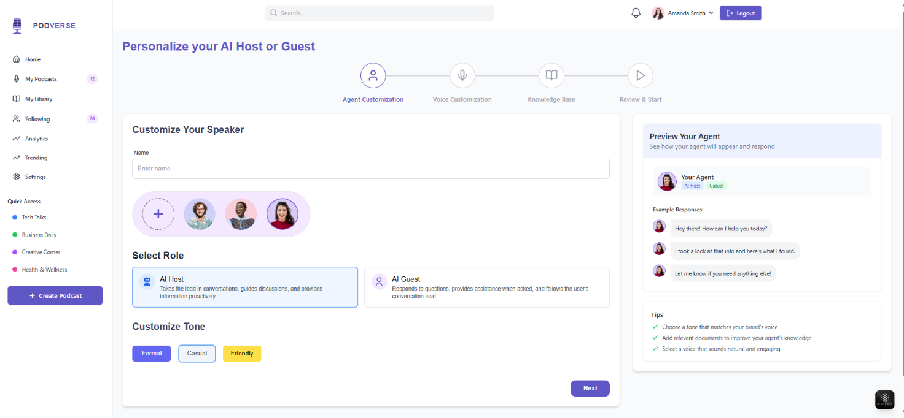

Default Voices
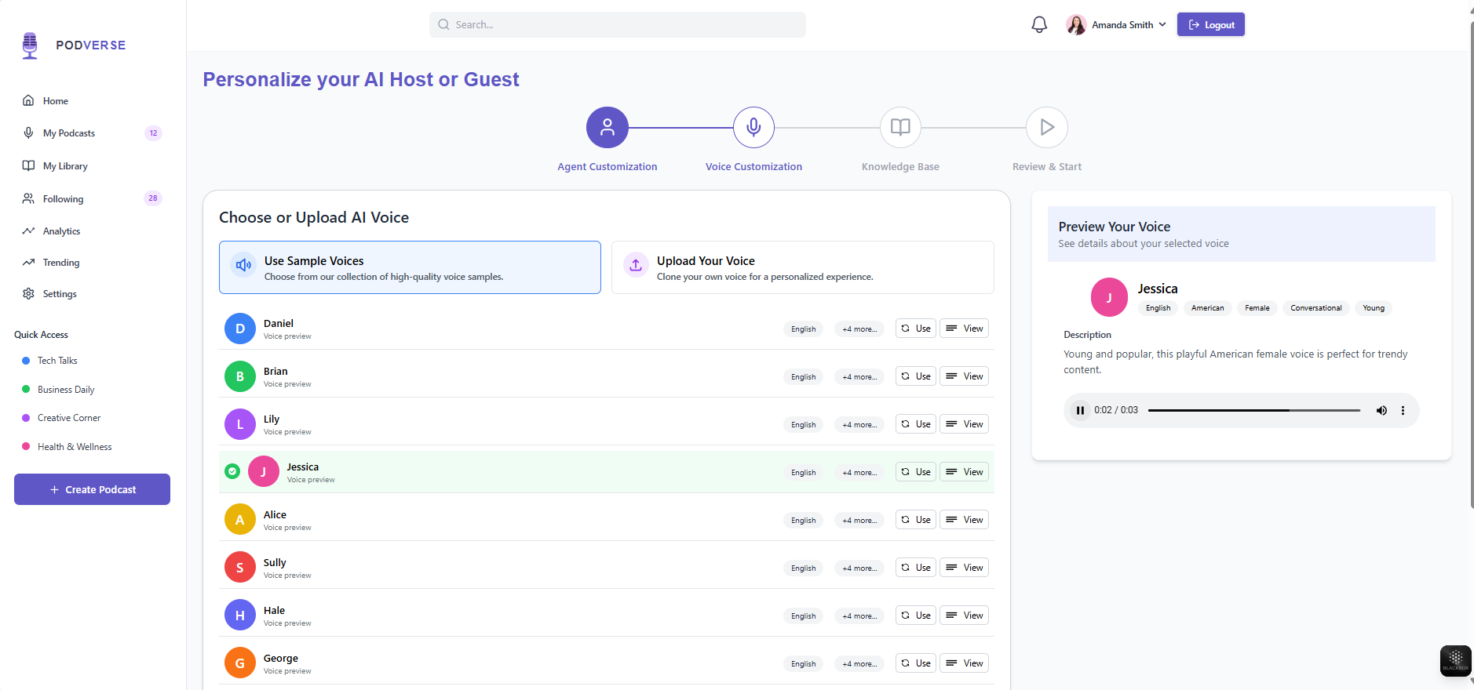

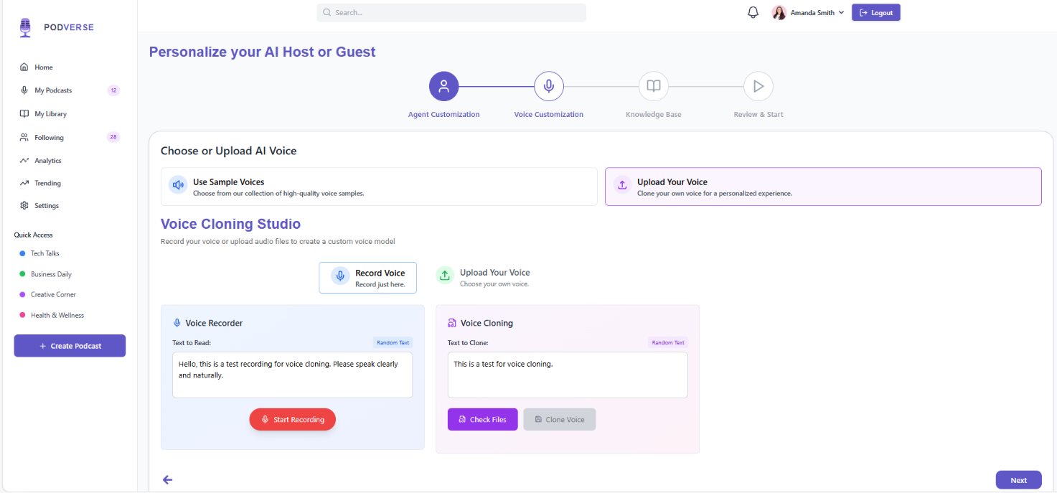
Voice Customization

Recording Studio

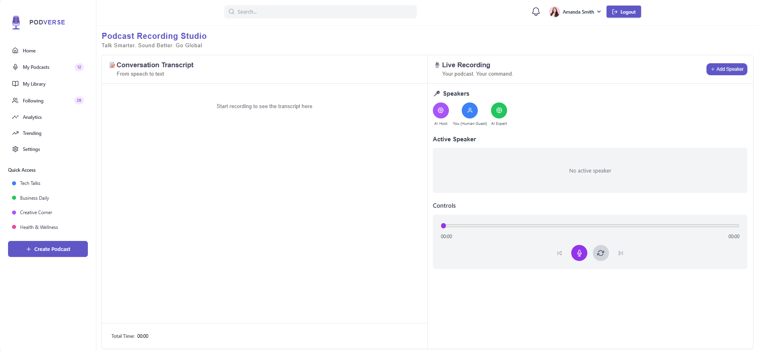

Deployment
The application is still in production environment. It is not deployed yet.

Testing and Evaluation

This section includes unit testing, functional testing, and integration testing details for the modules we have developed so far. The purpose of unit testing is to ensure that each component of the software functions as intended.

Unit Testing
This section has the unit level test cases for PodVerse system:

Unit Testing 1: Email Validation Function

Table 15: Unit Test Cases for Email Validation Function

No. | Test Script | Input | Expected Output | Result
1 | validateEmailFormat | Email: abc@gmail.com | true | Pass
2 | validateEmailFormat | Email: abc.gmail.com | false | Pass
3 | validateEmailFormat | Email: `` (empty) | false | Pass

Unit Testing 2: checkEmailExists()

Table 16: Unit Test Cases to Check Email Exists

No. | Test Case/Test Script | Attribute and Value | Expected Result | Result
1 | checkEmailExists | Email: sadiaimran837@gmail.com, Password: Sadia@123 | true | Pass
2 | checkEmailExists | Email: sadiaimran837@gmail.com | Error: "Email already exists" | Pass

Unit Testing 3: Password Encryption & Verification

Table 17: Unit Test Cases for Password Encryption & Verification

No. | Test Script | Input | Expected Output | Result
1 | encryptPassword() | Input: Test123! | Encrypted string returned | Pass
2 | verifyPassword() | Input: Test123!, Hash | true | Pass
3 | verifyPassword() | Input: WrongPass, Hash | false | Pass

Unit Testing 4: OTP Generator & Validator

Table 18: Unit Test Cases for OTP Generator & Validator

No. | Test Script | Input | Expected Output | Result
1 | generateOTP() | Triggered | 6-digit numeric OTP | Pass
2 | verifyOTP() | Input: 123456, Match | success | Pass
3 | verifyOTP() | Input: 999999, Mismatch | failure | Pass

Unit Testing 5: Voice Cloning File

Table 19: Unit Test Cases for Voice Cloning File

No. | Test Script | Input | Expected Output | Result
1 | processVoiceSample() | File: voice.wav | Cleaned mono audio | Pass
2 | extractVoiceProfile() | Cleaned audio | Voice profile (speaker vector) generated | Pass
3 | saveVoiceProfile() | Profile data, user ID | Voice profile linked to user in database | Pass

Unit Testing 6: Summarization

Table 20: Unit Test Cases for Summarization

No. | Test Script | Input | Expected Output | Result
1 | generateSummary() | Text: 1000 words | Summary ≤ 150 words | Pass
2 | generateSummary() | Input: `` (empty) | Error: Missing transcript | Pass
3 | saveSummaryToDB() | Summary, transcript_id | MongoDB write success | Pass

Unit Testing 7: Transcription Module

Table 21: Unit Test Cases for Transcription Module

No. | Test Case | Attribute and Value | Expected Result | Result
1 | preprocessAudio() | .wav file | Cleaned 16kHz audio path | Pass
2 | transcribeAudio() | Cleaned audio | Transcript string | Pass
3 | saveTranscriptToDB() | Transcript, podcast_id | MongoDB write success | Pass

Unit Testing 8: AI-Conversation Reply Generator

Table 22: Unit Test Cases for AI-Conversation Reply Generator

No. | Test Script | Input | Expected Output | Result
1 | generateReplyFromText() | Transcript: "Tell me something" | String reply from AI | Pass
2 | saveToConversationLog() | user_id, AI reply | DB write success | Pass

Unit Testing 9: AI Speaker Customization

Table 23: Unit Test Cases for AI Speaker Customization

No. | Test Case/Test Script | Attribute and Value | Expected Result | Result
1 | Upload valid avatar image | File: avatar.png | Image preview displayed, file saved | Pass
2 | Upload unsupported avatar file | File: avatar.txt | Error: "Only PNG, JPG supported" | Pass
3 | Select speaker role | Option: AI Guest | Role saved in session | Pass
4 | Upload valid knowledge base | File: kb_text.pdf | Text extracted and saved | Pass
5 | Upload unsupported knowledge base | File: kb.exe | Error: "Invalid file format" | Pass
6 | Save speaker config | Role + Avatar + KB | MongoDB profile updated | Pass

Unit Testing 10: Audio Recorder Module

Table 24: Unit Test Cases for Audio Recorder Module

No. | Test Script | Input | Expected Output | Result
1 | startRecording() | Trigger | Mic access granted | Pass
2 | stopRecording() | File path | Audio saved | Pass
3 | uploadToFirebase() | File: audio.wav | URL returned | Pass

Unit Testing 11: Knowledge Base Processing

Table 25: Unit Test Cases for Knowledge Base Processing

No. | Test Case/Test Script | Attribute and Value | Expected Result | Result
1 | Upload valid .txt file | File: facts.txt | Text content extracted and saved | Pass
2 | Upload valid .pdf file | File: data.pdf | Text extracted from PDF | Pass
3 | Upload corrupted file | File: bad.pdf | Error: "Unable to read file content" | Pass
4 | Link content to speaker config | Speaker ID: ai_6123abc | MongoDB updated with knowledge source | Pass

Functional Testing
The following are the functional test cases of PodVerse:

Functional Testing 1: SignUp & OTP Verification

Table 25: Functional Test Cases for SignUp & OTP Verification

No. | Test Case/Test Script | Attribute and Value | Expected Result | Actual Result | Result
1 | Register with valid details | Email: sadiaimran837@gmail.com, Password: Sadia@123 | OTP sent to registered email | OTP screen appeared, email received | Pass
2 | Duplicate email | Email: sadiaimran837@gmail.com | Error: "Email already in use" | Error message displayed | Pass

Functional Testing 2: Login

Table 26: Functional Test Cases for Login

No. | Test Case/Test Script | Attribute and Value | Expected Result | Actual Result | Result
1 | Valid login credentials | Email: rabeeachughtai1@gmail.com, Password: Rabeea@123 | Dashboard loaded | User redirected to dashboard | Pass
2 | Incorrect password | Email: rabeeachughtai1@gmail.com, Password: Wrong123 | Error: "Invalid credentials" | Error toast displayed | Pass

Functional Testing 3: Podcast Transcription

Table 27: Functional Test Cases for Podcast Transcription

No. | Test Case/Test Script | Attribute and Value | Expected Result | Actual Result | Result
1 | Upload podcast audio | File: podcast.wav | Full transcript displayed on screen | Transcript text loaded in textarea | Pass
2 | Upload empty or silent file | File: silence.wav | Error: “No speech detected” | Warning shown in toast | Pass

Functional Testing 4: Voice Cloning

Table 28: Functional Test Cases for Voice Cloning

No. | Test Case/Test Script | Attribute and Value | Expected Result | Actual Result | Result
1 | Upload valid voice sample | File: user_voice.wav | Voice cloned successfully, stored for reuse | “Voice cloned” message shown | Pass
2 | Upload unsupported format | File: user_voice.mp3 | Error: “Only WAV files are supported” | Validation error appeared | Pass

Functional Testing 5: Transcript Summarization

Table 29: Functional Test Cases for Transcript Summarization

No. | Test Case/Test Script | Attribute and Value | Expected Result | Actual Result | Result
1 | Generate summary | Transcript: 1000+ words | Summary displayed (≤150 words) | Short summary shown in summary tab | Pass
2 | Click summarize with empty input | Transcript: (empty) | Error: "Transcript required" | Validation toast: “Transcript empty” | Pass

Functional Testing 6: AI-User Conversation

Table 30: Functional Test Cases for AI-User Conversation

No. | Test Case/Test Script | Attribute and Value | Expected Result | Actual Result | Result
1 | Upload mic prompt | File: user_prompt.wav | AI reply generated and shown | Reply displayed below waveform | Pass
2 | Submit empty prompt | File: silence.wav | Error: “Please speak to continue” | “Please speak” toast shown | Pass

Functional Testing 7: Podcast Audio Recording & Upload

Table 31: Functional Test Cases for Podcast Audio Recording & Upload

No. | Test Case/Test Script | Attribute and Value | Expected Result | Actual Result | Result
1 | Start/Stop recording | Record → Stop clicked | Recording preview generated | Waveform rendered | Pass
2 | Upload to Firebase | File: recorded_audio.wav | File stored, Firebase URL returned | Link received and saved | Pass
3 | Save metadata | Title: “Ep1”, Tags: [AI, Tech] | Podcast entry created in MongoDB | Metadata saved, confirmation shown | Pass

Functional Testing 8: Podcast Library Access

Table 32: Functional Test Cases for Podcast Library Access

No. | Test Case/Test Script | Attribute and Value | Expected Result | Actual Result | Result
1 | Load personal podcast list | User ID: rabeeachughtai1@gmail.com | User podcasts listed | Podcast cards shown on screen | Pass
2 | Play uploaded podcast | File URL from DB | Audio plays in embedded player | Media player started with audio | Pass
3 | Show sample podcasts only | Filter: sample=true | Sample podcasts displayed | Filtered list of samples shown | Pass

Functional Testing 9: AI Speaker Customization

Table 33: Functional Test Cases for AI Speaker Customization

No. | Test Case/Test Script | Attribute and Value | Expected Result | Actual Result | Result
1 | Upload avatar image | File: avatar.png | Avatar displayed and saved | Image shown on profile | Pass
2 | Choose speaker role | Role: AI Host | Role stored successfully | Display updated with AI Host tag | Pass
3 | Upload valid knowledge base | File: kb_notes.pdf | Text extracted and attached to AI speaker | Content linked and displayed | Pass
4 | Upload unsupported KB | File: kb.exe | Error: “Invalid file format” | Error toast: "Only PDF/TXT allowed" | Pass

Business Rules Testing
This section contains various decisions and actions according to the business rules.

Business Rules Testing 1: Only one account can be registered for a given email address

Table 34: Business Rules Testing 1

Conditions | Rule 1 | Rule 2 | Rule 3
Email already registered | Yes | No | No
Password valid | Yes | Yes | No
Actions
Account created | No | Yes | No

Business Rules Testing 2: Password must meet security criteria

Table 35: Business Rules Testing 2

Conditions | Rule 1 | Rule 2 | Rule 3
Password contains digits | Yes | No | No
Password contains letters | Yes | Yes | No
Actions
Account created | Yes | No | No

Business Rules Testing 3: Voice Cloning – Audio Upload Constraints

Table 36: Business Rules Testing 3

Conditions | Rule 1 | Rule 2
File format supported | Yes | No
Audio meets quality standards | Yes | Yes
Audio accepted | Yes | No
File format supported | Yes | No

Business Rules Testing 4: Knowledge Upload Format

Table 37: Business Rules Testing 4

Conditions | Rule 1 | Rule 2
File format supported | Yes | No
Data is structured | Yes | Yes
File accepted | Yes | No

Integration Testing
This section has the integration test cases for the modules that we have developed. They make sure that the connections and interfaces between various components of the system function correctly.

Integration Testing 1: User Registration & Email Verification

Table 38: Integration Testing 1 for User Registration & Email Verification

No. | Test case/ Test script | Attribute and value | Expected result | Actual result | Result
1 | Valid Registration | Email, Password, Role = "Applicant" | "Registration successful. Please verify your email." | Same | Pass
2 | Duplicate Email | Already existing email | "Email already exists" | Same | Pass
3 | Invalid Role | Role = "Manager" | "Invalid role" | Same | Pass

Integration Testing 2: Login with Verification Flow

Table 39: Integration Testing 2 for Login with Verification Flow

No. | Test case/ Test script | Attribute and value | Expected result | Actual result | Result
1 | Login with verified user | Email, Password | "Login successful" | Same | Pass
2 | Login with unverified user | Valid credentials | "Email not verified" | Same | Pass
3 | Incorrect password | Valid email, wrong password | "Invalid password" | Same | Pass

Integration Testing 3: Voice Cloning Flow

Table 40: Integration Testing 3 for Voice Cloning Flow

No. | Test case/ Test script | Attribute and value | Expected result | Actual result | Result
1 | Clone voice with valid .wav | UserID, audio_sample | "Voice cloned successfully", path | Same | Pass
2 | Upload unsupported format | .mp3 file | Error: "Unsupported format" | Same | Pass

Integration Testing 4: Podcast Transcription

Table 41: Integration Testing 4 for Podcast Transcription

No. | Test case/ Test script | Attribute and value | Expected result | Actual result | Result
1 | Transcribe valid podcast | Valid .wav file | Transcript returned and saved | Same | Pass
2 | Upload non-WAV file | .mp3 | Error: Invalid format or convert | Same | Pass

Integration Testing 5: Transcript Summarization

Table 42: Integration Testing 5 for Transcript Summarization

No. | Test case/ Test script | Attribute and value | Expected result | Actual result | Result
1 | Summarize valid transcript | 1024 token input | Summary saved in MongoDB | Same | Pass
2 | Excessively long input | 2000+ tokens | Summarized within token limits | Same | Pass

Integration Testing 6: AI Podcast Generation

Table 43: Integration Testing 6 for AI Podcast Generation

No. | Test case/ Test script | Attribute and value | Expected result | Actual result | Result
1 | Record podcast with 2 speakers | conversation_list | Podcast saved in Firebase, metadata stored | Same | Pass
2 | Missing speaker embedding | Unknown role | Error or fallback voice | Same | Pass

References
- P. Nave. “Exploring RAG: Essential Steps to Implementing AI Agents and Deep Learning Strategies.” Internet: https://medium.com/@pratikabnave97/exploring-rag-essential-steps-to-
implementing-ai-agents-and-deep-learning-strategies-f41ceda143c4, Mar. 10, 2024 [Nov. 10,
2024].
- S. Smith. “The Future of Podcasting in 2024 and Beyond: Key Predictions.” Internet: https://www.opus.pro/blog/the-future-of-podcasting-in-2024-and-beyond-key-predictions, Mar. 22, 2024 [Nov. 10, 2024].
- G. Harris. “AI Knowledge Base: Enhancing Intelligence for Smart Decisions.” Internet:
https://www.getguru.com/reference/ai-knowledge-base, Apr. 5, 2024 [Nov. 10, 2024].

Plagiarism Report


