**Hands-on Exercise No. 1**

**Solution:**

1. Go to Google scholar and search recent research papers on the topic: “The Role of Sports and Recreation in Youth Development". https://scholar.google.com/

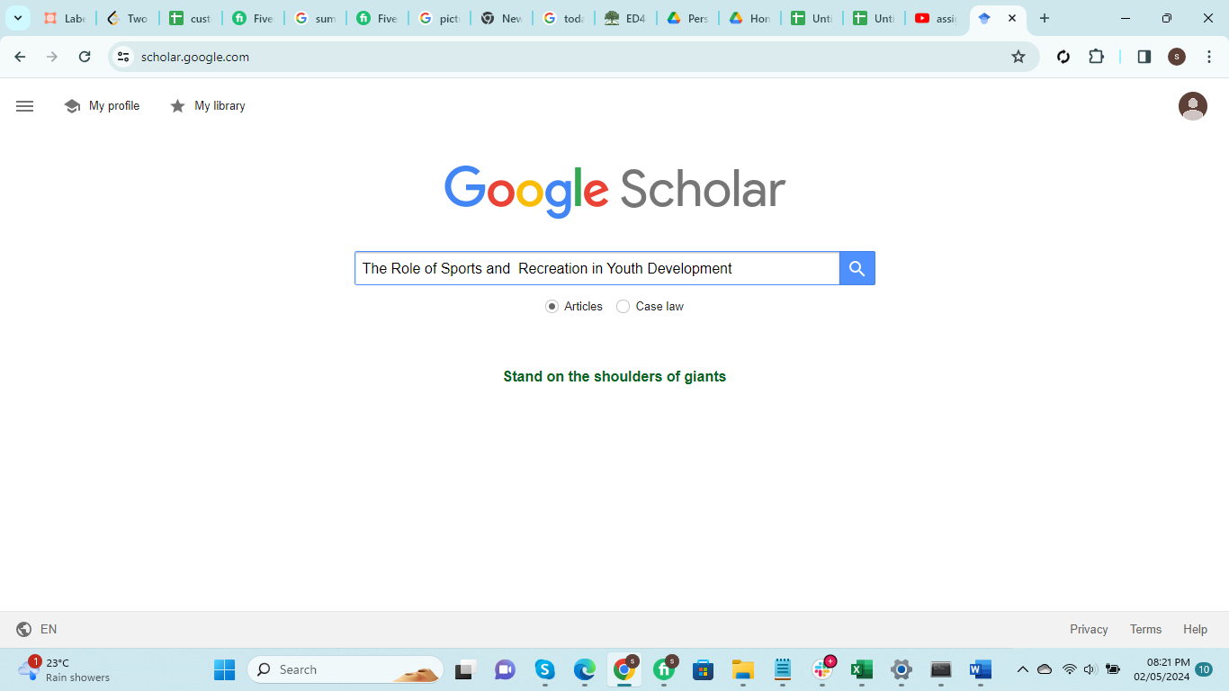

1. Login to Google Drive, open the google docs file and add adds-on extension "Word Cloud Generator". <https://drive.google.com/>

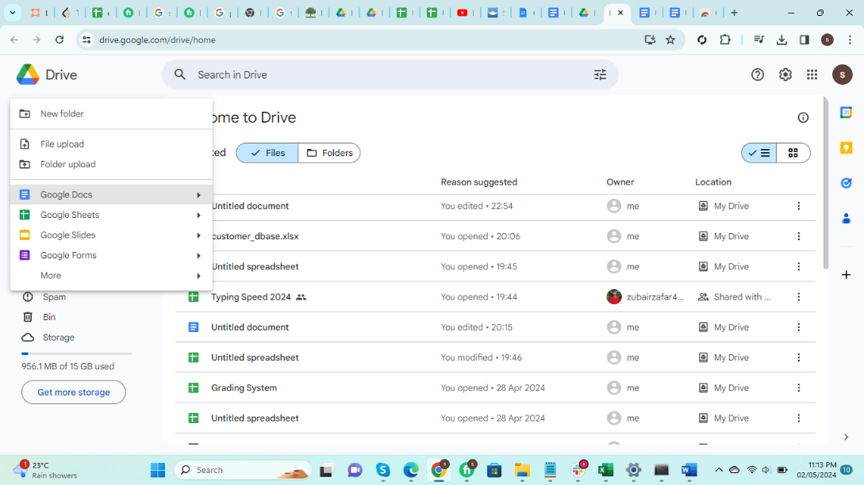

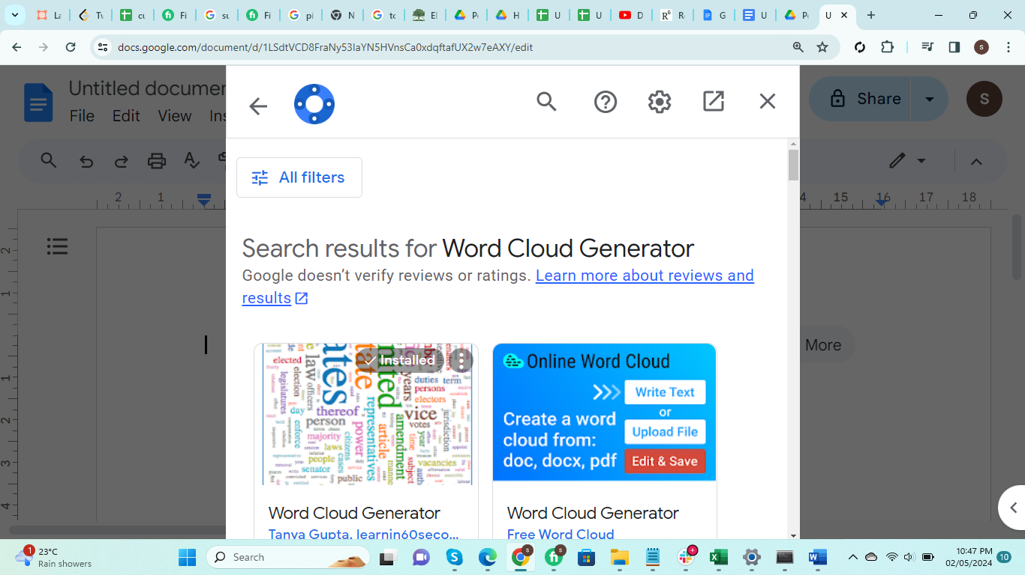

1. Copy the research paper’s (Abstract/Summary) and paste it into the google docs file, generate the Word Cloud by using the installed extension and then attach the generated image.

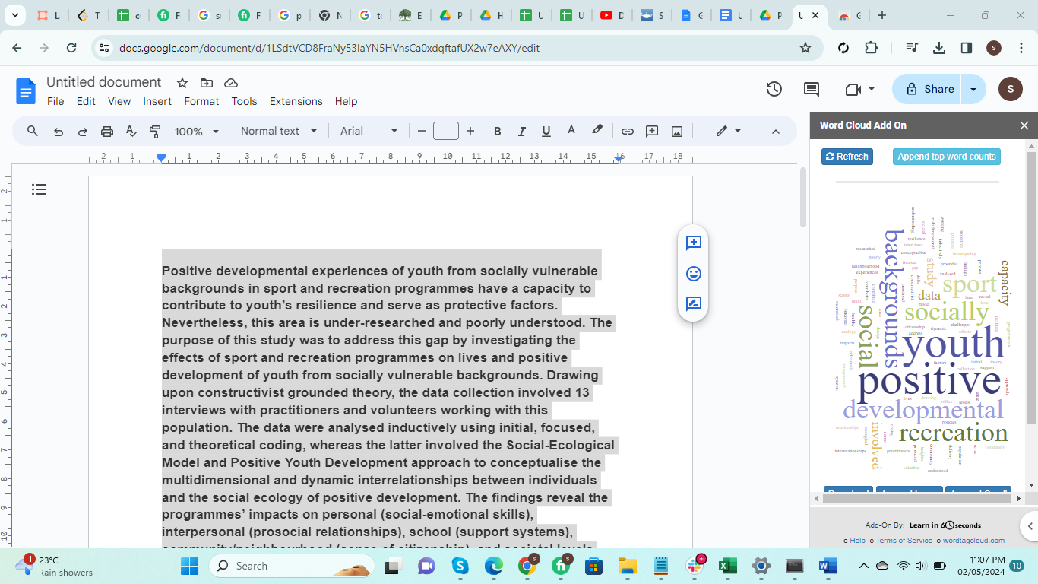

1. Write down the 5 most prominent words from the word cloud image. (3 Marks)

* Positive
* Youth
* Developmental
* Background
* Socially
* Recreation