Final Project Report

Android Agriculture-Seed Experiment using Image Processing



Project Supervisor
Asma Batool

Submitted By

F2202433DC

Sadia Rani BC190400747

Software Projects & Research Section,
Department of Computer Sciences,
Virtual University of Pakistan


CERTIFICATE

This is to certify that Sadia Rani (BC190400747),have worked on and completed their Software Project at Software & Research Projects Section, Department of Computer Sciences, Virtual University of Pakistan in partial fulfillment of the requirement for the degree of BS in Computer Sciences under my guidance and supervision.

In our opinion, it is satisfactory and up to the mark and therefore fulfills the requirements of BS in Computer Sciences.

Supervisor / Internal Examiner

Asma Batool
Supervisor,
Software Projects & Research Section,
Department of Computer Sciences
Virtual University of Pakistan

___________________
(Signature)

External Examiner/Subject Specialist
<<External Supervisor Name>>

___________________
(Signature)

Accepted By:

_____________
(For office use)

EXORDIUM

In the name of Allah, the Compassionate, the Merciful.

Praise be to Allah, Lord of Creation,
The Compassionate, the Merciful,
King of Judgment-day!

You alone we worship, and to You alone we pray for help,
Guide us to the straight path

The path of those who You have favored,

Not of those who have incurred Your wrath,
Nor of those who have gone astray.

DEDICATION

The work reported in this project was carried by me under the supervision of Project
Supervisor, Supervisor Name: Asma Batool

I hereby declare that the project titled ‘ Android Agriculture-Seed Experiment using Image Processing’ is the result of my original work .The project embodies a systematic study, analysis, and implementation of an Android application aimed at helping User in seed quality evaluation through processing images.

ACKNOWLEDGEMENT

I would like to express my sincere thanks to all those who have help me to the successful completion of the project 'Android App for Seed Quality Assessment'. My heartfelt thanks go to my project guide for his valuable advice and insightful suggestions. I thank my colleagues and friends for their cooperation and help on this journey. Finally, I am indebted to my family for their unwavering support and motivation.”

TABLE OF CONTENTS

CHAPTER NO. 1
gathering & Analyzing info 7

1.1 Introduction

1.2 purpose

1.3 scope

1.4 definitions, acronyms and abbreviations

1.5 Project requirements

1.5.1 Functional Requirements

1.5.2 Non-Functional Requirements

1.6 use cases and usage scenarios

1.6.1 Use Case Diagrams

1.6.2 Usage Scenarios

1.7 Development Methodology

1.7.1 Chosen Methodology

1.7.2 Reasons for Chosen Methodology
1.7.2 Work Plan (Gantt Chart)
1.7.2 Project Schedule (Submission Calendar)

CHAPTER NO. 2
designing the project 16

2.1 Introduction

2.2 purpose

2.3 scope

2.4 Architectural Representation (Architecture Diagram)

2.5Dynamic Model: Sequence Diagrams

2.6Object Model/Logical Model: Class Diagram

2.7 Database Model (Database Diagram)

2.8Graphical User Interfaces

Chapter no.3
DEvelopment 22
3.1 Development plan (Architecture Diagram)

CHAPTER 1
Gathering & Analyzing Info

Introduction

This is an interesting project for Android. This application will help farmers and buyers to know if the seeds they are using for plantation are good or not good.
This application detects the type of seeds and provides all the information about it to the users. Seed testing minimizes hazards in plant production. Seed testing determines seed quality problems before planting, saving time and money. Seed testing is also necessary to check the suitability of seeds for planting .This application will test the seed itself using image processing.

Purpose

The purpose of the project is to use the critical process of seed testing to improve agricultural practices. Using image processing and mobile technology, this app aims to provide farmers with a means to quickly and accurately assess seed quality. It facilitates the identification of defects and traits such as physical cleanliness, moisture, germination and vitality, thereby ensuring the availability of high quality seeds to the agricultural community. With the ability to capture seed images, apply image enhancement techniques and classify seeds, this innovative Android application aims to streamline seed quality assessment, ultimately contributing to improved agricultural productivity and sustainable farming practices

Scope
Seed testing is the foundation of all other seed technologies. Seed testing is a good way for growers and buyers alike to obtain information regarding seed quality or seed germination. It is meant by which the quality of seed can be measured, and property of seed is ensured. Seed testing is determining the standards of a seed by giving the identification namely physical purity, moisture, germination, vigor and thereby enabling the farming community to get quality seeds. Seed testing can be done for many reasons, including research purposes or to see if seed storage techniques are working or not. Seed testing is of great importance because seed quality forms the basis of food consumed by people around the world. High quality seeds provide the foundation for consumer health and safety This is an interesting android project. This application will help the farmers to detect if the seeds they are using defected or not defected. This application will detect the type of seeds and give every information about it to the users. This application itself will test the seed using Image processing. This application will make it easy for the customers to buy any type of seed like Wheat, rice, maize, sorghum, barley, peanut, soybean, lentil, common pea, common bean, coconut, walnut, pecan, and sunflower etc.

  - definitions, acronyms and abbreviations
User: User mean any person who will be use application.

1.5 Project requirements

1.5.1 Functional Requirements
1. Input Image
Take an input seed image from seed lot by using digital camera
2. Image Enhancement
Image enhancement is the process of adjusting digital images so that the results are more suitable for display or further image analysis. For example, you can remove noise, sharpen, or brighten an image, making it easier to identify key features.
3. RGB to Gray Conversion Convert image as gray image.
4. Gray to Binary conversion
Sharp filtering The gray image must be sharpened for a good vision.
5. Boundary Removal
6. Classification of Seed
The farmer is supposed to login, and their data will be stored. They simply need to take a picture of the seed through the app, and it will show the result. The recent search history would be stored in the database using SQLite.
1.5.2 Non-Functional Requirements
- Performance
When starting the application, the initial screen should not take more than 5 seconds to load. Also it should make sure that the application will not prevent to the user input.
2. Scalability
The application should be able to adapt itself to increased usage or be able to process more data over time.
3. Use-ability
Users should be able to use the application without any instructions or help from experts.
4. Reliability
The application should be reliable to perform the activity, i.e. when the user performs some important action, it should be acknowledging with a confirmation.
5. Security
All application data should be secured and encrypted with minimum requirements to protect it from external environment as well as internal attack
6. Availability
There should be a common plane where the user can access this application to install it.

1.6 use cases and usage scenarios

1.6.1 Use Case Diagrams
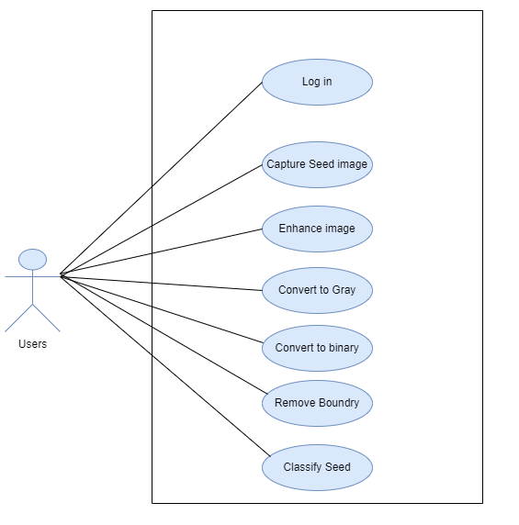

Usage Scenarios

Use Case Title | Login
Use Case ID | UC-1
Actions: | The user enters his/her name and password.  User press login button.
Description: | This use case describes how a user logs into the Application.
Pre-Condition: | The application must request that the user enter his/her name and password.
Post-Condition: | If the use case was successful, the User is now logged into the application.
Author: | F2202433DC
Alternative Path: | The actor can choose to either return to the back again login or cancel the login.
Exception: | If the user enters an invalid name and/or password, the system will displays an error message.

Use Case Title | Capture image
Use Case ID | UC-2
Actions: | User can Edit image.  User can also save image.  User delete image.
Description: | The user has to capture the image of the seed using their phone camera for the application.
Pre-Condition: | User should must has android device and seed.
Post-Condition: | User match it with images that are available within the app’s library.
Author: | F2202433DC
Alternative Path: | User select image from Gallery
Exception: | If there are no matching image with the library database, the user can send a request to add new type of seed into the app’s library database.

Use Case Title | Adjust image
Use Case ID | UC-3
Actions: | User Resizing, Rotating, cropping and save of image.
Description: | Editing images to make them for looking better.
Pre-Condition: | User should must capture image of seed.
Post-Condition: | User can edit image like rotating , resizing, cropping and save of image.
Author: | F2202433DC
Alternative Path: | If image does not edit, then user try again.
Exception:

Use Case Title | Conversion RGB to gray
Use Case ID | UC-4
Actions:
Description: | How user convert RGB image to gray image.
Pre-Condition: | User should must original image.
Post-Condition: | User Right-click the picture that he/she want to change, and then click Format Picture on the shortcut menu. User click the Picture tab. User , in the Color list, click Grayscale
Author: | F2202433DC
Alternative Path:
Exception:

Development Methodology

1.7.1 Chosen Methodology

VU Process Model
I have studied many model but I did choose VU process model because Vu process model is beneficial for my project. Using this model, I can easily developed my project. Vu Process model is the combination of two model Waterfall model and Spiral model.
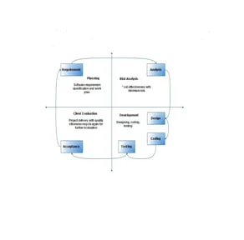

Reasons for Chosen Methodology
Reasoning for choosing VU Process Model
- Our project is divided into different phases that we have to complete and hand over to our manager.
- If any mistakes are found, he will suggest us to fix them and improve our project. This process will be adopted due to its spiral nature.
- The stage development cycle enforces discipline, every phase has a defined start and end point.
- So both models are suppressed in a single form and that will be our VU process model. It will give flawless result as each step is done in sequence

1.7.2 Work Plan (Gantt Chart)

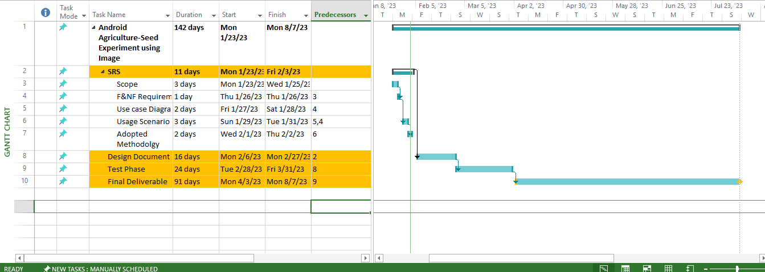

1.7.2 Project Schedule (Submission Calendar)
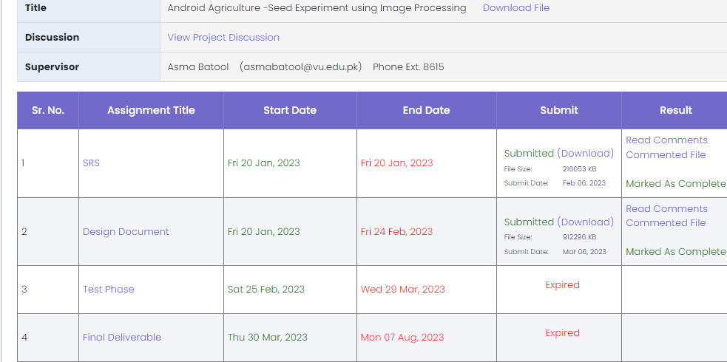

CHAPTER 2
Designing the Project

2.1 Introduction
A software design document (also known as a software design specification or technical specification documents) is a written report of a software product’s design, describing its overall architecture. A software design document helps ensure that the software design specifications are understood and clear to all. It specifies what is possible with the product and how it can be achieved. Software design documents not only help others understand the system and provide documentation for future projects, but also force us to think through the entire system architecture. Within the software design document are narrative and graphical documentation of the software design for the project including use
- Entity Relationship Diagram(ERD)
- Sequence Diagram
- Architecture Design Diagram
- Class Diagram
- Database Design
- Interface Design and
- Test case.

2.2 purpose

The purpose of a software design document is to provide a sufficiently complete description of the system design so that software development can proceed with an understanding of what is to be built and how it is expected to be built. A software design document provides the information necessary to provide a detailed description of the software and system to be built.

2.3 Scope A design document helps ensure that it is clear how to operate the system and provides expectations of what scale the system can achieve, how it is designed, and what performance can be expected. Design document can give any individuals answers without distracting anyone on the team. All major Design issue are discussed. Developers save a lot of time when all system functionality is captured and properly documented in a file.

2.5 Architectural Representation (Architecture Diagram)

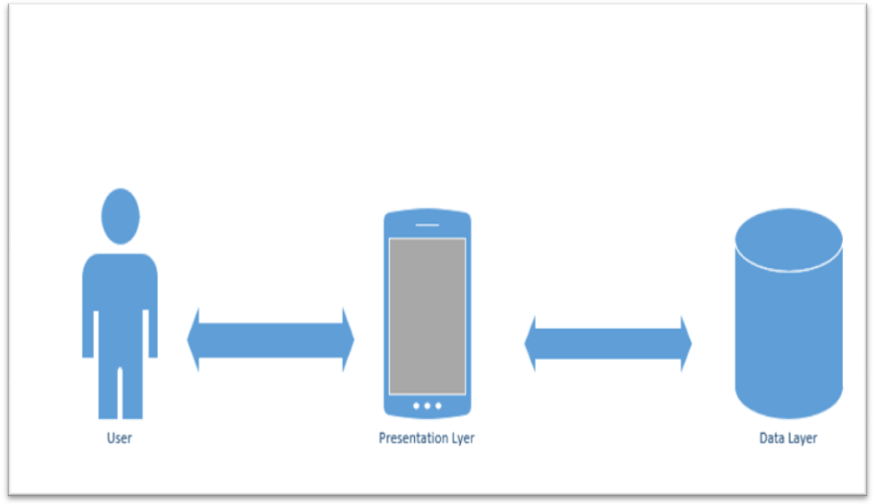

2.6 Dynamic Model: Sequence Diagrams
Use Case 1: User Logging In

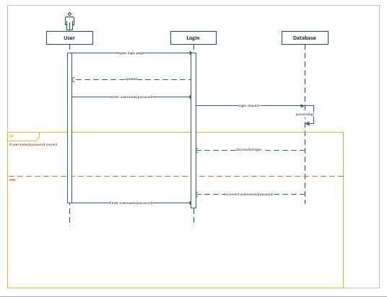

In Use Case 2: Taking a Picture of the Seed
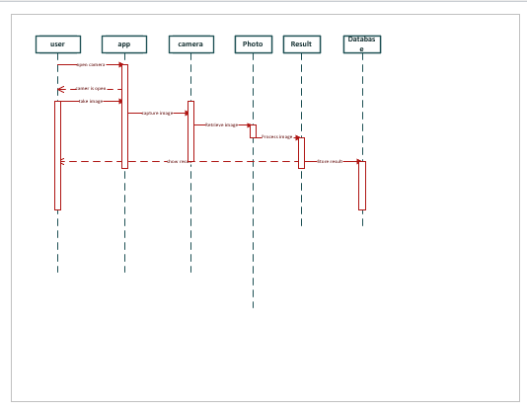

2.7 Object Model/Logical Model: Class Diagram

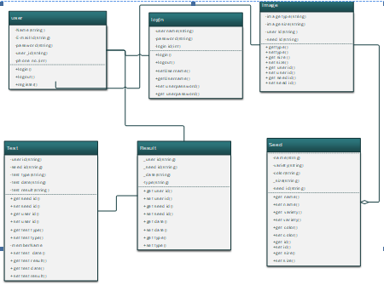

2.8 Database Model (Database Diagram)

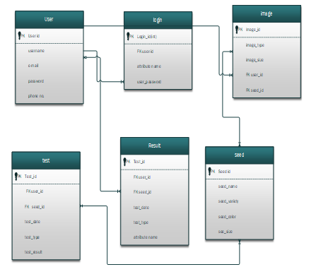

2.9 Graphical User Interfaces
Home Screen
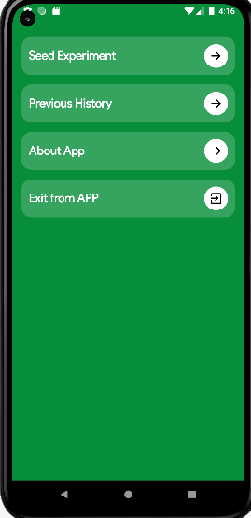
Main Screen
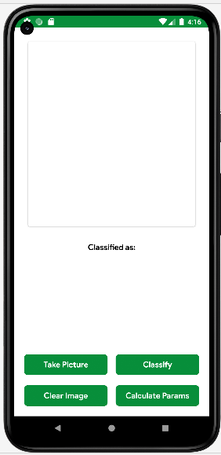

CHAPTER 3
Development

3.1 Development plan (Architecture Diagram)

