**Project Name: Hospital Management System**

**README file:**  Our project ‘Hospital Management System’ is based on database, html, css and php. We used XAMPP to keep records in the database. For the front end we used HTML and CSS. For the backend, we used PHP.

This system is dedicated for 3 types of user in the index page of the hospital named ABC Hospital Ltd. They are: Admin Login, User Login & Doctor Login.

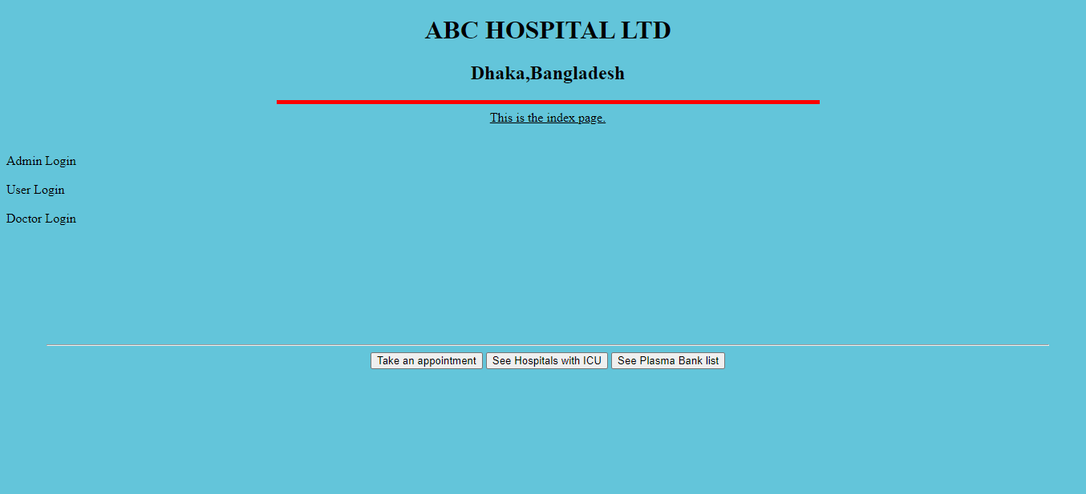

ADMIN LOGIN: If you click on the Admin Login panel it will lead you to a login page. Entering correct id and password will lead to another page where the admin can add or remove a doctor and a list of doctors otherwise it will show ‘Unsuccessful’. We wanted to add the patient feature in the admin panel but we already added the feature in the user login page.

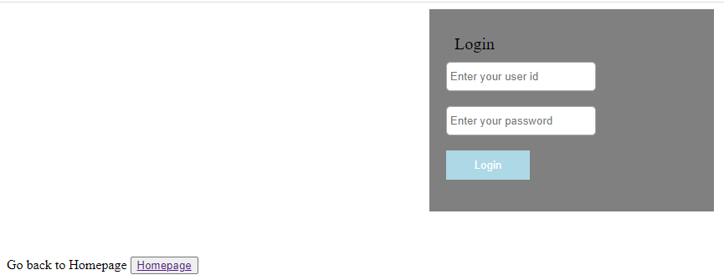

USER LOGIN: This feature is for the patients. Old patients can login and go to the index page. If new patient, then there’s a signup option.

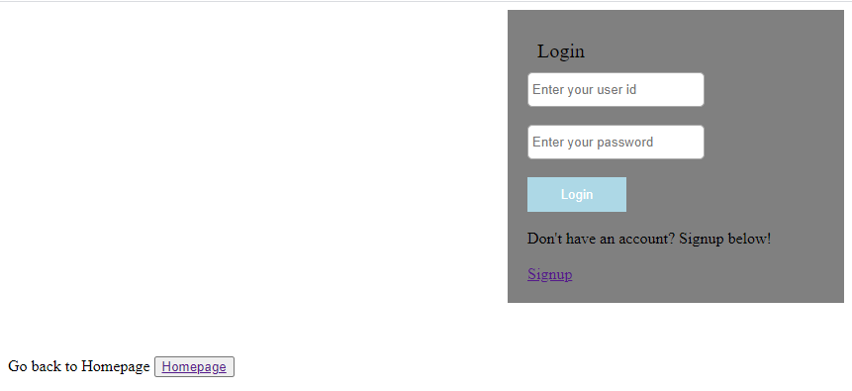

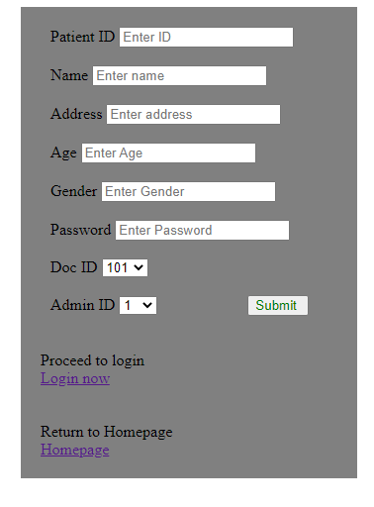

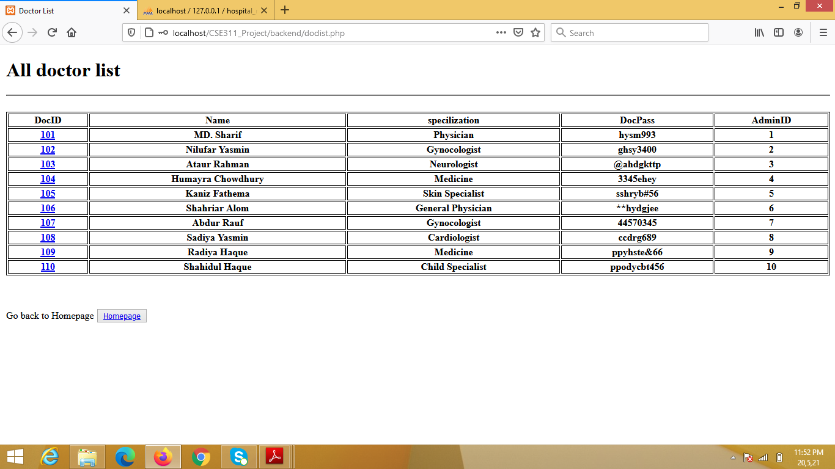

DOCTOR LOGIN: The doctors will login with id and password and will see the patient list.

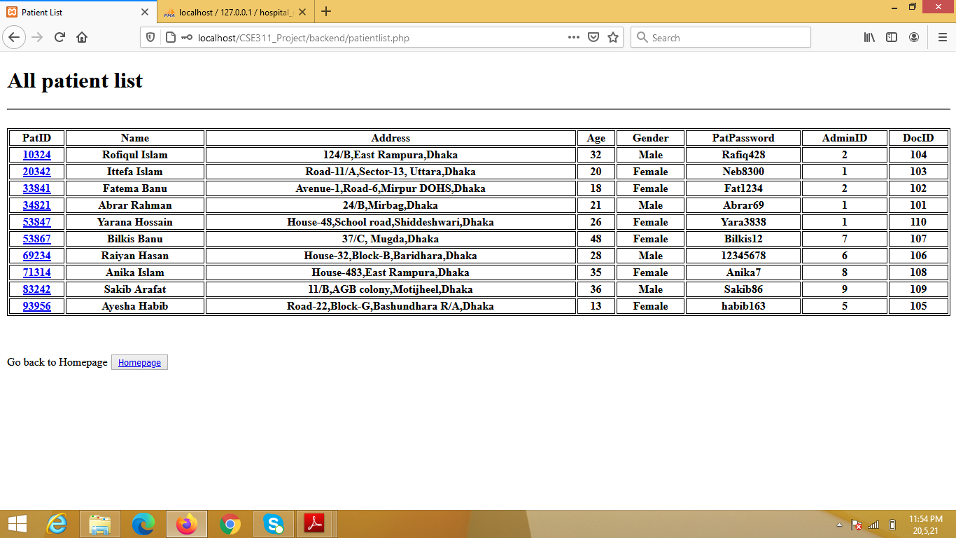

Also we have an option to go back to the homepage in all the login pages. In the index page we kept option named Take an appointment. Due to covid pandemic we wanted to add some extra feature: See Hospitals with ICU lists and Plasma bank lists. ’Take an appointment’ will lead to all the doctors list. ‘See Hospitals with ICU lists’ will lead to the available hospitals with ICU facilities and ‘Plasma bank lists’ will lead to the hospitals with available plasma banks.

