BOLTI KITAB (بولتی کتاب)
Phased System Architecture, Relational Schema Baseline & Operational Blueprint
Version 4.0 | Target Deployment: Microsoft Azure / Vultr
[MANDATE: Supervisor Architectural Directives & Guardrails] Working MVP first. Mobile app is the exclusive listening channel. Client web channel is storefront only (strictly no playback). Recording portal must be included. WebSockets required for real-time telemetry. Target Azure or Vultr (no AWS in Phase 1). PostgreSQL 16 approved baseline. Hardware requirements conservative and realistic across all phases. AI is explicitly Phase 2; CDN is explicitly Phase 3.

1. Executive Summary & Phased Strategy
Bolti Kitab (بولتی کتاب) is a dedicated streaming audiobook and spoken literature platform engineered specifically for Urdu and regional South Asian literature, poetry, and storytelling. The architecture bridges a massive digital and cultural gap: while millions of Urdu speakers seek high-quality spoken audiobooks, existing global platforms treat regional languages as secondary, lack localized payment integrations (e.g., JazzCash, EasyPaisa, regional cards), and do not provide dedicated recording and curation workflows for native voice artists.
To avoid premature optimization and excessive cloud spend, Bolti Kitab is built on a strict Three-Phase Evolution Roadmap: Phase 1 delivers a working MVP with mobile streaming, web storefront, recording studio, PostgreSQL 16, and direct cloud storage; Phase 2 introduces a contextual in-player AI companion with strict spoiler boundaries; and Phase 3 scales globally with edge CDN distribution, adaptive HLS ladders, and hardware DRM.
Figure 11: Bolti Kitab Three-Phase Evolution Strategy
Architecture Context: Strategic progression from working MVP to contextual AI and international edge distribution.
2. Supervisor Requirements & Architecture Guardrails
Every architectural decision in this document directly implements the supervisor's 14 explicit requirements:
# | Supervisor Requirement | Enforcement & Architectural Mapping
1 | Product: Bolti Kitab | Primary branding, database schemas, and API routes reflect Bolti Kitab (بولتی کتاب).
2 | Phase 1 Must Be a Working MVP | Focus strictly on core streaming, database, storage, payments, and recording workflows.
3 | Recording Portal Must Be Included | Built into the unified web portal (/studio) with Web Audio API recording, mic metering, and direct upload.
4 | Mobile App Must Be Included | Flutter mobile app for Android/iOS handles user library, offline session cache, and audio playback.
5 | Client Web Channel (Storefront Only) | Next.js SSR web storefront for catalog discovery, SEO, user registration, and book/subscription purchasing.
6 | Web Channel Must NOT Support Playback | Architectural constraint: No audio player components, media streaming endpoints, or stream tokens on the web.
7 | Mobile App is Exclusive Playback Channel | Playback Authorization Service issues streaming SAS tokens strictly to verified mobile client sessions.
8 | Phase 1 Must Include WebSockets | WebSocket hub (/ws/v1/channels) for studio telemetry, encoding alerts, catalog broadcast, and progress sync.
9 | Deployable on Azure or Vultr | Target Microsoft Azure (Azure Blob Storage, Flexible PostgreSQL) with exact mapping to Vultr.
10 | PostgreSQL 16 Approved Baseline | Authoritative relational database for identity, catalog, billing, and progress. DDL provided.
11 | Conservative Hardware Sizing | Realistic specifications separated into Minimum vs. Recommended across 6 operational environments.
12 | AI is NOT Part of Phase 1 Core | Whisper ASR, pgvector embeddings, and RAG companion strictly decoupled and scheduled for Phase 2.
13 | CDN is NOT Required for Phase 1 | No edge CDN PoPs. Clients stream directly from Cloud Object Storage via secure, time-limited SAS tokens.
14 | Phased Architectural Evolution | System boundaries, network topologies, and data flows defined across three distinct phases.

3. Product Scope & Functional Decomposition
Bolti Kitab provides a cohesive digital ecosystem connecting listeners, narrators, content moderators, and administrators. Four primary personas govern the platform: Listeners (mobile-only streaming, purchases, offline cache), Narrators (web recording studio, mic metering, multi-take submissions), Reviewers/Editors (audio quality review queue, ffprobe metrics, chapter binding), and Administrators (user management, plan pricing, catalog activation).
4. Phase 1 MVP Scope & System Boundaries
The Phase 1 MVP delivers an end-to-end commercial platform while strictly enforcing four architectural boundaries: (1) Mobile-only listening; (2) Direct cloud storage streaming without backend audio proxying; (3) Unified web portal using RBAC; and (4) Zero CDN and zero AI.
Figure 1: Phase 1 System Context Diagram
Architecture Context: External actors, client applications, reverse proxy ingress, and cloud storage boundaries.
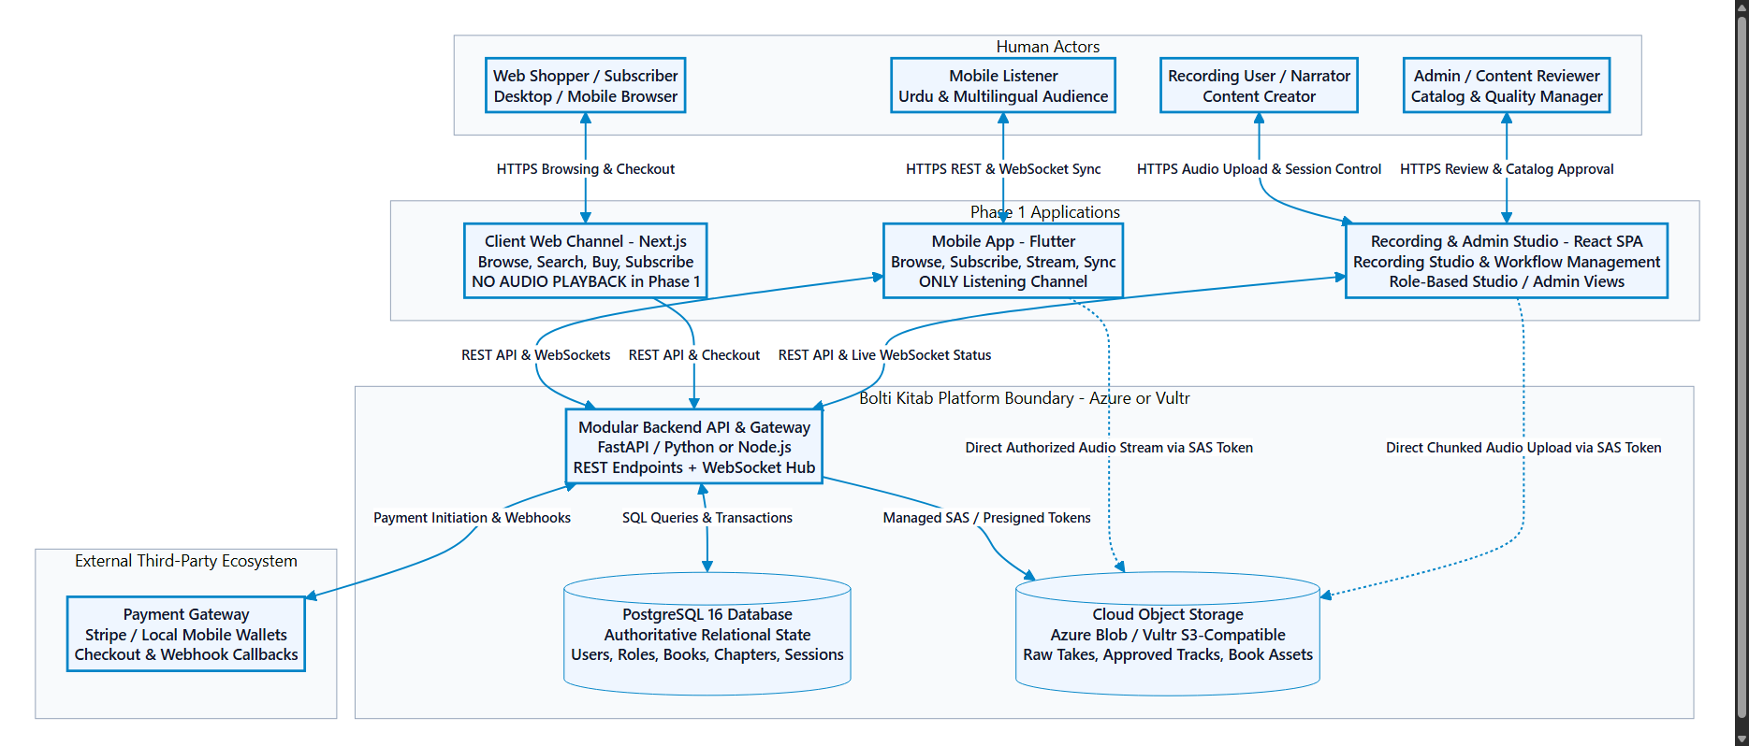
5. Phase 1 Applications
Client Portfolio: Phase 1 comprises three purpose-built client applications:
- Flutter Mobile Application (Exclusive Playback): Native audio engine (just_audio, audio_service), background lockscreen controls, local resume cache (Hive), and direct cloud storage streaming.
- Client Web Channel (Next.js Storefront): Server-side rendered book catalog, author biographies, shopping cart, and hosted payment gateway checkout. Explicitly contains NO audio player.
- Unified Recording & Admin Portal (React / Tailwind): Single deployed web application with role-based UI. Renders Recording Studio for narrators and Moderation Console for editors/admins.
6. Phase 1 Complete System Architecture
The complete system architecture is organized into four clean tiers: Presentation Tier (Mobile, Web Storefront, Unified Portal), Ingress Tier (Caddy/Nginx reverse proxy), Modular Backend Tier (FastAPI/Node.js application services), and Data Tier (PostgreSQL 16 & Cloud Object Storage).
Figure 2: Phase 1 Complete System Architecture
Architecture Context: End-to-end multi-tier system topology illustrating direct streaming and persistence connections.
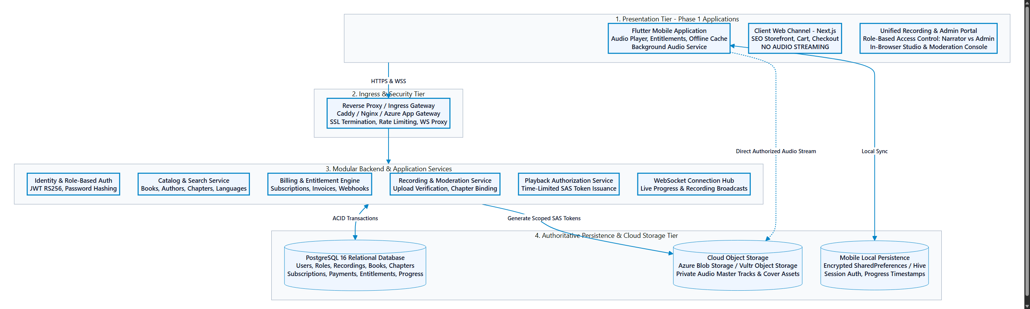
7. Recording Portal Architecture & Audio Ingestion Flow
The Recording Portal (/studio) provides in-browser recording via the Web Audio API, real-time mic volume metering, take management, and direct chunked audio upload using write-scoped SAS tokens. An automated background job executes ffprobe to verify duration, sample rate (44.1 kHz), and channel count before content moderators approve takes and publish them to the catalog.
Figure 3: Recording Portal to Storage and Catalog Flow
Architecture Context: Three-step ingestion workflow: Session Initialization, Take Upload, and Admin Review & Chapter Binding.
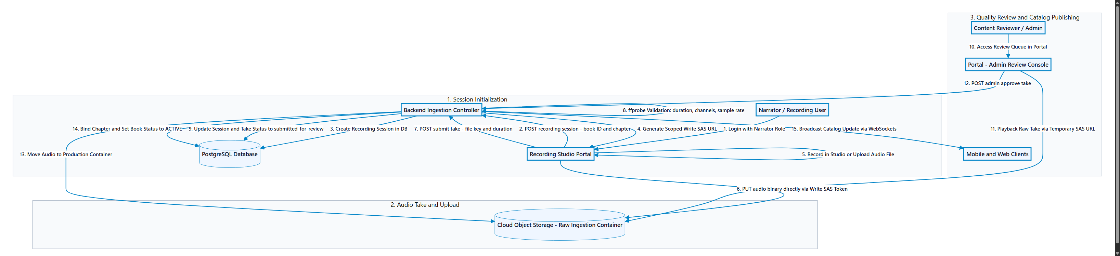
8. Client Web Channel (Storefront & Purchase Only)
The Client Web Channel is an explicit commercial storefront. Users browse books, review synopsis and narrator details, and initiate hosted checkout sessions via Stripe or local mobile wallets (JazzCash, EasyPaisa). Upon payment completion, the confirmation screen directs users to stream on the mobile app.
Figure 4: Client Web Purchase Flow
Architecture Context: Sequence diagram illustrating browse, checkout session creation, hosted gateway payment, and entitlement grant.
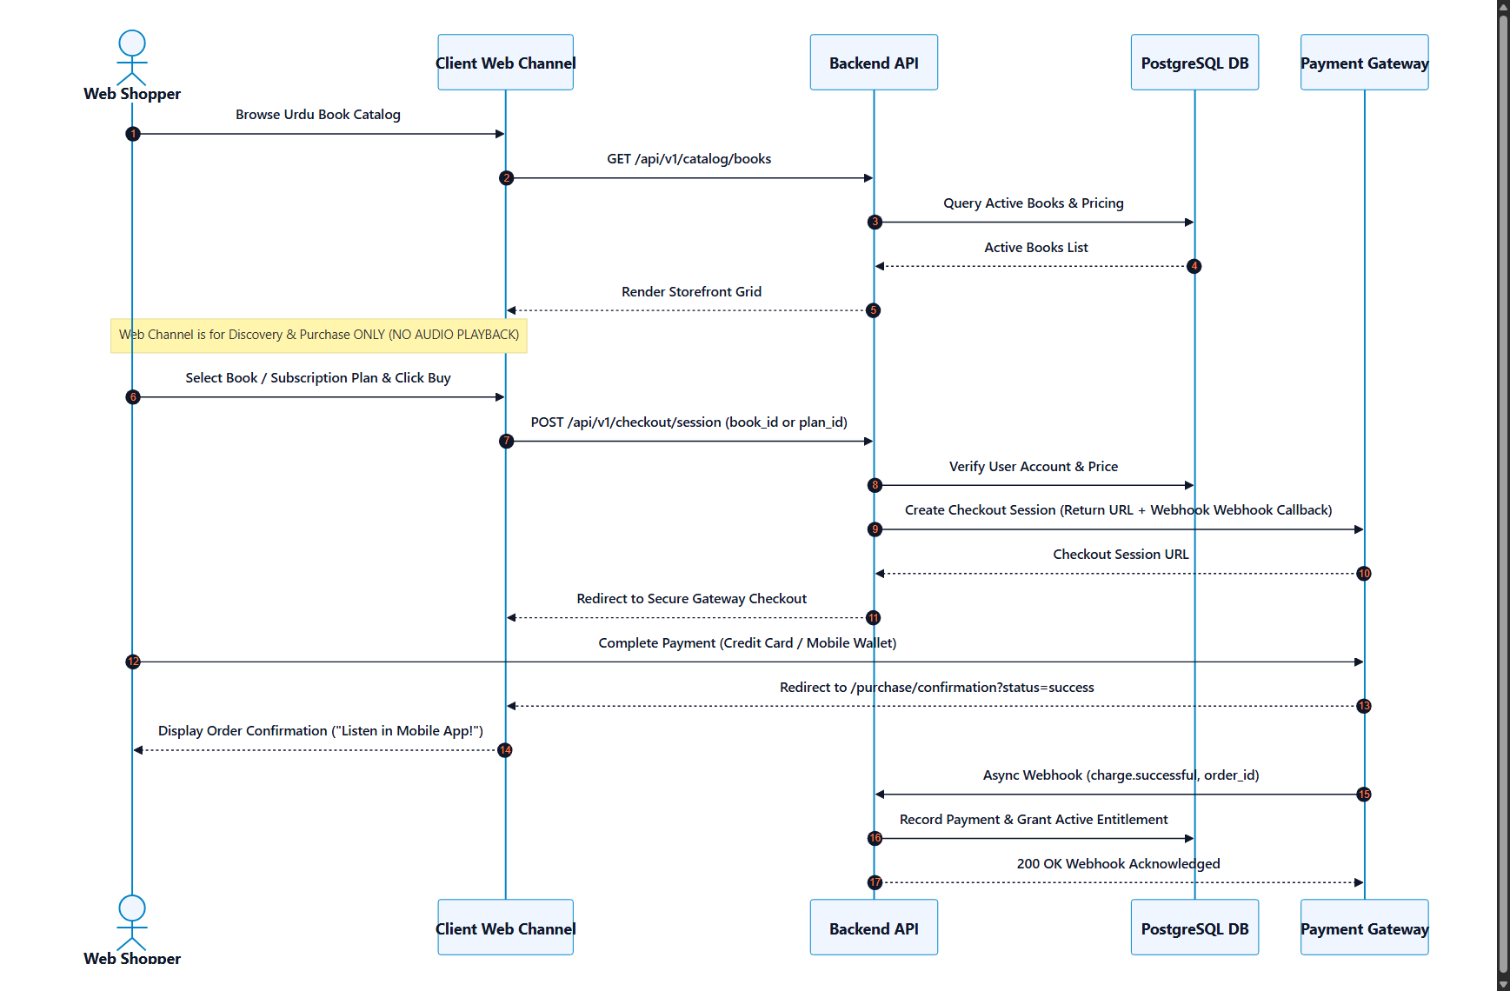
9. Mobile Application Architecture (Exclusive Playback Client)
The Flutter mobile application exclusively handles audio listening. When the user taps play, the mobile client requests a streaming token from /api/v1/playback/token. The backend verifies active entitlements and returns a 60-minute time-limited SAS streaming URL. The mobile player streams audio bytes directly from Azure Blob Storage / Vultr Object Storage via HTTP Range requests. Progress is synchronized every 10–15 seconds.
Figure 5: Mobile Playback Flow
Architecture Context: Direct streaming pattern: Backend authorizes and issues SAS token; mobile client streams directly from cloud storage origin.
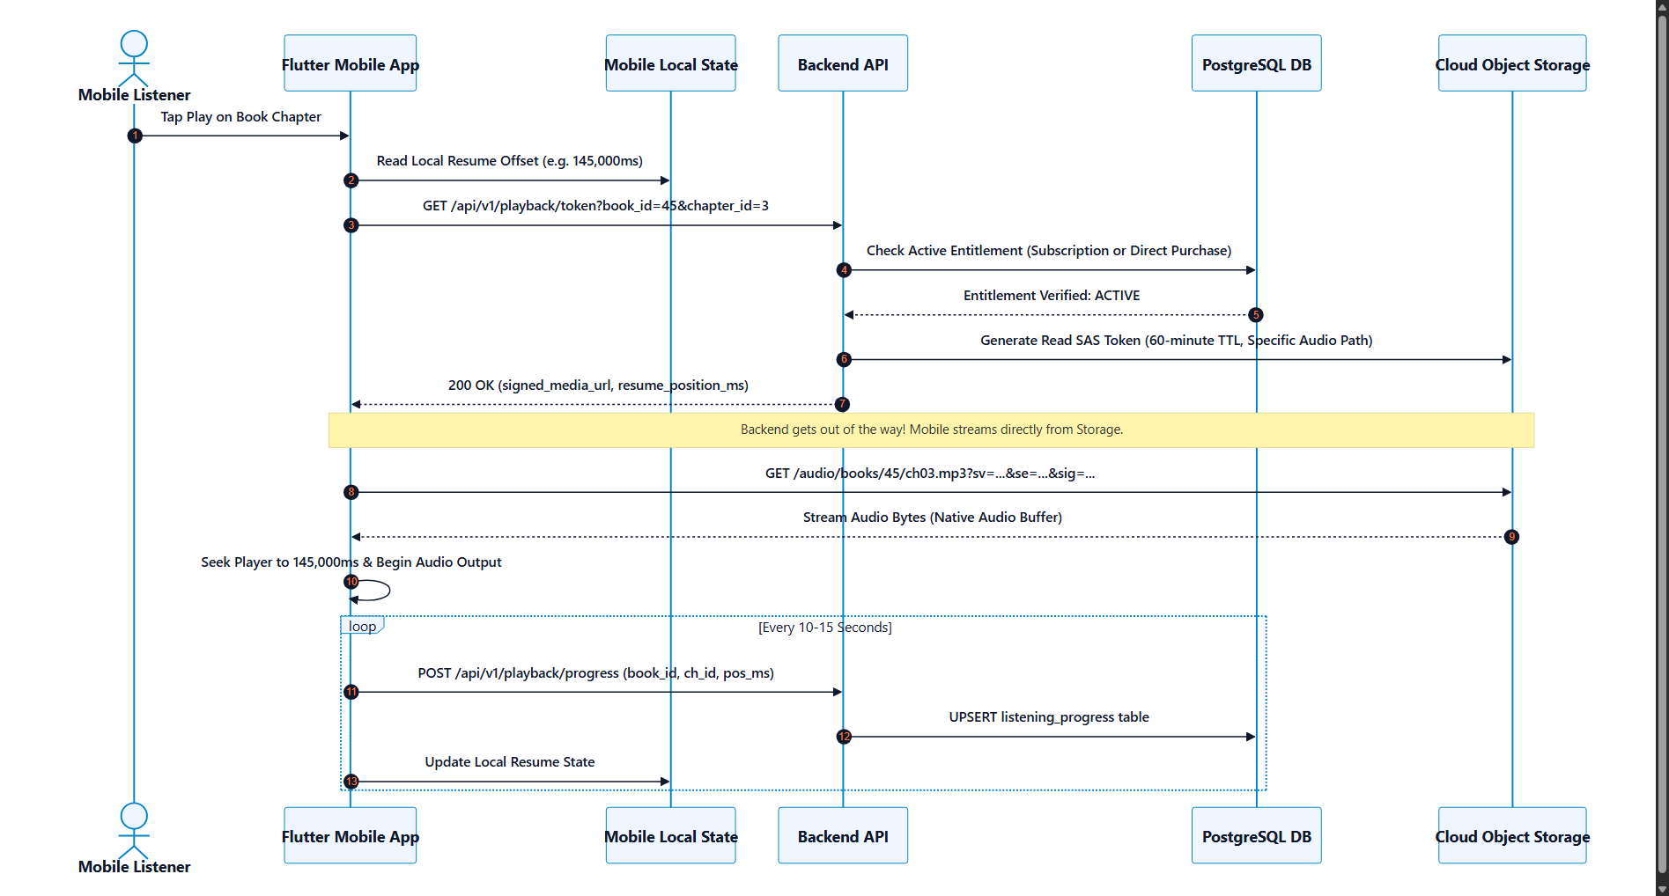
10. Backend Architecture & Core API Design
The backend is structured as a high-performance Modular Monolith (FastAPI / Node.js). Key modules include Auth (RS256 JWT, Argon2id), Catalog (books, chapters), Billing (checkout sessions, webhooks, entitlements), Recordings (sessions, takes, ffprobe inspection), Playback (SAS token issuance), and WebSocket Hub (real-time telemetry).
11. Database Architecture & Initial Phase 1 Relational Schema Baseline
PostgreSQL 16 is the authoritative relational database engine. The schema enforces strict foreign key relationships, check constraints, and performance indexes.
Figure 8: Phase 1 Database and Data Model (ERD)
Architecture Context: Entity Relationship Diagram modeling users, roles, books, chapters, recordings, payments, and progress.
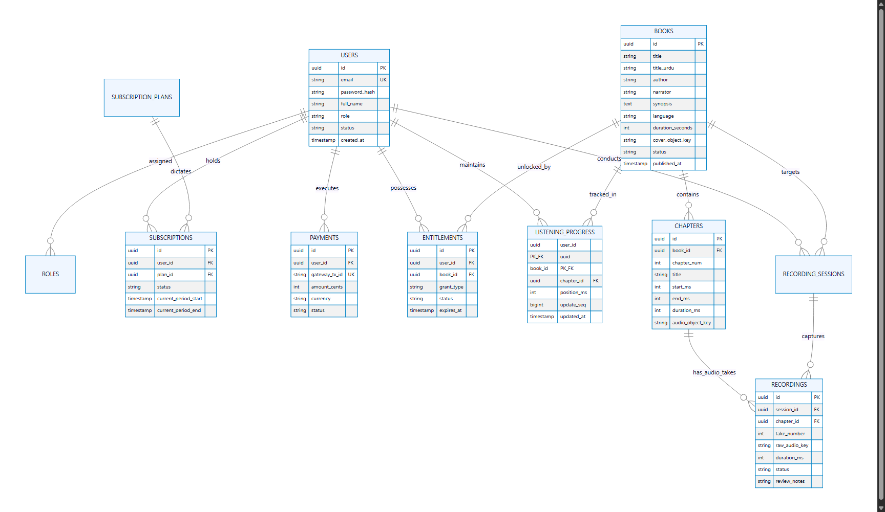
Implementation Baseline: Initial Phase 1 PostgreSQL 16 DDL Baseline:
-- BOLTI KITAB (بولتی کتاب) - PHASE 1 RELATIONAL SCHEMA BASELINE
CREATE EXTENSION IF NOT EXISTS "uuid-ossp";
CREATE TABLE users (
id UUID PRIMARY KEY DEFAULT uuid_generate_v4(),
email VARCHAR(255) NOT NULL UNIQUE,
password_hash VARCHAR(255) NOT NULL,
full_name VARCHAR(128) NOT NULL,
role VARCHAR(32) NOT NULL DEFAULT 'listener'
CHECK (role IN ('listener', 'narrator', 'editor', 'admin')),
status VARCHAR(32) NOT NULL DEFAULT 'active'
CHECK (status IN ('active', 'suspended', 'pending_verification')),
created_at TIMESTAMPTZ NOT NULL DEFAULT CURRENT_TIMESTAMP,
updated_at TIMESTAMPTZ NOT NULL DEFAULT CURRENT_TIMESTAMP
);
CREATE TABLE books (
id UUID PRIMARY KEY DEFAULT uuid_generate_v4(),
title VARCHAR(255) NOT NULL,
title_urdu VARCHAR(255) NOT NULL,
author VARCHAR(128) NOT NULL,
narrator_name VARCHAR(128) NOT NULL,
synopsis TEXT,
language VARCHAR(32) NOT NULL DEFAULT 'ur' CHECK (language IN ('ur', 'en', 'pa', 'sd')),
duration_seconds INTEGER NOT NULL DEFAULT 0,
price_cents INTEGER NOT NULL DEFAULT 0,
currency VARCHAR(8) NOT NULL DEFAULT 'PKR',
cover_object_key VARCHAR(512),
status VARCHAR(32) NOT NULL DEFAULT 'draft'
CHECK (status IN ('draft', 'in_recording', 'in_review', 'active', 'archived')),
published_at TIMESTAMPTZ,
created_at TIMESTAMPTZ NOT NULL DEFAULT CURRENT_TIMESTAMP
);
CREATE TABLE chapters (
id UUID PRIMARY KEY DEFAULT uuid_generate_v4(),
book_id UUID NOT NULL REFERENCES books(id) ON DELETE CASCADE,
chapter_num INTEGER NOT NULL,
title VARCHAR(255) NOT NULL,
title_urdu VARCHAR(255),
start_ms INTEGER NOT NULL DEFAULT 0,
end_ms INTEGER NOT NULL DEFAULT 0,
duration_ms INTEGER NOT NULL DEFAULT 0,
audio_object_key VARCHAR(512),
is_preview_free BOOLEAN NOT NULL DEFAULT FALSE,
status VARCHAR(32) NOT NULL DEFAULT 'pending'
CHECK (status IN ('pending', 'recorded', 'approved', 'rejected')),
created_at TIMESTAMPTZ NOT NULL DEFAULT CURRENT_TIMESTAMP,
CONSTRAINT uq_book_chapter_num UNIQUE (book_id, chapter_num)
);
CREATE TABLE recording_sessions (
id UUID PRIMARY KEY DEFAULT uuid_generate_v4(),
narrator_id UUID NOT NULL REFERENCES users(id),
book_id UUID NOT NULL REFERENCES books(id),
chapter_id UUID NOT NULL REFERENCES chapters(id),
status VARCHAR(32) NOT NULL DEFAULT 'in_progress'
CHECK (status IN ('in_progress', 'completed', 'abandoned')),
notes TEXT,
created_at TIMESTAMPTZ NOT NULL DEFAULT CURRENT_TIMESTAMP
);
CREATE TABLE recordings (
id UUID PRIMARY KEY DEFAULT uuid_generate_v4(),
session_id UUID NOT NULL REFERENCES recording_sessions(id) ON DELETE CASCADE,
chapter_id UUID NOT NULL REFERENCES chapters(id),
take_number INTEGER NOT NULL DEFAULT 1,
raw_audio_key VARCHAR(512) NOT NULL,
duration_ms INTEGER NOT NULL DEFAULT 0,
file_size_bytes BIGINT NOT NULL DEFAULT 0,
sample_rate_hz INTEGER NOT NULL DEFAULT 44100,
channels INTEGER NOT NULL DEFAULT 2,
status VARCHAR(32) NOT NULL DEFAULT 'submitted_for_review'
CHECK (status IN ('uploading', 'submitted_for_review', 'approved', 'rejected')),
review_notes TEXT,
reviewed_by UUID REFERENCES users(id),
reviewed_at TIMESTAMPTZ,
created_at TIMESTAMPTZ NOT NULL DEFAULT CURRENT_TIMESTAMP,
CONSTRAINT uq_session_take UNIQUE (session_id, take_number)
);
CREATE TABLE subscription_plans (
id UUID PRIMARY KEY DEFAULT uuid_generate_v4(),
name VARCHAR(64) NOT NULL,
billing_interval VARCHAR(16) NOT NULL CHECK (billing_interval IN ('monthly', 'annual')),
price_cents INTEGER NOT NULL,
currency VARCHAR(8) NOT NULL DEFAULT 'PKR',
is_active BOOLEAN NOT NULL DEFAULT TRUE,
created_at TIMESTAMPTZ NOT NULL DEFAULT CURRENT_TIMESTAMP
);
CREATE TABLE subscriptions (
id UUID PRIMARY KEY DEFAULT uuid_generate_v4(),
user_id UUID NOT NULL REFERENCES users(id) ON DELETE CASCADE,
plan_id UUID NOT NULL REFERENCES subscription_plans(id),
status VARCHAR(32) NOT NULL DEFAULT 'active'
CHECK (status IN ('active', 'past_due', 'canceled', 'expired')),
gateway_subscription_id VARCHAR(128),
current_period_start TIMESTAMPTZ NOT NULL,
current_period_end TIMESTAMPTZ NOT NULL,
created_at TIMESTAMPTZ NOT NULL DEFAULT CURRENT_TIMESTAMP
);
CREATE TABLE payments (
id UUID PRIMARY KEY DEFAULT uuid_generate_v4(),
user_id UUID NOT NULL REFERENCES users(id),
gateway VARCHAR(32) NOT NULL CHECK (gateway IN ('stripe', 'jazzcash', 'easypaisa', 'manual')),
gateway_tx_id VARCHAR(128) NOT NULL UNIQUE,
amount_cents INTEGER NOT NULL,
currency VARCHAR(8) NOT NULL DEFAULT 'PKR',
status VARCHAR(32) NOT NULL CHECK (status IN ('pending', 'succeeded', 'failed', 'refunded')),
created_at TIMESTAMPTZ NOT NULL DEFAULT CURRENT_TIMESTAMP
);
CREATE TABLE entitlements (
id UUID PRIMARY KEY DEFAULT uuid_generate_v4(),
user_id UUID NOT NULL REFERENCES users(id) ON DELETE CASCADE,
book_id UUID NOT NULL REFERENCES books(id) ON DELETE CASCADE,
grant_type VARCHAR(32) NOT NULL CHECK (grant_type IN ('subscription', 'direct_purchase', 'promotional')),
status VARCHAR(32) NOT NULL DEFAULT 'active' CHECK (status IN ('active', 'revoked', 'expired')),
expires_at TIMESTAMPTZ,
created_at TIMESTAMPTZ NOT NULL DEFAULT CURRENT_TIMESTAMP,
CONSTRAINT uq_user_book_entitlement UNIQUE (user_id, book_id)
);
CREATE TABLE listening_progress (
user_id UUID NOT NULL REFERENCES users(id) ON DELETE CASCADE,
book_id UUID NOT NULL REFERENCES books(id) ON DELETE CASCADE,
chapter_id UUID NOT NULL REFERENCES chapters(id),
position_ms INTEGER NOT NULL DEFAULT 0,
update_seq BIGINT NOT NULL DEFAULT 1,
is_completed BOOLEAN NOT NULL DEFAULT FALSE,
updated_at TIMESTAMPTZ NOT NULL DEFAULT CURRENT_TIMESTAMP,
PRIMARY KEY (user_id, book_id)
);
CREATE INDEX idx_books_status_lang ON books(status, language);
CREATE INDEX idx_chapters_book_num ON chapters(book_id, chapter_num);
CREATE INDEX idx_recordings_review_queue ON recordings(status) WHERE status = 'submitted_for_review';
CREATE INDEX idx_entitlements_user_active ON entitlements(user_id, status) WHERE status = 'active';

12. Object Storage Architecture (Direct Streaming, Azure Blob vs Vultr)
Under Direct Storage Streaming, the backend validates user entitlements and generates a 60-minute time-limited SAS token (Azure) or presigned URL (Vultr) in under 15ms. The mobile application connects directly to storage origin via HTTPS Range requests. Backend application servers never proxy audio bytes, preventing bandwidth bottlenecks.
13. Authentication, Authorization & Security Architecture
Security is enforced via RS256 JWT tokens containing user role claims (listener, narrator, editor, admin). Passwords are hashed using Argon2id. Client-side routing and backend middleware enforce strict role boundaries in the unified web portal.
14. Payment Gateway & Entitlement System Architecture
The billing engine supports subscriptions and individual book purchases. Hosted checkouts handle sensitive payment processing. Gateway webhooks are verified via cryptographic HMAC signatures and processed with strict database idempotency guards.
Figure 6: Payment and Entitlement Flow
Architecture Context: End-to-end payment lifecycle: checkout initiation, hosted UI payment, webhook verification, and entitlement unlock.
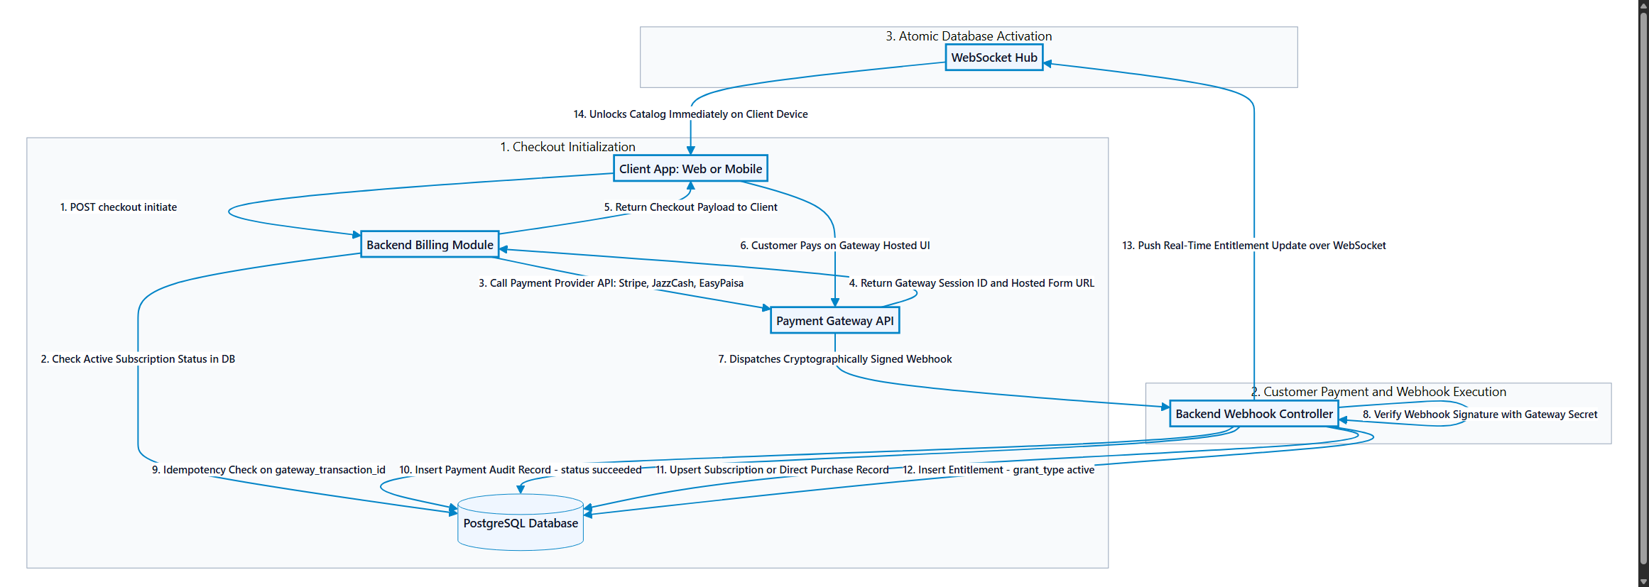
15. WebSocket Communication & Real-Time State Management
Phase 1 includes a WebSocket hub (/ws/v1/channels) supporting four specific real-time use cases: (1) Studio Live Recording Status and peak audio level telemetry; (2) Ingestion and automated ffprobe audio validation alerts; (3) Admin catalog publication broadcasting; and (4) Cross-device listening progress synchronization.
Figure 7: Phase 1 WebSocket Communication Flow
Architecture Context: Client channels, reverse proxy upgrade, and backend real-time event distribution.
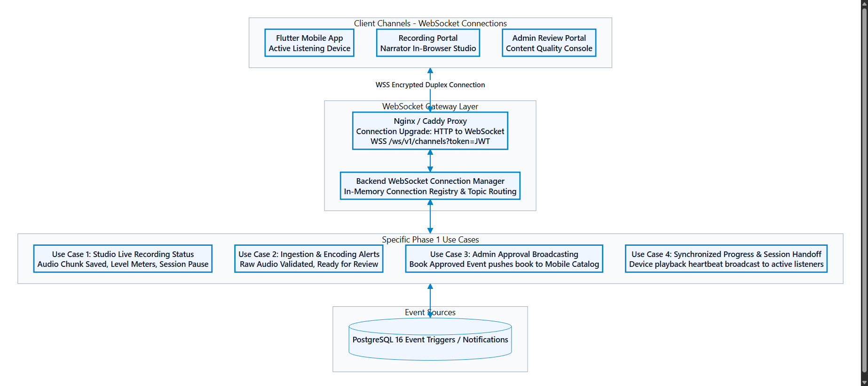
16. Phase 2 AI & RAG Architecture (Intelligent Product)
Phase 2 introduces the In-Player AI Companion. Master audio is transcribed offline using Urdu Whisper ASR with word-level timestamps. Chunks (200–300 tokens) are indexed in PostgreSQL 16 using pgvector HNSW indexes. To guarantee zero narrative spoilers, retrieval enforces a strict SQL boundary: end_ms <= user_position_ms. Boundary crossing chunks are dynamically truncated at the exact word timestamp before passing to the LLM.
Figure 9: Phase 2 AI and RAG Architecture
Architecture Context: Offline transcription and vector indexing pipeline paired with strict spoiler-mitigated online retrieval.
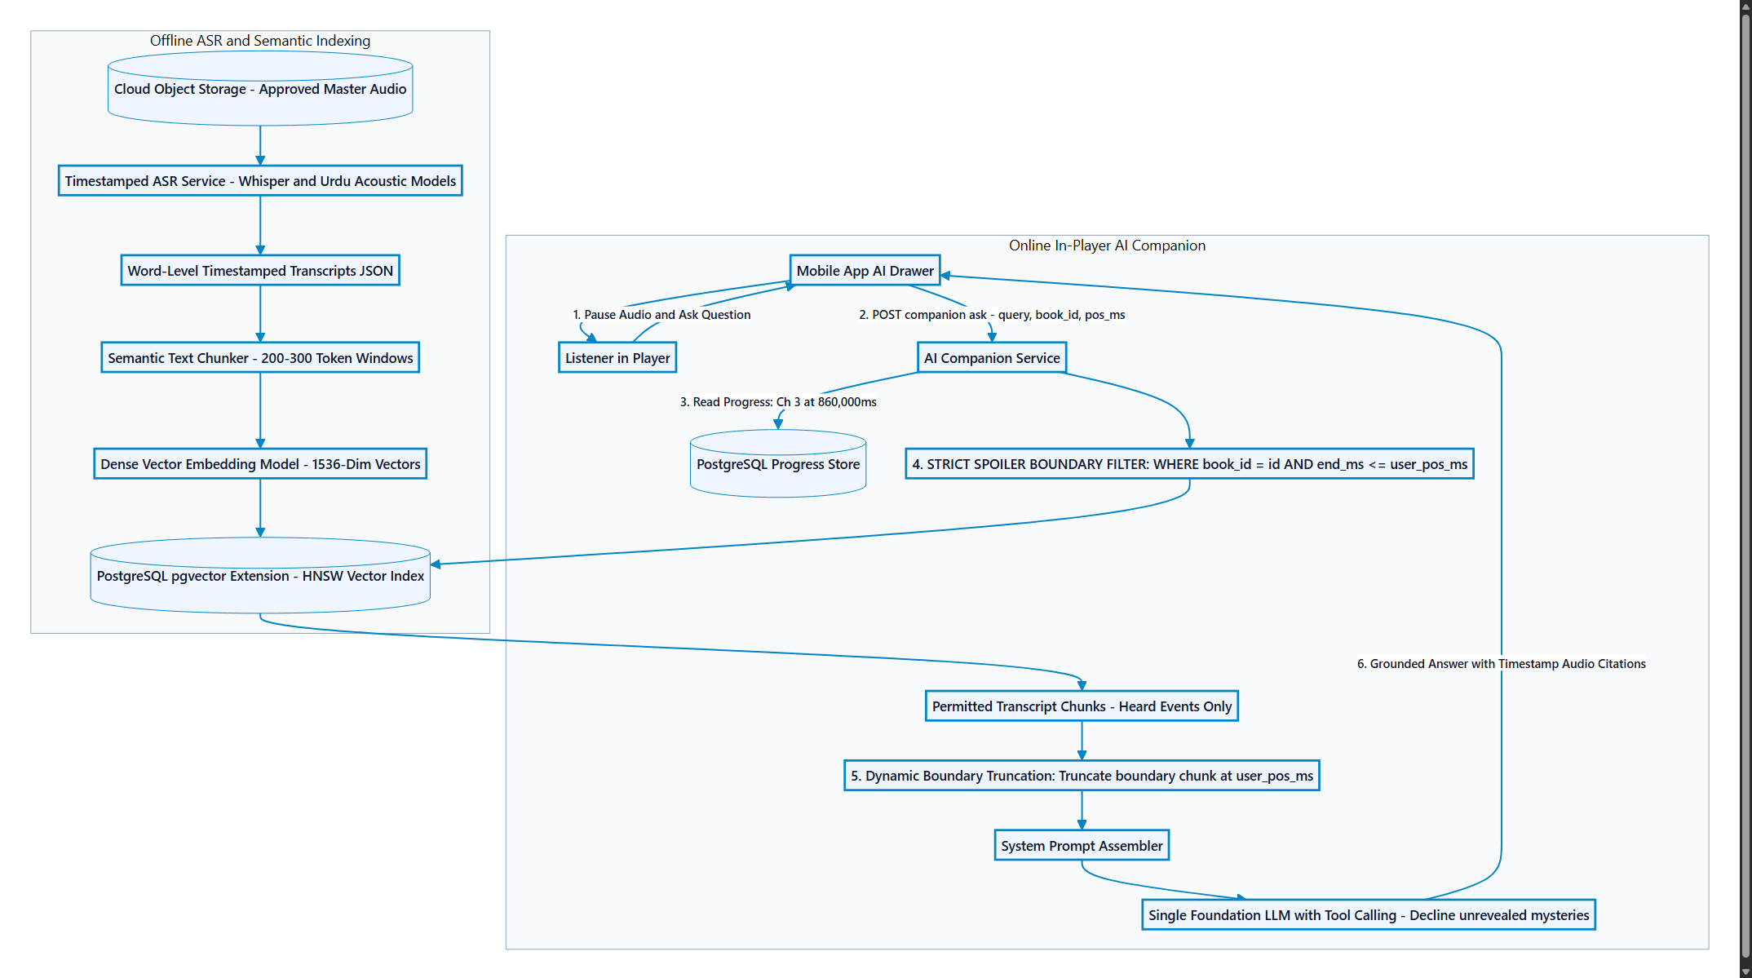
17. Phase 3 Production Scale & Enterprise Distribution
Phase 3 scales Bolti Kitab for hundreds of thousands of concurrent listeners: Global Edge CDN with asymmetric signed cookies, multi-bitrate adaptive HLS transcoding (32k, 64k, 128k AAC), horizontally auto-scaled container pods, PostgreSQL Multi-AZ with read replicas, and commercial hardware DRM (Widevine & FairPlay).
Figure 10: Phase 3 Production Architecture
Architecture Context: Global edge distribution, automated transcoding ladder, and enterprise-grade high availability.
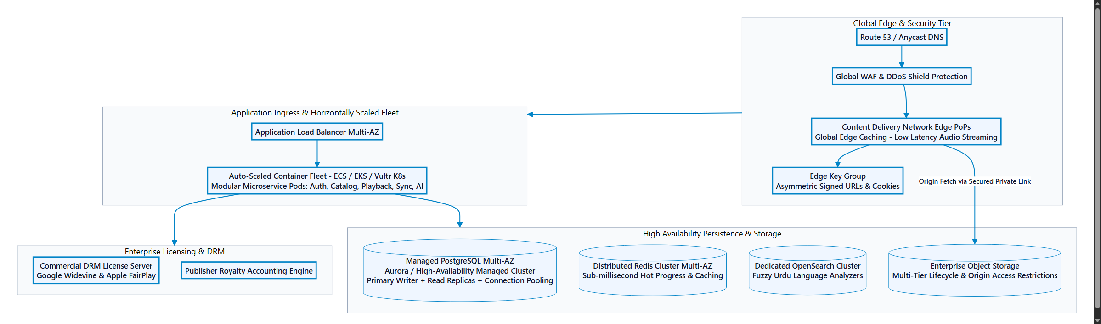
18. Cloud Platform Evaluation & Deployment Matrix (Azure vs Vultr)
Comparison between Microsoft Azure (primary enterprise target) and Vultr (portable low-cost target):
Dimension | Microsoft Azure (Recommended) | Vultr (Budget Alternative) | Architectural Decision
Object Storage | Azure Blob Storage (Hot Tier) with native SAS tokens | Vultr Object Storage (S3 API) with presigned URLs | Azure Recommended for granular SAS scoping.
Relational DB | Azure Database for PostgreSQL Flexible Server | Vultr Managed Databases for PostgreSQL | Azure Recommended for parameter tuning & scaling.
Compute / Ingress | Azure Container Apps / App Service | Vultr Cloud Compute (VC2) + Caddy Proxy | Tie. Azure simplifies ops; Vultr is cost-effective.
WebSocket | Direct WS on Container Apps or Web PubSub | Direct WSS on Caddy reverse proxy | Direct WS on reverse proxy selected for Phase 1.
Outbound Bandwidth | $0.087 / GB egress after 100 GB/mo free | 1 TB to 5 TB free egress included per instance | Vultr advantage on bandwidth.
Phase 1 Cost | ~$65 - $95 / month | ~$32 - $48 / month | Vultr is 50% cheaper; Azure provides enterprise SLA.

19. Hardware Requirements & Sizing
Conservative, realistic hardware sizing across six operational environments:
Environment | Minimum Specification (Bootstrap) | Recommended Specification (Resilience)
1. Local Dev Workstation | 4 Cores, 8 GB RAM, 256 GB NVMe, Docker, Flutter SDK | 8 Cores, 16-32 GB RAM, 512 GB-1 TB NVMe SSD
2. Studio Recording Hardware | USB Condenser Mic (AT2020USB+), Laptop, Headphones | XLR Mic (Rode NT1-A), Focusrite 2i2, Vocal Booth, MDR-7506
3. CI/CD Build Server | GitHub-Hosted Runner (2 vCPU, 7 GB RAM, 14 GB SSD) | Dedicated Runner (4 vCPU, 8 GB RAM, 50 GB NVMe SSD)
4. Staging Cloud Server | 2 vCPU, 4 GB RAM, 40 GB NVMe (Docker Compose) | 2-4 vCPU, 8 GB RAM, 80 GB NVMe SSD
5. MVP Production Cloud | 1 vCPU, 2 GB RAM (App) + B1ms PostgreSQL + 100 GB Blob | 2 vCPU, 4 GB RAM (App) + B2s PostgreSQL + 500 GB Blob
6. Phase 2 AI Companion Node | 4 vCPU, 16 GB RAM (CPU Whisper) + 2 vCPU pgvector | 1x NVIDIA T4/L4 GPU (16 GB VRAM) + 4 vCPU, 16 GB pgvector

20. Technical Risks, Failure Modes & Mitigation Strategies
Risk mitigation matrix for direct streaming, token expiration, uploads, webhooks, and AI spoilers:
Failure Mode / Risk | Impact | Architectural Mitigation Strategy
Direct Streaming SAS Expiration | High | Mobile app proactively requests fresh SAS token if under 5 minutes remain.
Narrator Upload Dropout | Medium | Studio portal uses chunked uploads with local IndexedDB take caching.
Origin Bandwidth Saturation | High | Conservative 64 kbps AAC encoding; storage origin provides 60 MB/s per object.
Payment Webhook Replay / Drop | High | Cryptographic HMAC verification + strict DB idempotency checks on gateway_tx_id.
WebSocket Connection Leak | Medium | Heartbeat ping/pong every 30s; inactive sockets auto-terminated after 60s.
LLM Spoiler Leaks (Phase 2) | Critical | Hard SQL boundary (end_ms <= position_ms) + dynamic word-level boundary truncation.

21. Architecture Decision Records (ADRs)
- ADR-001: Mobile-Only Playback Boundary in Phase 1: Restrict playback exclusively to Flutter mobile app; remove all audio players and streaming tokens from web channel.
- ADR-002: Direct Cloud Storage Streaming via Time-Limited Tokens: Backend authorizes access and issues 60-min SAS URLs; mobile streams directly from storage origin (no backend proxy).
- ADR-003: Unified Web Application for Recording and Administration: Deploy a single web app with RBAC: /studio for narrators, /admin for editors/reviewers. Consolidates build pipelines.
- ADR-004: Native PostgreSQL 16 as Single Database Engine: Use PostgreSQL 16 for all relational data; prepare schema for Phase 2 pgvector extension.
- ADR-005: Deferral of CDN and Multi-Bitrate HLS to Phase 3: Stream MP3/AAC directly from cloud storage origin. Defer edge CDN PoPs and HLS ladders to Phase 3.
- ADR-006: Deferral of AI and Vector Indexing to Phase 2: Exclude Whisper transcription, embeddings, and RAG Q&A from Phase 1. Focus on core streaming MVP.
- ADR-007: Strict Spoiler Retrieval Boundary and Dynamic Boundary Truncation: Enforce end_ms <= position_ms at database retrieval, combined with word-level boundary chunk slicing.
- ADR-008: Selection of Azure as Primary Cloud Target with Vultr Portability: Target Azure Blob and Flexible PostgreSQL primarily; maintain abstracted storage adapter for Vultr portability.
22. Sequential Engineering Implementation Roadmap
The engineering implementation plan follows an 8-sprint sequence starting directly from the database schema:
- Sprint 1 (Days 1–5): PostgreSQL 16 Relational Schema Baseline & Migrations: Execute DDL, seed roles, catalog, and admin account.
- Sprint 2 (Days 6–9): Cloud Storage Setup & Direct SAS Service: Provision private containers; build write/read SAS token generators.
- Sprint 3 (Days 10–14): Authentication, RBAC & Core API Layer: Argon2id hashing, RS256 JWT lifecycle, REST catalog endpoints.
- Sprint 4 (Days 15–20): Recording Portal Studio & Moderation: Web Audio API recording, ffprobe inspection, Admin Review Console.
- Sprint 5 (Days 21–28): Flutter Mobile App Playback Engine: just_audio integration, direct storage streaming, Hive local state.
- Sprint 6 (Days 29–35): Client Web Storefront & Payments: Next.js storefront, Stripe/JazzCash checkouts, webhook entitlement activation.
- Sprint 7 (Days 36–40): WebSocket Gateway Hub: /ws/v1/channels connection manager for studio telemetry and catalog broadcasts.
- Sprint 8 (Days 41–45): Integration Testing & Production Deployment: End-to-end user flows, audio validation, Azure/Vultr deployment.

