BLASTp Homology Analysis Report: Characterization of Synphilin-1
Date: June 10, 2026
Course: Bioinformatics (task 1)
Author: Sadikshya Adhikari

1. Introduction
The Basic Local Alignment Search Tool (BLAST) is an essential bioinformatic utility designed to find regions of local similarity between biological sequences. The program compares nucleotide or protein sequences to sequence databases and calculates the statistical significance of matches. This report details a BLASTp (Protein BLAST) analysis executed on an unknown query sequence to determine its identity, characterize its structural homology, and infer evolutionary relationships across diverse taxa.
Identifying homologous proteins provides critical insight into evolutionary conservation, allowing researchers to predict the functional properties of unknown proteins based on well-characterized orthologs in other species.

2. Methodology
A protein sequence of unknown origin was utilized as the query sequence. A BLASTp search was performed using the National Center for Biotechnology Information (NCBI) portal (blast.ncbi.nlm.nih.gov) against the standard Non-redundant protein sequences (nr) database.
The search was executed utilizing default algorithm parameters:
- Matrix: BLOSUM62
- Gap Costs: Existence: 11, Extension: 1
- Conditional compositional score matrix adjustment: Enabled
The query sequence text was submitted in standard FASTA format. Upon execution, the graphical summary, description tables, and pairwise alignments were documented and evaluated.

3. Results & Evaluation Metrics

3.1 Data Summary Table
The search returned significant alignments across a broad spectrum of the phylum Chordata. The primary target hits, ranging from primates to amphibians, have been curated below based on their statistical significance:
Accession | Organism & Common Name | Product Description | Max Score | Query Cover | E-Value | Percent Identity
NP_005451.2 | Homo sapiens (Human) | synphilin-1 isoform 1 | 1883 | 100% | 0.0 | 100.00%
NP_001295029.1 | Homo sapiens (Human) | synphilin-1 isoform 2 | 1858 | 100% | 0.0 | 95.13%
XP_004854543.1 | Heterocephalus glaber (Naked mole-rat) | synphilin-1 isoform X1 | 1588 | 100% | 0.0 | 89.99%
NP_001192707.1 | Bos taurus (Cattle) | synphilin-1 | 1550 | 100% | 0.0 | 89.25%
NP_001186083.1 | Mus musculus (House mouse) | synphilin-1 isoform 2 | 1526 | 100% | 0.0 | 86.52%
XP_067425464.1 | Emydura macquarii (Turtle) | synphilin-1 | 1322 | 100% | 0.0 | 77.31%
XP_030325996.1 | Strigops habroptila (Kakapo bird) | synphilin-1 isoform X1 | 1313 | 100% | 0.0 | 76.11%
XP_069481678.1 | Ambystoma mexicanum (Axolotl) | synphilin-1 isoform X2 | 1172 | 100% | 0.0 | 68.61%

3.2 Visual Evidence
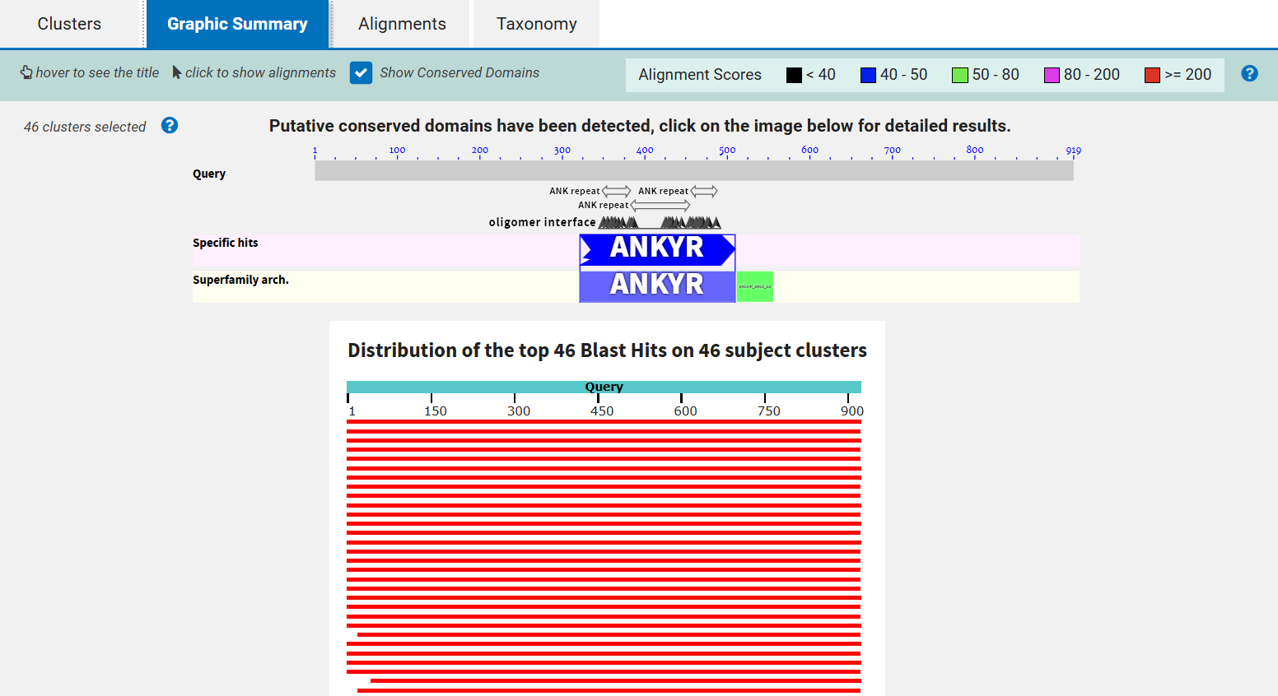Figure 1: Graphic Summary showing the distribution of high-scoring segment pairs (HSPs) matching the 900+ amino acid query sequence.
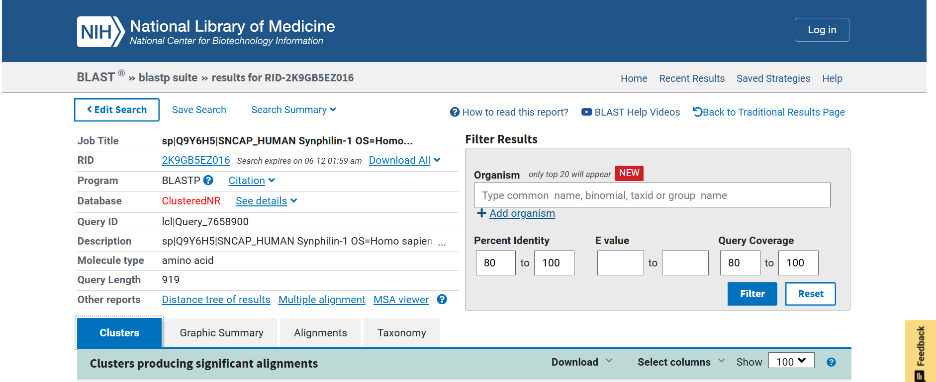Figure 2: Top portion of the BLASTp Description table detailing Max Score, Total Score, Query Cover, E-value, and Percent Identity.

4. Discussion

4.1 Interpretation of BLAST Metrics
The query sequence yielded a perfect match (100% Query Cover, 100% Percent Identity, Bit Score of 1883) to Human Synphilin-1 isoform 1 (Accession: NP_005451.2). This conclusively identifies the query sequence as human Synphilin-1.
- Expect Value (E-value): For all top 50+ hits evaluated, the E-value is 0.0. An E-value of 0.0 signifies that the statistical probability of these alignments occurring due to random sequence shuffling is practically impossible. This confirms true biological homology across all listed organisms.
- Query Coverage: The query coverage remains at 100% across radically divergent species (e.g., humans, birds, turtles, and amphibians). This uniform coverage indicates that the homology is not confined to a single isolated domain (like a simple binding motif), but rather spans the entire length of the structural protein.
- Sequence Divergence: A clear evolutionary gradient is observable via the Percent Identity metric. Human intra-species variants (isoform 2) share 95.13% identity. Non-human placental mammals (naked mole-rats, cattle) drop to roughly 86%–90% identity. Non-mammalian amniotes like reptiles/birds (Emydura macquarii and Strigops habroptila) preserve 70 percentage identity. Finally, highly divergent lineages like the amphibian axolotl (Ambystoma mexicanum) display a baseline identity of 68.61%.

4.2 Biological and Evolutionary Implications
Synphilin-1 (encoded by the SNCAIP gene) is an alpha-synuclein-interacting protein highly expressed in brain tissue. Structurally, it features major protein-protein interaction domains, including ankyrin repeats and a coiled-coil domain. In medical science, it is widely recognized for its accumulation within Lewy bodies, pointing to a critical structural role in the pathogenesis of Parkinson's disease.
The deep sequence conservation highlighted by this BLAST analysis (nearly 69% identical sequence retention in amphibians over hundreds of millions of years of divergence) demonstrates severe purifying selection. Because the sequence has been rigidly maintained across deep time, we can infer that the structural orientation required for Synphilin-1 to anchor to synaptic vesicles and interact with the cytoskeleton is fundamental to vertebrate neurological physiology.
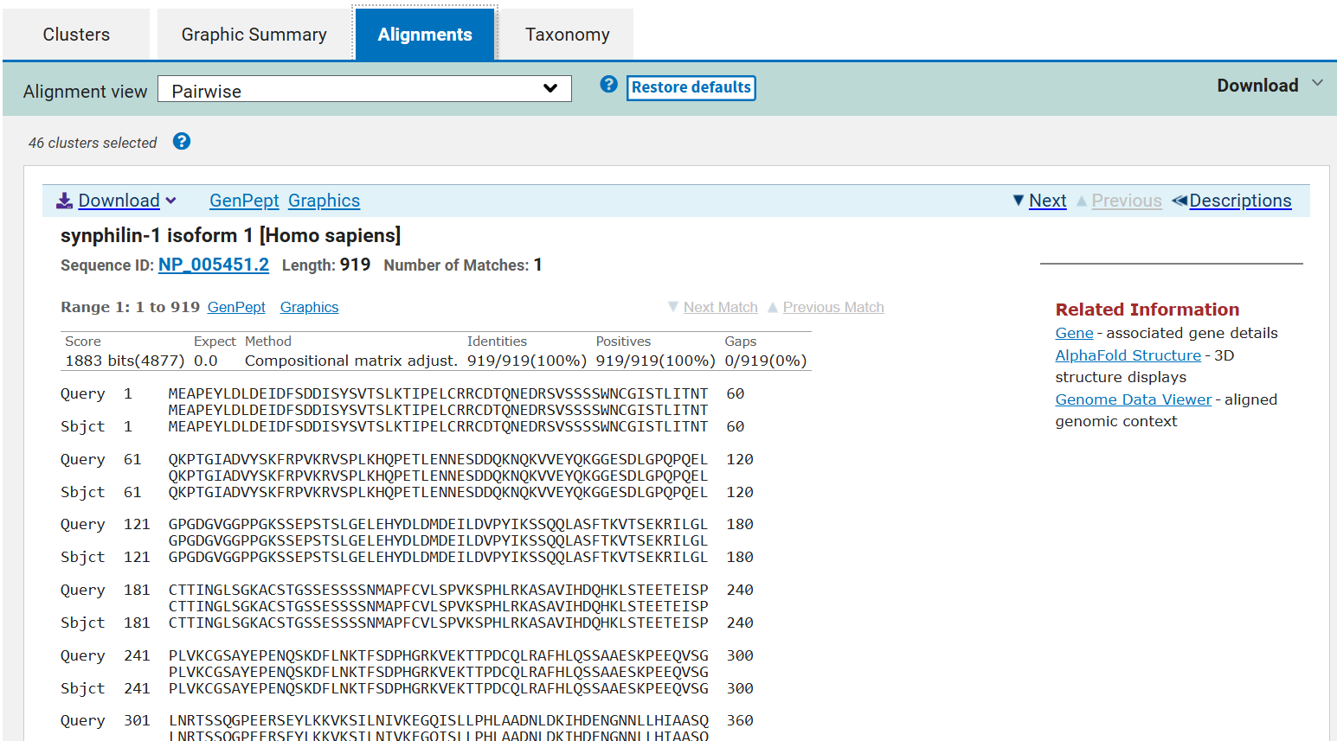Figure 3: Detailed amino acid pairwise alignment highlighting conserved residues and localized gap boundaries.

5. Conclusion
The bioinformatic analysis of the unknown protein sequence successfully identified the query as Human Synphilin-1 isoform 1. Cross-species analysis validated robust sequence homology across mammals, birds, reptiles, and amphibians. The uniform 100% query coverage paired with consistent E-values of 0.0 mathematically establishes an ancient evolutionary origin for this protein, underscoring its indispensable functional role within the vertebrate central nervous system.

Multiple Sequence Alignment (MSA) Report: Conservation Analysis of Synphilin-1
Date: June 11, 2026
Course: Bioinformatocs(task 2)
Author: Sadikshya Adhikari

1. Introduction
Multiple Sequence Alignment (MSA) involves aligning three or more biological sequences (DNA, RNA, or protein) to identify regions of evolutionary conservation, structural motifs, and functional domains. While pairwise alignments (like standard BLAST) compare only two sequences at a time, MSA provides a deeper evolutionary context. It highlights positions that have remained unchanged across millions of years, indicating their strict functional necessity.
In this report, MSA was performed on Synphilin-1, a major protein component of Lewy bodies in Parkinson’s disease. Synphilin-1 contains crucial structural motifs, including Ankyrin repeats (mediating protein-protein interactions) and a coiled-coil domain. Aligning divergent species allows us to map exactly where these vital motifs reside.

2. Methodology

2.1 Sequence Selection
Five orthologous protein sequences representing diverse branches of vertebrate evolution were selected from the NCBI repository:
- Human (Homo sapiens): NP_005451.2 — Mammal (Primate)
- Cattle (Bos taurus): NP_001192707.1 — Mammal (Ungulate)
- Mouse (Mus musculus): NP_001186083.1 — Mammal (Rodent)
- Turtle (Emydura macquarii): XP_067425464.1 — Reptile
- Axolotl (Ambystoma mexicanum): XP_069481678.1 — Amphibian

2.2 Alignment Parameters
The FASTA sequences were retrieved and inputted into Clustal Omega via the EMBL-EBI bioinformatics suite.
- Tool: Clustal Omega (v1.2.4)
- Output Format: ClustalW with character counts
- Color Scheme: ClustalX (amino acids colored by chemical properties to emphasize structural conservation)

3. Results & Alignment Interpretations

3.1 Clustal Omega Consensus Legend
When reviewing the alignment results below, the consensus symbols indicate the following:
- An asterisk (*) indicates positions which have a single, fully conserved residue across all 5 species.
- A colon (:) indicates conservation between groups of strongly similar properties (scoring $>0.5$ in the Gonnet PAM 250 matrix).
- A period (.) indicates conservation between groups of weakly similar properties (scoring $\le0.5$ in the Gonnet PAM 250 matrix).

3.2 Representative MSA Text Blocks
Below are highly informative segments extracted from the total alignment, demonstrating how the protein shifts from variable regions to highly rigid, conserved structural motifs.

Segment A: The Variable N-Terminus Region
The N-terminal region of Synphilin-1 shows high structural flexibility and lower conservation outside of mammals, which is typical for intrinsically disordered regulatory regions.
Plaintext
Human MREAPEAAAPAGGGREKHLSSQPLL---FPPGPGSTPEVPEGEGLCPEEGALGPPVSSQE 57
Cattle MREAPEAA-PTGGGREKQLSSQPLL---FPPSPGSIPEVPEGEGLSPEEGALGPPVCSQE 56
Mouse MREAPEGA-PLGGVQEKQLSLQPLI---LPASPGVIPEAPEEDGLCLEEGALGPSVSPQD 56
Turtle MRES---A-VSDGVREKQFSCHPLLPSLFPPCADLIAEVPENEAL---EGGVGSLVS-RE 52
Axolotl MRES---A--AEGVKEKQVTSQPLLTSLFPISSEPVGEALETESL---EESVESAVS-KE 51
Interpretation: The first 60 amino acids show an influx of deletions (gaps -) and weaker consensus markers (. and :), proving that the precise sequence in this specific tail is less biologically rigid.

Segment B: Highly Conserved Functional Motif (Ankyrin Repeat Region)
Further down the sequence, we encounter the Ankyrin repeats. This motif is structurally crucial as it forms the binding scaffolding that locks onto alpha-synuclein.
Plaintext
Human GLTPLHLAAQRGHYEVAKVLLQHGADVNCA---GERGYTPLHLAAMNGHEDIVEVLLRHG 524
Cattle GLTPLHLAAQKGHYEVAKVLLQHGADVNCA---GERGYTPLHLAAMNGHEDIVEVLLRHG 524
Mouse GLTPLHLAAQKGHYDVAKVLLQHGADVNCA---GERGYTPLHLAAMNGHEDIVEVLLKHG 520
Turtle GLTPLHLAAQRGHYEVAKVLLQHGADVNCTGGQGERGYTPLHLAAMNGAEDIVEVLLKHG 531
Axolotl GLTPLHIAAQKGHFDVAKVLLCHGADVNCT---SERGYTPLHLAAMNGHEEIVEVLLRHG 513
******:**::***:****** *******: .************** *;******:**
- Interpretation: This region demonstrates near-flawless conservation (*) across all 5 highly distinct organisms. The repeating GLTPLHLAA baseline motif is completely preserved from human down to the axolotl. A single mutation here would likely disrupt the protein's structural fold, leading to a loss of function, which explains why evolution has strictly rejected variations at these coordinates.

Complete Clustal Omega Alignment Map
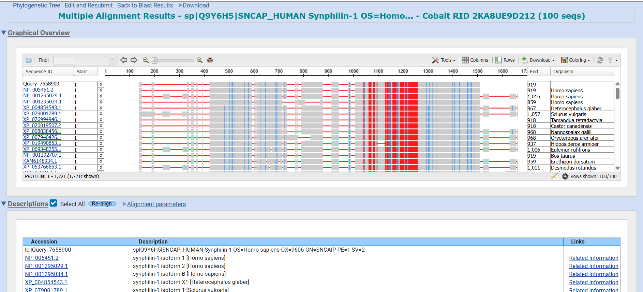Figure 1: Full-length MSA displaying the ClustalX consensus colors emphasizing hydrophobic, polar, and charged amino acid conservation blocks.

5. Conclusion
The Multiple Sequence Alignment effectively maps the evolutionary anatomy of Synphilin-1. While the N-terminal and C-terminal peripheral zones tolerate minor evolutionary drifts, the core interior, specifically housing the Ankyrin repeats tends to remains functionally locked.
The immaculate conservation of these motifs across mammals, reptiles, and amphibians underscores a deep-time evolutionary mandate: the structural sequence driving structural binding in the central nervous system must remain exact to preserve cellular viability

A Comparative Study of Foundational Bioinformatics Databases: NCBI, UniProt, and the Protein Data Bank (PDB)
Course: Bioinformatics / Core Tool Study
Project ID: CodeAlpha Task 4 (Mini Project)
Date: June 10, 2026

Abstract
Biological data generation scales exponentially with the expansion of high-throughput sequencing and structural biology technologies. Managing, structural archiving, and computationally retrieving this data requires robust database architectures. This mini-project conducts a rigorous comparative analysis of three primary databases: the National Center for Biotechnology Information (NCBI), the Universal Protein Resource (UniProt), and the Protein Data Bank (PDB).
The paper evaluates their underlying storage architecture, curation standards, data file layouts, and primary analysis toolsets, mapping out their distinct but interconnected roles in modern biomedical workflows.

1. Introduction
Modern bioinformatics relies heavily on public-access data repositories to organize information generated from wet-lab molecular experiments. Biological databases function as central access points, transforming raw nucleotide sequences, peptide sequences, and atomic coordinates into annotated, searchable biological knowledge.
To navigate these resources effectively, researchers classify databases into two structural types:
- Primary Databases: Direct repositories for raw experimental data submitted directly by researchers (e.g., GenBank, PDB).
- Secondary/Curated Databases: Derived repositories that clean, compile, filter, and add expert manual annotations to primary data strings (e.g., UniProtKB/Swiss-Prot, RefSeq).
This comparative investigation breaks down the three foundational repositories that bridge genomics, transcriptomics, proteomics, and structural biology.

2. Comprehensive Database Profiles

2.1 NCBI (National Center for Biotechnology Information)
Established in 1988 in Bethesda, Maryland, NCBI is a federally funded division of the National Institutes of Health (NIH). Rather than operating as a standalone singular database, NCBI functions as an expansive, interconnected ecosystem of over 40 distinct databases unified under the Entrez meta-search engine.
- Primary Mission: To store and manage public genomic records, literature, chemical descriptors, and clinical variation data.
- Core Components: * GenBank: The global primary repository for nucleotide submissions.
  - PubMed: The global standard for biomedical literature citations.
  - RefSeq: A curated, non-redundant collection of reference genomic, transcriptomic, and protein sequences.

2.2 UniProt (Universal Protein Resource)
UniProt is a specialized, multi-institutional consortium combining the European Bioinformatics Institute (EMBL-EBI), the SIB Swiss Institute of Bioinformatics, and the Protein Information Resource (PIR).
- Primary Mission: To provide a comprehensive, central resource for protein sequence patterns and functional annotations.
- Core Components:
  - UniProtKB/Swiss-Prot: The gold standard for protein curation, featuring manually reviewed entries with deep literature annotations describing protein functions, post-translational modifications (PTMs), active sites, and disease phenotypes.
  - UniProtKB/TrEMBL: An unreviewed, automatically annotated component that handles high-throughput translations of EMBL/GenBank coding sequences.

2.3 PDB (Protein Data Bank)
Founded in 1971, the PDB is managed by the Worldwide Protein Data Bank (wwPDB) consortium, including RCSB PDB (USA), PDBe (Europe), and PDBj (Japan).
- Primary Mission: To maintain the single international structural archive for 3D atomic coordinate data of biological macromolecules.
- Core Components: The database archives physical measurements derived from empirical structural biology techniques, specifically X-ray Crystallography, Nuclear Magnetic Resonance (NMR) spectroscopy, and high-resolution Cryo-Electron Microscopy (cryo-EM).

3. Structural Comparison Matrix
To analyze the boundaries between these resources, the table below highlights their operational profiles:
Feature / Metric | NCBI | UniProt | Protein Data Bank (PDB)
Primary Domain | Genomics, Transcriptomics, Literature, & General Biology | Functional Proteomics & Protein Sequences | Structural Biology & 3D Atomic Coordinates
Data Types Stored | DNA, RNA, Amino Acid Sequences, Clinical Variants, Medical Literature | Curated Peptide Chains, PTMs, Functional Domains, Metabolic Profiles | 3D Spatial Coordinates ($X, Y, Z$) of atomic structures, Electron Densities
Curation Model | Mixed (Archival GenBank vs. Expert-Curated RefSeq) | Strict Division (Automated TrEMBL vs. High-Level Manual Swiss-Prot) | Strict Experimental Validation (Empirical structure metrics)
Core Search Tool | Entrez Search Engine, BLAST | BLAST, Align, Retrieve/ID Mapping, Peptide Search | Advanced Attribute Searching, Structural Motifs, 3D Mol* Viewer
Standard File Formats | FASTA, GenBank Flat File, ASN.1 | FASTA, XML, Text Flat Files | PDB format, mmCIF (Macromolecular Crystallographic Information File)
Primary Identifier Style | Accession Numbers (e.g., NP_005451.2, NM_000314) | Alphanumeric Accession IDs (e.g., Q9Y6H5, P05067) | 4-Character Alphanumeric codes (e.g., 1A8G, 6VXX)

4. Analysis of File Formats and Data Interoperability
Data sharing between these systems is crucial for bioinformatic analysis workflows. A sequence must move cleanly from genomic discovery to structural modeling.

4.1 The Sequence Level: FASTA and GenBank formats
NCBI and UniProt share the FASTA sequence format as their primary flat text output. FASTA is highly accessible due to its simplicity, relying on a single-line header initiated by a > character, followed by raw single-letter nucleotide or amino acid codes.
However, FASTA files lack complex metadata. To preserve functional annotation coordinates, NCBI uses the GenBank flat file structure, while UniProt uses XML or specialized tab-delimited text documents to list exact PTM boundaries, active binding pockets, and subcellular localization signals.

4.2 The Spatial Level: PDB vs. mmCIF formats
Unlike sequence databases, the PDB requires multi-dimensional tracking. Historically, the .pdb format recorded spatial layouts using strict columns specifying the exact Cartesian space coordinates ($X, Y, Z$) of every single atom in a folded molecule.
Due to the size limitations of old file systems (capped at 99,999 atoms and 62 peptide chains), the modern PDB has transitioned to the mmCIF (.cif) format. The mmCIF framework accommodates massive macromolecular complexes, such as whole ribozyme architectures and intact viral capsids resolved via cryo-EM.

5. Algorithmic and Analysis Integration
The true power of these databases emerges when they function as a unified ecosystem. A standard pipelines-driven research project moves through these systems sequentially:
[NCBI] Identify GenBank/RefSeq Disease Transcript
│
▼ (Conceptual Translation)
[UniProt] Map Sequence Variants, Active Sites, & PTMs in Swiss-Prot
│
▼ (Residue Cross-Mapping via SIFTS)
[PDB] Fetch Experimental 3D Crystallographic Atomic Coordinates
This structural crossover is maintained via continuous data integration initiatives like SIFTS (Structure Integration with Function, Taxonomy, and Sequence). SIFTS offers an automated, residue-by-residue translation map between UniProt sequence entries and PDB structural models. This allows researchers to immediately identify whether a mutated amino acid sequence found in an NCBI patient clinical trial maps directly onto a vulnerable drug-binding binding pocket inside an active PDB structure.

6. Conclusion
While NCBI, UniProt, and PDB show distinct differences in their internal data structures and primary biological scopes, they are not competing entities. Instead, they form a cooperative data pipeline:
- NCBI serves as the broad genetic anchor, charting the foundational genomic maps of life.
- UniProt works as the functional translator, defining the precise cellular duties and post-translational life cycles of encoded proteins.
- PDB acts as the structural lens, capturing the definitive physical atomic architecture required to turn raw sequence strings into practical structural targets for biochemical engineering and drug discovery.
Mastering the cross-talk between these three core resources is a foundational skill for modern bioinformaticians working in structural biology and computational medicine.

References
- Sayers, E. W., et al. (2022). "Database resources of the National Center for Biotechnology Information." Nucleic Acids Research, 50(D1), D20-D26.
- UniProt Consortium. (2023). "UniProt: the universal protein knowledgebase in 2023." Nucleic Acids Research, 51(D1), D523-D531.
- Burley, S. K., et al. (2021). "RCSB Protein Data Bank: powerful resources for structural biology and biomedicine." Nucleic Acids Research, 49(D1), D437-D446.
- Dana, J. M., et al. (2019). "SIFTS: updated guidance for improving data interoperability between protein sequence and 3D structure." Nucleic Acids Research, 47(D1), D482-D489.

