1. **What commands would you use to set your username and email globally?**

**Command:** git config --global user.name "Sadiek Momin"

git config --global user.email [mominsadiek@gmail.com](mailto:mominsadiek@gmail.com)

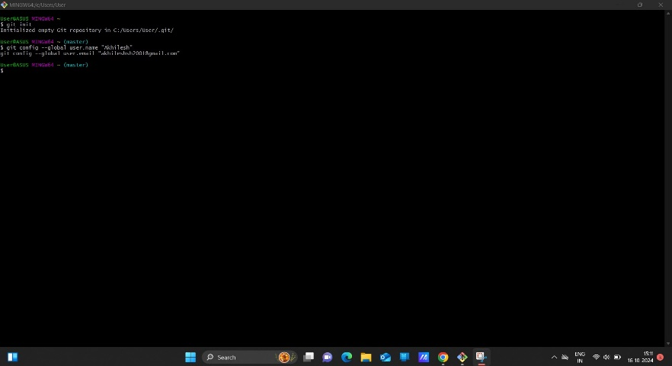

1. **What command would you use to clone the repository from the following URL:** <https://github.com/example/repo.git>**?**

**Command:** git clone <https://github.com/Sadiek-Momin/Sadiek.git>

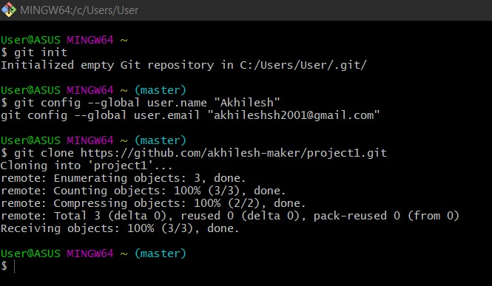

1. **What command would you use to create and switch to a branch called new-feature?**

**Command:** git checkout -b new-feature

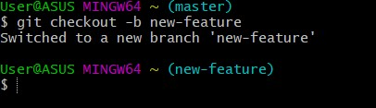

1. **What command would you use to stage this new file for commit?**

**Command:** touch feature.py

git add feature.py

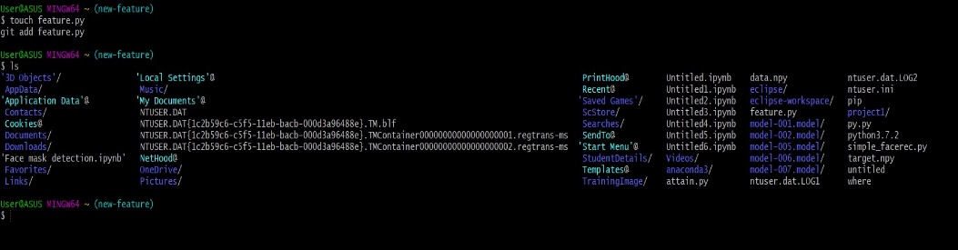

1. **What command would you use to commit your staged changes with the message "Add new feature implementation"?**

**Command:** git commit -m "Add new feature implementation"

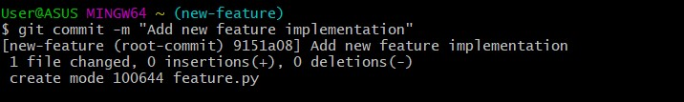

1. **What command would you use to push your changes in the new-feature branch to the remote repository?**

**Command:** git push origin new-feature

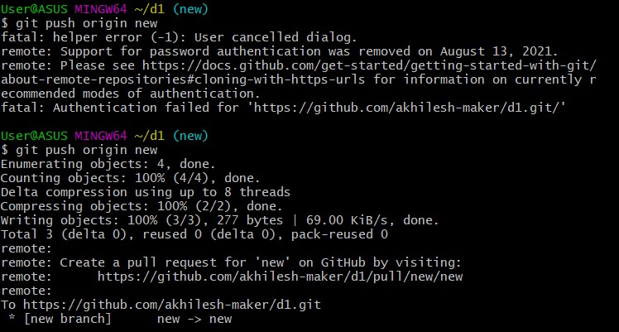

1. **What command would you use to pull the latest changes from the main branch of the remote repository?**

**Command:** git pull origin main

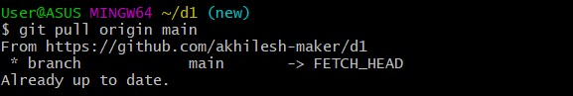

1. **What command would you use to remove feature.py from your repository?**

**Command:** git rm feature.py

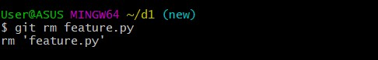

1. **What commands would you use to commit the removal and push the changes to the remote repository?**

**Command:** git commit -m "Remove feature.py"

git push origin new-feature

