**Module 5**

In today’s world people want more than one UI to connect to a program. This tends to cause a problem because you would need to basically re-write you code to fit the new UI. This would make your program grow large.

When creating a program for the first time if you plan for this then when your boss comes to you and says they want to add a new UI then you do not need to re-write your code. To do this you will use a “Class Library”. A Class Library is another project that can be add to your solution just like any project.

Right click on the Solution in the Solution Explorer then “Add” > “New Project”.

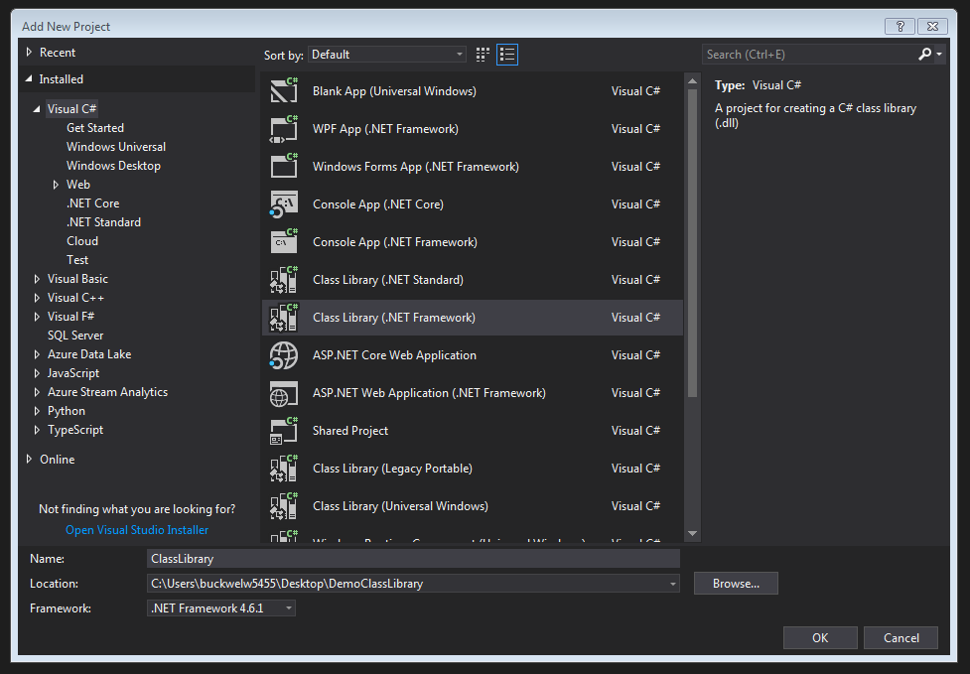

You come to the screen above. You will need to click on “Class Library(.NET Framework)”. Give your library a name and then click Ok. Your new Class Library should appear in the Solution Explorer like below.

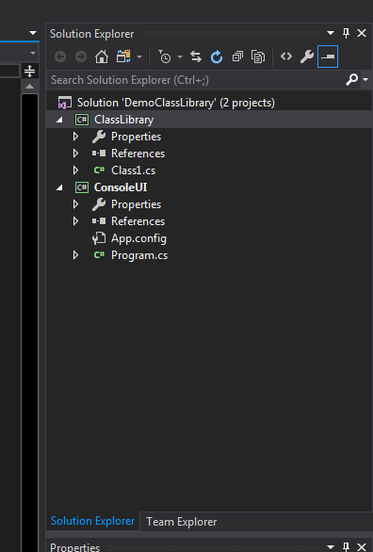

We are now down yet. We must get the project to see the new library. Under your UI project right click on “References” > “Add Reference”. You will get the screen below.

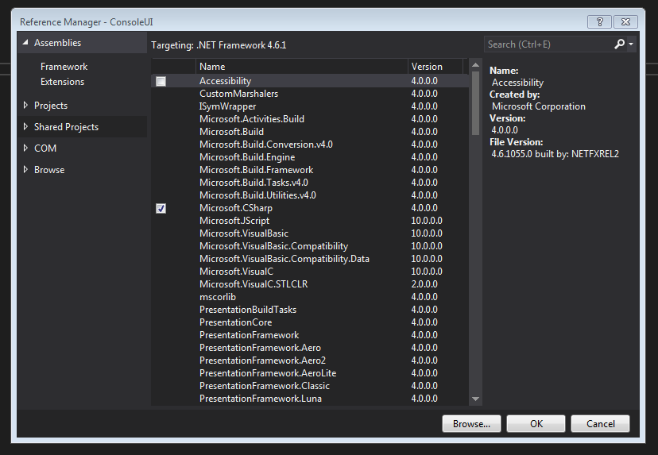

On the left hand side you will need to click on “Projects”.

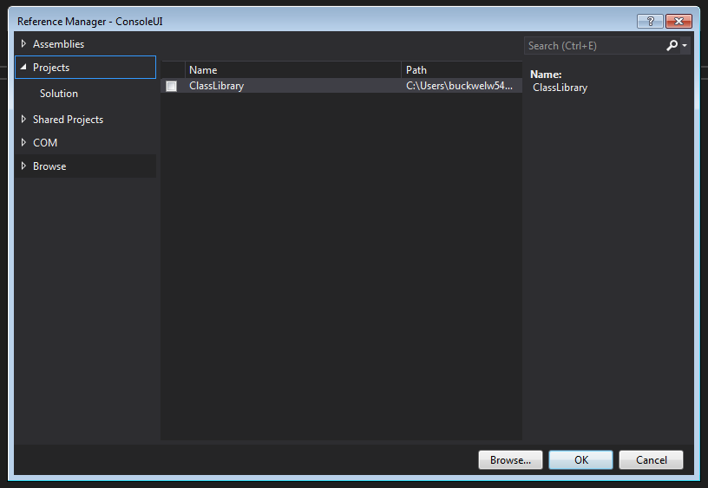

Click on the name of your Class library and then click Ok.

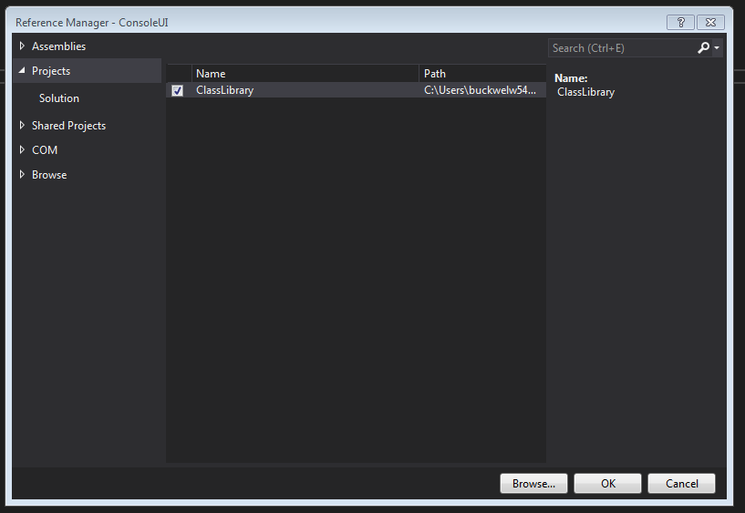

Now back in the “Main” method of the Program.cs of the UI Project we need to add a using statement. For this Demo we will type – “using ClassLibrary;”

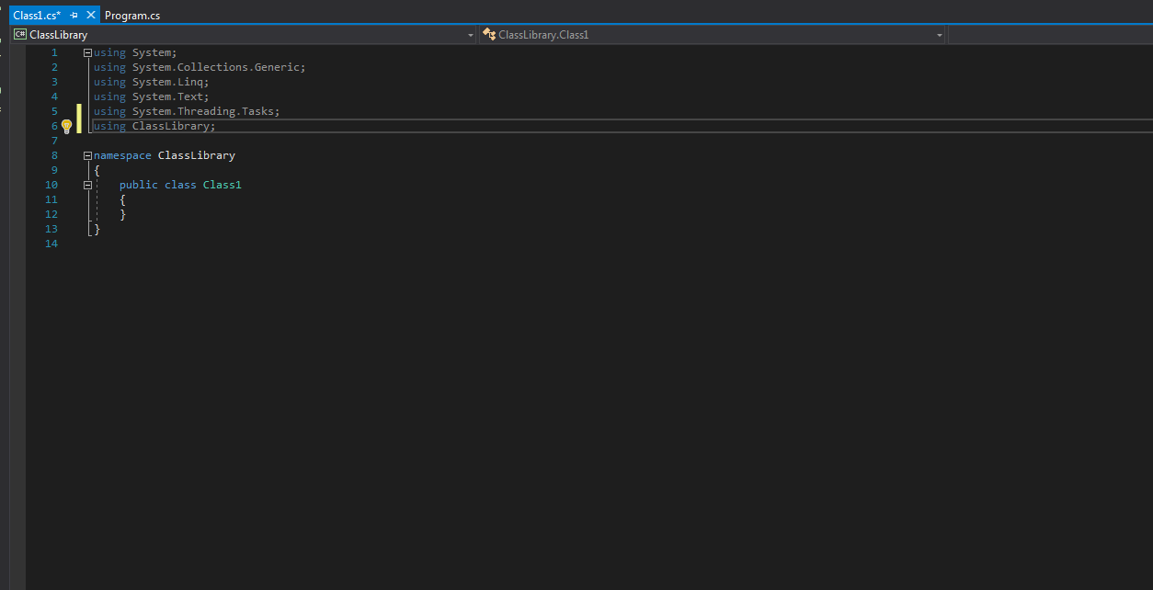

Now we have access to the ClassLibrary.